Supplementary information
Social networks in primates: smart and tolerant species have more efficient networks

Cristian Pasquaretta, Marine Levé, Nicolas Claidière, Erica van de Waal, Andrew Whiten, Andrew J.J. MacIntosh, Marie Pelé, Mackenzie L. Bergstrom, Christèle Borgeaud, Sarah F. Brosnan, Margaret C. Crofoot, Linda M. Fedigan, Claudia Fichtel, Lydia M. Hopper, Mary Catherine Mareno, Odile Petit, Anna Viktoria Schnoell, Eugenia Polizzi di Sorrentino, Bernard Thierry, Barbara Tiddi & Cédric Sueur

- Supplementary methods
Primate Social networks
We compiled interaction matrices for primate species following procedures similar to previous meta-analyses^{1–4}. These data came from published studies or from unpublished data provided by the authors on groups already studied (Table 1). Only interactions involving close proximity were considered, including grooming, contact sitting or proximities less than one meter. We used only one kind of the above mentioned interactions per group. We preferred body contacts to proximities as this measure is more reliable and reflects more individual preference than proximity. Observation periods (in months) and time of observation (number of focal hours per group) are not correlated with measures of efficiency, densities, centrality or modularity (-0.265 < r < 0.049, P > 0.023, α = 0.005_{adjusted}). We favoured social network measures allowing comparisons between groups despite the differences in data collection methods^{5,6}. We compiled a total of 78 primate social networks. Details are given in Table 1.

Phylogenetic analysis
In order to test if the observed variation in the efficiency traits was determined by phylogenetic relationship among species we tested whether the phylogenetic signal (defined as the non independence of a trait among species) was significantly different from 0 using randomization procedure for each of the two efficiency values⁷. If, the ratio of the observed residual standard error on its randomize expected value among species, K is < 1, then the trait analysed are not significant influenced by the phylogenetic relationships. The influence of phylogenetic matrix was tested on a mean efficiency value for each species using the phylosignal function in the R package picante^{7,8}. There was no influence of phylogeny on both the efficiency values (Global Efficiency: K = 0.389, P = 0.673; Average Dyadic Efficiency: K = 0.318, P = 0.891).

Statistical analysis
We applied a Bayesian mixed model approach (package MCMCglmm in R^{9–12}) to evaluate which predictors might affect the efficiency of the network. We used the Markov-chain Monte-Carlo (MCMC) method for two main reasons. First it allows mixed models to deal with a highly unbalanced dataset (see species and family columns in Table 1) obtaining reliable estimates of the predictors contrary to what a frequentist approach does. Second it creates a Markov chain sequence that converge to a stationary posterior distribution allowing for the estimation of the mean and the 95% credibility intervals for each predictor while checking whether they overlap zero or not¹⁰. We specified simulation parameters in the MCMC as following: 100000 iterations, a thinning interval of 100 (i.e. only one iteration from every 100 in the Markov chain is used to estimate the posterior distribution of the parameters to reduce the autocorrelation between successive iterations) and a burn-in of 1000 to ensure convergence (the parameters are estimated after discarding the first 1000 models)¹⁰. We carried out multi-model inference and model average to ranking models according to their Deviance Information Criterion¹¹ to evaluate the relative weight of evidence of each predictor on network efficiency using the dredge and model.avg functions in the R Package MuMIn ¹³
Global Efficiency was negatively related to group size and positively related to neocortex Ratio, respectively (Extended data table 1 in the Main Text). The same results were obtained after removing Homo sapiens from the analysis (Extended data table 2 in the Main Text). Average Dyadic Efficiency was negatively related both to group size and centralisation index (Extended data table 3 in the Main Text) and the results were similar when removing Homo sapiens (Extended data table 4 in the Main Text).
- Supplementary tables
Extended data table 1 – Fixed effects for Global Efficiency model using the complete dataset. Posterior density means and their upper (U – 95% CI) and lower (L – 95% CI) credibility intervals are provided. Significant p-values (pMCMC) are presented in bold. Relative weight of evidence for each predictor is expressed as a percentage of influence on the response variable relative to other predictors tested.

 | Posterior Mean | L – 95% CI | U – 95% CI | pMCMC | Relative weight %
intercept | 0.450 | 0.35 | 0.553 | < 0.001
Group Size | -0.135 | -0.168 | -0.01 | < 0.001 | 100
Neocortex ratio | 0.024 | 0.009 | 0.039 | 0.003 | 88
Centralisation | -0.001 | -0.001 | 0.001 | 0.061 | 67
Sex ratio | 0.035 | -0.043 | 0.118 | 0.388 | 25

Extended data table 2 – Fixed effects for Global Efficiency model excluding Homo sapiens. Posterior density means and their upper (U – 95% CI) and lower (L – 95% CI) credibility intervals are provided. Significant p-values (pMCMC) are presented in bold. Relative weight of evidence for each predictor is expressed as a percentage of influence on the response variable relative to other predictors tested.
 | Posterior Mean | L – 95% CI | U – 95% CI | pMCMC | Relative weight %
intercept | 0.524 | 0.403 | 0.651 | < 0.001
Group Size | -0.152 | -0.189 | -0.116 | < 0.001 | 100
Neocortex ratio | 0.017 | 0.001 | 0.035 | 0.046 | 76
Centralisation | -0.001 | -0.001 | 0.001 | 0.121 | 57
Sex ratio | -0.012 | -0.11 | 0.081 | 0.812 | 28

Extended data table 3 – Fixed effects for Average Dyadic Efficiency model using the complete dataset. Posterior density means and their upper (U – 95% CI) and lower (L – 95% CI) credibility intervals are provided. Significant p-values (pMCMC) are presented in bold. Relative weight of evidence for each predictor is expressed as a percentage of influence on the response variable relative to other predictors tested.
 | Posterior Mean | L – 95% CI | U – 95% CI | pMCMC | Relative weight %
intercept | 1.492 | 1.276 | 1.693 | < 0.001
Group Size | -0.152 | -0.209 | -0.09 | < 0.001 | 100
Neocortex ratio | -0.025 | -0.057 | 0.004 | 0.088 | 61
Centralisation | -0.003 | -0.005 | -0.002 | < 0.001 | 100
Sex ratio | -0.049 | -0.205 | 0.086 | 0.492 | 26

Extended data table 4 – Fixed effects for Average Dyadic Efficiency model excluding Homo sapiens. Posterior density means and their upper (U – 95% CI) and lower (L – 95% CI) credibility intervals are provided. Significant p-values (pMCMC) are presented in bold. Relative weight of evidence for each predictor is expressed as a percentage of influence on the response variable relative to other predictors tested.
 | Posterior Mean | L – 95% CI | U – 95% CI | pMCMC | Relative weight %
intercept | 1.413 | 1.206 | 1.636 | < 0.001
Group Size | -0.121 | -0.18 | -0.064 | < 0.001 | 100
Neocortex ratio | -0.014 | -0.051 | 0.023 | 0.378 | 36
Centralisation | -0.004 | -0.005 | -0.003 | < 0.001 | 100
Sex ratio | -0.076 | -0.222 | 0.07 | 0.308 | 27

Extended data table 5: Dataset of the 78 primates groups
Group | Species | Family | Interaction | Context | Sex ratio | Group Size N | Number of connections I | Diameter D | Density
1 | Alouatta palliata | Aotidae | Proximities | Wild | 0.5 | 17 | 85 | 2 | 0.625
2 | ateles geoffroyi | Atelidae | Body contacts | Wild | 0.4286 | 15 | 46 | 3 | 0.438
3 | Cebus capucinus | Cebidae | Body contacts | Wild | 0 | 7 | 19 | 2 | 0.905
4 | Cebus capucinus | Cebidae | Body contacts | Wild | 0.3333 | 12 | 12 | 4 | 0.182
5 | Cebus capucinus | Cebidae | Body contacts | Wild | 0.5 | 14 | 22 | 4 | 0.242
6 | Cebus capucinus | Cebidae | Body contacts | Wild | 0.6923 | 13 | 21 | 3 | 0.269
7 | Cebus capucinus | Cebidae | Body contacts | Wild | 0 | 5 | 10 | 1 | 1
8 | Cebus capucinus | Cebidae | Body contacts | Wild | 0 | 6 | 15 | 1 | 1
9 | Cebus capucinus | Cebidae | Body contacts | Wild | 0 | 10 | 44 | 2 | 0.978
10 | Saimiri sciureus | Cebidae | Proximities | Captive | 0.25 | 8 | 16 | 3 | 0.571
11 | Saimiri sciureus | Cebidae | Proximities | Captive | 0.3 | 10 | 24 | 3 | 0.533
12 | Saimiri sciureus | Cebidae | Body contacts | Captive | 0.3333 | 12 | 66 | 1 | 1
13 | Saimiri sciureus | Cebidae | Proximities | Captive | 0.4444 | 9 | 16 | 4 | 0.444
14 | Sapajus apella | Cebidae | Body contacts | Wild | 0.1818 | 11 | 33 | 3 | 0.6
15 | Sapajus apella | Cebidae | Body contacts | Wild | 0.2667 | 15 | 21 | 4 | 0.2
16 | Sapajus apella | Cebidae | Body contacts | Wild | 0.2857 | 10 | 25 | 3 | 0.556
17 | Sapajus apella | Cebidae | Body contacts | Wild | 0.3 | 10 | 37 | 2 | 0.822
18 | Sapajus apella | Cebidae | Body contacts | Wild | 0.4 | 8 | 13 | 3 | 0.464
19 | Sapajus apella | Cebidae | Body contacts | Wild | 0.5 | 12 | 33 | 2 | 0.5
20 | Sapajus apella | Cebidae | Body contacts | Captive | 0.5714 | 7 | 21 | 1 | 1
21 | Sapajus paella | Cebidae | Body contacts | Wild | 0 | 5 | 9 | 2 | 0.9
22 | Sapajus paella | Cebidae | Body contacts | Wild | 0.25 | 8 | 17 | 2 | 0.607
23 | Cercopithecus diana | Cercopithecidae | Body contacts | Captive | 0.4286 | 7 | 19 | 2 | 0.905
24 | cercopithecus mitis | Cercopithecidae | Body contacts | Wild | 0 | 17 | 102 | 2 | 0.75
25 | Chlorocebus pygerythrus | Cercopithecidae | Body contacts | Wild | 0.3947 | 38 | 460 | 2 | 0.654
26 | Chlorocebus pygerythrus | Cercopithecidae | Body contacts | Wild | 0.4 | 25 | 217 | 2 | 0.723
27 | Chlorocebus pygerythrus | Cercopithecidae | Body contacts | Wild | 0.5385 | 26 | 259 | 3 | 0.797
28 | Erythrocebus patas | Cercopithecidae | Body contacts | Wild | 0.1111 | 8 | 28 | 1 | 1
29 | Macaca arctoides | Cercopithecidae | Body contacts | Wild | 0.381 | 21 | 40 | 4 | 0.19
30 | Macaca arctoides | Cercopithecidae | Body contacts | Captive | 0.1429 | 14 | 90 | 2 | 0.989
31 | Macaca fuscata | Cercopithecidae | Body contacts | Wild | 0.36 | 25 | 248 | 2 | 0.823
32 | Macaca fuscata | Cercopithecidae | Body contacts | Wild | 0.4194 | 31 | 117 | 4 | 0.252
33 | Macaca fuscata | Cercopithecidae | Body contacts | Wild | 0.4667 | 15 | 30 | 4 | 0.286
34 | Macaca fuscata | Cercopithecidae | Proximities | Captive | 0.3571 | 14 | 90 | 2 | 0.989
35 | Macaca fuscata | Cercopithecidae | Body contacts | Wild | 0.3333 | 21 | 64 | 3 | 0.305
36 | Macaca fuscata | Cercopithecidae | Body contacts | Captive | 0.3636 | 22 | 125 | 2 | 0.541
37 | Macaca mulatta | Cercopithecidae | Body contacts | Wild | 0.4375 | 16 | 49 | 4 | 0.408
38 | Macaca mulatta | Cercopithecidae | Body contacts | Captive | 0.2222 | 9 | 34 | 2 | 0.944
39 | Macaca mulatta | Cercopithecidae | Body contacts | Captive | 0.4 | 10 | 32 | 2 | 0.711
40 | Macaca nigra | Cercopithecidae | Body contacts | Captive | 0.375 | 16 | 98 | 2 | 0.817
41 | Macaca radiata | Cercopithecidae | Body contacts | Wild | 0.3478 | 23 | 162 | 2 | 0.64
42 | Macaca radiata | Cercopithecidae | Body contacts | Wild | 0.4375 | 16 | 89 | 2 | 0.742
43 | Macaca tonkeana | Cercopithecidae | Body contacts | Captive | 0.2857 | 15 | 28 | 4 | 0.267
44 | Macaca tonkeana | Cercopithecidae | Body contacts | Captive | 0.3 | 10 | 37 | 2 | 0.822
45 | Macaca tonkeana | Cercopithecidae | Body contacts | Captive | 0.48 | 25 | 231 | 2 | 0.77
46 | Macaca tonkeana | Cercopithecidae | Body contacts | Captive | 0.5625 | 18 | 150 | 2 | 0.981
47 | Macaca tonkeana | Cercopithecidae | Body contacts | Captive | 0.5714 | 10 | 45 | 1 | 1
48 | Mandrillus sphinx | Cercopithecidae | Body contacts | Captive | 0.2778 | 18 | 24 | 5 | 0.157
49 | Papio ursinus | Cercopithecidae | Body contacts | Wild | 0.2667 | 15 | 69 | 2 | 0.657
50 | Homo sapiens | Hominidae | Proximities | NA | 0 | 22 | 39 | 5 | 0.169
51 | Homo sapiens | Hominidae | Proximities | NA | 1 | 34 | 55 | 5 | 0.098
52 | Homo sapiens | Hominidae | Proximities | NA | 0.4138 | 29 | 240 | 2 | 0.591
53 | Homo sapiens | Hominidae | Proximities | NA | 0.5455 | 11 | 46 | 2 | 0.836
54 | Pan paniscus | Hominidae | Proximities | Captive | 0.6 | 5 | 9 | 2 | 0.9
55 | Pan troglodytes | Hominidae | Body contacts | Wild | 1 | 15 | 27 | 4 | 0.257
56 | Pan troglodytes | Hominidae | Body contacts | Wild | 0.3333 | 12 | 50 | 2 | 0.758
57 | Pan troglodytes | Hominidae | Body contacts | Captive | 1 | 9 | 31 | 2 | 0.861
58 | Pan troglodytes | Hominidae | Body contacts | Captive | 0.1667 | 5 | 10 | 1 | 1
59 | Pan troglodytes | Hominidae | Body contacts | Captive | 0.1818 | 11 | 55 | 1 | 1
60 | Pan troglodytes | Hominidae | Proximities | Captive | 0.2857 | 7 | 21 | 1 | 1
61 | Pan troglodytes | Hominidae | Proximities | Captive | 0.2857 | 7 | 21 | 1 | 1
62 | Pan troglodytes | Hominidae | Body contacts | Captive | 0.3333 | 9 | 18 | 1 | 1
63 | Pan troglodytes | Hominidae | Proximities | Captive | 0.3333 | 6 | 11 | 2 | 0.733
64 | Pan troglodytes | Hominidae | Proximities | Captive | 0.3333 | 6 | 15 | 1 | 1
65 | Pan troglodytes | Hominidae | Proximities | Captive | 0.375 | 8 | 26 | 2 | 0.929
66 | Pan troglodytes | Hominidae | Body contacts | Captive | 0.5 | 8 | 28 | 1 | 1
67 | Pan troglodytes | Hominidae | Body contacts | Captive | 0.5 | 10 | 45 | 1 | 1
68 | Pan troglodytes | Hominidae | Body contacts | Wild | 0.3276 | 58 | 1643 | 2 | 0.994
69 | Pan troglodytes | Hominidae | Proximities | Wild | 0.4286 | 21 | 108 | 2 | 0.514
70 | Pan troglodytes | Hominidae | Proximities | Captive | 0.6471 | 17 | 134 | 2 | 0.985
71 | Pongo | Hominidae | Proximities | Captive | 0.2 | 5 | 6 | 3 | 0.6
72 | Eulemur catta | Lemuridae | Proximities | Wild | 0.5 | 12 | 55 | 2 | 0.833
73 | Eulemur catta | Lemuridae | Proximities | Wild | 0.5 | 12 | 59 | 2 | 0.894
74 | Eulemur catta | Lemuridae | Proximities | Wild | 0.5455 | 11 | 42 | 2 | 0.764
75 | Eulemur fulvus | Lemuridae | Body contacts | Captive | 0.6364 | 11 | 48 | 2 | 0.873
76 | Eulemur rufifrons | Lemuridae | Proximities | Wild | 0.5833 | 12 | 42 | 2 | 0.636
77 | Eulemur rufifrons | Lemuridae | Proximities | Wild | 0.6364 | 11 | 33 | 2 | 0.6
78 | Eulemur rufifrons | Lemuridae | Proximities | Wild | 0.6429 | 14 | 45 | 3 | 0.495

Group | Neocortex ratio Cr | Global Efficiency | Average Dyadic Efficiency | Centralisation index | Modularity | Observation period (months) | focal hours per group | Reference
1 | 1.82 | 0.1 | 0.813 | 39.5 | 0.254 | Unknown | Unknown | ¹⁴
2 | 2.35 | 0.1087 | 0.7143 | 81.2 | 0.4 | 4 | 161 | ¹⁵
3 | 4.88 | 0.1842 | 0.9524 | 34.7 | 0.214 | 5 | 110 | ^{16–18}
4 | 4.88 | 0.25 | 0.4767 | 110.58 | 0.415 | 14 | 107 | ^{18,19}
5 | 4.88 | 0.1591 | 0.5156 | 91.46 | 0.489 | 14 | 59 | ^{18,19}
6 | 4.88 | 0.2063 | 0.5769 | 71.61 | 0.357 | 10 | 88 | ^{18,19}
7 | 4.88 | 0.5 | 1 | 32.32 | 0.208 | 5 | 110 | ^{16–18}
8 | 4.88 | 0.4 | 1 | 41.16 | 0.197 | 24 | 603 | ^{18,20}
9 | 4.88 | 0.1136 | 0.9889 | 14.25 | 0.31 | 5 | 110 | ^{16–18}
10 | 2.21 | 0.1667 | 0.4556 | 71.13 | 0.499 | 1 | 112 | ²¹
11 | 2.21 | 0.1389 | 0.7519 | 70.2 | 0.603 | 1 | 180 | ²¹
12 | 2.21 | 0.1818 | 1 | 28.05 | 0.339 | 1 | 11 | ⁸
13 | 2.21 | 0.1406 | 0.6968 | 108.56 | 0.748 | 1 | 144 | ²¹
14 | 4.88 | 0.1111 | 0.785 | 84.71 | 0.382 | 8 | 124 | ^{18,23,24}
15 | 4.88 | 0.1786 | 0.523 | 92.94 | 0.308 | 8 | 73 | ^{18,23,24}
16 | 4.88 | 0.1333 | 0.7519 | 90.39 | 0.001 | 15 | 542 | ^{18,25}
17 | 4.88 | 0.1351 | 0.911 | 97.5 | 0.41 | 24 | 1466 | ^{18,26}
18 | 4.88 | 0.2051 | 0.6458 | 117.29 | 0.412 | 15 | 721 | ^{18,25}
19 | 4.88 | 0.1818 | 0.697 | 95.1 | 0.362 | 2 | 300 | ²²
20 | 4.88 | 0.3333 | 1 | 37.09 | 0.237 | 1 | 11 | ⁸
21 | 4.88 | 0.2778 | 0.95 | 21.58 | 0.362 | 2 | 300 | ²²
22 | 4.88 | 0.2353 | 0.804 | 104.38 | 0.491 | 8 | 83 | ^{18,23,24}
23 | 2.29 | 0.1842 | 0.9524 | 57.21 | 0.373 | 6 | 88 | ²⁷
24 | 2.42 | 0.0833 | 0.875 | 31.21 | 0.197 | 18 | Unknown | ²⁸
25 | 2.17 | 0.0413 | 0.8184 | 29.48 | 0.195 | 24 | Unknown | ^{29,30}
26 | 2.17 | 0.0576 | 0.8617 | 33.56 | 0.189 | 24 | Unknown | ^{29,30}
27 | 2.17 | 0.0335 | 0.8979 | 19.78 | 0.178 | 24 | Unknown | ^{29,30}
28 | 2.96 | 0.2857 | 1 | 26.72 | 0.372 | 1 | 259 | ³¹
29 | 2.43 | 0.1313 | 0.5885 | 55.88 | 0.295 | 3 | 300 | ³²
30 | 2.43 | 0.0778 | 0.9945 | 47.64 | 0.22 | 28 | 191 | ³³
31 | 2.6 | 0.0504 | 0.91 | 7.39 | 0.227 | 12 | 288 | ³⁴
32 | 2.6 | 0.0662 | 0.579 | 53.09 | 0.392 | 16 | 1179 | ³⁵
33 | 2.45 | 0.125 | 0.5699 | 65.57 | 0.455 | 12 | 764 | ³⁶
34 | 2.45 | 0.0787 | 0.9877 | 42.135 | 0.322 | 12 | 273 | ³⁷
35 | 2.45 | 0.1094 | 0.6349 | 89.7 | 0.489 | 12 | 140 | ³⁸
36 | 2.45 | 0.088 | 0.7706 | 37.94 | 0.435 | 8 | 108 | ³⁹
37 | 2.6 | 0.0816 | 0.7875 | 69.64 | 0.312 | 2 | 72 | ⁴⁰
38 | 2.6 | 0.1324 | 0.9722 | 13.49 | 0.251 | 6 | 480 | ⁴¹
39 | 2.6 | 0.1563 | 0.8556 | 22.45 | 0.399 | 6 | 480 | ⁴¹
40 | Unknown | 0.0816 | 0.9083 | 21.88 | 0.247 | 8 | 289 | ^{39,41}
41 | 2.28 | 0.071 | 0.8182 | 34.32 | 0.228 | 3 | Unknown | ⁴³
42 | 2.28 | 0.0899 | 0.8714 | 26.75 | 0.297 | 5 | 470 | ⁴²
43 | Unknown | 0.1339 | 0.5067 | 78.78 | 0.187 | 11 | 254 | ^{41,46}
44 | Unknown | 0.1351 | 0.9111 | 24.16 | 0.256 | 5 | 10 | ^{41,45}
45 | Unknown | 0.0541 | 0.885 | 11.38 | 0.255 | 6 | 120 | ⁴¹
46 | Unknown | 0.06 | 0.992 | 20.41 | 0.208 | 7 | 1000 | ^{41,44}
47 | Unknown | 0.2222 | 1 | 15.39 | 0.212 | 7 | 1000 | ^{41,44}
48 | Unknown | 0.15 | 0.4243 | 58.24 | 0.367 | 5 | 120 | ⁴⁷
49 | 2.81 | 0.1087 | 0.8286 | 65.96 | 0.368 | 14 | 359 | ⁷
50 | 4.1 | 0.1128 | 0.488 | 24.35 | 0.483 | Unknown | Unknown | ⁴⁹
51 | 4.1 | 0.1236 | 0.494 | 38.94 | 0.44 | 36 | Unknown | ⁵¹
52 | 4.1 | 0.0604 | 0.796 | 16.86 | 0.185 | Unknown | Unknown | ⁵⁰
53 | 4.1 | 0.1196 | 0.918 | 81.18 | 0.293 | Unknown | Unknown | ⁴⁸
54 | 3.22 | 0.2778 | 0.95 | 45.61 | 0.066 | 2 | 60 | ⁵²
55 | 3.22 | 0.1389 | 0.5425 | 52.71 | 0.222 | 6 | 360 | ^{55,56}
56 | 3.22 | 0.12 | 0.8788 | 48.3 | 0.331 | 7 | 1800 | ⁵⁴
57 | 3.22 | 0.1452 | 0.9583 | 46.7 | 0.174 | 4 | 12 | ⁵³
58 | 3.22 | 0.5 | 1 | 47.99 | 0.19 | 4 | 12 | ⁵³
59 | 3.22 | 0.2 | 1 | 28.59 | 0.134 | 4 | 12 | ⁵³
60 | 3.22 | 0.1842 | 0.9524 | 47.4 | 0.204 | 4 | 12 | ⁵³
61 | 3.22 | 0.3333 | 1 | 30.78 | 0.191 | 4 | 12 | ⁵³
62 | 3.22 | 0.5 | 1 | 35.62 | 0.176 | 4 | 12 | ⁵³
63 | 3.22 | 0.2727 | 0.8667 | 75.91 | 0.255 | 4 | 12 | ⁵³
64 | 3.22 | 0.4 | 1 | 29.08 | 0.195 | 4 | 12 | ⁵³
65 | 3.22 | 0.1538 | 0.9643 | 32.87 | 0.145 | 4 | 12 | ⁵³
66 | 3.22 | 0.2857 | 1 | 49.3 | 0.153 | 4 | 12 | ⁵³
67 | 3.22 | 0.2222 | 1 | 27.16 | 0.108 | 4 | 12 | ⁵³
68 | 3.22 | 0.0177 | 0.9967 | 7.89 | 0.247 | 3 | 155 | ^{57,58}
69 | 3.22 | 0.0972 | 0.99 | 12.07 | 0.366 | 7 | 190 | ⁵⁹
70 | 3.22 | 0.0634 | 0.982 | 37.01 | 0.204 | 12 | 466 | ⁶
71 | 3.17 | 0.2778 | 0.783 | 95.94 | 0.535 | 2 | 50 | ⁵²
72 | 1.18 | 0.1091 | 0.9167 | 67.69 | 0.367 | 2 | 286 | ⁶⁰
73 | 1.18 | 0.1017 | 0.947 | 57.26 | 0.427 | 3 | 171 | ⁶⁰
74 | 1.18 | 0.131 | 0.8818 | 79.54 | 0.55 | 2 | 276 | ⁶⁰
75 | 1.23 | 0.1146 | 0.9364 | 42.23 | 0.463 | 4 | 18 | ⁶¹
76 | 1.23 | 0.1429 | 0.8182 | 43.29 | 0.312 | 10 | 110 | ⁶²
77 | 1.23 | 0.1667 | 0.8 | 91.17 | 0.367 | 10 | 129 | ⁶²
78 | 1.23 | 0.1037 | 0.7097 | 90.11 | 0.441 | 10 | 120 | ⁶²

- Supplementary Figures

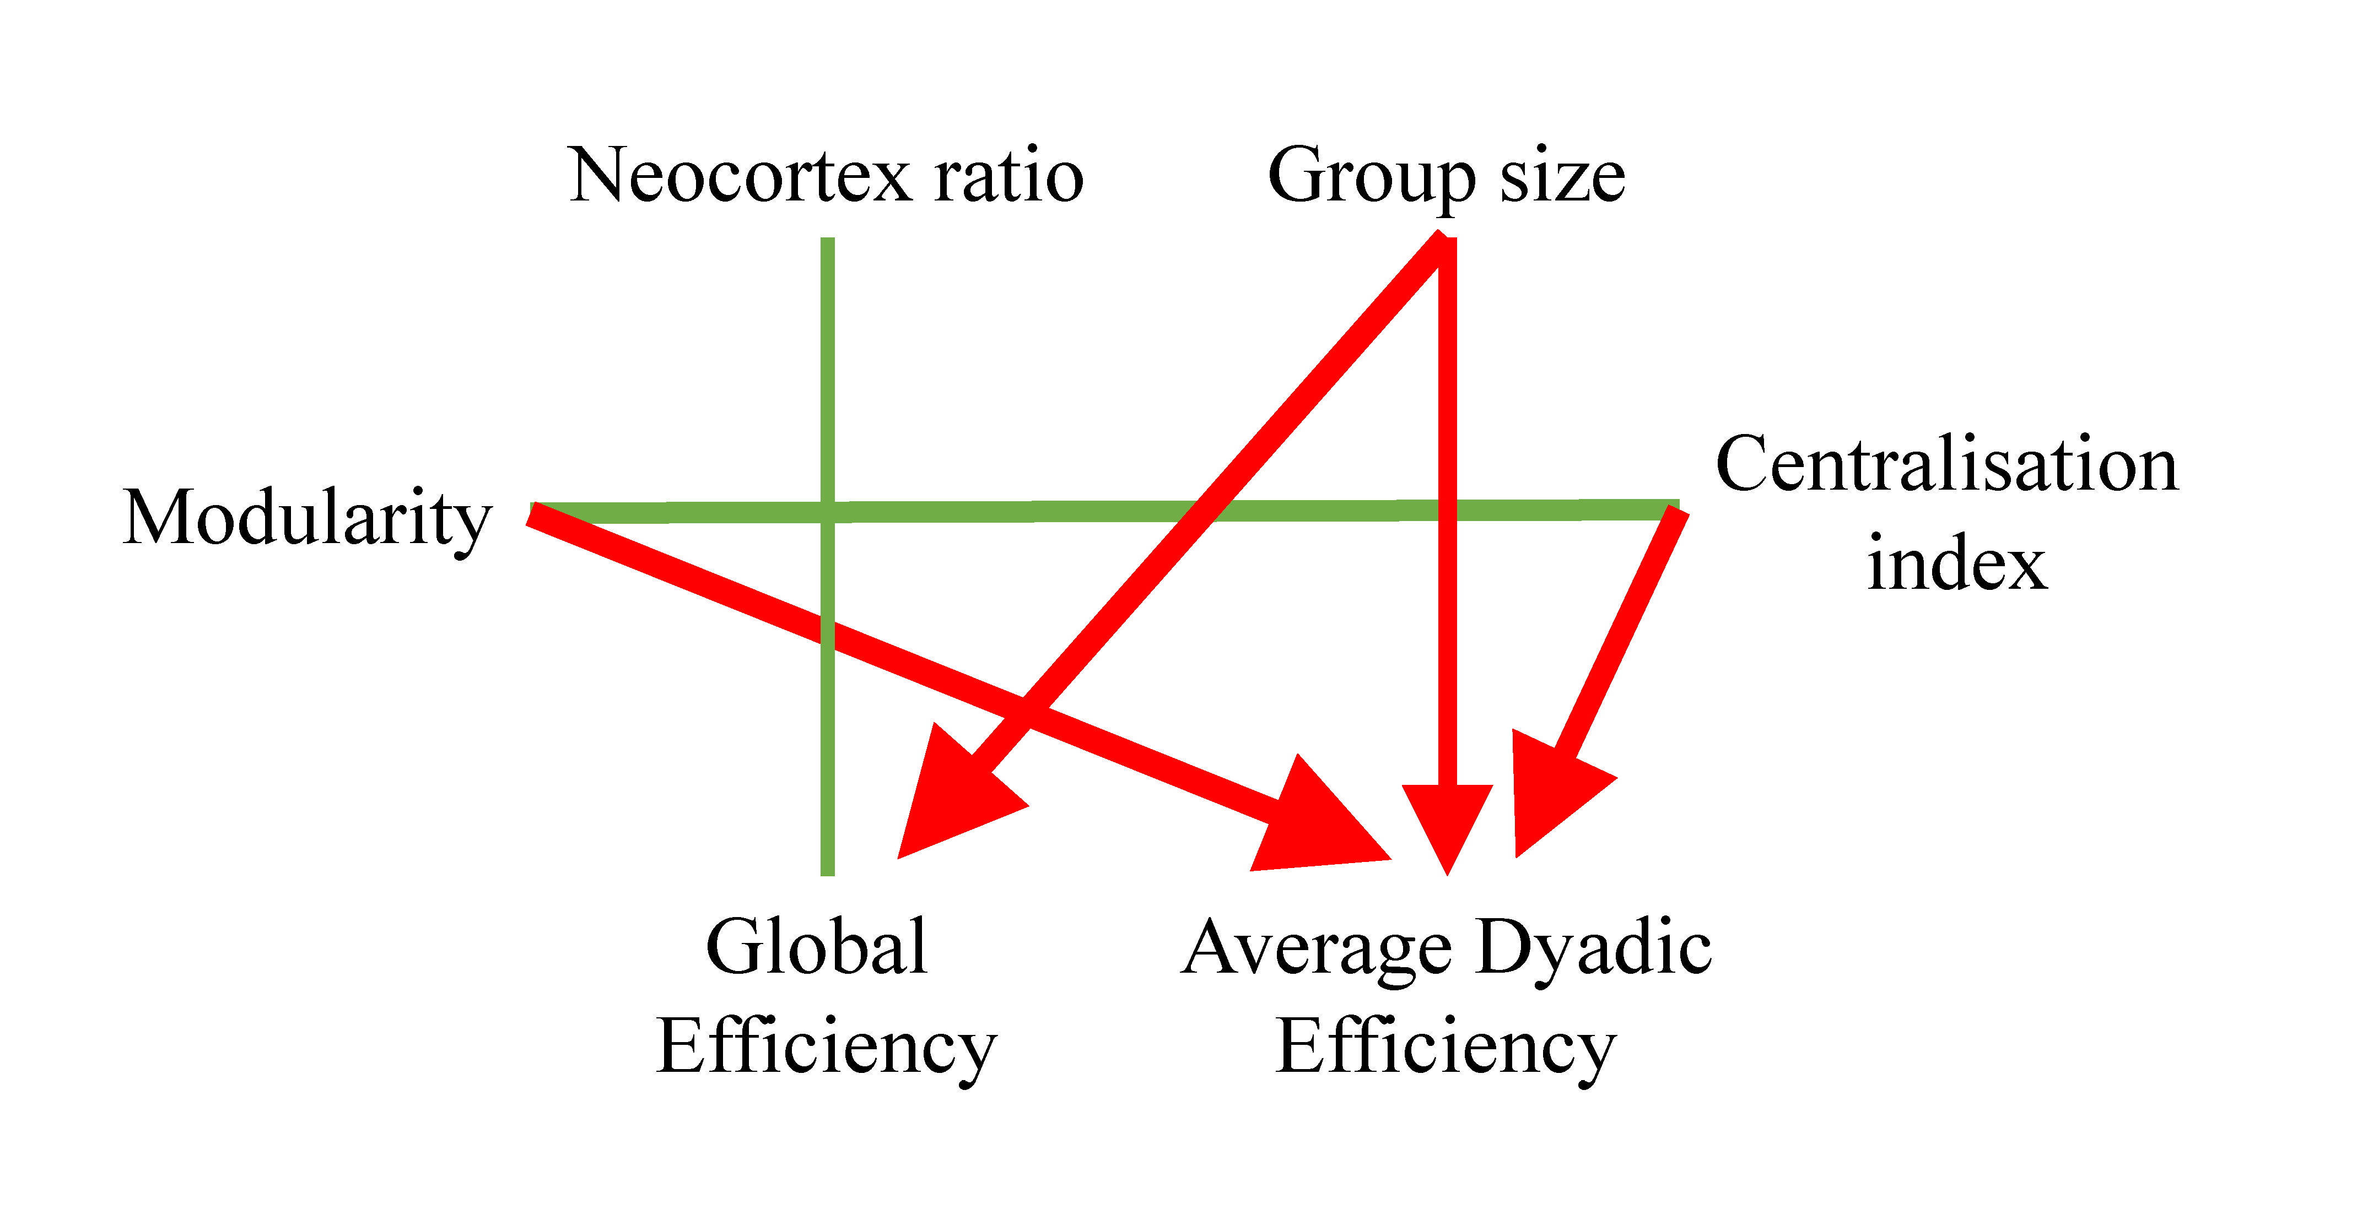
Extended data figure 1: Principal relationships between variables. Green lines indicate positive correlations between variables and red lines indicate negative correlations. An arrow indicates a causal relationship between variables. Thickness of lines vary according to strength of relationships between variables.
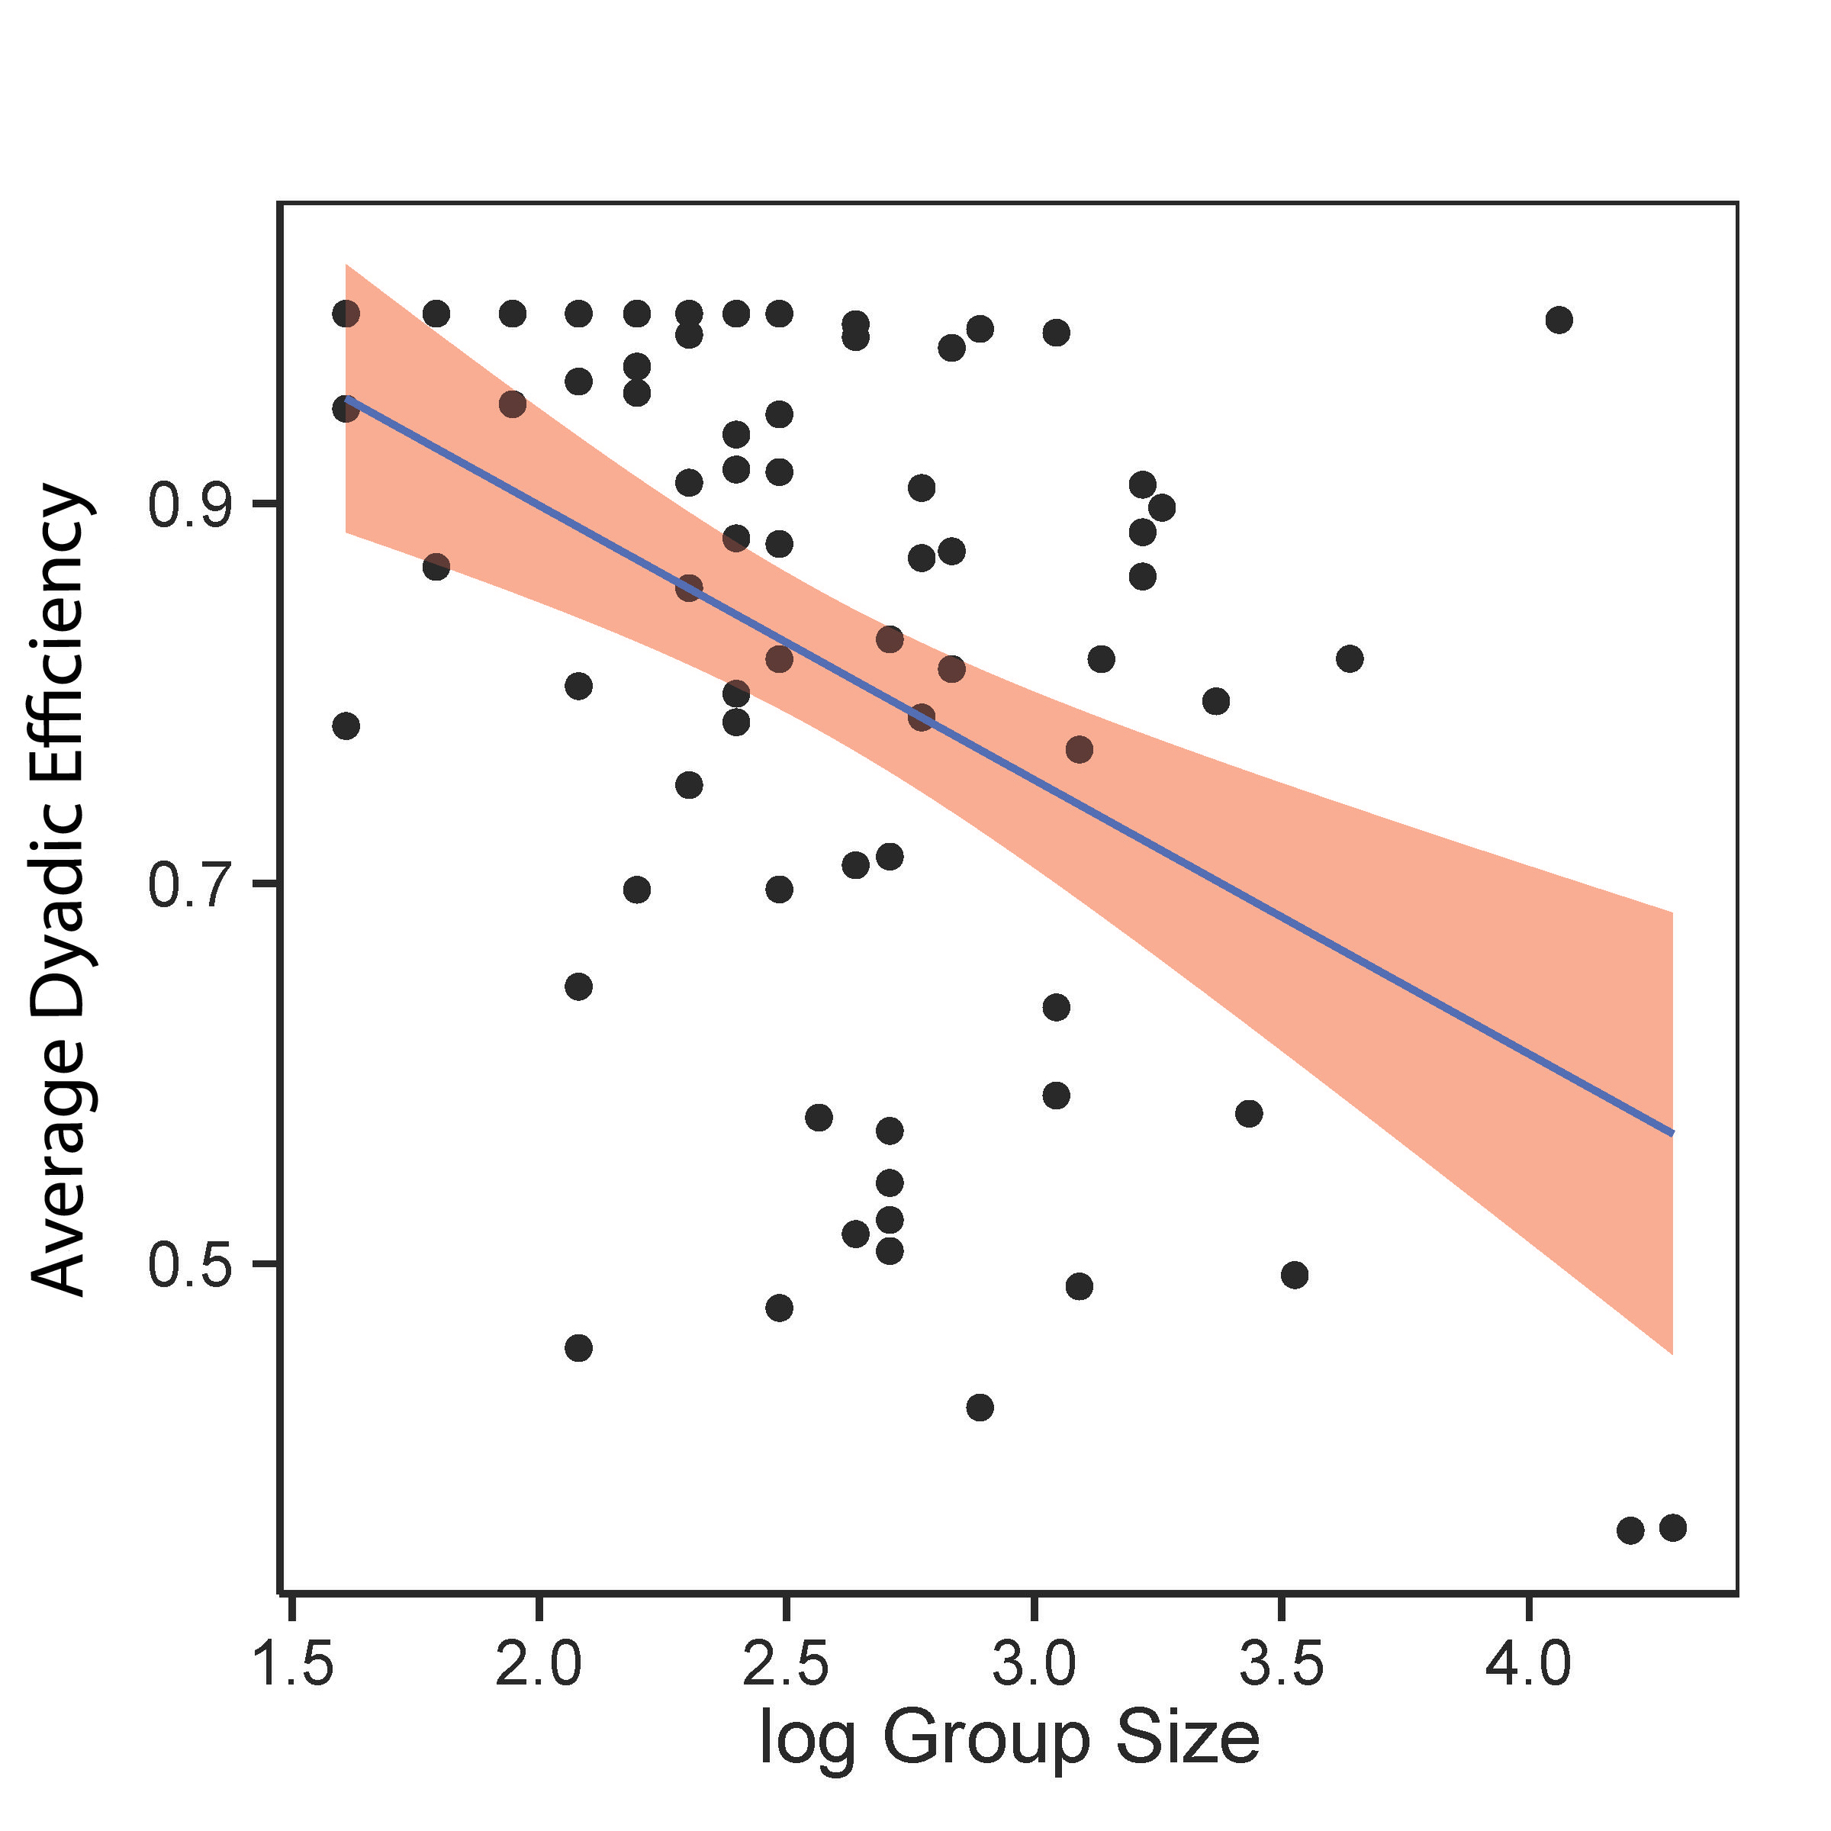
Extended data figure 2: Relationship between log(group size) and Average Dyadic Efficiency.
References
1. Griffin, R. H. & Nunn, C. L. Community structure and the spread of infectious disease in primate social networks. Evol. Ecol. 26, 779–800 (2012).
2. Kudo, H. & Dunbar, R. I. M. Neocortex size and social network size in primates. Anim. Behav. 62, 711–722 (2001).
3. Lehmann, J. & Dunbar, R. I. M. Network cohesion, group size and neocortex size in female-bonded Old World primates. Proc. R. Soc. B Biol. Sci. 276, 4417 –4422 (2009).
4. Schino, G. Grooming, competition and social rank among female primates: a meta-analysis. Anim. Behav. 62, 265–271 (2001).
5. Sueur, C. et al. A comparative network analysis of social style in macaques. Anim. Behav. 82, 845–852 (2011).
6. Faust, K. & Skvoretz, J. Comparing Networks Across Space and Time, Size and Species. Sociol. Methodol. 32, 267–299 (2002).
7. Blomberg, S. P., Garland, T. & Ives, A. R. Testing for Phylogenetic Signal in Comparative Data: Behavioral Traits Are More Labile. Evolution 57, 717–745 (2003).
8. Kembel, S. W. et al. Picante: R tools for integrating phylogenies and ecology. Bioinformatics 26, 1463–1464 (2010).
9. R Development Core Team. R: A language and environment for statistical computing. (R Foundation for Statistical Computing, 2009).
10. Hadfield, J. D. MCMC methods for multi-response generalized linear mixed models: the MCMCglmm R package. J. Stat. Softw. 33, 1–22 (2010).
11. Gelman, A. et al. Bayesian Data Analysis, Third Edition. (CRC Press, 2013).
12. Smith, R. L. & Naylor, J. C. A Comparison of Maximum Likelihood and Bayesian Estimators for the Three- Parameter Weibull Distribution. Appl. Stat. 36, 358 (1987).
13. Barton, K. & Barton, M. K. Package ‘MuMIn’. Version 1, 18 (2013).
14. J Froehlich & Thorington, R. 1982. in Ecol. Trop. For. Seas. Rhythms Long-Term Chang. 291–305
15. Ahumada, J. A. Grooming behavior of spider monkeys (Ateles geoffroyi) on barro colorado Island, Panama. Int. J. Primatol. 13, 33–49 (1992).
16. Bergstrom, M. L. & Fedigan, L. M. Dominance among female white-faced capuchin monkeys (Cebus capucinus): hierarchical linearity, nepotism, strength and stability. Behaviour 147, 899–931 (2010).
17. Bergstrom, M. L. & Fedigan, L. M. Dominance style of female white-faced capuchins. Am. J. Phys. Anthropol. 150, 591–601 (2013).
18. Polizzi, E. et al. Comparing Affiliative Relationships of Cebus and Sapajus Species: A Social Networking Approach. in Folia Primatol. (Basel) 84, 313–313 (KARGER ALLSCHWILERSTRASSE 10, CH-4009 BASEL, SWITZERLAND, 2013).
19. Crofoot, M. C., Rubenstein, D. I., Maiya, A. S. & Berger-Wolf, T. Y. Aggression, grooming and group-level cooperation in white-faced capuchins (Cebus capucinus): insights from social networks. Am. J. Primatol. 73, 821–833 (2011).
20. Perry, S. Female-female social relationships in wild white-faced capuchin monkeys,Cebus capucinus. Am. J. Primatol. 40, 167–182 (1996).
21. Vaitl, E. A. Experimental analysis of the nature of social context in captive groups of squirrel monkeys (Saimiri sciureus). Primates 18, 849–859 (1977).
22. Izawa, K. Social behavior of the wild black-capped capuchin (Cebus apella). Primates 21, 443–467 (1980).
23. Tiddi, B., Aureli, F., Sorrentino, E. P. di, Janson, C. H. & Schino, G. Grooming for tolerance? Two mechanisms of exchange in wild tufted capuchin monkeys. Behav. Ecol. 22, 663–669 (2011).
24. Tiddi, B., Aureli, F., Schino, G. & Voelkl, B. Social relationships between adult females and the alpha male in wild tufted capuchin monkeys. Am. J. Primatol. 73, 812–820 (2011).
25. Izar, P. et al. Flexible and conservative features of social systems in tufted capuchin monkeys: comparing the socioecology of Sapajus libidinosus and Sapajus nigritus. Am. J. Primatol. 74, 315–331 (2012).
26. Verderane, M. P., Izar, P., Visalberghi, E. & Fragaszy, D. M. Socioecology of wild bearded capuchin monkeys (Sapajus libidinosus): an analysis of social relationships among female primates that use tools in feeding. BEHAVIOUR 150, 659–689 (2013).
27. Byrne, R. W., Conning, A. M. & Young, J. Social relationships in a captive group of Diana monkeys (Cercopithecus diana). Primates 24, 360–370 (1983).
28. Rowell, T. E., Wilson, C. & Cords, M. Reciprocity and partner preference in grooming of female blue monkeys. Int. J. Primatol. 12, 319–336 (1991).
29. Borgeaud, C., van de Waal, E. & Bshary, R. Third-Party Ranks Knowledge in Wild Vervet Monkeys (Chlorocebus aethiops pygerythrus). PLoS ONE 8, e58562 (2013).
30. Waal, E. van de, Borgeaud, C. & Whiten, A. Potent Social Learning and Conformity Shape a Wild Primate’s Foraging Decisions. Science 340, 483–485 (2013).
31. Nakagawa, N. Distribution of affiliative behaviors among adult females within a group of wild patas monkeys in a nonmating, nonbirth season. Int. J. Primatol. 13, 73–96 (1992).
32. Estrada, A., Estrada, R. & Ervin, F. Establishment of a free-ranging colony of stumptail macaques (Macaca arctoides): social relations I. Primates 18, 647–676 (1977).
33. Dow, M. M. & de Waal, F. Assignment methods for the analysis of network subgroup interactions. Soc. Netw. 11, 237–255 (1989).
34. Jaman, M. F. & Huffman, M. A. Enclosure environment affects the activity budgets of captive Japanese macaques (Macaca fuscata). Am. J. Primatol. 70, 1133–1144 (2008).
35. MacIntosh, A. J. J. et al. Monkeys in the Middle: Parasite Transmission through the Social Network of a Wild Primate. PLoS ONE 7, e51144 (2012).
36. Furuichi, T. Inter-male associations in a wild Japanese macaque troop on Yakushima Island, Japan. Primates 26, 219–237 (1985).
37. Corradino, C. Proximity structure in a captive colony of Japanese monkeys (Macaca fuscata fuscata): an application of multidimensional scaling. Primates 31, 351–362 (1990).
38. Takahashi, H. & Furuichi, T. Comparative study of grooming relationships among wild Japanese macaques in Kinkazan A troop and Yakushima M troop. Primates 39, 365–374 (1998).
39. Petit, O., Abegg, C. & Thierry, B. A Comparative Study of Aggression and Conciliation in Three Cercopithecine Monkeys (Macaca fuscata, Macaca nigra, Papio papio). Behaviour 134, 415–432 (1997).
40. Sade, D. S. Sociometrics of Macaca Mulatta III: n-path centrality in grooming networks. Soc. Netw. 11, 273–292 (1989).
41. Sueur, C. et al. A comparative network analysis of social style in macaques. Anim. Behav. 82, 845–852 (2011).
42. Sugiyama, Y. Characteristics of the social life of bonnet macaques (Macaca radiata). Primates 12, 247–266 (1971).
43. Koyama, N. Dominance, grooming, and clasped-sleeping relationships among bonnet monkeys in India. Primates 14, 225–244 (1973).
44. De Marco, A. Conflicts induce affiliative interactions among bystanders in a tolerant species of macaque (Macaca tonkeana). Anim. Behav. 80, 197–203 (2010).
45. Sueur, C., Petit, O. & Deneubourg, J. Selective mimetism at departure in collective movements of Macaca tonkeana: an experimental and theoretical approach. Anim. Behav. 78, 1087–1095 (2009).
46. Petit, O. & Thierry, B. Aggressive and peaceful interventions in conflicts in Tonkean macaques. Anim. Behav. 48, 1427–1436 (1994).
47. Petit, O., Bret, C., Sueur, C., Verrier, D. & Deneubourg, J.-L. Social Structure of a Semi-Free Ranging Group of Mandrills Mandrillus sphinx: What Role for Central Individuals? in Folia Primatol. (Basel) 84, 311–311 (KARGER ALLSCHWILERSTRASSE 10, CH-4009 BASEL, SWITZERLAND, 2013).
48. B, E. Experimental investigations of childhood play. Psychol. Bull. 31, 47–66 (1934).
49. Schwimmer, E. G. Exchange in the social structure of the Orokaiva. (1970).
50. Vickers, M. & Chan, S. Representing classroom social structure. (Melbourne: Victoria Institute of Secondary Education, 1981).
51. Zachary, W. W. An information flow model for conflict and fission in small groups. J. Anthropol. Res. 452–473 (1977).
52. Pelé, M., Dufour, V., Thierry, B. & Call, J. Token transfers among great apes (Gorilla gorilla, Pongo pygmaeus, Pan paniscus, and Pan troglodytes): Species differences, gestural requests, and reciprocal exchange. J. Comp. Psychol. 123, 375–384 (2009).
53. Silk, J. B., Brosnan, S. F., Henrich, J., Lambeth, S. P. & Shapiro, S. Chimpanzees share food for many reasons: the role of kinship, reciprocity, social bonds and harassment on food transfers. Anim. Behav. 85, 941–947 (2013).
54. Sugiyama, Y. & Koman, J. Social structure and dynamics of wild chimpanzees at Bossou, Guinea. Primates 20, 323–339 (1979).
55. Sugiyama, Y. Social behavior of chimpanzees in the Budongo Forest, Uganda. Primates 10, 197–225 (1969).
56. Sugiyama, Y. Social organization of chimpanzees in the Budongo Forest, Uganda. Primates 9, 225–258 (1968).
57. Shimada, M. Wild chimpanzees can perform social grooming and social play behaviors simultaneously. Primates 54, 315–317 (2013).
58. Shimada, M. Dynamics of the temporal structures of playing clusters and cliques among wild chimpanzees in Mahale Mountains National Park. Primates 54, 245–257 (2013).
59. SCHEL, A. et al. Network Analysis of Social Changes in a Captive Chimpanzee Community Following the Successful Integration of Two Adult Groups. Am. J. Primatol. 75, 254–266 (2013).
60. Koyama, N., Ichino, S., Nakamichi, M. & Takahata, Y. Long-term changes in dominance ranks among ring-tailed lemurs at Berenty Reserve, Madagascar. Primates 46, 225–234 (2005).
61. Jacobs, A., Sueur, C., Deneubourg, J. L. & Petit, O. Social Network Influences Decision Making During Collective Movements in Brown Lemurs (Eulemur fulvus fulvus). Int. J. Primatol. 32, 721–736 (2011).
62. Kappeler, P. M. & Fich℡, C. Female reproductive competition in Eulemur rufifrons: eviction and reproductive restraint in a plurally breeding Malagasy primate. Mol. Ecol. 21, 685–698 (2012).

