Supplementary Material for The Evolution of Marsupial Social Organization
Qiu, J.^{1,2}, Olivier, C.A.^{1,2}, Jaeggi, A.V.³ & Schradin, C.^{1,2}
Proceedings of the Royal Society B – Biological Sciences
DOI 10.1098/rspb

Table of Contents
S1 Climate variables .....................................................................................................2
S2 Results of PCA..........................................................................................................4
S3 Detailed description of social organization in marsupials..........................................6
S4 Database comparisons..............................................................................................9
S5 Ancestral state of social organization of all marsupials...........................................11
S6 Ancestral state of social organization and climate in Australian marsupials............12
S7 Ancestral state of social organization on the species level
with main social organization of all marsupials............................................................14
S8 Ancestral state of social organization of all marsupials,
including literatures without data but general statements.............................................15

S1 Climate variables
All climate variables were based on the monthly precipitation and monthly mean maximum temperature data from 1910 to 2019, calculated in QGIS 3.10 with function “raster calculator”. The formulas were as follows, where x is the year and CV is the coefficient of variation.

Mean temperature:

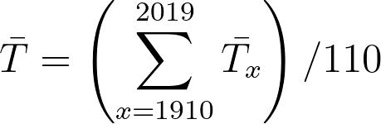

Mean precipitation:

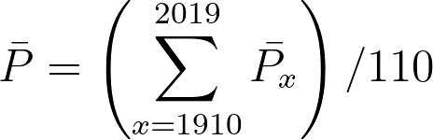

Within-year variation of temperature (Seasonality):
Calculated as the mean coefficient of variation of 110 years of the within-year coefficient of variation using values of 3-month periods representing the four seasons.
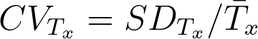

Within-year variation of precipitation (Seasonality):

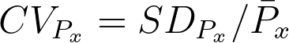

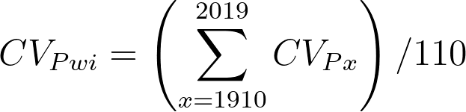

Between-year variation of temperature (Predictability):
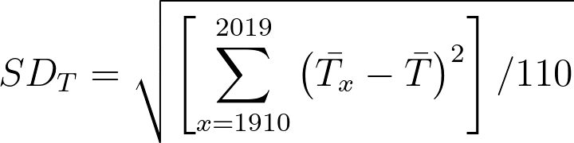

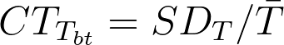

Between-year variation of precipitation (Predictability):
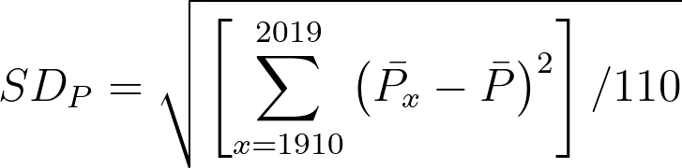

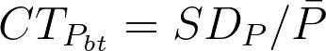

S2 Results of PCA

Table S2: Principal components analysis of climate variables from field sites in Australia. The first and second principal components were used in the Bayesian model. Main contributors to each component are highlighted in bold.
 | PC1 | PC2 | PC3 | PC4 | PC5 | PC6
Temperature | 0.50615443 | -0.1643753 | -0.07393863 | -0.1523658 | 0.80622429 | -0.19521418
Precipitation | 0.09935692 | 0.6925989 | 0.61461300 | 0.3105876 | 0.18941882 | -0.01848602
Within-year variation of precipitation | 0.44901165 | -0.1006374 | 0.48159407 | -0.6393961 | -0.38360364 | -0.01867350
Within-year variation of temperature | -0.49696003 | -0.2223531 | 0.32961454 | -0.1000740 | 0.09420245 | -0.75898298
Between-year variation of temperature | -0.49447968 | -0.1582850 | 0.32322702 | -0.3311586 | 0.39116653 | 0.60272939
Between-year variation of Precipitation | 0.20210148 | -0.6392688 | 0.41440274 | 0.5931373 | -0.07131469 | 0.14786179
Standard deviation | 1.8387 | 1.2399 | 0.69831 | 0.64882 | 0.34616 | 0.23129
Proportion of variance | 0.5634 | 0.2562 | 0.08127 | 0.07016 | 0.01997 | 0.00892
Cumulative proportion | 0.5634 | 0.8197 | 0.90095 | 0.97111 | 0.99108 | 1.00000

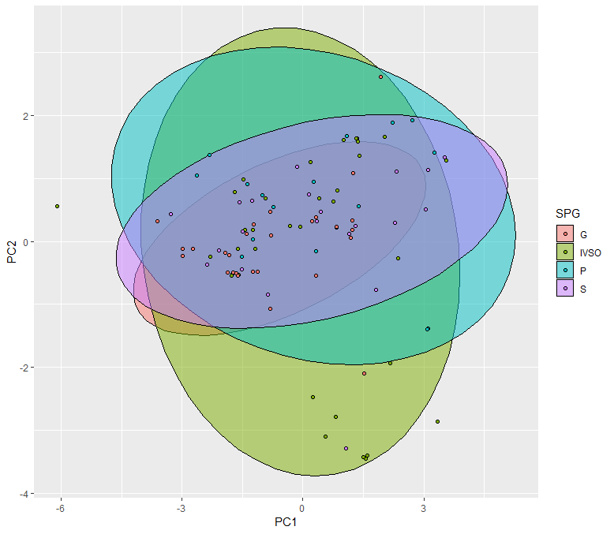
Figure S2: Relationship between the two main PC of the climate data and different forms of social organization. Each dot represents a population of Australian marsupials. G: populations that always lives in one form of group; IVSO: populations showing intra-specific variation in social organization; P: pair-living populations; S: solitary living populations.

S3 Detailed description of social organization in marsupials
For detailed information about social organization in population level, see our online dataset at https://doi.org/10.5061/dryad.jwstqjqd8.
1. Social organization in the different orders
The database covered 65 marsupial species of 4 orders (Diprotodontia, Dasyuromorphia, Didelphimorphia and Peramelemorphia). Three species (Ailurops melanotis, pair; Pseudocheirus occidentalis, solitary; Lasiorhinus latifrons, variable group) were excluded from the main analysis (which is based on 62 species) as they missed data on body mass or habitat heterogeneity. Only one population of Macropus giganteus shows IVSO of solitary + group and it was excluded from the main analysis for lack of habitat information. Three environment disruption events caused by death of group member (2 cases in Petaurus australis, 1 case in Petaurus gracilis) were recorded and excluded from the database.
In Diprotodontia (kangaroos, koalas and wombats), solitary living was found in 14 out of 40 studied species, pair-living in 23 species and group-living in 23 species (MMFF in 14, sex-specific in 7, MFF in 13, MMF in 4). In Dasyuromorphia (carnivorous marsupials), the solitary social organization was found in 8 of 12 studied species, pair-living in 6 species and group-living in 7 species (MMFF in 1, sex-specific in 5, MFF in 4, MMF in 2). Didelphimorphia (opossums) and Peramelemorphia (bandicoots) were two orders with relatively few species but higher percentage of species live in solitary. In Didelphimorphia, solitary was found in 7 of 8 studied species, pair-living in 4 species, and group-living (sex-specific group) in 1 species. In Peramelemorphia, solitary was found in all 5 studied species, pair-living and sex-specific group were found simultaneously in 1 species (Figure S3).
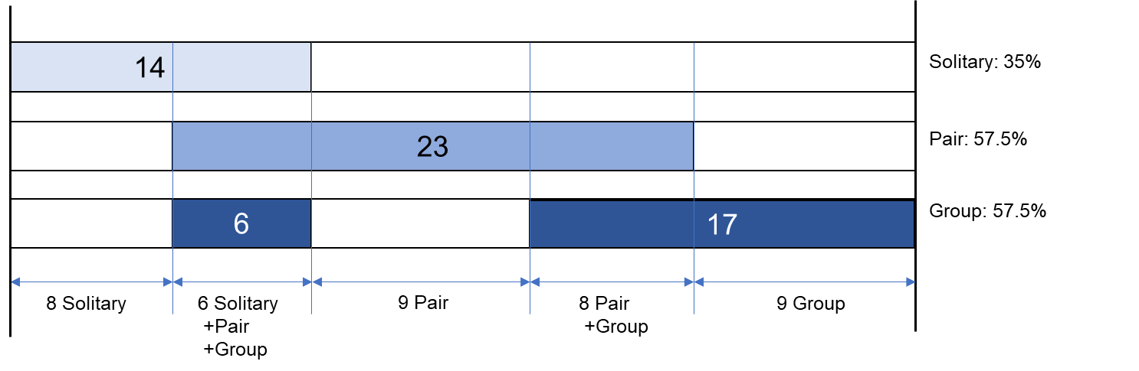
Diprotodontia

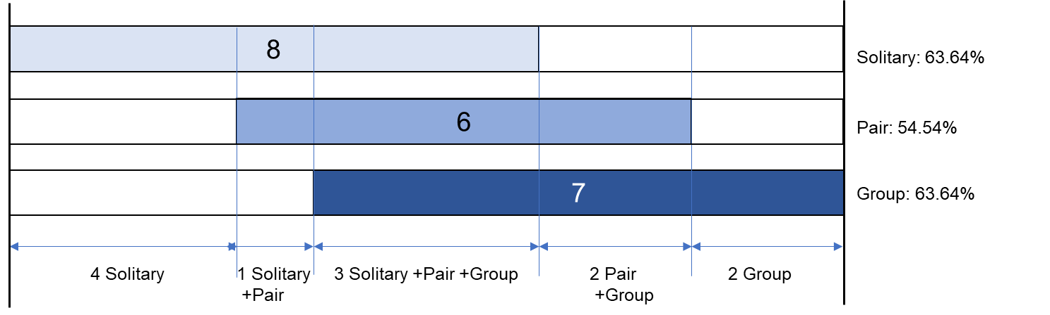
Dasyuromorphia
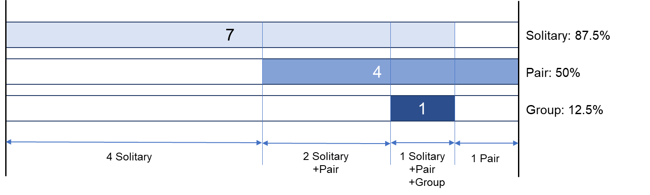
Didelphimorphia
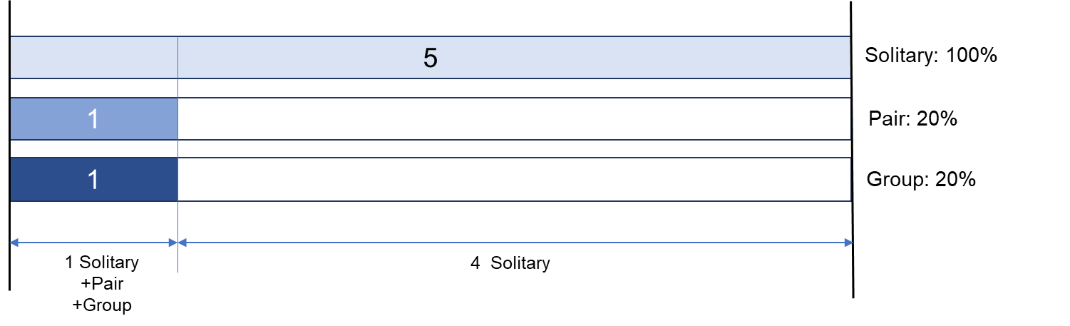
Peramelemorphia

Figure S3: Social organization observed in marsupial species from primary literature research. The coloured bar represents number of species observed in solitary/pair/group, the text below summaries the social organization of the species, as different forms may occur within the same species. “Group” includes 5 forms of group-living: one male, multi-female (MFF); one female, multi-male (MMF); multi-male, multi-female (MMFF); sex-specific group; variable group.

2. Intra-specific variation in social organization (IVSO)
IVSO was observed in 17 species (42.5%) of Diprotodontia, 7 species (58.3%) of Dasyuromorphia, 3 species (37.5%) of Didelphimorphia and 1 species (20%) of Peramelemorphia. Number of different forms of social organization found in the same species varied from 2 to 6.

Of the 28 species showing IVSO, 24 species showed two or more forms of solitary/pair-living/group-living, 4 species only showed two or more forms of group-living (sex-specific group, MFF, MMF, MMFF), such that in total 27.5% species were always group-living (7 species with a stable form of group composition and 4 species with variable group composition (Table S3).

Table S3: Overview of species with variable social organization (IVSO). Shown are the numbers of social units observed with the specific form of social organization. Solitary: solitary living; MF: pair-living; MFF: single male and multiple female group; MMF: single female and multiple males group; MMFF: multiple males and multiple females group.
 | Solitary | MF | Sex specific group | MFF | MMF | MMFF
Macropus fuliginosus |  |  | 67 |  |  | 53
Cercartetus nanus |  | 4 | 4
Macropus giganteus | 2 | 4 | 57 | 9 | 2 | 424
Macropus robustus |  | 1 |  |  |  | 1
Macropus rufus | 22 | 58 | 5 | 116 |  | 145
Petrogale assimilis | 2 | 28 |  | 1
Petrogale penicillata |  |  |  | 2 |  | 6
Petaurus australis |  | 21 |  | 6
Petaurus breviceps |  | 1 |  |  | 1 | 1
Petaurus norfolcensis |  | 14 |  |  | 2 | 3
Trichosurus cunninghami | 2 | 22 |  | 2
Potorous tridactylus |  | 1 |  | 2
Aepyprymnus rufescens | 116 | 63 | 6 | 6 | 3 | 2
Petropseudes dahli |  | 15 |  | 1
Pseudocheirus peregrinus | 54 | 69 | 1 | 5 | 3
Lasiorhinus krefftii |  |  |  | 1 | 1 | 8
Lasiorhinus latifrons |  | 3 | 1 | 1 | 3 | 6
Antechinus stuartii |  |  | 7 | 3 | 1 | 77
Antechinus subtropicus |  | 3 | 1 | 4
Dasycercus blythi |  | 6 | 1
Dasycercus cristicauda | 7 | 3 |  | 1
Dasyurus geoffroii | 8 | 1
Phascogale tapoatafa | 2 | 30 | 8 | 1 | 11
Sminthopsis crassicaudata | 39 | 33 | 10 | 6 | 11
Caluromys philander | 10 | 1
Didelphis marsupialis | 8 | 3
Didelphis virginiana | 12 | 4 | 1
Macrotis lagotis | 4 | 9 | 1

S4 Database comparisons
139 of the 348 marsupial species were presented in the three compared databases, 65 in our database, 108 in the Handbook of the Mammals of the World (HMoW), and 62 in Lukas & Clutton-Brock’s database (2013; Figure S4). The ratio of solitary to sociable (can live in pair or group) species differed significantly between our database (20:45) from the ratio of 54:54 reported in the Handbook of the Mammals of the World (Fisher’s exact test, p-value=0.0172), and extremely significant from the ratio of 56:6 reported by Lukas &Clutton-Brock 2013 (Fishers exact test, p<0.0001). IVSO was recorded in both our database and HMoW but not in the database of Lukas & Clutton-Brock (2013). The ratio of stable social organization to IVSO species of 37:28 in our database did not differ significantly from the ratio of 75:33 in HMoW (Fisher’s exact test, p-value=0.1031).

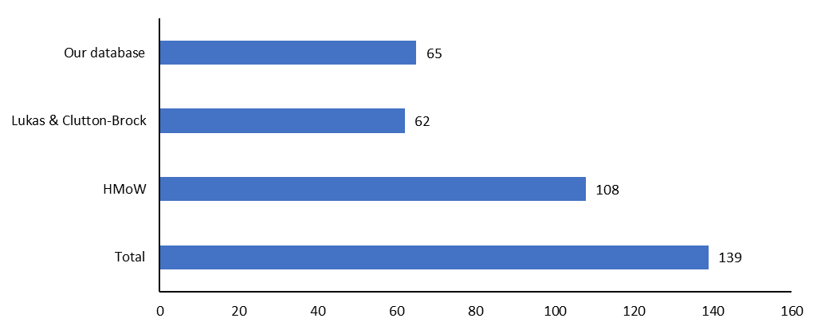
Figure S4: Number of species covered in the three databases. (Lukas&Clutton-Brock: Database published from Lukas&Clutton-Brock (2013), HMoW: The Handbook of the Mammals of the World)

S5 Ancestral state of social organization of all marsupials
- The R-code and the dataset are available at https://doi.org/10.5061/dryad.jwstqjqd8.

Table S5.1: The probability at root of different ancestral state of marsupial social organization (based on all social organization data on population level; S: solitary, P: pair, G: stable group, SP: solitary + pair, PG: pair + group, SPG: solitary + pair + group, VG: variable group).
 | Estimate | Cl-95% | CI u-95%
S | 0.35 | 0 | 0.88
PG | 0.25 | 0 | 0.91
P | 0.22 | 0 | 0.90
G | 0.09 | 0 | 0.53
SPG | 0.05 | 0 | 0.27
SP | 0.03 | 0 | 0.15
VG | 0.02 | 0 | 0.06

Table S5.2: Associations between habitat heterogeneity/number of studies per species with social organization pattern (“social organization”_“predictor”. i.e. G_Habitat hetrogeneity). Coefficients reflect the results of multinomial phylogenetic regression models with ‘solitary’ as the reference category (P: pair, G: stable group, SP: solitary + pair, PG: pair + group, SPG: solitary + pair + group, VG: variable group).
 | Estimate | Cl-95% | CI u-95%
G_Habitat heterogeneity | -0.44 | -1.71 | 0.61
G_Number of studies | 0.02 | -1.86 | 1.90
G_ Body mass | 0.12 | -0.70 | 1.05
P_Habitat heterogeneity | -1.02 | -2.64 | 0.53
P_Number of studies | -0.04 | -1.96 | 1.70
P_ Body mass | -0.27 | -1.20 | 0.68
PG_Habitat heterogeneity | -0.86 | -2.35 | 0.6
PG_Number of studies | -0.03 | -1.97 | 1.86
PG_ Body mass | -0.51 | -1.52 | 0.60
SP_Habitat heterogeneity | 0.48 | -0.71 | 1.71
SP_Number of studies | -0.10 | -2.23 | 2.11
SP_ Body mass | 0.14 | -0.71 | 1.71
SPG_Habitat heterogeneity | 0.97 | -0.26 | 2.45
SPG_Number of studies | -0.08 | -2.04 | 1.75
SPG_ Body mass | 0.03 | -0.98 | 0.99
VG_Habitat heterogeneity | 0.74 | -0.53 | 2.03
VG_Number of studies | -0.02 | -1.78 | 2.06
VG_ Body mass | 0.32 | -0.94 | 1.63

S6 Ancestral state of social organization and climate in Australian marsupials
- The R-code and the dataset are available at https://doi.org/10.5061/dryad.jwstqjqd8.

Table S6.1: The probability at root of different ancestral state of Australian marsupial social organization (based on all social organization data on population level; S S: solitary, P: pair, G: stable group, SP: solitary + pair, PG: pair + group, SPG: solitary + pair + group, VG: variable group).
 | Estimate | Cl-95% | CI u-95%
PG | 0.26 | 0 | 0.97
G | 0.21 | 0 | 0.95
S | 0.20 | 0 | 0.79
P | 0.18 | 0 | 0.96
SPG | 0.07 | 0 | 0.53
SP | 0.04 | 0 | 0.21
VG | 0.04 | 0 | 0.22

Table S6.2: Associations between principal component of climate with social organization pattern (“social organization”_“predictor”. i.e. G_Habitat hetrogeneity). Coefficients reflect the results of multinomial phylogenetic regression models with ‘solitary’ as the reference category (P: pair, G: stable group, SP: solitary + pair, PG: pair + group, SPG: solitary + pair + group, VG: variable group; PC1 / PC2: principal component of climate data).
 | Estimate | Cl-95% | Cl u-95%
G_PC1 | -0.64 | -1.38 | -0.00
SPG_PC2 | -1.42 | -2.51 | -0.31
G_Habitat heterogeneity | -0.96 | -2.29 | 0.30
G_Number of studies | -0.13 | -2.01 | 1.84
G_Body mass | -0.18 | -1.25 | 0.93
G_PC2 | 0.15 | -0.73 | 1.07
P_ Habitat heterogeneity | -0.76 | -2.31 | 0.91
P_ Number of studies | 0.05 | -1.74 | 2.18
P_Body mass | -0.49 | -1.88 | 0.80
P_PC1 | -0.27 | -1.08 | 0.50
P_PC2 | 1.00 | -0.11 | 2.18
PG_Habitat heterogeneity | -0.88 | -2.40 | 0.75
PG_ Number of studies | -0.00 | -2.02 | 1.84
PG_Body mass | -0.66 | -1.99 | 0.34
PG_PC1 | 0.42 | -0.34 | 1.42
PG_PC2 | 0.62 | -0.60 | 2.05
SP_ Habitat heterogeneity | -0.51 | -2.34 | 1.37
SP_ Number of studies | 0.10 | -1.81 | 1.84
SP_Body mass | 0.05 | -1.36 | 1.78
SP_PC1 | 0.35 | -0.78 | 1.62
SP_PC2 | -0.38 | -1.68 | 1.19
SPG_ Habitat heterogeneity | 0.69 | -0.63 | 2.07
SPG_ Number of studies | -0.03 | -1.99 | 1.91
SPG_Body mass | -0.13 | -1.36 | 0.97
SPG_PC1 | -0.01 | -1.00 | 1.01
VG_ Habitat heterogeneity | 0.47 | -0.95 | 1.96
VG_ Number of studies | 0.05 | -1.96 | 1.99
VG_Body mass | 0.24 | -1.03 | 1.59
VG_PC1 | -0.7 | -1.55 | 0.10
VG_PC2 | -0.50 | -1.56 | 0.42

S7 Ancestral state of social organization on the species level with main social organization of all marsupials

- The R-code and the dataset are available at https://doi.org/10.5061/dryad.jwstqjqd8.

When only considering the main social organization at the species level, the Bayesian model found that the marsupial ancestors was more likely to be solitary living, but with high uncertainty (Table S7). The phylogenetic signal in social organization was moderately high with 0.18 (95% CI = 0.01 – 0.48).

Table S7. The probability at root of different ancestral state of marsupial social organization (based on main social organization data on population level; S: solitary, P: pair, G: group).
 | Estimate | Cl-95% | CI u-95%
S | 0.57 | 0 | 1.00
P | 0.22 | 0 | 1.00
G | 0.20 | 0 | 1.00

S8 Ancestral state of social organization of all marsupials, including literatures without data but general statements

- The R-code and the dataset are available at https://doi.org/10.5061/dryad.jwstqjqd8.

In this model we included information from studies that did not report data on social organization, but made a general statement about the main form of social organization observed. Thus, this model excludes IVSO but includes 22 more species with general statements but no data on social organization. The Bayesian model predicted that the marsupial ancestors was more likely to be solitary living with higher probability than the model in Supplementary materials S5, but also with high uncertainty (Table S8). The phylogenetic signal in social organization was lower with 0.145 (95% CI = 0.044 – 0.266).

Table S8. The probability at root of different ancestral state of marsupial social organization (based on main social organization data on population level; S: solitary, P: pair, G: group).
 | Estimate | Cl-95% | CI u-95%
S | 0.59 | 0.01 | 1.00
P | 0.29 | 0.00 | 0.97
G | 0.12 | 0.00 | 0.82

