Supplementary information

Primate brain size data were taken from (Stephan et al. 1981), while data on group size are from Dunbar (1992) and Smuts et al (1987); we classified species’ social systems ourselves, with reference to the primary literature and guidance from Smuts et al. (1987) and van Schaik & Kappeler (2003). Carnivore brain sizes were taken from (Dunbar & Bever 1998; Kruska 1988), and social system and group size from (Gittleman 1989), except for missing species which were based on (Nowak 1999). Ungulate brain size data were taken from several different sources (Jerison 1973; Oboussier 1966); (Haarmann 1975; Mangold-Wirz 1966). Information on sociality, group size, diet and habitat use were taken from additional published sources (Brashares et al. 2000; Jarman 1974; Kingdon 1997; Nowak 1999). Ungulate phylogeny was a composite based on several recently published trees (Flagstad et al. 2001), (Gatesy et al. 1997) (Murphy et al. 2001); carnivore phylogeny on (Bininda-Emonds et al. 1999)et al¹⁸, and primate phylogeny was based on (Purvis 1995).
For primate total brain size, the best model retained log group size (F_{1,38} = 13.37, p <0.001) and diet (F_{1,38} = 76.43, p < 0.001). For carnivores, the best model retained social system (F_{3,81} = 5.29, p = 0.002) and strata use (F_{1,81}= 16.30, p < 0.001, model adjusted r² = 0.22), whereas for ungulates, the best model retained social system (F_{3,61} = 4.52, p = 0.006) and diet (F_{4,61} = 4.12, p = 0.005, model adjusted r² = 0.22).
Primate activity budget data were collected from the following sources: Cercopithecus lhoesti (Kaplin & Moermond 2000); Cercopithecus mitis (Pazol & Cords 2005); Lagothrix lagothricha (Defler 1995); Ateles belzebuth, A. geoffroyi, A. paniscus (Korstjens et al. in press); P. ruformitratus, P. temminckii, P. tephrosceles, P. badius (Korstjens & Dunbar in press); Aotus trivirgatus, Callecebus moloch, Cebus apella, Allouatta palliata, Saguinus fusicollis, Saguinus imperator, Siamiri sciurus, Papio anubis (Leonard & Robertson 1997); Presbytis entellus (Fashing 2001); Pan paniscus, P.troglodytes (Lehmann et al. in press); Gorilla gorilla (Lehmann et al. unpub. manuscript); Hylobates agillis, H. concolor, H. hoolock, H. klossii, H. lar, H. muelleri, H. pileatus, H.syndactylus (Lan and Dunbar). Ungulate activity budgets were collected from the following sources: Damaslicus dorcas, Redunca fulvorufula (Klein & Fairall 1986), Kobus ellipsiprymnus (Wirtz & Oldekop 1991); Theropithecus gelada (Dunbar unpub. Data), Ourebia ourebia (Adamczak 1999), Aepyceros melampus, Raphicerus campestris, Tragelaphus strepsiceros (du Toit & Yetman 2005); Oreotragus oreotragus (R.Dunbar, unpublished); Syncerus caffer (Turner et al. 2005); Capra hircus (R.Dunbar, unpublished).

References

Adamczak, V. G. 1999 Variation in the mating system of oribi, Ourebia ourebi, vol. Ph.D. Liverpool: University of Liverpool.
Bininda-Emonds, O. R. P., Gittleman, J. L. & Purvis, A. 1999 Building large trees by combining phylogenetic information: a complete phylogeny of the extant Carnivora (Mammalia). Biological Reviews 74, 143-175.
Brashares, J. S., Garland, T. & Arcese, P. 2000 Phylogenetic analysis of coadaptation in behavior, diet, and body size in the African antelope. Behavioral Ecology 11, 452-463.
Defler, T. R. 1995 The Time Budget Of A Group Of Wild Woolly Monkeys (Lagothrix Lagotricha). International Journal Of Primatology 16, 107-120.
du Toit, J. T. & Yetman, C. A. 2005 Effects of body size on the diurnal activity budgets of African browsing ruminants. Oecologia 143, 317-325.
Dunbar, R. I. M. 1992 Neocortex Size As A Constraint On Group-Size In Primates. Journal Of Human Evolution 22, 469-493.
Dunbar, R. I. M. & Bever, J. 1998 Neocortex size predicts group size in carnivores and some insectivores. Ethology 104, 695-708.
Fashing, P. J. 2001 Activity and ranging patterns of guerezas in the Kakamega Forest: Intergroup variation and implications for intragroup feeding competition. International Journal Of Primatology 22, 549-577.
Flagstad, O., Syvertsen, P. O., Stenseth, N. C. & Jakobsen, K. S. 2001 Environmental change and rates of evolution: the phylogeographic pattern within the hartebeest complex as related to climatic variation. Proceedings Of The Royal Society Of London Series B-Biological Sciences 268, 667-677.
Gatesy, J., Amato, G., Vrba, E., Schaller, G. & DeSalle, R. 1997 A cladistic analysis of mitochondrial ribosomal DNA from the bovidae. Molecular Phylogenetics And Evolution 7, 303-319.
Gittleman, J. L. 1989 Carnivore group living: comparative trends. In Carnivore behavior, ecology and evolution, vol. 1 (ed. J. L. Gittleman), pp. 183-208. Ithaca: Cornell University.
Haarmann, K. 1975 Morphologische und histologische Untersuchungen am Neocortex von Boviden (Antiplopinae, Cephalopinae) und Traguliden mit bemerkungen zur Evolutionshöhe. J. Hirnfirsch 16, 91-116.
Jarman, P. J. 1974 Social organization of antelope in relation to their ecology. Behaviour 48, 215-&.
Jerison, H. J. 1973 Evolution of the brain and intelligence. London: Academic Press.
Kaplin, B. A. & Moermond, T. C. 2000 Foraging ecology of the mountain monkey (Cercopithecus l'hoesti): Implications for its evolutionary history and use of disturbed forest. American Journal Of Primatology 50, 227-246.
Kingdon, J. 1997 The Kingdon field guide to mammals. London.: Academic Press.
Klein, D. R. & Fairall, N. 1986 Comparative foraging behavior and associated energetics of impala and blesbok. Journal Of Applied Ecology 23, 489-502.
Korstjens, A. H. & Dunbar, R. I. M. in press Time constraints limit group sizes and distribution in red and black-and-white colobus monkeys. International Journal Of Primatology.
Korstjens, A. H., Verhoeckx, I. L. & Dunbar, R. I. M. in press Time as a constraint on group size in spider monkeys. Behavioural Ecology and Sociobiology.
Kruska, D. 1988 Mammalian domestication and its effectof brain structure and behavior. In Intelligence and Evolutionary Biology (ed. H. J. Jerison & I. Jerison), pp. 211-249. Berlin: Springer-Verlag.
Lehmann, J., Korstjens, A. H. & Dunbar, R. I. M. in press Fission-fusion social systems as a strategy for coping with ecological constraints: a primate case. Evolutionary Ecology.
Lehmann, J., Korstjens, A. H. & Dunbar, R. I. M. unpub. manuscript. Time management in Great Apes: implications for gorilla biogeography.
Leonard, W. R. & Robertson, M. L. 1997 Comparative primate energetics and hominid evolution. American Journal Of Physical Anthropology 102, 265-281.
Mangold-Wirz, K. 1966 Cerebralisation Und Ontogenesemodus Bei Eutherien. Acta Anatomica 63, 449-&.
Murphy, W. J., Eizirik, E., Johnson, W. E., Zhang, Y. P., Ryderk, O. A. & O'Brien, S. J. 2001 Molecular phylogenetics and the origins of placental mammals. Nature 409, 614-618.
Nowak, R. M. 1999 Walker's mammals of the world.
Oboussier, H., Schliemann, H. 1966 Hirn-Körpergewichtsbeziehungen bei Boviden. Zeitschritft fur Säugertierkunde 31, 464-471.
Pazol, K. & Cords, M. 2005 Seasonal variation in feeding behavior, competition and female social relationships in a forest dwelling guenon, the blue monkey (Cercopithecus mitis stuhlmanni), in the Kakamega Forest, Kenya. Behavioral Ecology And Sociobiology 58, 566-577.
Purvis, A. 1995 A composite estimate of primate phylogeny. Philosophical Transactions Of The Royal Society Of London Series B-Biological Sciences 348, 405-421.
van Schaik, C.P. & Kappeler, P.M. 2003. The evolution of social monogamy in primates. In: U.R.Reichard & C.Boesch (eds) Monogam: Mating Strategies and Partnerships in Birds, Humans and Other Mammals, pp. 81-92.
Smuts, B. B., Cheney, D. L., Seyfarth, R. M., Wrangham, R. W. & Struhsaker, T. T. 1987 Primate Societies. Chicago: Univ Chicago Press.
Stephan, H., Frahm, H. & Baron, G. 1981 New and revised data on volumes of brain structures in insectivores and primates. Folia Primatologica 35, 1-29.
Turner, W. C., Jolles, A. E. & Owen-Smith, N. 2005 Alternating sexual segregation during the mating season by male African buffalo (Syncerus caffer). Journal Of Zoology 267, 291-299.
Wirtz, P. & Oldekop, G. 1991 Time budgets of waterbuck (Kobus ellipsiprymnus) of different age, sex and social status. Zeitschrift Fur Saugetierkunde-International Journal Of Mammalian Biology 56, 48-58.

Table S1. Definitions of the ecological and social criteria used in all analyses across the three focal taxa.
Factor | Primates |  | Carnivores |  | Ungulates
Diet | Folivore | >75% leaves | Vegetarian | >75% leaves and fruit | Grazer | >75% Grasses and annuals
Diet | Frugivore | >75% Fruit | Mixed-invertebrates | Primarily insects, molluscs, worms plus other material | Browser | >75% leaves, bark
Diet | Folivore-Fruigivore | >75% leaves and fruit | Mixed- vertebrates | Primarily small vertebrates, Some fruit, plus some invertebrates. | Frugivore | >75% fruit
 |  |  |  |  | Browser-Frugivore | >75% fruit and browse
Diet | Omnivore | Mixed diet- fruit, gum, insects, vertebrates | Large vertebrates | Diet primarily composed of large vertebrates and some carrion | Grazer-Browser | >75% grasses and browse
 |  |  |  |  | Omnivore | Mixed including tubers and some animal matter
Habitat | Open | Species found in open grassland and savanna habitats
Habitat | Mixed | Species found in either both open and forested habitats or in habitat matrices (e.g. woodland-savanna)
Habitat | Closed | Species found in closed/forested habitats
Strata | Terrestrial | Primarily moves and forages on the group | Terrestrial | Primarily moves and forages on the group
Strata | Semi-arboreal | Generally moves on the ground, can forage and sleep in the trees | Semi-arboreal/Arboreal | Can move on the ground, often forages and sleeps in trees
Strata | Arboreal | Spends the most time including resting, moving and sleeping in trees
Activity | Diurnal | Active during daylight hours
Activity | Cathemeral/All hours | Active either at dawn and dusk or at any hour
Activity | Nocturnal | Primarily active at night

Figure S1. Primate phylogeny and phylogenetic residuals
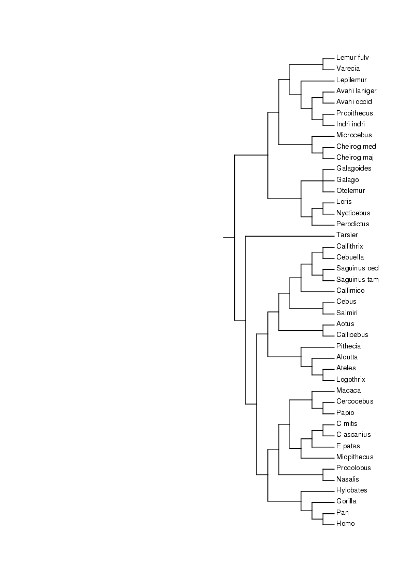
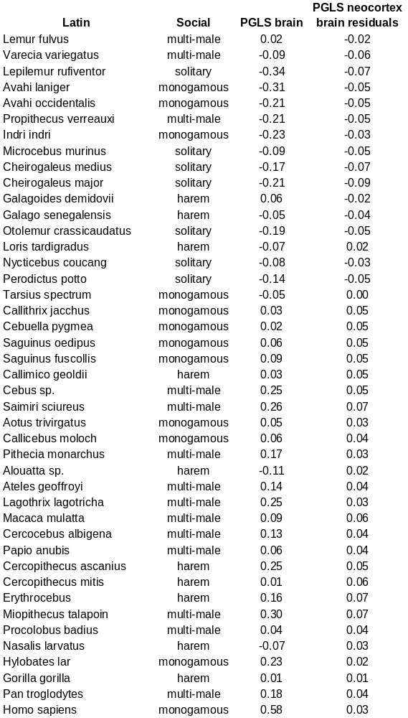
Figure S2. Ungulate phylogeny and social data
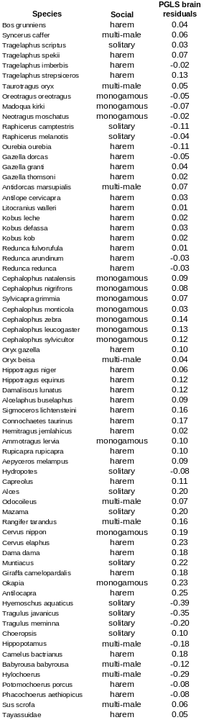
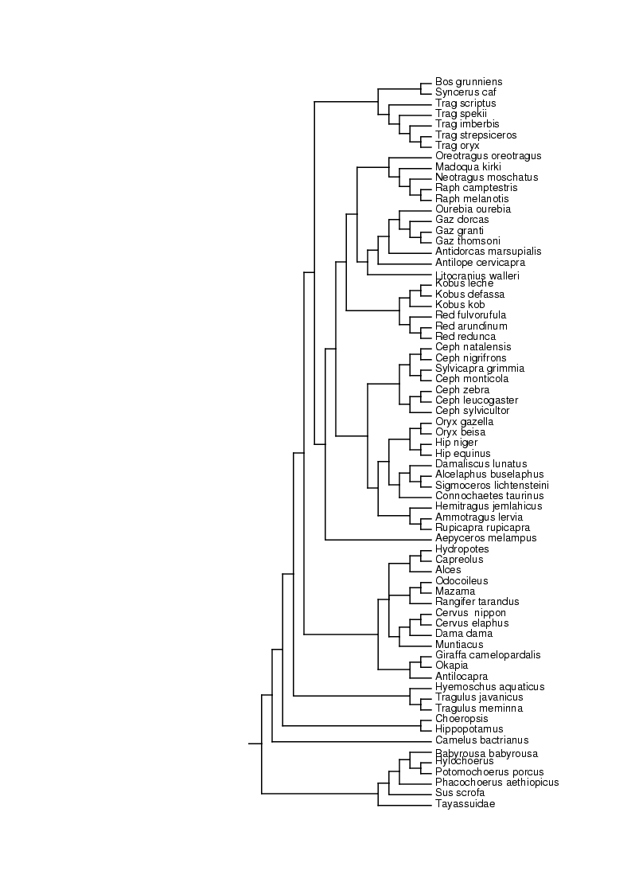
Figure S3. Carnivore tree and social data.
