Supplementary Methods and Results

Content

1. Protein extraction protocol 3
2. Multiple linear regression analysis 5
3. Concentration diagrams 13
4. Association between warm time and concentration of MBP and NFL 14
5. Validation data 16

1. Protein extraction protocol
Material:
- Brain samples, provided in 2 ml Eppendorf tubes, stored in -80°C freezer.
- Lysing buffer, N-PER™ Neuronal Protein Extraction Reagent. Thermo Scientific™. Catalog no.: 87792.
- Protease inhibitors, Halt™ Protease Inhibitor Cocktail, EDTA-Free (100X). Thermo Scientific™. Catalog no.: 78439
- Handheld homogenizer (Sonicator)
- Conical Centrifuge Tubes Falcon™ 50 mL, polypropylene. Falcon Ref no.: 352097.
- Conical Centrifuge tubes Falcon™ 15 mL, polypropylene. Corning™. Falcon Ref. no.: 352097.
- Microcentrifuge Tube Eppendorf™ Polypropylene Protein LoBind 1.5 mL. Eppendorf Order no.: 0030108116
- Cryo preservation tubes, Sarstedt Screw Cap Micro tube 0.5 ml, polypropylene. Ref. no.: 72.730.005
- Scalpel, spatula, glass plate, methanol, paper swab, ice, dry ice.

Protocol
- Preparation of lysing buffer
  - 10 µl HALT™ Protease Inhibitor Cocktail is added per 1 ml of N-PER™ (according to the product sheet). Thereafter gentle mix (to avoid formation of bubbles) of the mixture, and store in refrigerator prior to use.
- Preparation of brain samples
  - Prepare 1 per sample of 15 ml Falcon conical centrifuge tubes. Every tube is marked and weighed separately and thereafter stored on ice.
  - Remove the brain samples from the -80°C freezer and put them on dry ice. Thaw 2 samples at a time very shortly on ice (approx. 1 min), just so the tissue loosens from the tube wall.
  - Place the tissue on a glass plate on ice with a spatula. Cut approx 450-550 mg from the still frozen brain sample. Immediately transfer the remaining part back to the 2 ml Eppendorf tubes and back on dry ice.
  - Then finely divide the brain tissue with a scalpel and immediately transfer to the 15 ml Falcon™ tubes on ice. The glass plate, scalpel and spatula should be cleaned with a paper swab and thereafter methanol between each sample.
  - Weigh the 15 ml Falcon™ tubes + brain sample separately and calculate the net weight of brain sample. Keep samples on ice.
  - Remove or add brain sample if net weight is > 700 mg or < 400 mg for grey substance and < 450 mg for white matter per sample, and calculate net weight again.
  - Put the remaining brain samples back in -80°C freezer to minimize time on dry ice.
  - Add lysing buffer (N-PER™ + HALT™ Protease Inhibitor Cocktail) to the brain samples at a ratio of 1 ml/100 mg brain sample. Keep on ice.
  - Homogenize the brain samples with a hand-held homogenizer (Sonicator) on ice in a fume hood to avoid potential aerosols. Use the following sonicator settings: Amplitude 40, other settings 0. Sonicate in a sequence of 10 seconds x 6 with 10 seconds pause between each 10 seconds of sonication. Wash the Sonicator tip with paper swab and methanol between samples.
  - Incubate the homogenates on ice for approx. 1 hour.
  - Transfer the homogenate to Eppendorf™ Protein Lobind microcentrifuge tubes. Usually 3-5 microcentrifuge tubes per homogenate is needed.
  - Centrifugate the homogenates at 10.000 g in 10 min at 4°C.
  - Prepare and mark a new set of 15 ml Falcon™ tubes, 1 per brain sample. Put on ice.
  - Collect the supernatant (protein extract) from the microcentrifuge tubes and put the supernatant for each brain sample together in a 15 ml Falcon™ tube and vortex. Put on ice.
  - Transfer the protein extract to marked cryo preservation tubes in aliquots of 300 µl, and thereafter immediately put the aliquots in -80°C freezer, for later downstream analyses.

2. Multiple linear regression analysis
The results from multiple linear regressions analysis are presented in table S1-S6. Separate analyses were done for each neuroglial protein and CNS region. Numbers in bold represents significance level < 0.05. Due to the limited sample size (n=10) and to identify any biologically meaningful associations, P-values for each analysis where plotted in histograms and assessed visually, where a left skewed distribution centred around zero was considered to be significant (Fig. S1).

Table S1. GFAP, multiple linear regression results.
Brain section | Variable | Estimate | Std. Error | t value | Pr(>|t|)
Frontal lobe cortex | log2(warm time) | -1.136 | 0.629 | -1.806 | 0.121
Frontal lobe cortex | log2(cold time) | -0.697 | 0.721 | -0.967 | 0.371
Frontal lobe cortex | Age | -0.003 | 0.075 | -0.046 | 0.965
Parietal lobe cortex | log2(warm time) | -1.297 | 0.690 | -1.881 | 0.109
Parietal lobe cortex | log2(cold time) | -0.638 | 0.790 | -0.807 | 0.451
Parietal lobe cortex | Age | -0.012 | 0.083 | -0.141 | 0.893
Temporal lobe cortex | log2(warm time) | -1.068 | 0.519 | -2.057 | 0.085
Temporal lobe cortex | log2(cold time) | -0.651 | 0.595 | -1.093 | 0.316
Temporal lobe cortex | Age | 0.036 | 0.062 | 0.579 | 0.584
Occipital lobe cortex | log2(warm time) | -1.627 | 0.610 | -2.667 | 0.037
Occipital lobe cortex | log2(cold time) | -0.817 | 0.699 | -1.169 | 0.287
Occipital lobe cortex | Age | -0.004 | 0.073 | -0.050 | 0.962
Frontal lobe white matter | log2(warm time) | 0.256 | 0.556 | 0.461 | 0.661
Frontal lobe white matter | log2(cold time) | -1.632 | 0.637 | -2.563 | 0.043
Frontal lobe white matter | Age | 0.145 | 0.067 | 2.186 | 0.071
Parietal lobe white matter | log2(warm time) | -0.112 | 0.673 | -0.167 | 0.873
Parietal lobe white matter | log2(cold time) | -1.464 | 0.771 | -1.899 | 0.106
Parietal lobe white matter | Age | 0.123 | 0.081 | 1.526 | 0.178
Temporal lobe white matter | log2(warm time) | -0.540 | 0.914 | -0.590 | 0.577
Temporal lobe white matter | log2(cold time) | -1.442 | 1.048 | -1.376 | 0.218
Temporal lobe white matter | Age | 0.068 | 0.110 | 0.619 | 0.559
Occipital lobe white matter | log2(warm time) | -0.215 | 1.036 | -0.207 | 0.843
Occipital lobe white matter | log2(cold time) | -1.428 | 1.187 | -1.203 | 0.274
Occipital lobe white matter | Age | 0.036 | 0.124 | 0.289 | 0.783
Caudate nucleus | log2(warm time) | -1.286 | 0.450 | -2.859 | 0.029
Caudate nucleus | log2(cold time) | -0.290 | 0.515 | -0.563 | 0.594
Caudate nucleus | Age | 0.036 | 0.054 | 0.662 | 0.533
Internal capsule | log2(warm time) | -0.985 | 0.724 | -1.361 | 0.222
Internal capsule | log2(cold time) | -0.250 | 0.830 | -0.301 | 0.774
Internal capsule | Age | 0.079 | 0.087 | 0.911 | 0.398
Hippocampus | log2(warm time) | -0.331 | 0.396 | -0.836 | 0.450
Hippocampus | log2(cold time) | -0.277 | 0.424 | -0.654 | 0.549
Hippocampus | Age | 0.022 | 0.049 | 0.442 | 0.681
Thalamus | log2(warm time) | -0.594 | 0.926 | -0.642 | 0.545
Thalamus | log2(cold time) | -0.453 | 1.062 | -0.426 | 0.685
Thalamus | Age | 0.024 | 0.111 | 0.217 | 0.836
Mesencephalon | log2(warm time) | -0.594 | 0.565 | -1.052 | 0.333
Mesencephalon | log2(cold time) | -0.538 | 0.648 | -0.831 | 0.438
Mesencephalon | Age | -0.037 | 0.068 | -0.545 | 0.606
Pons | log2(warm time) | -1.173 | 0.753 | -1.557 | 0.170
Pons | log2(cold time) | 0.295 | 0.863 | 0.342 | 0.744
Pons | Age | -0.081 | 0.090 | -0.902 | 0.402
Medulla oblongata | log2(warm time) | -0.570 | 0.369 | -1.544 | 0.173
Medulla oblongata | log2(cold time) | -0.231 | 0.423 | -0.547 | 0.604
Medulla oblongata | Age | -0.024 | 0.044 | -0.549 | 0.603
Cervical spinal cord | log2(warm time) | -0.592 | 0.444 | -1.333 | 0.240
Cervical spinal cord | log2(cold time) | 2.433 | 3.241 | 0.751 | 0.487
Cervical spinal cord | Age | -0.110 | 0.108 | -1.021 | 0.354
Cerebellum | log2(warm time) | -0.407 | 0.558 | -0.730 | 0.493
Cerebellum | log2(cold time) | -0.382 | 0.639 | -0.597 | 0.572
Cerebellum | Age | -0.011 | 0.067 | -0.170 | 0.871

Table S2. MBP, multiple linear regression results.
Brain section | Variable | Estimate | Std. Error | t value | Pr(>|t|)
Frontal lobe cortex | log2(warm time) | 0.189 | 0.161 | 1.177 | 0.284
Frontal lobe cortex | log2(cold time) | 0.445 | 0.184 | 2.418 | 0.052
Frontal lobe cortex | Age | 0.003 | 0.019 | 0.156 | 0.881
Parietal lobe cortex | log2(warm time) | 0.557 | 0.204 | 2.735 | 0.034
Parietal lobe cortex | log2(cold time) | 0.058 | 0.234 | 0.249 | 0.812
Parietal lobe cortex | Age | 0.035 | 0.024 | 1.438 | 0.201
Temporal lobe cortex | log2(warm time) | 0.547 | 0.331 | 1.654 | 0.149
Temporal lobe cortex | log2(cold time) | 0.162 | 0.379 | 0.428 | 0.684
Temporal lobe cortex | Age | 0.036 | 0.040 | 0.896 | 0.405
Occipital lobe cortex | log2(warm time) | 0.452 | 0.254 | 1.784 | 0.125
Occipital lobe cortex | log2(cold time) | 0.226 | 0.291 | 0.779 | 0.466
Occipital lobe cortex | Age | -0.001 | 0.030 | -0.024 | 0.982
Frontal lobe white matter | log2(warm time) | 0.573 | 0.231 | 2.480 | 0.048
Frontal lobe white matter | log2(cold time) | -0.009 | 0.265 | -0.036 | 0.973
Frontal lobe white matter | Age | 0.019 | 0.028 | 0.671 | 0.527
Parietal lobe white matter | log2(warm time) | 0.586 | 0.301 | 1.947 | 0.099
Parietal lobe white matter | log2(cold time) | 0.170 | 0.345 | 0.492 | 0.640
Parietal lobe white matter | Age | 0.021 | 0.036 | 0.583 | 0.581
Temporal lobe white matter | log2(warm time) | 0.603 | 0.209 | 2.880 | 0.028
Temporal lobe white matter | log2(cold time) | 0.088 | 0.240 | 0.367 | 0.726
Temporal lobe white matter | Age | 0.017 | 0.025 | 0.667 | 0.530
Occipital lobe white matter | log2(warm time) | 0.585 | 0.194 | 3.008 | 0.024
Occipital lobe white matter | log2(cold time) | 0.084 | 0.223 | 0.375 | 0.720
Occipital lobe white matter | Age | 0.022 | 0.023 | 0.938 | 0.385
Caudate nucleus | log2(warm time) | 0.431 | 0.147 | 2.935 | 0.026
Caudate nucleus | log2(cold time) | 0.031 | 0.168 | 0.185 | 0.860
Caudate nucleus | Age | -0.016 | 0.018 | -0.923 | 0.392
Internal capsule | log2(warm time) | 0.929 | 0.267 | 3.486 | 0.013
Internal capsule | log2(cold time) | -0.542 | 0.306 | -1.773 | 0.127
Internal capsule | Age | 0.002 | 0.032 | 0.052 | 0.960
Hippocampus | log2(warm time) | 0.011 | 0.187 | 0.057 | 0.957
Hippocampus | log2(cold time) | 0.091 | 0.200 | 0.455 | 0.673
Hippocampus | Age | 0.018 | 0.023 | 0.794 | 0.472
Thalamus | log2(warm time) | 0.306 | 0.411 | 0.743 | 0.485
Thalamus | log2(cold time) | 0.004 | 0.471 | 0.009 | 0.993
Thalamus | Age | 0.017 | 0.049 | 0.347 | 0.740
Mesencephalon | log2(warm time) | 0.647 | 0.354 | 1.830 | 0.117
Mesencephalon | log2(cold time) | 0.120 | 0.405 | 0.296 | 0.778
Mesencephalon | Age | 0.097 | 0.042 | 2.297 | 0.061
Pons | log2(warm time) | 0.723 | 0.272 | 2.659 | 0.038
Pons | log2(cold time) | -0.147 | 0.311 | -0.472 | 0.653
Pons | Age | 0.064 | 0.033 | 1.963 | 0.097
Medulla oblongata | log2(warm time) | 0.565 | 0.231 | 2.442 | 0.050
Medulla oblongata | log2(cold time) | 0.068 | 0.265 | 0.256 | 0.807
Medulla oblongata | Age | 0.044 | 0.028 | 1.572 | 0.167
Cervical spinal cord | log2(warm time) | 0.417 | 0.176 | 2.373 | 0.055
Cervical spinal cord | log2(cold time) | 0.184 | 0.201 | 0.915 | 0.395
Cervical spinal cord | Age | 0.058 | 0.021 | 2.768 | 0.033
Cerebellum | log2(warm time) | 0.916 | 0.207 | 4.425 | 0.004
Cerebellum | log2(cold time) | -0.268 | 0.237 | -1.129 | 0.302
Cerebellum | Age | 0.031 | 0.025 | 1.246 | 0.259

Table S3. NFL, multiple linear regression results.
Brain section | Variable | Estimate | Std. Error | t value | Pr(>|t|)
Frontal lobe cortex | log2(warm time) | 0.320 | 0.254 | 1.262 | 0.254
Frontal lobe cortex | log2(cold time) | -0.189 | 0.291 | -0.651 | 0.539
Frontal lobe cortex | Age | -0.029 | 0.030 | -0.945 | 0.381
Parietal lobe cortex | log2(warm time) | 0.510 | 0.210 | 2.427 | 0.051
Parietal lobe cortex | log2(cold time) | -0.298 | 0.241 | -1.236 | 0.263
Parietal lobe cortex | Age | -0.026 | 0.025 | -1.034 | 0.341
Temporal lobe cortex | log2(warm time) | 0.290 | 0.261 | 1.111 | 0.309
Temporal lobe cortex | log2(cold time) | -0.112 | 0.299 | -0.373 | 0.722
Temporal lobe cortex | Age | -0.005 | 0.031 | -0.171 | 0.870
Occipital lobe cortex | log2(warm time) | 0.493 | 0.285 | 1.731 | 0.134
Occipital lobe cortex | log2(cold time) | -0.228 | 0.326 | -0.700 | 0.510
Occipital lobe cortex | Age | -0.022 | 0.034 | -0.649 | 0.540
Frontal lobe white matter | log2(warm time) | 1.557 | 0.462 | 3.371 | 0.015
Frontal lobe white matter | log2(cold time) | -0.796 | 0.529 | -1.504 | 0.183
Frontal lobe white matter | Age | 0.012 | 0.055 | 0.209 | 0.841
Parietal lobe white matter | log2(warm time) | 1.469 | 0.399 | 3.677 | 0.010
Parietal lobe white matter | log2(cold time) | -0.729 | 0.458 | -1.592 | 0.163
Parietal lobe white matter | Age | 0.024 | 0.048 | 0.510 | 0.628
Temporal lobe white matter | log2(warm time) | 1.183 | 0.431 | 2.745 | 0.034
Temporal lobe white matter | log2(cold time) | -0.821 | 0.494 | -1.663 | 0.147
Temporal lobe white matter | Age | -0.015 | 0.052 | -0.282 | 0.787
Occipital lobe white matter | log2(warm time) | 1.187 | 0.422 | 2.810 | 0.031
Occipital lobe white matter | log2(cold time) | -0.735 | 0.484 | -1.517 | 0.180
Occipital lobe white matter | Age | -0.006 | 0.051 | -0.118 | 0.910
Caudate nucleus | log2(warm time) | 0.886 | 0.424 | 2.089 | 0.082
Caudate nucleus | log2(cold time) | -0.749 | 0.486 | -1.541 | 0.174
Caudate nucleus | Age | 0.005 | 0.051 | 0.099 | 0.924
Internal capsule | log2(warm time) | 0.960 | 0.544 | 1.765 | 0.128
Internal capsule | log2(cold time) | -1.210 | 0.623 | -1.941 | 0.100
Internal capsule | Age | -0.003 | 0.065 | -0.042 | 0.968
Hippocampus | log2(warm time) | 0.404 | 0.714 | 0.567 | 0.601
Hippocampus | log2(cold time) | -0.806 | 0.763 | -1.057 | 0.350
Hippocampus | Age | -0.043 | 0.088 | -0.493 | 0.648
Thalamus | log2(warm time) | 0.811 | 0.525 | 1.545 | 0.173
Thalamus | log2(cold time) | -0.548 | 0.601 | -0.910 | 0.398
Thalamus | Age | -0.001 | 0.063 | -0.012 | 0.991
Mesencephalon | log2(warm time) | 1.130 | 0.382 | 2.956 | 0.025
Mesencephalon | log2(cold time) | -0.668 | 0.438 | -1.525 | 0.178
Mesencephalon | Age | -0.004 | 0.046 | -0.077 | 0.941
Pons | log2(warm time) | 1.015 | 0.276 | 3.679 | 0.010
Pons | log2(cold time) | -0.487 | 0.316 | -1.539 | 0.175
Pons | Age | -0.002 | 0.033 | -0.067 | 0.948
Medulla oblongata | log2(warm time) | 1.027 | 0.318 | 3.225 | 0.018
Medulla oblongata | log2(cold time) | -0.359 | 0.365 | -0.984 | 0.363
Medulla oblongata | Age | -0.016 | 0.038 | -0.411 | 0.695
Cervical spinal cord | log2(warm time) | 1.043 | 0.313 | 3.337 | 0.016
Cervical spinal cord | log2(cold time) | -0.376 | 0.358 | -1.048 | 0.335
Cervical spinal cord | Age | 0.030 | 0.037 | 0.814 | 0.447
Cerebellum | log2(warm time) | 0.415 | 0.335 | 1.238 | 0.262
Cerebellum | log2(cold time) | -0.278 | 0.384 | -0.725 | 0.496
Cerebellum | Age | 0.025 | 0.040 | 0.629 | 0.552

Table S4. TAU, multiple linear regression results.
Brain section | Variable | Estimate | Std. Error | t value | Pr(>|t|)
Frontal lobe cortex | log2(warm time) | 0.083 | 0.083 | 1.000 | 0.356
Frontal lobe cortex | log2(cold time) | 0.035 | 0.095 | 0.368 | 0.726
Frontal lobe cortex | Age | -0.017 | 0.010 | -1.697 | 0.141
Parietal lobe cortex | log2(warm time) | 0.055 | 0.125 | 0.442 | 0.674
Parietal lobe cortex | log2(cold time) | -0.002 | 0.143 | -0.011 | 0.992
Parietal lobe cortex | Age | -0.038 | 0.015 | -2.530 | 0.045
Temporal lobe cortex | log2(warm time) | 0.140 | 0.087 | 1.616 | 0.157
Temporal lobe cortex | log2(cold time) | -0.086 | 0.099 | -0.869 | 0.418
Temporal lobe cortex | Age | -0.006 | 0.010 | -0.598 | 0.571
Occipital lobe cortex | log2(warm time) | 0.097 | 0.149 | 0.650 | 0.540
Occipital lobe cortex | log2(cold time) | -0.012 | 0.170 | -0.072 | 0.945
Occipital lobe cortex | Age | -0.030 | 0.018 | -1.668 | 0.146
Frontal lobe white matter | log2(warm time) | -0.318 | 0.120 | -2.642 | 0.038
Frontal lobe white matter | log2(cold time) | -0.140 | 0.138 | -1.012 | 0.350
Frontal lobe white matter | Age | -0.044 | 0.014 | -3.074 | 0.022
Parietal lobe white matter | log2(warm time) | -0.322 | 0.131 | -2.462 | 0.049
Parietal lobe white matter | log2(cold time) | -0.092 | 0.150 | -0.611 | 0.564
Parietal lobe white matter | Age | -0.030 | 0.016 | -1.905 | 0.105
Temporal lobe white matter | log2(warm time) | -0.179 | 0.222 | -0.807 | 0.451
Temporal lobe white matter | log2(cold time) | 0.095 | 0.255 | 0.373 | 0.722
Temporal lobe white matter | Age | -0.042 | 0.027 | -1.573 | 0.167
Occipital lobe white matter | log2(warm time) | -0.283 | 0.163 | -1.736 | 0.133
Occipital lobe white matter | log2(cold time) | -0.026 | 0.187 | -0.140 | 0.893
Occipital lobe white matter | Age | -0.014 | 0.020 | -0.743 | 0.486
Caudate nucleus | log2(warm time) | 0.162 | 0.051 | 3.186 | 0.019
Caudate nucleus | log2(cold time) | 0.026 | 0.058 | 0.449 | 0.670
Caudate nucleus | Age | 0.003 | 0.006 | 0.504 | 0.632
Internal capsule | log2(warm time) | -0.302 | 0.233 | -1.297 | 0.242
Internal capsule | log2(cold time) | 0.207 | 0.267 | 0.776 | 0.467
Internal capsule | Age | 0.005 | 0.028 | 0.187 | 0.858
Hippocampus | log2(warm time) | 0.001 | 0.223 | 0.006 | 0.995
Hippocampus | log2(cold time) | 0.270 | 0.238 | 1.133 | 0.320
Hippocampus | Age | -0.020 | 0.028 | -0.714 | 0.515
Thalamus | log2(warm time) | 0.007 | 0.223 | 0.031 | 0.976
Thalamus | log2(cold time) | 0.139 | 0.255 | 0.545 | 0.605
Thalamus | Age | -0.003 | 0.027 | -0.122 | 0.907
Mesencephalon | log2(warm time) | -0.200 | 0.248 | -0.808 | 0.450
Mesencephalon | log2(cold time) | 0.117 | 0.284 | 0.412 | 0.694
Mesencephalon | Age | 0.012 | 0.030 | 0.388 | 0.712
Pons | log2(warm time) | 0.141 | 0.167 | 0.841 | 0.433
Pons | log2(cold time) | -0.002 | 0.192 | -0.011 | 0.992
Pons | Age | -0.012 | 0.020 | -0.623 | 0.556
Medulla oblongata | log2(warm time) | -0.039 | 0.050 | -0.776 | 0.467
Medulla oblongata | log2(cold time) | -0.046 | 0.057 | -0.798 | 0.456
Medulla oblongata | Age | -0.012 | 0.006 | -1.978 | 0.095
Cervical spinal cord | log2(warm time) | -0.236 | 0.152 | -1.546 | 0.173
Cervical spinal cord | log2(cold time) | 0.274 | 0.175 | 1.571 | 0.167
Cervical spinal cord | Age | -0.036 | 0.018 | -1.998 | 0.093
Cerebellum | log2(warm time) | -0.100 | 0.188 | -0.532 | 0.614
Cerebellum | log2(cold time) | -0.042 | 0.216 | -0.196 | 0.851
Cerebellum | Age | -0.004 | 0.023 | -0.173 | 0.868

Table S5. UCHL1, multiple linear regression results.
Brain section | Variable | Estimate | Std. Error | t value | Pr(>|t|)
Frontal lobe cortex | log2(warm time) | 0.218 | 0.283 | 0.770 | 0.471
Frontal lobe cortex | log2(cold time) | -0.335 | 0.325 | -1.033 | 0.341
Frontal lobe cortex | Age | 0.011 | 0.034 | 0.326 | 0.756
Parietal lobe cortex | log2(warm time) | 0.212 | 0.305 | 0.693 | 0.514
Parietal lobe cortex | log2(cold time) | -0.174 | 0.350 | -0.496 | 0.637
Parietal lobe cortex | Age | 0.007 | 0.037 | 0.190 | 0.855
Temporal lobe cortex | log2(warm time) | 0.287 | 0.390 | 0.737 | 0.489
Temporal lobe cortex | log2(cold time) | -0.343 | 0.447 | -0.767 | 0.472
Temporal lobe cortex | Age | 0.017 | 0.047 | 0.355 | 0.735
Occipital lobe cortex | log2(warm time) | 0.416 | 0.399 | 1.042 | 0.337
Occipital lobe cortex | log2(cold time) | -0.337 | 0.458 | -0.738 | 0.489
Occipital lobe cortex | Age | 0.017 | 0.048 | 0.360 | 0.731
Frontal lobe white matter | log2(warm time) | -0.200 | 0.110 | -1.812 | 0.120
Frontal lobe white matter | log2(cold time) | -0.007 | 0.126 | -0.057 | 0.956
Frontal lobe white matter | Age | -0.010 | 0.013 | -0.745 | 0.484
Parietal lobe white matter | log2(warm time) | -0.118 | 0.119 | -0.986 | 0.362
Parietal lobe white matter | log2(cold time) | -0.006 | 0.137 | -0.041 | 0.969
Parietal lobe white matter | Age | 0.003 | 0.014 | 0.218 | 0.835
Temporal lobe white matter | log2(warm time) | -0.018 | 0.091 | -0.195 | 0.852
Temporal lobe white matter | log2(cold time) | -0.002 | 0.105 | -0.015 | 0.988
Temporal lobe white matter | Age | 0.004 | 0.011 | 0.410 | 0.696
Occipital lobe white matter | log2(warm time) | -0.085 | 0.142 | -0.600 | 0.570
Occipital lobe white matter | log2(cold time) | -0.044 | 0.162 | -0.273 | 0.794
Occipital lobe white matter | Age | 0.012 | 0.017 | 0.695 | 0.513
Caudate nucleus | log2(warm time) | 0.990 | 0.527 | 1.879 | 0.109
Caudate nucleus | log2(cold time) | -0.951 | 0.604 | -1.574 | 0.167
Caudate nucleus | Age | 0.046 | 0.063 | 0.724 | 0.496
Internal capsule | log2(warm time) | 0.170 | 0.406 | 0.419 | 0.690
Internal capsule | log2(cold time) | -0.269 | 0.465 | -0.580 | 0.583
Internal capsule | Age | 0.024 | 0.049 | 0.489 | 0.642
Hippocampus | log2(warm time) | -0.019 | 0.442 | -0.043 | 0.968
Hippocampus | log2(cold time) | -0.108 | 0.472 | -0.228 | 0.830
Hippocampus | Age | 0.007 | 0.055 | 0.124 | 0.907
Thalamus | log2(warm time) | 0.522 | 0.545 | 0.958 | 0.375
Thalamus | log2(cold time) | -0.824 | 0.624 | -1.320 | 0.235
Thalamus | Age | 0.027 | 0.065 | 0.410 | 0.696
Mesencephalon | log2(warm time) | 0.061 | 0.275 | 0.221 | 0.833
Mesencephalon | log2(cold time) | -0.116 | 0.315 | -0.367 | 0.726
Mesencephalon | Age | 0.027 | 0.033 | 0.828 | 0.439
Pons | log2(warm time) | 0.141 | 0.195 | 0.721 | 0.498
Pons | log2(cold time) | -0.321 | 0.224 | -1.437 | 0.201
Pons | Age | -0.029 | 0.023 | -1.260 | 0.254
Medulla oblongata | log2(warm time) | 0.134 | 0.208 | 0.645 | 0.543
Medulla oblongata | log2(cold time) | -0.207 | 0.238 | -0.869 | 0.418
Medulla oblongata | Age | 0.000 | 0.025 | 0.000 | 1.000
Cervical spinal cord | log2(warm time) | -0.032 | 0.118 | -0.274 | 0.793
Cervical spinal cord | log2(cold time) | -0.012 | 0.135 | -0.089 | 0.932
Cervical spinal cord | Age | -0.010 | 0.014 | -0.684 | 0.519
Cerebellum | log2(warm time) | 0.214 | 0.336 | 0.635 | 0.549
Cerebellum | log2(cold time) | -0.303 | 0.386 | -0.786 | 0.462
Cerebellum | Age | 0.016 | 0.040 | 0.408 | 0.697

Table S6. Total protein, multiple linear regression results.
Brain section | Variable | Estimate | Std. Error | t value | Pr(>|t|)
Frontal lobe cortex | log2(warm time) | -0.040 | 0.062 | -0.642 | 0.545
Frontal lobe cortex | log2(cold time) | -0.020 | 0.071 | -0.289 | 0.782
Frontal lobe cortex | Age | -0.005 | 0.007 | -0.619 | 0.559
Parietal lobe cortex | log2(warm time) | -0.003 | 0.062 | -0.043 | 0.967
Parietal lobe cortex | log2(cold time) | -0.023 | 0.071 | -0.320 | 0.760
Parietal lobe cortex | Age | -0.014 | 0.007 | -1.852 | 0.113
Temporal lobe cortex | log2(warm time) | 0.014 | 0.051 | 0.275 | 0.793
Temporal lobe cortex | log2(cold time) | -0.013 | 0.058 | -0.217 | 0.836
Temporal lobe cortex | Age | -0.003 | 0.006 | -0.520 | 0.622
Occipital lobe cortex | log2(warm time) | 0.081 | 0.039 | 2.050 | 0.086
Occipital lobe cortex | log2(cold time) | -0.066 | 0.045 | -1.466 | 0.193
Occipital lobe cortex | Age | -0.001 | 0.005 | -0.314 | 0.764
Frontal lobe white matter | log2(warm time) | 0.105 | 0.072 | 1.455 | 0.205
Frontal lobe white matter | log2(cold time) | -0.151 | 0.073 | -2.076 | 0.093
Frontal lobe white matter | Age | 0.016 | 0.012 | 1.306 | 0.248
Parietal lobe white matter | log2(warm time) | 0.117 | 0.081 | 1.440 | 0.200
Parietal lobe white matter | log2(cold time) | -0.145 | 0.093 | -1.559 | 0.170
Parietal lobe white matter | Age | 0.006 | 0.010 | 0.639 | 0.546
Temporal lobe white matter | log2(warm time) | 0.138 | 0.060 | 2.315 | 0.060
Temporal lobe white matter | log2(cold time) | -0.141 | 0.068 | -2.066 | 0.084
Temporal lobe white matter | Age | 0.009 | 0.007 | 1.251 | 0.258
Occipital lobe white matter | log2(warm time) | 0.125 | 0.074 | 1.683 | 0.143
Occipital lobe white matter | log2(cold time) | -0.139 | 0.085 | -1.634 | 0.153
Occipital lobe white matter | Age | 0.010 | 0.009 | 1.166 | 0.288
Caudate nucleus | log2(warm time) | 0.126 | 0.068 | 1.852 | 0.114
Caudate nucleus | log2(cold time) | -0.089 | 0.078 | -1.143 | 0.297
Caudate nucleus | Age | 0.014 | 0.008 | 1.678 | 0.144
Internal capsule | log2(warm time) | 0.061 | 0.095 | 0.647 | 0.541
Internal capsule | log2(cold time) | -0.055 | 0.109 | -0.508 | 0.630
Internal capsule | Age | 0.009 | 0.011 | 0.827 | 0.440
Hippocampus | log2(warm time) | 0.046 | 0.066 | 0.688 | 0.529
Hippocampus | log2(cold time) | -0.051 | 0.071 | -0.715 | 0.514
Hippocampus | Age | 0.010 | 0.008 | 1.261 | 0.276
Thalamus | log2(warm time) | 0.160 | 0.087 | 1.836 | 0.116
Thalamus | log2(cold time) | -0.135 | 0.100 | -1.352 | 0.225
Thalamus | Age | 0.016 | 0.010 | 1.480 | 0.189
Mesencephalon | log2(warm time) | 0.074 | 0.113 | 0.658 | 0.535
Mesencephalon | log2(cold time) | -0.133 | 0.129 | -1.031 | 0.343
Mesencephalon | Age | 0.022 | 0.014 | 1.634 | 0.153
Pons | log2(warm time) | 0.125 | 0.074 | 1.695 | 0.141
Pons | log2(cold time) | -0.131 | 0.085 | -1.551 | 0.172
Pons | Age | 0.010 | 0.009 | 1.076 | 0.323
Medulla oblongata | log2(warm time) | 0.174 | 0.076 | 2.303 | 0.061
Medulla oblongata | log2(cold time) | -0.174 | 0.087 | -2.011 | 0.091
Medulla oblongata | Age | 0.013 | 0.009 | 1.440 | 0.200
Cervical spinal cord | log2(warm time) | 0.090 | 0.056 | 1.599 | 0.161
Cervical spinal cord | log2(cold time) | -0.086 | 0.064 | -1.342 | 0.228
Cervical spinal cord | Age | 0.013 | 0.007 | 1.963 | 0.097
Cerebellum | log2(warm time) | 0.030 | 0.062 | 0.481 | 0.648
Cerebellum | log2(cold time) | -0.011 | 0.071 | -0.152 | 0.884
Cerebellum | Age | 0.002 | 0.007 | 0.332 | 0.751

Figure S1. Histograms of P-values from multiple linear regression analyses. All studied proteins.

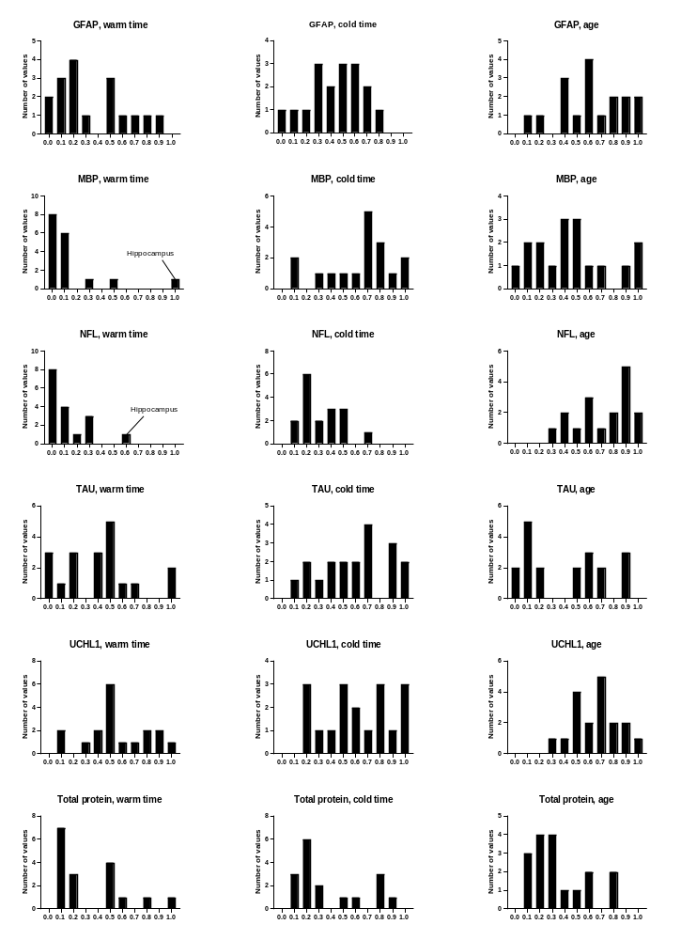

3. Concentration diagrams
Figure S2. Concentrations of GFAP, MBP, NFL, Tau, UCHL1 and Total protein in selected anatomical regions of the CNS, presented in diagrams.
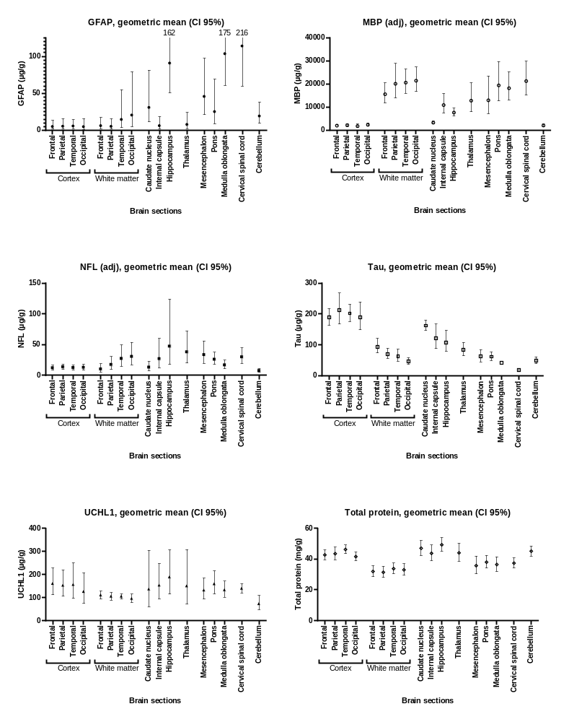

4. Association between warm time and concentration of MBP and NFL
Figure S3. Association between warm time and MBP in all CNS regions. Increased duration of warm time was associated with higher concentrations of MBP in all CNS regions except hippocampus.
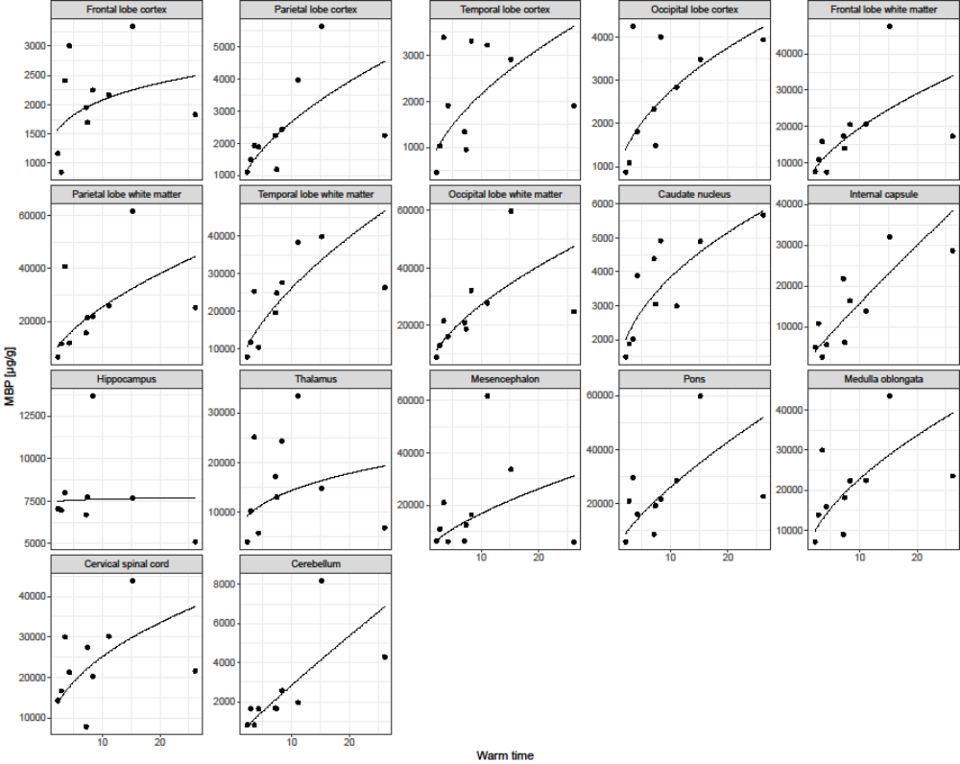

Figure S4. Correlation between warm time and NFL in all CNS regions. Increased duration of warm time was associated with higher concentrations of NFL in all CNS regions except hippocampus.
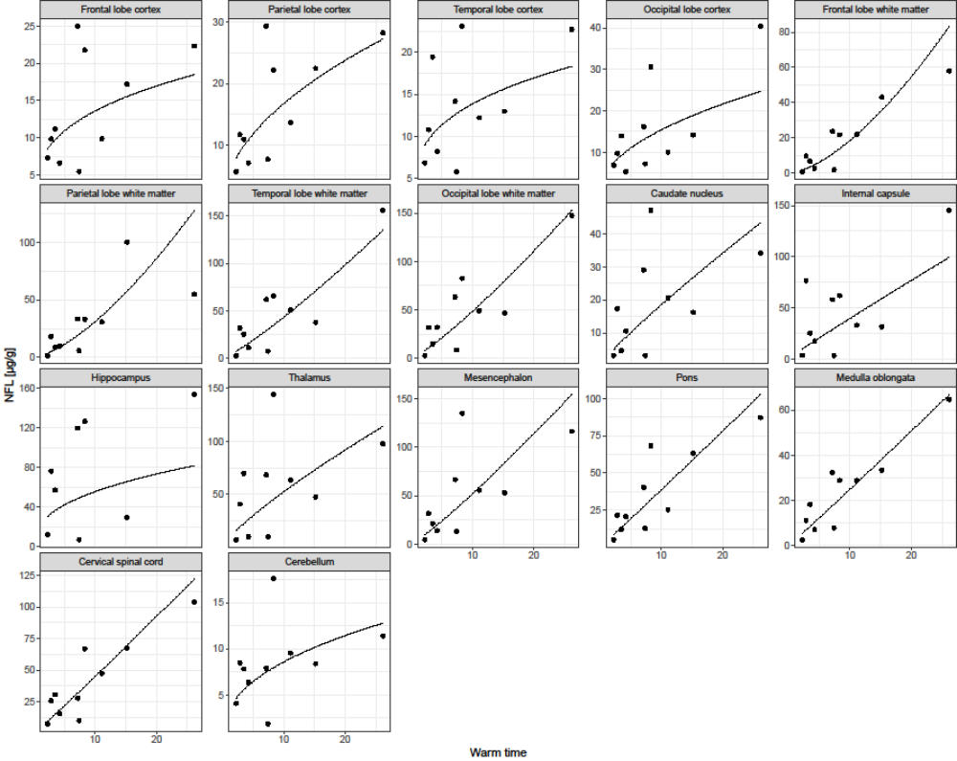

5. Validation data
A dilution linearity assessment was performed for two of the assays, the GFAP (Human GFAP DuoSet ELISA-kit, R&D Systems™. Catalog no.: DY2594-05), and UCHL1 (Human UCH-L1/PGP9.5 DuoSet ELISA, R&D Systems™. Catalog no.: DY6007-05). For GFAP three samples were tested from one of the donors; frontal cortex, frontal white matter and internal capsule (Fig. S5-S7) and for UCHL1 two samples were tested; frontal cortex and internal capsule (Fig. S8-S9). A spike and recovery test was performed for UCHL1 (Table S7).

Figure S5. Dilution linearity of GFAP assay in frontal cortex. DF = dilution factor, and * = out of range of standard curve.

Figure S6. Dilution linearity of GFAP assay in frontal white matter. DF = dilution factor, and * = out of range of standard curve.

Figure S7. Dilution linearity of GFAP assay in internal capsule. DF = dilution factor, and * = out of range of standard curve.

Figure S8. Dilution linearity of UCHL1 assay in frontal cortex. DF = dilution factor, and * = out of range of standard curve.

Figure S9. Dilution linearity of UCHL1 assay in internal capsule. DF = dilution factor, and * = out of range of standard curve.

Table S7. Spike and recovery test for UCHL1. The test was performed on two samples, frontal cortex and internal capsule, at 10,000 times dilution. Spikes were 0 (no spike), 0.5 (medium spike), and 1.0 (high spike) ng/ml and added to the samples. Blank = reagent diluent used in the assays to dilute the samples.
 | No spike | Medium spike | NET | Recovery | High spike | NET | Recovery
Frontal cortex | 0.442 | 0.738 | 0.296 | 99% | 1.252 | 0.810 | 120%
Internal capsule | 0.315 | 0.579 | 0.264 | 89% | 0.957 | 0.642 | 95%
Blank | 0.000 | 0.298 | 0.298 | 100% | 0.675 | 0.675 | 100%

