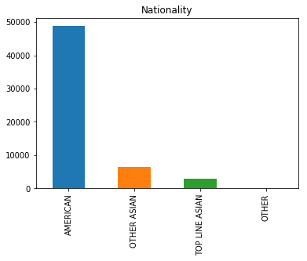

In this variable we have the mode in ‘AMERICAN’ that is the 83,67% of the total.

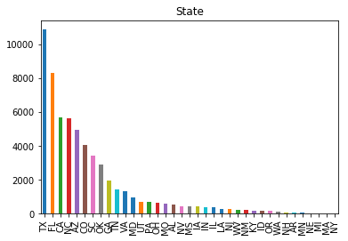

In this variable we have the mode in ‘TX’ that is the 18,63% of the total. We also have the 51,90% of the total frequency between: ‘TX’, ‘FL’, ‘CA’, ‘NC’.

**VEHODO**

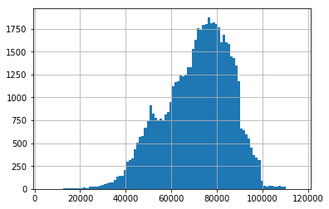

The mean of this variable is 71478.09 and the standard deviation is 14591.22.  
Furthermore the we have the minimum in 4825.0, first quartile is 61785.0, second quartile is 73359.0, third quartile is 82427.0 and the maximum is 115717.

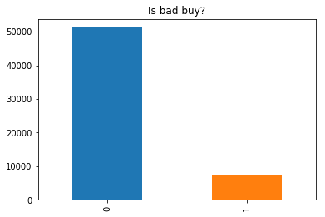

IsBadBuy: In the dataset we can see an unbalanced distribution of the values IsBadBuy: 87,65% of the auto is a good buy and the remaining 12,35% is a bad buy. The information about the dataset is that shoddy vehicles are exception at the auction.

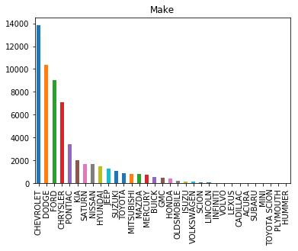

Make: ‘Chevrolet’ is the most frequent brand. The distribution of the values highlights this with 23,71% of the total in ‘Chevrolet’, followed by Dodge (17,73%), Ford (15,41%) and Chrysler (12,15%). The American cars represents the 83,59% of the entire training set.

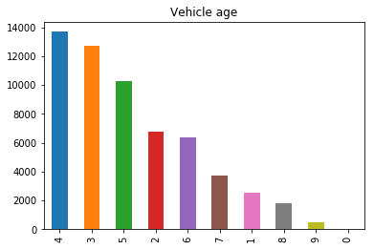

VehicleAge: The most frequent values is 4 (23,44%). We saw that the percentage of bad buy increase with the increasing of the vehicle age. The percentage of bad buy with vehicles age less than 2 years is 10%, indeed for vehicles that have 6 years is 20% and for vehicles that have 9 years is 31%.

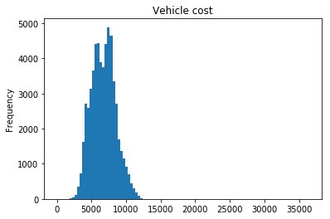

The mean of this variable is 6730.01 and the standard deviation is 1762.07.  
Furthermore the we have the minimum in 1, first quartile is 5430, second quartile is 6700, third quartile is 7900 and the maximum is 36485.

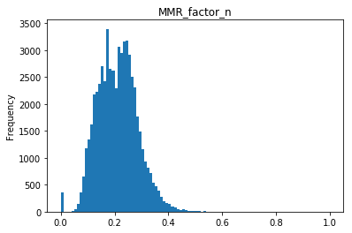

The mean of this variable is 8037.83 and the standard deviation is 2785.63.  
Furthermore the we have the minimum in 0, first quartile is 5989, second quartile is 8039.25, third quartile is 9847 and the maximum is 37992.25.