Technical Test – Yonder

**Steps follow:**

I install Docker and I run the image yondermakers/yonder-devops-tech-assessment:latest. To run this image, after some docker documentation, I went to the Extensions menu on the left side:

Here I searched for java and found Digma Continous Feedback:

I managed to find here an example on github (https://github.com/digma-ai/otel-sample-app-java) , from where I downloaded Java 17 and the IntelliJ IDEA 2023.3.5 program. Further I ran in this program the following code with access to the Docker image in order to access the endpoints binding to port 30000:



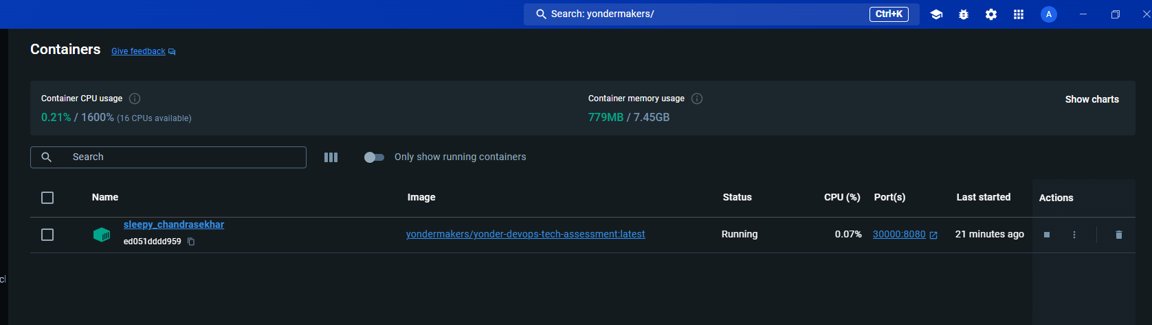

Next I accessed the link http://localhost:30000/ and ended up accessing the first endpoint which is a text file.

**Answers:**

Question 1: Exemplify two data structures that you know and describe some situations where you would use them.

Two data structures are list and array.

I used a list structure in one of the projects I worked on. Specifically, I utilized a list of values representing the speed of a car (50, 70, 100), using specific code, aiming to display these speeds on a cluster in order without encountering errors. I must ensure that the speed consistently increases up to the desired value, and if the value is incorrect, an error is signaled.

The second structure I used is a matrix with two rows, the first row representing the speed level, and the second row representing the maximum speed for each level. Here, it is verified that the car does not exceed the specific speed for each level.

Question 2: You open a web browser and access http://www.tss-yonder.com. What is the IP address behind this website and how does the browser know how to get the correct IP?

In order to see the IP address for the tss-yonder.com website, I used the **nslookup tss-yonder.com** command in the command prompt. Here it showed me the IPv6 and IPv4 addresses for the site.

The browser knows how to return the correct IP address because when a website is accessed from the browser, the browser looks at the DNS (Domain Name System) to find the website's IP address before opening the website.

Question 3: Exemplify two transport protocols and think of two applications that would use each of them.

Two transport protocols are TCP and UDP.

TCP defines how to establish and maintain a network conversation by which applications can exchange data. TCP is used in applications like sending email and World Wide Web (HTTP).

UDP is a communication protocol used across the Internet for especially time-sensitive transmissions. UDP is used in applications like Domain Name System (DNS) and online multiplayer games.

Question 4: You wrote a chat web application in your favorite programming language. You need to host this somewhere and run it so that the entire world can start using it. Describe how you would do that and the tools you would use.

In order for the application to be used by the whole world and to run as expected, I first need to choose a Hosting Provider according to my budget. Next I would have to launch my web application, which means transferring the application code to the server, configuring it to work. After that, I need to choose a domain.

In order to choose the tools I want to use, I would first research the market and see what tools would be best so I don't have problems with them. At a glance, I would choose Google Cloud Platform as my hosting provider. And I would buy the domain name from Google Domains.

Question 5: Now your application is famous but unfortunately it has a lot of bugs. You want only you and a couple of your friends to be able to access it until you patch it. Describe two ways you can achieve this.

Two methods I would take to make it possible for me and a few close friends to access the app are the following:

- I would put the IPs of the computers we use on the site, so that only our IPs can connect and the rest are rejected.

- I would set up a VPN that we have to connect to before accessing the web application for it to work.

Question 6: Your application is ready for the public once again. You realize that you forgot about security and any network administrator can see the messages that a user sends or receives. How would you improve your application to prevent this? Is there any way to do this so that not even the application owner (you) can see the messages between two random users?

To prevent this, and so that not even the application owner (me) can see the messages between two users, I would create a security shield. This security shield would be created so that only people participating in the conversation can see and access it.

Question 7: What are cookies and what are they used for? Find a cookie used by http://www.tss-yonder.com and copy its name and value. What do you think is its purpose?

Cookies are text file with small pieces of data that are used to identify your computer as you as a network. They are used for session management, personalization and tracking.

A cookie used by <http://www.tss-yonder.com> is:

Name: cookieconsent_status

Value: dismiss

I think this cookie is used for the interaction that happens on the site between a visitor and the management platform that lets users decide whether to allow cookies to retrieve their data.

Question 8: While writing your application you need to create more worker processes for processing some data. How can you create child processes in your favorite language? What are the possible states of a process?

In order to create a child process I must have a source code that can start this process, namely a parent process. The possible states of a process are new, ready, running, blocked, and exit.

Question 9: Your application is running but it still has a few problems. Occasionally, it returns an error page. How can you find the PID of your application? What would you do to debug it?

I can find the PID for my application using Task Manager and select the Detail tab. To debug it I could check the logs. I can look in the application logs to see if there are any error messages that may indicate the cause of the problem.

Question 10: What DBMS would you use to store your application data and why? How would you store the passwords of each user?

To store my application data I would use Relational SQL Database because they allow storing and managing large amounts of structured data in a way that is easy to query and update. In order to store each user's data, I would require the user to log in with username and password.

In the next step, I accessed the second endpoint using http://localhost:30000/drivers-licenses/list to see the list.

In order to make the code in Python and make it work I used the Jupyter Notebook extension from Docker Desktop.

The code I made is in the document: Alexandra_Coman_code_python.docx