Your Title Here

Experiment 1, Experimentation & Evaluation 2024

# Abstract

Short (120-130 words) summary of your entire report. Give the reader a quick idea of what you did and what the main findings were (if you prepare this report ahead of time, leave out the findings until after you finish the analysis).

# 1. Introduction

The topic of investigation of our experiment is the performance, more specifically the execution time required by four different sorting algorithms (the lower the better). The latter are: BubbleSortUntilNoChange, BubbleSortWhileNeeded, QuickSortGPT and SelectionSortGPT.

The motivation for this study stems from the need of a company to decide which implementation of sorting algorithm to include in the Java library they are developing.

**# TODO: OUTLINE OUR PROPOSED EXPERIMENT**

|  |
| --- |
| **Hypotheses:** |
| QuickSortGPT is the sorting algorithm that delivers the best performance across all array types, sizes and data orderings, since it is the one with the better time complexity. |

# 2. Method

In the following subsections, describe everything that a reader would need to replicate your experiment in all important details.

## 2.1 Variables

The independent variables (i.e. the values changed during the experiment) are the following: the sorting algorithm, the type of data, its orderings in the array and the array size.

|  |  |
| --- | --- |
| **Independent variable** | **Levels** |
| Sorting algorithm | BubbleSortUntilNoChange, BubbleSortWhileNeeded, QuickSortGPT and SelectionSortGPT |
| Data Type | Integer and String |
| Data Orderings in the array | Best case: the data in the array are already sorted  Average case: the data in the array are in random ordering  Worst case: the data in the array are reverse sorted |
| Array Size | Small: 100  medium: 10’000  Large: 100’000 |

The dependent variable (i.e. what is measured in the experiment) is the execution time of the sorting algorithms.

|  |  |
| --- | --- |
| **Dependent variable** | **Measurement Scale** |
| Execution time | Ratio scale (in ns) |

The control variable(s) (i.e., what is kept constant during the experiment) are the following:

hardware, Operating System, running applications, JDK and warmup.

|  |  |
| --- | --- |
| **Control variable** | **Fixed Value** |
| Hardware | Model: Dell Inc. Precision 5570  Memory: 16.0 GiB  Processor: 12th Gen Intel® Core™ i7-12700H × 20  Graphics: 1: Intel® Graphics (ADL GT2)  Graphics: NVIDIA RTX A1000 Laptop GPU  Disk Capacity: 512.1 GB |
| Operating System | OS Name: Ubuntu20.04.6 LTS  OS Type: 64-bit  GNOME VERSION: 3.36.8  Windowing System: X11 |
| Running applications | IDE and the shell |
| Warmup | 10 |

## 2.2 Design

Check off the characteristics of your experimental design:

**Type of Study** (check one):

|  |  |  |
| --- | --- | --- |
| **⃞ Observational Study** | ⃞ **Quasi-Experiment** | ⃞ **Experiment** |

**Number of Factors** (check one):

|  |  |  |
| --- | --- | --- |
| ⃞ **Single-Factor Design** | ⃞ **Multi-Factor Design** | ⃞ Other |

The experiment we designed is neither an Observational Study nor a Quasi-Experiment, as we are not looking at a phenomenon in a systematic and scientifically rigorous way in its environment, and we have complete control over manipulation of the independent variables. Therefore, it is an Experiment.

Moreover, it follows a Multi-Factorial Design, since we have more than one independent variable in the study.

The following image shows the Experiment considering one algorithm on one data type.

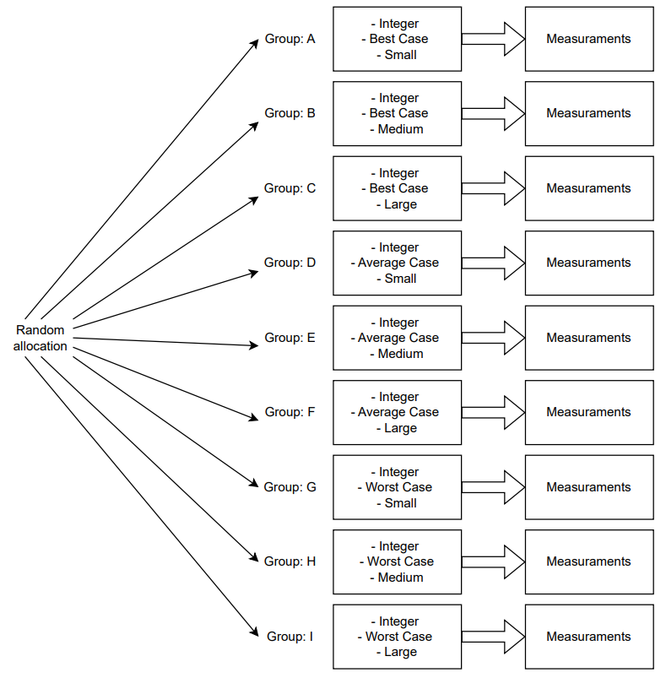

## 2.3 Apparatus and Materials

Describe in sufficient detail any relevant “props” that you used in your experiment. This could be the computer you used (exact model and specification), the software used (URL, version numbers), the way you measured, e.g., time (A stopwatch? A background process on the computer that got automatically triggered?). Omit needless detail (e.g., think whether details like the size of the table the laptop was placed on, or the hard disk size, might have affected your results or not).

## 2.4 Procedure

Describe how you used your props and/or the participants to perform your actual experiment, i.e., how you actually carried out a single experimental run. What was done to the participants? What did they have to do? How long did each session take (unless this is an actual dependent variable)? If you did not have participants, explain, e.g., what software was started by whom in what order.

# 3. Results

## 3.1 Visual Overview

Provide an insightful overview of the data you collected. This requires some engineering from your part, to find a good degree of summarization: On one end of the spectrum, you don't summarize, and report hundreds of raw measurement values in a block of text. On the other end of the spectrum, you report a single number (like a mean value). Both approaches are bad.

Instead, use appropriate visual summaries (such as **scatter plots**, **histograms**, **box plots**, or **empirical cumulative distribution functions**) to show the distribution of your data. If you have a very small number of measurement values, then report all of them in a **well organized table** (where rows and/or columns correspond to different levels of different factors).

## 3.2 Descriptive Statistics

For each group or condition, summarize the set of measured values with a "five-number summary": **minimum**, **first quartile**, **median**, **third quartile**, and **maximum**.

Make sure you explain – in your words – what these statistics mean “in plain English”, but don’t yet interpret them (this is for the Discussion section).

# 4. Discussion

## 4.1 Compare Hypothesis to Results

Provide a brief restatement of the main results from the previous section, and if (or if not) these support your research hypothesis.

If there is a discrepancy between your hypothesis and the results of your experiment, speculate about why you were unable to find evidence to support your hypothesis.

## 4.2 Limitations and Threats to Validity

Acknowledge any faults or limitations your study has, and how seriously these affect your

results. How could these be remedied in future work?

## 4.3 Conclusions

End with the main conclusions that can be drawn from your study.

Appendix

# A. Materials

Any documents you used for your informed consent (information sheets, consent) or as part of your apparatus (e.g., manual, hand-out), please include them here.

# B. Reproduction Package (or: Raw Data)

Before, during, and after the experiment you collected all kinds of data. Don't ever throw such data away! Any plots, tables, summaries, and statistics provided in this report should be recreatable from the raw data you have.

If you only collected a small amount of data, put it in this Appendix right here.

If you collected data in forms that are better kept in separate files, then zip up those files, and submit them as a "reproduction package" supporting this report.