

**Report – Dobot robotic arm with Smart Camera**

|  |  |
| --- | --- |
| Name | **Di Rienzo Alessandro and Mori Giorgio** |
| Date | **23.07.2024** |
| Version | **1.0** |
|  | |

Index

1 Objective 3

2 Introduction 3

3 Main project 3

3.1 MV camera 3

3.2 Arduino Board 3

3.3 Dobot magician 4

3.4 Arm attachment ( 3D printed prototype) 4

3.5 Servo motor 4

4 C 4

5 GitHub link 4

# Objective

We want to connect an OpenMV camera to a Dobot magician to use it for collecting samples and conduction experiments using a 3D printed support to hold an automatic Pipette.

The main idea is to have a programmable platform useful for conducting experiments by handling samples and using the camera to notice changes in the substances, indicating chemical reactions.

# Introduction

During this project we had to find a way to connect the camera to the robotic arm, after some research we chose to use the UART (serial port) of the robot using an Arduino MEGA board. We also had to design and 3D print a support to hold the camera and the pipette system.

Softwares used:

* Arduino IDE
* OpenMV IDE
* DobotStudio
* OnShape CAD design

# Main project

## OpenMV Cam H7MV camera

We used this camera attached to the robot to have a top-down view of the arm for tracking the coordinates of the vitro plate. The camera was programmed in a way that after detecting a circle, it sends the coordinates x and y relative to the camera view and it also sends the given radius of the circle. Everything gets sent to the Arduino board using the UART pins of the camera.

## Arduino Board

**OpenMV Camera:**

TX (OpenMV) → RX1 (Pin 19) (Arduino Mega)

RX (OpenMV) → TX1 (Pin 18) (Arduino Mega)

GND (OpenMV) → GND (Arduino Mega)

VIN (OpenMV) → 5V (Arduino Mega)

**Arduino Mega:**

TX1 (Pin 18) → RX (OpenMV)

RX1 (Pin 19) → TX (OpenMV)

GND → GND (OpenMV)

5V → VIN (OpenMV)

GND → GND (Dobot Magician)

TX2 (Pin 16) → RX (Dobot Magician)

RX2 (Pin 17) → TX (Dobot Magician)

Pin 6 → Servo Motor Signal Pin

GND → GND (Servo Motor)

5V → 5V (Servo Motor)

**Dobot Magician:**

TX (Dobot) → RX0 (Pin 0) (Arduino Mega)

RX (Dobot) → TX0 (Pin 1) (Arduino Mega)

GND (Dobot) → GND (Arduino Mega)

5V (Dobot) → 5V (Arduino Mega)

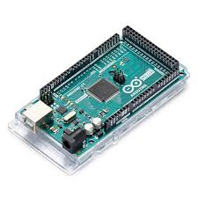

We have specifically opted for an Arduino MEGA 2560 board because of the limitations of the libraries to control the Dobot that we found, the processor found on this board is the only one supported, given its architecture.

The programmed board acts as an intermediary between the Dobot, the Camera and the servo motor used to compress the pipette, the program receives the coordinates from the camera and converts them. After adapting them to the robot Cartesian’ coordinates, it uses the “new_dobot_api” package containing functions and methods to make the Arduino connect to the serial port found on the back of the Dobot and sends commands to move the robot to the desired position. The board also receives the radius of the sample holder, this information will be used to determine the robot’s arm height, when the radius found is the one wanted, therefore the height is correct, the pipette will activate.

## Dobot magician

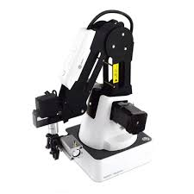The Dobot Magician Robotic arm is not programmed in any way using its own IDE, it only receives the raw data from the Arduino Serial Port 2 and moves accordingly. To the very end of the arm there is the 3D printed support attached that houses the camera, the servo motor and the pipette.

The data received from the Serial port is the Manufacturer’s own communication protocol, as stated before we can communicate with it using Arduino with the methods provided by the library.

## Arm attachment ( 3D printed prototype) with servo and pipette

* Immagine che contiene design

  Descrizione generata automaticamenteUsing OnShape CAD a support for holding everything was designed

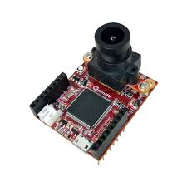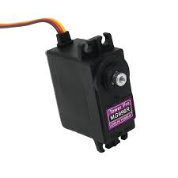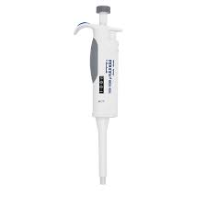

# C

# GitHub link