ITALIAN RESTAURANT IN NEW YORK CITY

COURSERA CAPSTONE PROJECT

Introduction:

Italian cuisine is one of the best in the world. The aim of this project is to find the most popular neighborhoods with italian restaurants in the Big Apple. This can be useful for suggesting where to open another restaurant that can be the bearer of our beautiful culture. As part of this project, we will list and visualize all major New York City's boroughs that have great Italian resturants based on ratings, tips and likes. We will then conclude by proposing the most suitable and competitive neighborhood for opening a new activity.

Data:

Data For this project we need the following data :

New York City data that contains list Boroughs, Neighborhoods along with their latitude and longitude. Data source : <https://cocl.us/new_york_dataset> Description : This data set contains the required information. And we will use this data set to explore various neighborhoods of New York city. Indian resturants in each neighborhood of New York city. Data source : Fousquare API Description : y using this api we will get all the venues in each neighborhood. We can filter these venues to get only indian resturants. GeoSpace data Data source: <https://data.cityofnewyork.us/City-Government/Borough-Boundaries/tqmj-j8zm> Description: By using this geo space data we will get the New York borough boundaries that will help us visualize choropleth map.

In our analysis we get data from this dataset for New York city data:

<https://cocl.us/new_york_dataset>

By using our personal Client ID on Foursquare, we can interact with FourSquare API and get top 100 venues within a radius of 1000 meters for a given latitude and longitude.

Foursquare is a social network based on geolocation for mobile devices.

First of all, with the function .head() we get the first 15 rows of the NYC data:

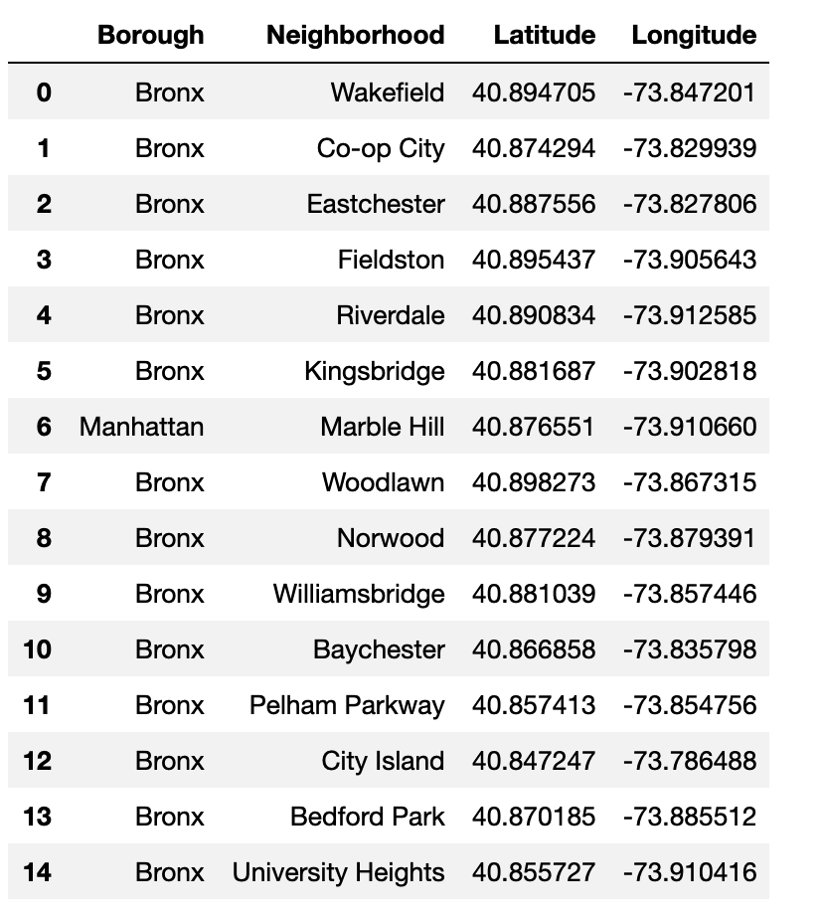

There are 307 different Neighborhoods and 5 Boroughs in New York. In the following plot we show the number of Neighborhood for each Borough:

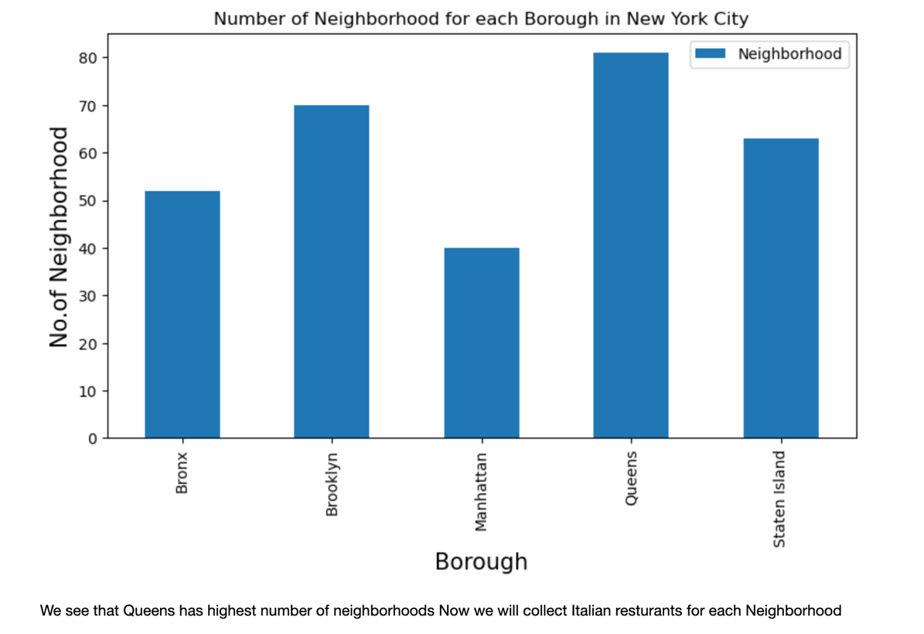

As we can see, Queens has the highest number of neighborhoods.

Let us now focus on all the italian resturants in New York City for all five Boroughs: Bronx, Brooklyn, Manhattam, Queens and Staten island.

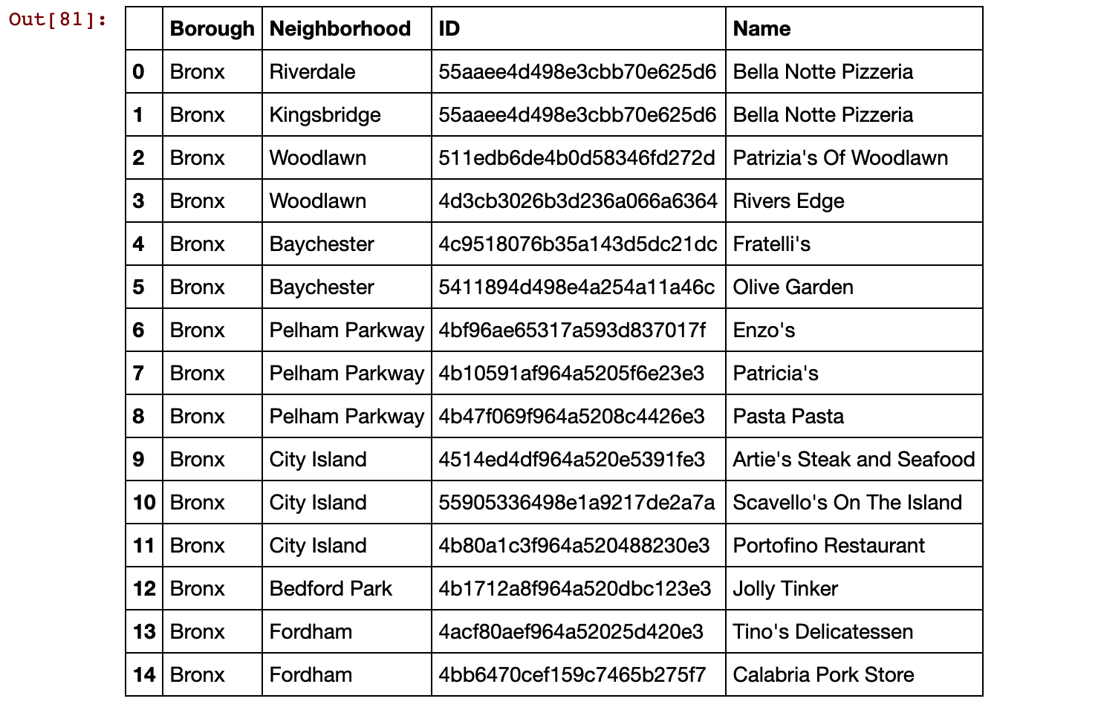

This table shows the first fifteen rows belonging to the Bronx Borough together with the names of each restaurant in every different Neighborhood. Other different Boroughs can be seen when showing a larger number of rows.

It is very interesting that every name refers to something connected to the Italian culture e.g. typical names, surnames, or kind of food.

For example, the most famous “Pizza, Pasta and Macaroni” might be used for the restaurant’s names to get people attention and remind Italy.

This is the best way to promote an activity to foreign people that can recognize the “Italian brand”. Moreover, this may catch also Italian tourists’ attention who are far away from their country but want to feel at home.

Knowing the number of Italian restaurants for each Neighborhood in New York City is very important for our investigation to understand what are the most popular places where to find Italian food.

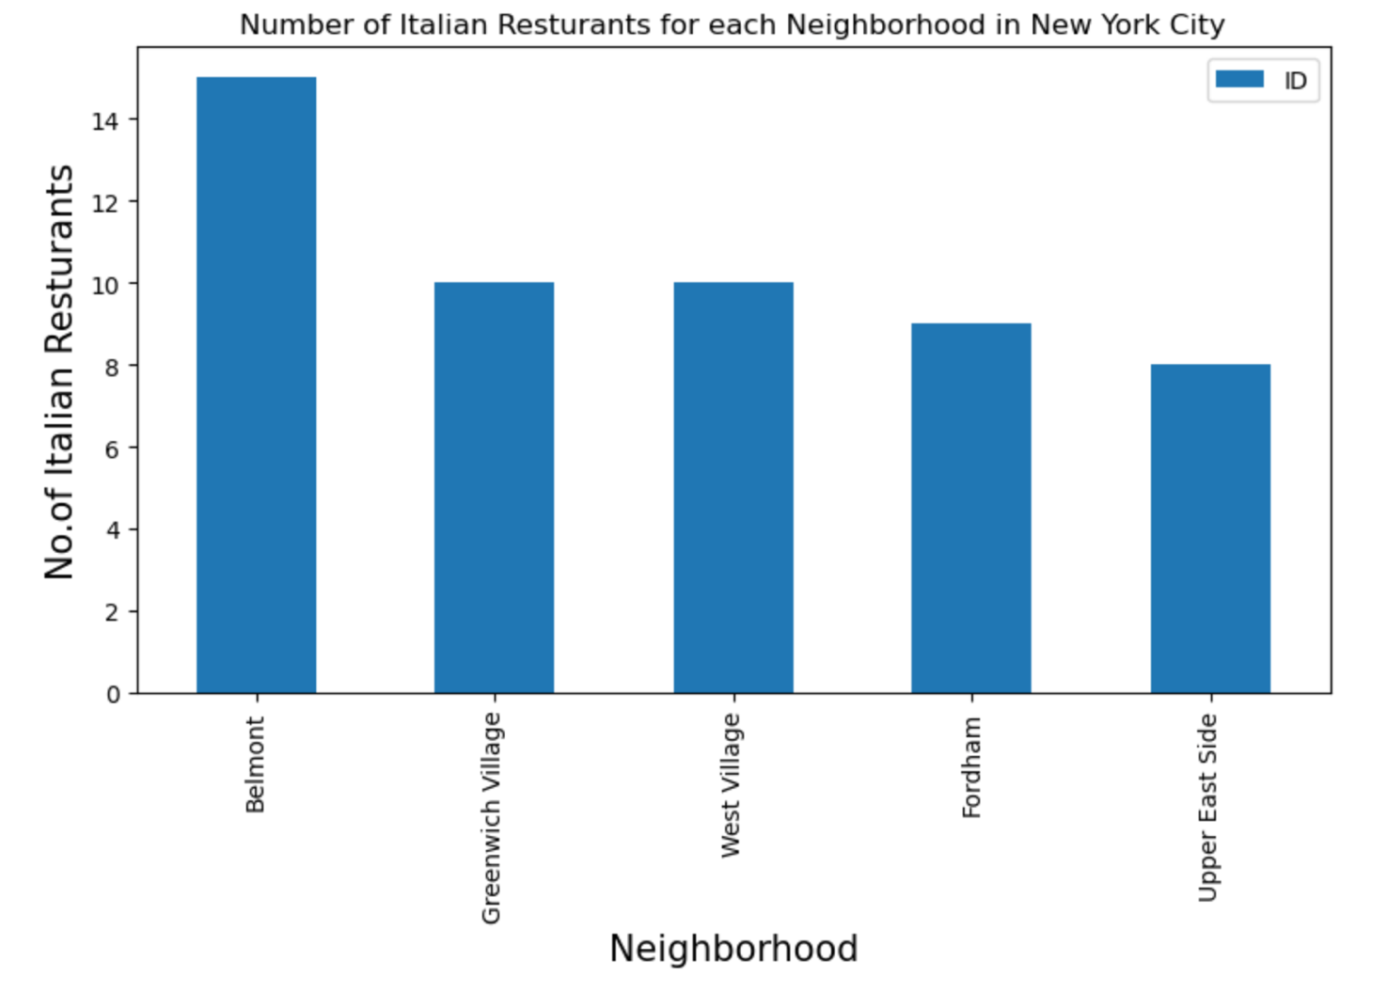

This might help to understand what could be the best places to open a new activity or maybe to infer which are the most competitive neighborhoods based on the number of Italian restaurants.

As we can see, Belmont in Bronx has the highest number of italian restaurants.

Now we create a .csv file in which we add ’rating’, ‘tips’ and ‘likes’ for each restaurant.

This can help us understanding if there are good restaurants.

We notice that the best rating is 9 and we get the top average rating for each Bronx’s Neighborhoods.

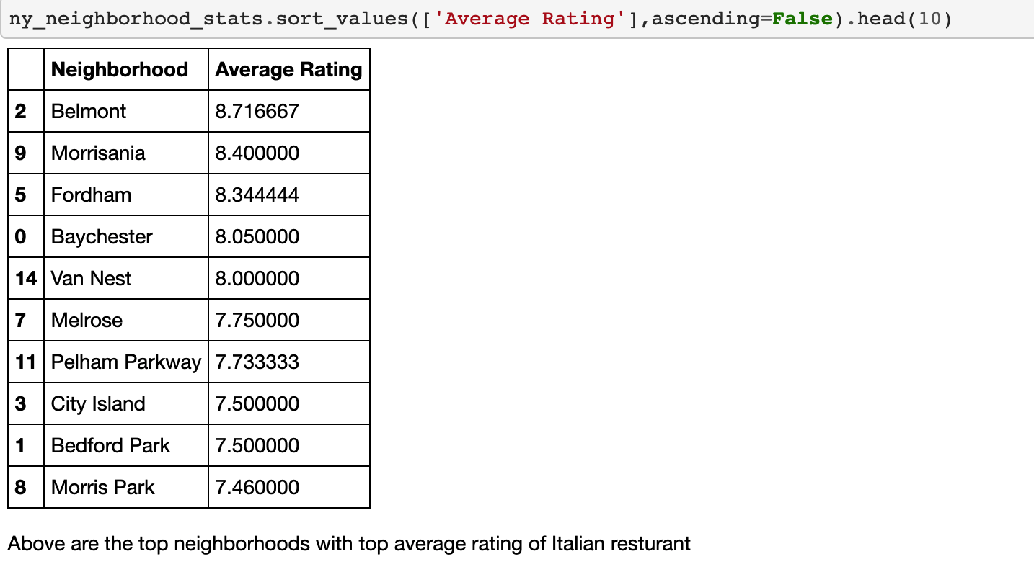

Now, we can see on the map the Italian restaurants that have the best rating in Bronx’s Neighborhood.

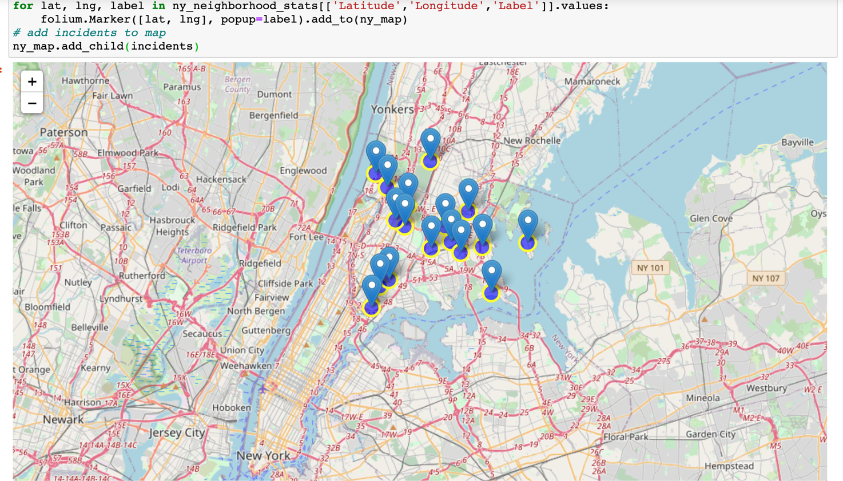

CONCLUSIONS:

This analysis provides that Bronx can be the most suitable for opening a new activity since we have the least number of italian restaurants. Manhattan, in contrast, has the highest frequency.

We also conclude that we need to focus on each Bronx’s neighborhood, because we see that Belmont is the most competitive neighborhood for opening a new activity.

Therefore, a different neighborhood would be more suitable in order to be the “bearer of the italian culture” in that place.