AE 352 Project (Homework 9-10)

EVALUATION OF ROBOTIC ARM SIMULATION

A 3-D Printed Model

FINAL REPORT

Steven Macenski, Chris Lorenz

12/17/2015

Our project to build a hardware version of the simulated robotic arm was successful. An exact model was constructed, with 1 meter in the simulation corresponding to 1 inch in the real model. In designing and constructing the arm, the simulations’ qualities were considered in detail. Particularly, the need for a similar, uniform density and low friction joints was accommodated.

The uniform density allowed us to use the same moment of inertia equations that the simulation uses for each link, with different mass properties corresponding to the final robot links’ masses. The allow for low friction, steel bearings and bushings were used with a toleranced threaded rod. A threaded rod was chosen because having less surface area in contact with the bushings allows for a lower dynamic and static friction coefficients.

We ultimately updated the simulations’ initial conditions and k.friction variables to correspond with each experiment. A value of k.friction = 7 yielded a similar dynamic response with our hardware as it did the simulation.

Issues were discovered upon reviewing the video. The equation dictating the period of a pendulum

$$T=2π\sqrt{\frac{L}{g}}$$

where T is the period, L is the length to the center of mass, and g is the acceleration due to gravity, reveals that the period of a pendulum is related only to its length and gravity, not the mass. Therefore, to adjust for the scaled down pendulum used (1:39.4), the gravity within the simulation was increased by an amount equal to the scaling factor. This scaling of the gravity term resulted in relatively good agreement between the hardware and simulation.

As our video (<https://www.youtube.com/watch?v=sjDitF3TRVw>) features, the dynamic model of the robot manipulator is closely tied to the hardware verification. In the 3 performed experiments, the settling time of the robot manipulators were fairly consistent with those found in the simulation. The simulation continued to swing with low amplitude for longer than the hardware, a direct result of the lack of static friction found in the simulation. A still image taken from a video of the hardware can be found below.

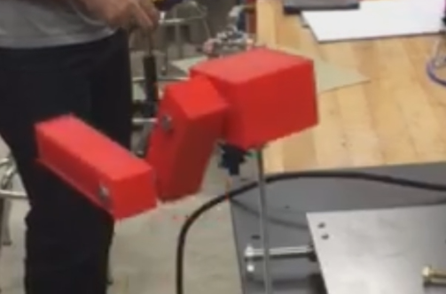

For the full range of motion experiments, there was an inconsistency with reaction. The hardware doesn’t jerk around as much as in the simulations and does not rotate its base as much. We believe this to be attributed by the increased friction in the base yaw joint as the mass of the robot is resting on it and torqueing the steel rod against it. The torque is increasing the contact force and preventing motion. This could have been solved with a much more closely toleranced steel rod, however within realistic and easily available rods, there are none that could have removed this inconsistency.