# Instructions to open App

1. Install Rstudio Desktop. Go to <https://www.rstudio.com/products/rstudio/download/> and choose the correct installer for your operating system. Once downloaded, run the installer and follow the instructions given within.

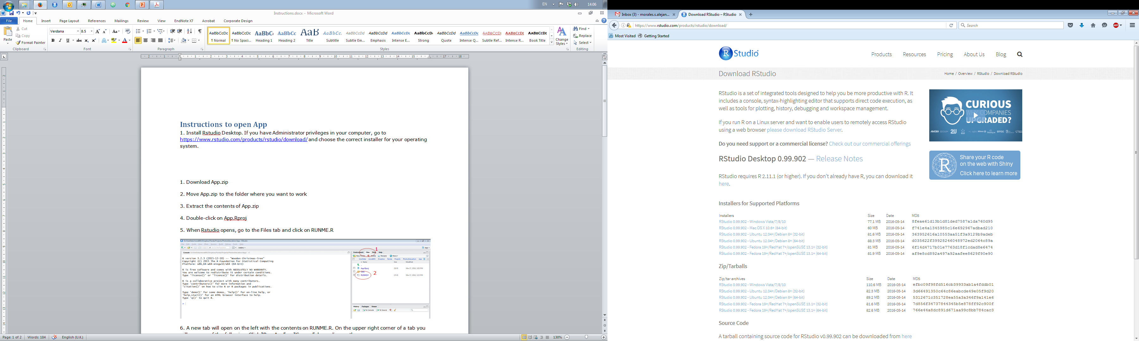

2. Install R. Go to <https://cran.rstudio.com/> and choose the correct installer for your operating system. Once downloaded, run the installer and follow the instructions given within.

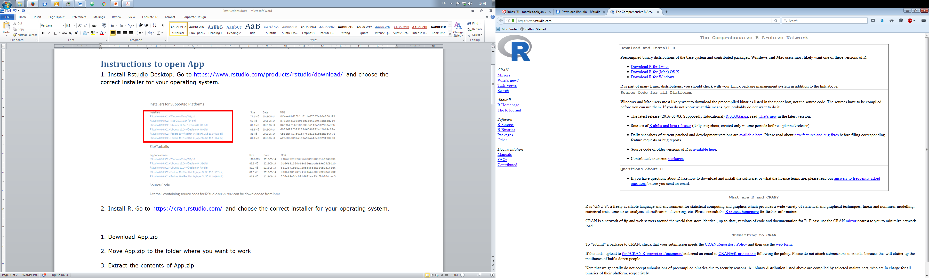

3. Go to the folder where the contents of the zip file were extracted. Double-click on App.Rproj

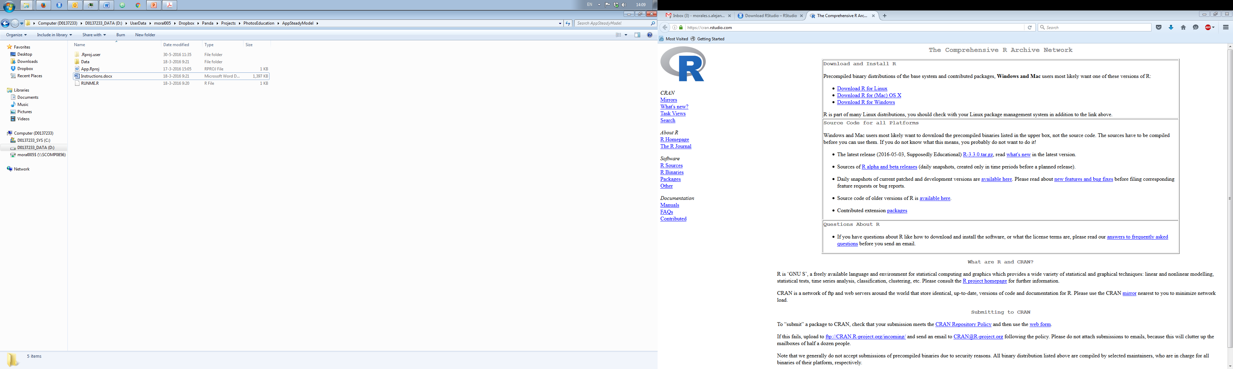

4. When Rstudio opens, go to the Files tab (by default on the upper right corner) and click on the file RUNME.R

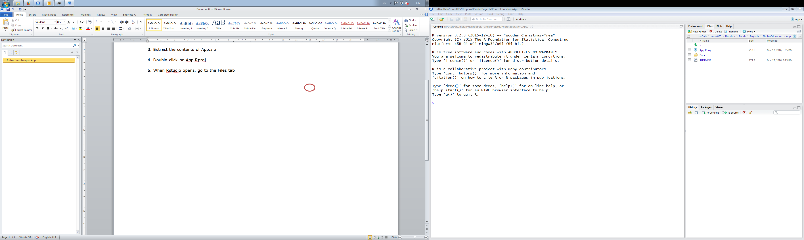

2

1

5. A new tab will open on the left with the contents on RUNME.R. On the upper right corner of a tab you will see one of the following. Click “Run App” or “Source” depending on the screen

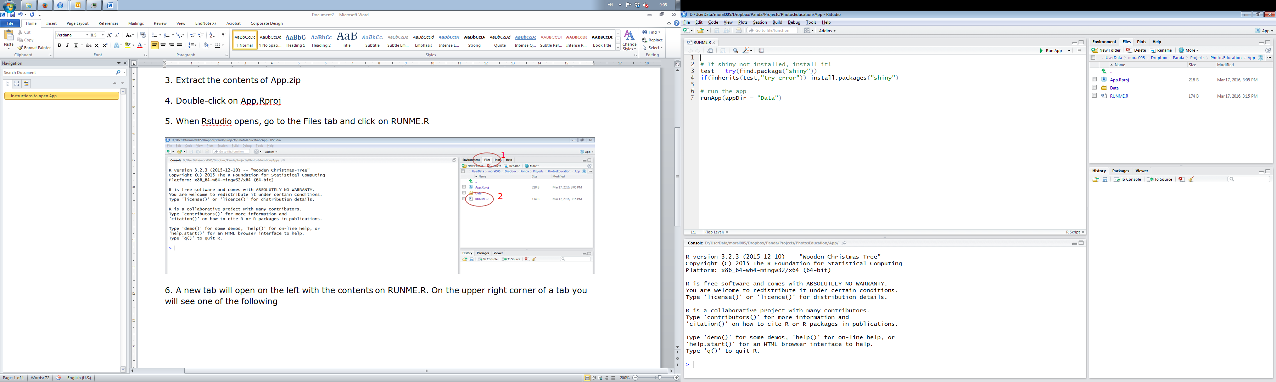

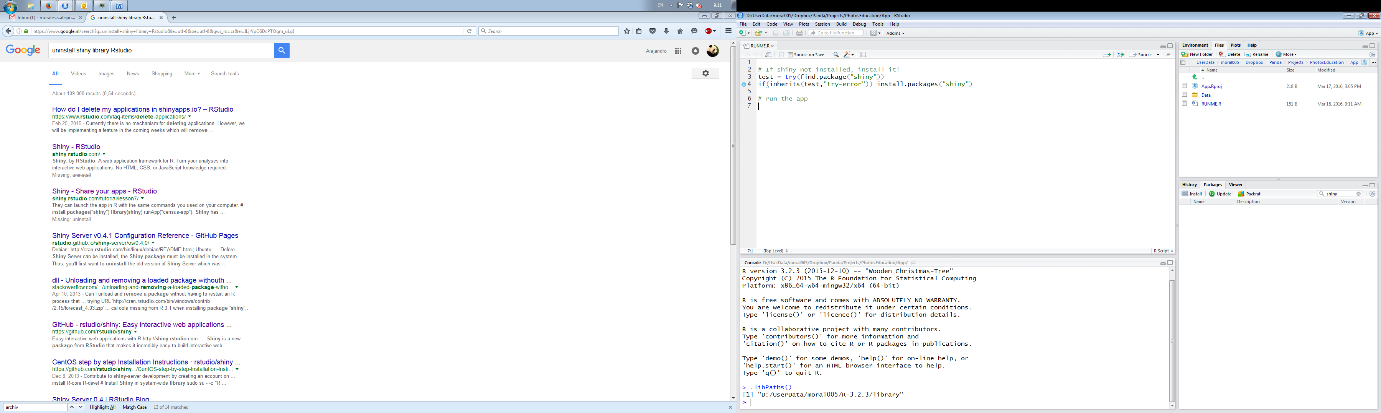

6. The first you time you run the app, you may get the following message. Click Yes.

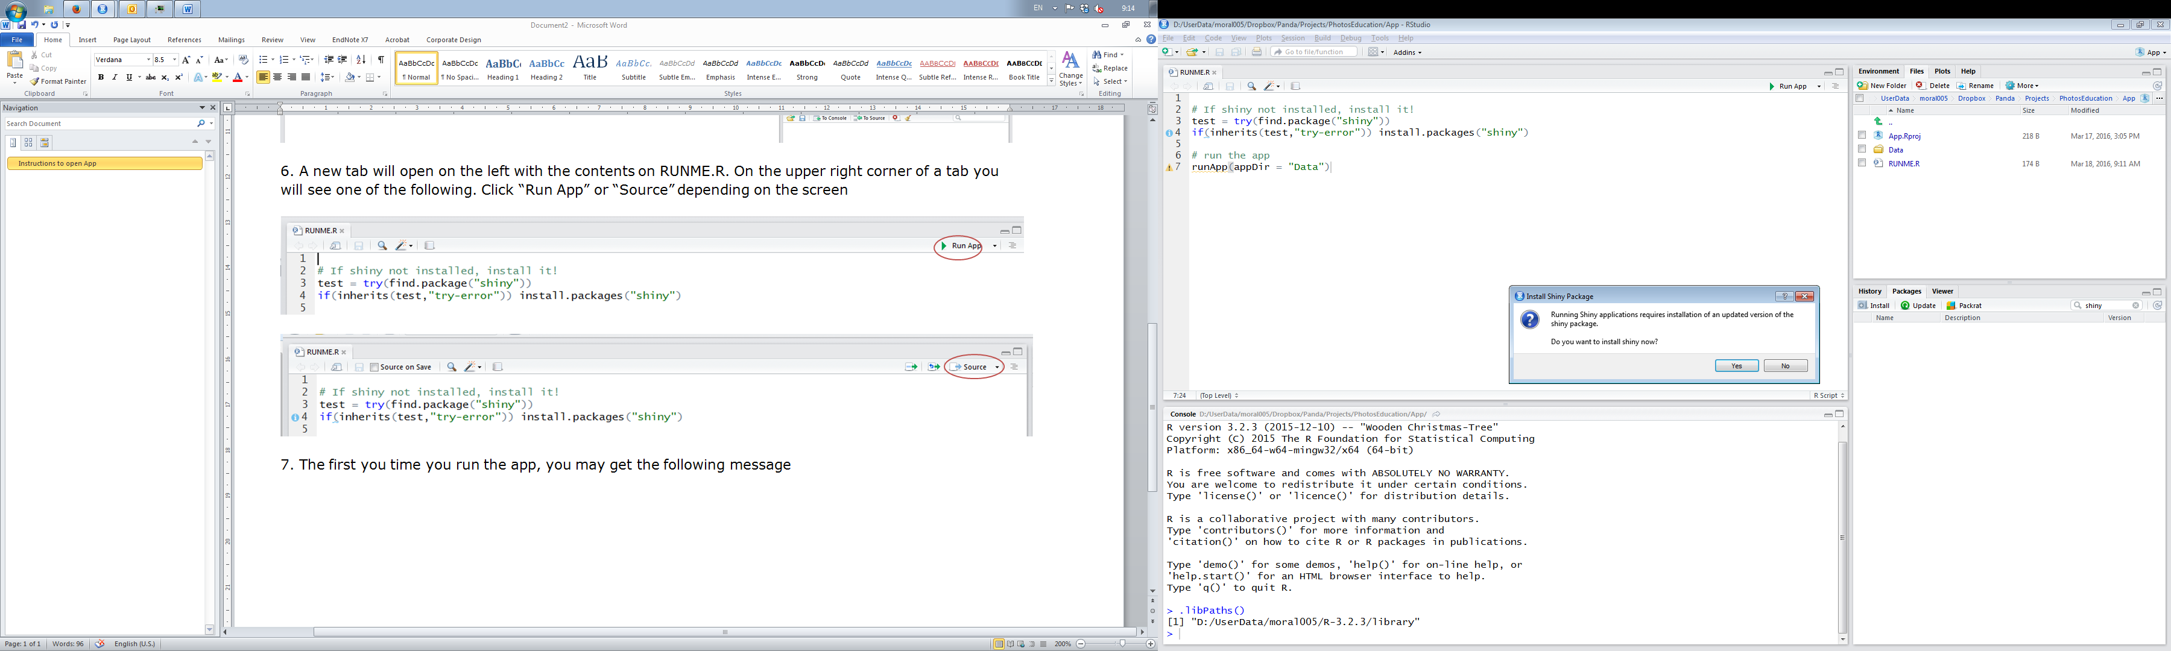

7. The first time you run the app, RStudio will have to download and install several dependencies required to run the App. During this time, the R console will remain busy (red messages will appear on the screen).

8. At the end the App will open. Depending on the settings it may open in your default Web browser or in a window.