FINAL ASSIGNMENT, SYSTEM CONTROL ENGINEERING I
Alessandro Puglisi, C4TL1107


For the final assignment I want to account two interesting and complete modelling and control problem, that I implement from the acquired knowledge coming from two courses of my previous master studies in Politecnico di Milano: “control of electrical machine and drives” and “control of mobile robot”.
Using the knowledge acquire in that courses I show here two different control problems, the first regarding the control of a DC motor, with the Matlab PID tuning and Simulink scheme used for simulation. The second one regarding the control of mobile robot, especially the trajectory tracking control of a car-like robot using the bicycle model, for this the simulation is conducted used ROS1 and a library used for solving ordinary differential equations, but some control theory analysis is conducted using Matlab.

Speed control of a Separately Excited DC Motor

PROBLEM STATEMENT
A DC (separately excited) motor is used to move an ATM trailway vehicle “Carrelli 1928” with the following characteristics:

- Line Voltage: 𝑉_{n} = 600V
- Efficiency: 𝜂 = 0.9 (neglecting excitation losses and iron losses)
- Motor rated speed [rad/s]: 𝜔_{n} = 314 rad/s
- Motor rated speed [km/h]: v_{n} = 60 km/h
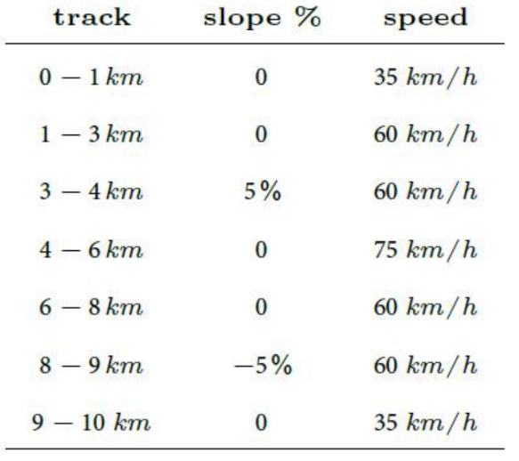
- Armature circuit time constant: 𝜏_{a} = 10ms
- Excitation circuit rated voltage: 𝑉_{e,n} = 120 V
- Excitation circuit rated current : I_{e,n} = 1 A
- Excitation circuit time constant: 𝜏_{e} =1s
- Tram mass: M_{t} = 10000 Kg
- Number of passengers: N_{p} = 200
- Single passenger weight: m_{p} = 80 Kg
- Time of acceleration: Dt_{a} = 25s

REQUESTS:
- Find the design parameters of the DC motor according to the data
- Design and simulate speed and current control in order to cover a 10km track considering the Table above (the slope is s%=100tan(ϑ))

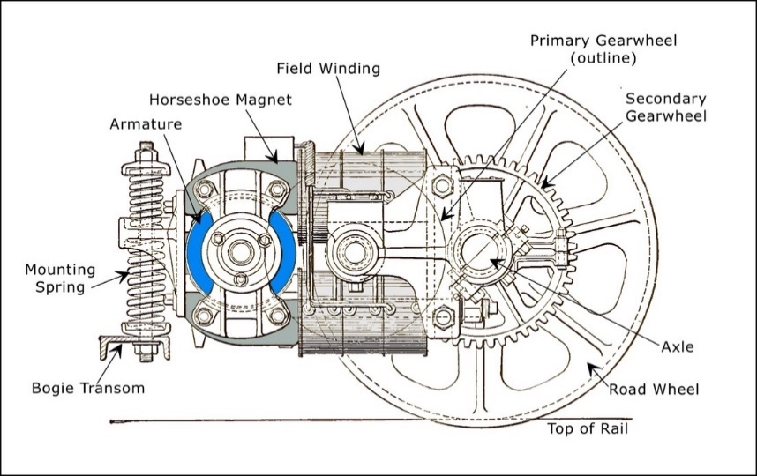
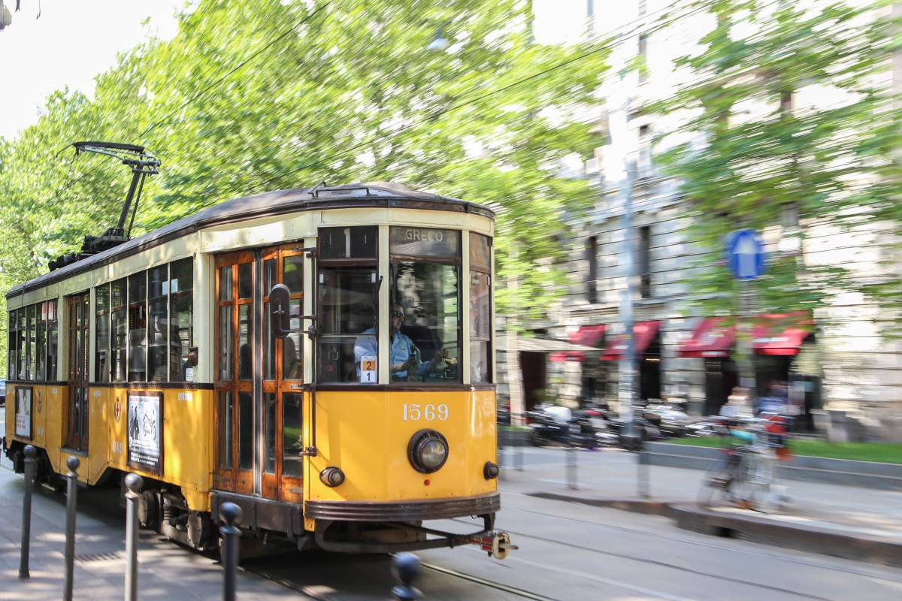

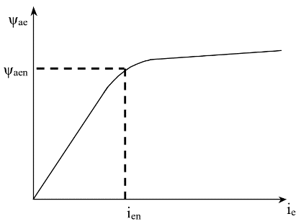
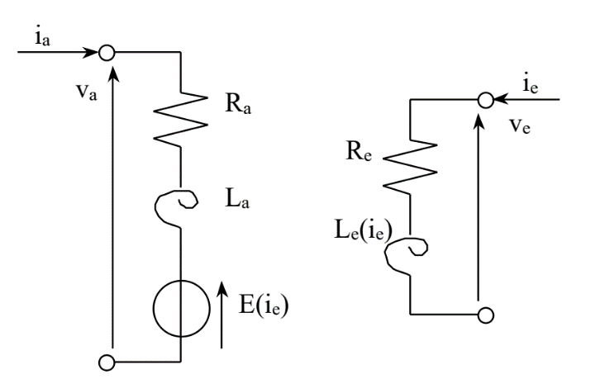
DC MOTOR DESIGN PARAMETERS
g(ie)
Va = Ra*ia + p Ψa + E
Ve = Re*ie + p Ψe
Ψa = La*ia
Ψe = f(ie)
Ψae = g(ie)
E = K*Ψae*Ωm
Te = K*Ψae*ia
Te – Tr = J$*\dot{Ω}$m + beta* Ωm

We compute it directly on Matlab, so we have all the parameters for the tuning of the controllers and the implementation of the complete Simulink control Scheme:
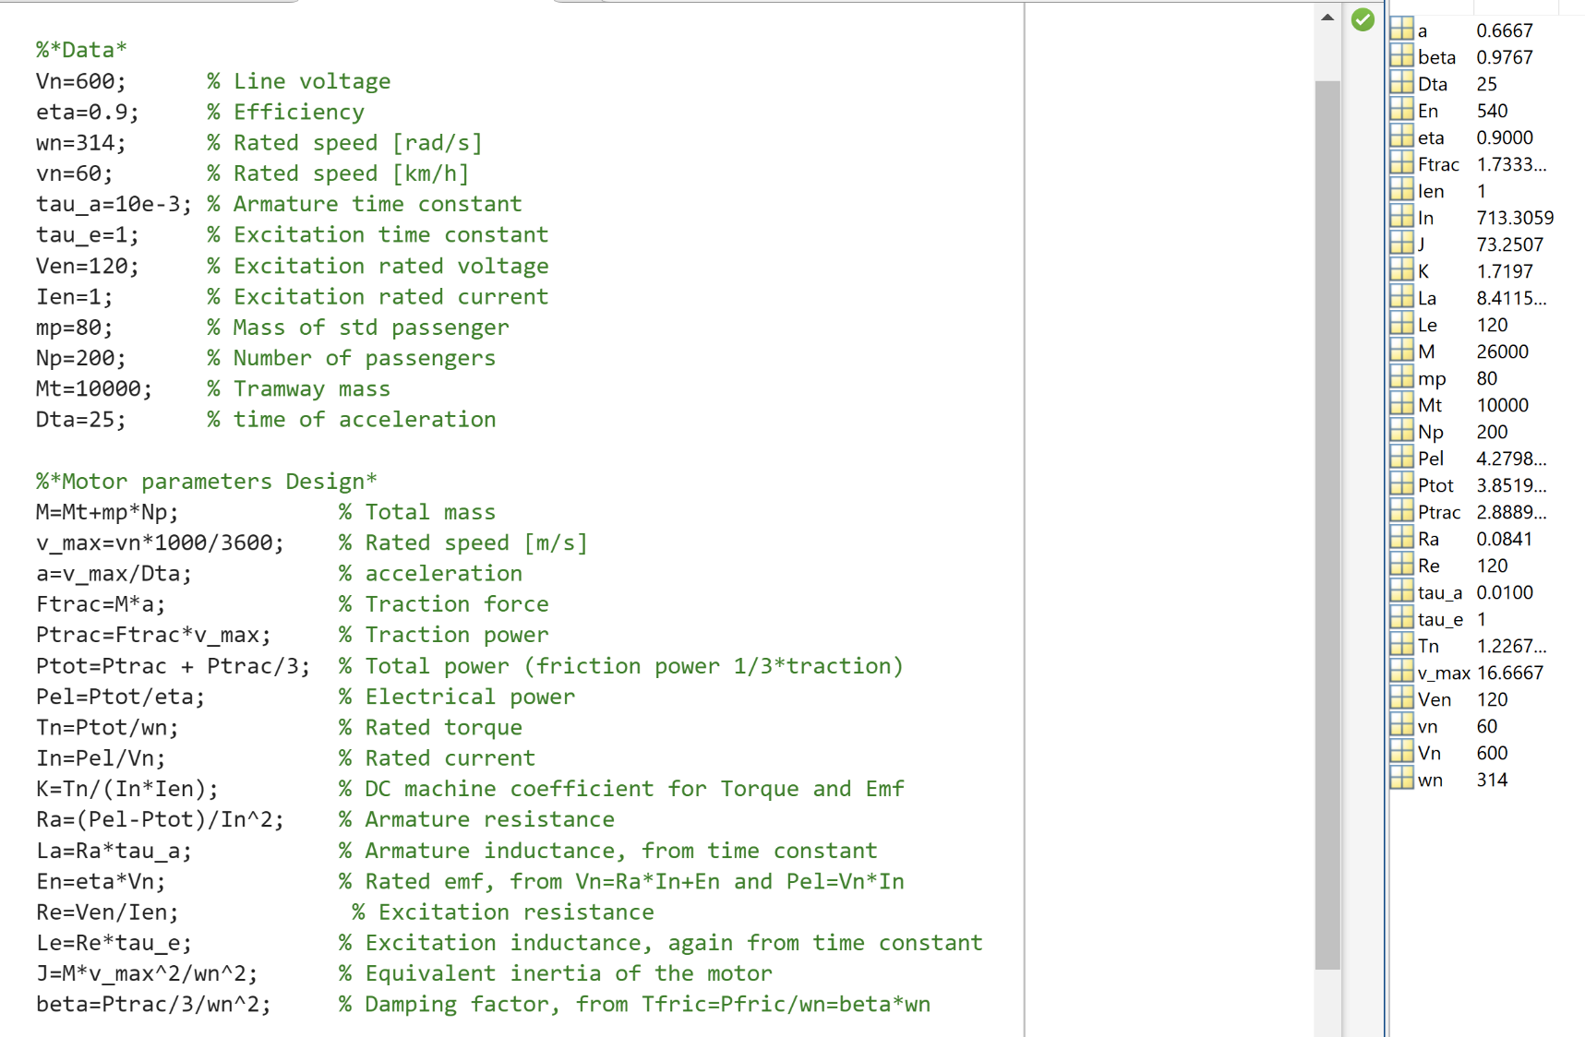

Before discussing about modelling and control of the system, let’s discuss about the Operating regions of the machine:
It is a representation of the machine limitation in steady state condition, very helpful to understand our feasible control region. In particular for this application we can notice a problem in 4-6 Km part of the track: the speed is above the rated one (wn, usually near the so called wb base speed, corresponding to the max reachable speed due to power supply limitations or rated working condition of the machine)
DC OPERATING REGIONS:
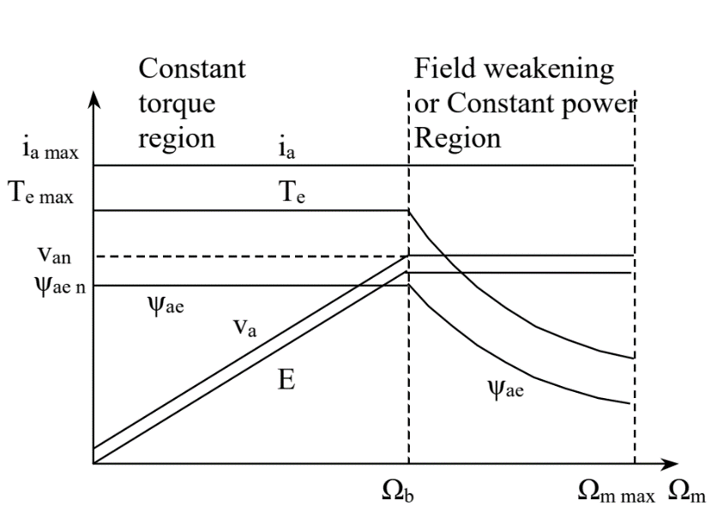
As we can see, it is possible to work above the base speed by means of the “Flux weakening” procedure. Obtained with a flux control, which through the control variable (ie) reduce the flux and so limit the e.m.f (not exceeding va limitations),this allow to increase the speed above its limit!
If instead we work below the base speed: the flux controller maintain Ψae on its rated value (best fe material usage)
(We can manage it in a simplified way)

CONTROL TUNING AND SCHEME

Separately excited DC machine is based on two control schemes acting in parallel with the feedback data:
- Speed/Torque control (based on speed reference, cascade structure)
- Flux control (based on a flux reference managed as explained before)

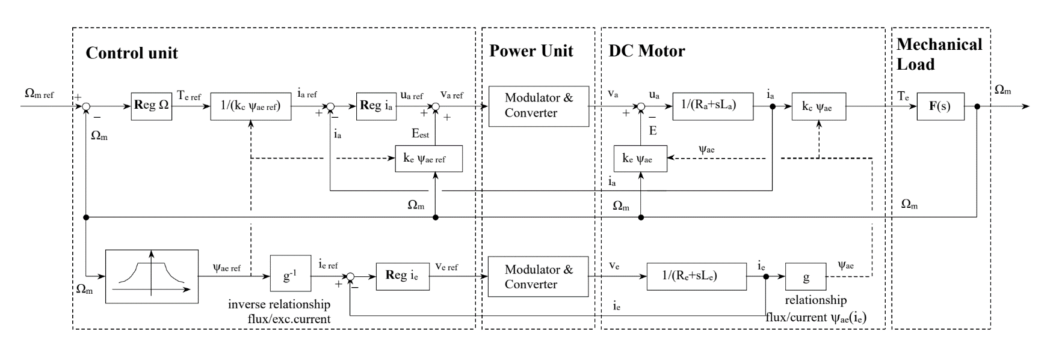
Overall control scheme:
For our case study we know the speed reference from the table, and we can easily model armature and excitation windings, but also the mechanical load (from J, beta and Tr as gravitational resistive torque using the track slope and total tram mass). We will discuss other implementation issues (like the flux dynamic g inversion) later on when we will have to model it on Simulink.
Now we focus on the tuning of the PI Regulators for speed, armature current and excitation current, that can be computed using usual PI tuning procedure, with some assumptions to make the tuning affordable in a simple way.

An easy PI tuning approach is by cancellation, using the regulator zero to cancel the downstream system TF pole, and add a useful integral action. The relevant aspect of it is the “downstream” system seen by each regulator:
- Reg(ia): inner loop (must be 10 times faster than the outer one, this information helps us on the choice of the cut off frequency), assuming good compensation, fast power supply and good sensors with negligible delay. This can be tuned on armature windings TF, Ga(s) = 1/(Ra+s*La)
- Reg(Ω): much slower than inner loop, that can be considered as a unitary gain (if weel tuned), so neglected. Tuned on the mechanical load TF F(s) = 1/(beta+J*s)
- Reg(ie): tuned on the excitation windings TF Ge(s) = 1/(Re+s*Le)

Once discussed the general aspect, let’s make the computations in Matlab:

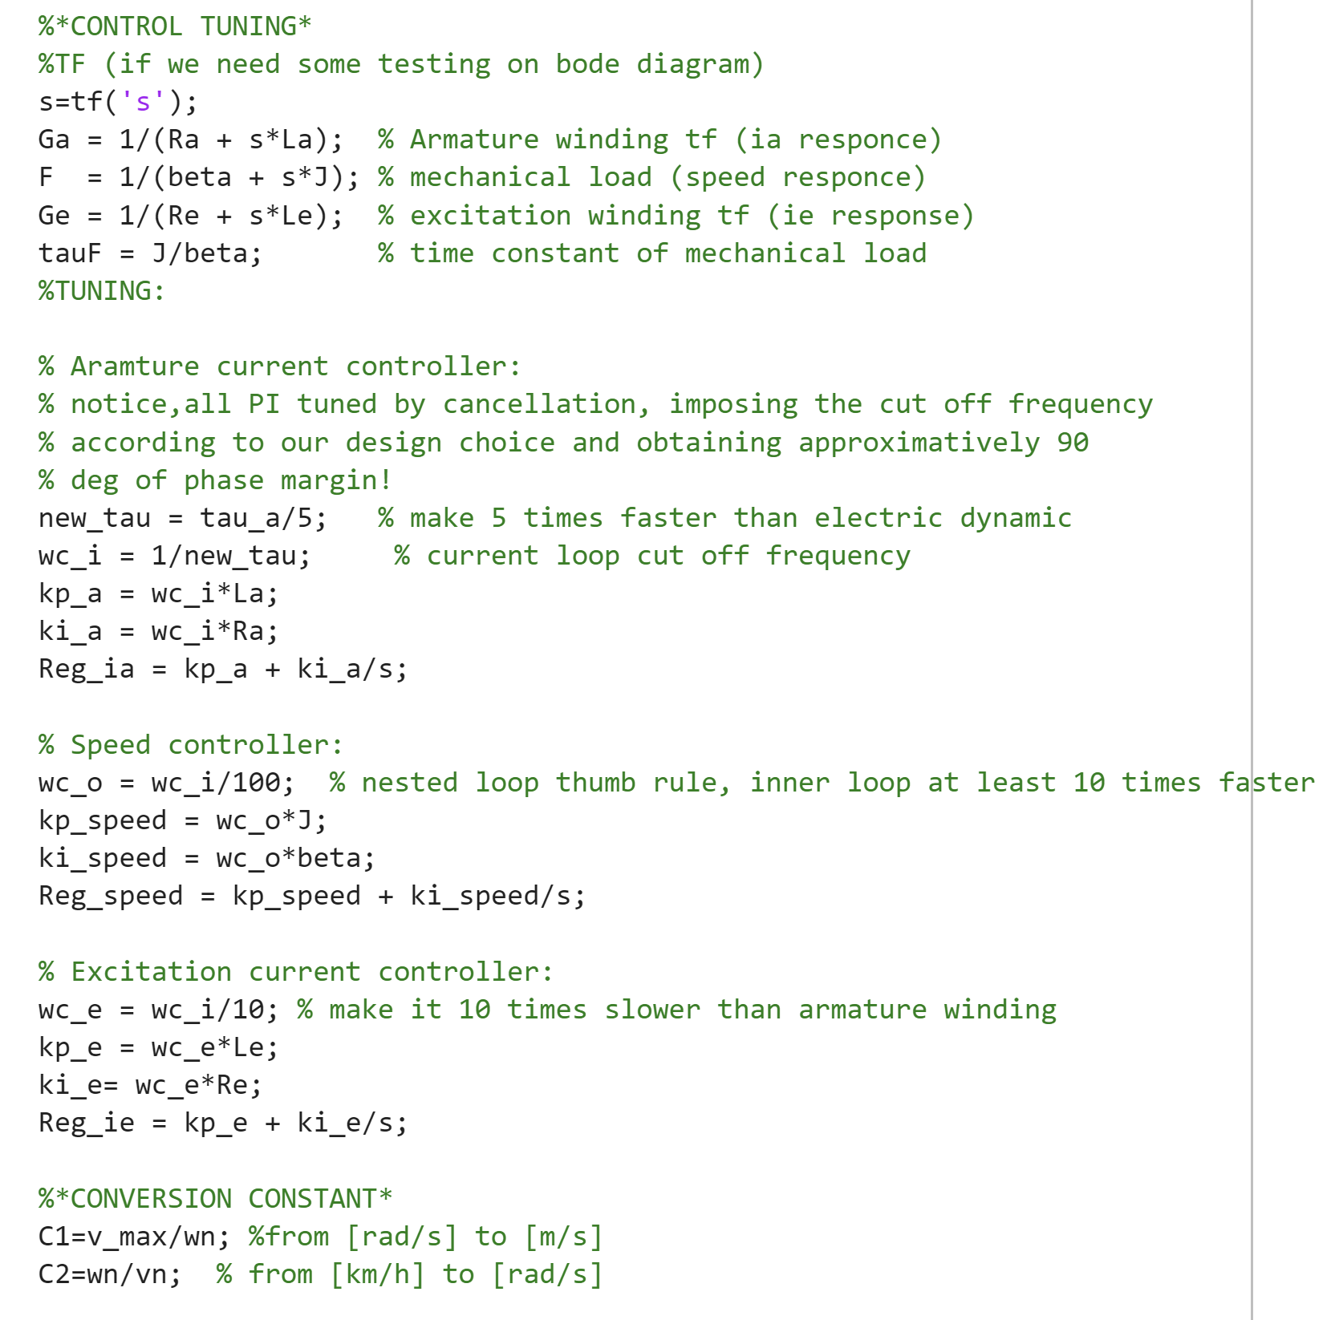

Useful later on for the Simulink scheme.
C1 to go from Force to Torque while C2 to convert from linear to angular speed
SOME COMMENTS ON THE TUNING RESULTS:

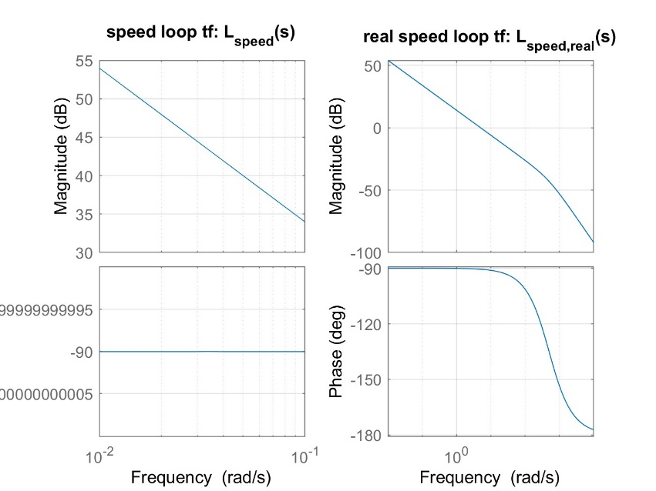

Comparing the resultant speed loop transfer function (used to check performance):

Approximated) with inner loop considered as unitary gain
L_speed = F*Reg_speed;

“Real”) including the inner loop
L_speed_real = F*Reg_speed*(L_ia/(1+L_ia));

As we can see, in the bandwidth of our interest for the mechanical world (we set up an wc_o = 5Hz) the real one behaves like the approximated one.

Checking the resultant loop transfer function obtained by the current controllers, the performance are as we expected

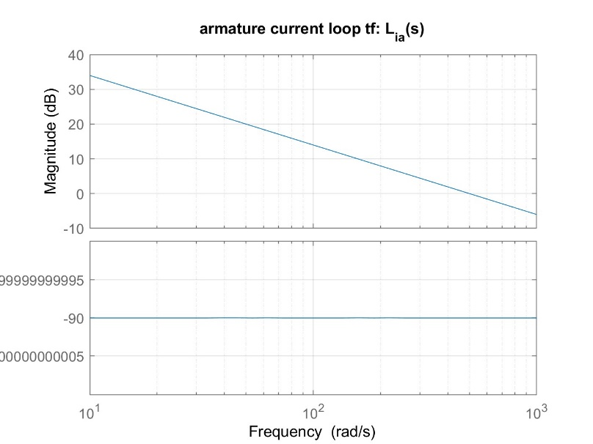
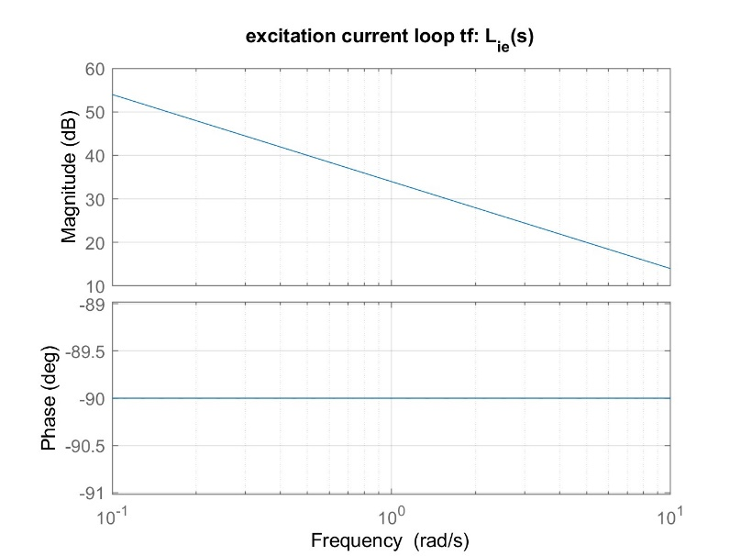
Now that we have all the necessary parameters in terms of system model and controllers, we can finally implement the Simulink scheme to simulate our result!
SIMULINK SCHEME IMPLEMENTATION
First, the overall scheme is :

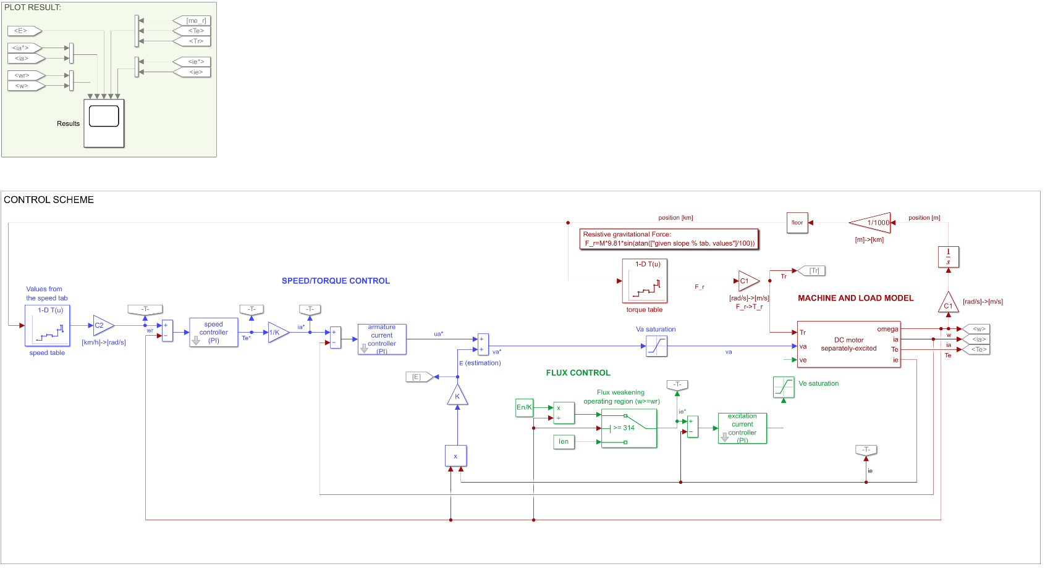

Now Let's zoom in on the most interesting blocks:
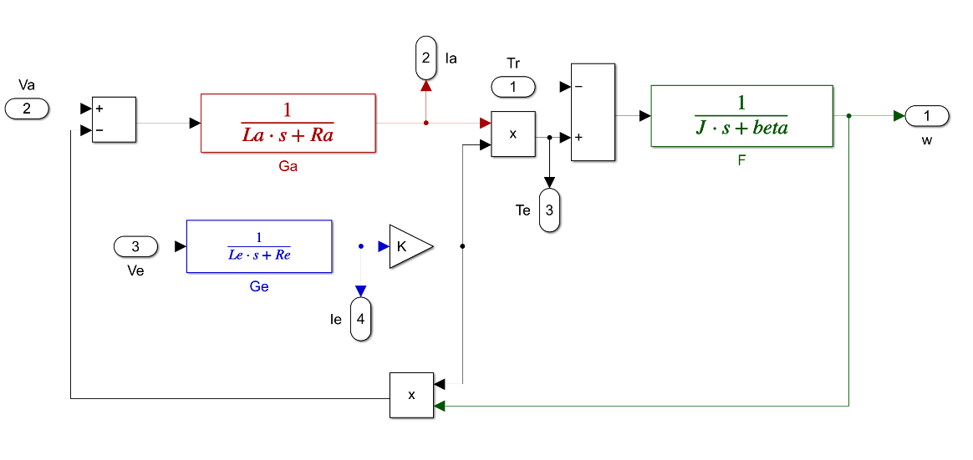
SYSTEM AND LOAD MODEL:

Laplace domain of the dynamical model of the system, including the Resistive torque (acting as a disturbance to compensate) and the mechanical load model

Where the resistive torque is purely resistive and it is given by the resistive force multiplied by a proper scaling factor (C1):

Fr = M*9.81*sin(theta) is the only resistive force, found as force parallel to the ground due to the overall weight of the tram, where the values of theta is taken from the slope of the current track, properly identified by speed integration.
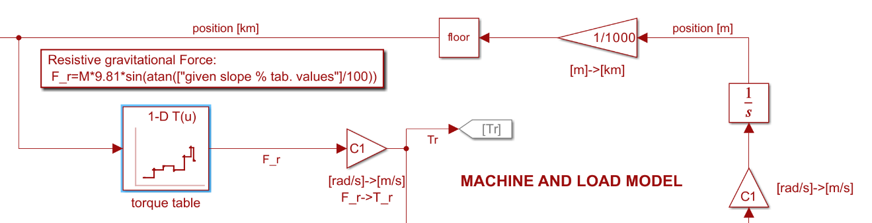
(Resistive torque computation)

PI CONTROLLERS: ANTI-WINDUP AND SATURATIONS
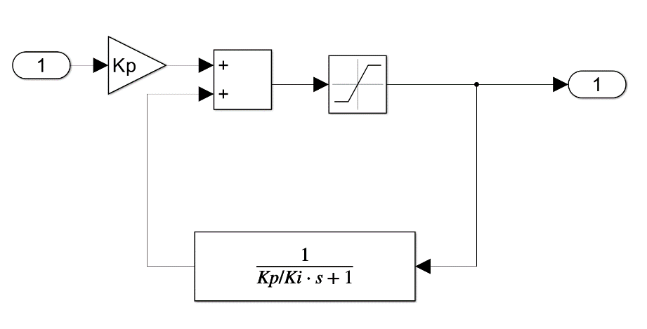
Each PI regulator internally is made with an anti-windup strategy (using the control parameters found) where the SATURATION block is limited on the control variable limits, for example:
Reg_ia acts on ua, which is limited in between [-(Vn-En);Vn-En]

And we also need to add additional saturation to model the Power Supply limitations in for Ve and Va.

EXCITATION CONTORL, FLUX WEAKENING AND OPERATING REGIONS:
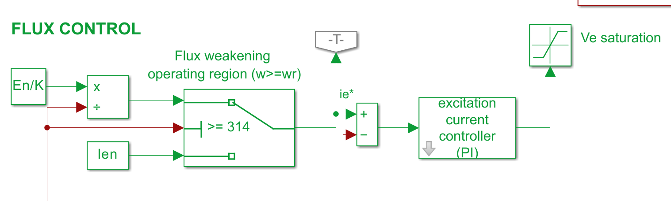

Ie
w

As discussed before, we need to manage the possibility to have a speed request higher than the rated one (in our case coincide with the base speed, because we compute the parameters in such a way that Vamax coincide with Van).
We identify the working region with a simple condition based selector, which decide between

$\left\{\begin{aligned}Ie=Ie_{n} w<w_{n} \\ Ie=\frac{E_{n}}{K*w} w>w_{n}\end{aligned}\right.$
Ψae(ie) = ie (linearized below rated value)

RESULTS OF SIMULATION
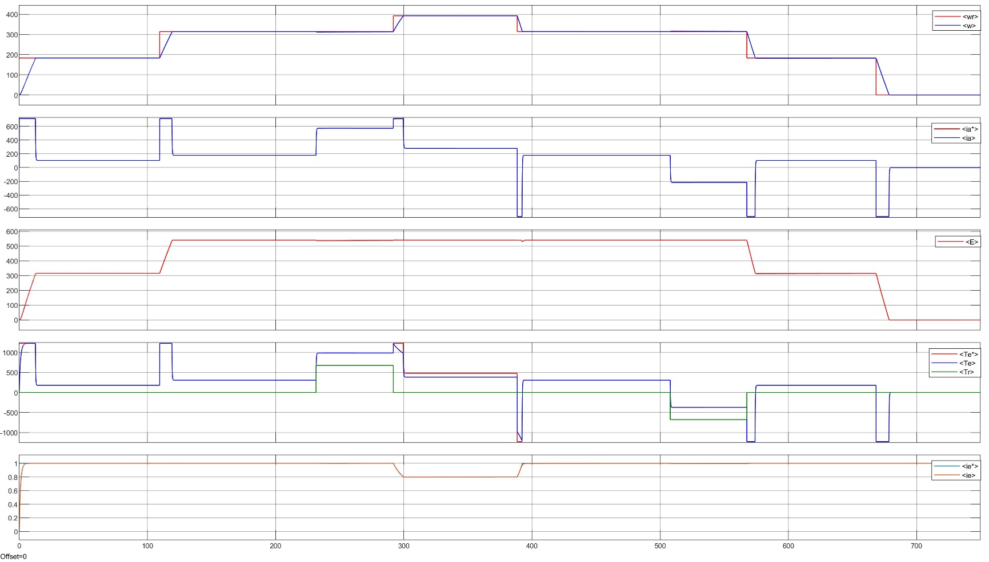

From a first check the results seems very good!
We can make some comments on this final results:

- SPEED
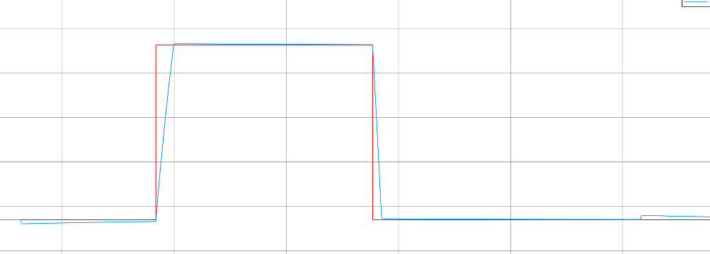
we can see a good tracking (with some delay due to the real mechanical dynamic modelled, so a real slope on the signal instead of a step)

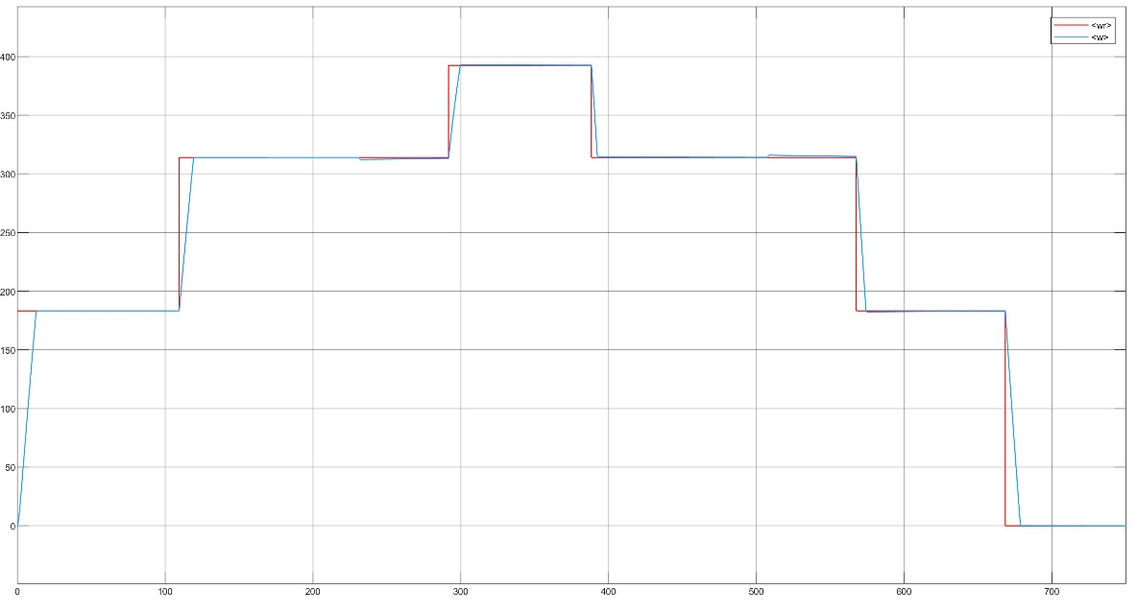
the only “Strange” behaviors appear on this points where we zoom in, where we can perceive some overshoot which are obvious due to the slope change, so the resistive torque disturbance, that we kill rapidly

- EXCITATION CURRENT
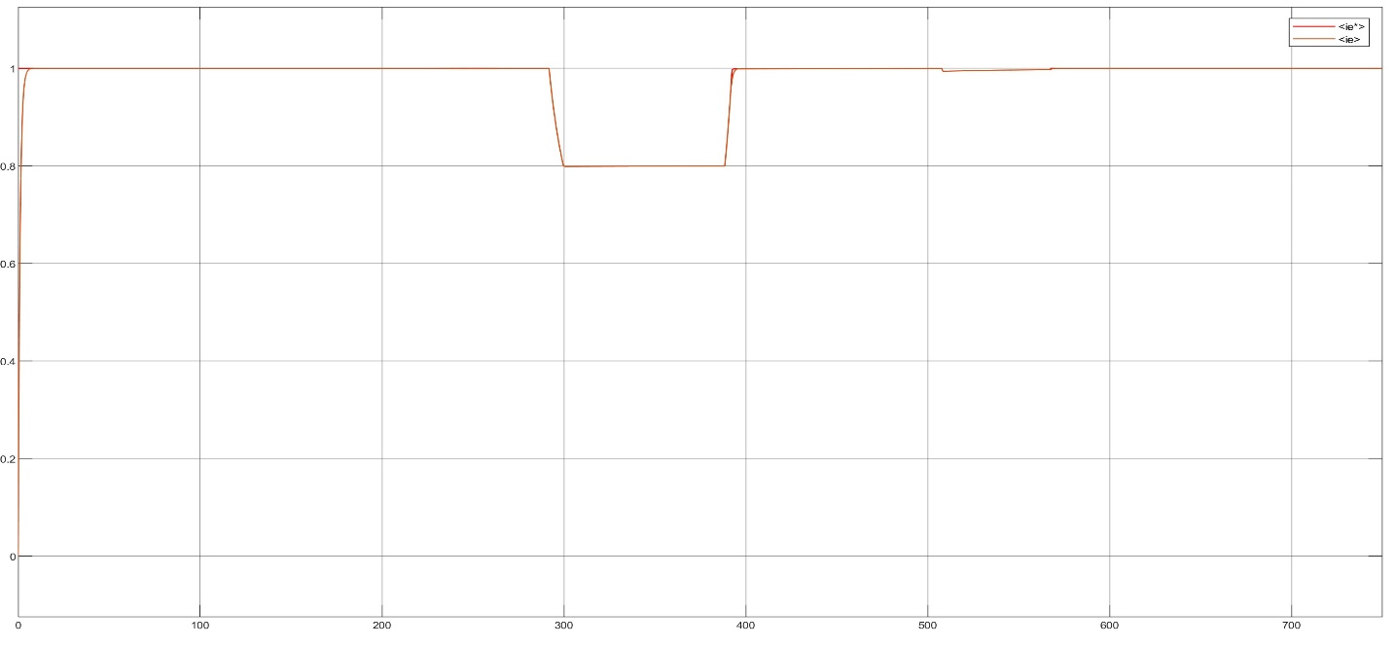

Perfect tracking, is interesting to notice the time interval where ie decreases, corresponding to the 4-6 km track on which we ask for speed higher than the rated one, and so we work on flux weakening region.
Plus some small disturbance on the time instant where suddenly the slope change, affecting the system.

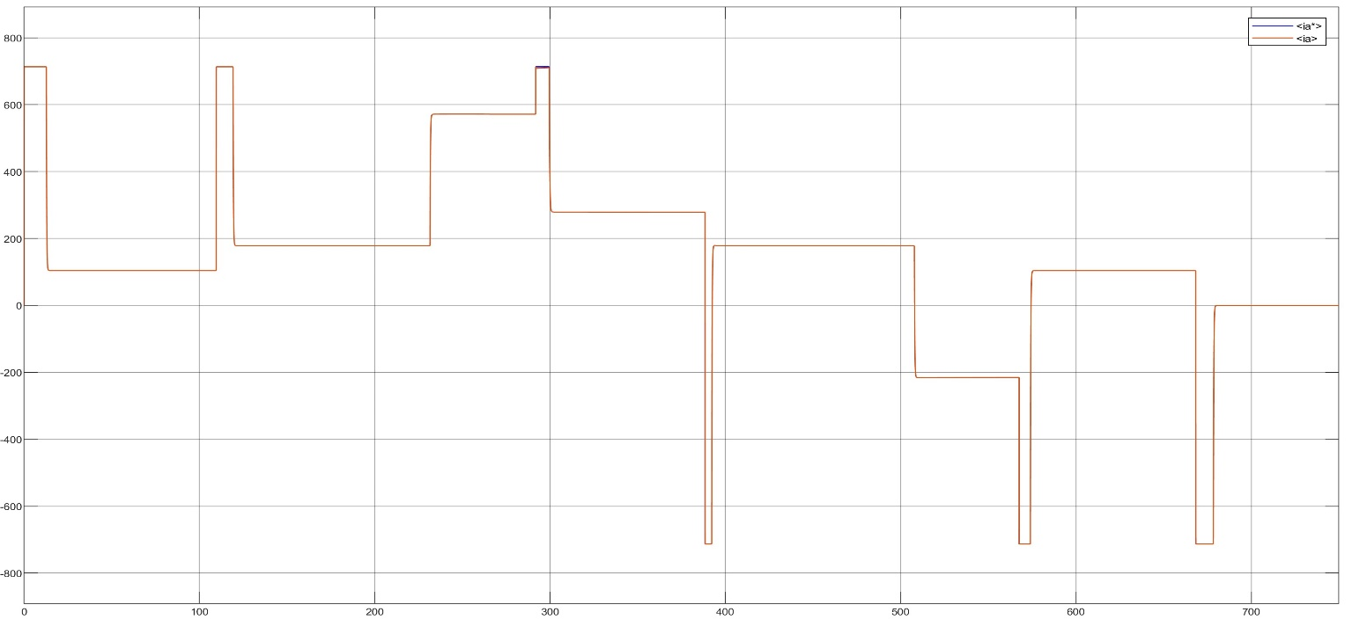
- ARMATURE CURRENT
Again perfect tracking, and we can highlight that whenever we ask for an higher speed, the system accelerate (increase the torque) by applying max current (rated one). And drops negative when we need to decrease rapidly the torque (decelerate)
- TORQUE
This match the armature current behavior as discussed before. Negative when we need to decelerate. We can notice a torque pick suddenly after the resistive torque goes to 0, that’s because all our effort, that was also to compensate the slope, for a small time acts without that resistive additional disturbance.

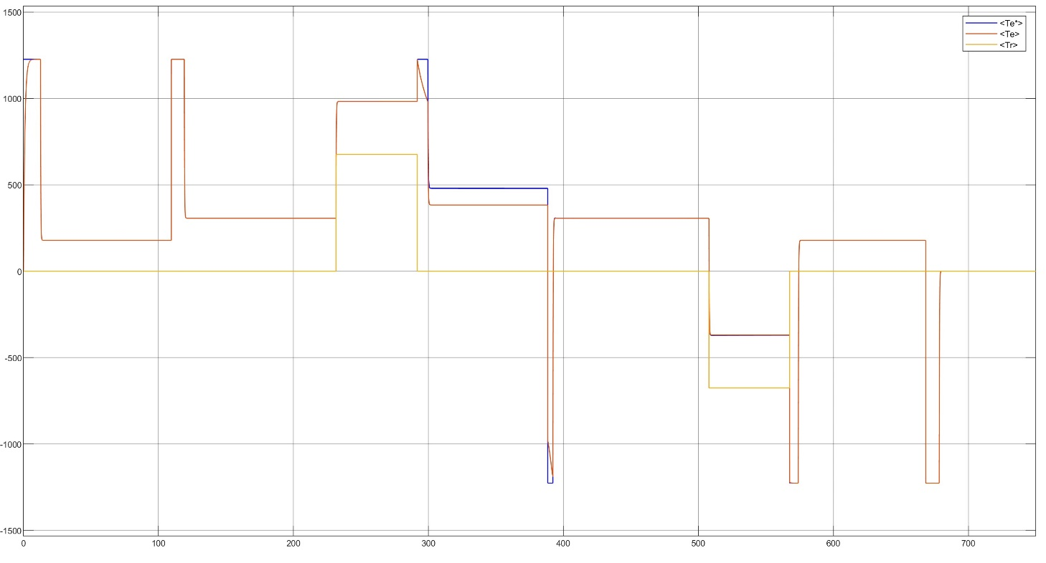

- ELECTROMOTIVE FORCE

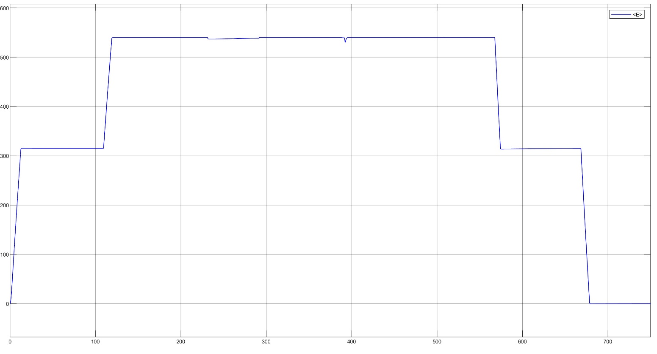
Directly proportional to the speed as modelled, and with some oscillations around the flux weakening region working range, where we try to maintain E constant even if at speed higher than the rated one.

