DMS 2022/23 YEARWORK PUGLISI ALESSANDRO
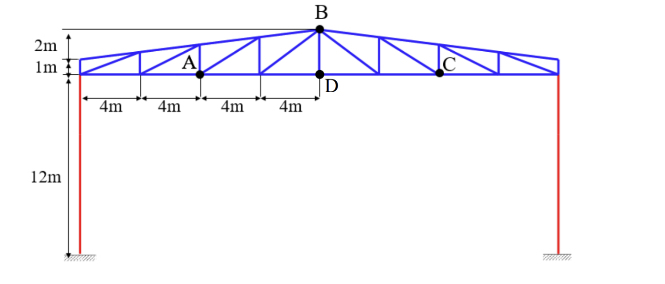
Consider the structure shown above, representing a hangar portal frame. All beams are made of steel (E=2.06e11 N/m2 , ρ=7800 kg/m3 ). Beams in blue color have IPE240 cross section (A=3.912e-3 m2 , Iy=3.892e5 m4 ) and beams in red color have IPE500 cross section (A=0.01155 m2 , Iy =4.82e-4 m4 ). Damping is defined according to the proportional damping assumption: [C]=α[M]+β[K], with α=0.2 s -1 and β=8.0e-5 s.
QUESTION 1) Define a FE model of the structure in the 0-20 Hz frequency range. Print the undeformed structure:
To define the FE model we need to identify all the nodes and beams (our FE accordingly to nodes) of the model. Respecting the assumption to work on quasi static region, which constrain the max length of the beam, respect our max frequency of analysis (20Hz). In particular we want to be on a working case such that
Ω_{max} >> w_{min,j} from this, taking our assumption of minimum natural frequency the bending one of each beam of type j and setting a safety factor of c=2, we obtain the final result (respect the two type of brams):
ω_{min}=c*2*π*f_{max} = 251.3274 rad/s $L_{max,j}= \sqrt{\frac{π^{2}}{w_{min}}\sqrt{\frac{{EI}_{j}}{m_{j}}}}$
taking the mass value of the beam type from the profile table m_240=30.7 kg/m, m_500=90.7 kg/m we obtain: type IPE240) L_{max} = 4.479 m
type IPE500) L_{max} = 6.41 m
After this, from a simple geometrical analysis of the structure and deciding the reference frame, we should define the coordinates of each node and identify the beams, writing correctly in a “.inp” file all our FE features
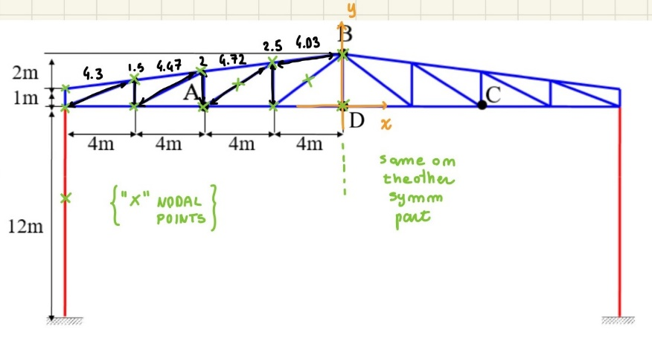
FE MODEL OF THE STRUCTURE
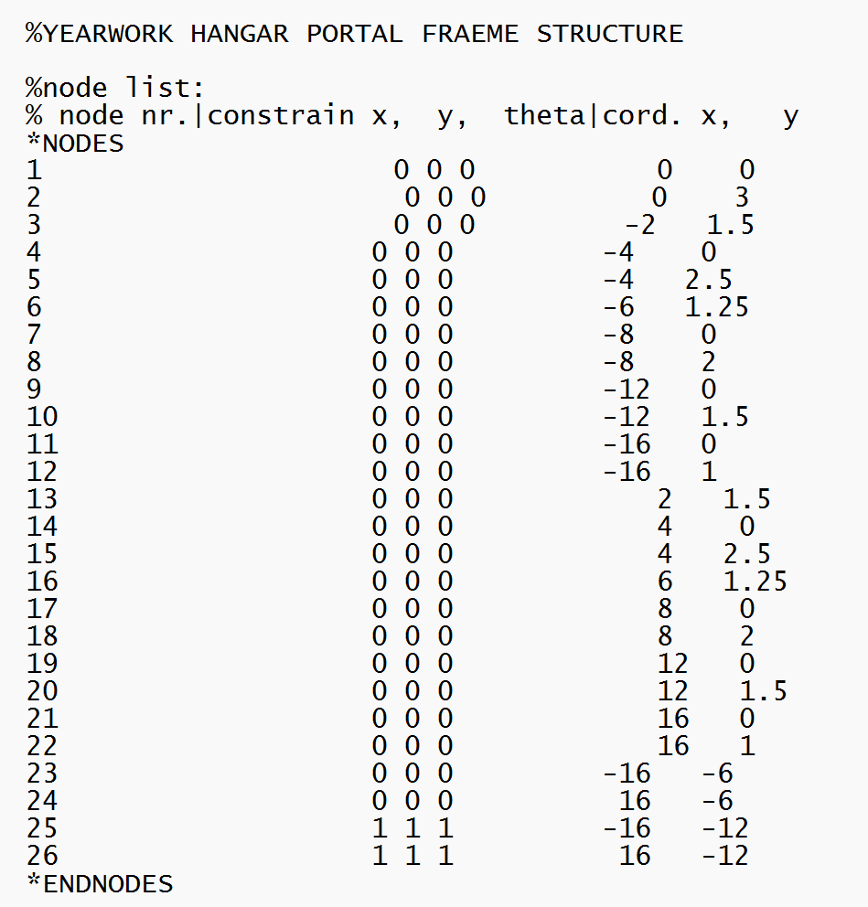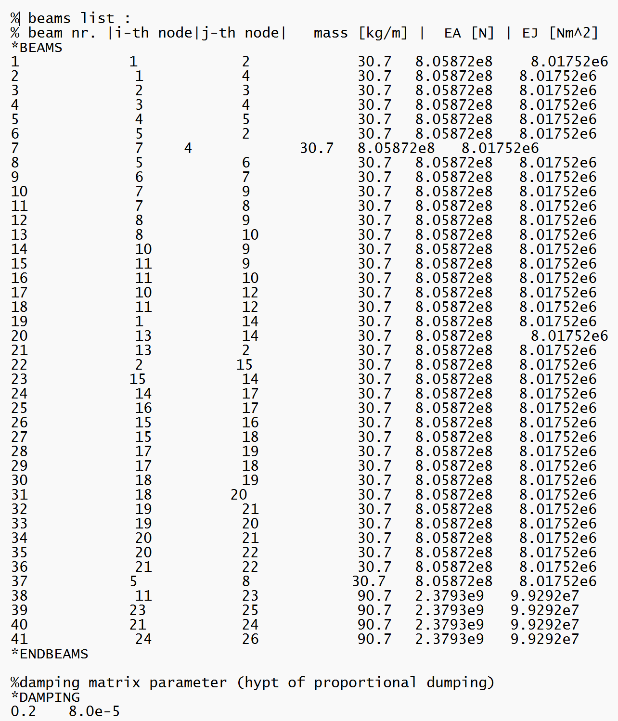
Using the syntax required by the Matlab software for the FEM solution. I properly define nodes, beams and dumping parameters of the system into the proper section, identified by its keyword.
This allows the solution of the first question directly using the menu of the program user interface.
(also points 2 and 3 will be solved directly thanks to the use of this FEM software implemented on matlab).

UNDEFORMED STRUCTURE
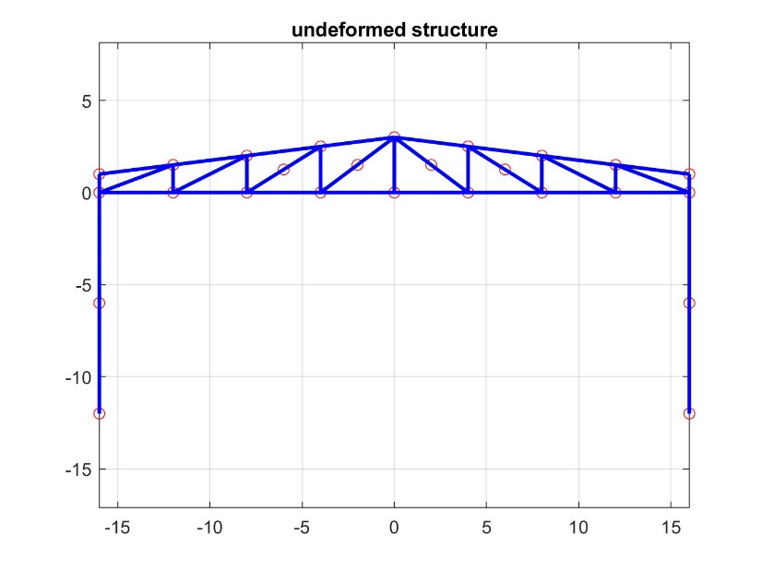
QUESTION 2) Compute and print the first 4 natural frequencies of the structure and their modal shapes.
Directly from Matlab FEM software we can compute the modal shapes, and so the corresponding natural frequencies (here highlighted).
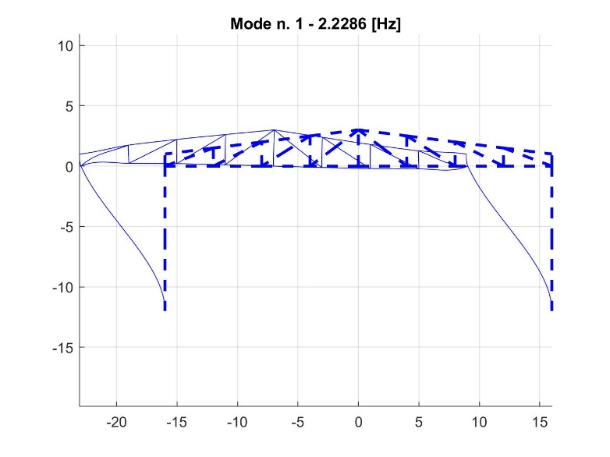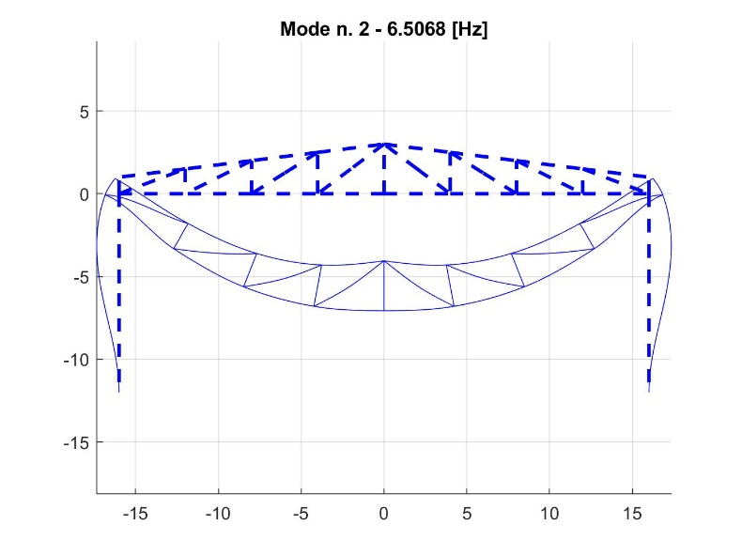
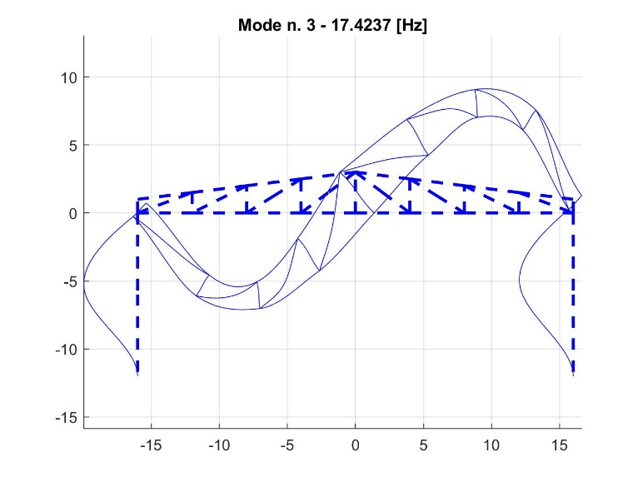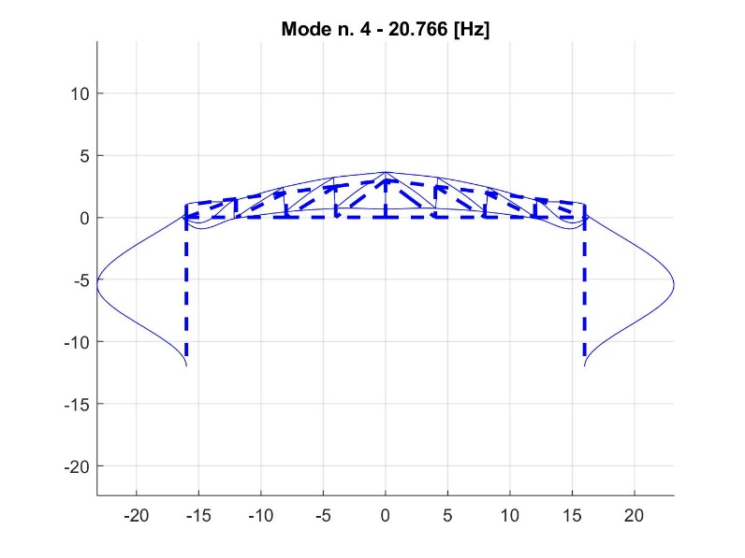
(even if the forth natural frequencies is out of the range of validity of our model, because it is out by a small amount we can still consider valid the result)

QUESTION 3) Compute and print the Bode diagrams of the frequency response functions for a unit input force applied at point A in vertical direction considering as output the horizontal and vertical displacements of point B. Compute and print the Bode diagrams (in linear scale) of the frequency response functions for the same input force considering as outputs the horizontal and vertical acceleration of point B.
With the correct node and direction inputs on the program we can easily obtain these results. Notice that even if the suggestion are to use a frequency range of [0:0.01:20] I consider a range up to 25Hz to include also the possible nodal resonance respect forth natural frequency (near 20Hz).

FRF of horizontal displacement of point B respect vertical force applied on point A:

FRF of vertical displacement of point B respect vertical force applied on point A:

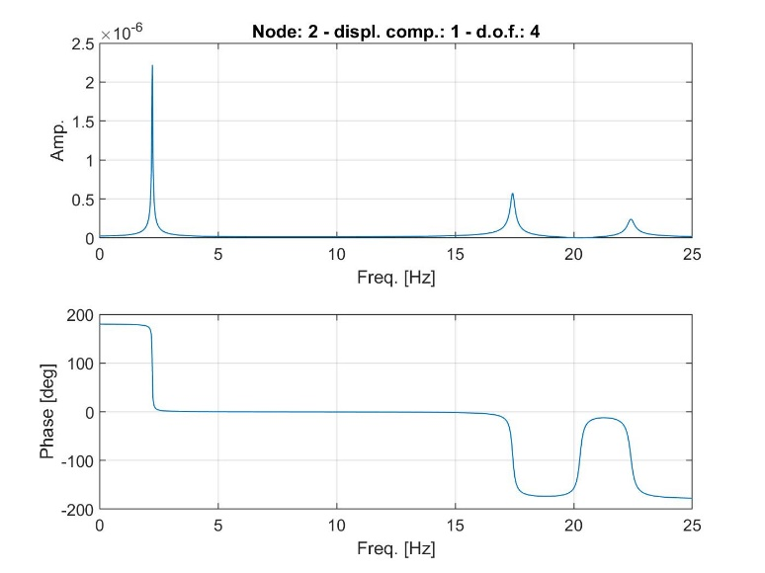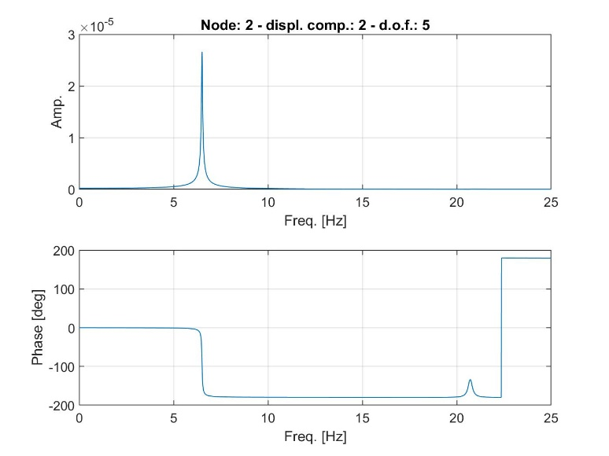
FRF of vertical acceleration of point B respect vertical force applied on point A:

FRF of horizontal acceleration of point B respect vertical force applied on point A:

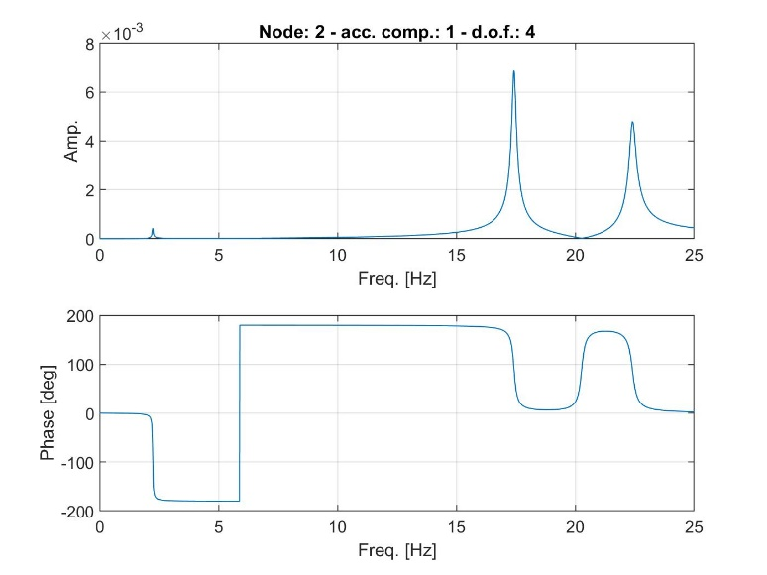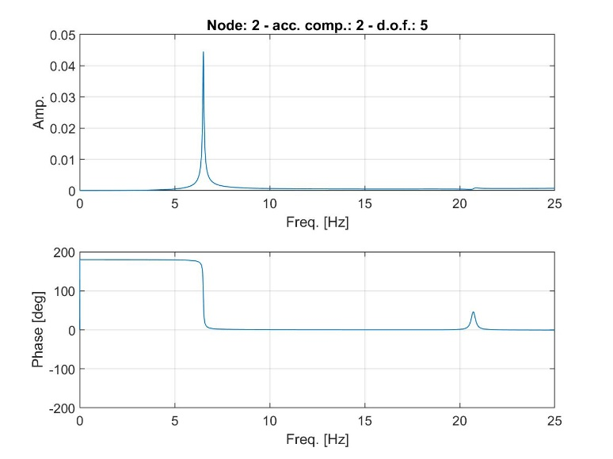

QUESTION 4) Compute and print the Bode diagrams of the frequency response functions for a unit horizontal displacement applied in phase at the base of both pillars, considering as output the horizontal reaction force and clamping moment in the clamp of the left pillar.
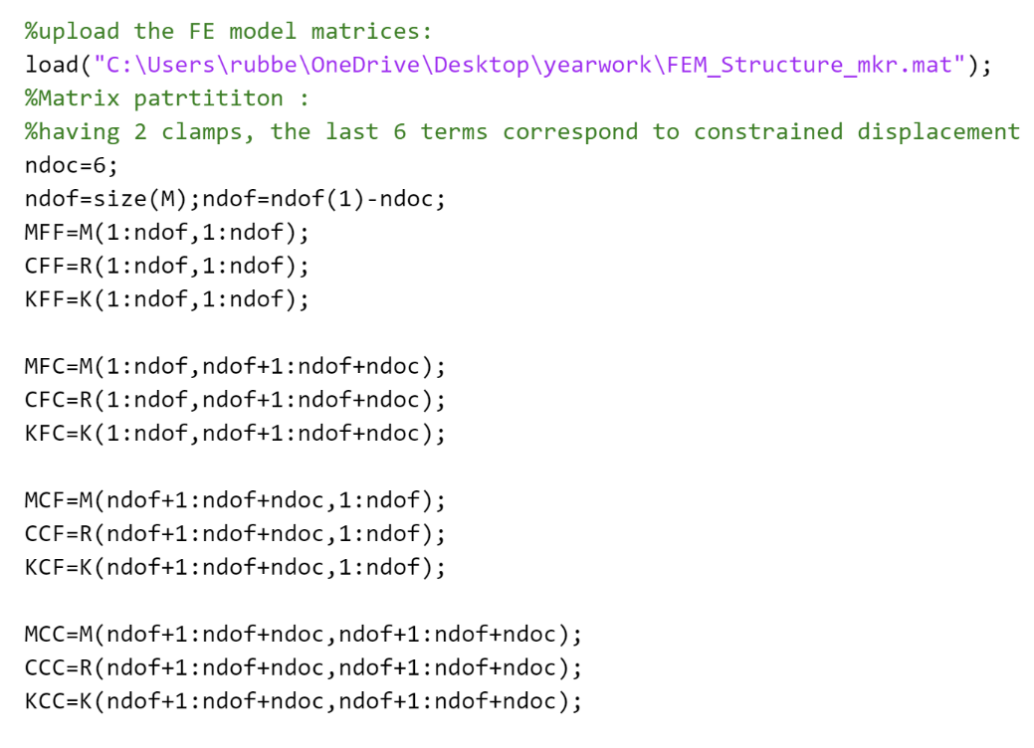
From now on the FEM software don’t provide us a direct solution for this and the next questions. So we have to extract from the FE model the Matrices: M, R (corresponding to C), K and also idb (that can be useful for matrix partition). Partition it correctly respect constrained and free nodal coordinates and according to this solve the problem as a classical multi DOF system (final step of modal approach).

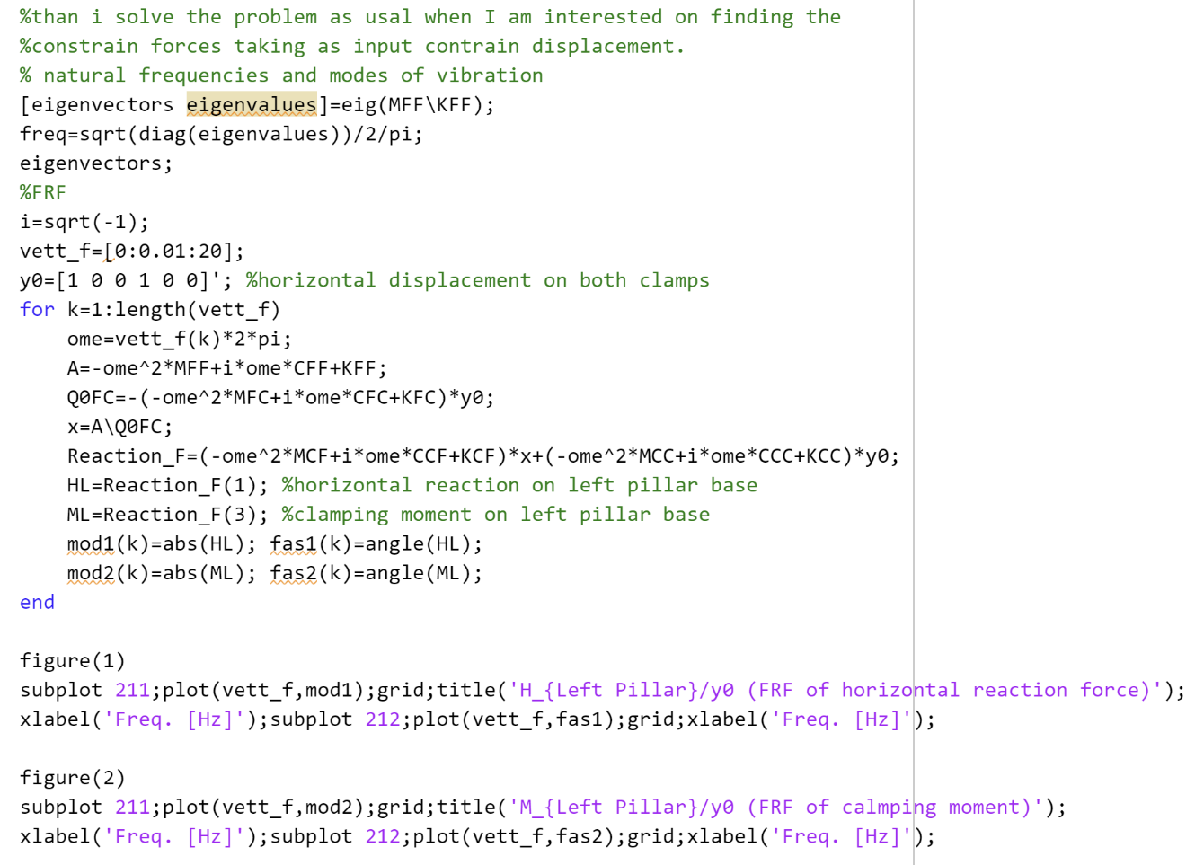
NOTE for QUESTION 7: remind the result of the clamping moment amplitude cause it will be useful to check for the next request.
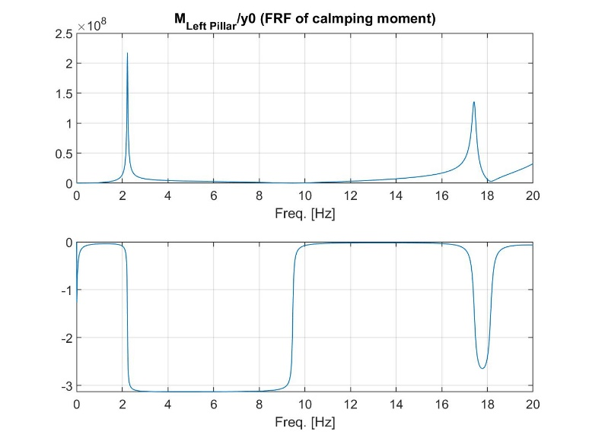
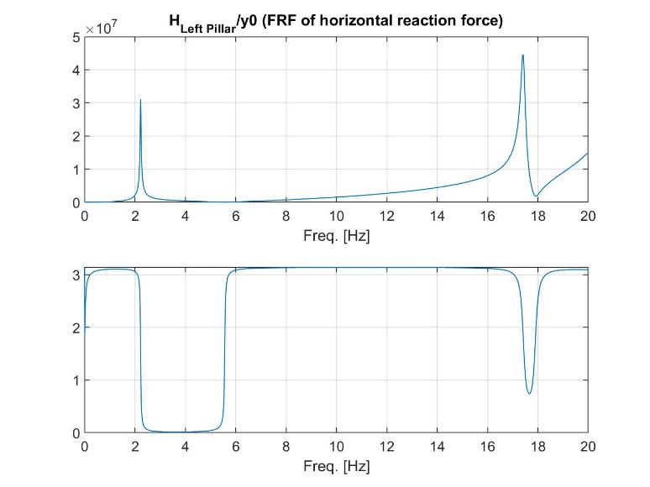
FRF of horizontal reaction force on left pillar respect horizontal displacement on both pillars’ base

FRF of clamping moment on left pillar respect horizontal displacement on both pillars’ base

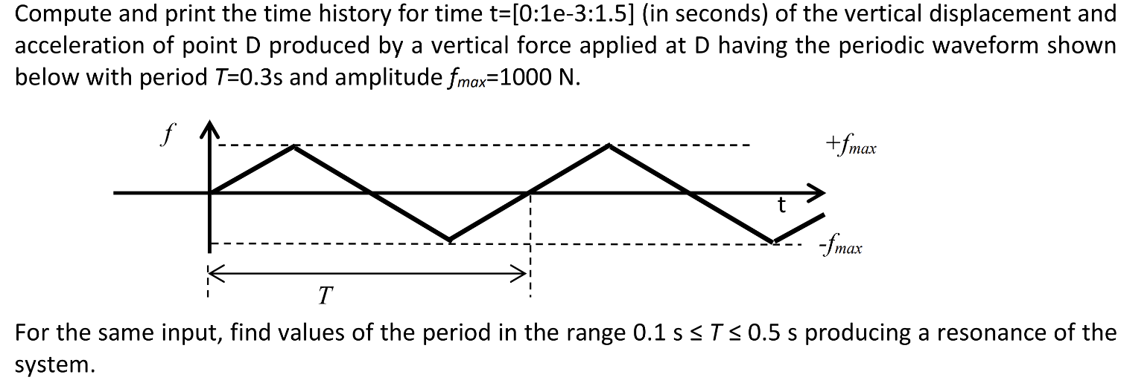
QUESTION 5)
to solve this point we should write the periodic input using Fourier series theory. We should identify the fundamental circular frequency Ω₀ and define the input as a linear combination of harmonic components, truncating the infinite series on the max frequency of our analysis. (Using properly these definitions):
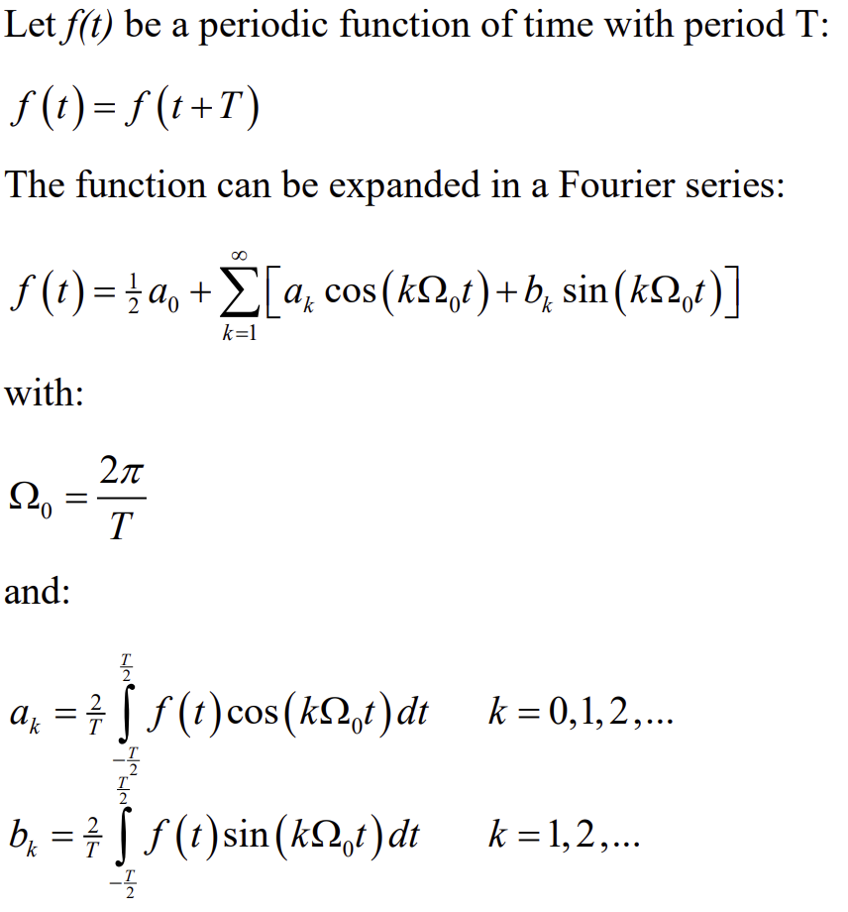
Because the periodic input force is an odd function for sure all a_{k} coefficients are 0, and because the signal is zero mean, also a₀=0, so we find only b_{k} coefficients. Then we can compute the overall response of the system using the input approximated by its truncated Fourier series, by the superimposition approach (considering the effect of each part of the series). So doing all by analytical approach:
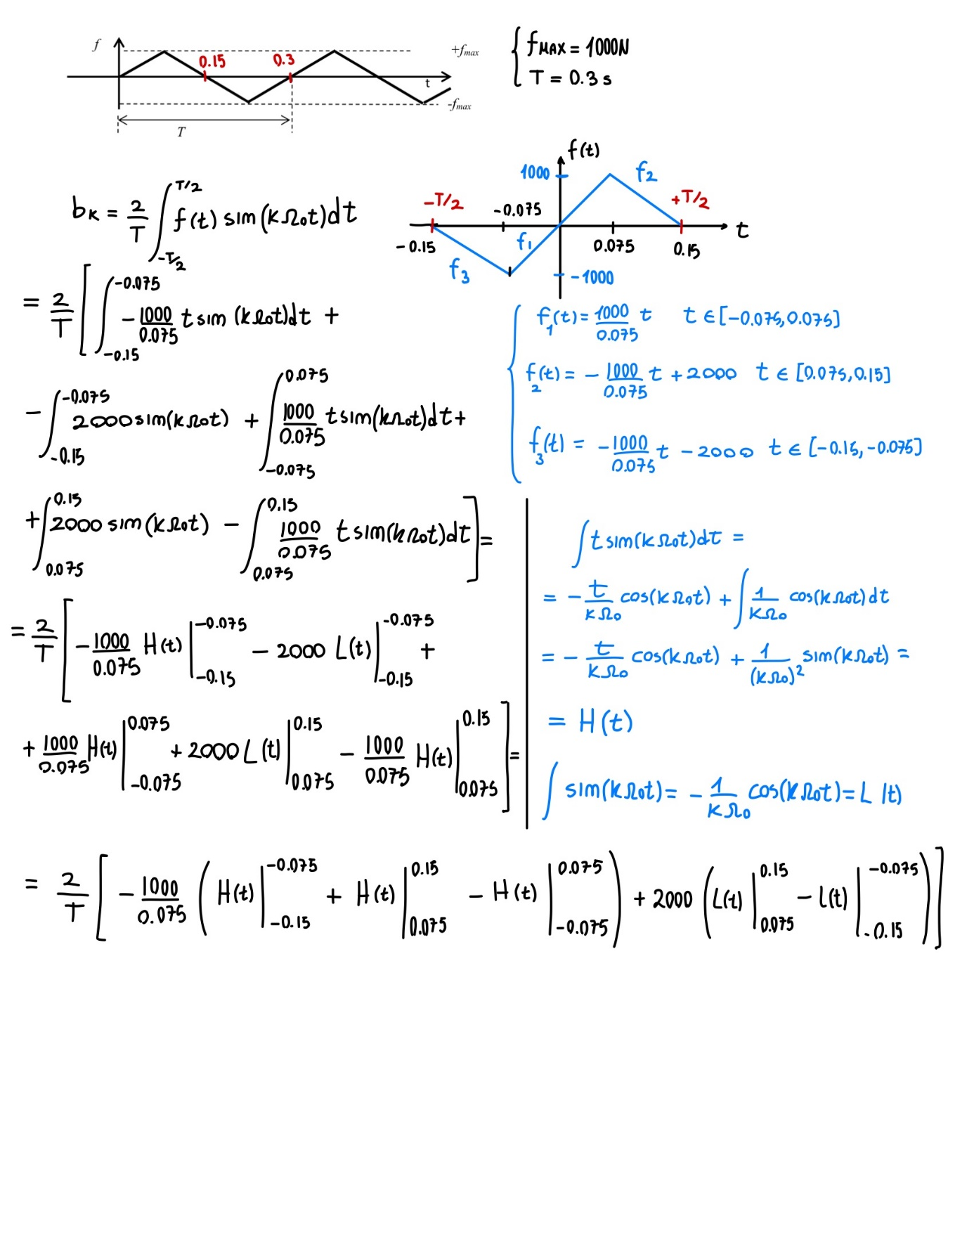
(probably there are possible mathematical simplification and other possible ‘shortcut’ to simplify this long expression)

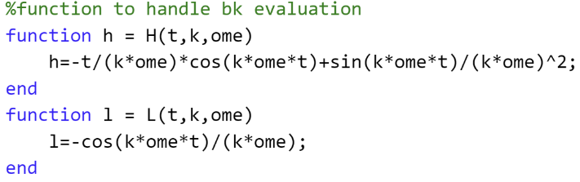
Then I can properly implement all this on matlab:
Definition of waveform by Fourier:
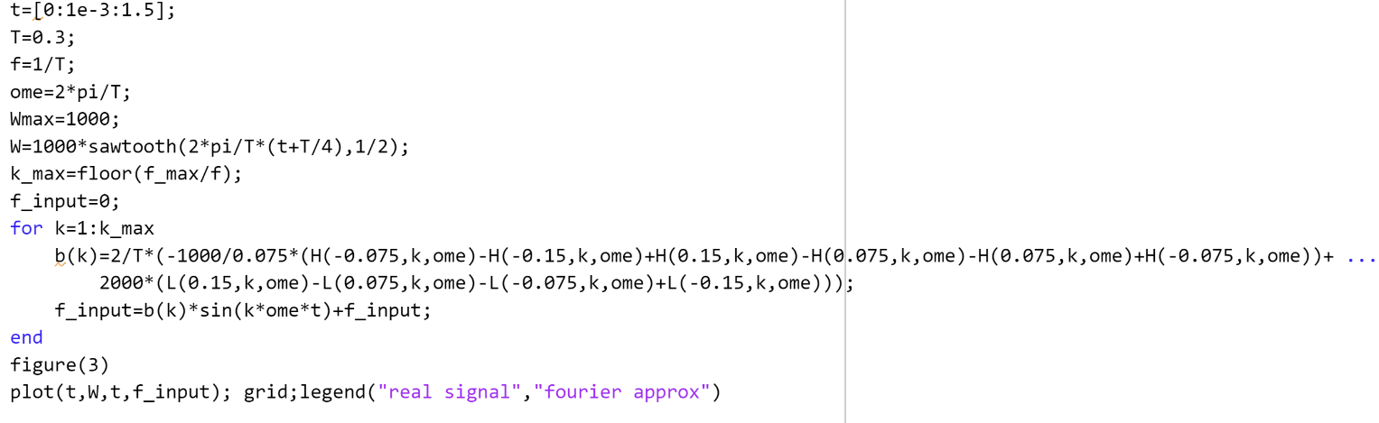
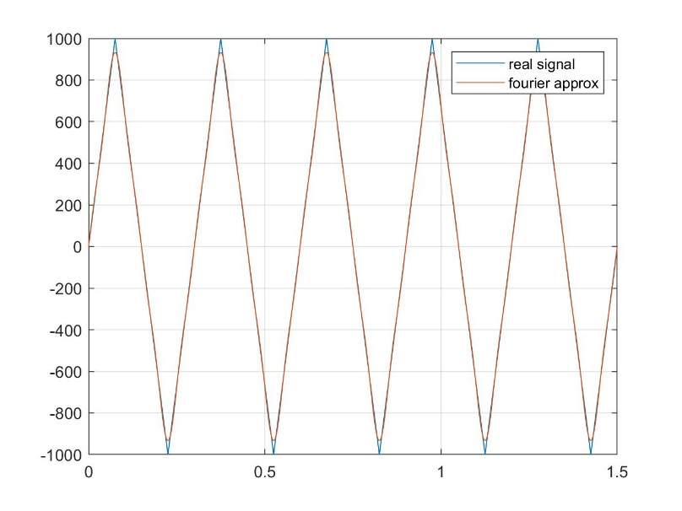
Even if we truncate the series on the 6th component they are almost equals.

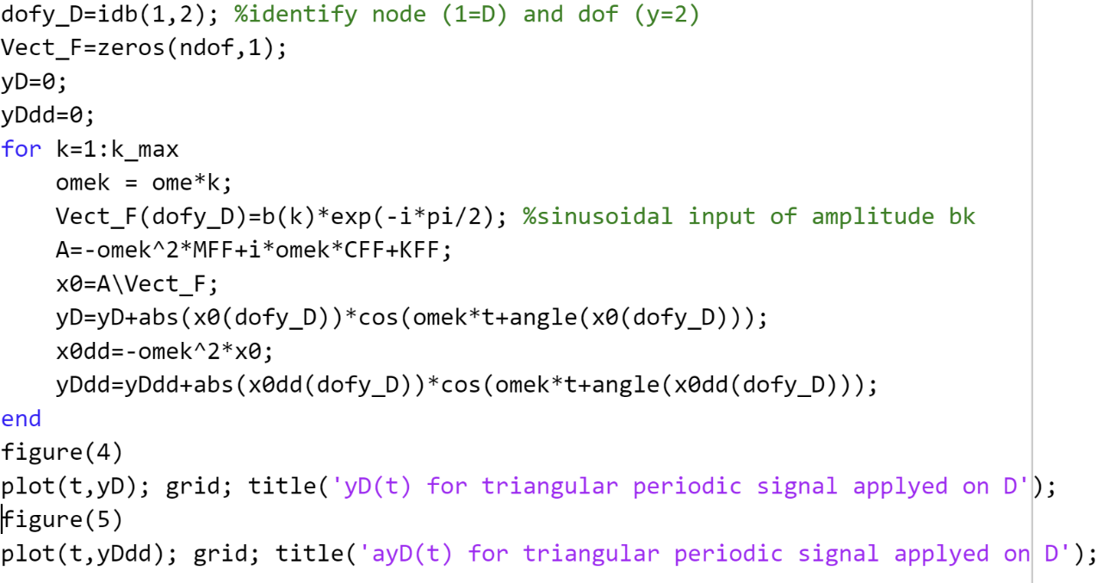
Computation of time history by superimposition of harmonic components:

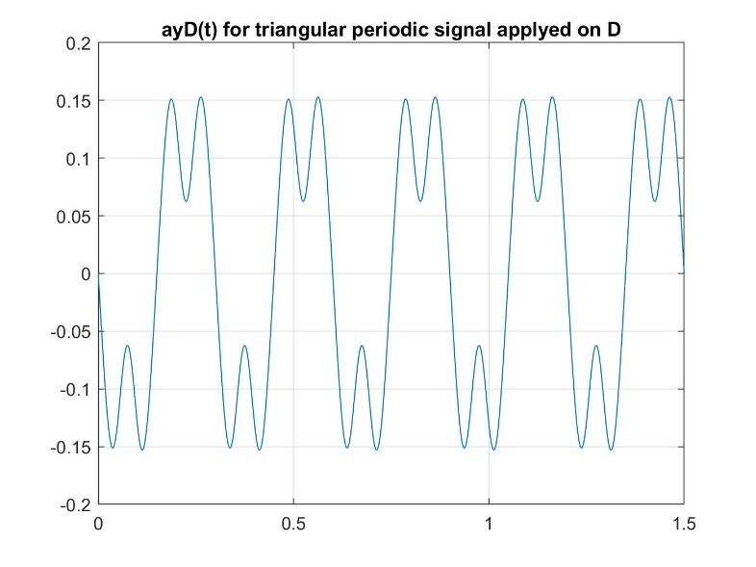
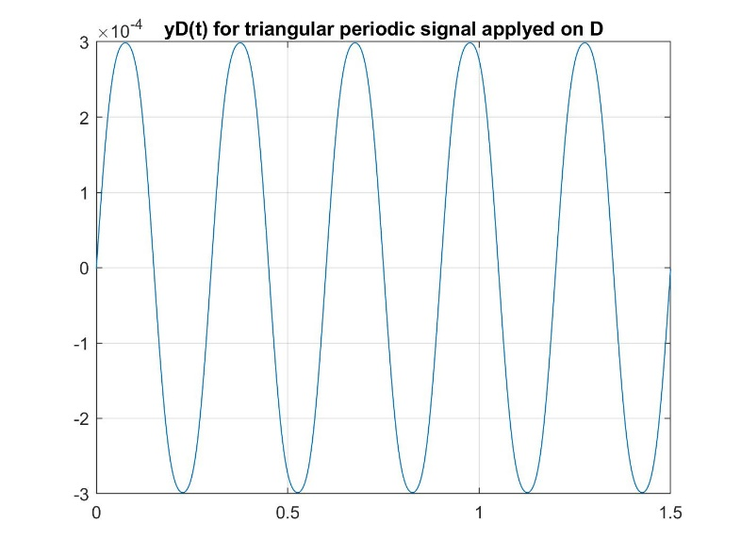
Time history of y_{D} for input waveform on D Time history of ay_{D} for input waveform on D

Period which produces resonance:
To find this problem we should consider the fact that the FRF of the system give us all information about the behavior of the system output respect a certain input frequency, so we just need to compute the FRF of vertical point D displacement respect unitary amplitude vertical force on same point (co-located FRF), and check if in the range 2÷10Hz there is a resonance pick:
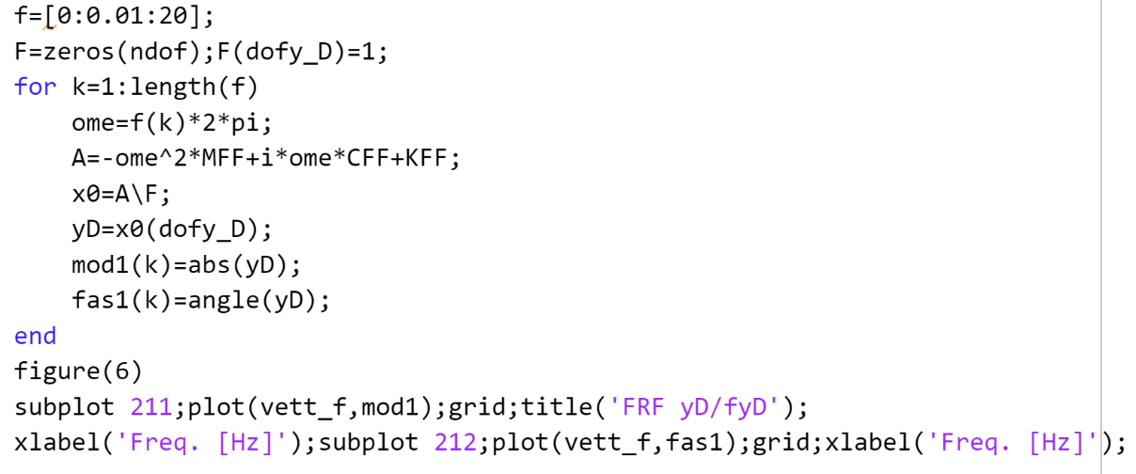
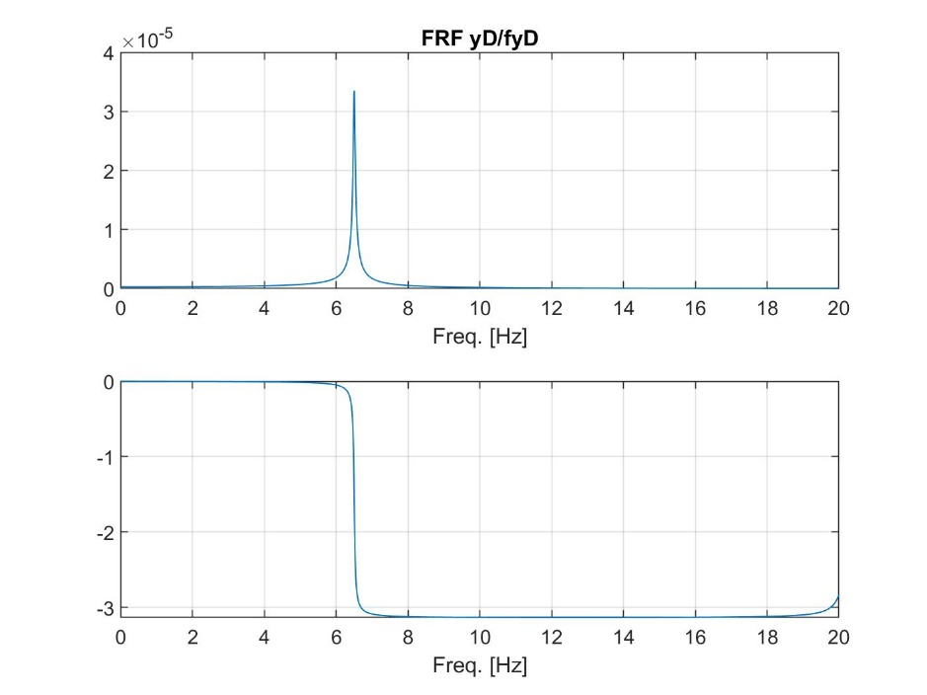
Just looking to the amplitude FRF Bode plot and zooming in we find the resonance frequency f_{res}=6.51 Hz
Corresponding to a period of T=0.154s

QUESTION 6) Plot the Bode diagrams of the horizontal and vertical acceleration of points B and C for the excitation produced by an unbalanced mass ms=5kg having eccentricity ε=5mm and rotating around point A with angular speed Ω=2πf (f=[0:0.01:20]).
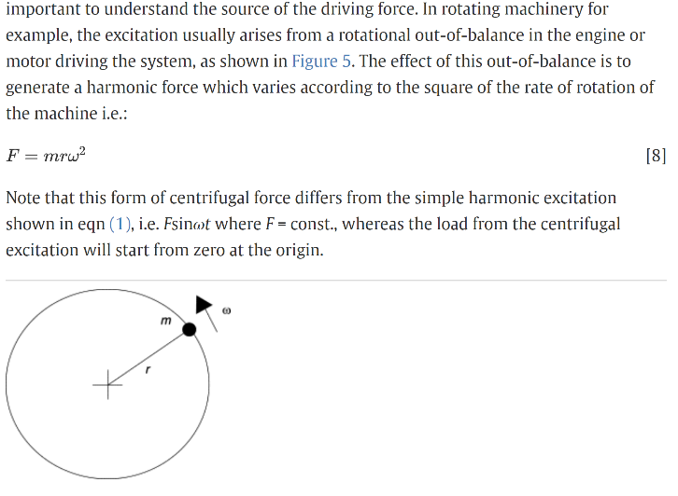
taking as reference a passage of “Encyclopedia of Vibration” we can treat the centrifugal force created by the unbalanced mass through its projection along x and y coordinates. So as two forcing effect respectively sinusoidal and cosinusoidal applied on point A.
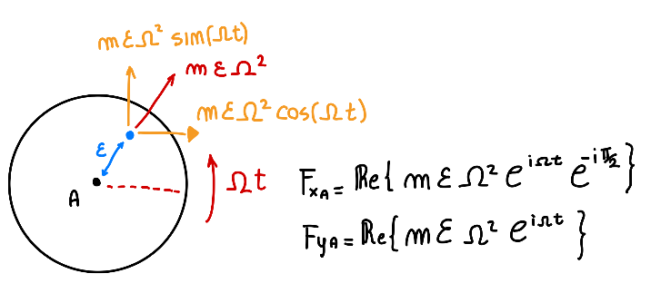
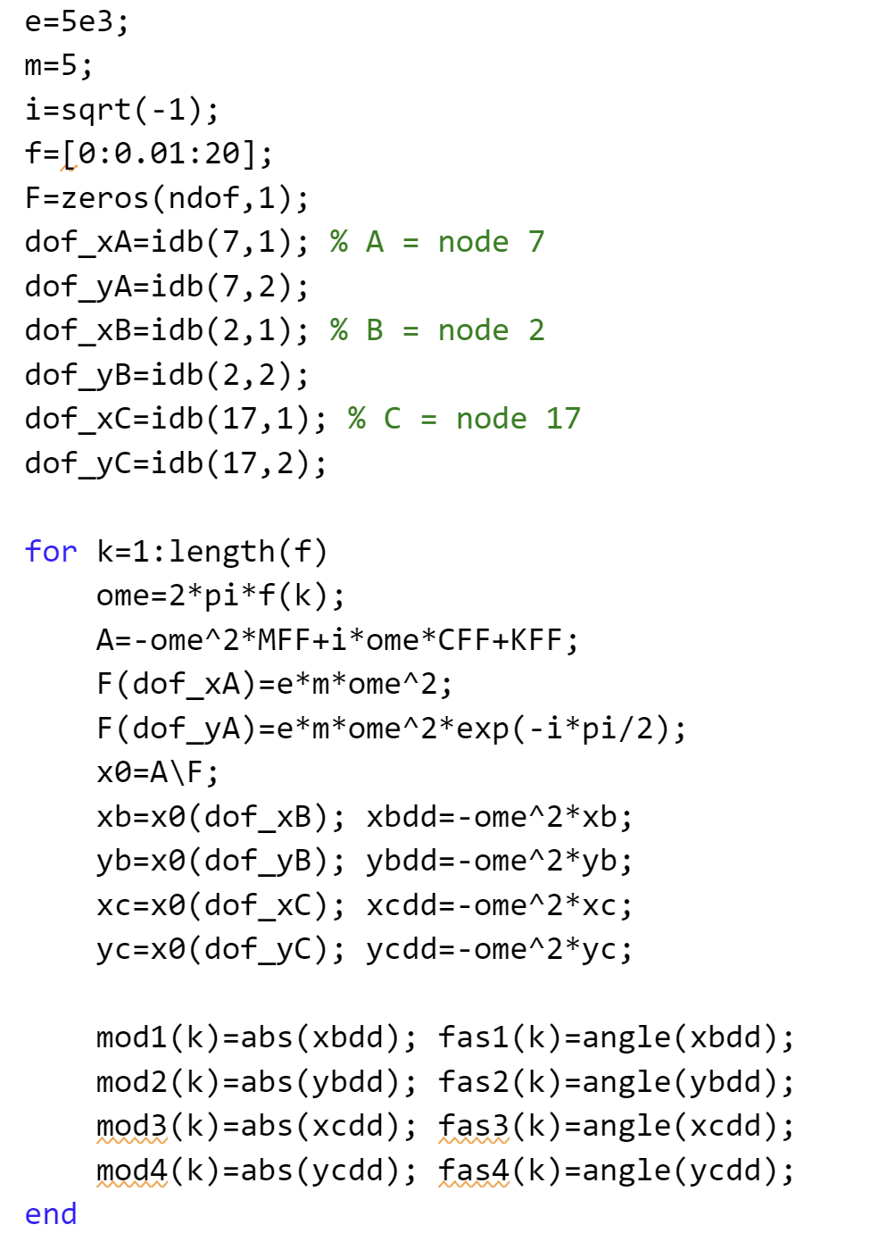
We can solve it on Matlab using the matrix of the FE Model. As usual:
FRF of the horizontal acceleration of B
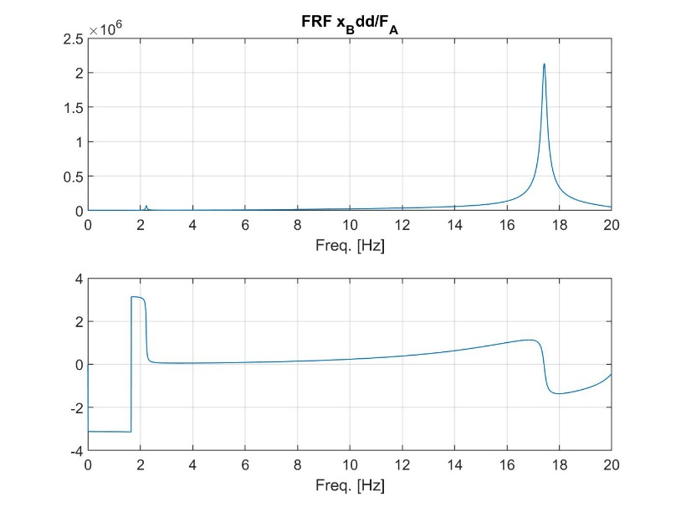
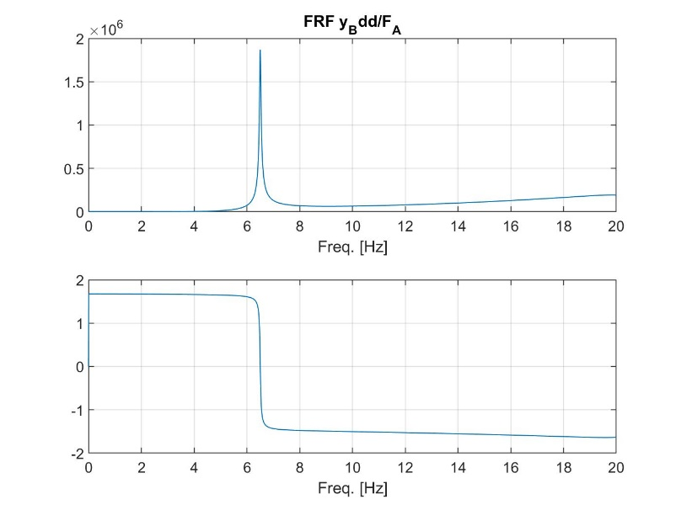
FRF of the vertical acceleration of B

FRF of the horizontal acceleration of C
FRF of the vertical acceleration of C
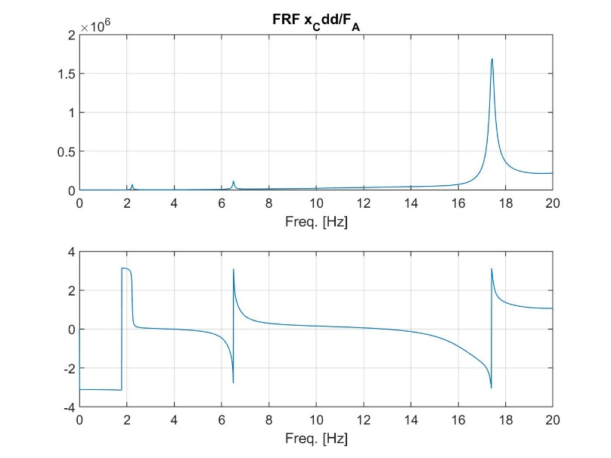
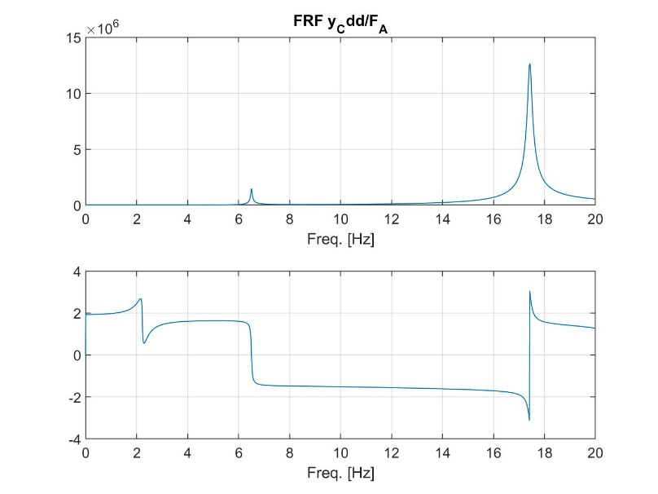

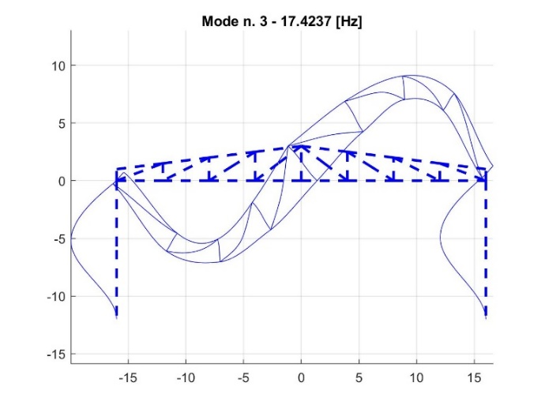
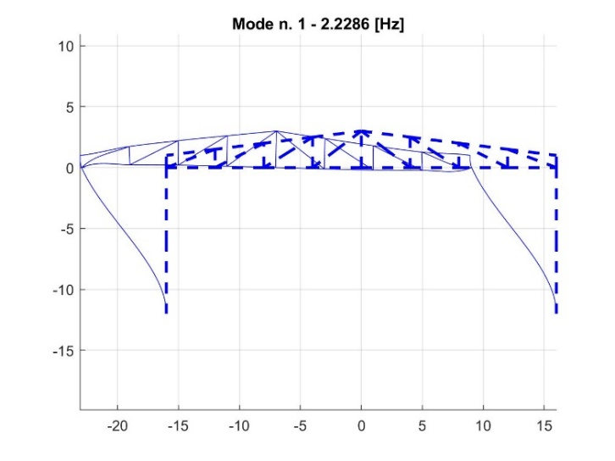
QUESTION 7) Define a modified design of the structure to reduce by a factor 2 at least (reduction to 50% of original value) the clamping moment in the clamp of the left pillar under the excitation condition described at point 4. In defining the modified design, consider the following constraints: a.) The distance between the two pillars and their height cannot be changed. The space delimited by the two pillars, the floor and the roof must remain clear to allow proper use of the hangar; b.) the increase of the structure’s total mass shall not exceed 5%; c.) no change of material properties can be used, i.e. material shall remain the same; d.) changes in the sections of the beams are possible, but a standardized section (types IPE, HPE or HPM) shall be used;

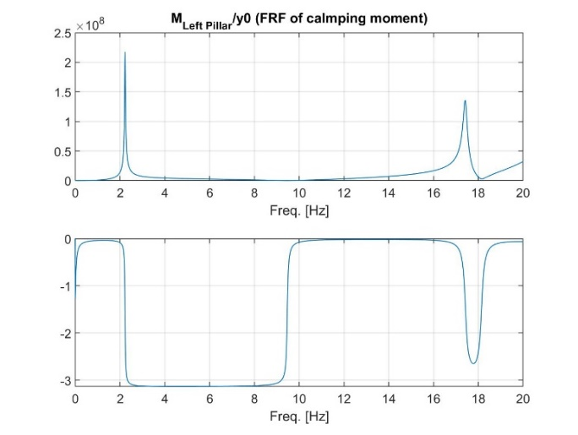
As we can see from the modal shapes and from the FRF the clamping moment is more related to these frequencies of resonance, corresponding to bending deformation of the vertical pillar, so reduce the left bending moment we can try to increase the stiffness of these pillars introducing additional supports, respecting the constrains.
To do this we just redefine the structural FE model file defined on point 1 adding the desired beams (specify new nodes and beams) and use again the code of QUESTION 4 to check if our design guarantee the request.
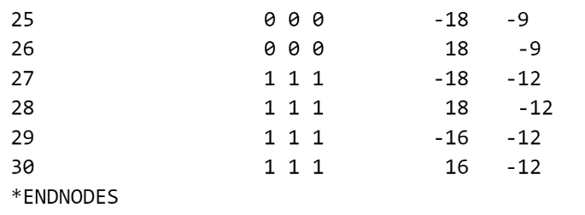
(being careful to the new dof and doc added to the model..) in fact now ndoc=12, while the rest of the code used in point 4 was already generalized to handle a design change. Except for y0=[0 0 0 0 0 0 1 0 0 1 0 0]' because now we have added 6 more constrain displacement. And we have to correctly handle also the extraction of our needed result extracting from Reaction_F the elements 7 and 9, no more 1 and 4.
Modifying the inp file as follow:

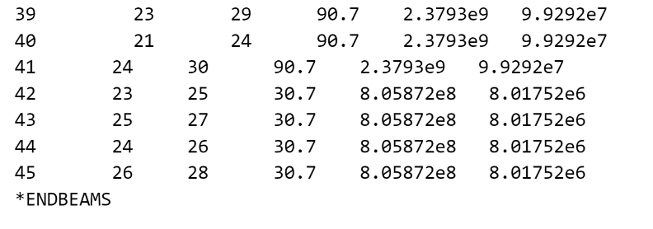

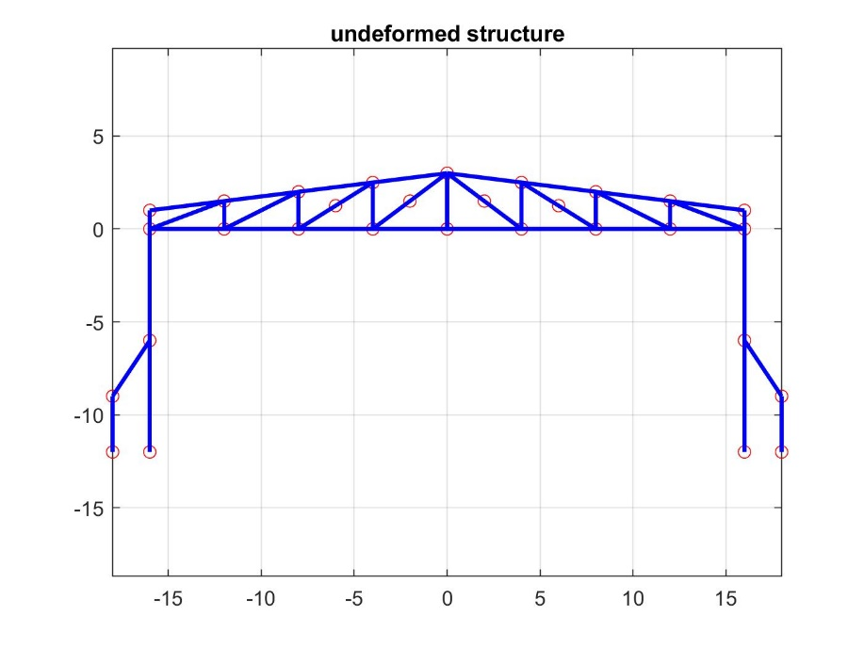
and with this new design we add an overall mass this new IPE240 beams of
New design structure
405.24 Kg
respect the initial total mass of
5.8983e03 Kg
So it increase the mass by the 6.8%, DON’T RESPECT REQUIREMENT (b) for a bit. Even if it almost delete the resonance at low frequency and reduce a lot the magnitude of the FRF as we can see from the plot
So we can try to play with its dimension to guarantee requirement (b).
With the new design I obtain the following structure (where I properly define differently the nodes and beams) which satisfy also requirement (b) increasing the mass by 296.4Kg corresponding to exactly 5% more respect initial design and obtaining an interesting high reduction of the bending moment on the left pillar
FRF of left bending moment
Definitive design structure
