**1** *CO*2 **cooling cycle**

A typical vapor-compression refrigeration system is shown in figure 1. This kind of cycle uses a circulating refrigerant that absorbs heat from a space to be cooled and rejects this heat elsewhere. This method is extensively used for air-conditioning of buildings and automobiles, domestic and commercial refrigerators, large-scale warehouses for frozen storage... The one shown in figure 1 uses *CO*2 as refrigerant. However, other refrigerants such as R-134 could also be used.

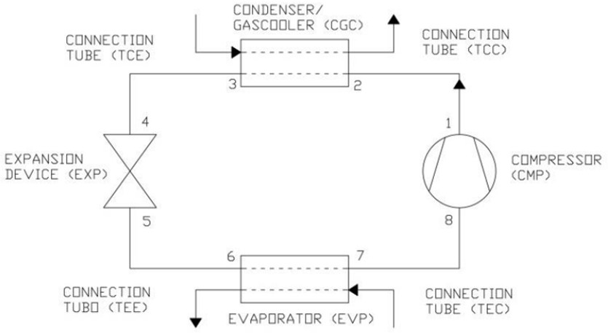

Figure 1: *CO*2 cooling cycle [1] The The main components of the cooling cycle are briefly discussed:

1. **Compressor:** It is the first component of the cycle. Its main objective is to raise the pressure and temperature of the refrigerant to a superheated vapor state before entering the condenser.
2. **Condenser:** It is the part of the circuit where heat is rejected. This heat can be either transferred from the refrigerant to a water tower or directly to ambient air.
3. **Expansion valve:** It is probably the most important component of the circuit because it connects the condenser (high pressure part of the circuit), with the evaporator (low pressure part of the circuit). At the expansion valve, the flow undergoes a very important expansion, reducing its pressure a lot and decreasing its temperature considerably. Due to this, the refrigerant typically leaves the valve as a liquid vapor mixture.
4. **Evaporator:** Finally, at the evaporator is where ambient heat is absorbed. A fan is usually employed to force the circulation of the hot air around the coils of the

evaporator. The hot air evaporates the liquid part of the refrigerant, absorbing the latent heat of vaporization but with a modest increase in temperature. Once the heat has been absorbed, the refrigerant goes back to the compressor to start the cycle again.

The temperature and pressures measured at the *CO*2 cooling cycle of figure 1 are shown in the following table:

Table 1: Temperature and pressure at each point of the cooling cycle of figure 1

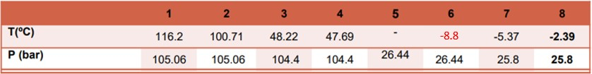

With this information, the following is requested:

**Questions: Find the enthalpy at each point of the** *CO*2 **cooling cycle of figure** **1** **with the data provided in table** **1.** **Plot the enthalpy variations in a h-p diagram along with the saturation bell of** *CO*2**. Additionally, compute the temperature at the exit of the expansion valve.**

**References**

[1] J. Rigola, “Aplicació de Matlab-Octave a problemes d’enginyeria tèrmica - classnotes,” UPC, Escola Superior d’Enginyeries Industrial, Aeroespacial i Audiovisual de Terrassa, course 2018-2019.