*Annex 1*

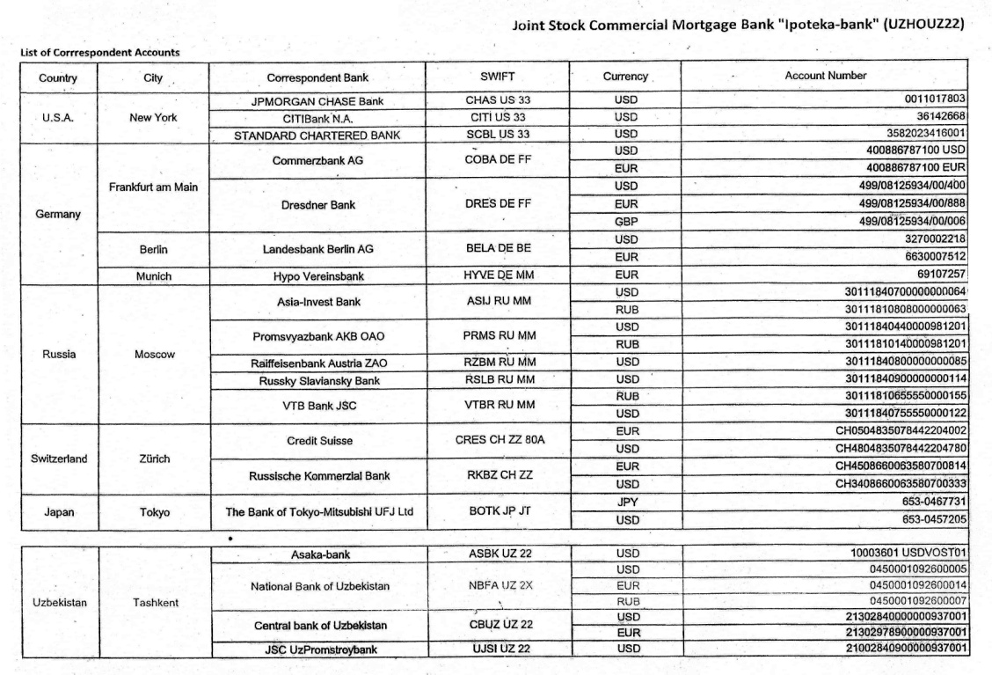*The bank may require a List of Correspondent Accounts. According to this, please submit them these data.*