|  |
| --- |
| Title in English. Instructions to authors (Arial 13)  The maximum length for the title is 150 characters (including spaces) and the title should be in lowercase letters except for the first letter, proper nouns, and acronyms.  **[First Name] [Last Name]** & [First Name] [Last Name] (Indicate the presenter in bold font) (Arial 10)  *[Department], [Affiliation], [Country],* *[Presenter’s email address]* (Same affiliation)  [First Name] [Last Name]  *[Department], [Affiliation], [Country]* (Other affiliation) |
| ABSTRACT: Please find below the instructions to present your paper at the 5th CACSMGE Int. Conf., Samarkand, 5-7 October 2022. Papers should be typed in Times New Roman 9 using **MS Word** (.docx) and **PDF format** in **A4 format** and should not exceed **6 pages**. Abstracts should not exceed 10 lines. Please use this template to format your paper. |
| KEYWORDS: please provide a relevant keyword list (up to 5 keywords, single line only). |

1 INTRODUCTION. first LEVEL heading

First paragraph (no indentation). Please use this template to format your paper. English (UK) or (US) spelling is accepted.

Second paragraph (indented, no blank line between paragraphs). In-text references are as follows (Darcy 1856, Gibson & Henkel 1954) and placed in chronological order.

1.1 *Second level heading*

Include a single blank line before each figure (centered, as shown in Figure 1). For the figure captions, please use the format shown in Figure 1. Note that figure captions are placed below the figure.

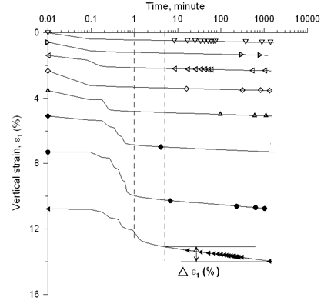

Figure 1. Figure caption (Times New Roman 8). Please provide good quality drawings (min. 300 dpi) with figure text and legends (character size > 1 mm) that are legible. Number figures consecutively.

The proceedings will be published electronically but will also be available in hard copy (black-and-white), for those who wish to purchase them. Please be mindful of this, so that plots, in particular, can be interpreted in B&W. Use SI units.

1.1.1 *Third level heading*

Insert one blank line before and after each table (see Table 1). For table captions, please use the format shown in Table 1. Note that table captions are placed above the table.

Table 1. Table caption numbered consecutively. Tables placed below caption. Use Times New Roman 8 for the caption, text and numbers in the table.

|  |  |  |
| --- | --- | --- |
| Parameter | *a* | *b* |
| Parameter *x* (unit) | 14.0 | 19.2 |
| Parameter *y* (unit) | 8.4 | 0.5 |

Equations should be numbered consecutively at the end of the line, in parentheses (see Eq. 1). Place a single blank line above and below the equation.

$y=\sqrt{b^{2}-4ac}$ (1)

Please do not use footnotes.

2 ConclusionS

In this section the most significant results of your work should be summarized.

3 Acknowledgements

Place any acknowledgements, should they be needed, in this section, between the ‘Conclusions’ and ‘References’ sections.

4 references

References in alphabetical order, using Times New Roman 8 point font.

Gibson R.E. and Henkel D.J. 1954. Influence of duration of tests at constant rate of strain on measured “drained” strength. *Géotechnique* 4 (1), 6-15.

Darcy H. 1856. *Les fontaines publiques de la ville de Dijon*. Dalmont, Paris.

Terzaghi K. 1936. The shearing resistance of saturated soils. *Proc. 1st Int. Conf. Soil Mech.*, Cambridge, Mass., 1, 54-56.