## Advanced Programming (Java) QAP1

Alexander Barry

January 30th

SD12

## Questionnaire

1. This assignment took me approximately 6 hours total, if I were to guess. I needed to practice OOP in Java, and had to familiarize myself with IntelliJ
2. To complete this assignment, I utilized W3Schools, Ainee’s lecture notes, and StackOverflow
3. N/A
4. N/A
5. I thought the first question was the most difficult, I had to think a little extra for the transfer method. The other two questions seemed to come somewhat naturally after doing practice questions.

## Problem 1 Screenshot

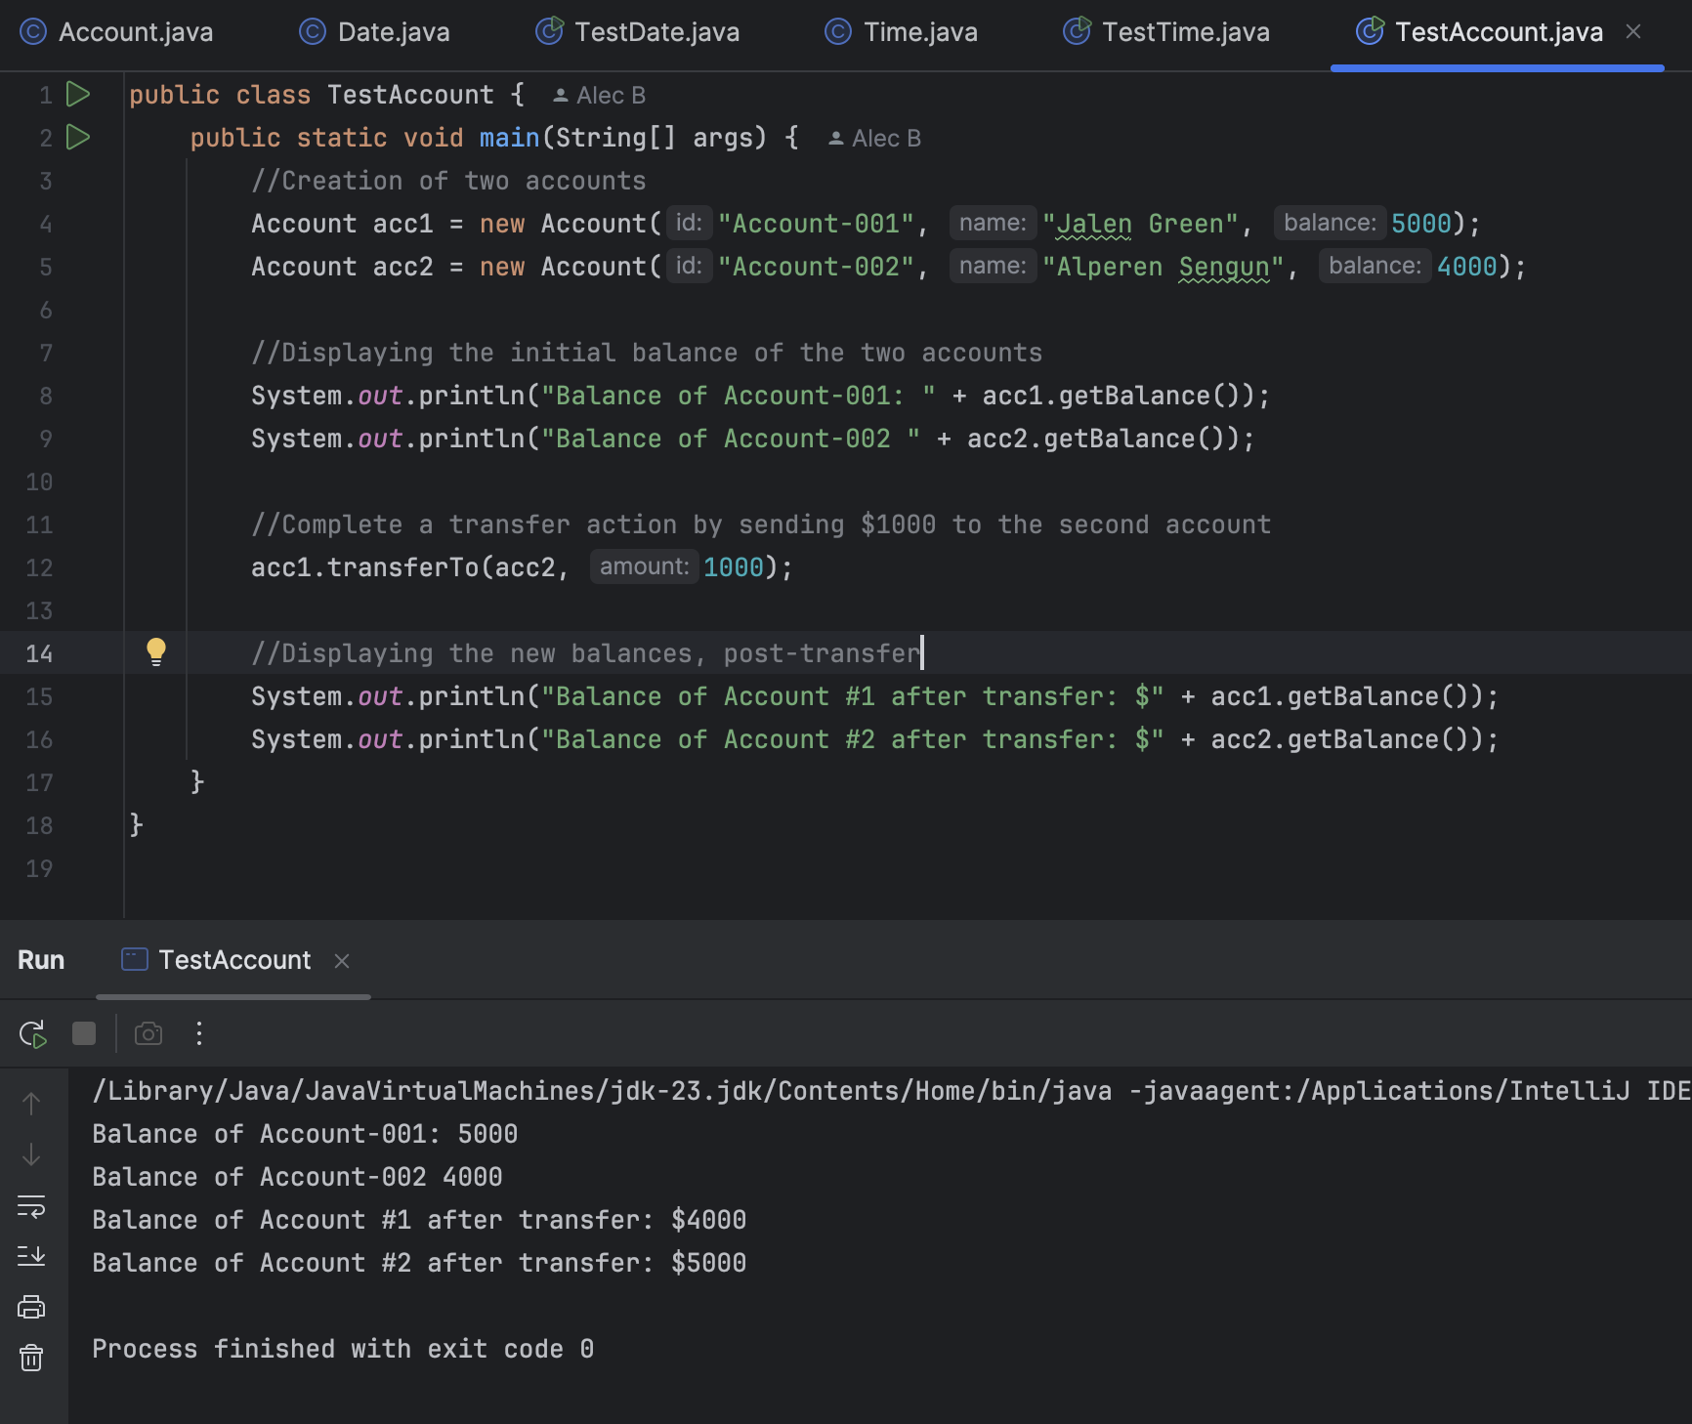

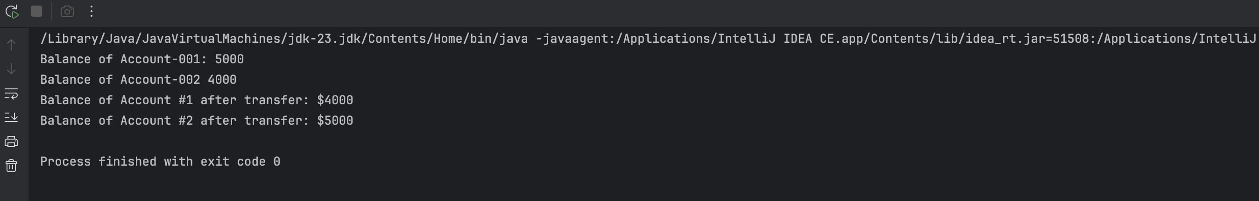

## Problem 2 Screenshot

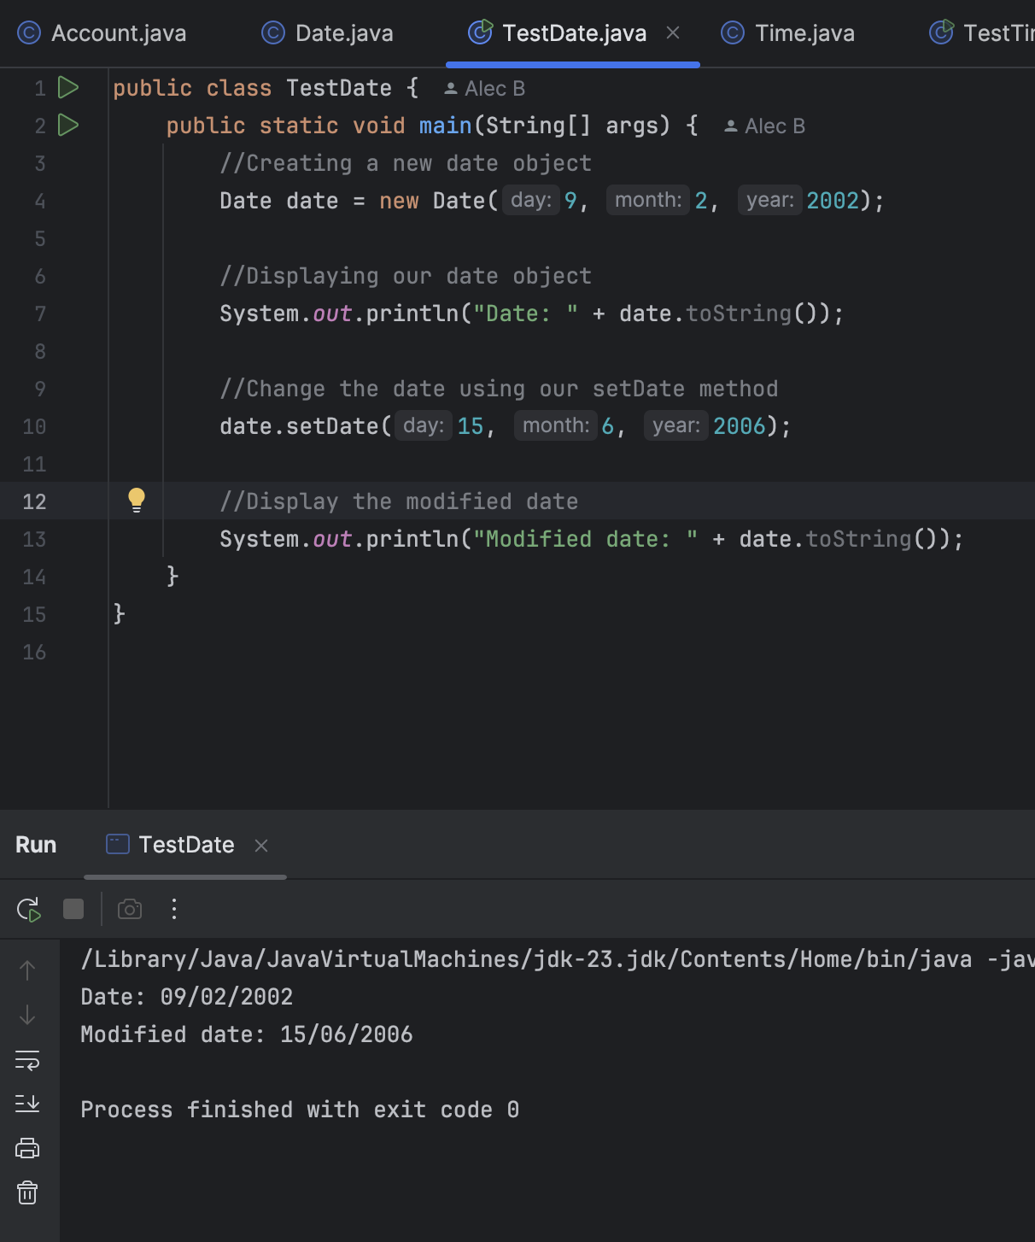

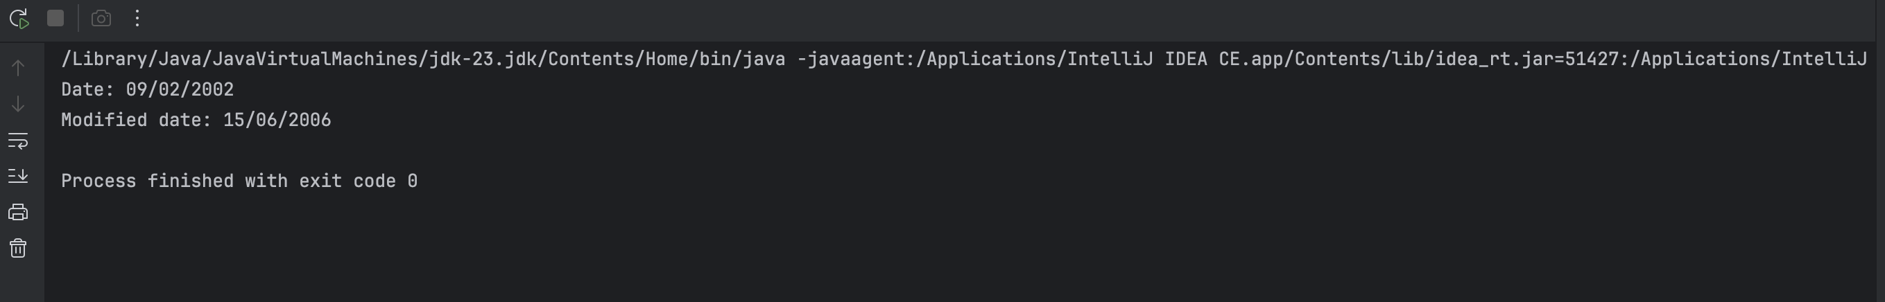

## Problem 3 Screenshot

