Alec Harb

M/CS 335

Programming Assignment 1

May 20, 2020

1. The graph below suggests that a growth in (m+n) corresponds to a growth in iterations. In both cases of bounded/unbounded problems, this relationship appears to be exponential. Additionally, it looks as though a bounded problem requires, on average, slightly more iterations for the same problem size as an unbounded problem.

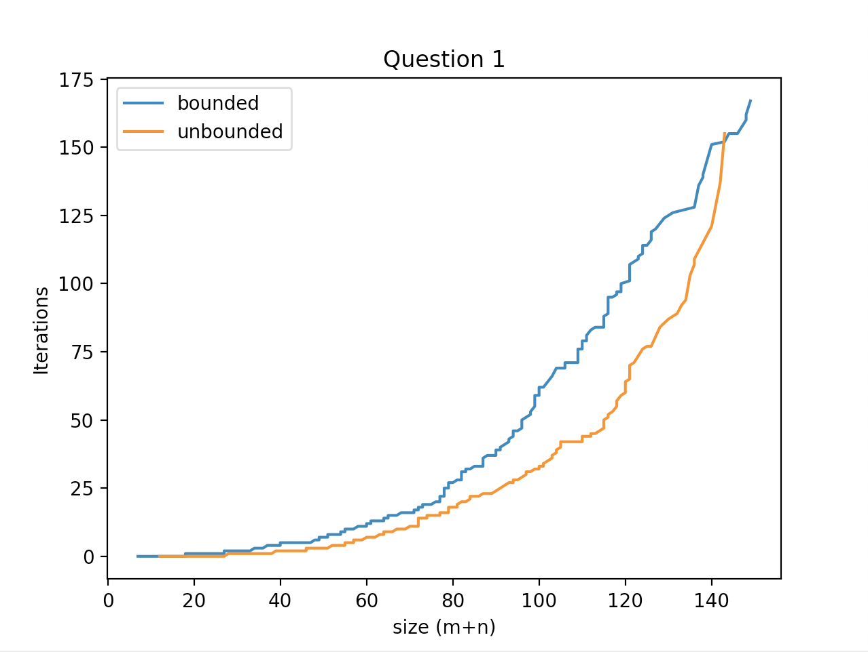

1. Looking at only size (m) on the x-axis, we see that the growth in m leads to a growth in iterations. For bounded problems, the relationship appears exponential. For unbounded problems, the relationship appears slightly exponential but with a much smaller growth factor than the bounded problems.

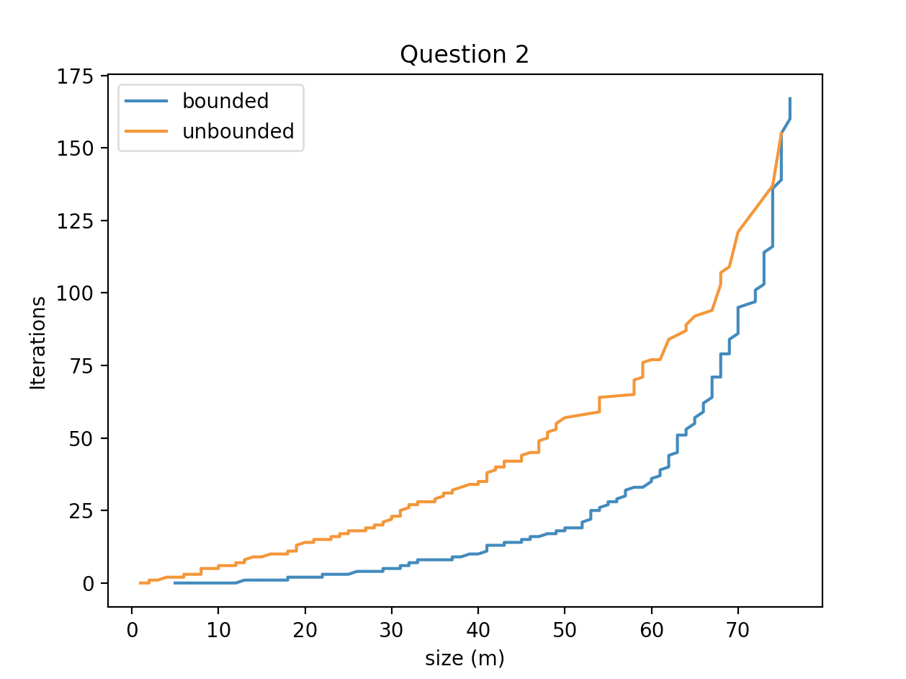

1. Looking at graph from question 1, it appears that an unbounded problem will result in less iterations. This suggests that it is generally faster to determine if a problem is unbounded than to determine the optimal value if it is bounded. However, when looking at the second graph in question 2, it appears that if we just look at the width of the problem (looking at the number of constraints), an unbounded problem will require more iterations than a bounded problem.
2. In the graphs below, (m+n) is on the x-axis, but only tall problems are graphed in the first graph and only wide problems are graphed in the second graph. Looking at the blue lines in both graphs, it appears that tall problems follow a somewhat linear trend (or exponential with a very low growth factor) while wide problems more closely follow an exponential trend. This suggests that as the size of the problem increases, tall problems are generally faster to solve than wide problems when the problem is bounded. Looking at the orange lines in the unbounded case, we can see an opposite relationship; tall problems follow an exponential trend while wide problems follow closer to a linear trend. This suggests that for unbounded problems, wide problems are faster to solve than tall problems as the problem size increases.

