**Application Installer Examples**

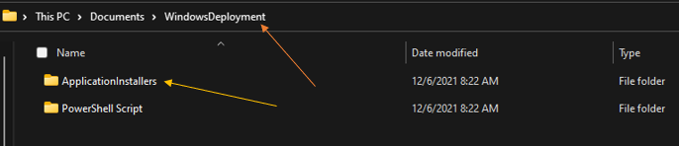In Reference to Step 10, On Line 608 the path is referring to this folder (Orange Line). Inside the WindowsDeployment Folder is the ApplicationInstallers Folder (Gold Line) that contains subfolders for the respective applications. The ApplicationInstallers Folder is what gets copied to the local machine for faster installation and is removed when the script exits.

Using AdobeAcrobat as an example, in the AdobeInstall function on Line 622 it is referencing this folder (Green Line) in the local copy of it which is at C:\WinDeployApps on the local machine and then running the Setup.exe file (Blue Line) in AdobeAcrobat.

(NOTE: The Setup.exe was generated using the [Adobe DC Customization Wizard](https://www.adobe.com/devnet-docs/acrobatetk/tools/Wizard/basics.html))

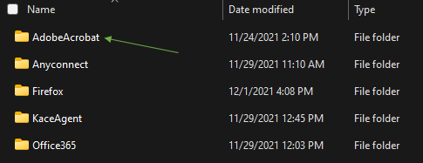

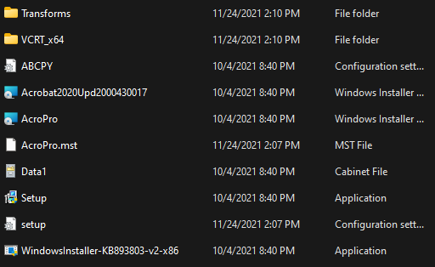

Another common program is Office 365, it is **Highly Recommended** to use [Office Customization Tool - Products and releases](https://config.office.com/deploymentsettings) to create an xml file that the Office365 Setup.exe file will use to install Office.

If you utilize Kace for managing your endpoints you can install the Kace Agent as well following these steps.

1. Log into your Kace Management Console
2. 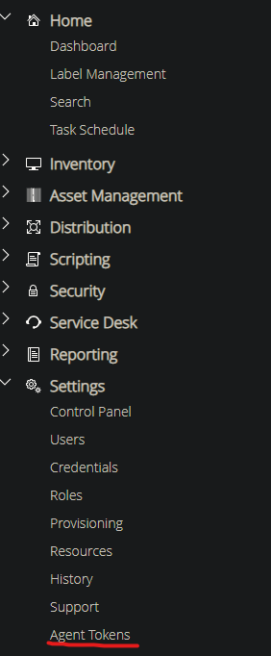Under Settings Click “Agent Tokens”
3. Select your Organization
4. 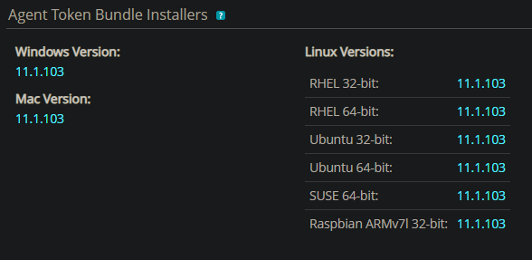Under Agent Token Bundle Installers click on the Windows Version (Orange Line)
5. Save it to a folder called KaceAgent in your ApplicationInstallers Folder

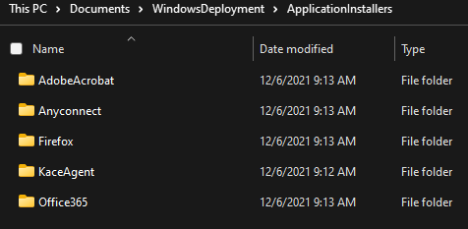

1. Update Line 630 with the name of your MSI file make sure the /qn is after it to have no dialog boxes appear during the installation.