**Assignment Purpose**

This repo is for CSC 142’s assignment 2 (lab 1), which is about doing control flow and user input in Java. If-else, loops, and scanner objects are all discussed and practiced.

**Code Purpose**

Per assignment requirements this code does two things: calculating average student grades and calculating bank fees.

**Usage Example**

Navigate to the src folder, run ‘java main.Main’, and follow the on-screen instructions.

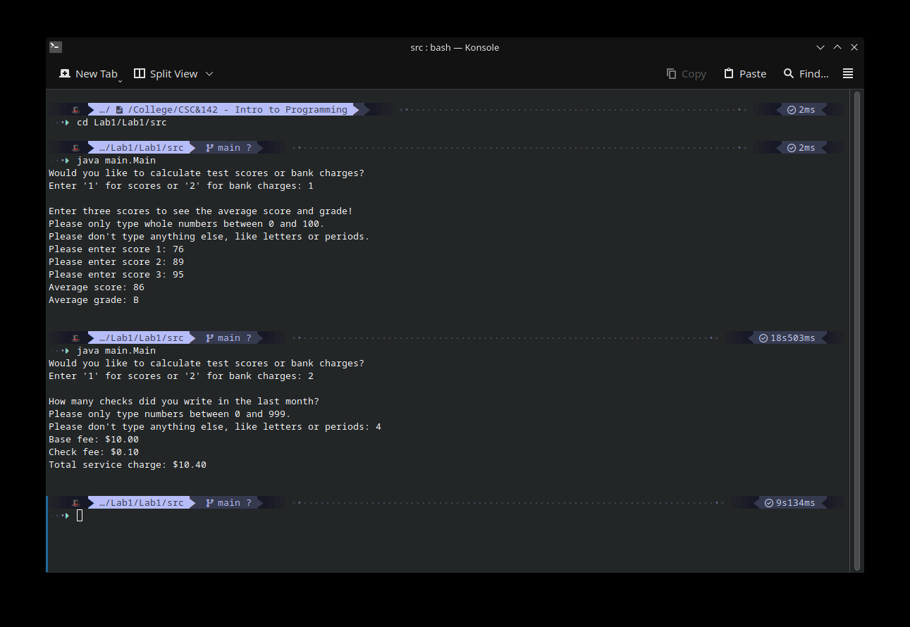

**Challenges Faced**

Most of my experience is in Python, so the syntax and compiling took a bit of figuring out. Git is also something that I’ve used but not very much, so figuring out how to use EGit took longer than I care to admit.