MQCS

(Materials Quality Certification System)

Supplier Ramping Guide

**Document Information**

|  |  |  |  |
| --- | --- | --- | --- |
| Document Version | Owner | Date | Comments |
| 2.0 | Isaias Chavarria Mora | WW04 – 2018 | Creating a new version of the document, with better formats to understand easier. |
|  |  |  |  |
|  |  |  |  |

Main Sections

(You can use this section to Navigate quickly to a specific part of the document.)

[1 MQCS Process Overview (CofA) 3](#_Toc504488036)

[2 Supplier Ramping Process 6](#_Toc504488037)

[3 Format Files accepted by MQCS 9](#_Toc504488038)

[4 Getting Started with Intel XML eCofA Format 11](#_Toc504488039)

[5 Getting Started with RossetaNet eCofA Format 31](#_Toc504488040)

[6 XML Validation Tool 38](#_Toc504488041)

[7 Appendix A - Frequently Asked Questions 47](#_Toc504488042)

[8 Appendix B – XML Samples 50](#_Toc504488043)

# MQCS Process Overview (CofA)

The Intel Fab Materials group requires that suppliersprovide product quality certificates for review and receive approval before their material arrives at Intel for use. The Intel Materials Quality Certificate System (MQCS)analyzes the files provided and replies with an initial disposition while capturing the data and status for Intel fab users.

There are four basic transactions - 1) The Intel Part Number (IPN) SPEED specification is created, signed-off in the electronic Product Data Management (ePDM) and the required parameters and specification limits are downloaded to MQCS. 2) The supplier sends theircertificates to an Intel Business-to-business (B2B) contractor based on file type, where it is screened and forwarded; the supplier should get a confirmation receipt. 3) The supplier certificate is sent into MQCS for validation against the SPEED specification, and with the newest XML file, the supplier control limits. 4) The MQCS initial disposition response is provided back to the supplier via e-mail or RosettaNet. If the supplier does not receive a timely MQCS response, there has been a failure in one of these transactions or the file has a structural problem that has prevented its being processed, perhaps in the MQCS "Problem" folder.

Whena supplier is going to begin to provide quality certificates, the TSOopens an IT ticket to create their B2B account, and then test and prove each of the three processing steps through the MQCS "Ramping" server before converting to the "Production" environment. The Intel Fab Material group would prefer to use the Control Limit Schema (XML 2106) or RosettaNet whenever possible. The lot and container status are then pushed to local warehouses supporting Intel fabs, and fab data systems and used as confirmation upon receipt at each step from the delivery to point-of-use.The GFM ChemTech provides daily tactical support, the TSO is responsible for supplier management, and Intel users request MQCS access through the Access Governance System (AGS) and query data at: <https://mqcs.intel.com/#/search> .

Following diagram shows the data flow through companies.

Machine generated alternative text:
Specification and CofA Processing Flow - Both Formats (Intel & RosettaNet)
Product
Specifications
Supplier’s
CotA system
4. RosettaNet
2A17 CofA
5. CofA delivery
to Intel
6. File delivery
to MQCS
9. Disposption
Results
4. Send CofA
to Liaison
Technologies
Supplier
RosettaNet
8. Receipt
Delivery to supplier
6. CofA delivery
5. Receipt: File to Intel
received by
Liaison
11. Receipt:
CofA Decision
7. File delivery
to MQCS
8. Receipt:
‘File delivered
(optional)
9. Receipt:
CofA
processing
results
Legend
Orange: Product Specifications
Green: RosettaNet 2A1 7 and 2A18 CofA
Blue: Intel-specific XML CofA
Red: Manual Dispositioning of Reject
Analysis
Yellow: product Shipment and Storage
Shipping Dock
Product
14, Supplier
Summary Report
Shipment to warehouse
3PL warehouse
13. Product
Temperatures
and lot
expiration
dates
Supplier 1. Product spec
Acct Rep Review and approval
Intel sPOED
ePOM
2. Approved Product
Specification
Intel SPEED
15. Supplier
Reject Report
Liaison Technologies
Intel
RosettaNet
7. RosettaNet
2A1 8 Receipt
10. Notification
to ship
Supplier
Contact
O. Manual
)isposition
of Reject
Analysis
GFM Chem
Tech Admin

## CofA Process General Steps

* 1. Kickoff meeting between Intel Technical Supplier Owner (TSO) and supplier, to define eCofA process
  2. The Intel Technical Supplier Owner will create the specification drawing in SPEED after the kickoff meeting with suppliers
  3. The supplier logs into the Intel SPEED ePDM external web site to view and approve their product specifications
  4. Intel SPEED ePDM external web site sends those approvals to the internal SPEED application server
  5. SPEED sends copies of the approved product specifications to Intel's Materials Quality Certificate System™ (MQCS)
  6. From this point the next steps will depend on the file format supplier sent

The process can be split in two ways, the first one is use 2A17 RosettaNet eCofA and the other one is Intel’s XML files format.

### RosettaNet XML flow (Green)

If supplier is using 2A17 to send certificates. The detailed steps for setup can be found later in 2A17 RosettaNet Guide.

* 1. The supplier quality certificate system sends their eCofA through their RosettaNet gateway(or appropriate RosettaNet processing either internally our outsourced)
  2. The supplier RosettaNet gateway delivers the supplier eCofA to Intel's third party gateway GXS.
  3. Intel's third party gateway GXS delivers the eCofA to MQCS.
  4. MQCS processes the eCofA and returns an eCofA receipt (RosettaNet PIP 2A18) to Intel's third party gateway GXS.
  5. Intel's RosettaNet gateway sends the eCofA receipt to the supplier RosettaNet gateway.
  6. The supplier RosettaNet gateway delivers the eCofA receipt to the supplier quality certificate system.
  7. If the eCofA processed properly, the certificate disposition will be reported back to the supplier mail contact listed for the site in MQCS. Once the certificate is Approved or Passed, the supplier quality certificate system sends a notification to their shipping department that the product can ship to the Intel dock.

### Intel’s XML formats flow (Blue)

If supplier is using Intel’s files format to send certificates. The detailed steps for setup can be found later in XML Intel Guide.

* 1. The supplier quality certificate system sends their eCofA to Liaison Technologies.
  2. Liaison Technologies sends an e-mail to the supplier confirming receipt of the eCofA.
  3. Liaison Technologies delivers the supplier eCofA to Intel's File Transfer System (FTS).
  4. Intel's FTS delivers the eCofA to MQCS.
  5. Intel's FTS sends an e-mail to the supplier confirming delivery of the eCofA.
  6. If the eCofA processed properly, the certificate disposition will be reported back to the supplier mail contact listed for the site in MQCS. Once the certificate is Approved or Passed, the supplier quality certificate system sends a notification to their shipping department that the product can ship to the Intel dock.

# Supplier Ramping Process

Ramping a new supplier is a process for testing environment before move to production system, so in that way supplier can submit electronic Certificates of Analysis (eCofAs) and it typically requires IT development effort on the part of the supplier.  This section contains the list of folks involved, the process, and your steps to start the process.

## Teams Involved

The process of ramping a supplier entails a large number of steps and a coordinated effort between multiple people and teams at both Intel and supplier:

* Supplier Account Manager
* Supplier's technical representative
* Intel TSO
* Intel SPEED Configuration Management: Huong Nguyen
* Intel Fab Materials Operations
* One of these two communications teams:
  + Intel's File Transfer System (FTS) team (for Intel-formatted CofAs)
  + Intel's RosettaNet gateway team (for industry-standard formatted CofAs)
* MQCS tech team: Any technical from MQCS team help or issue go to it.intel.com (internal users) in Supplier ramping help IT

## The Process

Each step has an informational comment about the reasons for that step following it, noted with the icon used in this sentence.

1. **Supplier TSO** coordinates and runs the initial kickoff meeting with most of the folks above (except the communications teams; they get involved later).

This kickoff meeting assists all of the folks involved with many things:

* Understand the product the new supplier will send to Intel,
* Understand the business in which that product will be used, and
* Gives each person a chance to ask questions.

1. **Supplier** selects which of the two submission formats (Intel-specific or industry standard) in which they'll format their quality data.

The Intel’s files format is generally a bit easier to create, but it can be used only to send in data to Intel.

The RosettaNet XML format is a multi-industry, multi-company, world-wide standard.

1. Subsequent detailed technical discussions happen between the Intel technical team and the supplier technical team

Those discussions between the Intel technical team and the supplier technical team allow the supplier technical team to get clarification on the technical aspects of preparing the XML data (in either Intel's XML format or the RosettaNet XML format).

1. These things all happen, in any order, or in parallel:
   1. Intel's specs for the supplier's products get setup in Intel's SPEED system.

Those specifications are necessary against which to validate the incoming quality data. Without that data, the CofA data is meaningless.

1. The supplier approves their specifications through Intel's SPEED ePDM supplier web page.

This approval marks the specification with a status that enables MQCS to use that specification for its spec compliance testing.

1. Intel Fab Materials Operations sets up supplier information in MQCS.

The MQCS supplier information maps the MQCS supplier and site against the SPEED manufacturer.

1. Supplier builds their certificate formatting system.

It's possible for very low volume suppliers to hand-prepare their CofAs, but impractical for larger suppliers.

1. Supplier coordinates their internal business processes to wait for Intel's certificate system approval prior to shipping their product to Intel.

Intel requires the supplier receive the approval prior to shipping.

1. Supplier works with the appropriate Intel communication team to setup communications channels for certificate submissions; this includes the forms and processes implemented by the team.

Both communication channels require testing and confirmation of correct functionality with the supplier.

1. Supplier tests through the MQCS testing environment

The supplier must prove they can send valid CofAs that process properly before approval to send those to production.

After enough testing through test system, supplier is approved for production.

# Format Files accepted by MQCS

1. RosettaNet XML(FM)
2. Intel XML format (FM)
   1. ChemGas Schema
   2. QMM Schema
   3. Silicon Quality Schema
   4. Control Limits Schema
3. Plain text.Q01 (AT)
4. Excel File (AT)

## Comparison Chart

This chart is meant for your technical team so that you can decide in which format to submit eCofAs. Following the comparison chart are the next steps to in the process of submitting eCofAs to Intel.

|  |  |  |
| --- | --- | --- |
| Comparison Aspect | Intel XML Format | RosettaNet XML |
| *What companies use this format?* | Intel only | The RosettaNet eCofA format is a multi-company, industry-independent format. Recently adopted by the ISMI group of companies as a standard for their quality data exchange. |
|  |  |  |
| *How is the eCofA sent?* | Intel has contracted with Liaison Technologies; you send your eCofAs to Liaison Technologies, which forwards them to Intel. | Communication is done through the RosettaNet gateways at your company and Intel. |
| *In what communication protocols can I send the eCofA files?* | Liaison Technologies supports a variety of protocols. | RosettaNet gateway has a pre-defined protocol. |
| *Are there any special changes to the eCofA before it is sent?* | The file is sent as-is without any modification. | The RosettaNet eCofA is "wrapped" in a RosettaNet standard, XML-based envelope, common to all RosettaNet PIPs. |
|  |  |  |
| *How complex is the XML structure?* | Fairly simple XML format, mostly XML elements, and only a couple of elements have attributes. | A much more complex XML structure that includes many XML elements with attributes. |
| *How soon will I know if the eCofA format is correct?* | Only after the file has been received by Intel during the Intel load process.    Failure of the XML structure requires fixing the structure and submitting the eCofA again. | Early in the communication cycle, your RosettaNet gateway will prevent sending invalid XML.      This prevents bad structure from getting communicated, and prevents needing to retransmit an original. |
| *Is there a built-in validation code lists?* | No | Yes: XSD schemas enforce code values. |
| *For codified fields, what codes are used in the XML?* | The codes are specific to Intel. | Industry standard codes based on the RosettaNet code lists. |
| *When are code values in the XML data validated to ensure that they are correct?* | Only after the file has been received by Intel during the Intel load process. | Early in the communication cycle, your RosettaNet gateway will prevent sending invalid XML values (with the sole exception of the material parameter code values, which are validated later). |
|  |  |  |
| *Can upstream eCofAs be communicated?* | No | Yes |
| *Can the XML format be expanded for new capabilities?* | No, Intel is not supporting changes to this format. | Yes, RosettaNet has a standardized process for changing the XML structures of their various transactions (RosettaNet PIPs). |

# Getting Started with Intel XML eCofA Format

This section provides instructions to Intel's material suppliers so that they are able to submit electronic Certificate of Analysis (eCofA) transactions formatted in the Intel XML electronic Certificate of Analysis (eCofA) format.

This section is targeted at the supplier's technical group.

## eXtensible Markup Language (XML)

XML stands for eXtensible Markup Language designed to store and transport data to be both human and machine readable. The style language consists of start tags and end tags in between which the real data resides.

An easy sample of what is an xml file is represented in the following table:

|  |
| --- |
| <?xml version="1.0" encoding="UTF-8"?>  <supplier>  <name>XYZ company</name>  <phonenumber>(+555)555 5555</phonenumber>  <country>US</country>  </supplier> |

In line 1 some metadata can be added regarding xml version, encoding, language, and so on. All XML start with a root tag, in this case our root tag is <supplier>, which mean than in the nested tags below this is regarding supplier information. And next tags are: <name>, <phonenumber>and<country>.

Each tag must to be closed, </supplier>, once the information is added, in this case as you can see tags can contains more tags or the information to be read. The close tag is well the less or greater than symbol <>, inside the tag closing but with the detail that the slash “/” must to be added in front of the tag name.

## Learn about XML

XML is, by itself, not a format. It is a style in which formats are defined. In this section there are some links to places where you can find information about the language.

For a good example, so you may want to look at the Intel quality certificate XML layout. Many of the XML concepts are demonstrated in the format, and you can see how tags and end tags are used.

## XML Editors

Many editors for XML data are available in the market, both freeware, shareware, and commercial. Because the market is so dynamic in this area, we have chosen to omit any particular list of editors.

## XML Format for Special Characters

In all XML documents certain characters represent XML markup, and therefore a special way is needed to represent those characters in the XML document.

This table lists the five special characters and the XML representation of them. Note that the closing semicolon is required in the XML representation.

|  |  |  |
| --- | --- | --- |
| Character to represent | Name of character | XML representation |
| & | Ampersand | &amp; |
| < | Less than | &lt; |
| > | Greater than | &gt; |
| " | Double quote | &quote; |
| ' | Apostrophe | &apos; |

If you need to send in values for a material parameter using the Less Than numeric value or the Greater Than numeric value, then there is a special way to code this because XML will not allow you to use the > or < symbols. See the **Special Coding for Less Than** section below.

## Intel’s XML Quality Certificate Layout

For Xml samples, please refer to the XML samples in the appendixes section.

* [ChemGas schema Sample](#_ChemGas_schema_Sample)
* [QMM Schema Sample](#_QMM_Schema_Sample)
* [Sillicon Sample](#_Sillicon_Sample)
* [Control Limits 2016 Schema Sample](#_Control_Limits_2016)

### Notes about Intel's XML Quality Certificate Layout

As with all XML files, the tags in the XML document are case sensitive. **Incorrect capitalization results in load errors**. This means that whole file must be rebuilt and resent.

Although our XML format document shows the XML hierarchy as is indented, it is not required. XML, like HTML, need not be visually formatted well. It needs to be **well formed**, but not well formatted visually. That being said, we’d prefer that the incoming file be formatted similar to the one above.

This quality certificate format allows for multiple certificates in a single file. **Warning:** If you choose to include multiple certificates in a single file and for some formatting reason the file fails processing; the entire file must be resent. If your internal processing system does not allow for you to keep track of all the certificates that were included in that file, then you may have reprocessing problems.

Based on our experience, once the suppliers have their systems tested, it is seldom that a file fails. It is easier and faster to process multiple certificates in a single file rather than separate files. The choice to consolidate or separate the certificates is entirely yours.

The quality certificate format also allows multiple containers to be specified inside a single certificate. This prevents you from having to duplicate certificate info for just container differences.

For the details of each field in the format, see the appendix Intel’s Quality Certificate XML Fields.

### Naming Your XML Certificate Files

There are a few requirements for how to name your XML files. First, they must have the extension .xml. Files without the XML extension will not get processed by our system. And it’s a good idea if you put your company acronym or name at the beginning of the file name.

Another requirement is that you name each file with its own unique name – we have a process on our end that checks to make sure that the filename that you send us is unique within the last ten days. If the new file sent has the same exact filename as one that has been previously sent, our system will not process it and will send you an email stating so. See the section below about the different emails you will receive.

Other than those two things, you can name your files in a way that makes sense to you. We can handle this because we append the date and time of processing onto the file name internally when we process each file.

A naming convention that could work is to have the company name followed by the lot identifier. An example would by MyCompany\_ABC1234.xml.

Another is to have the file creation date time in the name. So you might call it MyCompany\_2000-12-25-14\_15\_00.xml for a file created on December 25th at 2:15 in the afternoon your time.

## Liaison Technologies

### About Liaison Technologies

Intel has contracted with a company named Liaison Technologies for file communications. Move information about the communications like between the supplier and Intel can be read here <https://supplier.intel.com/static/FileTransfer/> when you engage with the Intel Global Fab Materials department ([gfm.chemtech@intel.com](mailto:gfm.chemtech@intel.com) ), they will send your contact information to Liaison Technologies, which will then contact you.

### Multiple Accounts

Intel requires suppliers to setup two accounts with Liaison Technologies: testing and production.

#### Testing Account

The supplier testing system is identical to production with the sole exception of the additional marking on the e-mails (certificate receipts and reports) about the report coming from the testing system. It processes certificates in the same way and at the same frequency as the production system. However, you may send any data that you wish through the test system; it will not affect production

#### Production Account

Send only production data through the production account, this accounts needs to be configured after the test account has been confirmed and tested.

## Certificate Processing Problems

There are two major categories of processing problems: file processing and data validation. Generally, when there is a file processing problem, none of the data is loaded into Intel's certificate system. When there are data validation issues, the data was loaded into the certificate system and must be corrected with the submission of a replacement certificate.

### File Processing

File processing errors can occur be for a couple of reasons: there is an XML problem or a file naming problem.

#### File Processing - XML

If there is an XML structure problem (such as an element name opened and not also closed), the certificate system will send back an e-mail to the e-mail address identified in the XML file. The e-mail gets a subject line "Materials Quality Certificate XML load error", and the subject looks similar to this:

The material quality certificate XML file that you submitted for processing:

*(The file name you submitted will be listed here)*

Had an error during loading:

Error Code:

File Position:

Line:

Line Position:

Reason:

This error prevented your file from being loaded into our system. Please correct the error and resubmit the file.

The fields above will have detailed information about the problem that occurred. File load problems can occur if the data type in the XML file doesn't match the proper type (XML date format incorrect, etc.) In all, there are about 150 possible reasons that the XML can fail. About 100 can be because of certificate problems, about 50 would be because of configuration errors in the Intel system. Those that are certificate problems are reported to the supplier.

As stated earlier, none of the data in the file was processed by the Intel certificate system, so the file structure needs to be corrected and the data needs to be re-sent. If you sent an original certificate, the next submission also should be an original.

#### File Processing - File Name

We have a safety net in our system that prevents loading files that were accidentally sent multiple times. If the same file name is received within a certain period of time (10 days, currently), the file stops processing. As with other file processing problems, none of the data will have loaded.

## Xml Validations

For each XML file format in the next tables is summarized the tags available to create the eCofA document, in the first column is the tag name, the second is the type, third if is tag required and at the end some details regarding that tag.

The header that all XML files must to have is: <?xml version="1.0"?> This header is a identifier that said that the document is an XML file.

**General color code:**

**Tag Type:**

|  |  |
| --- | --- |
| Color | Meaning |
|  | Must tag |
|  | Optional tag |
|  | Abstract component |
|  | Field tag |
|  | Section tag |
|  | Root tag |

**Must:** This tag is must to be in the XML file

**Optional tag:** The tag can be let in blank

Abstract component: This component can be replaced with the abstract values placed in the XSD template

**Field tag:** Simple field tag

**Section tag:** Container for other tags

Root tag: After header required in each XML the root tag is the most important tag. Inside the root tag we have a very important value to be added this value help to the system to identify which type or certificate is going to process.

<QualityCertificateFile xmlns="x-schema:..\Schema\ChemGasQualityCertificateSchema2001Jul.xml">

|  |  |
| --- | --- |
| Certificate Type | String Value |
| Chem Gas Certificate | x-schema:..\Schema\ChemGasQualityCertificateSchema2001Jul.xml |
| Silicon Certificate | x-schema:..\Schema\SiliconQualityCertificateSchema2001Apr.xml |
| QMM Certificate | x-schema:..\Schema\QMMQualityCertificateSchema2005Apr.xml |

### ChemGas file tags description table

|  |  |  |  |
| --- | --- | --- | --- |
| Tag Name | Tag Type | Required | Details/Comments |
| validmeasurementvalue (abstract) |  |  | Just one can be used, measurementValue or globalTestValue |
| <measurementValue> |  |  | Alphanumeric 35 characters |
| <globalTestValue> |  |  | Alphanumeric 35 characters |
| validreleasetypes(abstract) |  |  | Just one can be used, releaseType or thisDocumentReleaseType |
| <releaseType> |  |  | Numeric, 2 characters, valid just 00, 05, 14 and 15, Original |
| <thisDocumentReleaseType> |  |  | Numeric, 2 characters, valid just 00, 05, 14 and 15, Original |
| Validmaterialparameters(abstract) |  |  | Just one can be used, Parameters or MaterialParameters |
| <Parameters> |  |  |  |
| <DetailParameters> |  |  |  |
| <globalSourceComponent> |  |  | Alphanumeric, 30 characters |
| <globalMaterialParameterCode> |  |  | Alphanumeric, 12 characters |
| <globalTestUnitOfMeasure> |  |  | Alphanumeric, 3 characters |
| <globalMeasurementQualifier> |  |  | Alphabetic, 3 characters |
| <globalSpecificationSpecType> |  |  |  |
| <globalTestValue> |  |  |  |
| <MaterialParameters> |  |  |  |
| <MaterialParameter> |  |  |  |
| <shortName> |  |  | Alphanumeric, 12 characters |
| <sourceComponent> |  |  | Alphanumeric, 30 characters |
| <characteristic> |  |  | Alphanumeric, 50 characters |
| <measurementType> |  |  | Alphanumeric, 35 characters |
| <unitOfMeasure> |  |  | Alphanumeric, 2 characters |
| <measurementQualifier> |  |  | Alphabetic |
| [validmeasurementvalue](#valueMesuarementValue_ChemGas) (abstract) |  |  | Alphanumeric, 35 characters |
| <QualityCertificateFile> |  |  |  |
| <FileCreationInfo> |  |  |  |
| <responsiblePartyEmail> |  |  | Alphanumeric, 50 characters |
| <BusinessSites> |  |  |  |
| <BusinessSiteDescription> |  |  |  |
| <manufacturerNumber> |  |  | Numeric |
| <manufacturerName> |  |  | Alphanumeric |
| <manufacturingPlantCode> |  |  | Alphanumeric, 30 characters |
| <incomingFaxNumber> |  |  | Alphanumeric, 21 characters |
| <QualityCertificates> |  |  |  |
| <QualityCertificate> |  |  |  |
| <thisDocumentGenerationDateTime> |  |  | Alphanumeric, 19 characters, e.g. 2017-02-22T10:25:41 |
| [Validreleasetypes](#validReleaseTypes_ChemGas)(abstract) |  |  | Alphanumeric |
| <ProductDescription> |  |  |  |
| <productName> |  |  | Alphanumeric, 80 characters |
| <manufacturerPartNumber> |  |  | Alphanumeric, 35 characters |
| <manufacturerordernumber> |  |  | Alphanumeric, 30 characters |
| <partNumber> |  |  | Alphanumeric, 21 characters |
| < revisionNumber > |  |  | Alphanumeric, 2 characters |
| <partRevisionNumber> |  |  | Alphanumeric, 2 characters |
| <lotCreatedDate> |  |  | Alphanumeric, 19 characters, e.g. 2017-02-22T10:25:41 |
| <lotNumber> |  |  | Alphanumeric, 30 characters |
| <shipment> |  |  |  |
| <deliverTo> |  |  | Alphanumeric 3 characters |
| <Containers> |  |  |  |
| <containerNumber> |  |  | Alphanumeric, 30 characters |
| <shipmentNumber> |  |  | Alphanumeric, 20 characters |
| <Comments> |  |  |  |
| <comment> |  |  | Alphanumeric, 255 characters |
| [validmaterialparameters](#validMaterialParameters_ChemGas) |  |  |  |

### QMM file tags description table

|  |  |  |  |
| --- | --- | --- | --- |
| Tag name | Tag Type | Required | Details/Comments |
| BusinessSiteDescription |  |  |  |
| manufacturerNumber |  |  | Numeric |
| manufacturerName |  |  | Alphanumeric, 35 characters |
| manufacturingPlantCode |  |  | Alphanumeric, 30 characters |
| incomingFaxNumber |  |  | Alphanumeric, 21 characters |
| QualityCertificates |  |  |  |
| QualityCertificate |  |  |  |
| thisDocumentGenerationDateTime |  |  | Alphanumeric, 19 characters, e.g. 2017-02-22T10:25:41 |
| releaseType |  |  | Numeric, 2 characters, valid just 00, 05, 14 and 15, Original |
| ProductDescription |  |  |  |
| productName |  |  | Alphanumeric, 80 characters |
| manufacturerPartNumber |  |  | Alphanumeric, 35 characters |
| serialNumber |  |  | Alphanumeric, 30 characters |
| partNumber |  |  | Alphanumeric, 21 characters |
| partRevisionNumber |  |  | Alphanumeric, 2 characters |
| lotCreatedDate |  |  | Alphanumeric, 19 characters, e.g. 2017-02-22T10:25:41 |
| lotNumber |  |  | Alphanumeric, 30 characters |
| shipment |  |  |  |
| deliverTo |  |  | Alphanumeric 3 characters |
| scheduledShipDate |  |  |  |
| actualShipDate |  |  | Alphanumeric, 19 characters, e.g. 2017-02-22T10:25:41 |
| Containers |  |  |  |
| containerNumber |  |  | Alphanumeric, 30 characters |
| Comments |  |  |  |
| comment |  |  | Alphanumeric, 255 characters |
| MaterialParameters |  |  |  |
| MaterialParameter |  |  |  |
| shortName |  |  | Alphanumeric, 12 characters |
| sourceComponent |  |  | Alphanumeric, 30 characters |
| characteristic |  |  | Alphanumeric, 50 characters |
| unitOfMeasure |  |  | Alphanumeric, 2 characters |
| Measurements |  |  |  |
| Measurement |  |  |  |
| measurementType |  |  | Alphanumeric, 35 characters |
| measurementValue |  |  | Alphanumeric 35 characters |
| QualityCertificateFile |  |  |  |
| FileCreationInfo |  |  |  |
| responsiblePartyEmail |  |  | Alphanumeric, 50 characters |
| BusinessSites |  |  |  |
| BusinessSites |  |  |  |

### SiconQualityCertificate file tags description table

|  |  |  |  |
| --- | --- | --- | --- |
| Tag Name | Tag type | Required | Details |
| <QualityCertificateFile |  |  |  |
| <FileCreationInfo |  |  |  |
| <responsiblePartyEmail |  |  | Alphanumeric, 50 characters |
| <BusinessSites |  |  |  |
| <BusinessSiteDescription |  |  |  |
| <manufacturerNumber |  |  | Numeric |
| <manufacturerName |  |  | Alphanumeric, 35 characters |
| <manufacturingPlantCode |  |  | Alphanumeric, 30 characters |
| <incomingFaxNumber |  |  | Alphanumeric, 21 characters |
| <QualityCertificates |  |  |  |
| < QualityCertificate |  |  |  |
| <thisDocumentGenerationDateTime |  |  | Alphanumeric, 19 characters, e.g. 2017-02-22T10:25:41 |
| <releaseType |  |  | Numeric, 2 characters, valid just 00, 05, 14 and 15, Original |
| <ProductDescription |  |  |  |
| <productName |  |  | Alphanumeric, 80 characters |
| <manufacturerPartNumber |  |  | Alphanumeric, 35 characters |
| <partNumber |  |  | Alphanumeric, 21 characters |
| <partRevisionNumber |  |  | Alphanumeric, 2 characters |
| <drawingNumber |  |  | Alphanumeric, 21 characters |
| <drawingRevisionNumber |  |  | Alphanumeric, 2 characters |
| <procurementSpec |  |  | Alphanumeric, 10 characters |
| <procurementSpecRev |  |  | Alphanumeric, 2 characters |
| <purchaseOrderNumber |  |  | Alphanumeric, 17 characters |
| <purchaseOrderLineNumber |  |  | Alphanumeric, 9 characters |
| <purchaseOrderReleaseNumber |  |  | Alphanumeric, 9 characters |
| <lots> |  |  |  |
| <Lots> |  |  |  |
| <lotNumber |  |  | Alphanumeric, 30 characters |
| <lotQuantity |  |  | Alphanumeric, 10 characters |
| <shipment |  |  |  |
| <shipmentNumber |  |  | Alphanumeric, 20 characters |
| <shipmentQuantity |  |  | Numeric |
| <scheduledShipDate |  |  | Alphanumeric, 28 characters |
| <actualShipDate |  |  | Alphanumeric, 28 characters |
| <Comments |  |  |  |
| <comment |  |  | Alphanumeric, 255 characters |
| <MaterialParameters |  |  |  |
| <MaterialParameter |  |  |  |
| <characteristic |  |  | Alphanumeric, 50 characters |
| <shortName |  |  | Alphanumeric, 12 characters |
| <unitOfMeasure |  |  | Alphanumeric, 2 characters |
| <Measurements |  |  |  |
| <Measurement |  |  |  |
| <measurementType |  |  | Alphanumeric, 35 characters |
| <measurementValue |  |  | Alphanumeric 35 characters |

## Control Limits 2016 Schema

|  |  |  |  |
| --- | --- | --- | --- |
| Tag Name | Tag Type | Required |  |
| BusinessSiteDescription |  |  |  |
| manufacturerNumber |  |  | Numeric |
| manufacturerName |  |  | Alphanumeric, 30 |
| manufacturingPlantCode |  |  | Alphanumeric, 30 characters |
| incomingFaxNumber |  |  | Alphanumeric, 21 characters |
| QualityCertificates |  |  |  |
| QualityCertificate |  |  |  |
| thisDocumentGenerationDateTime |  |  | Alphanumeric, 19 characters, e.g. 2017-02-22T10:25:41 |
| releaseType |  |  | Numeric, 2 characters, valid just 00, 05, 14 and 15, Original |
| ProductDescription |  |  |  |
| productName |  |  | Alphanumeric, 80 characters |
| manufacturerPartNumber |  |  | Alphanumeric, 35 characters |
| manufacturerOrderNumber |  |  | Alphanumeric, 30 characters |
| partNumber |  |  | Alphanumeric, 21 characters |
| partRevisionNumber |  |  | Alphanumeric, 2 characters |
| lotCreatedDate |  |  | Alphanumeric, 2 characters |
| lotNumber |  |  | Alphanumeric, 30 characters |
| shipment |  |  |  |
| deliverTo |  |  | Alphanumeric 3 characters |
| scheduledShipDate |  |  | Alphanumeric, 19 characters, e.g. 2017-02-22T10:25:41 |
| actualShipDate |  |  | Alphanumeric, 19 characters, e.g. 2017-02-22T10:25:41 |
| Containers |  |  |  |
| containerNumber |  |  | Alphanumeric, 30 characters |
| Comments |  |  |  |
| comment |  |  | Alphanumeric, 255 characters |
| MaterialParameters |  |  |  |
| MaterialParameter |  |  |  |
| RawLotID |  |  |  |
| RawMaterialType |  |  |  |
| shortName |  |  |  |
| sourceComponent |  |  |  |
| characteristic |  |  |  |
| unitOfMeasure |  |  |  |
| Measurements |  |  |  |
| Measurement |  |  |  |
| measurementType |  |  |  |
| measurementValue |  |  |  |
| measurementQualifier |  |  |  |
| UCL |  |  |  |
| LCL |  |  |  |
| MDL |  |  |  |
| CLCalc |  |  |  |
| QualityCertificateFile |  |  |  |
| FileCreationInfo |  |  |  |
| responsiblePartyEmail |  |  |  |
| BusinessSites |  |  |  |
| BusinessSites |  |  |  |

## Data Validation

Certificates loaded into the certificate system must pass both validations and spec compliance. Once loaded into the system, original certificates that failed validations (got a validation status of reject analysis) need to be replaced with a replacement certificate.

#### Validations

A basic set of validations ensures that the information in the certificate is correct. These include things like checking the manufacturer number, site code, Intel part number, and many others. If any of the key certificate values are incorrect, the certificate will get a status of reject analysis.

#### Warnings

There are a few validations which will still allow the certificate to pass validations, but will still log a message against the certificate. In that case the certificate status still passes and the warnings are reported.

#### Spec Compliance

After the data fields are checked against the reference tables successfully, the system runs the certificate through spec compliance. That validates that the certificate measurement values are within the allowed values on the Intel specification. Spec compliance problems will give the certificate a Reject Analysis status.

## E-Mails Supplier Receives

### Receipt from Liaison Technologies

For every file you send to Liaison Technologies, you will receive back a receipt that they received your file and passed it along to Intel. This is called: Intel File Transfer System - Delivery Confirmation for Sender. If you need to get this email changed then you will need to go to this website for instructions for changing: <https://supplier.intel.com/static/FileTransfer/>

### XML Error E-Mail

Inside each Certificate of Analysis XML file you send to Intel, there is an email address using this tag: <responsiblePartyEmail>Joe.Schmoe@supplier.com</responsiblePartyEmail>. This email is used by Intel’s automated processing system to send back errors if the XML file itself was poorly formed or was named with a duplicate file name. The supplier has complete control over who they want to be the person listed here and can change this whenever needed without notifying Intel. You may want to use the email of your Information Systems (IT) person who would be interested in whether the file was sent and received correctly, this may be a different person than the one who is interested in what status the certificate received when it went thru the automated spec compliance process.

### Certificate of Analysis Disposition Report

For every Certificate of Analysis that you send to Intel, you will received back this Disposition Report informing you what status your certificate received during the specification compliance process. The Analysis Disposition field in the report will inform you whether the certificate PASSED spec compliance or received a status of REJECT ANALYSIS meaning that it did not pass the automated compliance check and needs to be looked at by the Intel Global Fab Materials Admin ([gfm.chemtech@intel.com](mailto:gfm.chemtech@intel.com)) for further analysis.

This report is send to the email address that you gave to the Intel GFM Admin and it cannot be sent to more than one person per Supplier Site. You can however have a different email address for each of your sites, or if you really need it to go to more than one person at a single site, then we recommend you setting up a generic email address at your end and have this generic email address inside your company, forward this report to as many people as you need.

### Example Disposition Report

|  |
| --- |
| Intel Corporation  2200 Mission College Blvd  Mailstop SC3-06  Santa Clara, CA 95052  Tel (408) 765-4879  e-mail: gfm.chemtech@intel.com    NOTICE    This information is intended for the use of the individual or entity named in this e-mail. If you are not the intended recipient, be aware that any disclosure, copying, distribution, or use of the contents of this information is prohibited.    Intel GFM Contact GFM ChemTech Administrator  Intel GFM Contact Phone 480-554-7606  Intel Supplier Owner name  Intel Supplier Owner Phone phone number  Product Description THMR-iP2650 HP 5cP  Intel Part Number 035111111  Supplier Part Number C123456789  Current Intel Number Rev 03  Spec Rev Number Used for Disp 03  Supplier Lot Number D54321  Cofa Create Date Jan 12 2009 9:20AM  Supplier Site Supplier Plant  Supplier Name Supplier  Supplier's Outgoing Receipt Supplier Quality person  Supplier's Outgoing Receipt Pho Supplier Phone  Supplier Order Number Supplier order number  Shelf Life Start Date Jan 7 2009 12:00AM  Intel Expiration Date Jul 9 2009 12:00AM  Receipt Date Jan 12 2009 9:26AM  Date This Form Transmitted Jan 12 2009 9:28AM  Analysis Disposition Reject Analysis    (a list of any errors or warning your certificate received during the specification compliance process)    CofA Errors  66. WARNING: THIS INTEL PART NUMBER HAS A MORE CURRENT REVISION. PLEASE VALIDATE THE MOST CURRENT REVISION. |

(if the certificate was dispositioned by the Intel GFM Admin, the information will be listed here)

Disposition

Disposition Date

## Intel XML Background

By designing our quality certificate format in the eXtensible Markup Language (XML) and using Liaison Technologies to transport the files, we accomplish several desirable goals:

* The Intel XML certificate format is simple. When compared to Electronic Data Interchange (EDI) and all its standards, we think that it is much easier and less expensive to get up and running under XML than under EDI.

* The Intel XML format, by virtue of its design, is readable by both people and computers. Thus, troubleshooting becomes so much easier.

* Liaison Technologies uses many industry standard communications protocols for accepting files from you and delivering files to you. You can choose the protocol that works best for your information technology department.

* Liaison Technologies and the corresponding Intel Corporation communications components can send many confirmation documents to you, including confirmation of receipt (by Liaison Technologies) and confirmation of delivery (to Intel).

* By sending in certificates using the XML certificate format and Liaison Technologies to transport the files, the notification back to you—the supplier—can happen much faster than it does for the traditional EDI exchange. The accept/reject notification e-mails are returned typically within 10 minutes from the time that the certificate is sent., although the time can be longer depending on the processing queues at Liaison Technologies and at the Intel® Materials Quality Certificate System™ (MQCS).

At the time that the Intel XML format was developed, the standards organization RosettaNet\* had not yet decided on a standard layout for a quality certificate. Therefore, Intel had to design our own layout.

In mid-2007, the work was begun on the RosettaNet standard for the Certificate of Analysis (C of A, or CofA). In mid-2008, that standard became available, and Intel has adopted that standard in addition to the Intel-specific format.

# Getting Started with RossetaNet eCofA Format

This section provides instructions to Intel's material suppliers so that they are able to submit electronic Certificate of Analysis (eCofA) transactions formatted in the RosettaNet PIP 2A17 format to Intel. This section is targeted at the supplier's technical group.

This document is one of many documents that are necessary for the successful formatting and transmission of the eCofAs. This section is intended to serve as the starting place for all of those documents.

This document contains only the Intel-specific information associated with PIP 2A17 Notify of Certificate of Analysis and PIP 2A18 Notify of Certificate of Analysis Response. This section is meant to supplement, rather than replace, the other documentation on the RosettaNet web site. This document avoids duplicating the information already contained in other eCofA documents, but instead makes references into the contents of those other eCofA documents.

## Intel Teams

You'll work with three groups of folks in the process of submitting electronic Certificate of Analysis (eCofA) transactions formatted in the RosettaNet PIP 2A17 format:

* Intel Technical Supplier Owner (TSO)
* Intel RosettaNet Gateway team
* Intel® Materials Quality Certificate System™ (MQCS) team if any issue arise during ramping or production process

### Intel Technical Supplier Owner (TSO)

The Intel TSO is the single point of contact for the business relationship between Intel and the supplier.

### Intel RosettaNet Gateway Team

The Intel RosettaNet Gateway team provide the standard RosettaNet information for the supplier gateway to successfully communicate with Intel's RosettaNet gateway. (Good practice)

### Intel MQCS Team

The Intel MQCS team work with the supplier technical team in the setup and testing of the RosettaNet PIP 2A17 transaction.

## Intel RosettaNet Gateway

### What you need to have

You'll need these things, which you'll get when you contact Intel's RosettaNet team (see below):

* *Intel's Supplier Guide for RosettaNet PIP 2A17 Notify of Certificate of Analysis*.
* HTTPS Trading Partner Information and IP spreadsheet.
* The Intel Cons digital certificate.
* Your company DUNS number.
* The list of outbound IP addresses from your company's test server.
* Intel's Cons test environment is at: <https://b2btpacons.intel.com/RosettaNet>

### What you need to know

* Intel's RosettaNet gateway is the common communication channel used by all RN PIPs.
* Intel's RosettaNet gateway can accept both RosettaNet Implementation Framework (RNIF) versions 1.1 and 2.0.
* Intel's RN Gateway contact:

Betty McHenry,

Intel's RosettaNet gateway,

Betty.L.McHenry@intel.com,

916-356-0560

* Intel has both test and production gateways.
* Intel caches IP address in test.
* The Intel Cons digital certificate is used for SSL and signing.
* Intel uses the entire list of IP addresses across both the test and production environments and cannot limit traffic to a subset of that list.

### What you need to do

1. These are things that the Intel RosettaNet gateway team needs to configure:
   1. Your DUNS
   2. The list of test outgoing IP addresses
   3. Trading Partner test and production URLs
   4. Trading Partner’s digital certificate(s) for SSL and signing
   5. Indicate which RNIF version you would like to use for your implementation (Intel prefers RNIF 2.0)
2. Configure the entire list of IP addresses in your gateway.

## Intel® Materials Quality Certificate System™ (MQCS)

This page describes Intel's Material Quality Certificate System (MQCS) contacts for the eCofA.

### What you need to have

* The company-independent *RosettaNet eCofA Getting Started* document.
* The other documents referenced in the *RosettaNet eCofA Getting Started* document:
  + The PIP 2A17 document set: *PIP2A17\_V11[1].00.00\_NotifyOfCertificateOfAnalysis.zip*,
  + The PIP 2A18 document set: *PIP2A18\_V11.00.00\_NotifyOfCertificateOfAnalysisResponse.zip*,
  + The RosettaNet Implementation Guide document set: *RIG\_2A17\_V11.00.00.zip*, and
  + The most current version of the material parameter reference list: *CharacteristicParameterReferenceTable.xls*

### What you need to know

* The MQCS team contact information

Support team, MQCS.Support.Escalations@intel.com

* The MQCS team works through the generic e-mail address so that you can get support when various members of the team are out of the office because of vacations, holidays in the various countries, etc.

### What you need to do

1. Avoid sending e-mail directly to one of the MQCS team directly; instead, send all MQCS communication to the generic account.

## Intel's PIP 2A17 Required Fields

This page lists the fields that Intel uses from the RosettaNet PIP 2A17 Notify of Certificate of Analysis.

### What you need to have

* To understand each field, you'll need the PIP 2A17 document set: *PIP2A17\_V11[1].00.00\_NotifyOfCertificateOfAnalysis.zip*.

### What you need to know

* Each field here lists the full path to the element.
* The requirement of each field can be one of these values:

|  |  |
| --- | --- |
| Requirement statement | Description |
| Required | The XML element is required in every PIP 2A17. |
| Required, when necessary | The XML element is required, but only when the type of data in other XML elements in the PIP 2A17 require it. |
| Optional | The XML element can be omitted completely. The element should be included only when there is a value. |
| Optional, but helpful | The XML element value can be blank, but it would be better if the value was given. This option applies to the description fields for which there is a different element with the code value. |

### What you need to do

Following are the XML elements, complete with their path, and the Intel's requirement for that element:

|  |  |  |
| --- | --- | --- |
| XML Path and Element Name | Contents | Requirement |
| <CertificateOfAnalysisNotification>  <CertificateOfAnalysis>  <Comment> | Comment | Optional |
| <CertificateOfAnalysisNotification>  <CertificateOfAnalysis>  <DocumentIssuanceType> | Code value representing whether the 2A17 is the first sent or a replacement. | Required |
| <CertificateOfAnalysisNotification>  <CertificateOfAnalysis>  <LotIdentification>  <LotType> | Indicator for Lot Number or Batch Number as the number on the physical container label. | Required |
| <CertificateOfAnalysisNotification>  <CertificateOfAnalysis>  <LotIdentification>  <Primary> | The lot number in which the product was manufactured. | Required |
| <CertificateOfAnalysisNotification>  <CertificateOfAnalysis>  <LotIdentification>  <Secondary> | The batch number in which the product was manufactured. | Required, when necessary |
| <CertificateOfAnalysisNotification>  <CertificateOfAnalysis>  <Material>  <AnalysisDate> | The date on which the product composition was analyzed. | Required |
| <CertificateOfAnalysisNotification>  <CertificateOfAnalysis>  <Material>  <Characteristic>  <Code> | Code value of the material parameter test; from the Characteristic Parameter Reference Table (Excel spreadsheet) | Required |
| <CertificateOfAnalysisNotification>  <CertificateOfAnalysis>  <Material>  <Characteristic>  <CodeDescription> | Name corresponding to the code value of the material parameter test; from the Characteristic Parameter Reference Table (Excel spreadsheet) | Optional, but helpful |
| <CertificateOfAnalysisNotification>  <CertificateOfAnalysis>  <Material>  <Characteristic>  <QualityData>  <Result> | The measurement value. | Required |
| <CertificateOfAnalysisNotification>  <CertificateOfAnalysis>  <Material>  <Characteristic>  <QualityData>  <Type> | The type of measurement. | Required |
| <CertificateOfAnalysisNotification>  <CertificateOfAnalysis>  <Material>  <Characteristic>  <QualityData>  <UnitOfMeasure> | The RosettaNet code representing the unit of measure of the measurement value. | Required |
| <CertificateOfAnalysisNotification>  <CertificateOfAnalysis>  <Material>  <Characteristic>  <SubCode> | (See the 2A17 Codification and 2A17 Codification Examples in the RosettaNet Getting Started Guide.) | Required, when necessary |
| <CertificateOfAnalysisNotification>  <CertificateOfAnalysis>  <Material>  <Characteristic>  <TestingData>  <SourceComponent> | Code value of the material source component; from the Characteristic Parameter Reference Table (Excel spreadsheet) | Required, when necessary |
| <CertificateOfAnalysisNotification>  <CertificateOfAnalysis>  <Material>  <Characteristic>  <TestingData>  <SourceComponentDescription> | Name corresponding to the code value of the material source component; from the Characteristic Parameter Reference Table (Excel spreadsheet) | Optional, but helpful |
| <CertificateOfAnalysisNotification>  <CertificateOfAnalysis>  <Material>  <ContainerIdentifier> | Container Identifier | Optional |
| <CertificateOfAnalysisNotification>  <CertificateOfAnalysis>  <Material>  <Description> | Name of the product. | Optional, but helpful |
| <CertificateOfAnalysisNotification>  <CertificateOfAnalysis>  <Material>  <Grade> | Product Grade. | Optional |
| <CertificateOfAnalysisNotification>  <CertificateOfAnalysis>  <Material>  <ManufacturedBy>  <Location>  <DUNSPlus4> | DUNS Plus 4 of the manufacturer of the product. | Required |
| <CertificateOfAnalysisNotification>  <CertificateOfAnalysis>  <Material>  <ManufacturedDate> | Date of manufacturing of the product. | Required |
| <CertificateOfAnalysisNotification>  <CertificateOfAnalysis>  <Material>  <PartNumber> | Supplier's Part Number | Required |
| <CertificateOfAnalysisNotification>  <CertificateOfAnalysis>  <Material>  <Requirement>  <PartNumber> | Intel's Part Number | Required |
| <CertificateOfAnalysisNotification>  <CertificateOfAnalysis>  <Material>  <Requirement>  <RevisionNumber> | Intel's Part Number revision to which the product was manufactured. | Required |
| <CertificateOfAnalysisNotification>  <CertificateOfAnalysis>  <Material>  <SerialIdentifier> | Serial number of the item. Applies to solid products that have a serial number. | Required for serial numbered products. |
| <CertificateOfAnalysisNotification>  <DocumentHeader>  <DocumentInformation>  <Creation> | The date and time of the creation of the 2A17. | Required |
| <CertificateOfAnalysisNotification>  <DocumentHeader>  <DocumentInformation>  <DocumentIdentification>  <Identifier> | The supplier's unique identifier for the product. This value is returned in the 2A18 Response Notification. | Required |
| <CertificateOfAnalysisNotification>  <DocumentHeader>  <Sender>  <ContactInformation>  <Phone> | Supplier contact's phone number | Optional |
| <CertificateOfAnalysisNotification>  <DocumentHeader>  <Sender>  <PartnerIdentification>  <DUNS> | Supplier DUNS | Required |
| <CertificateOfAnalysisNotification>  <DocumentHeader>  <Sender>  <PartnerIdentification>  <PartnerName> | Supplier Name | Required |

# XML Validation Tool

The purpose of this document is in order to guide on the installation of Notepad++ as source code editor, and also installation of XML Tools plugin to give format and check XML validation in order to avoid any error in your XML to be sent to MQCS system regarding syntaxes or format errors.

## Notepad ++

A tool that we are having good experience working with XML formatting files is Notepad++. Notepad++ is a free source code editor that supports several languages, for us the most important is the XML. XML is extendible Markup Language in which document are defined rules for encoding documents in a format that is both human-readable and machine-readable.

Notepad++ is a powerful code editor to be used and give format to your XML files, this tool has a plug-in order to improve your experience on working XML files.

## Notepad++ installation:

First we need to go to Notepad++ web page, notepad++ software Intel Market has some problems with plugins installatio. Click in this link <https://notepad-plus-plus.org/> in order to get to the webpage. The image below show us the web page and then click in the left panel the option download, highlighted in the red box.

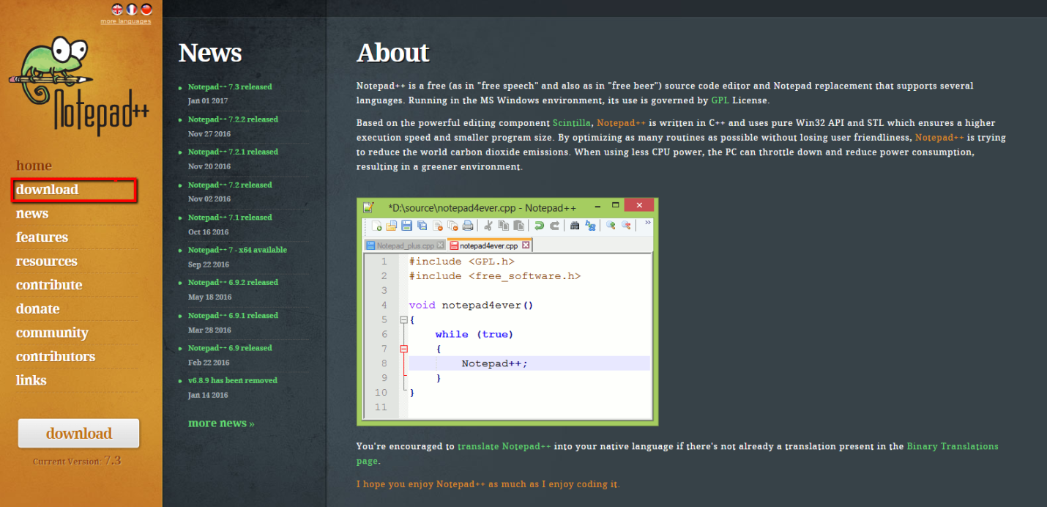

Once you clicked in that option you will be addressed to download section in which you need to click in the green button “download” in order to start the downloading. This will ask you to give the option on where you want to store the application installer, it is recommended to store the installer in Downloads folder in your PC, or any easy folder to find this file. Please take a look in the image below.

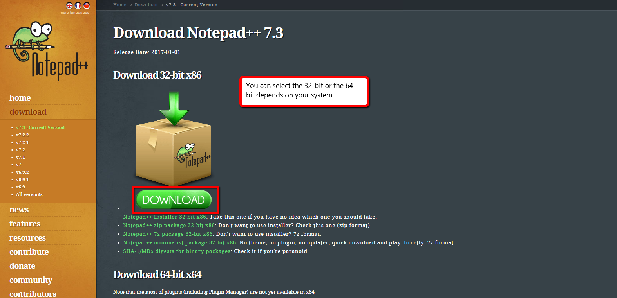

Then go to the folder where the installer was placed and double click on it. And the installation will start, just follow the step to install the basis.

Once the Notepad++ is installed, is time to download the XML Tools plugin for Notepad++. Please open Notepad++, in the main menu go to tab “Plugins”, then “Plugin Manager” and click on “Show Plugin Manager”. This action will open a new window with all the plugins available to install.

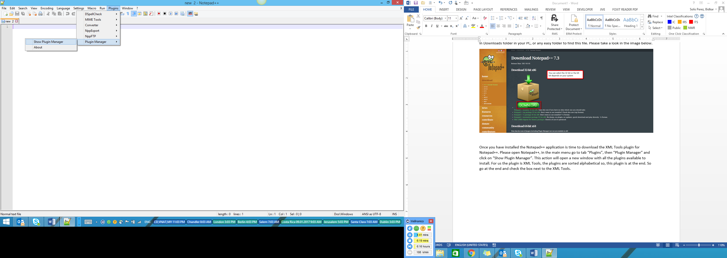

For us the plugin is XML Tools, the plugins are sorted alphabetical so, this plugin is at the bottom. So go at the bottom and check the box next to the XML Tools. Then after mark the checkbox, click on “Install” button and let the program to make the changes required to get the plugin available.

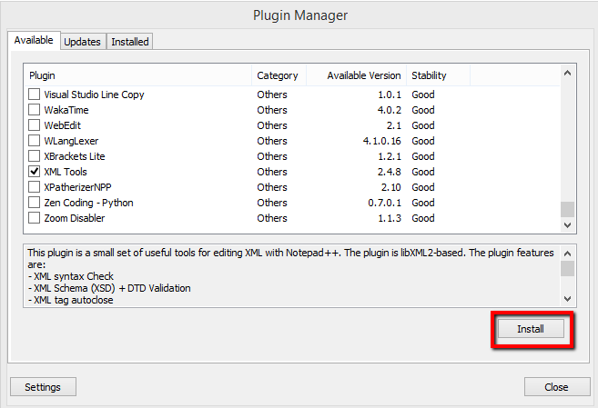

Then the installation will start.

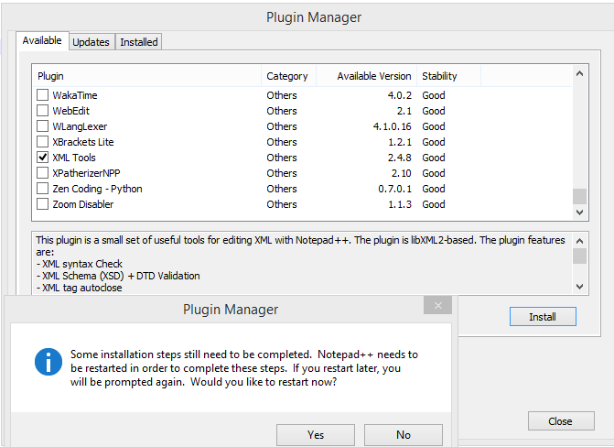

After installation wizard process is completed, the program will ask you a restart, click on Yes option to restart Notepad++ and then the plugin can be used.

This XML Tools plugin in can help you on:

1. Give a good visualization format to your XML file:

Using the option XML Tools-> Pretty Print function in order to format your XML in a pretty way. Or use the shortcut pressing *Ctrl+Alt+Shift+B*

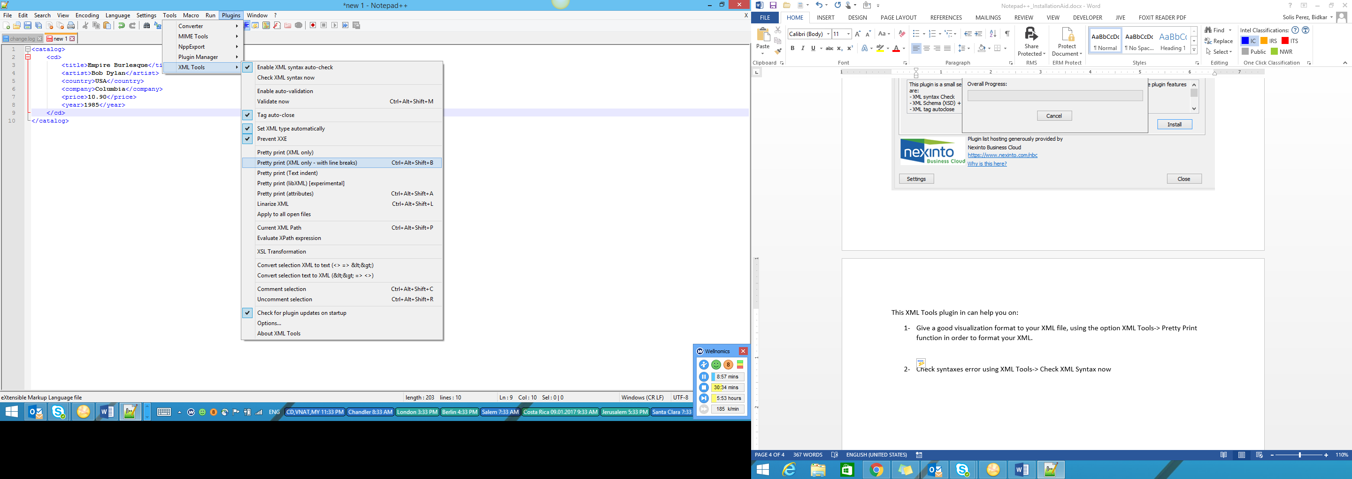

1. Check syntaxes error:

Using XML Tools-> Check XML Syntax now. This will help us on checking any syntaxes error in the XML file

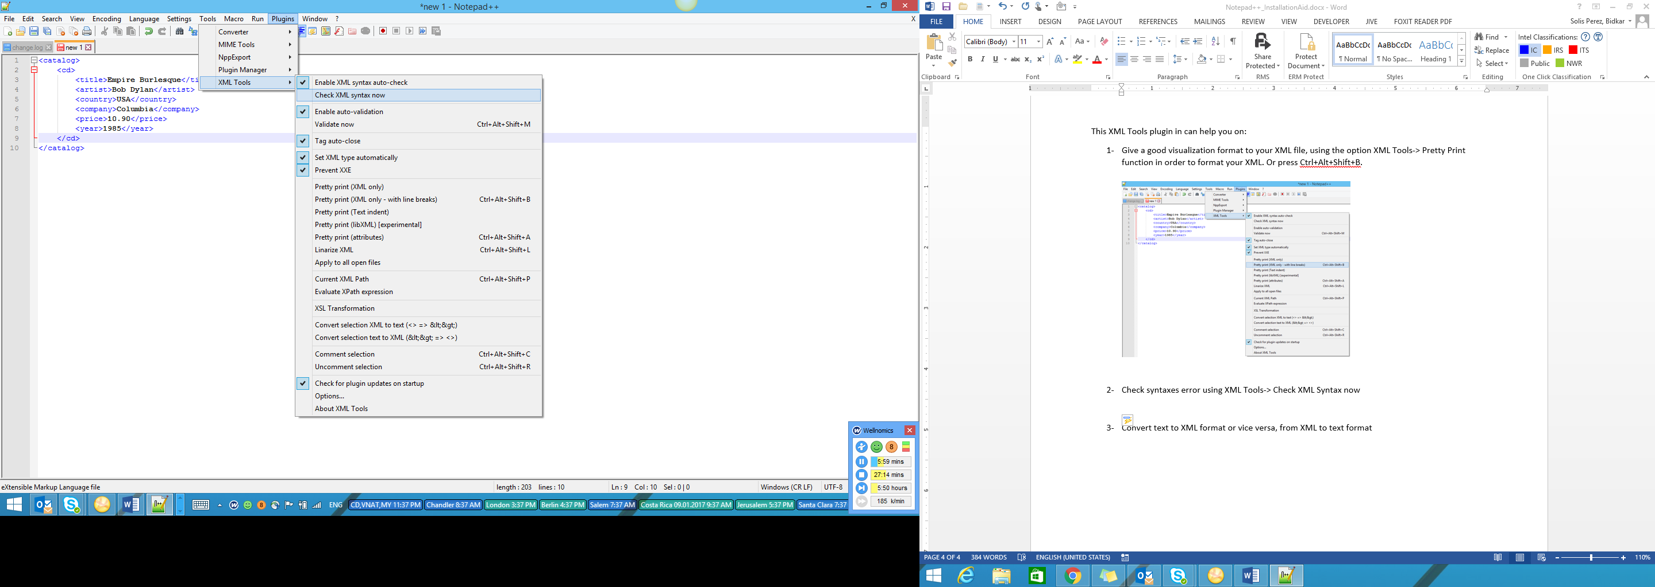

1. Validate an xml file with its respective schema:

Schema is like a template file where all the logic and tags for an XML are in there. The schema file use the file extension “xsd”. For example note.xsd, this xsd file is used to validate an xml file regarding his structure and logic. This mean, if a tag that is required, and is not in the file using. This capability will let you now that a tag is missed from your xml.

Another example, if the supplier forgot to close a tag, doing this validation is easy to catch this kind of mistake and then help to supplier to fix the xml closing the tag with the issue.

What is required to validate a file?

* XSD file
* XML file to validate

In notepad++ menu go to Plugins tab, then click on XML tools plugin and finally click on validate now. Or use the shortcut access ctrl+ alt + shift + M. Please see the image below. But something that is a must to do before validation is remove the string that is under xmlns in the first line highlighted in yellow: <QualityCertificateFile xmlns="x-schema:../Schema/ChemGasQualityCertificateSchema2001Jul.xml"> and replace with “http://www.intel.com/mqcs”.



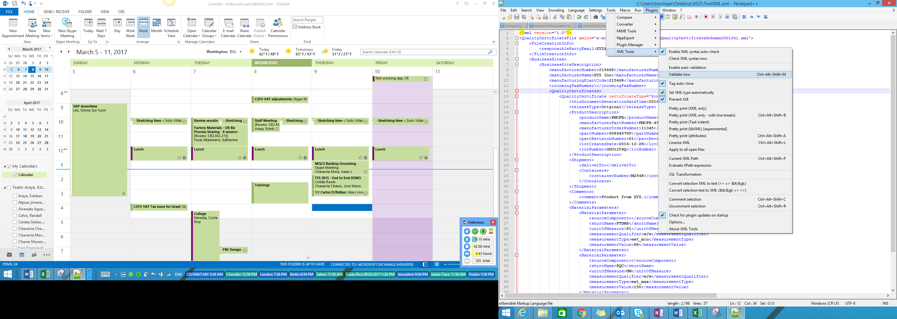

Once clicked the option validate now from XML tools menu, a new windows will appear requesting the XSD path. Please click in the three dots button in order to display a window to search the place where your XSD files is.

Then once you have selected the XSD file to use to validate the XML click on OK button and if ther is any issue a windows with error message will pop up and referencing what the issue is. Is no the windows will pop up a message as valid XML.

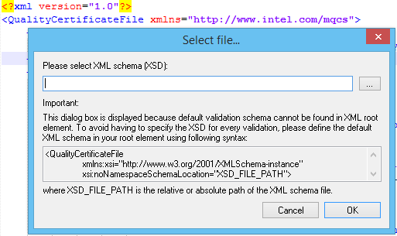

After XSD selected:

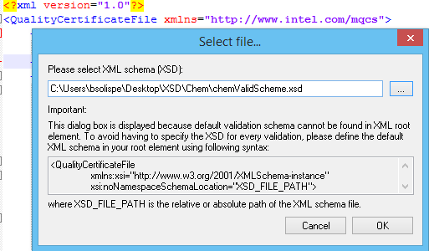

When que XML is correct, valid XML message will be displayed.

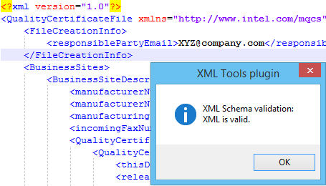

Now that was the happy path, then we are going to see couple of example on failures:

1. Premature tag closure

We have removed the “/” from tag <manufacturerName> the right wat is <manufacturerName>XYZ Inc</manufacturerName> and we have replaced in the file like this <manufacturerName>XYZ Inc<manufacturerName>. As you can see there is no close tag. This is an issue for XML, as you will see soon in the next capture.

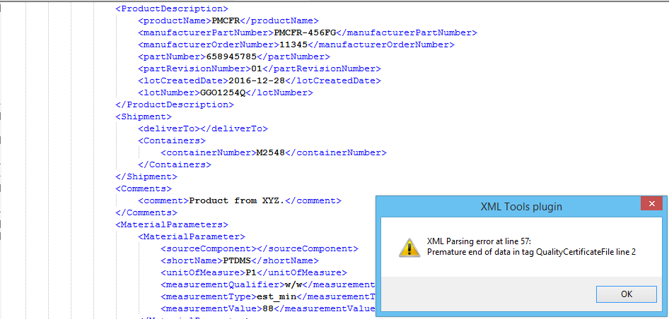

This mean that one tag was closed not properly. In order to fix this in line

1. Missed required tag

We have removed a required tag, also in XSD you can set which tag is a must and which are just optional. If the tag is required and is not in the xml, notepad plugin will trigger a failure message. As in the next capture below.

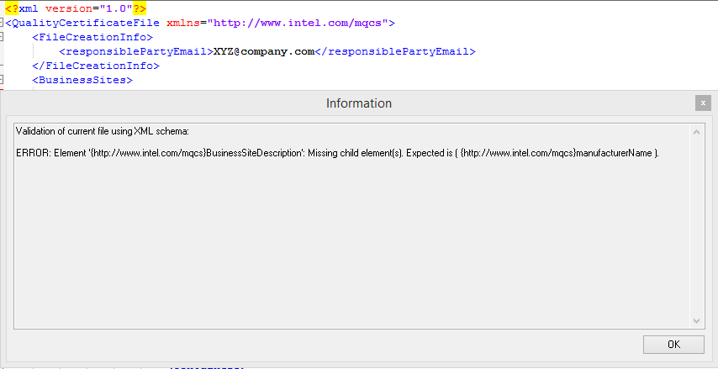

As we can see in the image above the message is regarding that one tag is missing a child tag, this tag in XSD is set as required tag.

# Appendix A - Frequently Asked Questions

|  |  |
| --- | --- |
| * + [Original vs. Replacement – <releaseType> tag](onenote:#Original%20vs.%20Replacement%20–%20%3creleaseType%3e%20tag&section-id={D3943D47-B4C8-4B7E-873A-B4133E2FCF24}&page-id={B4796360-D037-4B0D-BDA8-6798C6A787B1}&end&base-path=https://sharepoint.amr.ith.intel.com/sites/SNC-NonSAP-PS/MQCS/MQCS%20Documentation/Da) | 34 |
| * + [Intel part number and revision number](onenote:#Intel%20part%20number%20and%20revision%20number&section-id={D3943D47-B4C8-4B7E-873A-B4133E2FCF24}&page-id={BE5F349F-2049-4372-ABEC-476654915624}&end&base-path=https://sharepoint.amr.ith.intel.com/sites/SNC-NonSAP-PS/MQCS/MQCS%20Documentation/Data/Supplier) | 35 |
| * + [Destination at Intel - "deliver to" tag](onenote:#Destination%20at%20Intel%20-%20%22deliver%20to%22%20tag&section-id={D3943D47-B4C8-4B7E-873A-B4133E2FCF24}&page-id={E79BCB1A-617F-4554-B1EB-F01EE8379DEA}&end&base-path=https://sharepoint.amr.ith.intel.com/sites/SNC-NonSAP-PS/MQCS/MQCS%20Documentation/Data/) | 36 |
| * + [Material Parameter Tags](onenote:#Material%20Parameter%20Tags&section-id={D3943D47-B4C8-4B7E-873A-B4133E2FCF24}&page-id={494ED4E2-B484-4BA9-BEDB-97B01994A2D9}&end&base-path=https://sharepoint.amr.ith.intel.com/sites/SNC-NonSAP-PS/MQCS/MQCS%20Documentation/Data/Supplier%20Getting%20Started) | 37 |
| * + [Special Coding for Less Than and Greater Than](onenote:#Special%20Coding%20for%20Less%20Than%20and%20Greater%20Than&section-id={D3943D47-B4C8-4B7E-873A-B4133E2FCF24}&page-id={BEBF5A2F-D7A0-406B-9F12-EBDDA6A26780}&end&base-path=https://sharepoint.amr.ith.intel.com/sites/SNC-NonSAP-PS/MQCS/MQCS%20Documentation/D) | 39 |

### Original vs. Replacement – <releaseType> tag

The combination of Intel part number + supplier’s lot number (+ container number if applicable) is used to determine the uniqueness of a certificate. The first time a certificate for this unique combination is sent to Intel, the releaseType should be “00” for Original. The supplier can either send in a 2-digit numeric code (00 for Original) or the word Original. If the certificate had errors on it and the supplier wants to send in a replacement, then they can send the same Intel part number + supplier’s lot number combination but change the releaseType to “05” or the word “Replacement”. Intel’s application will accept the replacement certificate and also find the original certificate and mark it with verbiage saying that it has been replaced. If you are sending in certificates for PreShip items, then the 2-digit code for a Pre-Ship Original is 14 and the Replacement should be marked as Pre-Ship Replacement with the releaseType of “15”)

### Intel part number and revision number

The tag <partNumber> refers to the Intel part number. The next tag, <revisionNumber> refers to the revision of the Intel part number. The part number and revision number are listed on the top of the specification that was sent from Intel. The Intel Global Fab Materials department will update the revision number if a change needs to be made on the specification. The supplier will be notified in advance that a new revision of the specification has been created, and the new revisonNumber will need to be sent in the XML certificates.

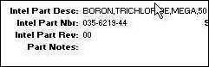

*Example of Intel specification showing Intel part information*

### Destination at Intel - "deliver to" tag

The tag <deliverTo> will be used by those suppliers who are sending Preship certificates only.

### Material Parameter Tags

For every Material Parameter line on the specification, there are a set of 6 XML tags that are required.

C:\8C6A0AE5\FEB25074-3222-4586-ABA9-58B7C48DE2A6_files\image003.jpg

*Example of Intel specification showing Material Parameter information*

### Source Component

If the spec shows a line that says: Source: Something then this information is required to be sent on the certificate. The tag is

<sourceComponent>put code here</sourceComponent>

You will need to check with Intel for a list of the appropriate codes. AE = Argon MIX = Mixture etc.  **If the spec doesn’t list a Source:Something line, then include the tags but leave it blank between them.**

### Material Parameter

The spec shows the material parameter code in the column TestCode. The tag is

<shortName>put code here</shortName>

For the above example, you would enter the code: **ZCD** for Carbon Dioxide. The list of valid material parameter values was sent to you in your packet in an excel spreadsheet.

### Specification Type

For most of the specs for ChemGas, you will be sending the value of: **Value** The tag is:

<measurementType>Value</measurementType>

Some of the specs for other commodities will require the suppliers to send in both a minimum and a maximum and other types such as standard deviation. Those suppliers would then send something besides the word “Value”. For EDI, this information used to be called the Measurement Significance Code (04-equal, 07-less than, etc).

### Actual Test Value

**In between these tags**

<measurementValue**>.4258**</ measurementValue>

you will enter the actual value of your test for this material parameter. For the above example, the spec said that your test on Carbon Dioxide must be less than the maximum of .5 You would enter here what your actual test value is which would hopefully be less than the max on the spec and you would pass. When the spec shows the word BALANCE as the value that you should send in, then put the word **Balance** here instead of a numeric value. For EDI, this information used to be called the Measurement Attribute (05-undectable, 09-pass, 22-fail, 40-balance). If your test result value is **undetectable**, then send in zeros for the value. You can also send in the words: **Pass**, or **Fail** when it is appropriate.

### Measurement Qualifier

The spec shows the measurement qualifier in the column Meas.Qual. The tag is

<measurementQualifier>put code here</measurementQualifier>

For the above example, you would enter **v/v** or VOL, both are acceptable.

### Unit of Measure

The spec shows the unit of measure in the column UofM. The tag is

<unitOfMeasure>put value here</unitOfMeaure>

For the above example, you would enter **ppm** for parts per million. The list of valid Unit of Measure values was sent to you in your packet in an excel spreadsheet.

### Special Coding for Less Than and Greater Than

If you need to send in values for a material parameter using the Less Than type of value or the Greater Than type of value, there is a special way to code this because XML will not allow you to use the > or < symbols. Instead of using the < or > symbols, you will need to change the value you send in the <measurementType> tag. Instead of sending the word “Value” as you do for an exact measurement, you send the word “est\_max” or “est\_min”.

Here's an example of how to send in the data instead of the LESS THAN:

|  |
| --- |
| <MaterialParameter>  <sourceComponent />  <shortName>ALP</shortName>  <unitOfMeasure>PP</unitOfMeasure>  <measurementQualifier>BW</measurementQualifier>  <measurementType>est\_max</measurementType>  <measurementValue>0.003</measurementValue>  </MaterialParameter> |

Here's an example of how to send in the data instead of the GREATER THAN:

|  |
| --- |
| <MaterialParameter>  <sourceComponent />  <shortName>ALP</shortName>  <unitOfMeasure>PP</unitOfMeasure>  <measurementQualifier>BW</measurementQualifier>  <measurementType>est\_min</measurementType>  <measurementValue>0.003</measurementValue>  </MaterialParameter> |

# Appendix B – XML Samples

Following, you can find the XMl samples for every one Intel Format XML accepted.

## ChemGas schema Sample

|  |
| --- |
| <QualityCertificateFilexmlns="x-schema:../Schema/ChemGasQualityCertificateSchema2001Jul.xml">  <FileCreationInfo>  <responsiblePartyEmail>xyzsupplier@xyz.com</responsiblePartyEmail>  </FileCreationInfo>  <BusinessSites>  <BusinessSiteDescription>  <manufacturerNumber>120254</manufacturerNumber>  <manufacturerName>XYZ Inc</manufacturerName>  <manufacturingPlantCode>12015</manufacturingPlantCode>  <incomingFaxNumber />  <QualityCertificates>  <QualityCertificatecertificateType="SingleCertificate">  <thisDocumentGenerationDateTime>2016-12-29T16:03:00</thisDocumentGenerationDateTime>  <releaseType>Original</releaseType>  <ProductDescription>  <productName>KMDDJA</productName>  <manufacturerPartNumber>KMDJA-31AD-50Y</manufacturerPartNumber>  <manufacturerOrderNumber />  <partNumber>50123654</partNumber>  <partRevisionNumber>01</partRevisionNumber>  <lotCreatedDate>2016-12-28</lotCreatedDate>  <lotNumber>KKJODQ</lotNumber>  </ProductDescription>  <Shipment>  <deliverTo />  <Containers>  <containerNumber>C12457</containerNumber>  </Containers>  </Shipment>  <Comments>  <comment>Product comments</comment>  </Comments>  <MaterialParameters>  <MaterialParameter>  <sourceComponent />  <shortName>LKMDJ</shortName>  <unitOfMeasure>UM</unitOfMeasure>  <measurementQualifier>w/w</measurementQualifier>  <measurementType>est\_min</measurementType>  <measurementValue>45</measurementValue>  </MaterialParameter>  <MaterialParameter>  <sourceComponent />  <shortName>DKS</shortName>  <unitOfMeasure>UM</unitOfMeasure>  <measurementQualifier>w/w</measurementQualifier>  <measurementType>est\_max</measurementType>  <measurementValue>100</measurementValue>  </MaterialParameter>  </MaterialParameters>  </QualityCertificate>  </QualityCertificates>  </BusinessSiteDescription>  </BusinessSites>  </QualityCertificateFile> |

## QMM Schema Sample

|  |
| --- |
| <QualityCertificateFilexmlns="x-schema:..\Schema\QMMQualityCertificateSchema2005Apr.xml">  <FileCreationInfo>  <responsiblePartyEmail>XYZcontact@xyz.com</responsiblePartyEmail>  </FileCreationInfo>  <BusinessSites>  <BusinessSiteDescription>  <manufacturerNumber>1012659</manufacturerNumber>  <manufacturerName>XYZ Inc</manufacturerName>  <manufacturingPlantCode>084530121</manufacturingPlantCode>  <QualityCertificates>  <QualityCertificatecertificateType="SingleCertificate">  <thisDocumentGenerationDateTime>2017-01-03T07:46:00</thisDocumentGenerationDateTime>  <releaseType>00</releaseType>  <ProductDescription>  <productName>Product1</productName>  <manufacturerPartNumber>100312654</manufacturerPartNumber>  <partNumber>100312654</partNumber>  <partRevisionNumber>02</partRevisionNumber>  <lotCreatedDate>2017-01-03</lotCreatedDate>  <lotNumber>1234567</lotNumber>  <serialNumber>16458</serialNumber>  </ProductDescription>  <Shipment>  <deliverTo>Site1</deliverTo>  <actualShipDate>2017-01-03</actualShipDate>  </Shipment>  <Comments>  <comment />  </Comments>  <MaterialParameters>  <MaterialParameter>  <characteristic>FuncSpec1</characteristic>  <shortName>A01</shortName>  <unitOfMeasure>mm</unitOfMeasure>  <Measurements>  <Measurement>  <measurementType>Value</measurementType>  <measurementValue>PASS</measurementValue>  </Measurement>  </Measurements>  </MaterialParameter>  <MaterialParameter>  <characteristic>FuncSpec1</characteristic>  <shortName>A02</shortName>  <unitOfMeasure>mm</unitOfMeasure>  <Measurements>  <Measurement>  <measurementType>Value</measurementType>  <measurementValue>2.2</measurementValue>  </Measurement>  </Measurements>  </MaterialParameter>  <MaterialParameter>  <characteristic>FuncSpec1</characteristic>  <shortName>A03</shortName>  <unitOfMeasure>mm</unitOfMeasure>  <Measurements>  <Measurement>  <measurementType>Value</measurementType>  <measurementValue>300</measurementValue>  </Measurement>  </Measurements>  </MaterialParameter>  </MaterialParameters>  </QualityCertificate>  </QualityCertificates>  </BusinessSiteDescription>  </BusinessSites>  </QualityCertificateFile> |

## Sillicon Sample

|  |
| --- |
| <QualityCertificateFilexmlns="x-schema:..\Schema\SiliconQualityCertificateSchema2001Apr.xml">  <FileCreationInfo>  <responsiblePartyEmail>XYZcontact@xyz.com</responsiblePartyEmail>  </FileCreationInfo>  <BusinessSites>  <BusinessSiteDescription>  <manufacturerNumber>1012659</manufacturerNumber>  <manufacturerName>XYZ Inc</manufacturerName>  <manufacturingPlantCode>3547</manufacturingPlantCode>  <QualityCertificates>  <QualityCertificatecertificateType="SingleCertificate">  <thisDocumentGenerationDateTime>2017-01-03T07:50:39</thisDocumentGenerationDateTime>  <releaseType>Original</releaseType>  <ProductDescription>  <productName>PID Wafers</productName>  <manufacturerPartNumber>SD457</manufacturerPartNumber>  <partNumber>1234-454-789</partNumber>  <partRevisionNumber>01</partRevisionNumber>  <drawingNumber>754-2458-07</drawingNumber>  <drawingRevisionNumber>01</drawingRevisionNumber>  <procurementSpec>M\_17-68-201-035</procurementSpec>  <procurementSpecRev>10</procurementSpecRev>  <purchaseOrderNumber>15489945</purchaseOrderNumber>  <purchaseOrderReleaseNumber>00</purchaseOrderReleaseNumber>  <Lots>  <Lot>  <lotNumber>Lot1</lotNumber>  <lotQuantity>25</lotQuantity>  </Lot>  <Lot>  <lotNumber>Lot2</lotNumber>  <lotQuantity>25</lotQuantity>  </Lot>  <Lot>  <lotNumber>Lot3</lotNumber>  <lotQuantity>25</lotQuantity>  </Lot>  </Lots>  </ProductDescription>  <Shipment>  <shipmentNumber>XAMLD.15468</shipmentNumber>  <shipmentQuantity>250</shipmentQuantity>  <scheduledShipDate>2016-12-29</scheduledShipDate>  <actualShipDate>2017-01-03</actualShipDate>  </Shipment>  <MaterialParameters>  <MaterialParameter>  <characteristic>Substrate</characteristic>  <shortName>Sub1</shortName>  <unitOfMeasure>OHM-CM</unitOfMeasure>  <Measurements>  <Measurement>  <measurementType>est\_avg</measurementType>  <measurementValue>0.0085</measurementValue>  </Measurement>  <Measurement>  <measurementType>est\_min</measurementType>  <measurementValue>0.008</measurementValue>  </Measurement>  <Measurement>  <measurementType>est\_max</measurementType>  <measurementValue>0.0093</measurementValue>  </Measurement>  <Measurement>  <measurementType>est\_stds</measurementType>  <measurementValue>0.00050</measurementValue>  </Measurement>  <Measurement>  <measurementType>nsites</measurementType>  <measurementValue>1</measurementValue>  </Measurement>  <Measurement>  <measurementType>nwafers</measurementType>  <measurementValue>317</measurementValue>  </Measurement>  </Measurements>  </MaterialParameter>  <MaterialParameter>  <characteristic>Substrate</characteristic>  <shortName>Sub2</shortName>  <unitOfMeasure>micron</unitOfMeasure>  <Measurements>  <Measurement>  <measurementType>est\_avg</measurementType>  <measurementValue>774.728</measurementValue>  </Measurement>  <Measurement>  <measurementType>est\_min</measurementType>  <measurementValue>771.1108</measurementValue>  </Measurement>  <Measurement>  <measurementType>est\_max</measurementType>  <measurementValue>775.7264</measurementValue>  </Measurement>  <Measurement>  <measurementType>est\_stds</measurementType>  <measurementValue>0.6372</measurementValue>  </Measurement>  <Measurement>  <measurementType>nsites</measurementType>  <measurementValue>1</measurementValue>  </Measurement>  <Measurement>  <measurementType>nwafers</measurementType>  <measurementValue>317</measurementValue>  </Measurement>  </Measurements>  </MaterialParameter>  <MaterialParameter>  <characteristic>EPIX</characteristic>  <shortName>EPIX1</shortName>  <unitOfMeasure>micron</unitOfMeasure>  <Measurements>  <Measurement>  <measurementType>est\_avg</measurementType>  <measurementValue>2.739</measurementValue>  </Measurement>  <Measurement>  <measurementType>est\_min</measurementType>  <measurementValue>2.713</measurementValue>  </Measurement>  <Measurement>  <measurementType>est\_max</measurementType>  <measurementValue>2.783</measurementValue>  </Measurement>  <Measurement>  <measurementType>est\_stds</measurementType>  <measurementValue>0.0175</measurementValue>  </Measurement>  <Measurement>  <measurementType>nsites</measurementType>  <measurementValue>1</measurementValue>  </Measurement>  <Measurement>  <measurementType>nwafers</measurementType>  <measurementValue>90</measurementValue>  </Measurement>  </Measurements>  </MaterialParameter>  <MaterialParameter>  <characteristic>EPIX2</characteristic>  <shortName>EPIX2</shortName>  <unitOfMeasure>Atoms/cm^3</unitOfMeasure>  <Measurements>  <Measurement>  <measurementType>est\_avg</measurementType>  <measurementValue>9.95E15</measurementValue>  </Measurement>  <Measurement>  <measurementType>est\_min</measurementType>  <measurementValue>9.43E15</measurementValue>  </Measurement>  <Measurement>  <measurementType>est\_max</measurementType>  <measurementValue>1.05E16</measurementValue>  </Measurement>  <Measurement>  <measurementType>est\_stds</measurementType>  <measurementValue>3.37E14</measurementValue>  </Measurement>  <Measurement>  <measurementType>nsites</measurementType>  <measurementValue>1</measurementValue>  </Measurement>  <Measurement>  <measurementType>nwafers</measurementType>  <measurementValue>90</measurementValue>  </Measurement>  </Measurements>  </MaterialParameter>  <MaterialParameter>  <characteristic>Wafer1</characteristic>  <shortName>Wafer1</shortName>  <unitOfMeasure>micron</unitOfMeasure>  <Measurements>  <Measurement>  <measurementType>50%</measurementType>  <measurementValue>0.1481</measurementValue>  </Measurement>  <Measurement>  <measurementType>80%</measurementType>  <measurementValue>0.1641</measurementValue>  </Measurement>  <Measurement>  <measurementType>95%</measurementType>  <measurementValue>0.1903</measurementValue>  </Measurement>  <Measurement>  <measurementType>99%</measurementType>  <measurementValue>0.213</measurementValue>  </Measurement>  <Measurement>  <measurementType>est\_avg</measurementType>  <measurementValue>0.149</measurementValue>  </Measurement>  <Measurement>  <measurementType>est\_stds</measurementType>  <measurementValue>0.0226</measurementValue>  </Measurement>  <Measurement>  <measurementType>nsites</measurementType>  <measurementValue>1</measurementValue>  </Measurement>  <Measurement>  <measurementType>nwafers</measurementType>  <measurementValue>317</measurementValue>  </Measurement>  <Measurement>  <measurementType>est\_max</measurementType>  <measurementValue>0.2345</measurementValue>  </Measurement>  </Measurements>  </MaterialParameter>  <MaterialParameter>  <characteristic>Wafer2</characteristic>  <shortName>Wafer2</shortName>  <unitOfMeasure>LPD/Wafer</unitOfMeasure>  <Measurements>  <Measurement>  <measurementType>50%</measurementType>  <measurementValue>0</measurementValue>  </Measurement>  <Measurement>  <measurementType>80%</measurementType>  <measurementValue>0</measurementValue>  </Measurement>  <Measurement>  <measurementType>95%</measurementType>  <measurementValue>1</measurementValue>  </Measurement>  <Measurement>  <measurementType>99%</measurementType>  <measurementValue>2</measurementValue>  </Measurement>  <Measurement>  <measurementType>est\_avg</measurementType>  <measurementValue>0.1640</measurementValue>  </Measurement>  <Measurement>  <measurementType>est\_stds</measurementType>  <measurementValue>0.40360</measurementValue>  </Measurement>  <Measurement>  <measurementType>nsites</measurementType>  <measurementValue>1</measurementValue>  </Measurement>  <Measurement>  <measurementType>nwafers</measurementType>  <measurementValue>317</measurementValue>  </Measurement>  <Measurement>  <measurementType>est\_max</measurementType>  <measurementValue>2</measurementValue>  </Measurement>  </Measurements>  </MaterialParameter>  </MaterialParameters>  </QualityCertificate>  </QualityCertificates>  </BusinessSiteDescription>  </BusinessSites>  </QualityCertificateFile> |

## Control Limits 2016 Schema Sample

|  |
| --- |
| <QualityCertificateFilexmlns="x-schema:../Schema/UltQualityCertificateSchema2016Dec.xml">  <!-- 2016 schema -->  <FileCreationInfo>  <responsiblePartyEmail>Joe.Schmoe@supplier.com</responsiblePartyEmail>  </FileCreationInfo>  <BusinessSites>  <BusinessSiteDescription>  <manufacturerNumber>000000</manufacturerNumber>  <manufacturerName>My Supplier Company, Inc.</manufacturerName>  <manufacturingPlantCode>000000</manufacturingPlantCode>  <incomingFaxNumber>(800) 555-1212</incomingFaxNumber>  <QualityCertificates>  <QualityCertificatecertificateType="SingleCertificate">  <thisDocumentGenerationDateTime>2000-12-25T12:01:12</thisDocumentGenerationDateTime>  <releaseType>Original</releaseType>  <ProductDescription>  <productName>Description of the product</productName>  <manufacturerPartNumber>ABC123</manufacturerPartNumber>  <manufacturerOrderNumber>021111001</manufacturerOrderNumber>  <partNumber>035-0000-01</partNumber>  <partRevisionNumber>05</partRevisionNumber>  <lotCreatedDate>2000-12-25</lotCreatedDate>  <lotNumber>0000123</lotNumber>  </ProductDescription>  <Shipment>  <deliverTo>F11</deliverTo>  <Containers>  <containerNumber>A123456</containerNumber>  <containerNumber>A234567</containerNumber>  </Containers>  </Shipment>  <Comments>  <comment>This certificate data is made up.</comment>  </Comments>  <MaterialParameters>  <MaterialParameter>  <RawLotID>value(alpha-numeric)</RawLotID>  <RawMaterialType>value(alpha-numberic, e.g. KOH)</RawMaterialType>  <sourceComponent />  <shortName>BA</shortName>  <unitOfMeasure>PPB</unitOfMeasure>  <measurements>  <measurement>  <measurementType>value</measurementType>  <measurementValue>5</measurementValue>  <UCL>value</UCL>  <LCL>value</LCL>  <MDL>value</MDL>  <CLCalc>text(menu)</CLCalc>  <!-- Temp, Eng, Short-run, Analytical, Mean-sigma, Percentile, Curve-fitted -->  </measurement>  </measurements>  </MaterialParameter>  <MaterialParameter>  <RawLotID>value(alpha-numeric)</RawLotID>  <RawMaterialType>value(alpha-numberic, e.g. KOH)</RawMaterialType>  <sourceComponent />  <shortName>BA</shortName>  <unitOfMeasure>PPB</unitOfMeasure>  <measurements>  <measurement>  <measurementType>value</measurementType>  <measurementValue>5</measurementValue>  <UCL>value</UCL>  <LCL>value</LCL>  <MDL>value</MDL>  <CLCalc>text(menu)</CLCalc>  <!-- Temp, Eng, Short-run, Analytical, Mean-sigma, Percentile, Curve-fitted -->  </measurement>  </measurements>  </MaterialParameter>  </MaterialParameters>  </QualityCertificate>  </QualityCertificates>  </BusinessSiteDescription>  </BusinessSites>  </QualityCertificateFile> |