**Design**

**LANDING PAGE**

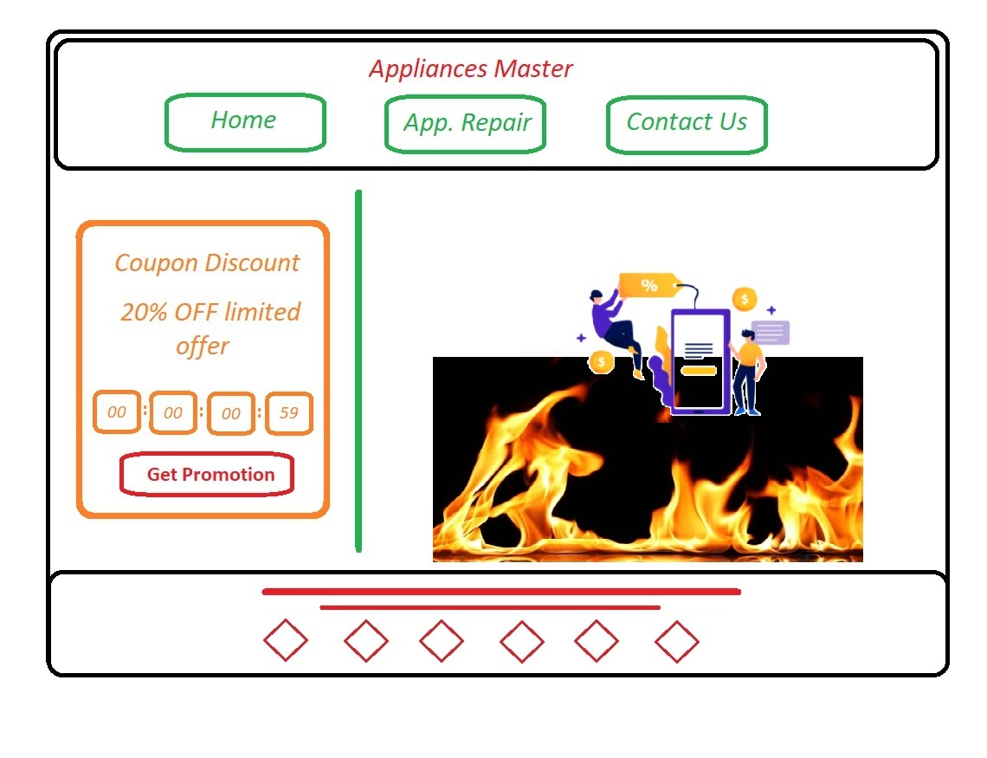

**APPLIANCES REPAIR PAGE**

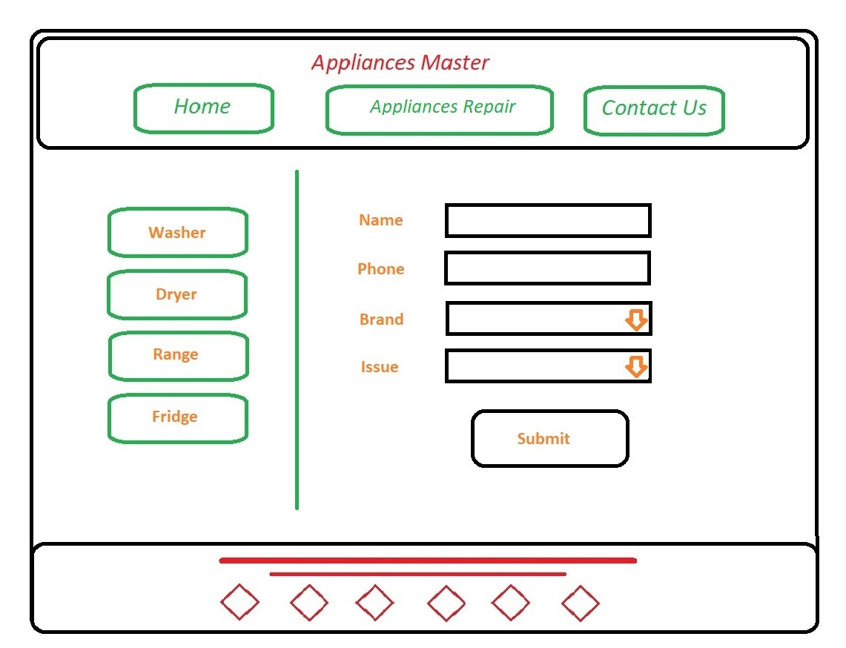

**FORM QUOTE PAGE**

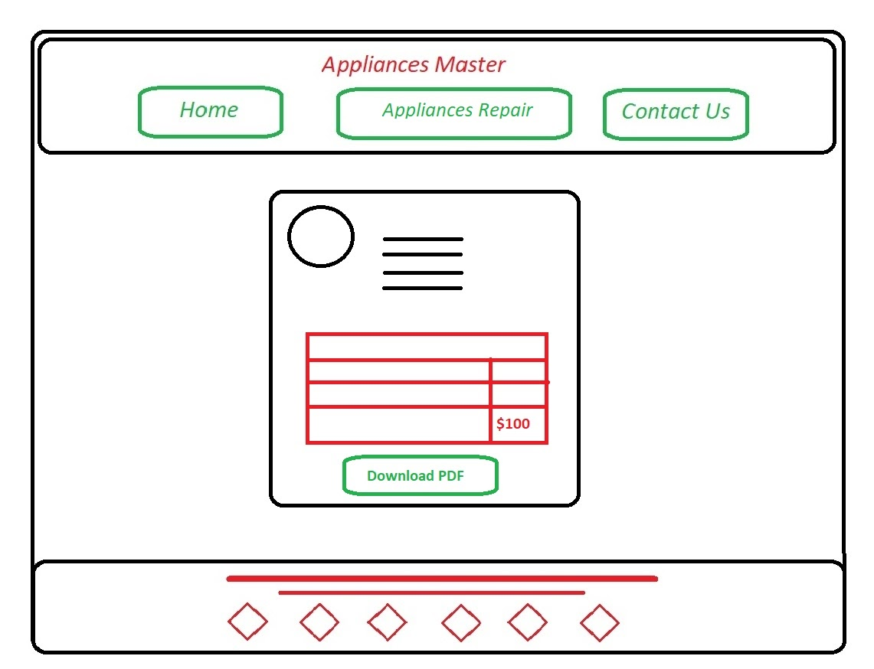

**CONTACT US PAGE**

