On index page the logo is Hyperlink to :

<http://arg.napier.ac.uk>

All the rest of the pages have links to index page

Hyperlink to :

Login/register page

If already logged in link to users page

Same for all the pages

Search provide the link to the result page, with users search result

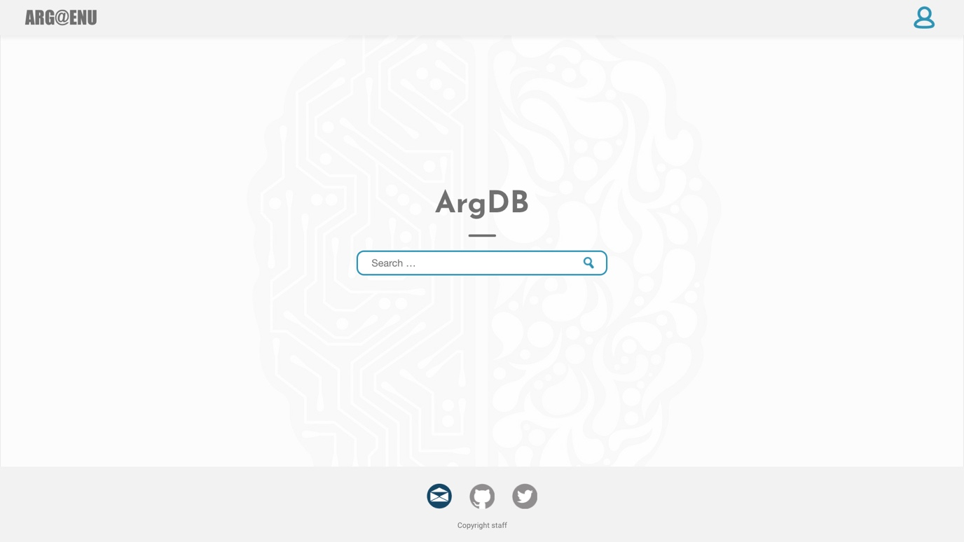

Icons change to navy blue on hover

Social media links

Envelope for clients email

Second for clients github

Third clients twitter

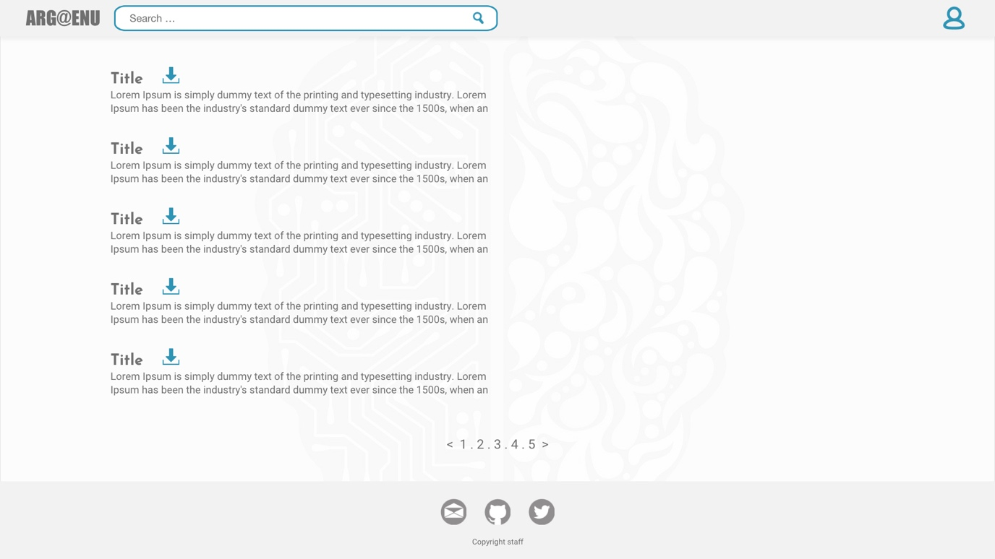

Search provide the link to the result page, with users search result.

Same for the rest of the pages

Short description of the argument

Pagination for the results.

Only 5 results shown on one page

Download icon instantly download the item

Title for the link send to a specific product page.

­­­

Download icon instantly download the item

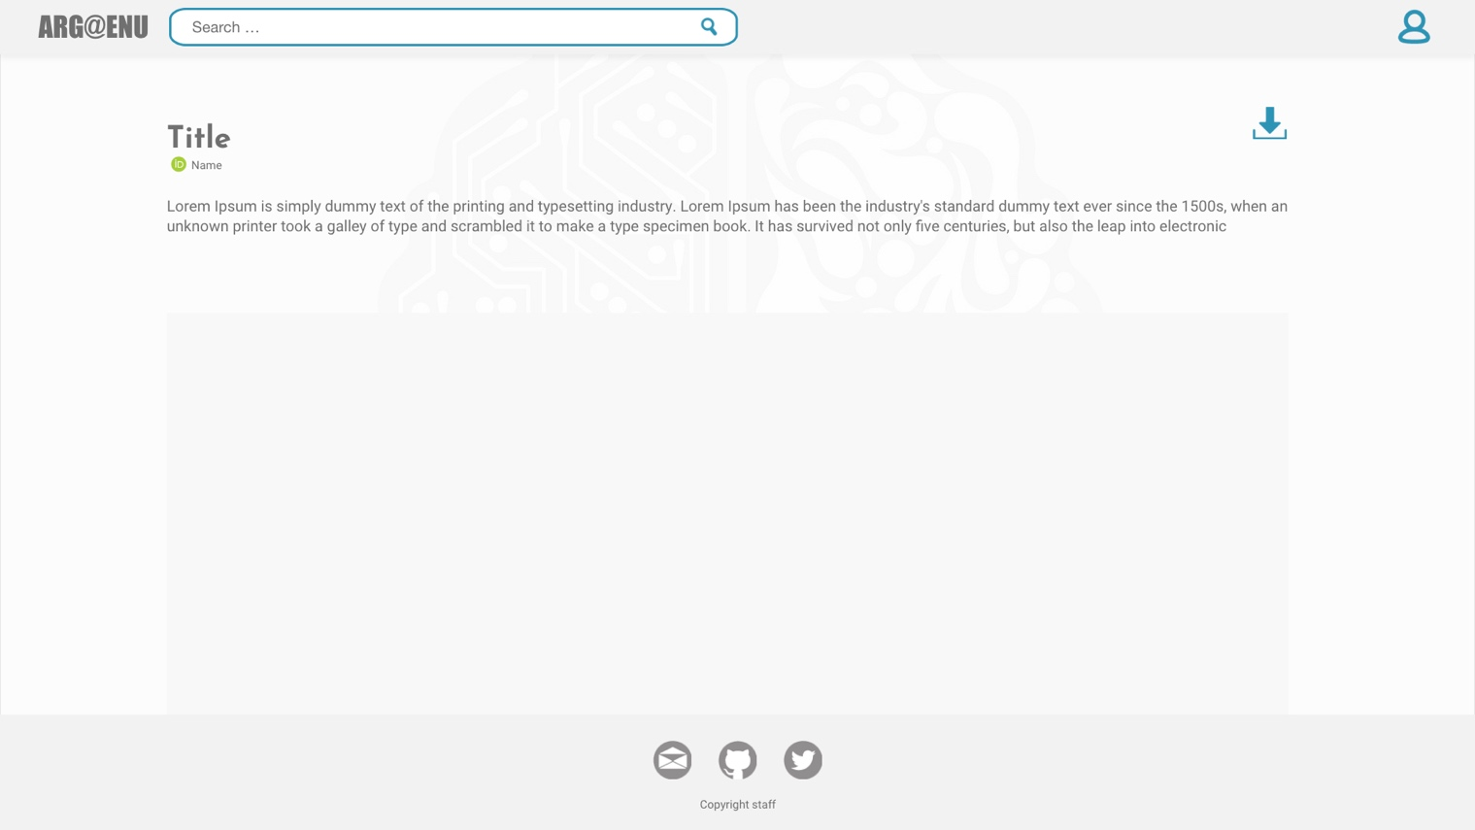

Argument description

Title of the argument

Name of the user who uploaded the argument.

Id logo appears only if user has orcid id uploaded

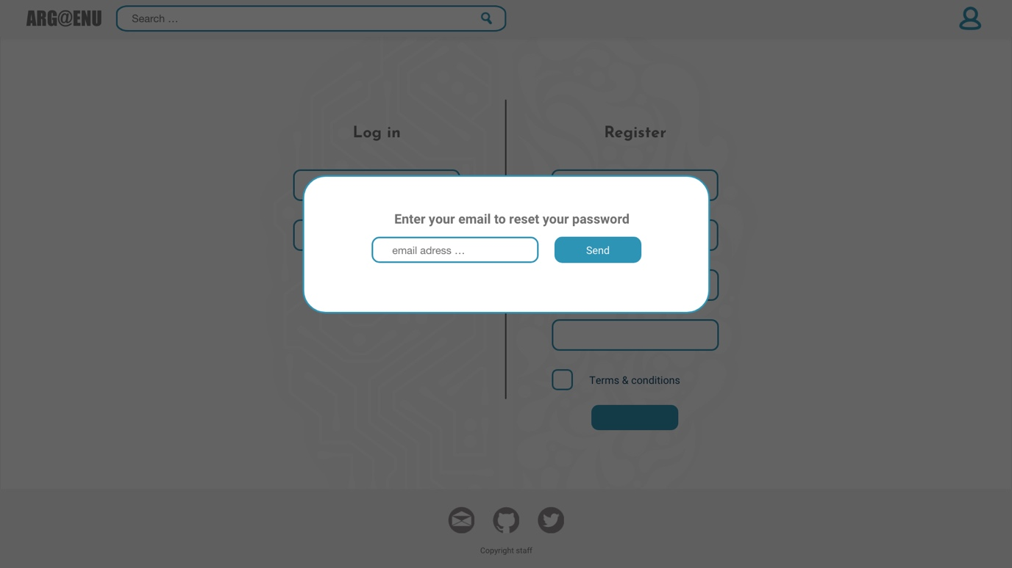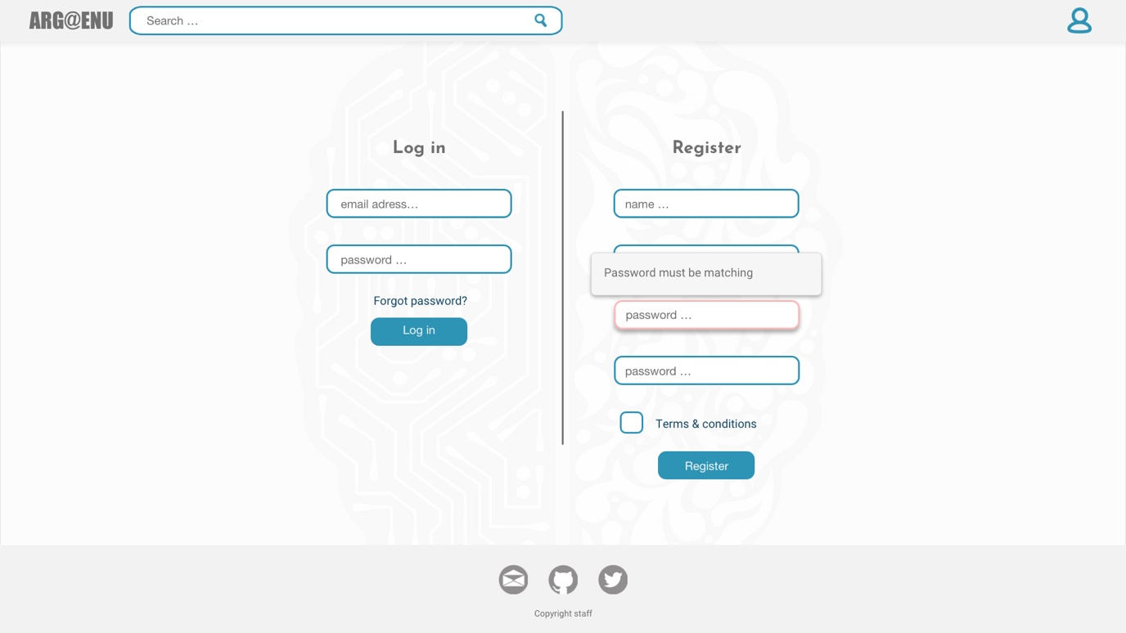

Once logged in links to users page.

Password input (when user is inputting the letters its shown as stars)

Pop up alert once pressed on the form input.

Alert will display what is requirements for the input.

Button to forgotten password pop up

All form inputs have to be validated:

For users input (flag up red if it is empty)

All inputs required to be filled in

Email form has to be validated, to confirm it is an email.

Send a confirmation email to confirm.

Password must be validated (flag up red if it is empty or doesn’t match with the requirements)

Two matching password

Contain at least one uppercase, lowercase and number

Must contain from 8 to 16 characters

Link to terms and conditions

Check box for terms and conditions

Once email is entered and the button send is pressed

If email is found on the database, confirm the that email has been sent with a message “Password reset has been sent to your email”

If email has not been found on the database, confirm that with message “ your email is not registered”

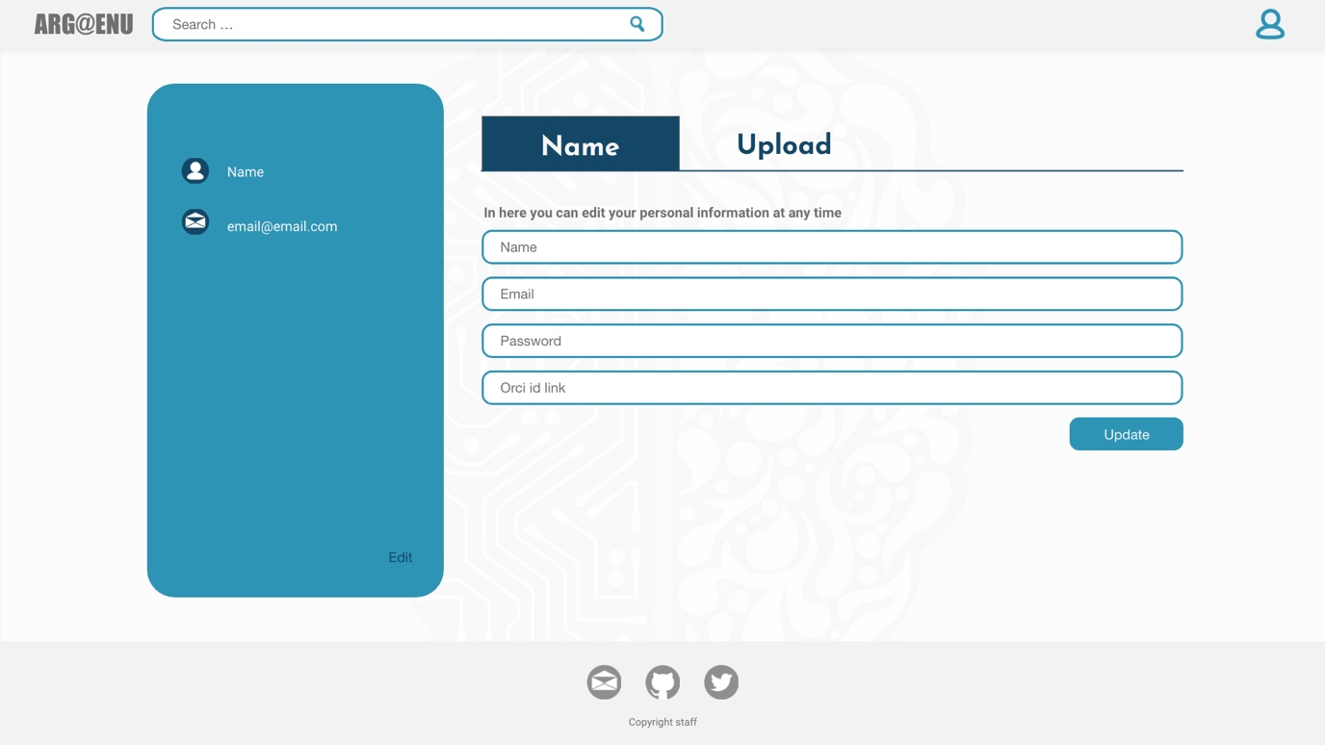

Form input as normal.

Orcid id not required to be filled in

Users name and email taken from database

Link to user upload page

A link to bring to user edit page.

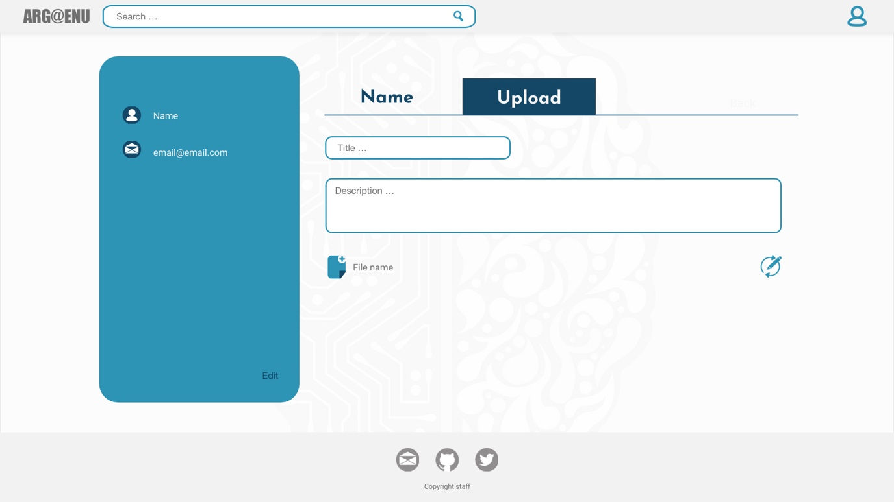

Title and description of the file, as requested has to be uploaded from the file. Once its uploaded, it can be edited

File upload to the database

Admin pages can be only accessed with appropriate credentials

First icon links to adminusersedit page

Second to delete the user data from database

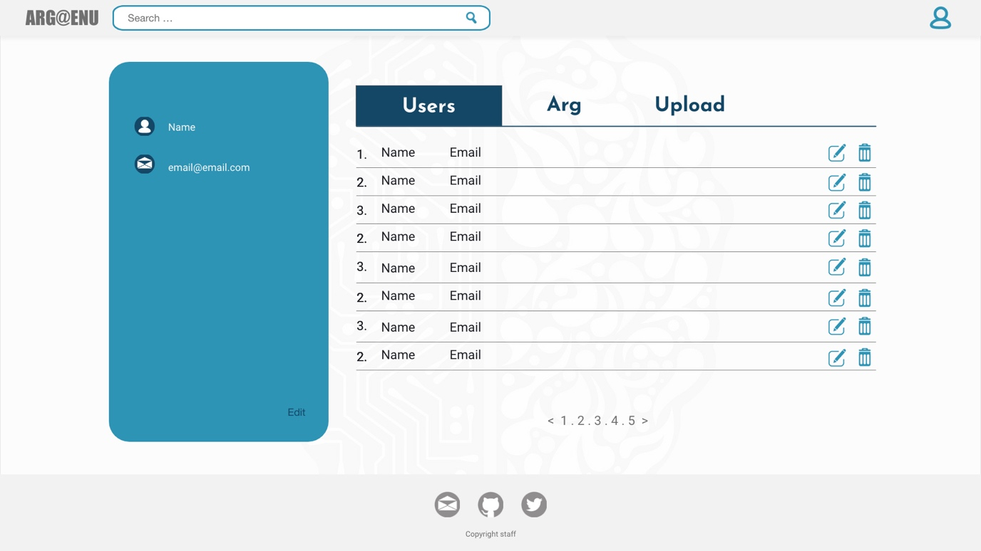

Hyperlink to adminarg page

Hyperlink to admin page

Hyperlink to adminulpoad page

Table to display registered users. All information on this table has to be gathered from database. Once pressed on element link to adminuseredit page

First. Number is unique account number,

Second. Name of the customer

Third. Email address

First icon links to adminusersedit page

Second for download the file

Third to delete data about argument from database

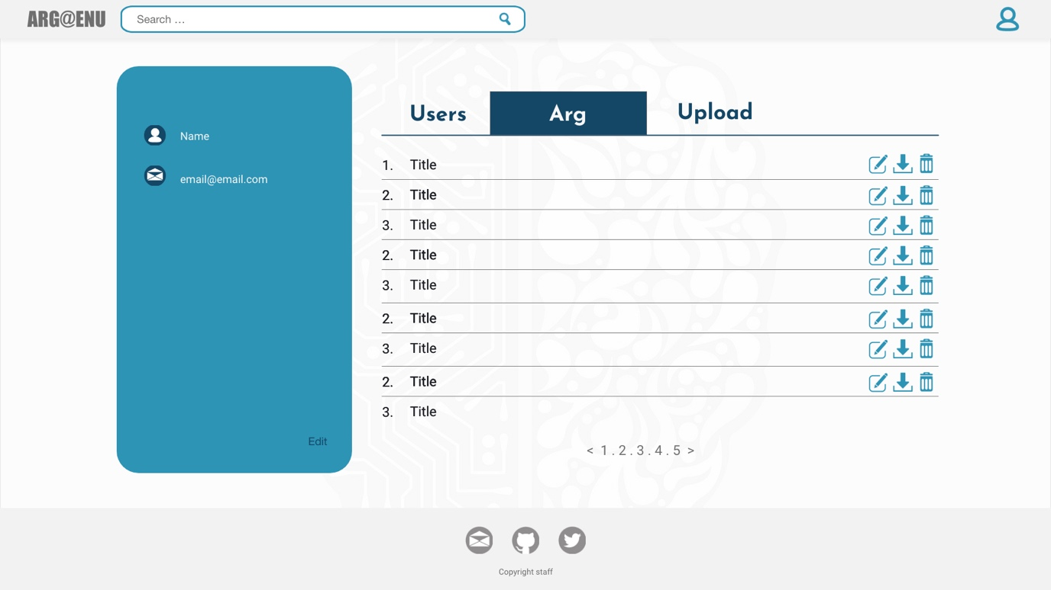

Table to displays uploaded arguments. All information on this table has to be gathered from database. Once pressed on the element link to adminargedit page

First.Unique argument number,

Second. Title of the argument

Third. Email address

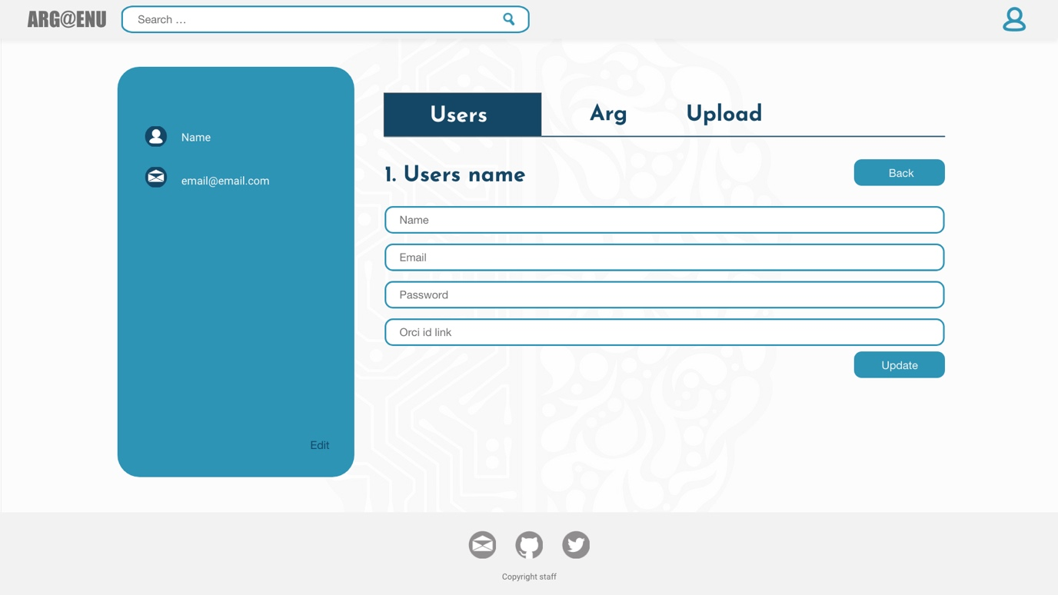

Update the database with new information

Back button, to go back to previous page

Users name taken from database

Unique account number taken from database

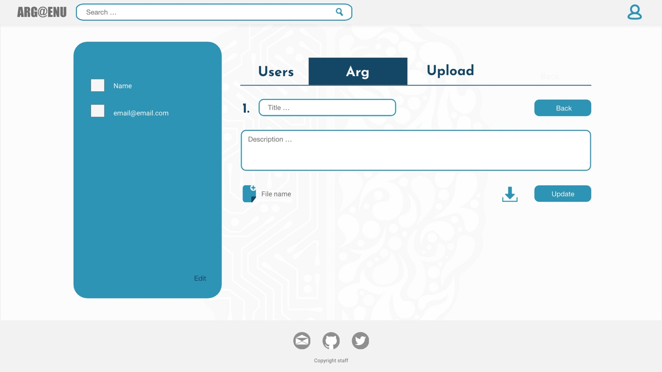

Update information

Download the file from database

File upload

Display the information about argument inside the form

Unique argument number

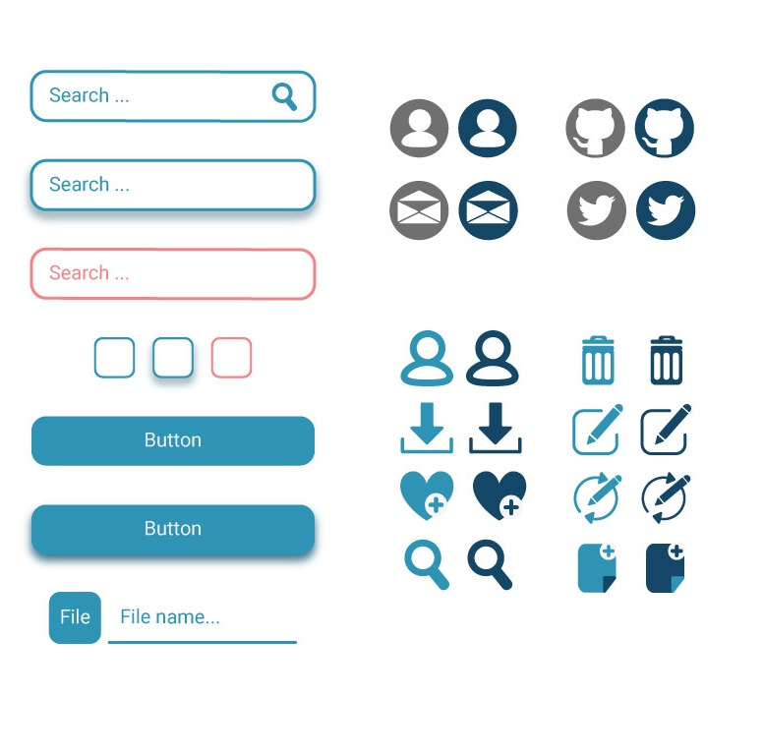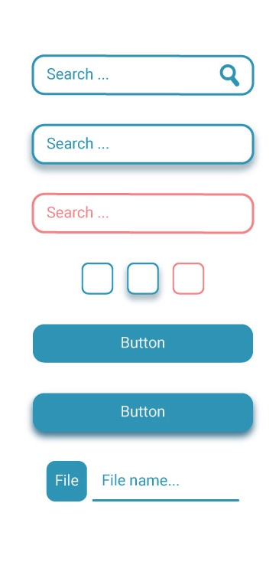

Icons displayed in grey and light blue are in stationary position

The navy blue is once mouse has been hover over or pressed

Input form has a 3px outline around it in colour

#2E94B5

The border corners have to the 15px rounded

Same applies to buttons

Button and input forms once hovered displays shadow