# Introduction

The product of this project is a prototype of an argument database, an open-source data repository website with an application programming interface. The prototype has to include a user-friendly web interface for searching the data repository and retrieving documents. Additionally, the website has to include login and register forms for users. Following the requirements provided by the client, Vaida is responsible for designing the website's interface and optimizing the user experience to create a simple, clear and easy to use website.

# Purpose

The purpose of the website is to provide students, researchers and lecturers with datastore of SADFace and JSON files that contain artificial intelligence arguments. The client wants this to be open source so that users can upload, retrieve and edit files.

# Scope

## Functional Requirements

A database that receives and stores user information and arguments in a format of SADFace, JSON files

User-friendly website API to interact with the database

Login/ Register System

Server/Website Security

Forgotten password system

## Non-functional requirements

Responsive and validated inputs for Login/ Register System

Cookies and terms and conditions

Validated website code (HTML, CSS, JAVASCRIPT, python, MongoDB)

Website to load in 3 seconds

Copyright images and icons

Appropriate colour scheme

# Methodology, Tools, and Techniques

The tools used to design website are Adobe Illustrator, Adobe XD, Adobe Photoshop and Microsoft Word.

For website development, the website will be using a customised bootstrap 4.0 framework to match the design.

# Audience

The intended audience of the website is divided into three groups:

Students - studying a relevant subject of artificial intelligence or computing, most likely in Napier University. Most likely using the website for academic purposes. The expected demographics of the audience are male, between 19-30 years of age, living and studying in Edinburgh, United Kingdom, with high experience in computing.

Researchers - the users of this group are interested in the relevant subject of artificial intelligence. Most likely to use the information for academic or research purposes. The expected demographics of the audience are between 30-60 years of age, living and working in the United Kingdom, with medium to high experience in computing.

Client (admin) - lectures in a relevant subject of artificial intelligence and computing, teaching students at Edinburgh Napier University. It is expected to use the website for maintenance, research and academic reasons. The expected demographics of the audience are male, between 30-40 years of age, living in Lothian region, United Kingdom, with high experience in computing.

# Design

## Design choices

The website's purpose is for the user to upload and download files from the datastore to their personal computer and upload their personal data to the database of the website. In today's day and age, users will not share data unless they feel secure about the vendor. For the website to be a success, the website has to create a trustworthy relationship with its audience and connect with the users, communication is the key. Most of the communication that induces trust comes from non-verbal actions and contact. The Mehrabian rule suggests that only 7% comes from literal words.

To successfully achieve a trustworthy relationship with the user the website design follows the framework from existing meta-studies provided by (Karimov et al. 2011) around trust-inducing design features.

The focus of this design is affect-based trust, which is influenced by visual design. In one of the books by (Norman 2004) about emotional design, he talks about the significance of attractive design in inflicting the desired emotion for the product to be a success. Visual design utilises typography, photography, illustrations and colours to induce trust on the user. The first impression is usually determent by these elements, which leads towards the attitude the user will have on the website. Poor quality of graphical elements will inflict the user's attitude negatively, which leads to a lack of trust.

## Colours

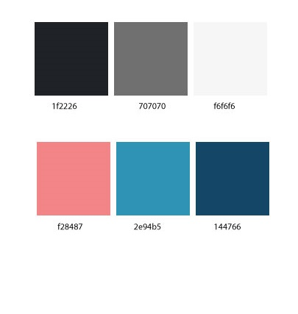Certain colours can evoke different emotions and feelings from a person, and a number of different researchers and experts support the believe that colour has an effect on someone's psychology. For the website to induce trust with a user, the colour blue was chosen as a primary colour. Blue is one of the colours often found in nature like a clear daytime sky or a rich, deep sea. This is one of the reasons people usually describe blue as a calm, secure and as a trustworthy colour. However, in some cases, the heavy use of the colour blue can formulate emotions of sadness or aloofness. To create the desired trustworthy environment for the website, the colour blue is used moderately to highlight

Figure 1 : Colour scheme of the website with corresponding hex code underneath

elements such as hyperlinks, icons and input forms.

To provide feedback on an error, including incorrect input into the form or incorrect password, the colour red is selected to alert the users. The colour is chosen to be less saturated so that the user feels comfortable and secure, as the bright red can signal danger and threat.

For the rest of the website, neutral colours such as light and dark greys are selected, to keep the website simple and modern.

## Typography

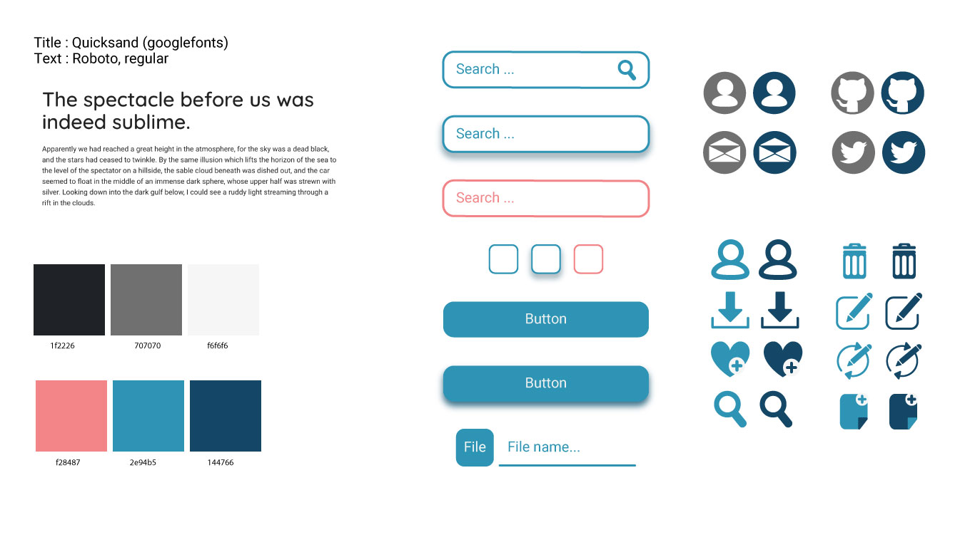While people have certain feelings associated with particular colours, the same thing could be stated regarding typography. For the design to convey a sense of trust and simplicity, the font family selected for this project is a sans serif font named Quicksand by google for titles and Robotics for body text. San serif fonts are clean, modern and symbolise a sense of honesty and judgment. The font does not contain distracting elements that could make it harder to read, and the edges are just slightly rounded to convey comfort. For the weight of the font, we have selected medium weight as it’s the most readable on a digital screen.

## Icons, buttons and input forms

For the website to be cohesive with its visual hierarchy, Vaida has created a set of icons to be used free of copyrights. The icons, buttons and input forms are designed to be slightly rounded to match with the font of the website and to convey a sense of comfort.

## Background

To convey the idea of artificial intelligence in a non-verbal way, the website uses a flat vector image of a human brain with computer components. This way the website conveys that idea in a clear and descriptive visual manner.

Figure 2: Icons design by Vaida Mastaraite

# Detailed wireframes

On index page the logo is Hyperlink to :

<http://arg.napier.ac.uk>

All the rest of the pages have links to index page

Hyperlink to:

Login/register page

If already logged in link to user’s page

Same for all the pages

Search provide the link to the result page, with users search result

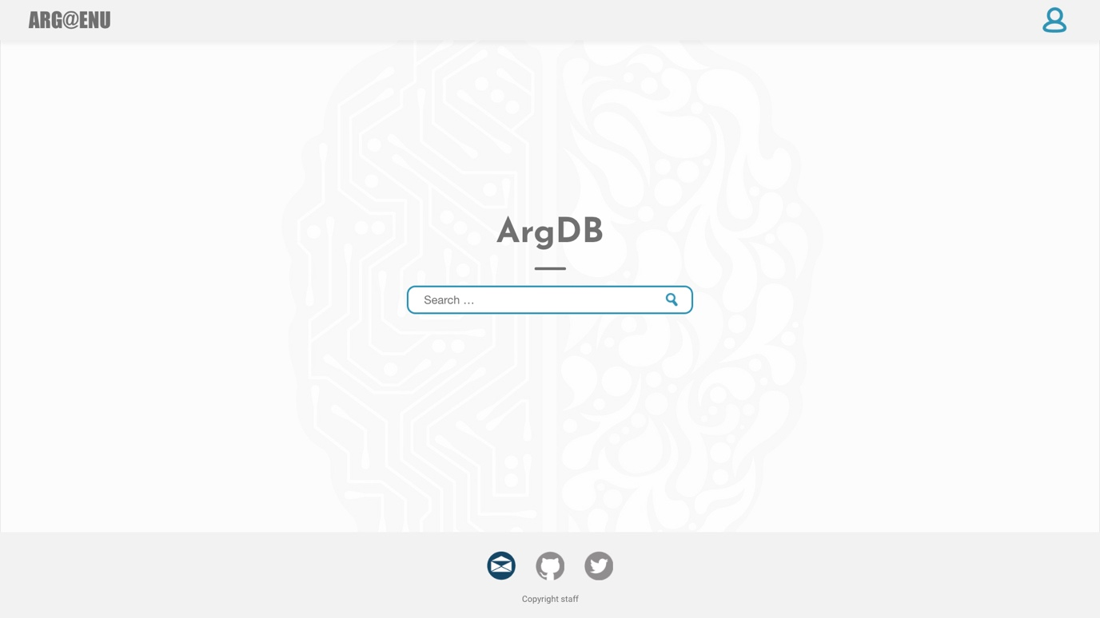

Icons change to navy blue on hover

Social media links

Envelope for client’s email

Second for clients GitHub

Third clients Twitter

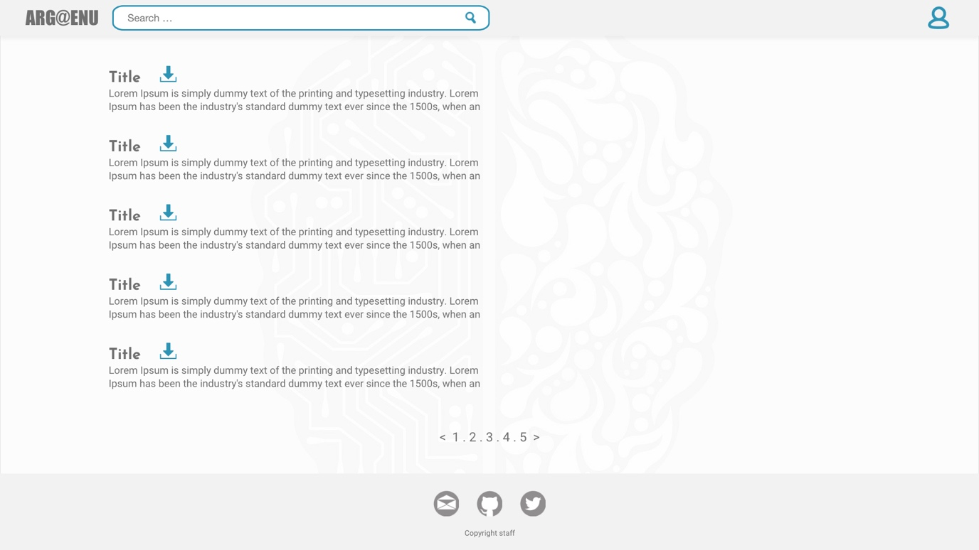

Search provide the link to the result page, with users search result.

Same for the rest of the pages

Short description of the argument

Pagination for the results.

Only 5 results shown on one page

Download icon instantly download the item

Title for the link send to a specific product page.

­­­

Download icon instantly download the item

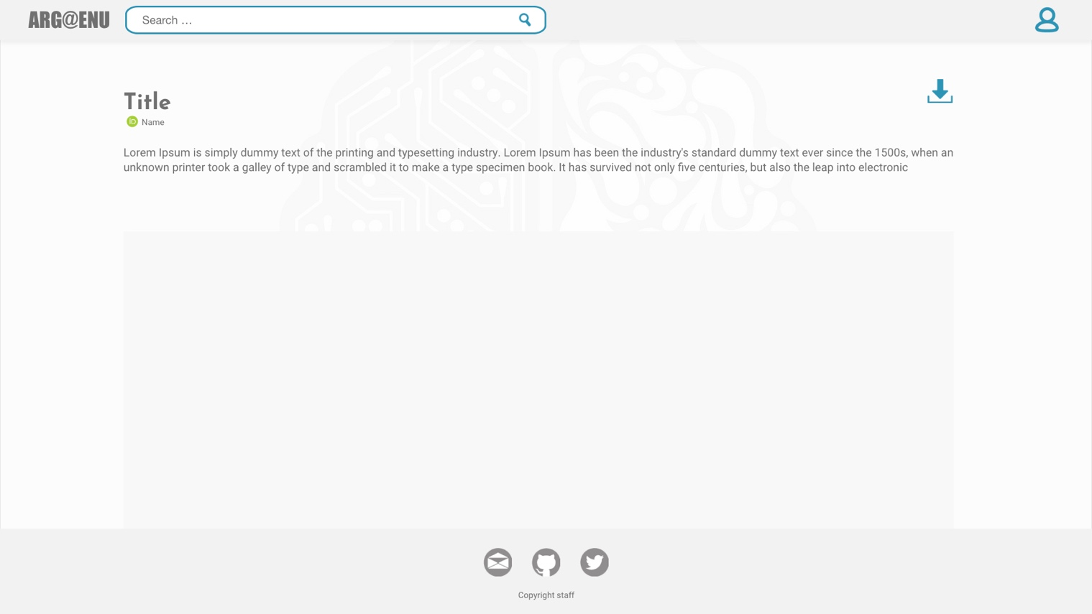

Argument description

Title of the argument

Name of the user who uploaded the argument.

Id logo appears only if user has Orcid id uploaded

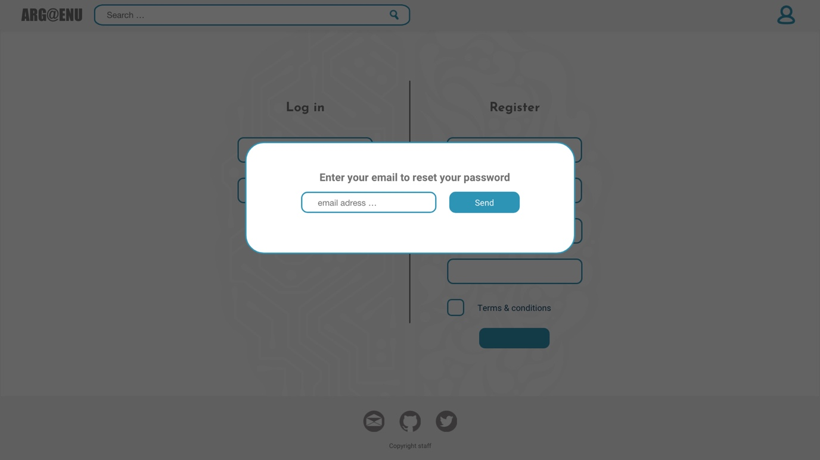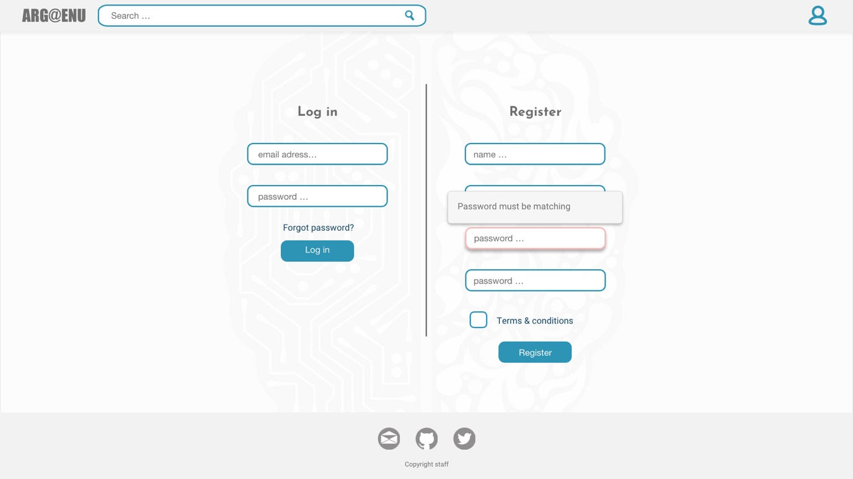

Once logged in links to users page.

Password input (when user is inputting the letters its shown as stars)

Pop up alert once pressed on the form input.

Alert will display what is requirements for the input.

Button to forgotten password pop up

All form inputs have to be validated:

For users input (flag up red if it is empty)

All inputs required to be filled in

Email form has to be validated, to confirm it is an email.

Send a confirmation email to confirm.

Password must be validated (flag up red if it is empty or doesn’t match with the requirements)

Two matching passwords

Contain at least one uppercase, lowercase and number

Must contain from 8 to 16 characters

Link to terms and conditions

Check box for terms and conditions

Once email is entered and the button send is pressed

If email is found on the database, confirm the that email has been sent with a message “Password reset has been sent to your email”

If email has not been found on the database, confirm that with message “ your email is not registered”

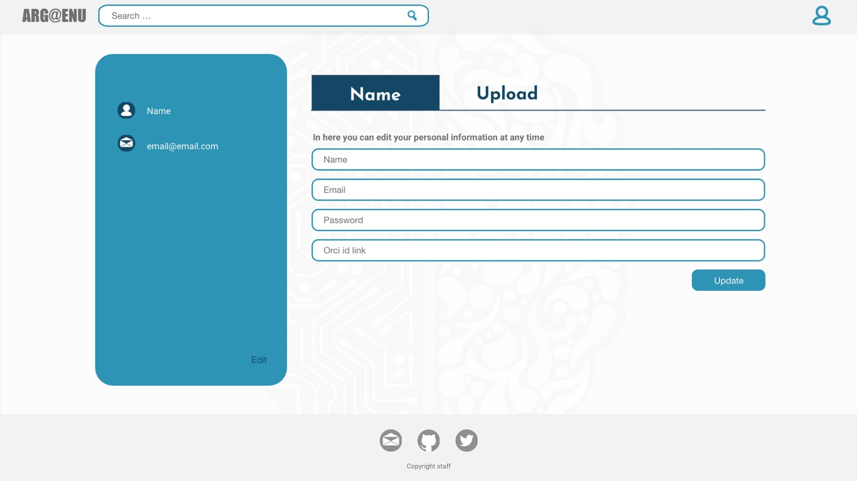

Form input as normal.

Orcid id not required to be filled in

Users name and email taken from database

Link to user upload page

A link to bring to user edit page.

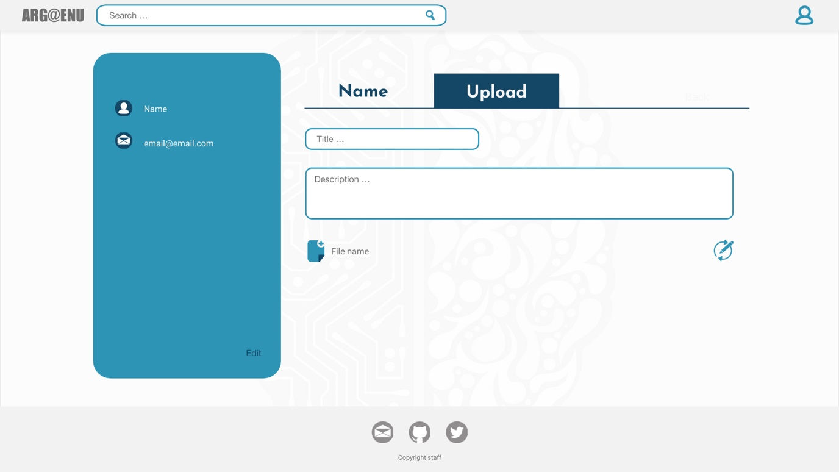

Title and description of the file, as requested has to be uploaded from the file. Once its uploaded, it can be edited

File upload to the database

Admin pages can be only accessed with appropriate credentials

First icon links to adminusersedit page

Second to delete the user data from database

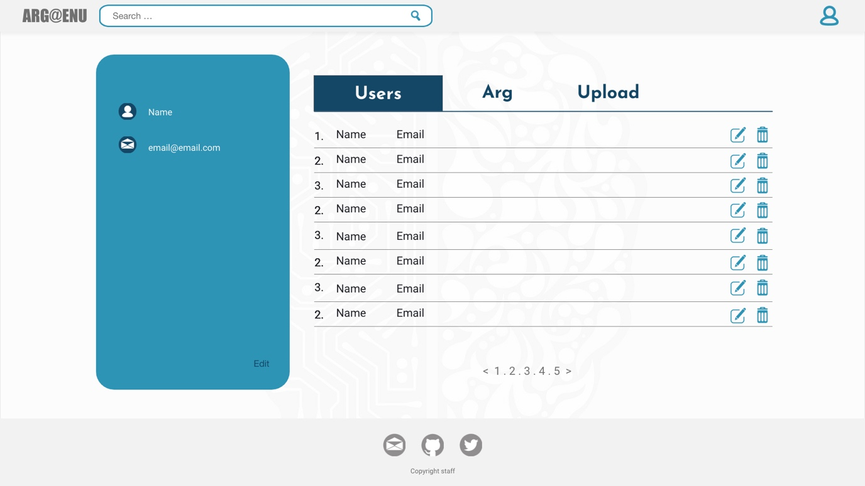

Hyperlink to adminarg page

Hyperlink to admin page

Hyperlink to adminulpoad page

Table to display registered users. All information on this table has to be gathered from database. Once pressed on element link to adminuseredit page

First. Number is unique account number,

Second. Name of the customer

Third. Email address

First icon links to adminusersedit page

Second for download the file

Third to delete data about argument from database

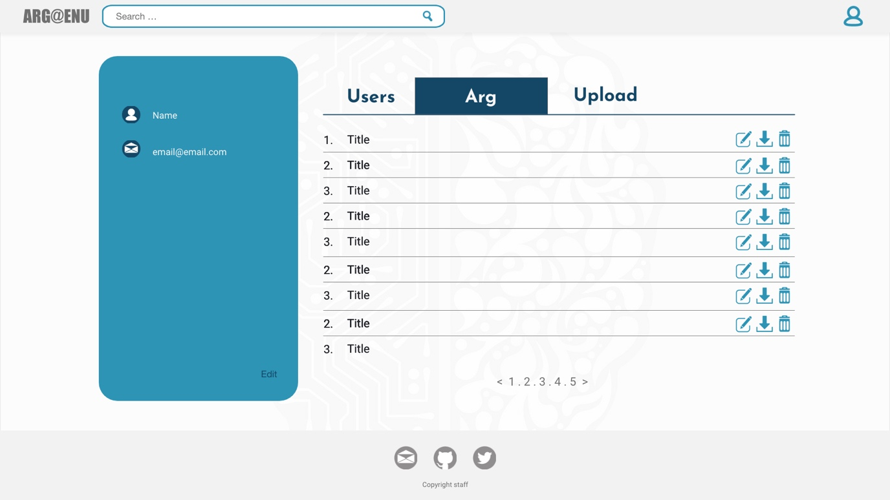

Table to displays uploaded arguments. All information on this table has to be gathered from database. Once pressed on the element link to adminargedit page

First. Unique argument number,

Second. Title of the argument

Third. Email address

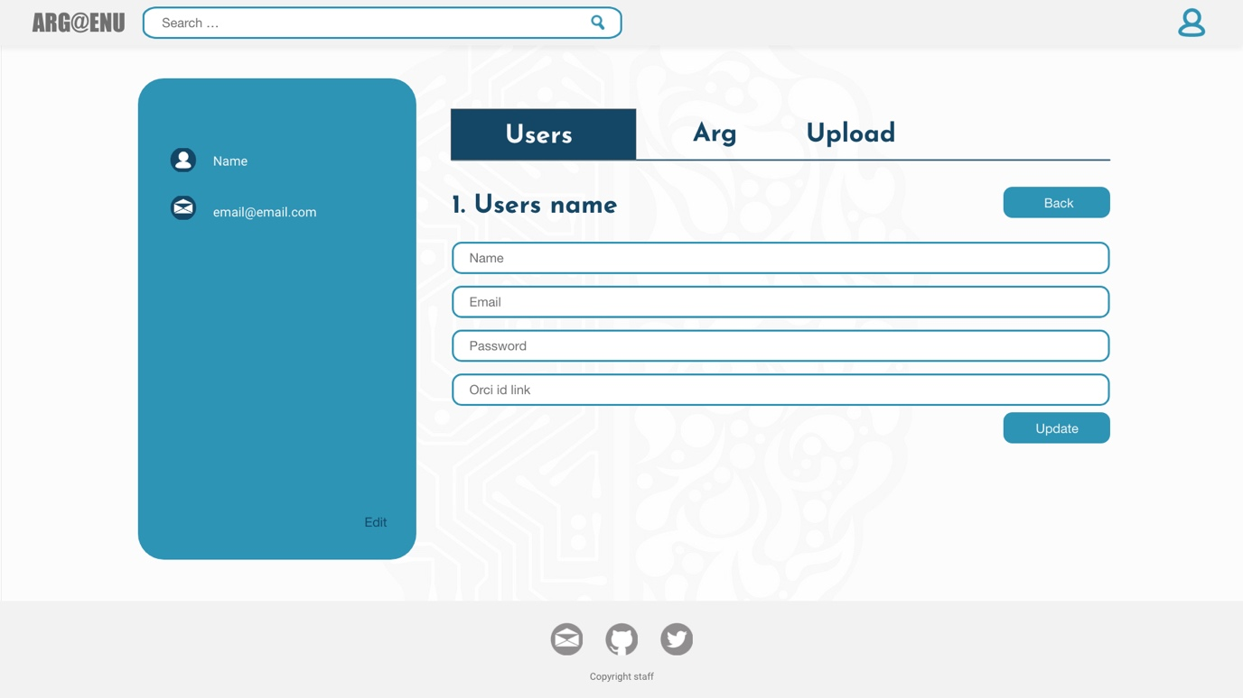

Update the database with new information

Back button, to go back to previous page

Users name taken from database

Unique account number taken from database

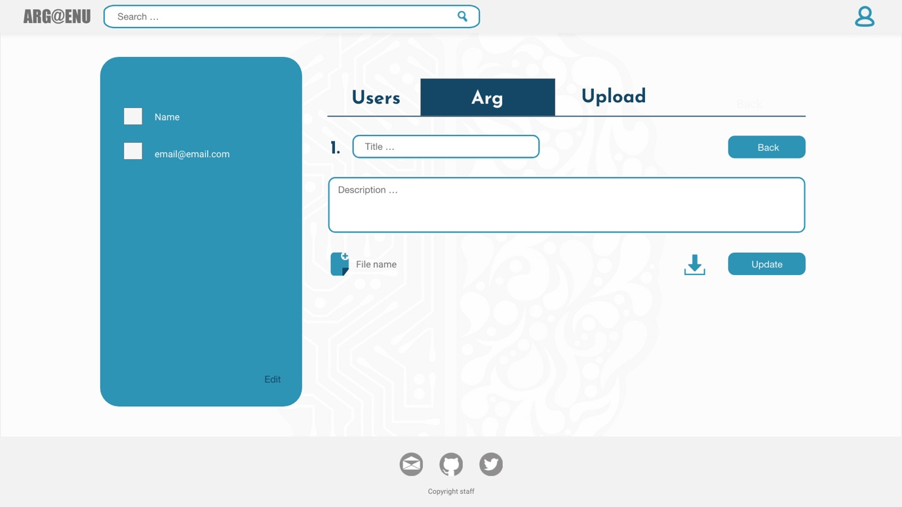

Update information

Download the file from database

File upload

Display the information about argument inside the form

Unique argument number

# References

Cyr, D., Bonanni, C. (2005). Gender and website design in e-business. Inderscience enterprises ltd, 3 (6), 565-582.

Karimov, F, Brengman, M., Van Hove, L. (2011). The effect of website design dimensions on initial trust: a synthesis of the empirical literature. Journal of Electronic commercial resource, 12(4), 272-301.

Newman, R., Antin, J. (2014, March, 14). Building for Trust. Retrieved February 22, 2019 from https://medium.com/airbnb-engineering/building-for-trust-503e9872bbbb.

Thatcher, J., Carter, M., Li, X., Rong, G. (2012). A Classification and Investigation of Trustees in B-to-C e-Commerce: General vs. Specific Trust. Communications of the Association for Information Systems, 32(4), 107-134.

Ganguly, B., Dash, S., Cyr, D., Head, M. (2010) The effects of website design on purchasing intentions in online shopping and: the mediating role of trust and the moderating role of culture. Inderscience enterprises ltd, 8(4/5), 302-329.

Riegelsberger, J., Sasse, M., McCarthy, J. (2005). The mechanics of trust: a framework for research and design. International Journal of Human-Computer Studies, 62(3), 381-422.

Office for National Statistics UK, (2018, June). Value of internet retail sales monthly in the United Kingdom (UK) from January 2013 to July 2018 (in million GBP). Retrieved March 5, 2019 from <https://www.statista.com/statistics/380070/uk-internet-retail-monthly-sales-value/>.

Norman, D. (2004) Emotional design. New York: Basic Books.

Norman, D. (2013) The design of everyday thing. New York: Basic Books.

Stone, T., Adams, S., Morioka, N.(2008). Color Design Workbook: A Real World Guide to Using Color in Graphic Design.United States of America: Rockport Publishers.

Labrecque, L., Milne, G.(2012)Exciting red and competent blue: the importance of color in marketing. Journal of the Academy of Marketing Science, 40(5),711–727