# **Behind the telescope**

Material

2× base plate 4×1 (50x200 mm)

2× lens cube 1×1, f=+40 mm

1× lens cube 1×1, f=-50 mm

1× lens cube 1×1, f=+100 mm

A refracting telescope (also called a refractor) is a type of optical telescope that uses lenses to form an image. Refractors were the earliest type of optical telescope. The first practical refracting telescopes appeared in the Netherlands about 1608. All refracting telescopes use the same principles. The combination of an objective lens and eyepiece lens is used to gather more light than the human eye is able to collect on its own, focus it, and present the viewer with a brighter, clearer, and magnified virtual image.

The magnification of such a simple telescope is given by

M = f1/│f2│,

where f1 is the focal length of the objective lens and f2 is the focal length of the eyepiece lens.

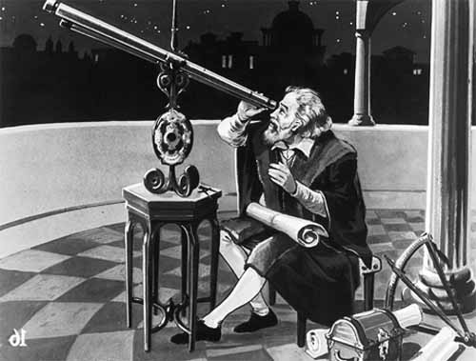

Figure 1: Galileo observing the planets with his telescope

## **Galilean Telescope**

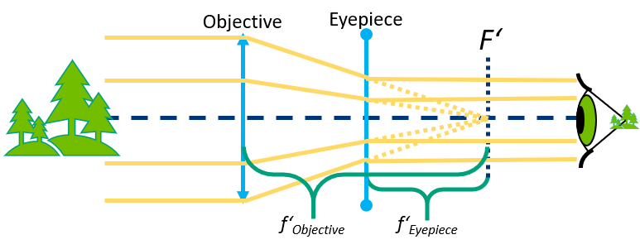

Figure 2: Scheme of Galilean telescope

The design Galileo Galilei used in 1609 is commonly called a Galilean telescope. It used a convergent (plano-convex) objective lens and a divergent (plano-concave) eyepiece lens [Galileo, 1610]. In a Galilean telescope, the image is non-inverted, since the design has no intermediary focus.

Galileo’s best telescope magnified objects about 30 times. Because of flaws in its design, such as the shape of the lens and the narrow field of view, the images were blurry and distorted. Despite these flaws, the telescope was still good enough for Galileo to explore the sky. The Galilean telescope could view the phases of Venus, and was able to see craters on the Moon and four moons orbiting Jupiter.

The concave lens L2 serves as an eyepiece and is placed in front of the focal plane of the objective lens L1 in such a way that the back focal point F1‘ of L1 coincides with the focal point F2 of L2. The distance between the principle planes of objective and eyepiece is f1 - │f2│. Besides F‘1 = F2 .

We then observe a virtual non-inverted magnified image of the observed object.

## **Keplerian Telescope**

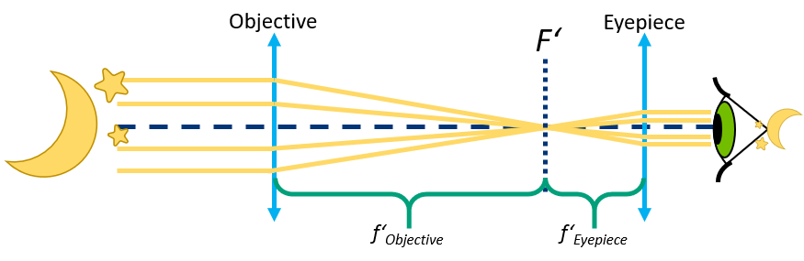

Figure 3: Scheme of Keplerian telescope

The Keplerian telescope, invented by Johannes Kepler in 1611, is an improvement on Galileo's design. It uses a convex lens as the eyepiece instead of Galileo's concave one. The advantage of this arrangement is that the rays of light emerging from the eyepiece are converging. This allows for a much wider field of view and greater eye relief, but the image for the viewer is inverted. Considerably higher magnifications can be reached with this design, but to overcome aberrations the simple objective lens needs to have a very high ratio of focal distances (Johannes Hevelius built one with a 46-metre focal length, and even longer tubeless "aerial telescopes" were constructed).

Keplerian telescope is composed of two convex lenses. The objective lens L1, focal distance f1, creates an image which is then observed through the eyepiece lens L2 with focal distance f2. The distance between the principle planes of objective and eyepiece is f1 + f2 . Besides F‘1 = F2.

We then observe a virtual inverted magnified image of the observed object.

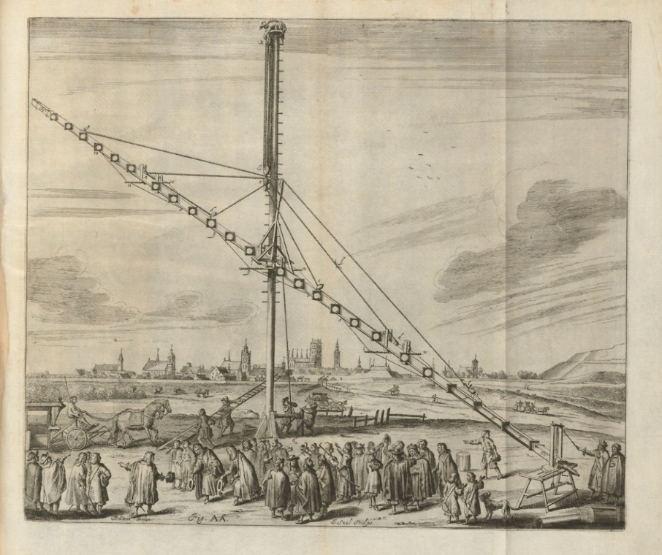

Figure 4: The 46-meters long Keplerian telescope built by Johannes Hevelius

## **Terrestrial telescope**

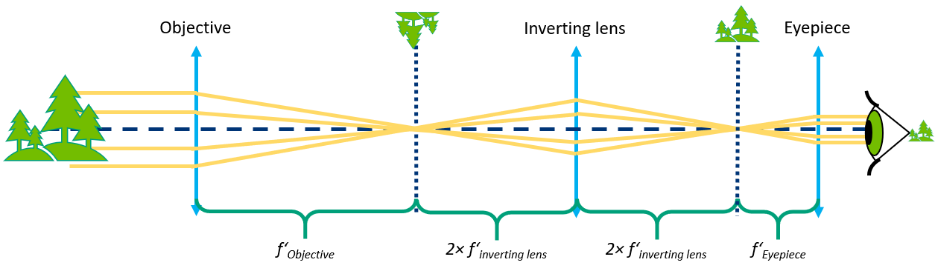

Figure 5: Scheme of terrestrial telescope

A terrestrial telescope is a telescope which, unlike most telescopes used for astronomical purposes, contains an arrangement of lenses presenting a non-inverted image to the observer, suitable for observation of objects on the Earth's surface.

A terrestrial telescope is, in a way, just a Keplerian telescope modified for terrestrial observation. An inverting lens is placed between the objective and the eyepiece and it inverts the image in the focal plane of the objective, so it’s flipped when viewed through the eyepiece.

The objective lens L1, focal distance f1, creates an image in its back focal plane. The inverting lens Li has a focal distance fi and is placed in the distance of f1+2fi behind the objective. It creates an inverted image (magnification -1) in the distance of 2fi which is then observed through the eyepiece lens L2 with focal distance f2. The distance between inverting lens and eyepiece is 2fi+f2. The whole system, form objective is therefore f1+f2+4fi long.

The inverting lens doesn’t contribute to the magnification and the magnification is calculated the same way as in a Keplerian telescope.

Source:

[1](https://en.wikipedia.org/wiki/Refracting_telescope) [2](https://en.wiktionary.org/wiki/terrestrial_telescope)