1-1 Count how many story-points the team completed in each sprint and in total of whole project.

Sprit 1 = 15/20

Sprint 2 = 40 / 64

Sprint 3 = 56 / 72

111/156 stories points were completed

1-2 Calculate the velocity and explain briefly what velocity is, in your own words.

$$sprint velocity \frac{15+40+56}{3}=37$$

Sprint velocity is the amount of worked finished by a team within each sprint, sprint velocity is an indication of how the team manages the load of work

1-3 Draw Burndown Chart and find out the velocity as well. 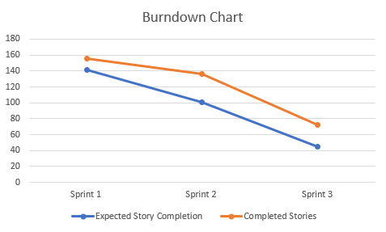

1-4 Based on the velocity, how many sprints would be needed if the team has still 190 story point remaining.

$$Expected number of sprints to completion \frac{190}{x}=37$$

x = 5 – 6 Sprints to complete all story points

1-5 Give four suggestions to improve the velocity of team

1. Within the sprint retrospectives the team should have a solid understanding of what’s to come in the next sprint and how the team can take on the load of work. Within each sprint there were user stories which were not completed which could suggest that the teams’ capabilities and expectations are too high and should rather narrow down tasks to ensure quality.

2. Team moral can also be another improvement as when team members work for each other quality and clarity of work will be improved as opposed to members working for themselves, collaboration amongst the team would clarify how each member is going in their tasks to ensure transparency and expectations.

3. Scrum master can better coordinate the expectations of the team and determine members strengths and weaknesses, have the backlog refined will ensure that team members aren’t overloaded. By setting clear goals and keeping the greater scope in mind so the team is motivated they are making progress and can see the full picture.

4. Avoiding context switching, where when one task gets too difficult to move onto another one or when team members work on unrelated features. The team should have a good understanding of expectations and have tasks prioritised accordingly depending on set skills. By keeping focus on one task at a time allows the team to ensure quality of work.