Gvalchca GA15.0
Alps 60% PCB with some weird layouts support. To update the firmware connect the PCB to your computer and enter bootloader by pressing hardware Reset button near the MCU.

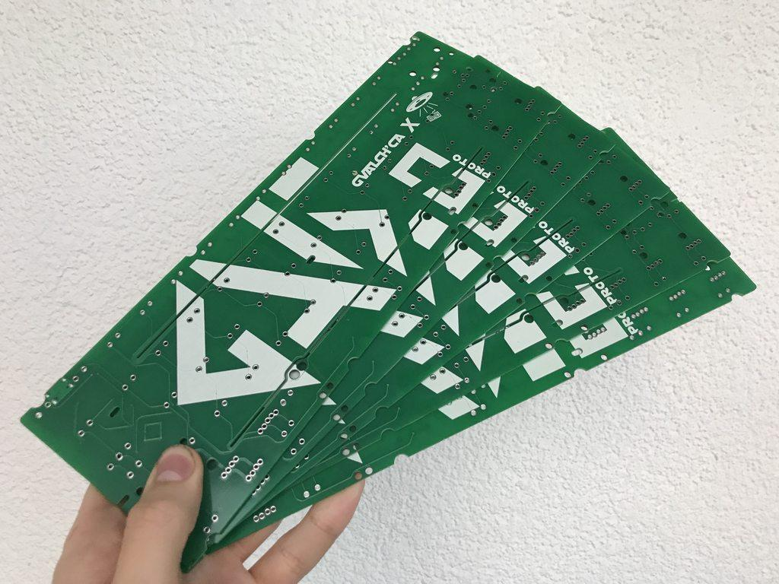

- Keyboard Maintainer: Gvalchca
- Hardware Supported: Gvalchca GA15.0
- Hardware Availability: KeebMeUp

Make example for this keyboard (after setting up your build environment):

make gvalchca/ga150:default

See the build environment setup and the make instructions for more information. Brand new to QMK? Start with our Complete Newbs Guide.

