ARN to Protein Translator – Notes

Lab summary
In this lab we translated ARN into proteins using the genetic code and applied it to a real virus genome downloaded from NCBI.
- ARN → protein: arn_to_protein.py reads the sequence from the start codon AUG, three letters at a time, adds the matching amino acid and stops at UAA, UAG or UGA (example: GCAUGUUUCCAGGAUAAGCU → Met-Phe-Pro-Gly).
- Real genome: San Bernardo virus, strain CoB37dA (NC_034154.1), 9,748 nucleotides, downloaded from NCBI as a FASTA (.fna.gz) file.
- Codon frequency: codon_frequency.py slides a 3-letter window one position at a time over the whole genome (9,746 windows) and counts all 64 codons.
- Result: the most frequent codons are UUU (Phe, 3.36%), AAA (Lys, 3.01%) and UUG (Leu, 2.90%), well above the 1.56% expected if all codons were equal – the genome is rich in A and U.
- Food: high-protein foods are rich in these amino acids, while fruits, oils and sugar have little – but diet cannot starve a virus, which uses the amino acids already inside the host's cells.

Task
Build an app that translates an ARN (RNA) molecule into a protein, using the genetic code from the slide. The ribosome reads the ARN sequence and adds an amino acid each time it finds a specific triplet (codon). Translation starts at AUG (Met) and ends at a STOP codon (UAA, UAG, UGA). Solution: arn_to_protein.py.

Genetic code (from the slide)
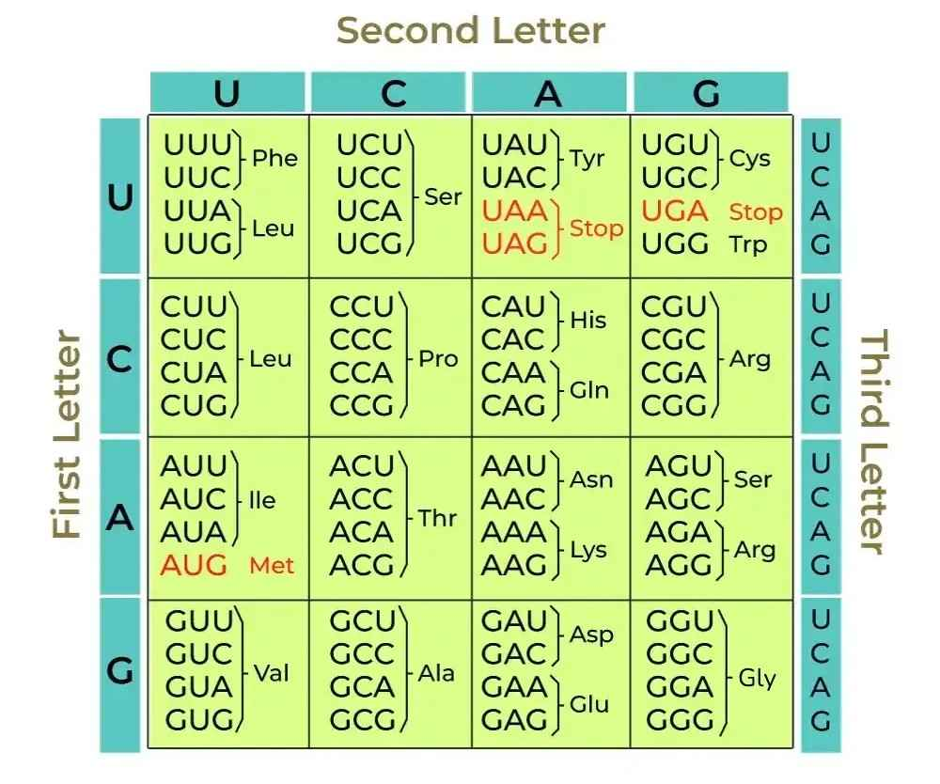

Example
GCAUGUUUCCAGGAUAAGCU → AUG UUU CCA GGA UAA → Met-Phe-Pro-Gly

Requirement 2 – Real genome from NCBI
Go to NCBI (https://www.ncbi.nlm.nih.gov/nuccore) and download, at your choice, a viral or a bacterial genome as a FASTA file (Send to → File → Format: FASTA). The program must read the FASTA file and translate the genome into proteins.
Suggested genome: bacteriophage phiX174, accession NC_001422.1 (about 5,400 nucleotides) – small enough to inspect by hand. Bacterial genomes have millions of nucleotides.
Run: python arn_to_protein.py genome.fasta 100 (the last number is the minimum protein length in amino acids)
A genome file is DNA, so the program first replaces T with U to get the ARN. Then it scans all 3 reading frames: every AUG starts a protein that ends at the next STOP codon. Short chains are ignored because they are usually random AUG…STOP matches, not real genes.

Requirement 3 – Codon frequency with a sliding window
Run through the entire genome with a sliding window of 3 letters (move one letter at a time) and measure the frequency of each of the 64 codons. Show the 10 most frequent codons and make a chart of their frequencies. Solution: codon_frequency.py.
Genome chosen: San Bernardo virus, strain CoB37dA (NCBI NC_034154.1, assembly GCF_002024715.1), 9,748 nucleotides → 9,746 windows.
Run: python codon_frequency.py GCF_002024715.1_ViralProj378398_genomic.fna.gz
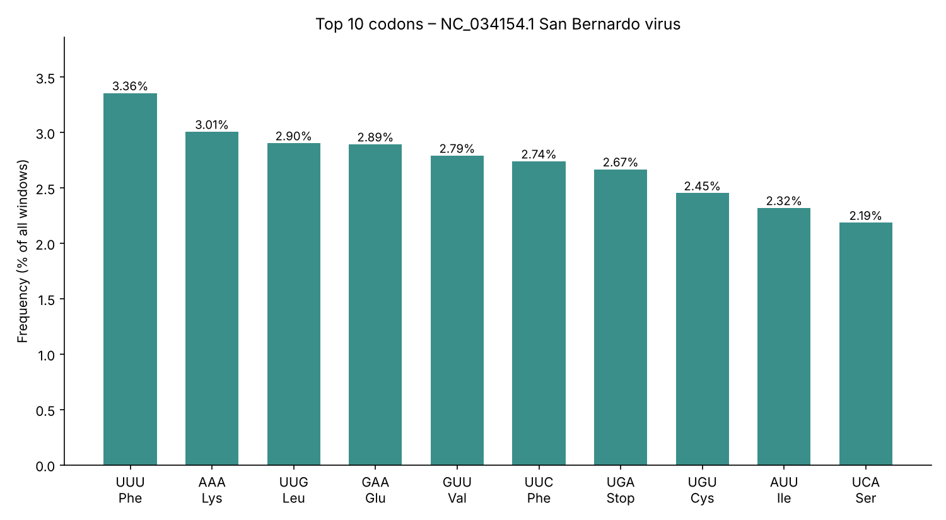
Top codons: UUU (Phe) 3.36%, AAA (Lys) 3.01%, UUG (Leu) 2.90%. If all 64 codons were equally common, each would be about 1.56%. The genome is rich in A and T (U), so codons made of these letters come out on top.

Requirement 4 – Foods and the virus's most common amino acids
The top 10 codons of San Bernardo virus code for Phe, Lys, Leu, Glu, Val, Cys, Ile and Ser (plus the Stop codon UGA). The table compares foods rich in each amino acid with foods that contain very little of it.
Amino acid | Codons in top 10 | Foods rich in it (to avoid) | Foods low in it
Phenylalanine (Phe) | UUU, UUC | Meat, fish, eggs, cheese, soy, nuts, aspartame (diet drinks) | Fruits, oils, sugar, watery vegetables
Lysine (Lys) | AAA | Meat, fish, eggs, dairy, beans, lentils, tofu | Rice, corn, wheat, fruits, oils
Leucine (Leu) | UUG | Whey, cheese, eggs, chicken, beef, soy, peanuts | Fruits, cucumber, lettuce, oils, sugar
Glutamate (Glu) | GAA | Parmesan, tomatoes, mushrooms, soy sauce, MSG | Fruits (apple, pear), oils, sugar
Valine (Val) | GUU | Dairy, eggs, meat, soy, pumpkin seeds | Fruits, oils, sugar, honey
Cysteine (Cys) | UGU | Eggs, poultry, garlic, onion, oats | Fruits, oils, sugar
Isoleucine (Ile) | AUU | Meat, fish, eggs, cheese, lentils | Fruits, oils, sugar, watery vegetables
Serine (Ser) | UCA | Soy, eggs, dairy, meat, nuts | Fruits, oils, sugar

Simple rule: high-protein foods (meat, fish, eggs, dairy, soy, legumes, nuts) are rich in all of these; oils, sugar, most fruits and watery vegetables have very little. A real example of such a diet is phenylketonuria (PKU), where patients limit phenylalanine under medical supervision.
Important: a diet cannot stop the virus. A virus builds its proteins from the amino acids inside the host's cells, which the body keeps at a steady level (breaking down its own muscle if needed). Phe, Lys, Leu, Val and Ile are essential – humans must eat them. Fighting viruses relies on the immune system, vaccines and antiviral drugs.

Ideas about the exercise
- The code is redundant: 61 codons encode only 20 amino acids, so different ARN sequences can produce the same protein (e.g. 4 codons for Gly). A dictionary codon → amino acid models this naturally.
- The reading frame matters: shifting the start by one letter changes every codon after it, which is why the ribosome first looks for AUG and then reads strictly in steps of 3 – the same reason insertions/deletions (frameshift mutations) are so damaging.

