Lab 5 – Gel Electrophoresis and DNA Repeats

Lab summary
- Sequence: Cloning vector pUC19c, complete sequence (NCBI L09137.2), 2,686 nucleotides, saved as a FASTA file (pUC19c_L09137.2.fasta).
- Samples: gel_electrophoresis.py cuts 10 random fragments of 100–2,686 bases from the sequence and stores them in a list (the array).
- Migration model: the distance a fragment travels is linear in log10 of its length, so short fragments run far and long ones stay close to the well.
- Result (example run): the 230 bp fragment ran furthest (7.0 cm) and the 2,565 bp fragment the least (1.4 cm); a DNA ladder in the first lane gives the scale.
- Output: the length and distance of each sample in the console, an animation of the run and the final gel picture gel_electrophoresis.png.
- Exercise 2: repeats_detector.py finds 43 tandem repeats of 6–10 bases with a 3–5 base unit in pUC19c (30 with a 3-base unit, 11 with 4, 2 with 5), for example TTGCG TTGCG at 581–590.

Tasks
Exercise 1
Gel electrophoresis is an analysis method used in all disciplines of the life sciences. The results of gel electrophoresis indicate the relative sizes of the fragments, which is useful for restriction mapping and for analyzing PCR fragments.
- Take an arbitrary DNA sequence from NCBI (National Center for Biotechnology Information), between 1000 and 3000 nucleotides (letters).
- Take 10 random samples from this sequence, between 100 and 3000 bases.
- Store these samples in an array.
- Simulate the migration of these DNA segments on the electrophoresis gel, based on their molecular weight (number of nucleotides).
Note: Short DNA fragments meet small friction forces and travel fast through the electrophoresis gel, while long DNA fragments exhibit a high friction force and travel slowly through the gel.
Solution: gel_electrophoresis.py.

Requirement 1 – The DNA sequence
pUC19c is a small circular cloning vector used in molecular biology labs. Its complete sequence (L09137.2) has 2,686 bp, inside the 1000–3000 range, with an almost even base composition: A 667, C 675, G 685, T 659. It starts with TCGCGCGTTTCGGTGATGACGG…

Requirements 2–3 – Random samples stored in an array
take_samples() picks, for each of the 10 samples, a random length and then a random start position so that the fragment fits inside the sequence. The fragments are kept in a Python list, samples[0] … samples[9]. The upper limit is 2,686 instead of 3,000, because a fragment cannot be longer than the sequence it is cut from.

Requirement 4 – Migration on the gel
DNA is negatively charged, so in the electric field it moves from the wells (cathode, −) towards the anode (+). The gel acts like a sieve: the longer the fragment, the more friction it meets. In a real agarose gel the distance travelled is roughly proportional to log10 of the size, so the program uses:
distance = 1 + 8 × (log10 3000 − log10 L) / (log10 3000 − log10 100) [cm]
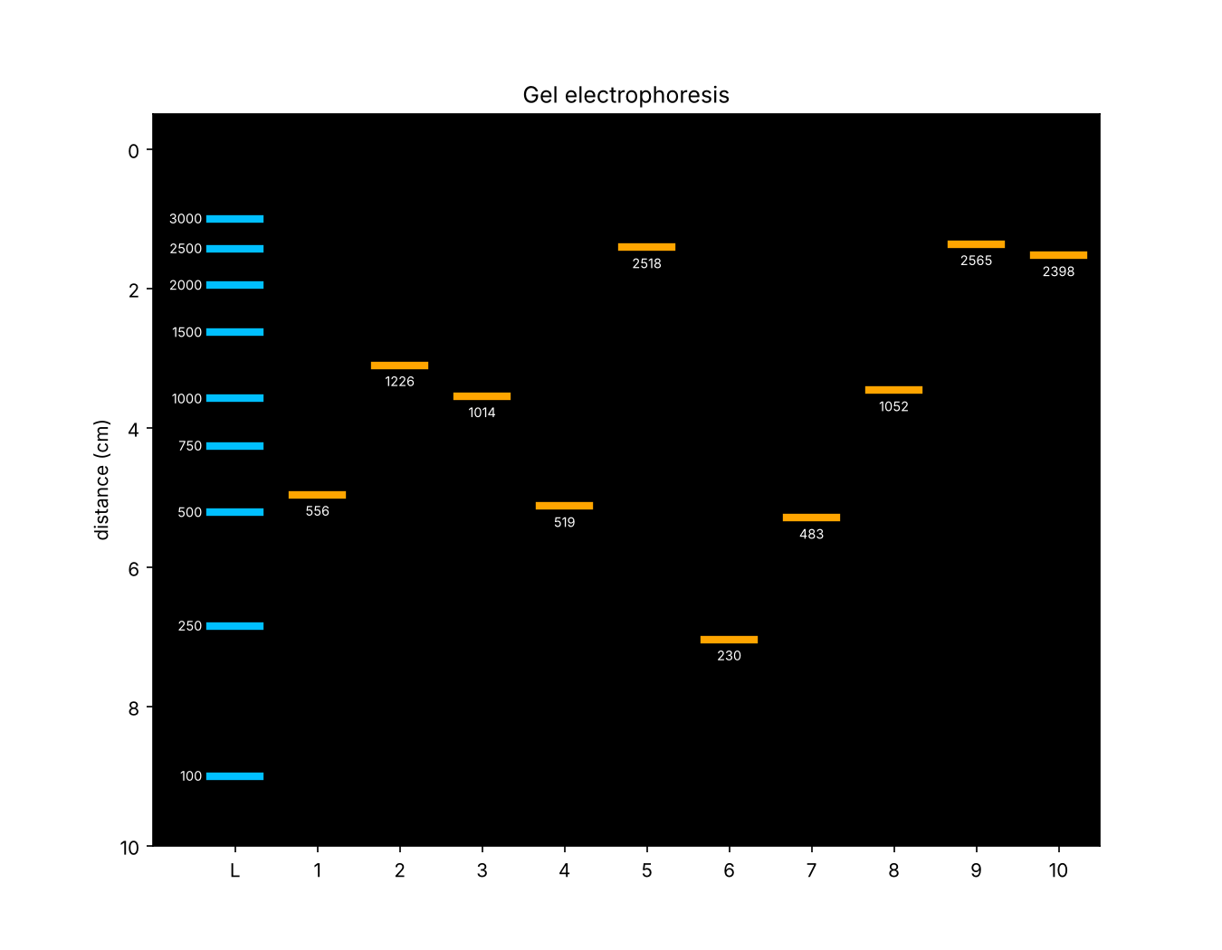
This puts 100 bp at about 9 cm and 3,000 bp at about 1 cm after a full run. During the animation every band moves in proportion to the run time, so they separate gradually.
Lane L is the ladder (3000 → 100 bp); lanes 1–10 are the samples. The order from the bottom (fastest) to the top (slowest) is: 230, 483, 519, 556, 1014, 1052, 1226, 2398, 2518, 2565 bp.

Exercise 2 – Repetitions in the DNA sequence
Take an arbitrary DNA sequence from NCBI, between 1000 and 3000 nucleotides. Implement a software application that detects repetitions between 6 and 10 bases in the DNA sequence. The length of the repeated unit is between 3 and 5 bases.
Sequence used: the same Cloning vector pUC19c (NCBI L09137.2, 2,686 bp) from Exercise 1. Solution: repeats_detector.py.

What counts as a repetition
A tandem repeat is the same unit written several times one after the other. With a unit of 3–5 bases and a total of 6–10 bases, the possible cases are:
- unit of 3 bases × 2 or 3 copies (6 or 9 bases), e.g. CAG CAG CAG
- unit of 4 bases × 2 copies (8 bases), e.g. GGCT GGCT
- unit of 5 bases × 2 copies (10 bases), e.g. TTGCG TTGCG

How the my solving works
- For each unit length k (3, 4, 5), it walks through the sequence and checks whether a base is equal to the base k positions further on (seq[j] == seq[j + k]). As long as this is true, the pattern keeps repeating.
- The length of such a stretch gives the number of complete copies of the unit. It keeps the repeat if there are at least 2 copies and the total is 6–10 bases.
- Units made of a shorter piece are skipped (AAA is really A × 3, ATAT is AT × 2), so they are not counted as 3- or 4-base units.
- After a repeat is found, the search jumps past it, so a region like GCAGCAG is reported once, not again as CAG CAG one position later.
- For each repetition the program prints the position (counted from 1, like on NCBI), the unit, the number of copies and the repeated bases.

