FLOWDEX NETWORK
The Universal Crypto Exchange
Bridging Blockchain and Traditional Finance

$FDN
Crypto • Stocks • Forex • Commodities • ETFs • Options • Futures • Indices
500+ Assets • Non-Custodial • Cross-Chain • Community-Owned
VERSION | DATE | STATUS | STAGE
6.0 | March 2026 | Public Release | Presale Live

This document describes the vision, architecture, tokenomics, and development roadmap of FlowDex Network — a non-custodial Universal Exchange enabling decentralized trading of crypto, tokenized stocks, forex, commodities, and more from a single interface. This whitepaper is for informational purposes only and does not constitute securities.

1. Executive Summary
FlowDex Network is a non-custodial Universal Exchange that enables decentralized trading of crypto assets, tokenized stocks, forex pairs, commodities, ETFs, indices, options, futures, and CFDs — all from a single on-chain interface. By bridging blockchain infrastructure with traditional financial markets, FlowDex gives any person on earth access to 500+ tradeable assets, 24/7, with no broker accounts, no geographic restrictions, and no custodial risk.
The convergence of traditional finance (TradFi) and decentralized finance (DeFi) is the defining trend of 2026. Tokenized real-world assets (RWAs) have surpassed $25 billion on-chain, Nasdaq has applied to the SEC to trade tokenized securities on-chain, and centralized exchanges like Bitget are reporting $4 billion per day in tokenized TradFi volume. Yet every existing solution requires users to trust a centralized intermediary with their funds. FlowDex is the missing piece: a fully decentralized, non-custodial platform where users trade both crypto-native tokens and tokenized real-world assets while retaining full control of their private keys.
FlowDex’s smart order routing engine aggregates liquidity from 50+ decentralized exchanges across 10+ blockchains, while simultaneously sourcing tokenized asset liquidity from providers like Ondo Finance, Backed Finance, and Dinari. The result: a user can swap ETH for tokenized Tesla stock, convert USDC to gold exposure, or trade EUR/USD forex pairs — all non-custodially, all settled on-chain, all from one interface.
The platform is powered by $FDN, an ERC-20 token on Ethereum with a fixed supply of 10 billion. $FDN serves four functions: protocol fee sharing (40% of all fees flow to stakers), governance (quadratic voting on all protocol decisions), routing priority (stakers’ trades execute first), and network security (validator staking when FlowDex migrates to its own appchain, FlowChain, in 2027).
FlowDex follows a phased development model. Phase 1 launches on Ethereum with crypto trading and the first wave of tokenized assets (stocks, forex, gold). Phase 2 expands to BSC, Solana, Arbitrum, and Polygon with 500+ tradeable assets including options and futures. Phase 3 migrates to FlowChain, a purpose-built appchain with 50,000+ TPS and sub-500ms finality, optimized for multi-asset routing at institutional scale.
The project will raise $80,000,000 through an 8-tier public presale with zero venture capital. Tier 1 is priced at $0.001 (98% discount to the $0.05 listing price). 75% of the total token supply goes to community-facing categories. Core team tokens are locked for 1 year with 4-year vesting.
Key Facts at a Glance
• Product: Non-custodial Universal Exchange — crypto, stocks, forex, commodities, ETFs, options, futures, indices, CFDs
• Asset Coverage: 500+ tradeable assets across 10+ blockchains
• Token: $FDN (ERC-20 on Ethereum) | 10 billion supply | Fixed, non-inflationary
• Listing Price: $0.05 per $FDN | FDV at listing: $500,000,000
• Presale: 8 tiers, $0.001–$0.05 | $80M raise | Tier 1 at 98% discount (whitelist only)
• Staking: 40% of protocol fees + emission rewards | Projected Y1 APY: 12–18%
• Architecture: ERC-20 (Phase 1) → Multi-Chain (Phase 2) → FlowChain Appchain (Phase 3)
• Community: 75% of tokens to community | No VC | MIT open-source license
• Security: Audited by Trail of Bits, OpenZeppelin, Zellic | Formal verification by Certora
• Comparable Projects: Injective ($3.5B FDV), dYdX ($1.2B FDV), Synthetix ($600M FDV)

2. The Problem
Today, if you want to trade Bitcoin, Tesla stock, EUR/USD, gold, and the S&P 500 index, you need at minimum four separate accounts: a crypto exchange (Binance, Coinbase), a stock broker (Robinhood, Interactive Brokers), a forex broker (MetaTrader, IG), and a commodities platform (CME futures). Each requires separate KYC, separate funding, separate interfaces, and separate fee structures. Your assets are siloed, your capital is fragmented, and you’re trusting four different custodians.
This fragmentation creates six fundamental problems that cost traders billions of dollars annually:
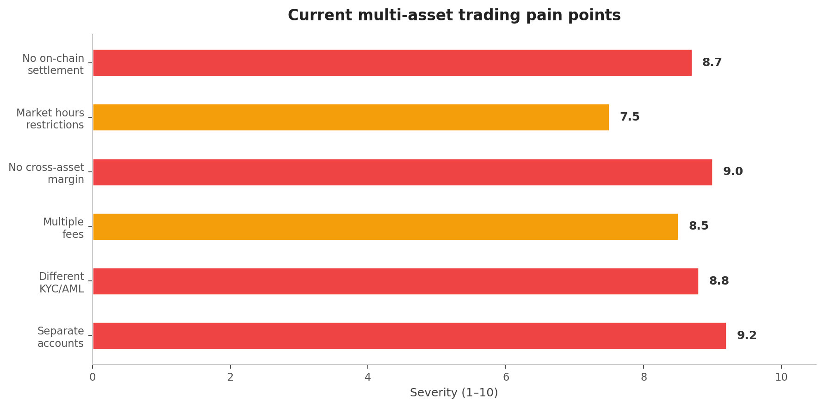
Figure 1: Pain points in current multi-asset trading (severity rated 1–10)

2.1 Fragmented Access
There is no single platform where you can trade crypto and traditional assets in a unified, non-custodial environment. Centralized exchanges like Bitget and BTCC have begun offering tokenized TradFi products (forex, stocks, commodities), but all require custody of user funds. Decentralized exchanges like dYdX and Injective only support crypto derivatives. The intersection — a decentralized platform supporting both crypto-native and real-world assets — does not yet exist at scale.

2.2 Custodial Risk
The FTX collapse ($8 billion in customer losses), Celsius ($4.7 billion), and Voyager ($1.3 billion) demonstrated the catastrophic risk of custodial exchanges. When you deposit funds into a centralized exchange, you are lending them to the exchange. If the exchange is insolvent, your funds are gone. This risk extends to every centralized forex broker, stock broker, and commodity platform. FlowDex eliminates this entirely: assets never leave the user’s wallet until the moment of on-chain execution.

2.3 Geographic Restrictions
Traditional financial markets are gated by geography. A trader in Nigeria cannot easily access US stock markets. A trader in Southeast Asia faces high friction to trade European forex pairs. Crypto exchanges increasingly restrict access by jurisdiction under regulatory pressure. Tokenized assets on a decentralized platform are borderless by default — if you have a wallet, you can trade.

2.4 Market Hours & Settlement
Stock markets operate ~6.5 hours per day, 5 days per week. Forex operates 5 days but is closed on weekends. Settlement takes T+1 to T+3 days. Crypto is 24/7 with instant settlement. By tokenizing traditional assets on blockchain rails, FlowDex enables 24/7 trading of stocks, forex, and commodities with instant on-chain settlement — no waiting, no counterparty risk.

2.5 Liquidity Fragmentation
Even within crypto, liquidity is scattered across hundreds of DEXs on dozens of chains. A $50,000 swap on a single DEX may suffer 2–3% slippage. By aggregating liquidity across 50+ DEXs and multiple RWA tokenization providers, FlowDex minimizes slippage to as low as 0.2%, saving traders hundreds to thousands on every significant trade.

2.6 No Cross-Asset Margin
In traditional finance, sophisticated traders can use cross-asset margin: using stock holdings as collateral for forex positions, or gold as collateral for equity options. This is impossible when assets are siloed across separate platforms. FlowDex’s unified interface with FlowChain’s native multi-asset support enables true cross-asset composability — a paradigm shift for DeFi.

3. Market Opportunity
FlowDex sits at the intersection of four massive markets that are actively converging: cryptocurrency exchanges, global forex, equities/ETFs, and tokenized real-world assets. The combined addressable market exceeds $10 trillion in daily volume.
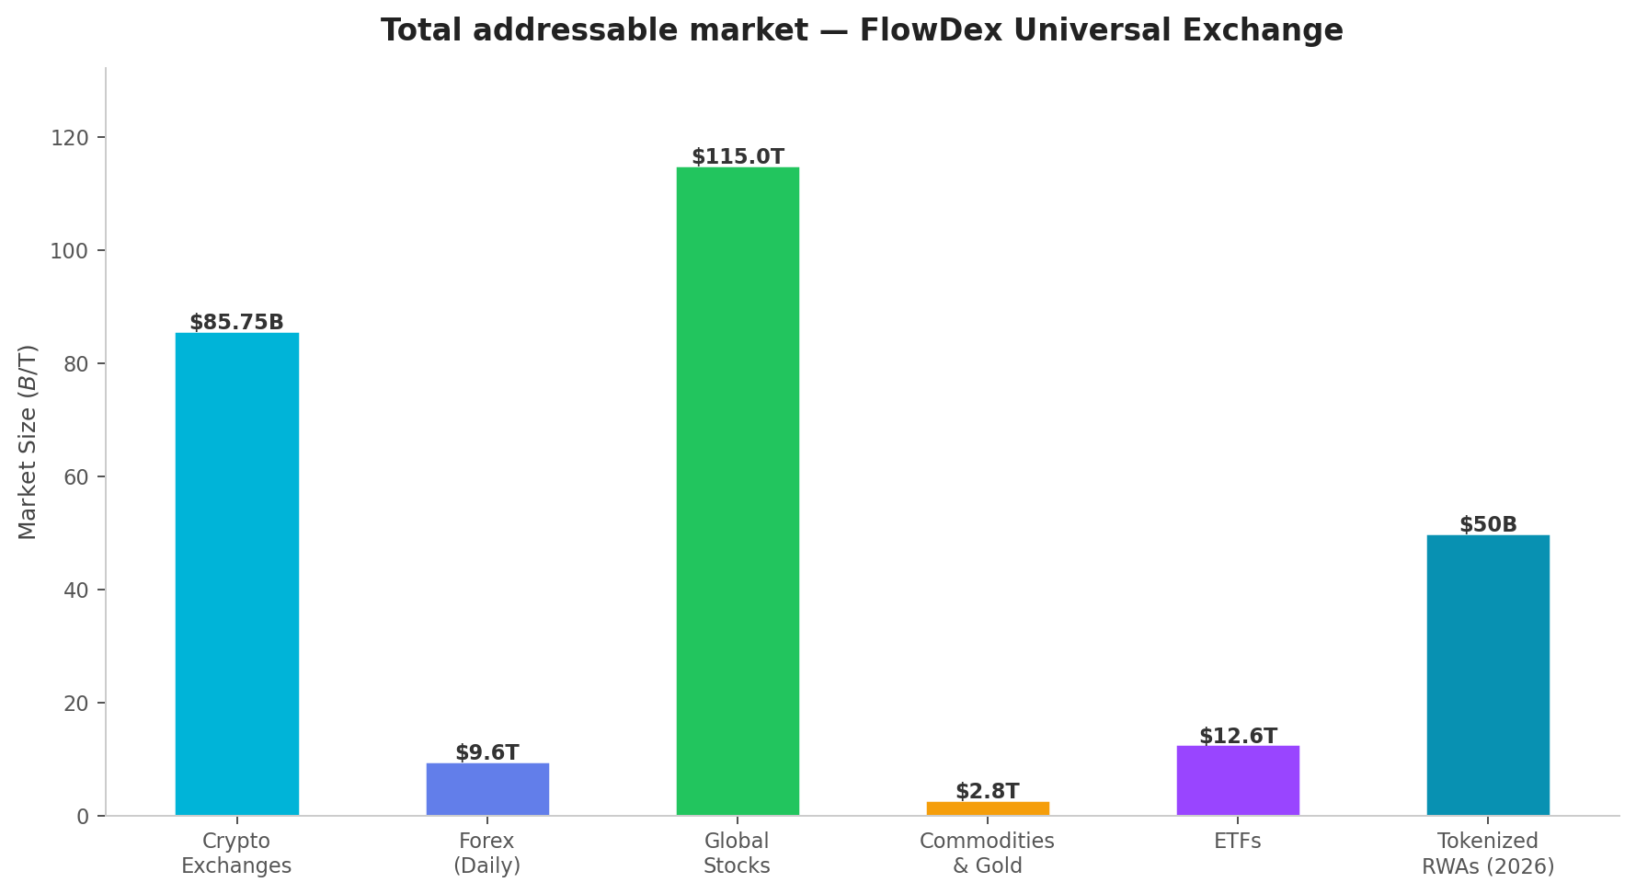
Figure 2: Total addressable market by asset class

3.1 Cryptocurrency Exchange Market
The global cryptocurrency exchange market is valued at approximately $85.75 billion in 2026, with forecasts reaching $314 billion by 2033 (20.3% CAGR). Daily crypto trading volume regularly exceeds $100 billion across spot and derivatives. DEX volume has grown from $25 billion monthly in 2020 to over $320 billion in 2024. The DEX aggregation opportunity alone represents $100–260 billion monthly.

3.2 Global Forex Market
The foreign exchange market is the largest financial market in the world, with daily trading volume hitting a record $9.6 trillion in Q2 2025 — up 28% from 2022. The forex CFD broker market alone is projected at $5.6 billion in annual revenue. By offering tokenized forex pairs settled in USDT/USDC, FlowDex taps into this enormous market through a crypto-native interface.

3.3 Tokenized RWAs & the TradFi Convergence
Tokenized real-world assets have tripled to $18.5 billion in 2025 and are projected to surpass $50 billion in 2026. Analysts from Boston Consulting Group project the tokenized RWA sector could reach $16 trillion by 2030. Nasdaq has applied to trade tokenized securities on-chain. BlackRock’s BUIDL fund has $2+ billion in tokenized treasuries. The infrastructure for tokenized traditional assets is live and scaling.
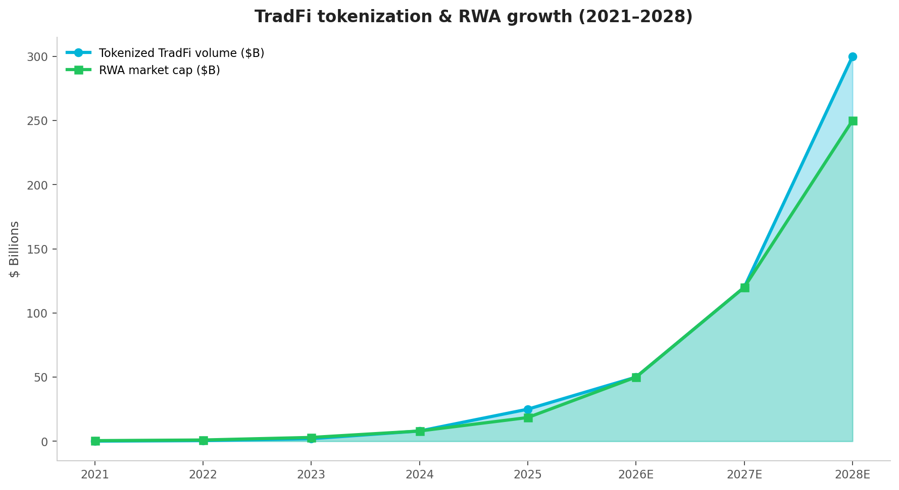
Figure 3: TradFi tokenization volume & RWA market cap growth (2021–2028 projected)

3.4 The Universal Exchange Opportunity
Bitget’s TradFi launch in January 2026 reached $4 billion per day in tokenized volume within weeks. BTCC launched 25+ TradFi instruments with 500x leverage. These data points prove massive demand for crypto-native access to traditional assets. But both are centralized — requiring users to trust the exchange with their funds.
FlowDex is positioned to capture the intersection of all four markets by offering the only non-custodial, cross-chain platform where users can trade crypto, stocks, forex, commodities, and more from a single wallet connection. The total addressable market exceeds $10 trillion daily — even capturing 0.01% represents $1 billion per day.
Market | Daily Volume | FlowDex Y2 Target | Capture Rate
Crypto (Spot + Derivatives) | $100B+ | $500M–$1B | 0.5–1.0%
Forex (Tokenized pairs) | $9.6T | $100M–$500M | 0.001–0.005%
Tokenized Stocks & ETFs | $10B+ (growing) | $50M–$200M | 0.5–2.0%
Commodities (Gold, Oil) | $2.8T (annual) | $20M–$100M | 0.01–0.05%
Tokenized RWAs | $50B mcap (2026) | $10M–$50M | 0.02–0.1%

4. The FlowDex Solution
FlowDex Network is the first non-custodial Universal Exchange — a single decentralized platform where users trade crypto, tokenized stocks, forex, commodities, indices, ETFs, options, futures, and CFDs. All trades execute on-chain, all assets remain in the user’s wallet until execution, and all settlements are instant and transparent.

4.1 What You Can Trade
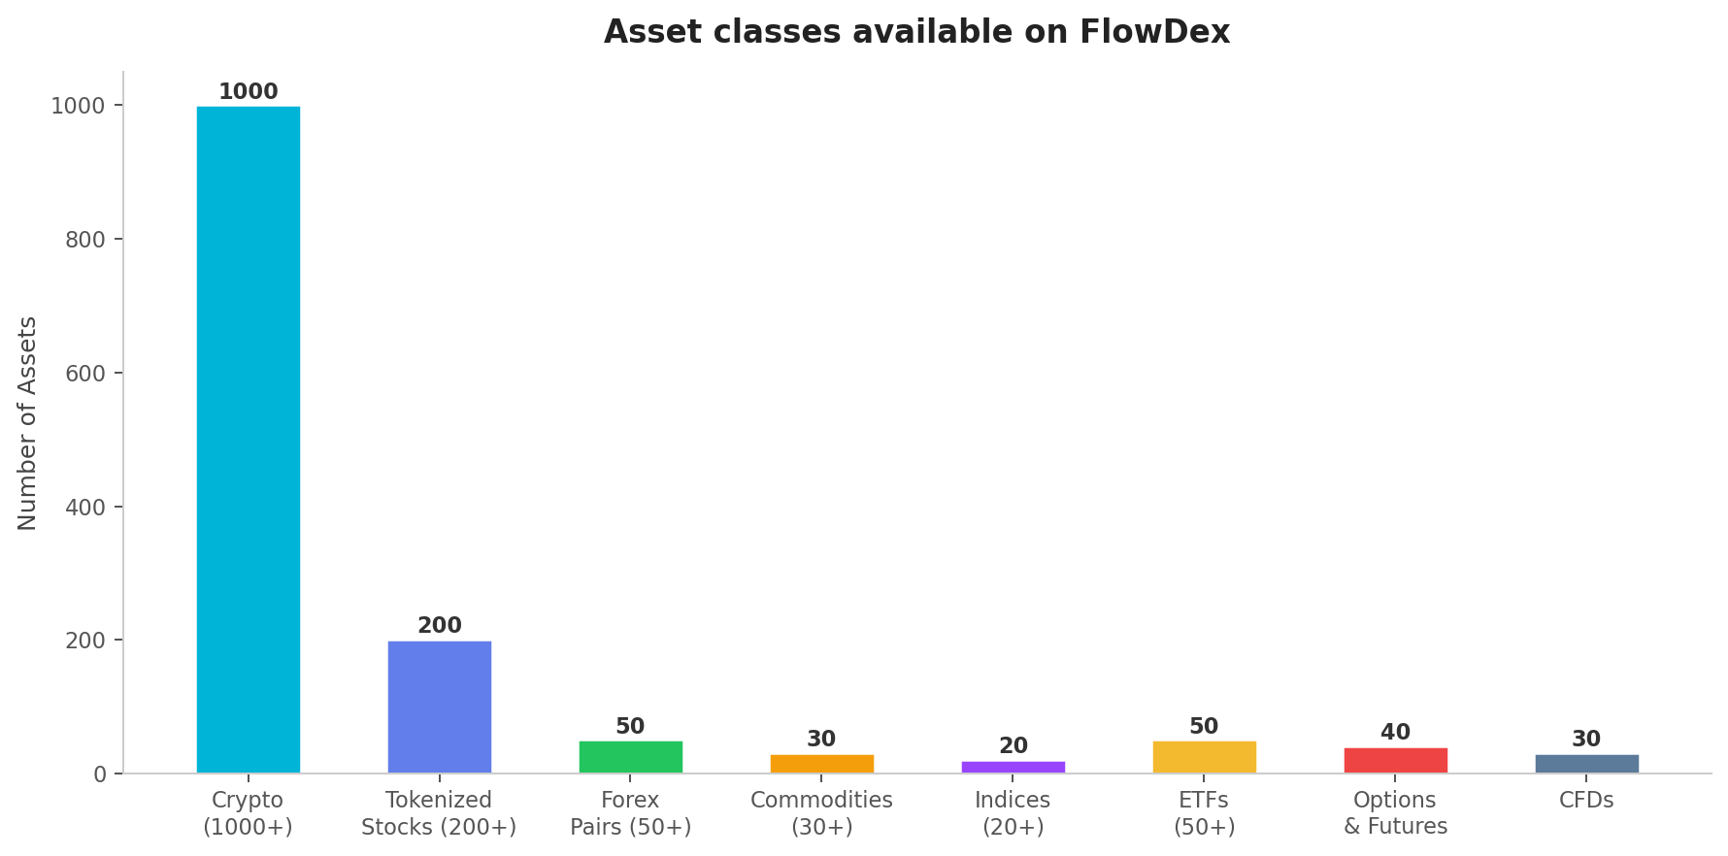
Figure 4: Asset classes available on FlowDex at full launch
FlowDex supports the following asset classes:
- Crypto: 1,000+ tokens across 10+ blockchains (Bitcoin, Ethereum, Solana, memecoins, DeFi tokens, etc.)
- Tokenized Stocks: 200+ US and international equities (Tesla, Apple, Nvidia, Meta, Amazon, etc.) via Ondo, Backed Finance, Dinari
- Forex Pairs: 50+ major, minor, and exotic pairs (EUR/USD, GBP/JPY, USD/CHF, etc.) via Chainlink and Pyth price feeds
- Commodities: 30+ instruments including gold (XAU), silver (XAG), crude oil (WTI/Brent), natural gas, platinum, palladium
- Indices: 20+ global indices (S&P 500, Nasdaq 100, FTSE 100, DAX, Nikkei 225, Hang Seng)
- ETFs: 50+ tokenized ETFs (QQQ, SPY, GLD, IWM, VTI, etc.)
- Options & Futures: Crypto perpetuals + tokenized options on stocks and indices
- CFDs: Contract-for-difference exposure to any supported asset with up to 100x leverage

4.2 How It Works
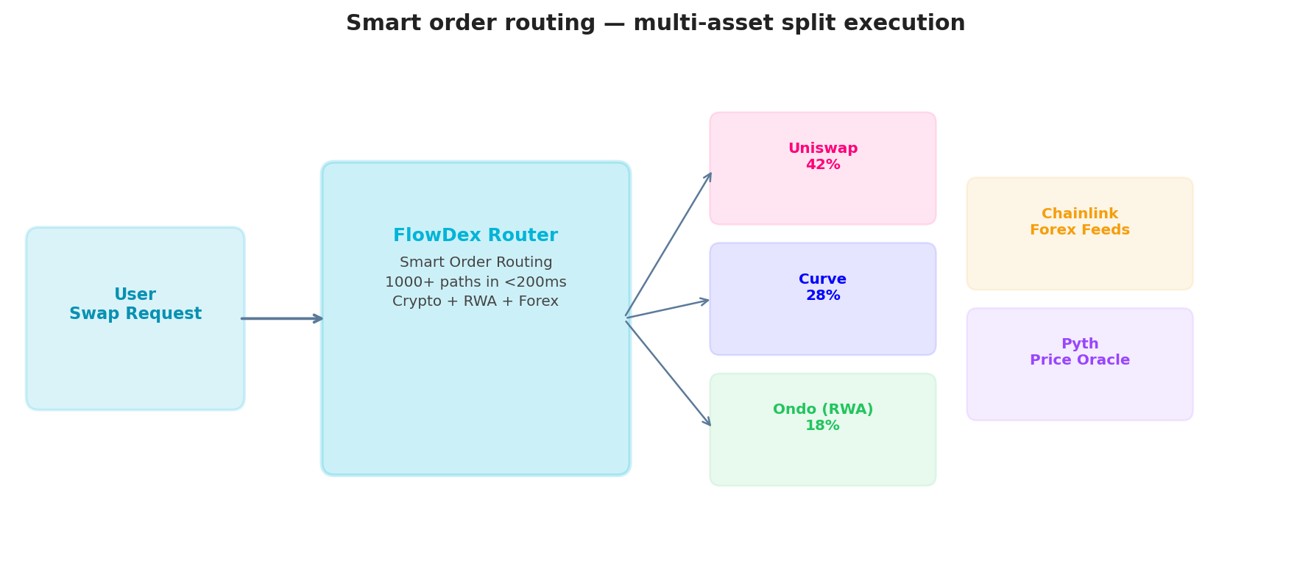
Figure 5: Smart order routing — multi-asset split execution across DEXs and RWA providers
When a user initiates any trade on FlowDex, the smart order routing engine:
- Step 1 — Scans all connected liquidity sources: 50+ DEXs for crypto, RWA tokenization providers (Ondo, Backed, Dinari) for stocks/ETFs, oracle-priced synthetic pools for forex and commodities.
- Step 2 — Evaluates 1,000+ potential execution paths in under 200 milliseconds, including multi-hop routes, cross-chain paths, and hybrid crypto-RWA routes.
- Step 3 — Splits the trade across the optimal combination of paths to minimize slippage, gas costs, and price impact.
- Step 4 — Executes atomically on same-chain or sequentially with confirmation tracking for cross-chain trades.
- Step 5 — Settles instantly on-chain. The user receives their tokens directly in their wallet. No deposits, no withdrawals, no custodial risk.
Universal Routing Optimization
maximize: ∑ Output(path_i) - ∑ Cost(path_i) subject to: ∑ Input(path_i) = Total_Input, ∀ path_i ∈ {DEX ∪ RWA ∪ Synthetic}

4.3 Key Differentiators
Feature | FlowDex | Bitget TradFi | Injective/Helix | dYdX
Custody | Non-custodial (wallet) | Centralized | Non-custodial | Non-custodial
Crypto Trading | 1,000+ tokens, 50+ DEXs | 1,300+ tokens | 200+ tokens | 170+ perps
Tokenized Stocks | 200+ via RWA providers | Yes (limited) | Yes (limited, ~20) | No
Forex | 50+ pairs | Yes | No | No
Commodities | 30+ (Gold, Oil, etc.) | Yes | Gold only | No
Cross-Chain | 10+ chains native | No (single platform) | Injective chain only | dYdX chain only
Fee Sharing | 40% to stakers | BGB discounts only | Limited | Partial
Own Blockchain | FlowChain (2027) | No | Injective L1 | dYdX chain (Cosmos)
Governance | Quadratic DAO | No | Yes | Yes

5. Platform Architecture
FlowDex follows a phased development architecture that balances immediate product delivery with long-term infrastructure ambition. This is the same model used by dYdX (Ethereum → StarkEx L2 → Cosmos appchain) and Injective (Ethereum → Cosmos chain). Ship product first, build infrastructure when you’ve earned the right to.
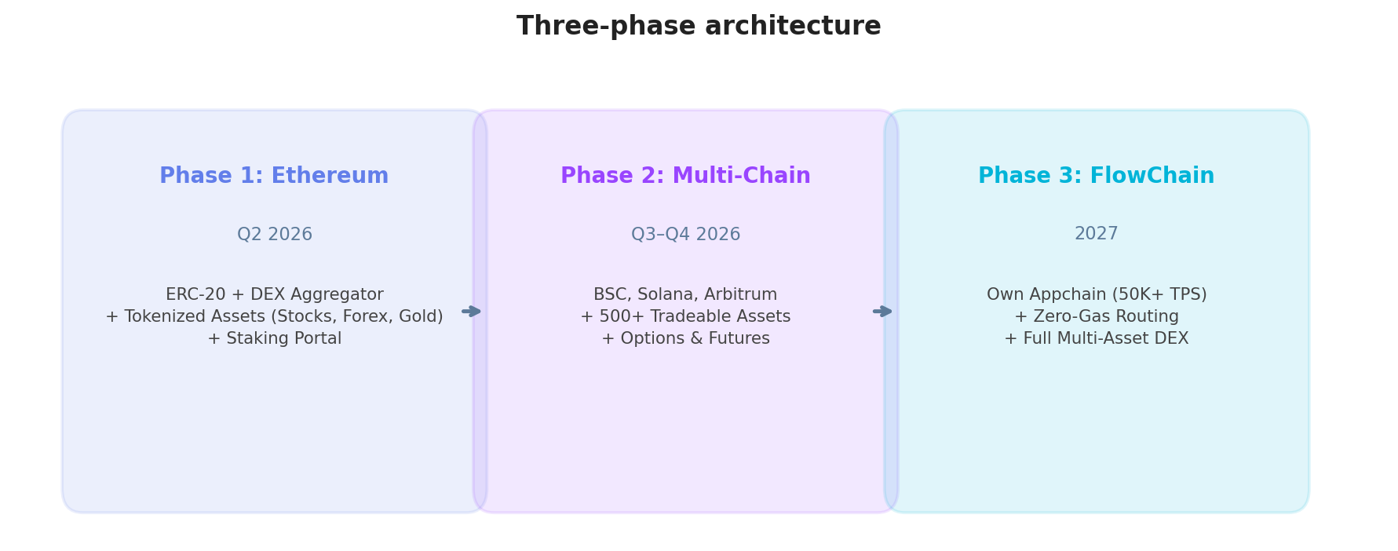
Figure 6: Three-phase development architecture

5.1 Phase 1: Ethereum Foundation (Q2 2026)
$FDN launches as an ERC-20 on Ethereum mainnet. Phase 1 delivers a fully functional multi-asset trading platform on Ethereum with:
- Smart order routing across 20+ Ethereum DEXs (Uniswap V3/V4, Curve, Balancer, SushiSwap, Maverick)
- Tokenized stock trading via Ondo Finance and Backed Finance (Tesla, Apple, Nvidia, S&P 500 ETF, etc.)
- Forex pair trading via Chainlink and Pyth oracle-priced synthetic pools (EUR/USD, GBP/JPY, etc.)
- Gold and commodity exposure via tokenized gold (PAXG, XAUT) and synthetic commodity contracts
- $FDN staking portal: stake to earn 40% of all protocol fees + emission rewards
- Governance module: on-chain quadratic voting for all protocol parameters
- Cross-chain swap routing via LayerZero V2 and Wormhole NTT

5.2 Phase 2: Multi-Chain + Full Asset Suite (Q3–Q4 2026)
Once Ethereum volume reaches $50M+ daily, FlowDex expands to BSC, Solana, Arbitrum, Polygon, and Avalanche with native deployments on each chain. Phase 2 expands the asset suite to 500+:
- 200+ tokenized stocks and ETFs across all major markets
- 50+ forex pairs covering all majors, minors, and key exotics
- 30+ commodity contracts (gold, silver, oil, natural gas, platinum, agricultural)
- Perpetual futures on all supported crypto and tokenized assets
- Options trading on major equities and indices
- Mobile app (iOS + Android) with full trading capabilities
- Institutional API for algorithmic and high-frequency traders

5.3 Phase 3: FlowChain Appchain (2027)
When FlowDex achieves sustained traction ($500M+ daily volume, 100,000+ MAU), the network migrates to FlowChain — a purpose-built application-specific blockchain optimized for multi-asset routing:
- 50,000+ TPS with sub-500ms finality
- Zero gas for routing calculations (stakers only)
- Custom precompiles optimized for multi-asset routing computation
- Native compliance modules (KYC/AML at the protocol level for RWA assets)
- Cross-asset margin: use any portfolio asset as collateral for any position
- 500+ permissionless validators secured by $FDN staking
- Full DAO governance handoff: protocol parameters, chain upgrades, fee structure — all community-controlled
Specification | Phase 1 (Ethereum) | Phase 2 (Multi-Chain) | Phase 3 (FlowChain)
Token Standard | ERC-20 | ERC-20 + bridged | Native chain token
Asset Coverage | 100+ (crypto + first RWAs) | 500+ (all asset classes) | 500+ with custom execution
Transaction Speed | ~12s (Ethereum) | Varies by chain | <500ms finality
Throughput | ~30 TPS | Varies by chain | 50,000+ TPS
Gas Costs | Ethereum rates | Varies by chain | Zero for routing; minimal for swaps
Validators | Ethereum (inherited) | Each chain’s native | 500+ $FDN stakers
Compliance | Basic | Enhanced | Native protocol-level KYC/AML modules

6. Tokenized Asset Infrastructure
FlowDex does not create its own tokenized assets. Instead, it aggregates liquidity from established, regulated tokenization providers — the same approach that made DEX aggregators like 1inch and Jupiter successful for crypto. FlowDex is the routing and execution layer, not the issuance layer.

6.1 RWA Tokenization Partners
Provider | Asset Types | Blockchain(s) | Backing | Status
Ondo Finance | US Treasuries, Stocks, ETFs | Ethereum, Solana, Arbitrum | 1:1 regulated custody | In Integration
Backed Finance | European & US Stocks, ETFs | Ethereum, Polygon | 1:1 regulated (Swiss FINMA) | In Discussion
Dinari | US Stocks (200+) | Ethereum, Arbitrum, BSC | 1:1 brokerage-backed | In Discussion
Paxos (PAXG) | Gold | Ethereum | 1:1 London Good Delivery bars | Planned
Tether Gold (XAUT) | Gold | Ethereum | 1:1 physical gold | Planned
Synthetix V3 | Forex, Indices, Commodities | Ethereum, Optimism, Base | Overcollateralized synthetic | Planned

6.2 Oracle Infrastructure for Real-World Pricing
Accurate, real-time pricing is essential for trading tokenized assets. FlowDex uses a redundant multi-source oracle system:
Provider | Coverage | Update Frequency | Role
Pyth Network | 500+ crypto + equity + forex feeds | 400ms | Primary feed for all routing and pricing
Chainlink | 200+ crypto + 40+ forex + commodity feeds | ~1 second | Secondary/validation; primary for forex
On-Chain TWAP | All DEX pairs | Per-block | Fallback and manipulation detection
Band Protocol | Forex + commodity feeds | ~5 seconds | Tertiary backup for RWA pricing
Mark Price (Multi-Oracle)
P_mark = median(P_pyth, P_chainlink, P_twap) | reject if |P_i - P_median| > 2%

6.3 Synthetic Asset Model (Forex & Commodities)
For assets where direct tokenization is not yet available at sufficient scale (certain forex pairs, exotic commodities), FlowDex uses overcollateralized synthetic positions — similar to the Synthetix model. Users deposit stablecoin collateral (USDT, USDC) and open synthetic positions that track real-world prices via oracle feeds. All positions are fully collateralized on-chain with transparent liquidation mechanics.
Synthetic Position Health
Health = Collateral_Value / (Position_Size × (1 + Maintenance_Margin)) | Liquidate if Health < 1.0

7. $FDN Tokenomics
The $FDN token is the economic backbone of the FlowDex Universal Exchange. It serves four distinct functions creating genuine, non-speculative demand: protocol fee sharing, governance participation, routing priority, and network security.

7.1 Token Specifications
Parameter | Details
Token Name | FlowDex Network
Ticker | $FDN
Token Standard | ERC-20 (Ethereum mainnet) at launch
Total Supply | 10,000,000,000 (10 billion) — fixed, non-inflationary, immutable
Blockchain | Ethereum (Phase 1) → Multi-chain (Phase 2) → FlowChain native (Phase 3)
Target Listing Price | $0.05 per $FDN
Fully Diluted Valuation | $500,000,000 at listing
Decimals | 18
Contract Audit | Trail of Bits + OpenZeppelin (pre-deployment)

7.2 Token Distribution
75% of the total supply goes to community-facing categories. Zero VC allocation.
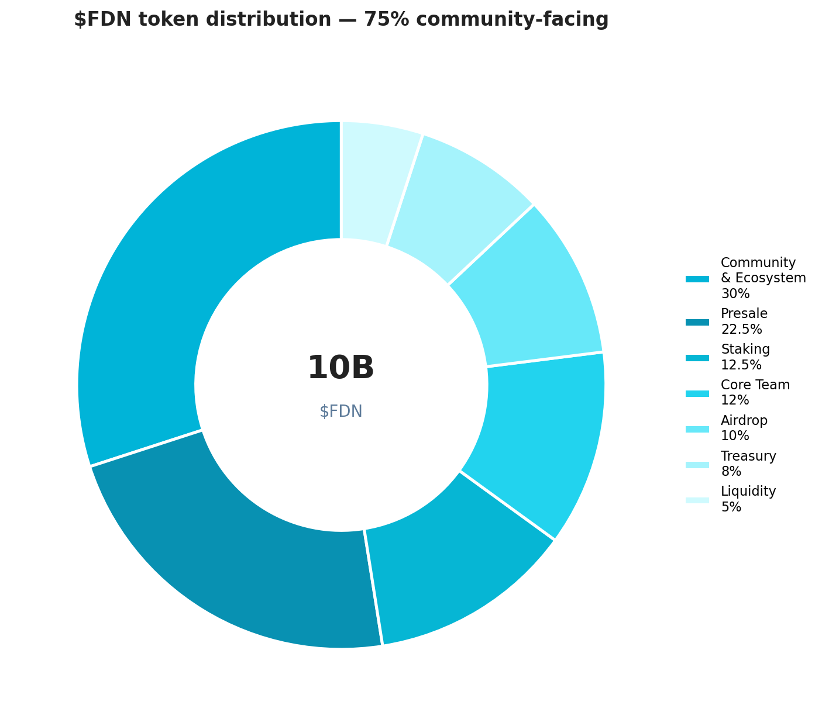
Figure 7: $FDN token distribution — 75% community-facing, no VC
Allocation | Percentage | Tokens | Vesting
Community & Ecosystem | 30.0% | 3,000,000,000 | 4-year distribution via rewards, grants, partnerships
Presale (8 Tiers) | 22.5% | 2,251,875,000 | Per-tier schedule (see Section 8)
Staking Rewards | 12.5% | 1,250,000,000 | 10-year declining emission schedule
Core Contributors | 12.0% | 1,200,000,000 | 1-year cliff + 4-year linear vesting
Genesis Airdrop | 10.0% | 1,000,000,000 | Fully unlocked at TGE
Treasury / DAO | 8.0% | 800,000,000 | Governed by on-chain proposals
Initial Liquidity | 5.0% | 500,000,000 | Unlocked at TGE for DEX/CEX pairs

7.3 Fee Structure & Revenue Sharing
FlowDex charges competitive fees across all asset classes, with 40% flowing directly to $FDN stakers:
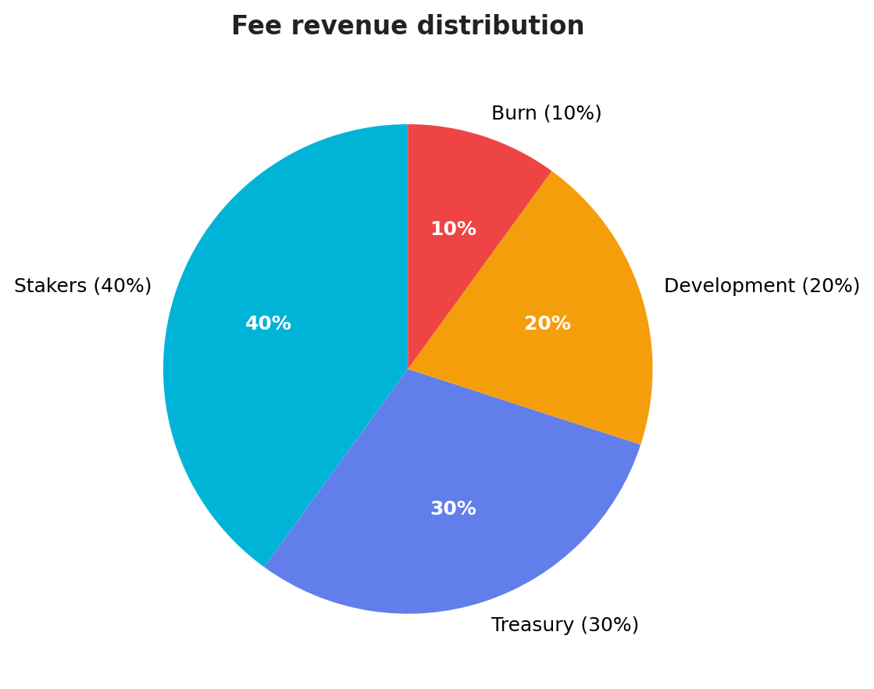
Figure 8: Fee revenue distribution
Fee Type | Rate | Distribution
Crypto Swap Fee | 0.03% of swap value | 40% stakers • 30% treasury • 20% development • 10% burn
RWA Trading Fee | 0.05% of trade value | 40% stakers • 30% treasury • 20% RWA provider • 10% burn
Forex/Commodity Fee | 0.02% + spread | 40% stakers • 30% treasury • 20% oracle providers • 10% burn
Cross-Chain Fee | 0.05% + bridge gas | 50% stakers • 30% treasury • 20% bridge providers
Priority Routing | 0.01% premium (opt-in) | 100% to stakers
Perpetual Funding | Variable rate | 40% stakers • 60% counterparty pool

Deflationary Burn
Annual_Burn = 0.10 × Total_Annual_Fees / Price_FDN

7.4 Staking Mechanics & Emission Schedule
$FDN staking rewards follow a declining emission curve over 10 years (1.25 billion $FDN total pool):
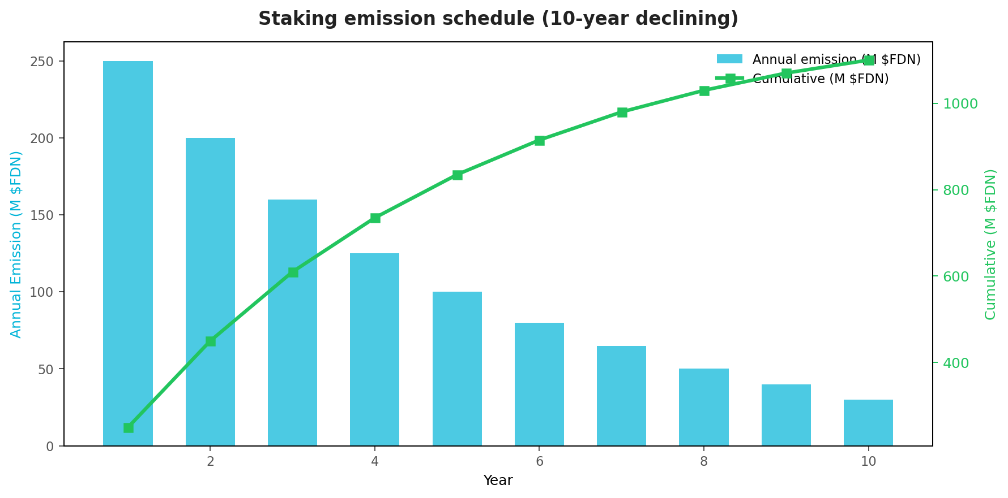
Figure 9: 10-year staking emission schedule
Year | Annual Emission | Cumulative | % of Pool | Est. APY
1 | 250,000,000 | 250,000,000 | 20.0% | 15–20%
2 | 200,000,000 | 450,000,000 | 16.0% | 12–16%
3 | 160,000,000 | 610,000,000 | 12.8% | 10–13%
4 | 125,000,000 | 735,000,000 | 10.0% | 8–11%
5 | 100,000,000 | 835,000,000 | 8.0% | 7–9%
6–10 | 265,000,000 total | 1,100,000,000 | 21.2% | 3–7% (declining)
Staking APY
APY = (0.40 × Annual_Protocol_Fees + Emission(year)) / Total_Staked_FDN
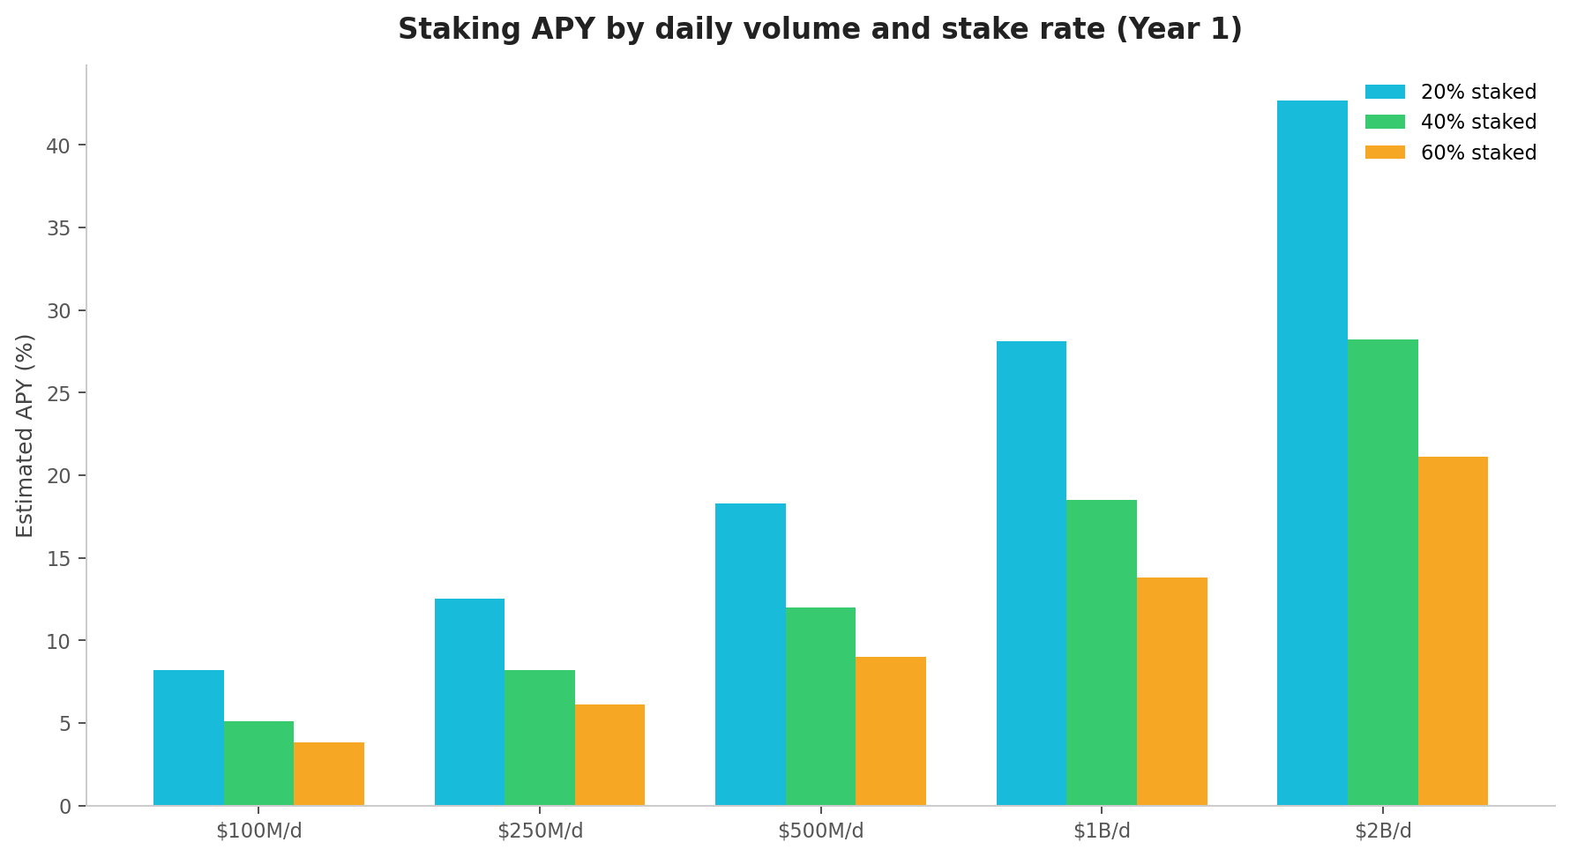
Figure 10: Staking APY projections by volume and stake rate (Year 1)

8. Presale Structure
FlowDex will raise $80,000,000 through an 8-tier public presale with zero venture capital. The tiered structure rewards early participants with progressively better entry prices. All funds are managed through a 4-of-7 multisig treasury with mandatory quarterly on-chain transparency reports.
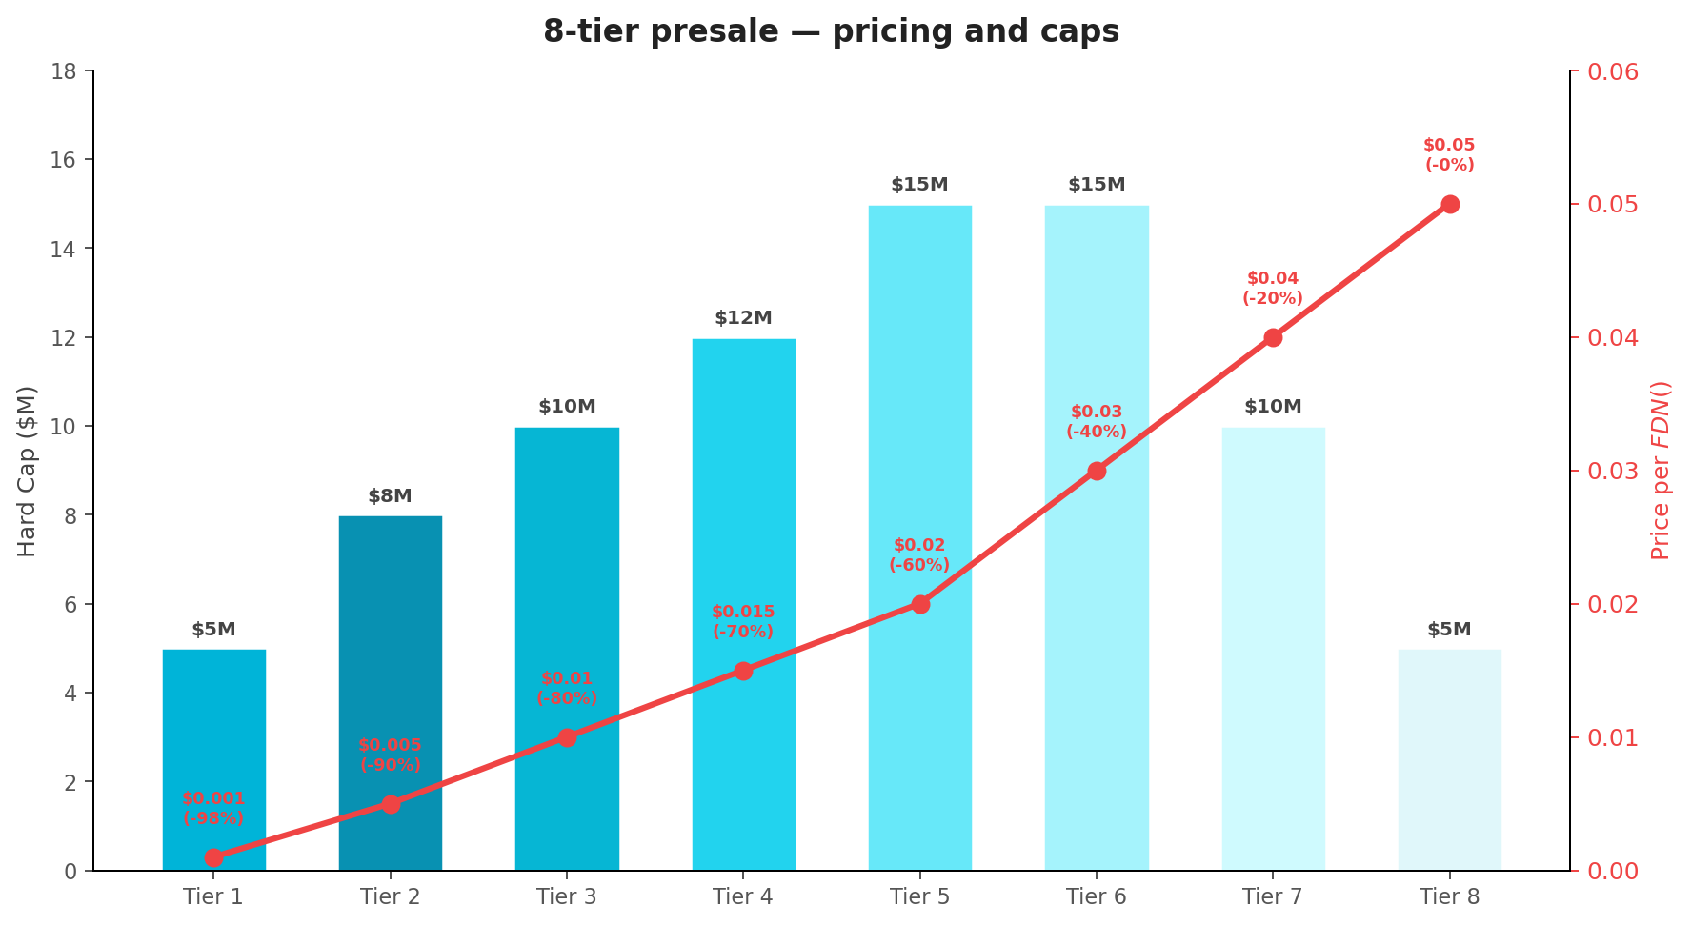
Figure 11: 8-tier presale — pricing, discounts, and caps
Tier | Price | Discount | Raise Target | Hard Cap | Tokens Allocated
Tier 1 (Whitelist) | $0.001 | 98% | $5,000,000 | $5M | 5,000,000,000
Tier 2 | $0.005 | 90% | $8,000,000 | $8M | 1,600,000,000
Tier 3 | $0.01 | 80% | $10,000,000 | $10M | 1,000,000,000
Tier 4 | $0.015 | 70% | $12,000,000 | $12M | 800,000,000
Tier 5 | $0.02 | 60% | $15,000,000 | $15M | 750,000,000
Tier 6 | $0.03 | 40% | $15,000,000 | $15M | 500,000,000
Tier 7 | $0.04 | 20% | $10,000,000 | $10M | 250,000,000
Tier 8 | $0.05 | 0% | $5,000,000 | $5M | 100,000,000

8.1 Investor Returns at Listing
The aggressive Tier 1 pricing creates massive early-mover incentive. At the $0.05 listing price alone, Tier 1 investors see a 4,900% return. This table shows what a $1,000 investment returns at listing across each tier:
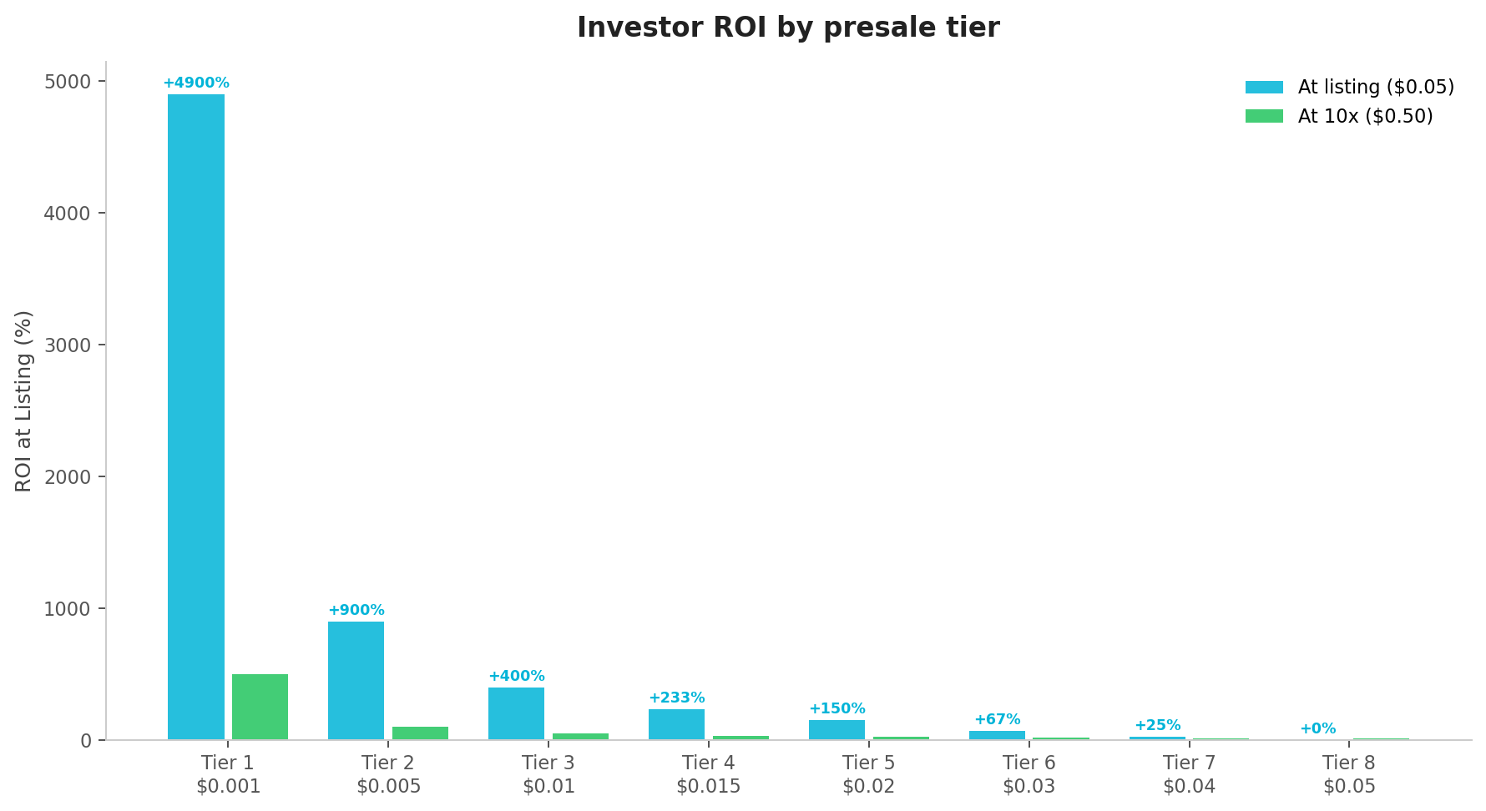
Figure 12: Investor ROI by presale tier at listing price
Tier | $1,000 Buys | Value at Listing ($0.05) | Profit | ROI
Tier 1 ($0.001) | 1,000,000 $FDN | $50,000 | $49,000 | +4,900%
Tier 2 ($0.005) | 200,000 $FDN | $10,000 | $9,000 | +900%
Tier 3 ($0.01) | 100,000 $FDN | $5,000 | $4,000 | +400%
Tier 4 ($0.015) | 66,667 $FDN | $3,333 | $2,333 | +233%
Tier 5 ($0.02) | 50,000 $FDN | $2,500 | $1,500 | +150%
Tier 6 ($0.03) | 33,333 $FDN | $1,667 | $667 | +67%
Tier 7 ($0.04) | 25,000 $FDN | $1,250 | $250 | +25%
Tier 8 ($0.05) | 20,000 $FDN | $1,000 | $0 | 0%

8.2 Comparable Project Performance
FlowDex’s positioning as a Universal Exchange places it in the same category as projects that have delivered exceptional returns to early investors:
Project | Category | Presale Price | All-Time High | Peak ROI
Synthetix (SNX) | Synthetic Assets | $0.07 | $28.53 | +40,671%
Injective (INJ) | DeFi Derivatives | $0.40 | $52.62 | +13,055%
dYdX (DYDX) | Perp DEX | $1.00 | $27.86 | +2,686%
1inch (1INCH) | DEX Aggregator | $0.50 | $7.78 | +1,456%
Jupiter (JUP) | Solana Aggregator | $0.40 | $1.85 | +363%
FlowDex addresses a significantly larger market than any of these projects (multi-asset vs crypto-only), which supports the potential for a larger eventual market cap. At Injective’s peak FDV of $5.2 billion, $FDN would be worth $0.52 per token — a 52,000% return from Tier 1.

8.3 Use of Presale Funds
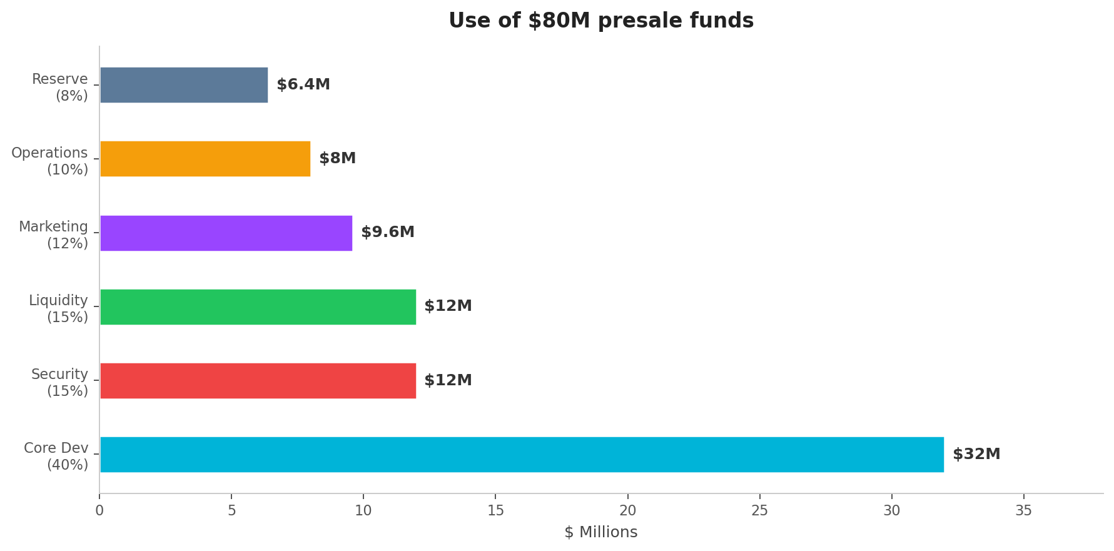
Figure 13: Allocation of $80M presale funds
Category | Allocation | Amount | Description
Core Development | 40% | $32,000,000 | Multi-asset protocol, routing engine, RWA integrations, FlowChain R&D, mobile apps
Security & Audits | 15% | $12,000,000 | 3+ audits (Trail of Bits, OpenZeppelin, Zellic), formal verification, $5M bug bounty
Liquidity | 15% | $12,000,000 | DEX/CEX liquidity, market makers, RWA liquidity partnerships
Marketing & Growth | 12% | $9,600,000 | Community, KOL partnerships, brand, events, regional expansion
Operations & Legal | 10% | $8,000,000 | Legal entities, regulatory (MiCA, CLARITY Act compliance), team ops
Strategic Reserve | 8% | $6,400,000 | Emergency fund, opportunistic partnerships, FlowChain validator incentives

8.4 Vesting & Unlock Schedule
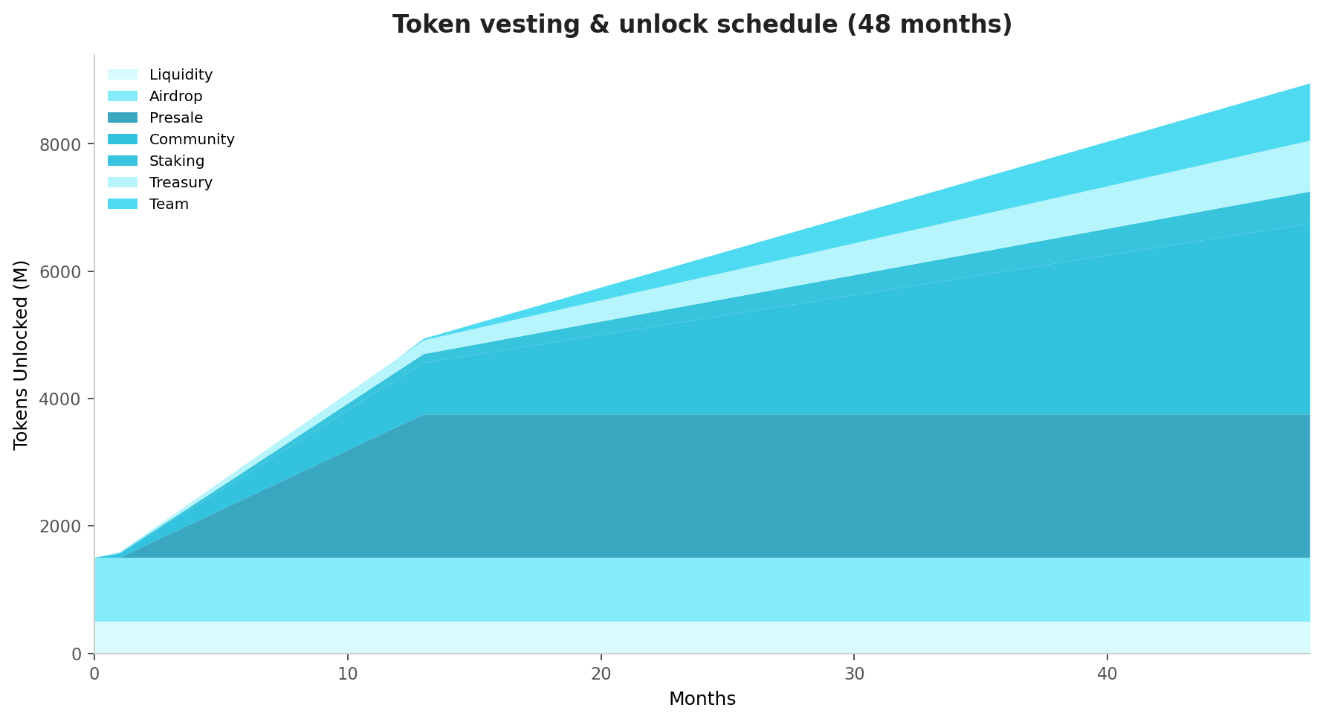
Figure 14: Token vesting and unlock schedule (48 months)
Investor Protections
• Token contract independently audited by 2+ tier-1 security firms before presale
• Automatic refund if minimum $20M raise threshold is not met (smart contract enforced)
• Core team tokens fully locked 1 year + 4-year vesting — team cannot sell before investors
• 4-of-7 multisig treasury with mandatory quarterly on-chain transparency reports
• All vesting enforced at smart contract level — immutable after deployment
• Zero VC allocation — 100% of non-team tokens go to the community

9. Governance
FlowDex governance ensures no single entity can unilaterally affect protocol operations or user funds. All major decisions are made through on-chain voting by $FDN stakers.
Parameter | Details
Proposal Threshold | 100,000 $FDN (staked) to submit
Voting Period | 7-day minimum, no early execution
Quorum | 30% of staked supply
Approval | 67% supermajority (critical) / 50% (standard)
Timelock | 48h delay before execution
Delegation | Full delegation without token transfer
Quadratic Voting Power
VP(a) = √(staked_FDN(a)) × min(1 + 0.1 × months_staked, 2.0)
A Security Council of 9 community-elected members handles emergencies (oracle failures, bridge exploits). Emergency actions require 6-of-9 multisig and mandatory community ratification within 72 hours.

10. Security
A platform routing user funds across 50+ DEXs, multiple bridges, and RWA providers across 10+ chains requires the highest possible security standards.

10.1 Audit Program
Firm | Scope | Status
Trail of Bits | Core routing, $FDN token, staking, RWA integration module | Engaged
OpenZeppelin | Cross-chain messaging, bridge integrations, admin controls | Scheduled Q2 2026
Zellic | Frontend, oracle integration, governance, synthetic asset module | Scheduled Q2 2026
Certora | Formal verification of routing, staking, vesting, and RWA contracts | Engaged

10.2 Additional Security
- $5,000,000 permanent bug bounty via Immunefi
- Real-time anomaly detection with automated circuit breakers
- Open source: all contracts under MIT license for community review
- No admin keys: immutable contracts post-deployment
- Multi-sig treasury: 4-of-7 for any fund movement
- 48-hour timelock on all governance changes
- Bridge security: federated multi-bridge architecture (LayerZero, Wormhole, Across, native L2)
Aggregate Bridge Security
BSS = 1 - ∏(1 - S_i) for i = 1..n bridges | 4 bridges × 99% = 99.999999% aggregate

11. Competitive Analysis
FlowDex occupies a unique position: the only non-custodial platform offering both crypto-native and tokenized real-world asset trading across multiple chains.
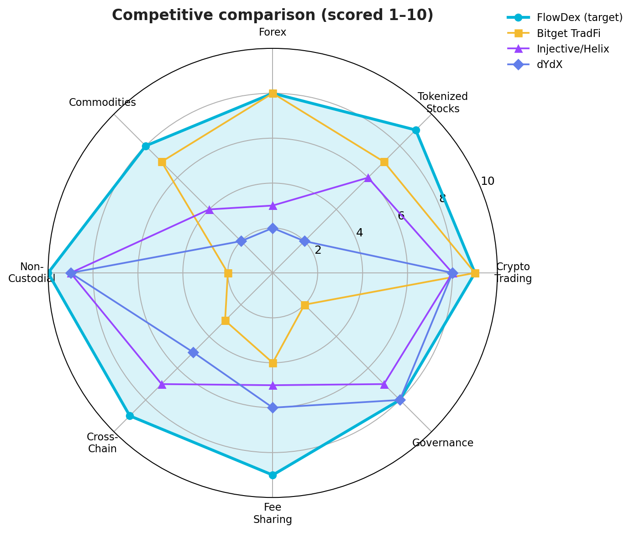
Figure 15: Competitive radar — FlowDex vs major platforms (scored 1–10)
Dimension | FlowDex | Bitget TradFi | Injective/Helix | dYdX | Synthetix
Crypto Trading | ✓ 1000+ tokens, 50+ DEXs | ✓ 1300+ tokens | ✓ 200+ tokens | ✓ 170+ perps | ✓ Synthetic crypto
Stocks/ETFs | ✓ 200+ tokenized | Partial | Partial (~20) | No | No
Forex | ✓ 50+ pairs | Yes | No | No | Yes (limited)
Commodities | ✓ 30+ instruments | Yes | Gold only | No | Yes (limited)
Non-Custodial | ✓ Always | No | Yes | Yes | Yes
Cross-Chain | ✓ 10+ chains | No | Injective only | dYdX only | Optimism + Base
Fee Revenue Sharing | ✓ 40% to stakers | BGB discounts | Limited | Partial | Yes
Own Blockchain | ✓ FlowChain (2027) | No | Yes (Cosmos) | Yes (Cosmos) | No

12. Team
The FlowDex core team operates pseudonymously, following the precedent set by Bitcoin (Satoshi Nakamoto), Ryoshi (SHIB), and many successful DeFi protocols. This is a deliberate design choice, not an evasion:
- Product Over Personality: The protocol should be judged on fundamentals, not personal brands.
- Security First: Teams managing $80M+ face real physical threats (kidnapping, extortion, social engineering).
- KYC-Verified: All core members are verified through an independent third-party legal entity.
- Progressive Doxxing: Team will be revealed as the project hits milestones — identity earned through results.
Alias | Role | Background
Atlas | Founder & CEO | Former quantitative trader at a top-5 global investment bank. 8+ years building DeFi protocols.
Helix | CTO | PhD in Distributed Systems from ETH Zurich. Former core engineer at a leading L1 blockchain.
Vector | Head of Risk | Former risk manager at a Tier-1 centralized exchange. Previously Goldman Sachs.
Cipher | Lead Smart Contracts | Core contributor to 2 audited DeFi protocols with combined TVL exceeding $1 billion.
Nova | Head of Research | PhD in Cryptography with 15+ peer-reviewed publications on zero-knowledge proofs.
Orbit | Head of Growth | Led community growth at two top-50 crypto projects from seed to $500M+ market cap.

13. Roadmap
Phase | Timeline | Key Milestones
Phase 0:Foundation | Q1 2026 | Whitepaper v6.0 • Website + whitelist • Community (Twitter, Telegram, Discord) • Security audits initiated • RWA provider partnerships • Strategic partnerships
Phase 1:Presale & Launch | Q2 2026 | 8-tier presale ($80M) • $FDN ERC-20 deployment • TGE • Ethereum aggregator v1 (20+ DEXs) • Tokenized stocks (100+) • Forex pairs (20+) • Gold/commodities • Staking • DEX/CEX listings
Phase 2:Multi-Chain | Q3–Q4 2026 | BSC, Solana, Arbitrum, Polygon • 500+ assets • 50+ DEXs • Options & futures • Cross-chain swaps • Governance DAO • Mobile app • Institutional API
Phase 3:FlowChain | 2027 | FlowChain testnet • Validator onboarding • Token migration • 50,000+ TPS • Zero-gas routing • Cross-asset margin • $1B+ monthly volume target
Phase 4:Maturity | 2028+ | 500+ validators • Full DAO handoff • Prediction markets • Structured products • Institutional prime brokerage • Advanced analytics • Global regulatory compliance

14. Risk Factors

14.1 Technology Risk
Smart contract vulnerabilities, routing algorithm failures, or bridge exploits could result in loss of funds. Cross-chain and multi-asset operations introduce complexity not present in single-chain protocols. RWA integration adds dependency on external tokenization providers.

14.2 Regulatory Risk
Tokenized securities may be classified differently across jurisdictions. The CLARITY Act (US) and MiCA (EU) provide frameworks but are still evolving. FlowDex may need to restrict certain asset classes in certain jurisdictions. There is no guarantee that $FDN will not be classified as a security.

14.3 Market Risk
$FDN may fluctuate significantly and could lose all value. The $0.05 listing price is a target, not a guarantee. RWA tokens may face liquidity challenges in stressed markets.

14.4 RWA Counterparty Risk
Tokenized assets depend on the solvency and operational integrity of the underlying issuers (Ondo, Backed, Dinari). If an RWA provider fails or depegs, users holding those tokens may lose value.

14.5 Competition Risk
Centralized exchanges (Bitget, BTCC) are rapidly adding TradFi products with superior UX. Decentralized competitors (Injective, Synthetix) may expand their asset coverage. Traditional brokers may adopt tokenization, reducing FlowDex’s differentiation.

14.6 Team & Execution Risk
The team operates pseudonymously. The project’s scope (multi-asset, multi-chain, own appchain) is ambitious. There is no guarantee that all milestones will be achieved on schedule.

15. Formula Reference
Formula | Expression | Application
Routing Optimization | max ∑ Output_i - ∑ Cost_i, s.t. ∑ Input_i = Total | Optimal multi-asset trade splitting
Staking APY | (0.4 × Fees + Emission) / Staked | Annual staking yield estimate
Burn Rate | 0.1 × Fees / Price | Annual token deflation
Voting Power | √(staked) × time_mult | Quadratic governance weight
Bridge Security | 1 - ∏(1 - S_i) | Aggregate multi-bridge safety
Mark Price | median(P_pyth, P_chain, P_twap) | Multi-oracle aggregation
Emission Decay | 250M × (0.81)^(y-1) | Staking emission per year
Synthetic Health | Collateral / (Size × (1+MM)) | Liquidation threshold

16. Legal Notice & Disclaimer
IMPORTANT: PLEASE READ THIS SECTION CAREFULLY.
This whitepaper is for informational purposes only and does not constitute an offer or solicitation to sell securities, investment products, or any regulated financial instrument in any jurisdiction. $FDN tokens are utility tokens intended for use within the FlowDex Network ecosystem and are not designed or intended to be securities.
Nothing in this whitepaper constitutes legal, financial, tax, or investment advice. Prospective participants should consult qualified advisors before any decision to purchase $FDN tokens.
No representation or warranty is made regarding accuracy, completeness, or reliability of information herein. Forward-looking statements regarding market projections, technology roadmap, and financial metrics are estimates only.
$FDN tokens have not been registered under securities laws of any jurisdiction. Participation may be restricted in certain jurisdictions including the United States, China, North Korea, Iran, Syria, and Cuba.
Tokenized assets traded on FlowDex are issued by third-party providers (Ondo Finance, Backed Finance, Dinari, etc.) and carry their own risks including counterparty risk, regulatory risk, and liquidity risk. FlowDex is the routing layer, not the asset issuer.

Contact
Channel | Details
Website | flowdex.network
Documentation | docs.flowdex.network
Email | team@flowdex.network
Twitter / X | @FlowDexNetwork
Telegram | t.me/FlowDexNetwork
Discord | discord.gg/flowdex
GitHub | github.com/flowdex-network

© 2026 FlowDex Network. All rights reserved.
FlowDex Network — The Universal Crypto Exchange — Bridging Blockchain and Finance

