5/27/2019

Conference Management System

*Team:*

*NOT FAST BUT FURIOUS*

*Team Members:*

*Achim Diana*

*Ardelian Alexandra*

*Braga Cristina*

*Balea Alexandru*

*Belcianu Catalin*

Content:

1. Project description
2. Use-case scenarios
3. Diagrams
4. Class diagram
5. Database diagram
6. Use-case diagram
7. Sequence diagrams
8. Activity diagrams
9. Interaction diagram
10. Activity diagram
11. Help manual

*Project Description:*

* *Functionalities:*
* A PC Member is able to log in, to change his personal info, to switch to author mode and to bid proposals
* The chair, co-chairs and conference-chairs are able to change the deadlines and to assign papers to reviewers
* A reviewer is able to review one or more papers, attach recommendations to a paper, upload and see evaluations
* A participant can pay the registration required for log in
* An author can create an account, log in, submit a paper and upload the full paper in pdf format
* A listener can specify the section he/she wants to participate in
* *Workflow:*

We started by analyzing the project requirements creating the use case diagrams.

Then we has to discuss about the implementation of the database. We created the database diagram and then the classes diagram. We created the database and after that we started implementing the application. First, we implemented the model classes and the validators. Then we connected the database and started adding the functionalities along with their associated UI forms.

* *Technologies used:*
* DB server: Microsoft SQL Server
* Programming language: C#
* ORM: Dapper
* Software for creating diagrams: Star UML
* Version control: GitHub
* Task management: Trello
* GUI: Visual Studio

*Use Case Scenarios:*

*Case 1: Someone wants to participate as an author*

If a person finds the information about a new conference on the site and wants to participate as an author, he first has to create a new account. He enters its full name, email address, username, password and affiliation. The information is added in the DB, and the account is created. If the username or the email are already used, the user is asked to choose another one and the process starts again. Then, the user logs in as an author using the username and the password he created. After that, he can submit one or more papers, at different sections, until de deadlines are reached. After the deadline, the option to submit a new paper is no longer available. Then the reviewers decide if the paper is to be evaluated or not, and the author is announced about their final review. If the paper is accepted, it is marked as so and the author will add the paper on pdf format on its profile and will present it at the conference, as a speaker. If the paper is rejected and the author has no other papers, or all his papers are rejected, he can no longer be a speaker at the conference, but can participate.

*Case 2: Someone wants to log in as a PC Member*

Once the steering committee decides to organize a conference, they choose the PC Members (program committee members) beforehand. Then, a chosen member has to log in to the conference site. Since all the PC Members are already in the conference database, a normal person will not be allowed to register as a PC Member.

After the PC Member has logged in, if he is a regular member he will be able to review papers, thus making him a reviewer too. If he is a chair or a co-chair he can change the deadlines, see the paper reviews and coordinate all the process of reviewing.

Diagrams

1. Class diagram

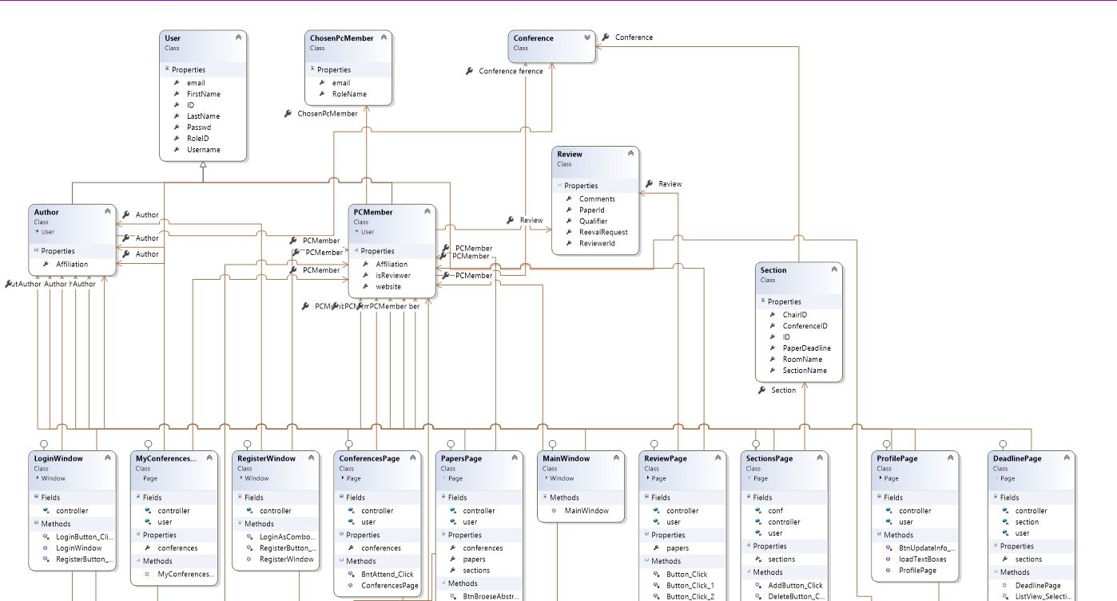

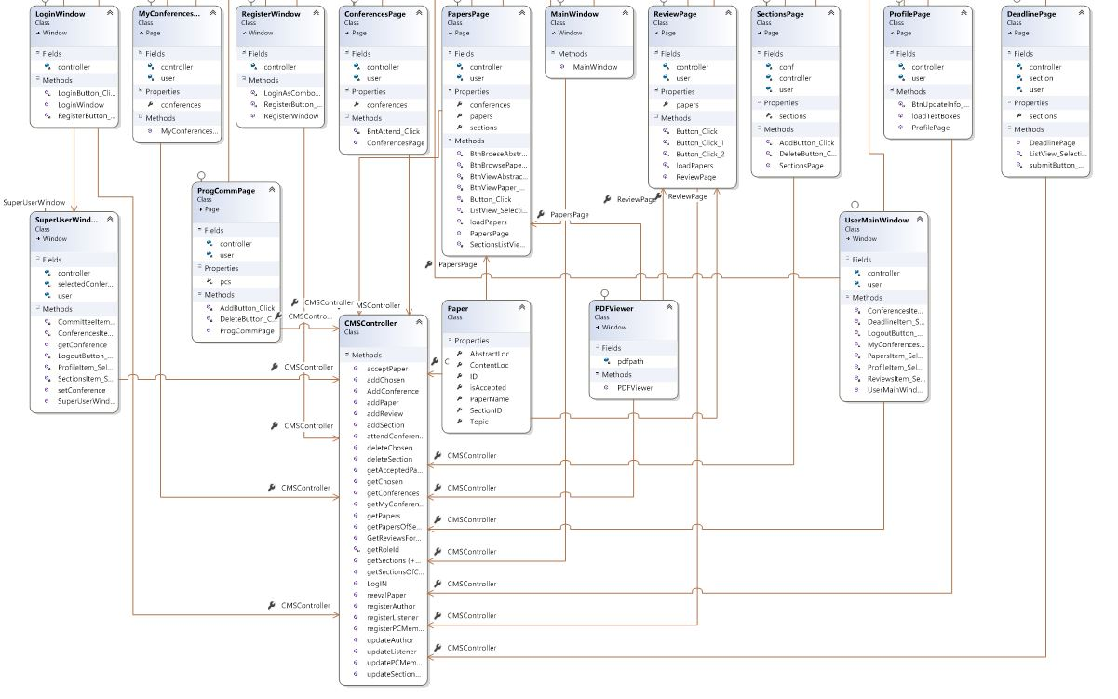

1. 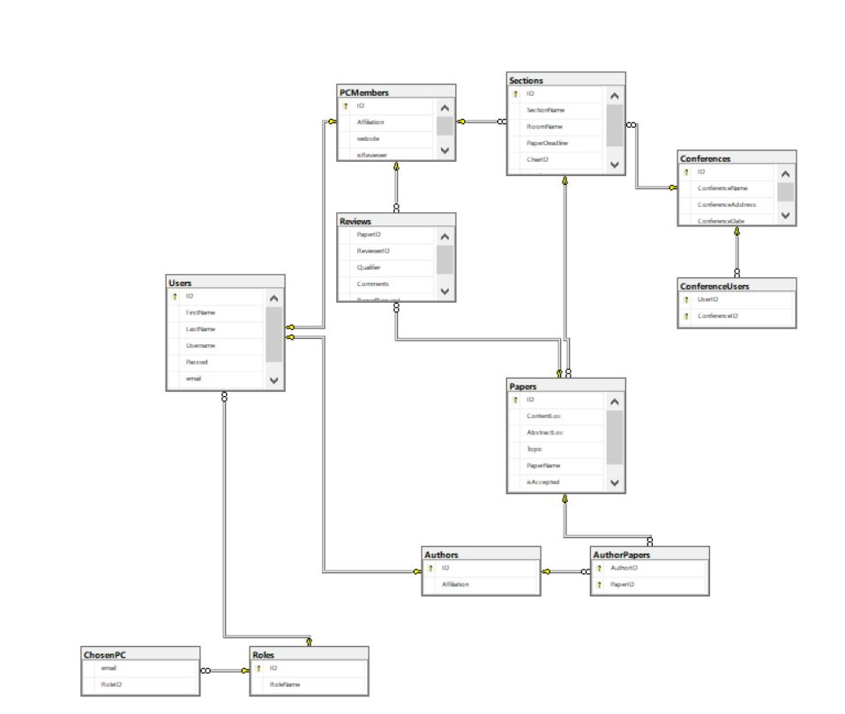Database diagram