

Software Quality Engineering (SQE)

Assignment 2_Deliverable 1

Group Information

Name: M.Mustagees Shahid (24P-3052)
Name: Malik Aleem Ahmad (24P-3076)
Name: Hunain Zahid (24P-3085)

Section: SE-5B

White Box Testing

1. Scope and Approach:
This document covers the assigned white-box analysis of registration_decision(): CFG, Cyclomatic Complexity, independent basis paths, Condition Coverage and MC/DC. Expected behavior is derived from the assignment SRS/REQUIREMENTS.md, not assumed from the implementation.
CFG scope: only the body of registration_decision() is included. Calls to prerequisites_satisfied() and check_credit_limit() are treated as single predicate evaluations; their internal decisions are not expanded. The compound capacity validation is expanded into three atomic conditions to show Python short-circuit behavior.

2. Control Flow Graph (CFG):
The diagram expands the capacity validation into A, B and C. A False result at A skips B; if the left side of the OR is already True, C is also skipped.
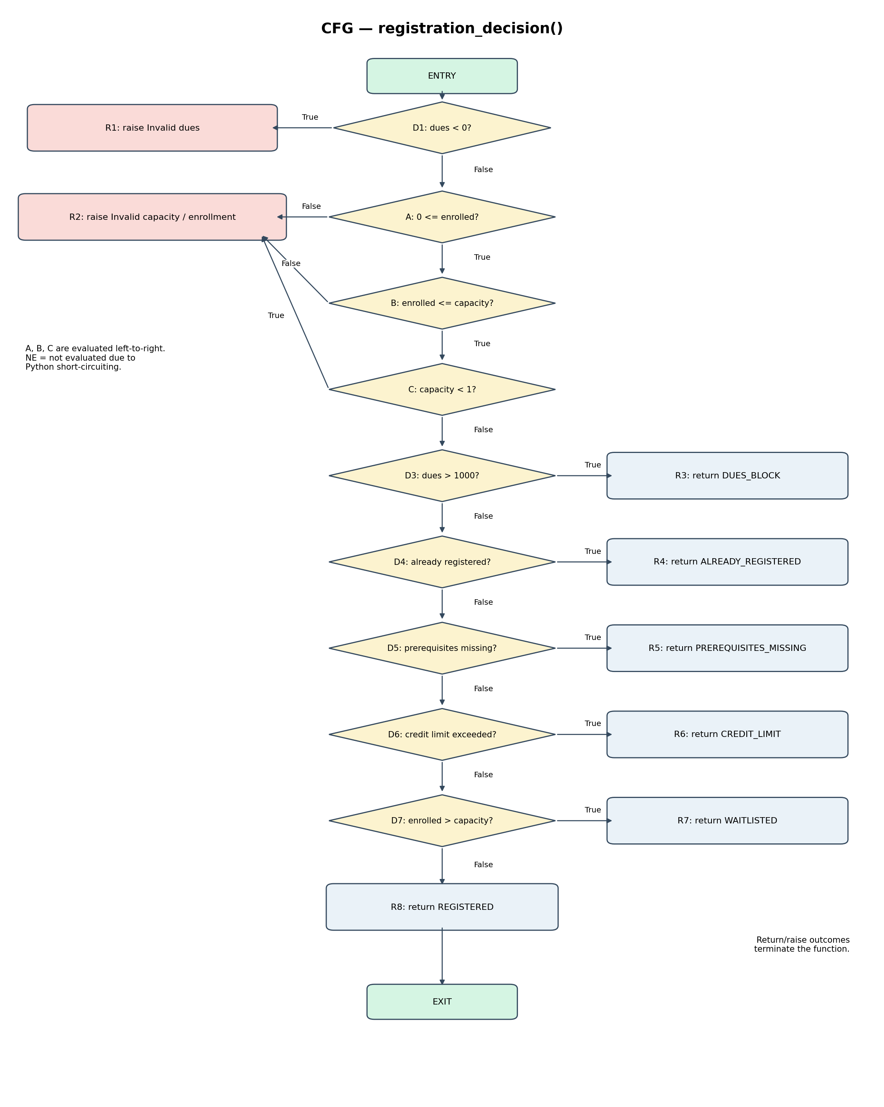

2.1 Node labels:
Node | Meaning
ENTRY | Start of registration_decision().
D1 | outstanding_dues < 0
A | 0 <= course.enrolled
B | course.enrolled <= course.capacity
C | course.capacity < 1
D3 | outstanding_dues > 1000
D4 | course.code is already registered
D5 | prerequisites are missing
D6 | credit limit is exceeded
D7 | course.enrolled > course.capacity
R1–R8 | Raise or return outcomes shown in the CFG.
EXIT | Function termination.

3. Cyclomatic Complexity:
Counting convention: A, B and C are counted as three atomic decision nodes because the compound validation uses short-circuit evaluation. Along with D1 and D3–D7, the CFG has 9 decision nodes.
Formula: V(G) = E − N + 2

Measure | Count | Explanation
N — Nodes | 19 | ENTRY + 9 decision nodes + 8 terminal outcome nodes + EXIT.
E — Edges | 27 | 18 decision edges + 1 entry edge + 8 terminal-to-exit edges.
V(G) | 27 − 19 + 2 = 10 | Cyclomatic Complexity.

Cross-check: decision nodes + 1 = 9 + 1 = 10. This matches E − N + 2. The result uses the stated expanded short-circuit convention consistently. For the E − N + 2 calculation, each return/raise outcome is treated as connecting to one conceptual common EXIT node; those terminal-to-EXIT links are omitted from the drawing to keep it readable.

4. Independent Basis Paths and Test Mapping:
With V(G) = 10, the CFG has 10 independent basis paths. The mapping below distinguishes existing tests from suggested representative inputs that are not currently in the test file.
Path | Decision sequence / outcome | Representative test or input | Status / note
P1 | D1=True → Invalid dues exception | test_negative_dues_raise_error(); dues=-1 | Existing; exercises path.
P2 | D1=False, A=False → invalid capacity | Parameterized invalid-capacity case: enrolled=-1, capacity=10 | Existing case.
P3 | D1=False, A=True, B=False → invalid capacity | Parameterized case: enrolled=11, capacity=10 | Existing case.
P4 | D1=False, A=True, B=True, C=True → invalid capacity | Parameterized case: enrolled=0, capacity=0 | Existing case.
P5 | Validation passes, D3=True → DUES_BLOCK | Suggested input: dues=1001, otherwise valid | Current test uses dues=1; it exposes the SRS defect but does not take the implementation's >1000 branch.
P6 | D3=False, D4=True → ALREADY_REGISTERED | test_already_registered_course_is_blocked() | Existing; exercises path.
P7 | D3=False, D4=False, D5=True → PREREQUISITES_MISSING | Suggested input: completed_courses=set(), required={'CS101'} | Current partial-prerequisite test exposes a defect but implementation returns True for any intersection.
P8 | Earlier checks False, D6=True → CREDIT_LIMIT | test_total_credits_above_18_are_rejected(); current=16, new=3 | Existing; exercises path.
P9 | Earlier checks False, D7=True → WAITLISTED | No feasible input in supplied function | Unreachable: earlier validation rejects enrolled > capacity.
P10 | All earlier checks False, D7=False → REGISTERED | test_course_with_available_seats_is_registered() or test_valid_course_capacity_does_not_raise_error() | Existing; exercises final path.

Note: P5 and P7 show suggested inputs because the current test file does not directly execute those implementation branches. P9 is structurally present but infeasible because the earlier validation rejects enrolled > capacity. Do not claim that an existing test executes a branch when the code actually takes another path.

5. Condition Coverage and MC/DC:
Selected compound decision:
if not 0 <= course.enrolled <= course.capacity or course.capacity < 1:
Atomic conditions:
- A = 0 <= course.enrolled
- B = course.enrolled <= course.capacity
- C = course.capacity < 1
The invalid-input decision is True when (not A) OR (not B) OR C. Python evaluates the chained comparison from left to right. If A is False, B is not evaluated. If the left side of the OR is already True, C is not evaluated.

5.1 Truth table from existing test inputs:
Case | enrolled | capacity | A | B | C | Invalid decision | Test location
TC1 | -1 | 10 | F | NE | NE | True | Parameterized invalid-capacity test
TC2 | 5 | 10 | T | T | F | False | test_valid_course_capacity_does_not_raise_error()
TC3 | 11 | 10 | T | F | NE | True | Parameterized invalid-capacity test
TC4 | 0 | 0 | T | T | T | True | Parameterized invalid-capacity test

F=False, T=True, NE=Not Evaluated at runtime. TC1 skips B and C because A is False and the OR decision is already True. TC3 skips C because the chained comparison is False, making the left side of the OR True.

5.2 Condition Coverage:
Condition | True demonstrated by | False demonstrated by | Result
A | TC2, TC3, TC4 | TC1 | Both outcomes covered
B | TC2, TC4 | TC3 | Both outcomes covered
C | TC4 | TC2 | Both outcomes covered

The existing inputs demonstrate True and False outcomes for each atomic condition. NE entries are retained to show actual runtime short-circuit behavior.

5.3 MC/DC independent effect pairs:
Condition | Test pair | Condition change | Decision change | Explanation
A | TC1 vs TC2 | A: F → T | True → False | B is logically True in both inputs and C logically False in both. In TC1, B and C are skipped at runtime; explain this as masking MC/DC.
B | TC2 vs TC3 | B: T → F | False → True | A remains True; C is logically False in both inputs (capacity=10), although C is skipped in TC3.
C | TC2 vs TC4 | C: F → T | False → True | A and B remain True; only C changes.

These pairs show the independent effect of A, B and C on the overall decision. For A and B, logical values are distinguished from runtime evaluation because Python may skip a condition. The A pair is explained using masking MC/DC.

6. Findings from the Supplied Implementation:
- Dues: implementation checks outstanding_dues > 1000, but the SRS says any positive amount must block registration.
- Prerequisites: implementation accepts any intersection; the SRS requires every prerequisite to be completed.
- Credit limit: implementation uses a strict less-than check; the SRS allows exactly 18 total credits.
- Availability: validation rejects enrolled > capacity, so the later WAITLISTED condition enrolled > capacity cannot be reached. The SRS says enrolled == capacity should waitlist.
- Withdrawal: implementation does not decrement course.enrolled, although the SRS requires this update.
These are implementation-versus-requirement observations. The assignment instructs students not to modify the implementation during initial test design/execution; defects should be tracked and fixed later through the team's workflow.

7. Test Execution Results:
The white-box test cases were executed using pytest to evaluate the supplied implementation against the requirements defined in the SRS.
7.1 Overall Test Results:
Test Result | Number of Tests
Passed | 13
Failed | 6
Total | 19

6.2 Failed Test Cases:
The following six test cases failed during execution:
Test Case | Expected Result | Actual Result
test_any_positive_dues_block_registration | Registration should be blocked for any positive dues. | Registration was allowed.
test_registration_blocked_when_one_prerequisite_is_missing | Registration should be blocked if any prerequisite is missing. | Registration was allowed.
test_total_credits_equal_to_18_are_allowed | Registration should be allowed when total credits equal 18. | CREDIT_LIMIT was returned.
test_full_course_student_is_waitlisted | Student should be added to the waitlist when the course is full. | REGISTERED was returned.
test_waitlisted_student_is_added_only_once | Student should be added to the waitlist only once. | A ValueError was raised on the second attempt.
test_withdraw_registered_course_updates_records | Course enrollment count should decrease after withdrawal. | Enrollment count remained unchanged.

6.3 Analysis:
The test execution showed that 13 tests passed and 6 tests failed. The failed tests indicate differences between the supplied implementation and the expected SRS requirements.
These failures were recorded as implementation defects. The implementation was not modified during the initial test execution, so the results reflect the behavior of the original supplied code.

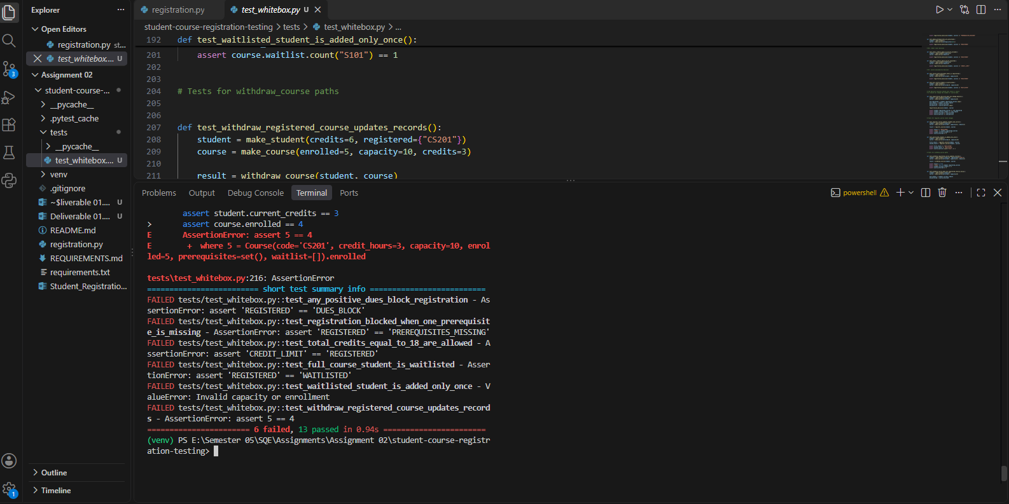

8. Conclusion:
Using the expanded short-circuit convention, the CFG has 19 nodes and 27 edges, producing V(G)=10. The basis-path analysis identifies ten independent paths, including a structurally unreachable WAITLISTED branch in the supplied implementation. The existing test inputs cover True and False outcomes for A, B and C, and the listed MC/DC pairs show each condition's independent effect while documenting short-circuit cases.

Black-Box Testing

1. Scope and Approach
Black-box testing was performed to check whether the Student Course Registration System works according to the Software Requirements Specification (SRS). Test cases were designed from expected inputs and outputs without depending on the internal code.
The following testing techniques were used:
Equivalence Class Partitioning (ECP)
Boundary Value Analysis (BVA)
Decision Table Testing
State Change Testing
Pytest was used to execute the test cases. The original implementation was not changed during initial testing.

2. Equivalence Class Partitioning (ECP)
ECP divides input data into valid and invalid groups. Representative values are selected from each group to reduce duplicate testing.
Input | Valid Class | Invalid Class
Current credits | 0–18 | Below 0 or above 18
Course credits | 1–4 | Below 1 or above 4
Outstanding dues | 0 | Negative values
Course capacity | 1 or greater | Below 1
Course enrollment | 0 to capacity | Below 0 or above capacity

A total of 25 ECP test entries were prepared in the testing documentation.

3. Boundary Value Analysis (BVA)
BVA checks values at the limits of input ranges because errors can occur at minimum and maximum boundaries.
Input | Minimum | Maximum
Current credits | 0 | 18
Course credits | 1 | 4
Total credits | 0 | 18
Course capacity | 1 | No fixed upper limit in SRS

For example, exactly 18 total credits should be allowed, while a total above 18 should be rejected.

4. Decision Table Testing
Decision Table Testing checks the system's output when multiple conditions affect a decision. Registration follows the priority order defined in the SRS.
Condition | Expected status
Outstanding dues greater than 0 | DUES_BLOCK
Course already registered | ALREADY_REGISTERED
One or more prerequisites missing | PREREQUISITES_MISSING
Total credits exceed 18 | CREDIT_LIMIT
Course is full and student is eligible | WAITLISTED
All checks pass and a seat is available | REGISTERED

5. State Change Testing
State Change Testing checks how system data changes after an operation.
Operation | Expected state change
Registration | Add course; increase student credits and course enrollment.
Waitlisting | Add student to waitlist once; do not change credits or enrollment.
Withdrawal | Remove course; decrease student credits and course enrollment.
Withdrawal when not registered | Return False; keep all records unchanged.

6. Test Case Design
A total of 39 black-box test cases were prepared. Each test case includes a Test Case ID, Requirement ID, Test Scenario, Test Input, Expected Result and Execution Status. The cases cover valid and invalid inputs, boundaries, registration decisions and state changes.

7. Test Execution Results
All 39 test cases were executed using Pytest.
Result | Number of test cases
Passed | 27
Failed | 12
Total | 39

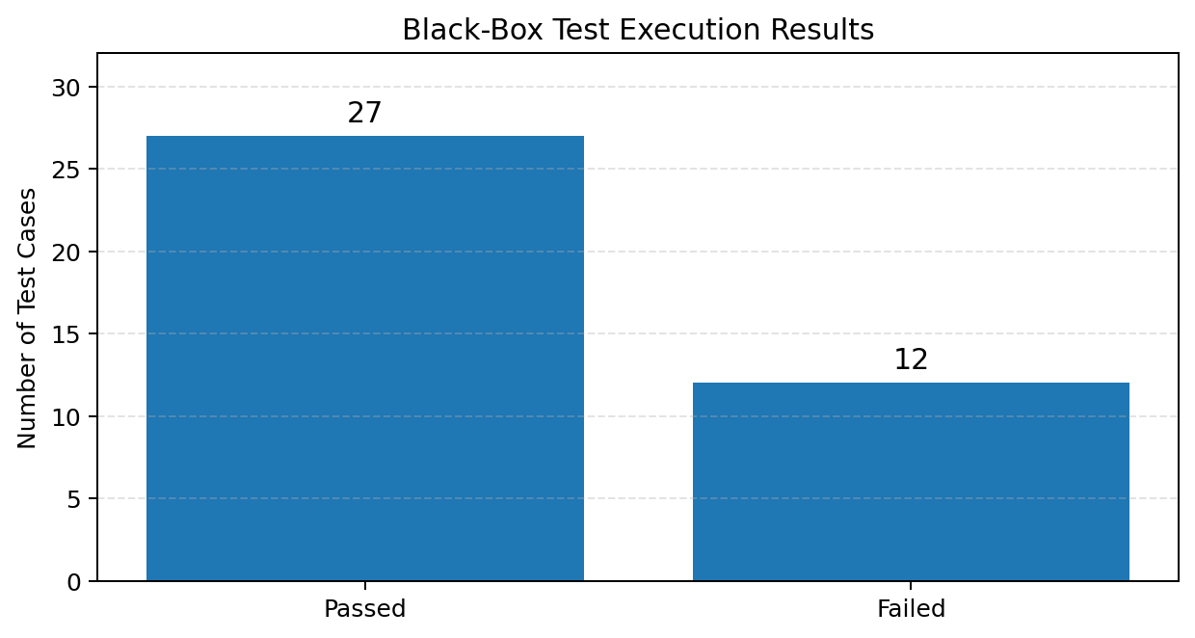
Figure 1: Black-box test execution results (27 passed and 12 failed).

7.1 Failed Test Cases
Test case(s) | Observed issue
TC-02, TC-18 | Exactly 18 credits were rejected.
TC-10, TC-17 | Registration was allowed with missing prerequisites.
TC-13, TC-22, TC-32 | Positive dues did not block registration.
TC-21, TC-26, TC-30, TC-31 | A full course did not return WAITLISTED.
TC-33 | Enrollment count did not decrease after withdrawal.

8. Defect Analysis
The failed tests were analyzed and grouped into five main defects.
Bug ID | Requirement | Defect description | Severity
BUG-01 | FR-01 | Exactly 18 credits are rejected. | High
BUG-02 | FR-03 | Registration is allowed with missing prerequisites. | High
BUG-03 | FR-04 | Some positive dues amounts do not block registration. | High
BUG-04 | FR-08 | Eligible students are not waitlisted when the course is full. | High
BUG-05 | FR-13 | Enrollment count is not decreased after withdrawal. | Medium

These defects show differences between the expected results in the SRS and the actual behavior of the supplied implementation. They were recorded for further investigation and correction.

10.Supporting Excel Documentation
The detailed test cases, input values, expected results, and execution records for each testing technique are provided in the respective Excel sheets. These sheets contain the complete testing data used during the analysis and execution of the Black-Box tests. Please refer to the attached Excel documentation for detailed information and supporting evidence.

9. Conclusion
Black-box testing was performed using ECP, BVA, Decision Table and State Change Testing. A total of 39 test cases were executed: 27 passed and 12 failed. The failed tests helped identify five main defects related to credit limits, prerequisites, dues, course capacity and withdrawal. The results show which parts of the system need improvement.

B2 – Statement and Branch Coverage

B4 – White-Box pytest Tests

C5 – GitHub Actions

B2. Statement and Branch Coverage

1. Initial Coverage
Initially, we executed the existing black-box test cases using pytest-cov to measure statement and branch coverage of registration.py.
Initial Test Results:
- Total test cases: 39
- Passed: 27
- Failed: 12
Initial Coverage Results:
Coverage Type | Covered | Total | Percentage
Statement Coverage | 49 | 53 | 92.45%
Branch Coverage | 21 | 26 | 80.77%

2. Coverage Gaps Identified
After checking the initial coverage report, we identified four uncovered statements and five uncovered branches.
The uncovered lines were 51, 59, 70, and 71.
These gaps were related to the dues-block condition and waitlist-handling logic.

3. Additional White-Box Tests
We added three additional white-box tests in tests/test_whitebox.py:
- test_dues_above_1000_reaches_dues_block_branch: Tests the dues-block return path using outstanding dues of Rs. 1001.
- test_waitlisted_student_is_added_once: Tests whether a student is added to the waitlist.
- test_existing_waitlist_student_is_not_added_again: Tests whether duplicate waitlist entries are prevented.
For the two waitlist tests, we used pytest's monkeypatch to isolate and test the waitlist-handling logic in register_course().

4. Final Coverage Results
After adding the three white-box tests, we executed both black-box and white-box tests together.
Final Test Results:
- Total test cases: 61
- Passed: 43
- Failed: 18
Final Coverage Results:
Coverage Type | Covered | Total | Percentage
Statement Coverage | 52 | 53 | 98.11%
Branch Coverage | 25 | 26 | 96.15%

5. Coverage Comparison
Coverage Type | Initial | Final | Improvement
Statement Coverage | 92.45% | 98.11% | +5.66 percentage points
Branch Coverage | 80.77% | 96.15% | +15.38 percentage points

6. Remaining Coverage Gap
One statement and one branch remained uncovered:
- Line 59: return "WAITLISTED"
- Missing branch: [58, 59]
The reason is that the implementation first validates that course.enrolled cannot exceed course.capacity. Later, the waitlist condition checks whether course.enrolled > course.capacity.
Therefore, the waitlist condition cannot be reached through valid inputs. This is a control-flow issue in the supplied implementation.
We did not modify registration.py because the assignment required testing the provided implementation.

7. Conclusion
The additional white-box tests improved statement coverage from 92.45% to 98.11% and branch coverage from 80.77% to 96.15%.
The remaining uncovered branch was documented as an implementation issue. The test failures were also preserved because they reveal differences between the supplied implementation and the expected requirements.

B4: White-Box Testing Using Pytest
White-box testing was performed using pytest to test the internal logic and execution paths of the registration system.
A total of 22 white-box test cases were executed:
- Passed: 16
- Failed: 6
The tests covered:
- Credit limit validation.
- Prerequisite checking.
- Outstanding dues validation.
- Registration decision priority.
- Course capacity and waitlisting.
- Duplicate waitlist entries.
- Registration state changes.
- Course withdrawal.
Additional tests were also added to check the dues-block branch and both waitlist branches using pytest monkeypatching.
The failed tests identified implementation defects where the actual output did not match the expected behavior defined in the requirements. The original implementation was not modified.

C5: GitHub Actions – Continuous Integration
A GitHub Actions workflow was created in .github/workflows/tests.yml.
The workflow automatically runs when code is pushed to the repository or when a pull request is created.
The workflow performs these steps:
- Checks out the repository.
- Sets up Python 3.14.
- Installs pytest and pytest-cov.
- Runs black-box and white-box tests.
- Generates statement and branch coverage reports.
- Uploads coverage reports as downloadable artifacts.
Execution Results:
- Total tests: 61
- Passed: 43
- Failed: 18
- Statement coverage: 97% (52/53 statements)
- Branch coverage: 96.15% (25/26 branches)
The workflow executed successfully, collected all 61 tests, generated coverage reports, and uploaded the coverage-reports artifact. The workflow showed a failed status because 18 tests detected existing defects in the supplied implementation.
Screenshots of the GitHub Actions execution, test results, and coverage artifact are attached as evidence.



