**Monoalphabetic Cipher Decryption Program:**

A monoalphabetic cipher is a substitution cipher where each letter in the plaintext is replaced by a letter in the cipher text. This cipher is prone to frequency analysis attack and therefore not secure.

This is a simple monoalphabetic cipher decryption program. This program obtains the frequency of each letter in the ciphertext and prints the results to the console which could be later used to calculate the mapping key to decrypt it.

The first program uses frequency analysis (minimum single-letter frequency) and assist it with analysis on the ciphertext using our knowledge of the English language.

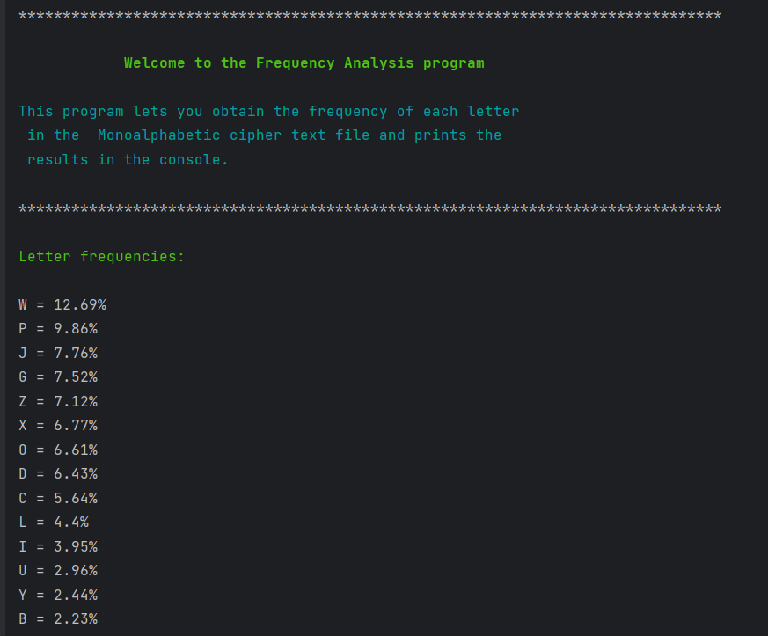

**Cryptanalysis.py**

The second program decrypts the cipher text using the key and prints the plaintext on the terminal. It also saves the plaintext as a file in the working folder.

**Plain_text.py**