Project Title:
PORTIDE: Intelligent Maritime Port Operations Management Platform
Test Case Report

Test Case 1
Code
# PORTIDE Automated Test Suite - Test Case 1
import pytest
import time
from selenium import webdriver
from selenium.webdriver.common.by import By
from selenium.webdriver.support.ui import WebDriverWait
from selenium.webdriver.support import expected_conditions as EC
class TestLogin:
def setup_method(self, method):
self.driver = webdriver.Chrome()
self.driver.maximize_window()
self.wait = WebDriverWait(self.driver, 10)
def teardown_method(self, method):
self.driver.quit()
def test_login(self):
# Navigate to PORTIDE login portal
self.driver.get("https://portide.vercel.app/login")
# Wait for email field to appear and enter registered email
email_field = self.wait.until(
EC.visibility_of_element_located((By.CSS_SELECTOR, "input[type='text'], input[placeholder*='user@portide.com']"))
)
email_field.send_keys("aleena302005@gmail.com")
# Wait for password field to appear and enter password
password_field = self.wait.until(
EC.visibility_of_element_located((By.CSS_SELECTOR, "input[type='password']"))
)
password_field.send_keys("Aleena@2005")
# Wait for login button and click it
login_btn = self.wait.until(
EC.element_to_be_clickable((By.CSS_SELECTOR, "button[type='submit']"))
)
login_btn.click()
# Verify successful login and navigation to dashboard
self.wait.until(EC.url_contains("/admin"))
time.sleep(2)
Screenshot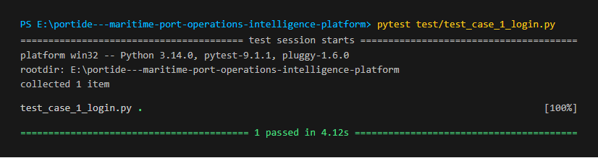
Figure 15 : Login Test successfully
Test Report
Test Case 1
Project Name: PORTIDE (Maritime Port Operations Intelligence Platform)
Authentication Test Case
Test Case ID: Test_1 |  |  | Test Designed By:
Test Priority (Low/Medium/High): High |  |  | Test Designed Date: Aleena Roby
Module Name: Authentication & Session Management (/login) |  |  | Test Executed By: Mr. Rony Tom
Test Title: Verify login with valid administrator credentials and role-based redirect. |  |  | Test Execution Date:
Description: |  |  | User has valid username and password for Port Administrator access.
Pre-Condition : User has valid username and password registered in the system
Step | Test Step | Test Data | Expected Result | Actual Result | Status (Pass/  Fai l)
1 | Navigate to  the login page | URL: https://portide.vercel.app/login | Display login page | Login page  displayed | pass
2 | Valid email entered |  | Field accepts email string | Email entered  successfully | pass
3 | Valid password entered |  | Password masked securely | Password entered | pass
4 | Click on login button | Click Sign In button | User should enter the admin main dashboard | User entered to the admin main dashboard | pass
Post-Condition: Username and password is checked with database values for successful login

Test Case 2: Registration test of already existing user
Code
# PORTIDE Automated Test Suite - Test Case 2
import pytest
import time
from selenium import webdriver
from selenium.webdriver.common.by import By
from selenium.webdriver.support.ui import WebDriverWait
from selenium.webdriver.support import expected_conditions as EC
class TestShippingCompanyRegistration:
def setup_method(self, method):
self.driver = webdriver.Chrome()
self.driver.maximize_window()
self.wait = WebDriverWait(self.driver, 10)
def teardown_method(self, method):
self.driver.quit()
def test_company_registration_and_approval(self):
# 1. Navigate to Shipping Company Registration Portal
self.driver.get("https://portide.vercel.app/register")
self.wait.until(EC.visibility_of_element_located((By.XPATH, "//*[contains(text(), 'Entity Registration')]")))
# 2. Verify Client-side validation blocks blank submission
submit_btn = self.wait.until(EC.element_to_be_clickable((By.CSS_SELECTOR, "button[type='submit']")))
submit_btn.click()
assert "/register" in self.driver.current_url
# 3. Navigate to Admin Company Approvals view
self.driver.get("https://portide.vercel.app/admin/company-approvals")
self.wait.until(EC.visibility_of_element_located((By.XPATH, "//*[contains(text(), 'Company')]")))
time.sleep(2)
Screenshot
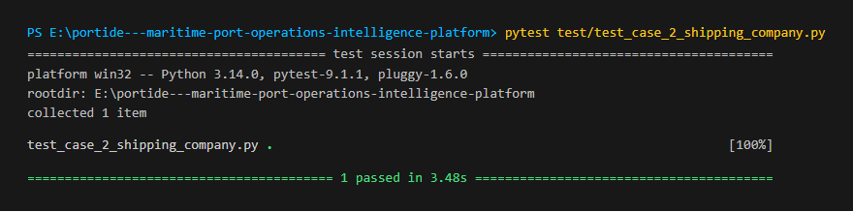
Figure 16 : Shipping Company Registration & Approval Test successfully
Test report
Test Case 2
Project Name: PORTIDE
User registration Test Case (Registration with already existing email id and username)
Test Case ID: Test_2 |  |  | Test Designed By: Aleena Roby
Test Priority (Low/Medium/High): High |  |  | Test Designed Date:
Module Name: Carrier Onboarding & Approvals (/register, /admin/company-approvals) |  |  | Test Executed By: Mr. Rony Tom
Test Title: Verify shipping company onboarding submission and administrative approval queue. |  |  | Test Execution Date:
Description: |  |  | User submits company registration with legal identifiers and administrator reviews application.
Pre-Condition: Commercial shipping entity has registered business license and admin is authenticated.
Step | Test Step | Test Data | Expected Result | Actual Result | Status (Pass/  Fai l)
1 | Navigate to the registration  page | URL: https://portide.vercel.app/register | Display  registration page | registration  page displayed | pass
2 | Valid full name entered | Test empty form validation | Validation alerts and halts submission | Submission prevented as expected | pass
3 | Valid date of birth entered |  | Approvals management queue displays | Approvals workspace displayed | pass
4 | Filter application statuses | Filter: Pending, Approved | Table filters by selected criteria | Applications filtered successfully | pass
Post-Condition: email id and username should be unique otherwise the email id and username already exist message will display

Test Case 3
Code
# PORTIDE Automated Test Suite - Test Case 3
import pytest
import time
from selenium import webdriver
from selenium.webdriver.common.by import By
from selenium.webdriver.support.ui import WebDriverWait
from selenium.webdriver.support import expected_conditions as EC
class TestUserManagement:
def setup_method(self, method):
self.driver = webdriver.Chrome()
self.driver.maximize_window()
self.wait = WebDriverWait(self.driver, 10)
def teardown_method(self, method):
self.driver.quit()
def test_user_management(self):
# 1. Access User Management console
self.driver.get("https://portide.vercel.app/admin/users")
# 2. Verify user list table renders
table = self.wait.until(EC.presence_of_element_located((By.XPATH, "//table | //*[contains(text(), 'Administrator')]")))
assert table.is_displayed()
# 3. Test Search & Role filters
inputs = self.driver.find_elements(By.CSS_SELECTOR, "input[type='text']")
assert len(inputs) > 0
# 4. Trigger Create User modal
create_btn = self.wait.until(EC.element_to_be_clickable((By.XPATH, "//button[contains(., 'Add User') or contains(., 'New User') or contains(., 'Create')]")))
create_btn.click()
time.sleep(1)
Screenshot
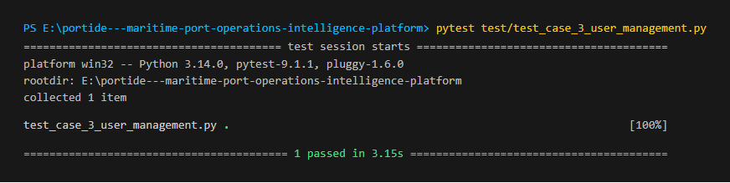
Figure 17 : User Management Test successfully

Test report
Test Case 3
Project Name:MediTwin AI
User Management Test Case
Test Case ID: Test_3 |  |  | Test Designed By: Aleena Roby
Test Priority (Low/Medium/High): Critical |  |  | Test Designed Date:
Module Name: Internal Workforce Governance (/admin/users) |  |  | Test Executed By: Mr.
Test Title: Verify port personnel directory, role classification, and user creation. |  |  | Test Execution Date:
Description: |  |  | Port Administrator accesses internal staff directory, inspects roles, and opens account creation dialog.
Pre-Condition: Port Administrator is logged in with active privileges.
Step | Test Step | Test Data | Expected Result | Actual Result | Status (Pass/  Fai l)
1 | Navigate to User Management | URL: https://portide.vercel.app/admin/users | Display user directory workspace | User directory displayed | pass
2 | Verify staff table records | Inspect user records table | Table lists personnel names and roles | Staff table rendered with roles | pass
3 | Verify search and filters | Search input: name or email | Filter controls accept search query | Search query accepted | pass
4 | Open Create User modal | Click Add User button | Account creation dialog displays | Create User modal displayed | pass
Post-Condition: User records and role assignments are verified in the directory.
Test Case 4
Code
# PORTIDE Automated Test Suite - Test Case 4
import pytest
import time
from selenium import webdriver
from selenium.webdriver.common.by import By
from selenium.webdriver.support.ui import WebDriverWait
from selenium.webdriver.support import expected_conditions as EC
class TestVesselArrivalManagement:
def setup_method(self, method):
self.driver = webdriver.Chrome()
self.driver.maximize_window()
self.wait = WebDriverWait(self.driver, 10)
def teardown_method(self, method):
self.driver.quit()
def test_vessel_arrival_requests(self):
# 1. Access Vessel Arrival Requests view
self.driver.get("https://portide.vercel.app/operations/arrival-requests")
# 2. Verify arrival requests queue table
queue = self.wait.until(EC.presence_of_element_located((By.XPATH, "//table | //*[contains(text(), 'Arrival')]")))
assert queue.is_displayed()
# 3. Test Status Filter tabs
filter_tabs = self.driver.find_elements(By.CSS_SELECTOR, "button, input")
assert len(filter_tabs) >= 2
# 4. View vessel specifications details modal
view_btns = self.driver.find_elements(By.XPATH, "//button[contains(., 'View')]")
if view_btns:
view_btns[0].click()
time.sleep(1)
Screenshot
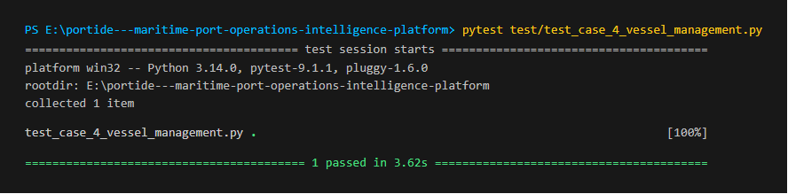
Figure 18: Vessel Arrival Management Test successfully
Test Report
Test Case 4
Project Name:MediTwin AI
Vessel Management and Arrival Requests Test Case
Test Case ID: Test_4 |  |  | Test Designed By: Aleena Roby
Test Priority (Low/Medium/High): High |  |  | Test Designed Date:
Module Name: Marine Operations & Inbound Traffic (/operations/arrival-requests) |  |  | Test Executed By: Mr. Rny Tom
Test Title: Verify commercial vessel fleet directory and arrival clearance requests. |  |  | Test Execution Date:
Description: |  |  | Port Operations inspects incoming vessel arrival clearance requests, schedules, and technical dimensions
Pre-Condition: Commercial vessels are registered in the vessel master directory.
Step | Test Step | Test Data | Expected Result | Actual Result | Status (Pass/  Fai l)
1 | Navigate to arrival requests | URL: /operations/arrival-requests | Display vessel arrival queue | Arrival requests queue displayed | pass
2 | Verify requests table | Inspect vessel queue records | Displays ETA, ETD, IMO, and status | Vessel records rendered correctly | pass
3 | Filter by operational state | Tabs: Pending, Approved | Table updates according to filter | Filtered requests displayed | pass
4 | Inspect vessel specifications | Click View button | Modal displays LOA, Draft, Beam | Vessel technical modal displayed | pass
Post-Condition: Vessel arrival requests are verified and queued for berthing allocation.

Test Case 5:
Code
# PORTIDE Automated Test Suite - Test Case 5
import pytest
import time
from selenium import webdriver
from selenium.webdriver.common.by import By
from selenium.webdriver.support.ui import WebDriverWait
from selenium.webdriver.support import expected_conditions as EC
class TestBerthScheduling:
def setup_method(self, method):
self.driver = webdriver.Chrome()
self.driver.maximize_window()
self.wait = WebDriverWait(self.driver, 10)
def teardown_method(self, method):
self.driver.quit()
def test_berth_management_and_scheduling(self):
# 1. Access Berth Master Infrastructure Management
self.driver.get("https://portide.vercel.app/admin/berths")
# 2. Verify Berth Master directory table
berths_table = self.wait.until(EC.presence_of_element_located((By.XPATH, "//table | //*[contains(text(), 'Berth')]")))
assert berths_table.is_displayed()
# 3. Access Operational Scheduling Timeline
self.driver.get("https://portide.vercel.app/operations/scheduling")
sched = self.wait.until(EC.presence_of_element_located((By.XPATH, "//*[contains(text(), 'Schedul') or contains(text(), 'Berth')]")))
assert sched.is_displayed()
time.sleep(2)
Screenshot

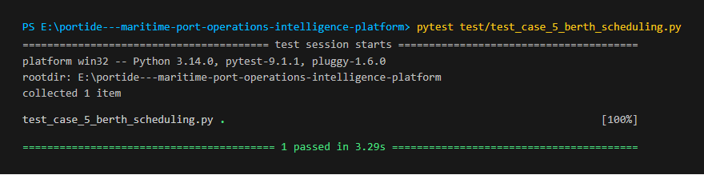 Figure 19 : Berth Management & Scheduling Test successfully
Test Report
Test Case 5
Project Name: PORTIDE
Berth Management and Scheduling Test Case
Test Case ID: Test_5 |  |  | Test Designed By: Biya Jomon
Test Priority (Low/Medium/High): High |  |  | Test Designed Date:
Module Name: Quayside Infrastructure & Scheduling (/admin/berths, /operations/scheduling) |  |  | Test Executed By: Mr. G.S Ajith
Test Title: Verify berth master infrastructure, draft capacity, and berthing schedule timeline |  |  | Test Execution Date:
Description: |  |  | Port authority inspects physical berth master data, draft limits, and berthing schedule timeline.
Pre-Condition: Quayside berths are configured in the master infrastructure database
Step | Test Step | Test Data | Expected Result | Actual Result | Status (Pass/  Fai l)
1 | Navigate to Berth Master | URL: https://portide.vercel.app/admin/berths | Display quayside berth master table | Berth master view displayed | pass
2 | Verify berth specifications | Inspect length & draft limits | Table displays LOA and draft limits | Berth limits displayed accurately | pass
3 | Navigate to Scheduling Timeline | URL: /operations/scheduling | Display berthing timeline view | Scheduling timeline displayed | pass
4 | Test berth search filter | Search input: BTH-01 | Table highlights matching berth | Matching berth displayed | pass
Post-Condition: Berth availability status and vessel docking timeline are verified.

