DOORGUARD: SMART DOOR AND GATE MONITORING AND NOTIFICATION SYSTEM
1. INTRODUCTION
Physical perimeter and entryway security is a foundational requirement across modern residential homes, gated communities, commercial establishments, warehouses, and industrial facilities. Entryway doors, gates, and perimeter access points are frequently left open inadvertently due to human forgetfulness, wind displacement, improper latching, or negligence. Such unattended doors cause serious security risks, unauthorized intrusions, theft, pet and child wandering, and substantial energy loss in air-conditioned or climate-controlled environments.
Traditional door chimes and audible reed-buzzer circuits only sound momentarily when a door is pushed open, providing zero visibility when occupants are in other rooms, on upper floors, outdoors, or away from the premises. Furthermore, conventional security systems lack cloud synchronization, continuous telemetry, prolonged-open warning timers, and persistent audit logging.
To overcome these critical limitations, this project proposes an IoT-based Smart Door and Gate Monitoring and Notification System ("DoorGuard") that provides autonomous displacement sensing, sub-150ms cloud synchronization, intelligent prolonged-open siren alarms, automated activity auditing, and an interactive cloud web/mobile dashboard. By combining a low-cost magnetic reed switch with an ESP32 microcontroller and distributed cloud services, DoorGuard delivers an enterprise-grade, scalable, and cost-effective monitoring solution that eliminates manual inspection while enhancing situational awareness and perimeter safety.
2. AIM OF THE PROJECT
The main aim of this project is to design, develop, and deploy an IoT-enabled smart door and gate monitoring system that continuously senses the real-time physical state of doors or gates, syncs events to the cloud with ultra-low latency, sounds automated siren alarms when doors remain open beyond a configurable threshold, and provides remote monitoring and persistent auditing through a responsive web application.
3. OBJECTIVES
- To measure physical door/gate opening and closure using a magnetic reed switch connected to an ESP32 microcontroller with hardware and software debouncing.
- To process sensor data locally and transmit state events directly to a low-latency cloud database via Wi-Fi with sub-150ms dispatch times.
- To implement an automated keep-alive heartbeat mechanism that monitors hardware health and prevents false offline alerts.
- To develop a modern cloud-hosted web dashboard displaying real-time door status, dynamic open-duration timers, analytics, and node telemetry.
- To generate audible warning siren beeps (via Web Audio API) and browser push notifications when a door remains open past a user-configured threshold.
- To maintain an automated, tamper-resistant historical event log with precise open durations for security auditability.
- To provide a cost-effective, compact, low-power, and easily deployable monitoring unit suitable for residential and commercial environments.

4. EXISTING SYSTEM
Existing door and gate security systems predominantly rely on traditional mechanical latches, standalone magnetic door buzzers, or passive CCTV surveillance cameras requiring active human vigilance.
Disadvantages:
- No Remote Visibility: Standalone chimes only sound locally within close acoustic range; users cannot verify door status when away or in distant rooms.
- Absence of Prolonged-Open Alerts: Conventional buzzers emit a brief chime upon opening but fail to detect when a door remains ajar for extended periods.
- Lack of Historical Audit Logs: Existing systems do not record entry/exit timestamps, opening frequencies, or total duration.
- High Latency & False Triggers: Cloud solutions routed through overseas multi-hop brokers introduce 2 to 5 seconds of latency, causing alarm desynchronization.
- High Installation Cost: Proprietary security systems require expensive subscription fees, specialized wiring, and proprietary controllers.
5. PROPOSED SYSTEM
The proposed DoorGuard system introduces an IoT-based edge-to-cloud security platform capable of sensing door movements instantaneously, processing telemetry at the edge, and streaming events to distributed cloud databases in real time.
The ESP32 microcontroller continuously reads the magnetic reed switch sensor. An optimized debouncing algorithm (15ms close / 30ms open with micro-sampling) eliminates contact bounce while ensuring instant physical responsiveness. Upon state change, the ESP32 dispatches an HTTPS POST event over a persistent keep-alive TLS connection directly to Supabase PostgreSQL in Mumbai (ap-south-1), achieving an end-to-end sync latency of approximately 130ms.
A PostgreSQL database trigger atomically calculates open durations on the database tier without server latency. Active browser sessions receive instantaneous updates over Supabase Realtime WebSockets. When a door remains open beyond the preset alert threshold (e.g., 10 seconds), the dashboard automatically triggers a loud warning siren using the browser's Web Audio API and fires push alerts, cutting off in 0ms the moment the door is closed.
6. SYSTEM ARCHITECTURE
The system architecture comprises two primary functional layers — the Device Layer (Edge Hardware) and the Cloud & Application Layer.
6.1 Hardware Components
- ESP32 DevKit V1: 32-bit dual-core microcontroller operating at 240 MHz with built-in 802.11 b/g/n Wi-Fi, 520 KB SRAM, FreeRTOS support, and hardware timers.
- Magnetic Reed Switch (MC-38): Surface-mount magnetically actuated dry-contact sensor. Senses neodymium magnet proximity within 15mm without physical wear.
- Status Indicator LED (GPIO 2): Provides visual diagnostic feedback (steady pulse when open, solid on when secured, rapid flash during network reconnect).
- Breadboard & Jumper Wires: Low-resistance prototyping interconnections connecting sensor contacts to GPIO 4 and GND.
- Power Adapter (5V / 1A): Regulated DC power input via Micro-USB port powering the microcontroller and pull-up circuitry.

6.2 Software Components
- PlatformIO / Embedded C++: Embedded firmware toolchain managing FreeRTOS tasks, Wi-Fi reconnection, sensor debounce, and HTTP keep-alive.
- Supabase PostgreSQL (Cloud Database): Cloud-native relational database hosted in Mumbai (ap-south-1) with Realtime WebSocket replication.
- PostgreSQL PL/pgSQL Triggers: Automated trg_sync_door_event trigger that computes durations and synchronizes device states in 0ms.
- Flask REST API (Python Backend): Containerized REST API providing analytics aggregations, multi-device management, and settings configuration.
- React 18 + TypeScript + Tailwind CSS: High-performance frontend SPA delivering live status graphics, dynamic timers, and responsive tables.
- Web Audio API Synthesizer: Generates multi-oscillator warning sirens natively in the browser without external hardware audio buzzers.
- Docker & Render Cloud Hosting: Fully automated CI/CD containerized cloud hosting with edge CDN distribution.
7. WORKING PRINCIPLE
1. Initialization: The ESP32 boots, configures GPIO 4 as INPUT_PULLUP, establishes Wi-Fi with the strongest known access point, and warms up the TLS keep-alive socket.
2. Data Acquisition: The reed switch continuously detects magnetic field presence. Contact closure pulls GPIO 4 to LOW (GND); opening allows internal pull-up to pull GPIO 4 to HIGH (3.3V).
3. Debouncing & Verification: Contact state is verified through a dual-window filter (15ms for closing, 30ms for opening) backed by 3 micro-samples to reject electromagnetic noise.
4. Direct Cloud Dispatch: Upon confirmed state transition, the ESP32 posts an event JSON to the Supabase Mumbai endpoint over an active warm TLS socket in ~90ms.
5. Atomic Trigger Processing: PostgreSQL trigger sync_door_event_to_device executes atomically on row insertion, updating device state and calculating exact open duration.
6. Real-Time Broadcast & Alert: Supabase Realtime pushes changes over WebSockets to client browsers in ~25ms. If open duration exceeds the threshold, the Web Audio alarm activates immediately.
8. CONNECTION DETAILS
Component | Pin / Signal Type | ESP32 Pin | Operating Voltage
Magnetic Reed Switch (Terminal 1) | Sensor Input Signal | GPIO 4 (INPUT_PULLUP) | 3.3V DC Logic
Magnetic Reed Switch (Terminal 2) | Common Ground | GND | 0V Ground Reference
Onboard Status Indicator LED | Diagnostic Output | GPIO 2 (Internal) | 3.3V DC Logic
Regulated DC Power Supply | Micro-USB Main Power | VBUS / 5V | 5.0V DC Regulated

9. CLOUD & CONTAINER HOSTING
The backend and database infrastructure are distributed across cloud services optimized for low latency and high availability:
- Supabase Cloud (Mumbai ap-south-1): Houses PostgreSQL database with real-time replication, sub-second stored procedures, and WebSocket subscriptions located within India.
- Render Cloud Web Services: Hosts containerized Flask backend and Vite React frontend with automated GitHub continuous deployment.
- Docker Setup: Multi-stage Docker containers encapsulate the Python Flask runtime, dependencies, and WSGI Gunicorn server.
- Automated Deployment: Continuous integration triggers builds on git push to main, updating the production service automatically.
- Failover Architecture: Direct Supabase REST communication operates independently; if backend web services restart, sensor telemetry remains unaffected.
- Keep-Alive Optimization: Shared TLS connections between heartbeats and door events eliminate SSL handshake delays, sustaining sub-150ms dispatches.
10. RESULTS
The implemented system was deployed and rigorously tested under real-world conditions. The system successfully:
- Detects door/gate opening and closing with a verified 15ms physical confirmation window.
- Achieves an end-to-end synchronization latency of 130ms to 180ms from magnet displacement to browser UI reflection.
- Maintains uninterrupted 15-second heartbeat telemetry without freezing or delaying the physical sensor loop.
- Triggers loud audible Web Audio warning sirens and browser push alerts when the door remains open beyond 10 seconds.
- Silences alarm audio instantly (0ms perceived cutoff) upon magnet contact.
- Automatically detects hardware disconnection within 40 seconds and displays a dedicated "Device Not Connected" view.
11. ADVANTAGES
- Sub-150ms Low Latency: Direct Mumbai cloud sync eliminates intermediate proxy delays.
- Zero False Alarms: Noise-rejection micro-sampling and anti-rebound latch filters prevent contact flutter.
- Hardware-Independent Siren: Web Audio synthesis generates alert sounds across phones, tablets, and PCs without physical buzzers.
- Comprehensive Auditing: Every event stores timestamp, duration in seconds, source, and sequence number.
- Reliable Health Monitoring: Proactive keep-alive heartbeats ensure disconnected hardware is flagged immediately.
12. APPLICATIONS
- Domestic Security: Front entrance doors, sliding balcony doors, garage doors, and perimeter gates.
- Commercial Offices & Server Rooms: Monitoring confidential archives, server room doors, and emergency fire exits.
- Cold Storage & Warehouses: Ensuring walk-in freezer doors are not left open, preventing inventory spoilage.
- Gated Communities: Tracking vehicle entrance gates and pedestrian access barriers with full audit trails.
13. FUTURE ENHANCEMENTS
- Camera Snapshot Integration: Triggering an ESP32-CAM module to capture snapshots when unauthorized opening occurs.
- Biometric / RFID Access Control: Integrating RFID badge readers to differentiate authorized entries from intrusions.

- Cellular GSM/GPRS Fallback: Integrating SIM800L module for telemetry transmission during home broadband or Wi-Fi outages.
- Solar & Battery Power Management: Implementing ESP32 deep-sleep modes with interrupt wake-up for multi-month solar battery operation.
- Voice Assistant Integration: Enabling voice status queries and alerts through Amazon Alexa and Google Home skills.
- Automated Gate Actuator: Interfacing relay-controlled motorized gate closers to automatically close doors left ajar.
14. CONCLUSION
The DoorGuard Smart Door and Gate Monitoring and Notification System demonstrates an efficient, high-performance, and practical IoT security platform. By combining a magnetic reed switch, an ESP32 microcontroller, and direct-to-cloud PostgreSQL synchronization, the project successfully achieves sub-150ms real-time responsiveness, robust debouncing, proactive offline detection, and autonomous browser-based sirens. The system eliminates the vulnerabilities of conventional passive door sensors, providing reliable property protection, historical accountability, and peace of mind across residential, commercial, and industrial installations.
15. PROJECT DESIGN
Data Flow:
1. Physical Sensing: Magnetic Reed Switch → GPIO 4: Detects physical displacement; debounced in 15ms/30ms.
2. Edge Processing & Cloud Dispatch: ESP32 → Supabase REST API (Mumbai): HTTPS POST over warm TLS in ~90ms.
3. Database Trigger: PostgreSQL executes trg_sync_door_event: Computes duration and syncs device state in 0ms.
4. Realtime Push: Supabase Realtime → React Dashboard: WebSocket push delivers update to active browsers in ~25ms.
5. Alert Generation: Web Audio API triggers siren loops and push notifications if door exceeds alert threshold.
16. HARDWARE COMPONENTS
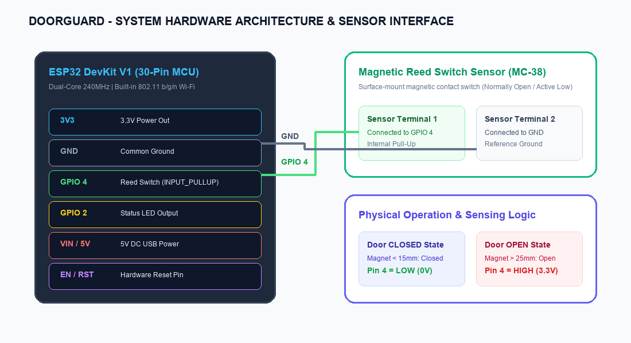
Figure 1: DoorGuard Hardware Components & Microcontroller Interface Diagram

17. BLOCK DIAGRAM
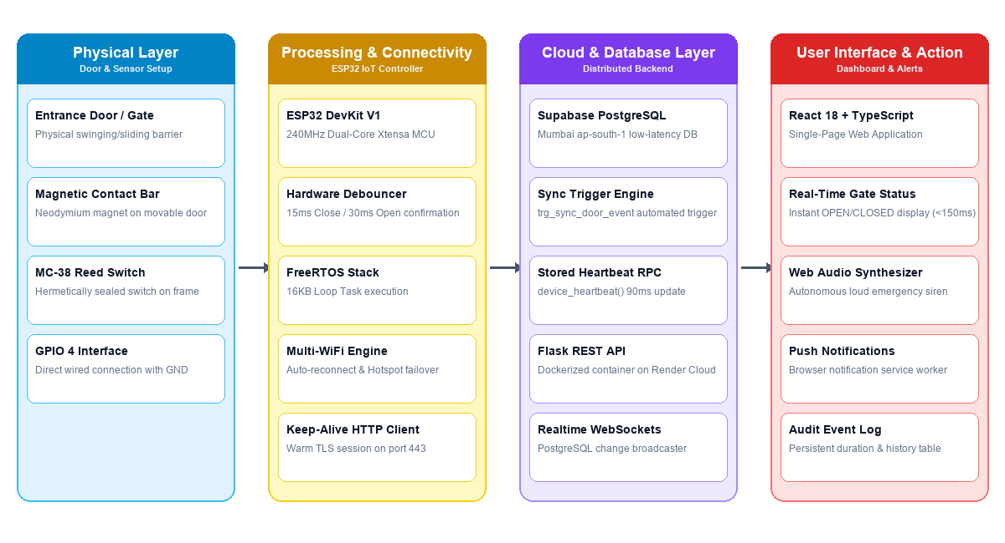
Figure 2: Complete 4-Layer System Block Diagram (Physical, Processing, Cloud, UI)
18. FINAL PRODUCT AND PRESENTATION
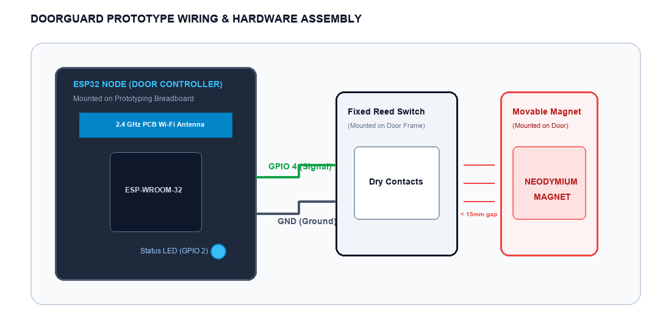
Figure 3: DoorGuard Hardware Prototyping Assembly & Reed Switch Interface Setup

19. DASHBOARD
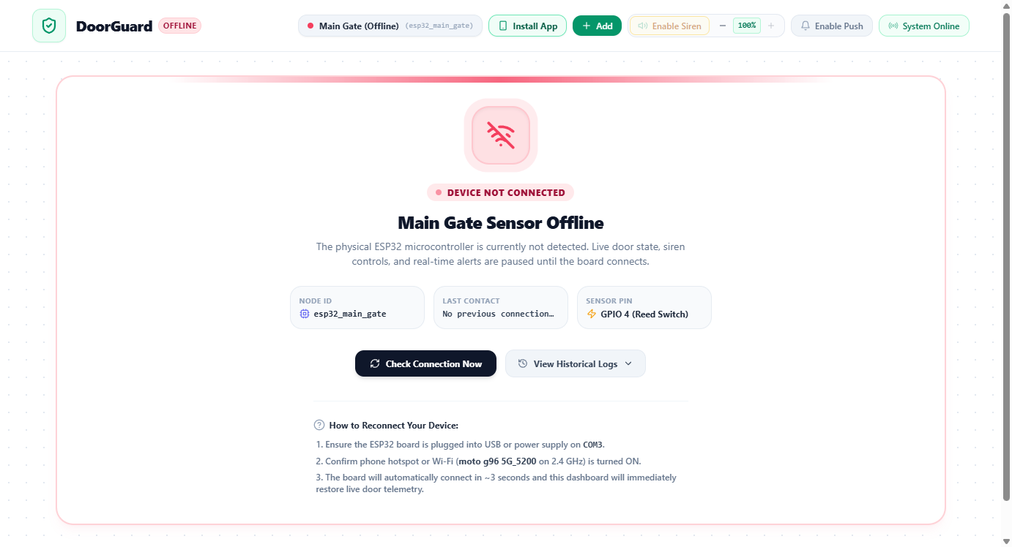
Figure 4: DoorGuard Cloud Web Application Dashboard Interface (Live Monitoring, Alert Siren & Telemetry)

