

DEPARTMENT OF COMPUTER & INFORMATION SYSTEMS ENGINEERING
BACHELORS IN COMPUTER SYSTEMS ENGINEERING
Course Code: CS-116
Course Title: Object Oriented Programming
Complex Engineering Problem ( CEP )
FE Batch 2025
Spring Semester 2026
Project Title: Library And Resource Management System
Dated : 10-May-2026

Group ID : G2-8
Member Names:
Rumaisa Waseem CS-25052
Laiba Qasim CS-25069
Aleena Khalid CS-25056
Section B
Submitted to: Ms. Fauzia Yasir

PROJECT CONTRIBUTION

Showing all classes, their attributes, methods, and relationships (inheritance, association)

— One short paragraph per class explaining its purpose and responsibility

— For each OOP concept, write 2 to 3 sentences explaining how and where you used it in your project

CHAPTER 4: TEST CASES
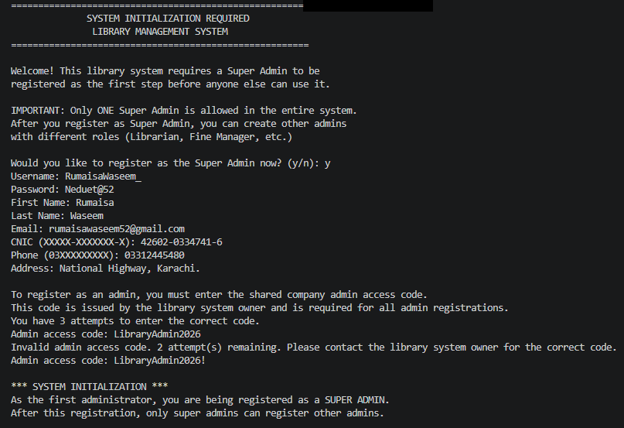
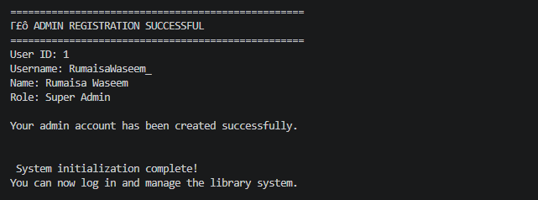

MAIN MENU:
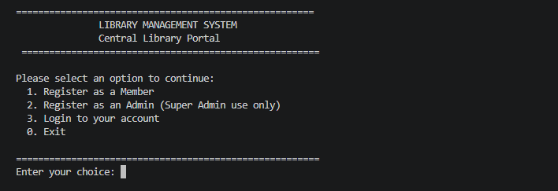
After Registration of Super Admin:
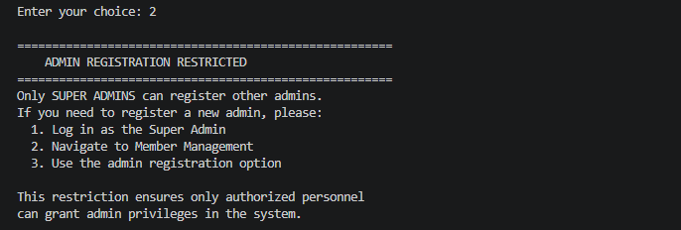

Super Admin Login:
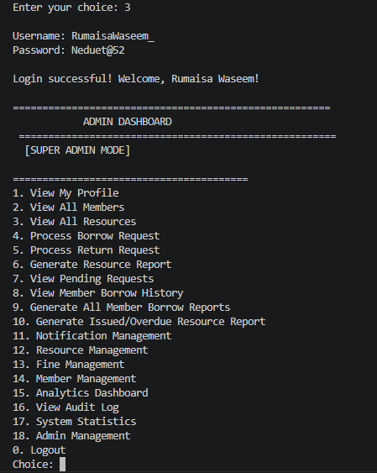

Member Registration:
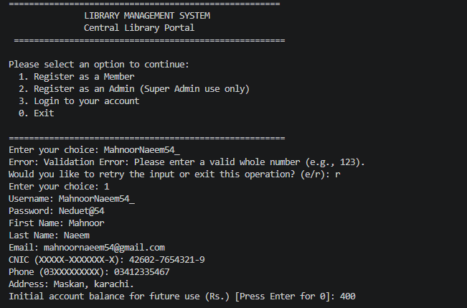
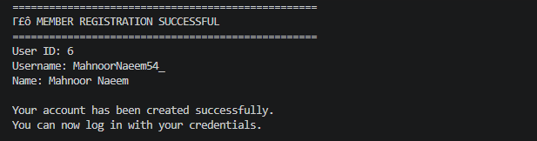

Member Login:
- Resource Management
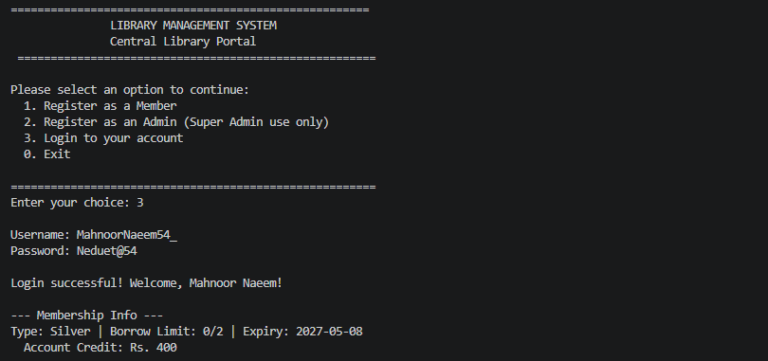
Dashboard:
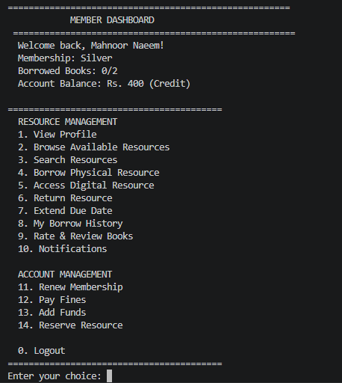

View Profile
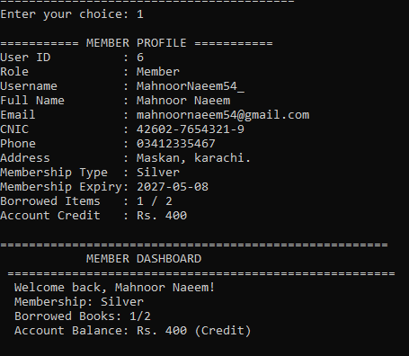
Search Resources
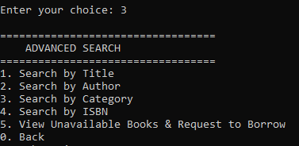
You can search resources based on their title, author, category and isbn
- Search by title
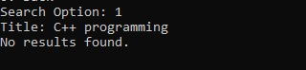

- Search by Category
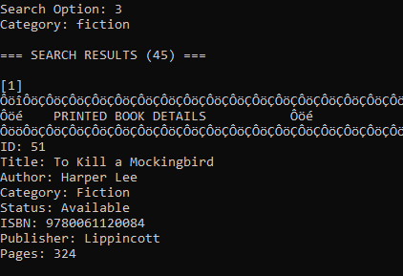
Show all the books below based on the category you entered
Borrow Physical Resource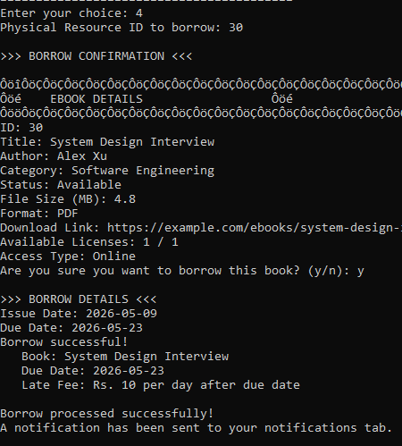
After borrowing, a notification will be sent to the notification tab
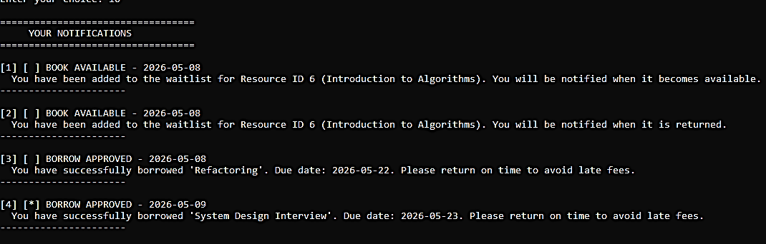
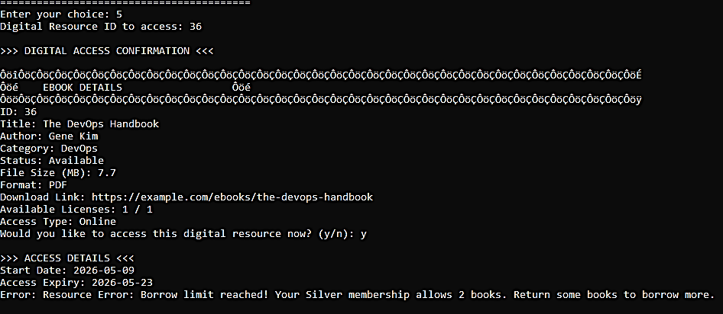
Access Digital Resource

Return Resource
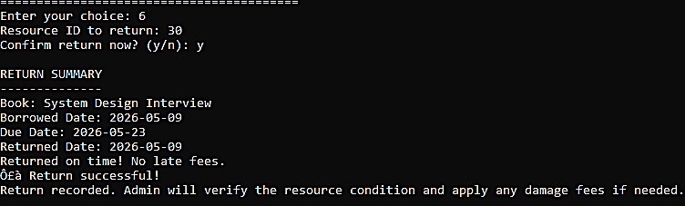

Extend Due Date
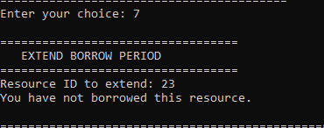
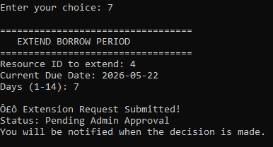
My Borrow History
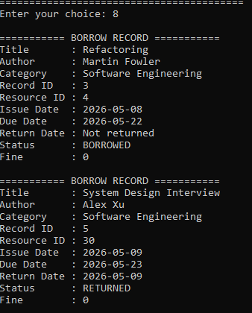

Rate and Review Books
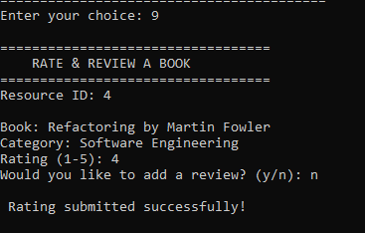
- Account Management
Reniew Membership
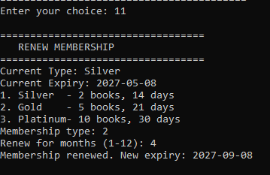
Pay Fines
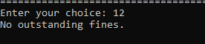
Add Funds
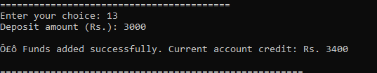

Reserve Resource
