**RAID**

**Technical and Usage Documentation**



**Document Revisions**

|  |  |  |
| --- | --- | --- |
| Date | Author | Description |
| 16-Apr-14 | T. Tedesco | New document for RAID v.01 |
| 13-May-14 | T. Tedesco | Updated document for RAID v.16. Updated Configuration menu and added Outbound Staging section in Configuration. Updated Main and Infeed in Configuration. Updated Maintenance and added Clear Shipment ID from DB in Maintenance. Updated About RAID in Help. |
| 11-Sep-14 | D. Stuckman | Updates and additions top to bottom. Including operational functions. |
| 09-Oct-14 | D. Stuckman | Added InfeedMilliSecTimeDelayBetweenMsgs |
| 06-Jan-15 | D. Stuckman | Updates incorporated update to v0.47 – major changes:  Additional ini setting:  New ini value editor with displayed variable type  Under Infeed section new setting SkipMsg567andSQLInsertInstead  Under Infeed section new setting Activ_Input_Conveyor  Under Socket Communication section new setting LogRawInboundData  RAID.Ini File [LastUserValues] Section which now saves and restores the last values stored in user text boxes  New Menu:  Database Updates  Additional menu functions:  Under Control - User Edit Before Send  Under Control - Prevent DB Updates After Message Advance  Under Maintenance – Delete TRAILER_FPDS  Add PLC column to ASRS Infeed Grid  Documented FPDS Request functionality for trailers |

Introduction 5

ASRS/WMS Interface 5

Client Installation 6

RAID Program Installation 6

Removing RAID from a PC 10

Database Table Installation 11

Access 11

Oracle 11

RTCIS Configuration 12

Associate ASRS Location to WCS System 12

Quality Status Change 13

RAID Configuration 14

RAID ini File Configuration within the Installed Application Folder 14

RAID.Ini File [Main] Section 14

RAID.Ini File [Infeed] Section 16

RAID.Ini File [Manual Output Requests] Section 17

RAID.Ini File [Outbound Staging] Section 18

RAID.Ini File [Socket Communication] Section 19

RAID.Ini File [Socket Listening Ports] Section 19

RAID.Ini File [LastUserValues] Section 20

Operation – Log In 21

Login 21

Operation – Menu Functions 22

Control Menu Functions 22

All Processes in Auto 22

Reset Message Counters 22

User Edit Before Send 22

Prevent DB Updates After Message Advance 22

Database Updates Menu Functions 23

Maintenance Menu Functions 23

Clear Shipment ID from Database 23

Delete Old Logs 23

Delete CUST_PALLET, CUST_SHIPMENT, CUST_LINEITEM 24

Delete Msg16 History 24

Delete TRAILER_FPDS 24

Delete Completed Shipments 24

Delete Completed Withdraws 24

Remove All Emulator Data 24

Tools Menu Functions 24

Search Log 25

Send Heartbeat 25

Send Heartbeat Automatically 25

Send XML from File 25

XML Editor 25

Help Menu Functions 27

About 27

Close All Pop Up Windows 27

Operation – Screen Display/Control 28

Overview 28

General Grid Operations 29

RTCIS Infeed 30

ASRS Infeed 31

ASRS Input Location 31

Final Destination Msg7 Control 31

ASRS Inventory Summary 32

Request Order 32

Shipment 32

Production Order 33

Order Stage/De-Stage 33

Shipment Control 33

Shipment Line Item Control 34

Order Compl 35

Staging Completion 35

UL Removal 36

QAChg History 38

RF Broadcast 38

Manual Output Req 38

Msg13 Control 38

Msg14 Control 39

Reconcile 40

FPDS Request 40

Glossary 42

Induction Flow Using DTL Driver 43

Acknowledgements 44

# Introduction

RAID is a Visual Basic 2010 application built to run on a Windows platform.

The purpose of RAID is to act as an emulator of an ASRS (Automated Storage and Retrieval System) for the WMS (Warehouse Management System) or for WMS emulator BAMBAM . RAID receives XML messages via a TcpIp socket connection from WMS/BAMBAM and acknowledges each message. Based upon the message received, RAID may trigger a different XML message to be sent to WMS through a different TCP socket, or may send a response to the original message with a field filled in.

Details of the XML messaging can be found in the Red Prairie document “RTCIS XML RAI Messaging Interface Specification”. The intent of this document is not to detail out every use case possible, but rather to provide context for a user to be able understand the basic framework of the tool as well as any watch outs.

BAMBAM/WMS are used interchangeably within this document. Currently RTCIS is the only WMS designed to support the RAI XML messaging functionality and in most cases a generic WMS reference is used instead of RTCIS.

## ASRS/WMS Interface

BAMBAM communicates to RAID via an IP address and fixed port number as defined in the BAMBAM configuration file.

RTCIS communicates to RAID via an IP address and fixed port number as defined in the rtcssesmnt application.

RAID communicates to BAMBAM/WMS via an IP address and fixed port number as defined in Configuration, SocketCommunication on the home page. SocketServerIP and SocketServerPort are defined here. These will match the BAMBAM configuration (bambam.ini) file or in the case of RTCIS the Integrator System Communication settings.

The transmissions to/from WMS are terminated with a <CR> <LF><LF>. If the RAID receives a transmission ending with <CR> <LF><LF> it will transmit back to WMS an A with no terminating characters. If RAID receives something other than a <CR> <LF><LF> at the end of transmission, it will transmit back to WMS an N with no terminating characters.

RAID connects to a RTCIS database in order to determine what ULIDs already exist within RTCIS on the input conveyor system that are not yet known to the ASRS database to use as a starting point for the automation messaging.

# Client Installation

A Microsoft Windows setup package has been created to simplify the installation and the process for using the setup package appears later in this section. An eSupport package does not exist to install RAID on SEWP pcs.

Request program installation files can currently be requested from [stuckman.de@pg.com](mailto:stuckman.de@pg.com).

Requires an Oracle Client to be installed. Oracle 11gR2 Client is available via eSupport.

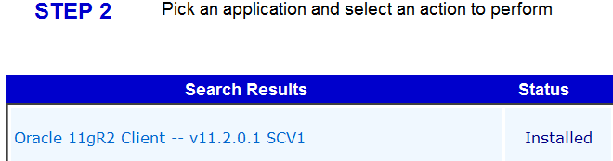

## RAID Program Installation

Obtain access to the file below on the installation pc either by network drive access or by copying the files to the local hard drive. The two files together form the RAID installation package

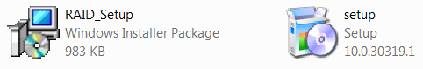

To install:

Close all applications

Double-click on Setup.exe

The following message will appear then disappear:

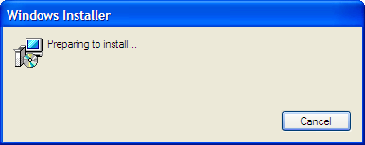

The following screen will then be presented:

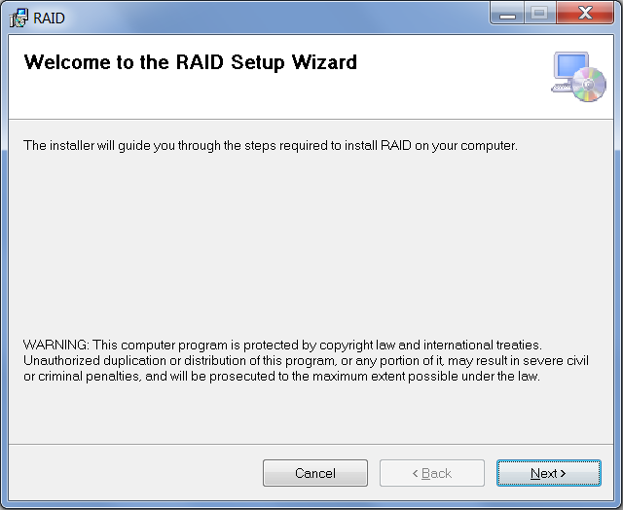

Select Next

The following screen will be presented:

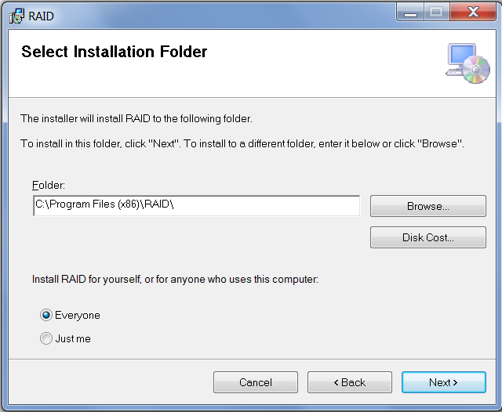

Change to Everyone if installing RAID on a shared workstation.

The program can be installed in any folder, but the preference is to leave it

at the default of C:\Program Files (x86)\RAID\.

The following screen will be presented after selecting Next:

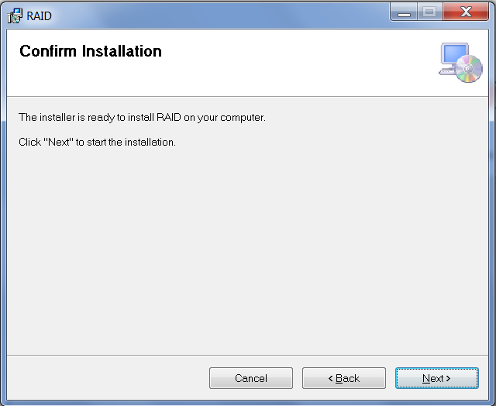

Select Next

The following screens will display:

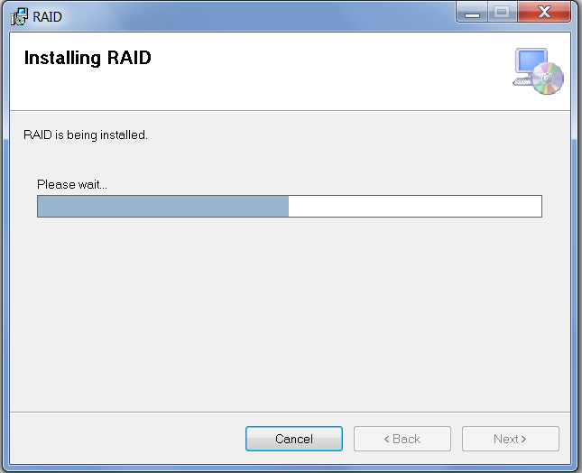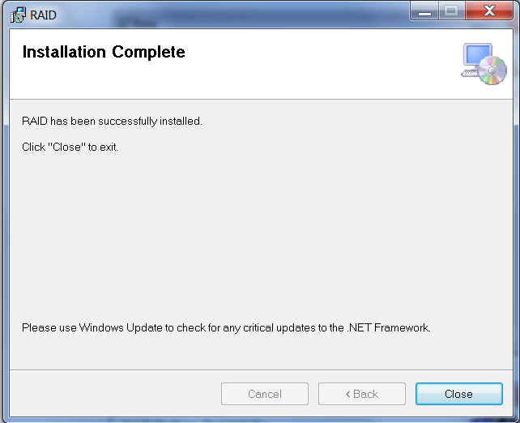

Select close

After you run setup use windows explorer to go to C:\ProgramData\RAID.

Right Click on the RAID folder and select properties. Click on the security tab to get the following screen:

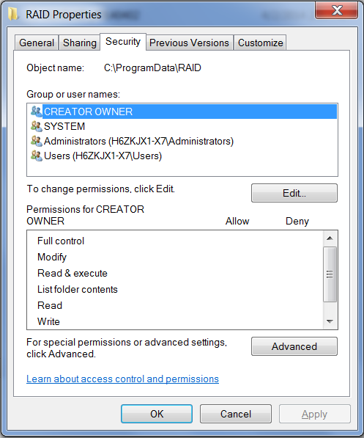

Select Edit, click on Users and Allow Full control to get the following screen:

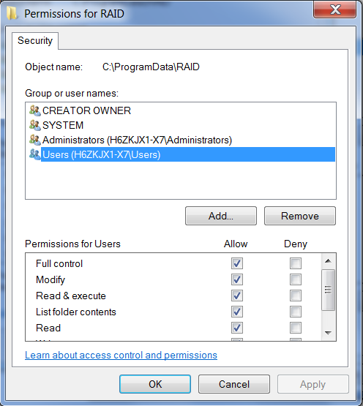

Save these changes.

If the Oracle11gR2 Client needed to be installed, the pc should be rebooted if has not been rebooted after the Oracle product was installed.

RAID Program Version Update

This step needs to occur after initial installation and anytime a new application version is made available.

Once RAID is installed, the setup.exe process can’t be used again until RAID is first uninstalled. Generally program updates are achieved by simply placing a new RAID.exe into c:\program files (x86)\RAID\ and replacing the existing RAID.exe

The program version of RAID can be found on the RAID Menu bar in the upper left hand corner of the screen as well as the initial database login screen:

Example Screen Shots:

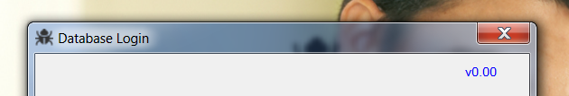

## 

## Removing RAID from a PC

From the pc’s Control Panel, Select “Add or Remove Programs”

Find RAID under Currently Installed Programs then remove it just like any other program

# Database Table Installation

## Access

RAID utilizes custom Access database tables as its data storage system. While it is not required to install Access to run RAID, having the ability to view/modify the data directly in the database may be useful to the user.

This requires Microsoft Access to be installed. MS Access 2007 v12 SCV2 is available via eSupport.

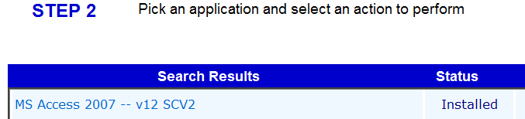

The RAID.mdb file is located in the ProgramData/RAID directory.

Six tables are required: CUST_LINEITEM, CUST_PALLET, CUST_SHIPMENT, DUAL, MSG16HST, CUST_TRAILER

## Oracle

The database connection is not set in the ini file configuration, but is set dynamically at application startup through the Database Login screen as shown below:

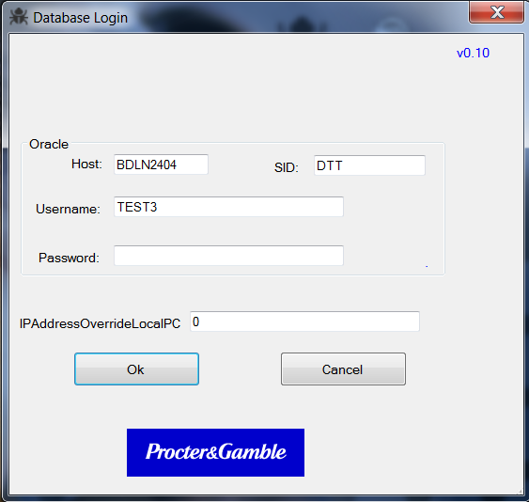

|  |  |
| --- | --- |
|  |  |

If this screen splashes up and then disappears the system is in a special development mode. Normal version of RAID allows different user data to be filled in for the Oracle database connection.

# RTCIS Configuration

**Set value of System Parameter:**

**ASRS: Using RAI Next Generation (XML) Interface or 1.0(libaal/libhal) Interface to Y**

## Associate ASRS Location to WCS System

For the RAI interface the designated ASRS system location is configured based on the following system parameters.

Check and record value for System Parameter *“Subsite for ACTIV”* ______ (1 for Euskirchen)

Check and record value for System Parameter *“ASRS: Location for ASRS”* ______ (CIMAT for Euskirchen)

With RAIng, you must use locatnmnt to setup a session key for the ASRS location:

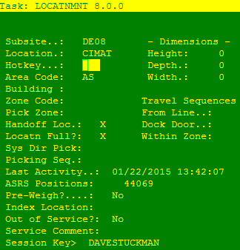

Session keys are setup via rtcsesmnt:

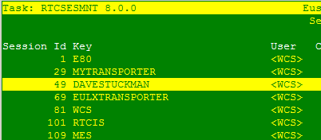

Set values similiarly to the below. Note that Sending Host and Send Port reference the host and port for which RAID is LISTENING on.

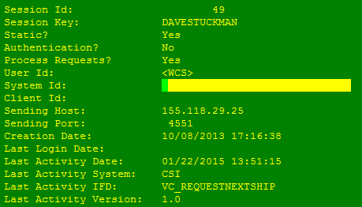

## Quality Status Change

The environment being tested in must be in the one and only line of the following file

/RAI/bin/ACTIV_run.group

(Note that there should be a link of /opt/rtcis/RAI to /RAI)

Via rtcis_config configure and start the ASRS QA Status driver

ASRSQAMSG ASRS QA STATUS CHANGE MESSAGE PROCESING 1 50

Translate QA Status for ASRS (Use HQ QA Status)? D Y

ACTSTGMNT TO ADD STAGING LANES

Modify ACTIV Staging Slot │

95 │ │

96 │ ACTIV Staging Loc: 400 │

98 │ Number of Levels: 3 │

99 │ Area Code: ST │

400 │ Zone Code: 21 │

│ Height: 999 Depth: 999 Width: 999 │

│ Travel Seq: From Line: XXX Dock: XXX W/in Zone: XXX │

│ Pref Dock Loc: │

│ Pick: In Sequence │

│

] Slot access denied- Slot 400 ASRS

# RAID Configuration

## RAID ini File Configuration within the Installed Application Folder

RAID has flexibility built into its setup through the use of an ini file that configures how RAID should run on each pc it is installed on. Changes can be made directly to the ini files or via RAID.exe menu options. If direct file changes are made, RAID needs to be restarted to utilize the modified settings. The ini file may not contain all the possible parameters because fields and values are only written out when they differ from the defaults. The ini file must reside in the C:\ProgramData\RAID folder. The installation folder is typically C:\Program Files(x86)\RAID\

After launching RAID.exe, access the visual configuration screen from the Configuration Main menu.

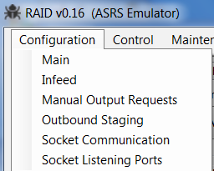

### RAID.Ini File [Main] Section

Sample Settings:

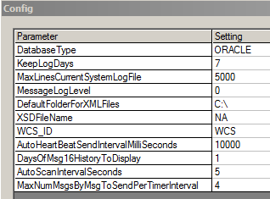

Clicking on a specific setting cell brings up a value editor. The editor describes the data type that should be entered and in some cases enforces the variable type (coding still a work in progress to transition to better input validation)

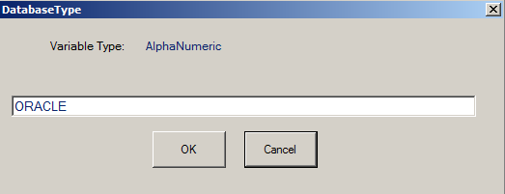

DatabaseType is set via the Login screen and would normally not be changed via the Config screen. The only currently valid value is ORACLE

Set KeepLogDays= to the number of days of log files to save. Raid will purge old log files based upon the user menu selection of Maintenance, Delete Old Logs

Set DefaultFolderForXMLFiles= to the local PC folder path which contains XML files to send to WMS. This parameter sets the default path/filename for the ‘Send XML from File’ option underneath the Tools menu. This parameter is optional.

Set XSDFilename= Set to NA. This parameter is not currently used.

Set WCS_ID= to the value desired to send for WCS_ID in the outbound message header:

<MESSAGE_HEADER>

<WCS_ID>WCS</WCS_ID>

<MESSAGE_ID>201107221037185705</MESSAGE_ID>

<TIMESTAMP>20110722103718</TIMESTAMP>

</MESSAGE_HEADER>

Set AutoHeartBeatSendIntervalMilliSeconds= This parameter sets the timer period for the ‘Send Heartbeat Automatically’ option underneath the Tools menu

Set DaysOfMSg16HistoryToDisplay= a value of 1 or greater to control the amount of data available in days under the “Msg16 History” Tab

Set AutoScanIntervalSeconds= This parameter sets the timer period for all processes that can be placed in Auto mode by the user

Set MaxNumMsgsByMsgToSendPerTimerInterval= to the number of messages to send per each function from current step to the next step when they are in Auto Mode. If both RTCIS Infeed and ASRS Infeed are in Auto and MaxNumMsgsByMsgToSendPerTimerInterval=3 then a total of 6 messages would be sent for each interval.

This setting also limits the number of messages when in manual mode to the number of messages per each Advance button selection. In manual mode it may be desirable to set this value to a high number.

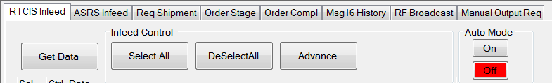

### RAID.Ini File [Infeed] Section

Sample Settings:

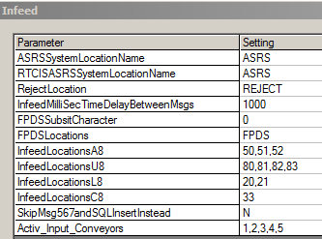

Set ASRSSystemLocationName to be the location RAID uses to identify the ASRS location where unit loads are stored once inducted.

Set RTCISASRSSystemLocationName to match the RTCIS system parameter:

LOCATNASRS ASRS: Location for ASRS

Set RejectLocation to the delivery location associated with the FPDS reject spur. When Input field is blank on the Input field under Msg7 control the RejectLocation will be sent to WCS.

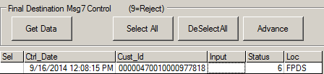

Set InfeedMilliSecTimeDelayBetweenMsgs to the interval in milliseconds between subsequent message sends for either multiple records selected or in Auto Mode for either the “RTCIS Infeed” (Msg5) or “ASRS Infeed” (AssignInductionLoc). This is used to more accurately reflect how fast message sends would occur in a production environment. When used with BamBam it should be set to 750 or above to work around problems with BamBam multithreading issues whereby BamBam can’t get item master data consistently from RTCIS without erroring.

FPDSSubsitCharacter should be set to the SUBSIT.SUBSIT value in RTCIS environment where the RAI ASRS currently exists. This value sets the subsite for the following scenarios:

* Unit loads exist but have not begun any automation processing.
* ASRS/WMS Reconciliation Report

Set FPDSLocations to the LOCATN.LOCATN values under the subsit specified by FPDSSubsitCharacter where unit loads exist but have not begun any automation processing. Multiple values are allowed and must be comma separated.

These values are used for the following scenarios:

* To randomly assign the Activ Input Location in the AssignFPDSLoc if a RequestFPDS message is received where the message type is A35.
* For data to include on the RTCIS Infeed tab

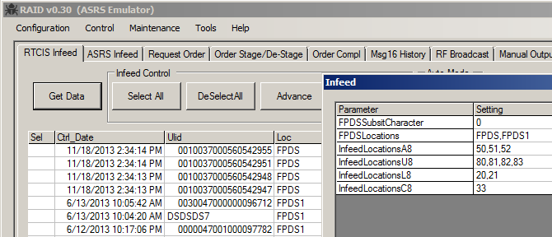

InfeedLocations “X”8 are the VTL input locations used in the Msg 8 response to tell WMS what Infeed location the ASRS has selected. Currently RAID round robins the input if more than one value is entered. Multiple values must be comma separated,

SkipMsg567andSQLInsertInstead is a Y/N setting. With BAMBAM this value can be set to N as messages 5,6, and 7 exist. RTCIS 8.0 will not have messages 5,6, and 7 for testing, so this should be set to Y to insert ULIDs from the RTCIS DB to the RAID DB.

Activ_Input_Conveyor will automatically populate for the conveyor value under the FPDS Request tab and subsequently the AssignFPDSLoc message. Multiple values are allowed and must be comma separated

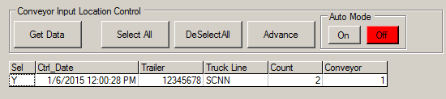

### RAID.Ini File [Manual Output Requests] Section

Sample Settings:

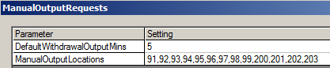

Set DefaultWithdrawalOutputMins to the value in minutes of the default value of the WDTime on the Manual Out Req tab. This screen value in turn populates the Message 13 response specifically AssignWithDrawalLoc.LocForRequest.WITHDRAWAL_OUTPUT_TIME.

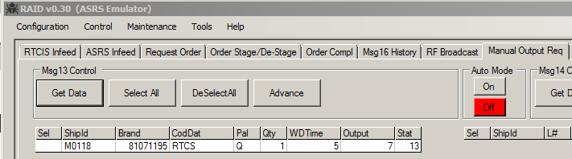

Set ManualOutputLocations= the VTL locations the ULIDs can be delivered to when requested out of ASRS. Corresponds to ACTIV_OUTPUT_LOCATION in the AssignWithdrawalLoc message.

### RAID.Ini File [Outbound Staging] Section

Sample Settings:

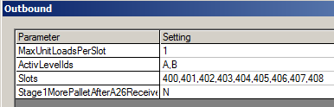

Set MaxUnitLoadsPerSlot to the number of unit loads that can fit into an outbound staging slot. The StageUL operation checks the number of units loads staged in a particular slot vs this value to determine if any more staging should be allowed.

Set ActivLevelIds to the levels of the slots in the ASRS. These values are used as a range to populate ACTIV_LEVEL_ID in the ProdOrderULStaged and ShipULStaged messages.

Set Slots to the numbers for the slot locations. RAID will send to WMS the first slot open in this list when a slot location is requested.

Set Stage1MorePalletAfterA26Receipt to Y if you want RAID to stage 1 more pallet after it receives an A26 (StopShipStaging), and N if you don’t. This setting is used to mimic workflow timing where the ASRS has Unit Load delivery in progress and is going to stage the pallet regardless of what RTCIS wants.

### RAID.Ini File [Socket Communication] Section

Sample Settings:

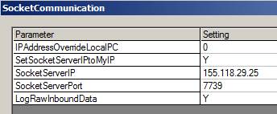

Set IPAddressOverrideLocalPC= 0 for RAID to automatically read the IPv4 address from the pc. This IP address is what is used for Socket Listening Services. When multiple IP addresses exist such as in VPN situations, this setting may need to be used to assure that the “right” IP address is utilized. This setting is also made available for configuration on the initial login screen.



Set SocketServerIPtoMyIP= to either Y or N. When set to Y, RAID will automatically set SocketServerIP= to the pc’s IP address. This is useful when RAID is talking to a WMS emulator such as BAMBAM that is running on the same PC.

Set SocketServerPort= to the port of the WMS listener.

With LogRawInboundData Set to Y, RAID will log the raw Hex values of the inbound messages.

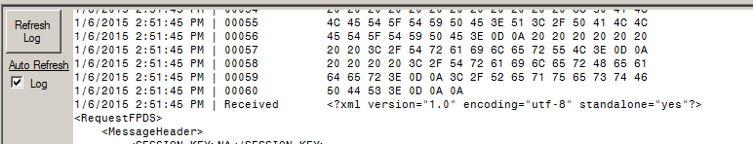

### RAID.Ini File [Socket Listening Ports] Section

Sample Settings:

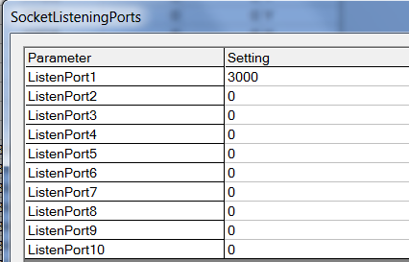

Set ListenPort1 to the agreed upon SocketServerPort that is set up on the WMS side. Up to 10 socket listeners can be started. In practice, only 1 is the normal configuration.

### RAID.Ini File [LastUserValues] Section

These values are the result of RAID automatically saving the user entries of all user text box entries when RAID closes in order to restore them at next program startup. These values are not configurable through the GUI.

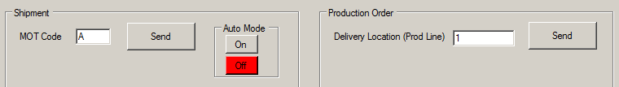

Sample Settings:

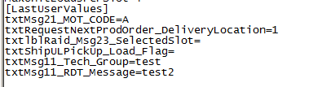

# Operation – Log In

## Login

RAID should be used only in non-production environments.

|  |  |
| --- | --- |
|  |  |

In development mode this screen splashes up and then disappears. The password is filled in by RAID so the Oracle connection is made. Future versions of RAID will allow different user data to be filled in for the Oracle database connection.

RAID does not require the configuration of an ODBC driver nor a Tnsnames.ora entry.

Set IPAddressOverrideLocalPC= 0 for RAID to automatically read the IPv4 address from the pc. This IP address is what is used for Socket Listening Services. When multiple IP addresses exist such as in VPN situations, this setting may need to be used to assure that the “right” IP address is utilized. This setting is also made available for configuration on the initial login screen.

# Operation – Menu Functions

## Control Menu Functions

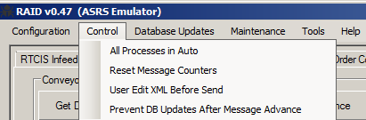

### All Processes in Auto

A toggle that either places all instances of Auto Mode selection in “On” when checked or “Off” when un-checked.

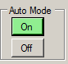

### Reset Message Counters

Clears out the Message Counter Displays in the lower right hand corner. Message Counters are also cleared whenever RAID is started.

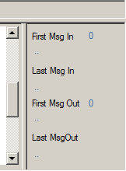

### User Edit Before Send

A toggle that instead of sending the XML places the XML into the XML editor, opens the editor and the user can edit (or not) and then send (or not)

### Prevent DB Updates After Message Advance

A toggle that tricks RAID into thinking that the XML message sent to WCS failed. This failure in turn is then for the most part coded to not update the RAID database and the user state is left where it initially was.

## Database Updates Menu Functions

This functionality is still under development. Instead of having to replace RAID.mdb, RAID now has limited ability to make automatically make database structure changes.

Check DB for Required Tables - checks the RAID.mdb for the expected table structure for the current application version and reports any discrepancies. Database checks are also performed at startup.

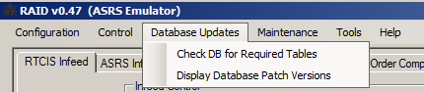

Display Database Patch Versions - simply lists which versions require a database patch.

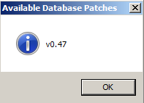

## Maintenance Menu Functions

The following functions are available for selection under the maintenance menu:

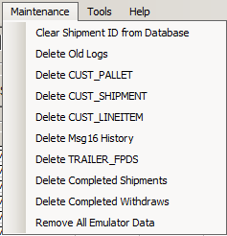

### Clear Shipment ID from Database

This clears all information from the ASRS database for a particular shipid. The ULIDs on the shipment are disassociated from the shipment and moved back to the ASRS (CUST_PALLET.SHIP_ID=null, CUST_PALLET.RETRO_LOC=, CUST_PALLET.RETRO_STATUS=7). The shipment is deleted from CUST_LINEITEM and CUST_SHIPMENT.

### Delete Old Logs

RAID stores all log data in the same directory as where RAID.ini and RAID.mdb exist, which for a standard install is c:\ProgramData\RAID\

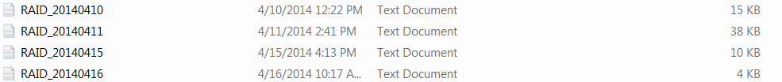

Selecting Delete Old logs purges the log files as specified by the KeepLogDays parameter. The purge is based upon the file last access date versus the date stamp in the file name.

### Delete CUST_PALLET, CUST_SHIPMENT, CUST_LINEITEM

This option deletes all data in the RAID Access tables that mirror the ASRS tables used. This function would be utilized to restart testing from a base condition for Shipments and Manual Withdraws. There is no messaging to WCS as a result of this data deletion.

### Delete Msg16 History

This option deletes all data in the MSG16HST table. This function would be utilized to restart testing from a base condition. There is no messaging sent as a result of this data deletion.

### Delete TRAILER_FPDS

This option deletes all data in the TRAILER_FPDS table. This function would be utilized to restart testing from a base condition for the Message 35/Request FPDS data . There is no messaging sent as a result of this data deletion.

### Delete Completed Shipments

This option deletes completed shipments from the RAID database. This function would be utilized to eliminate shipments that have completed all processing steps. In the example below the completed shipment is just cluttering up the display. There is no messaging sent as a result of this data deletion.

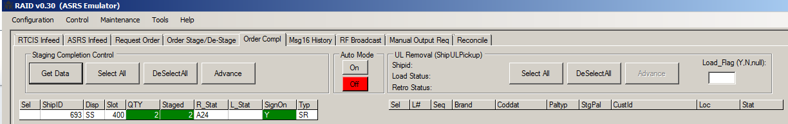

### Delete Completed Withdraws

This option deletes the completed withdraws from the RAID database. This function would be utilized to eliminate withdraws that have completed all processing steps. There is no messaging sent as a result of this data deletion.

### Remove All Emulator Data

This option deletes all data in RAID. This function would be utilized to restart testing from a clean base condition. A user may want to make a manual copy of RAID.mdb prior to performing this function. There is no messaging sent as a result of this data deletion.

## Tools Menu Functions

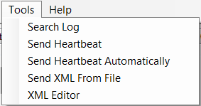

### Search Log

Search Log allows a string to be entered and if the string is found in the log it will be highlighted as shown below:

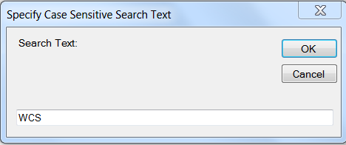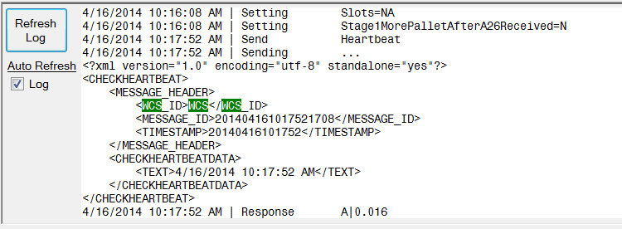

### Send Heartbeat

Send Heartbeat sends a Check_Heartbeat XML message to WMS. WMS should respond with an (A)ck. WMS should then also send a Confirm_Heartbeat which RAID should (A)ck.

### Send Heartbeat Automatically

Send Heartbeat Automatically sends a Check_Heartbeat XML message to WMS based upon the AutoHeartBeatSendIntervalMilliSeconds setting.

### Send XML from File

This option allows the user to send any XML message to WMS.

The default path for Send XML from File is set by the parameter DefaultFolderForXMLFiles.

Enter the filename after the path. For repeated tests of the same message, DefaultFolderForXMLFiles could be set to include the file name.

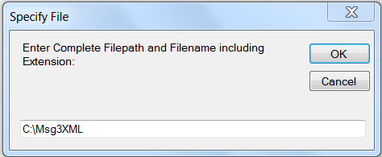

### XML Editor

RAID stores into memory the last XML message sent. When RAID is closed the last XML message is written to disk as LastXMLSent.txt into the ProgramData/RAID folder .

When the XML editor is launched, the text display will first check memory then disk if necessary to display the last XML message sent.

The text display does not update as messages are sent, only when the XML Editor form is launched, or when “Get Last XML Sent” is selected.

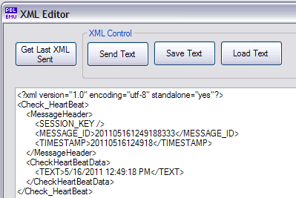

The text display can be edited by the user and then sent via sockets to the remote system by selecting “Send Text”

The text display can be saved and reloaded at a later time via the “Save Text” and “Load Text” buttons:

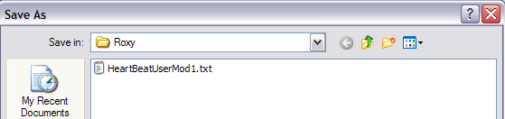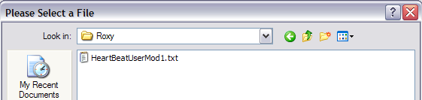

## Help Menu Functions

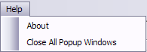

### About

The About display shows version and author information:

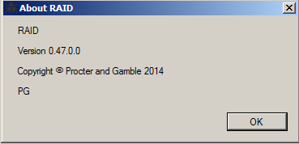

### Close All Pop Up Windows

This function closes all pop-up windows associated with RAID as multiple pop-ups are permitted to be opened.

# Operation – Screen Display/Control

## Overview

The purpose of this portion of the documentation is to give the user the basic concepts of how to utilize RAID emulation and the basic flow. The “RTCIS-RAIng Interface Spec” documentation should be used for the details on the messaging interface and detailed message flow. Usage of RAID is expected to included scenarios where the user intentionally tries to break the WCS-WMS interface and populates message field values that are unexpected in production. Since the RAID software was designed be as flexible as possible , it is expected that an experienced user is utilizing it in perhaps unexpected ways and that very specific instructions are not required.

The user may notice some inconsistences in naming conventions as well as general usage. The emulator build started before the development of the messaging specification and the developer is in a constant state of refactor. Thus, long term, things like ULID should be used for the SSCC-18 when its stored in the RTCIS database and CustID when its stored in the ASRS database. Currently CustID and ULID are used somewhat interchangeably. Column abbreviations are inconsistent as well, some because the emulation development staff was inconsistent, but sometimes to stay consistent with the original inconsistent messaging specification. The log file and display is designed such that in auto mode only the messaging flow is captured. In manual mode, the user is given more information such that there is always feedback after a button push so that the dreaded “Why did nothing happen?” occur when the user did something dumb or unexpected.

## General Grid Operations

While the RTCIS Infeed section will be used as an example, the same functionality is available on all similar grids.

Press “Get Data” to force a re-query and redisplay of all the grid data

Press ‘Select All” to change the Sel (Selected) Column to Y

Press ‘DeSelect All” to change the Sel (Selected) Column to <blank>

Press “Advance” to process the selected record(s) and typically send the next appropriate message in the flow sequence to WMS. In most cases, the grid data will NOT refresh automatically and user needs to press “Get Data” to refresh.

Select “On” under Auto Mode to have RAID automatically Get Data, Select all records, and Advance on a Timed Basis. Select Auto Mode Off to return to manual refresh and control..

Click on the Sel column of an individual record to toggle that specific records Sel flag between Y and <blank>

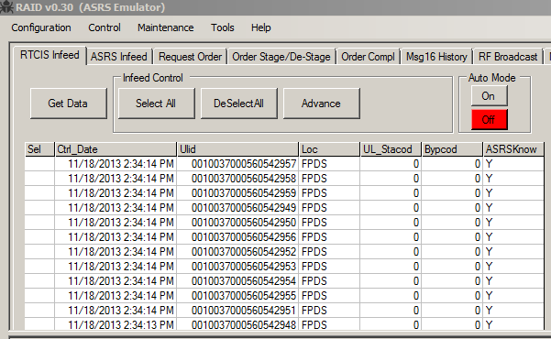

Left Click on an individual cell to override the displayed data. If the data is refreshed, the override is lost.

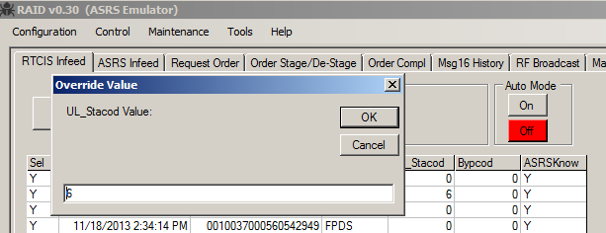

Right click on an individual cell to copy the value to the clipboard.

## RTCIS Infeed

The RTCIS Infeed tab retrieves data from RTCIS where unit loads are on a infeed system, but are not yet known to ASRS and no RAI messaging has occurred.

Infeed Flow:

* Advancing a UL sends a Msg5 (technically a PLC XML message) to the ASRS.
* If Msg5 is Acked by WMS the UL is created in the CUST_PALLET table and ASRSKnow = Y
* RAID then expects a RequestInduction from WMS
* If RequestInduction with D8 Message Type is received the UL is deleted from CUST_PALLET
* If RequestInduction with Message Type other than D8 is received, then the CUST_PALLET is updated and the UL should now be visible on the “ASRS Infeed Tab”

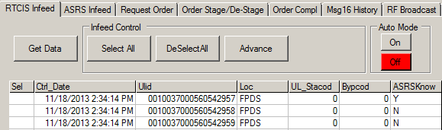

|  |  |
| --- | --- |
| Column | Description |
| Sel | Y or <blank> to determine if the record is Selected or not. |
| Ctrl_Date | The date the record was last touched in the RAID CUST_PALLET table |
| Ulid | The Unit Load ID without the check digit. The check digit is automatically added to messaging operations. |
| Loc | The current location of the Unit Load in RTCIS |
| Ul_Stacod | The Unit Load Status. Only values of 0 should be inducted into ASRS otherwise the UL should be routed to Reject. |
| Bypcod | Code used to control pallet routing on the FPDS (full pallet delivery system) at ASRS sites via dlvlocmnt setup. Examples: '9' = Reject area, '8' = Consignment area. Normally 0 to induct into ASRS |
| ASRSKnow | If the ULID is in the RAID CUST_PALLET DB Then Y else N |

## ASRS Infeed

### ASRS Input Location

The Input Location control retrieves data from ASRS where unit loads are on an Infeed system and exist in both the ASRS and WCS systems but the ULs have not been inducted into the ASRS storage location.

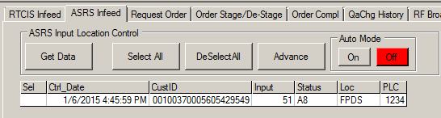

|  |  |
| --- | --- |
| Column | Description |
| Sel | Y or <blank> to determine if the record is Selected or not. |
| Ctrl_Date | The date the record was last touched in the RAID CUST_PALLET table |
| Cust_Id | The Unit Load ID with the check digit. |
| Input | The ASRS input to send to the WCS for the CUST_ID |
| Status | Internal status used by RAID to track what messaging step the CUST_ID. Normally the “X”8 type. |
| Loc | The current location of the Customer ID (ULID) in ASRS database table CUST_PALLET |
| PLC | The PLC User ID gets passed between WCS(MHE) , WMS and ASRS in order for the MHE to route the request message response back to the initiating PLC. |

Input Location Flow:

* Advancing a UL sends a AssignInductionLoc to the ASRS.
* RAID then expects a PLC Msg6 from WMS

### Final Destination Msg7 Control

The Msg7 Control retrieves data from ASRS where unit loads are on an Infeed system and exist in both the ASRS and WCS systems and WCS has communicated the Delivery Location via PLC message 6.

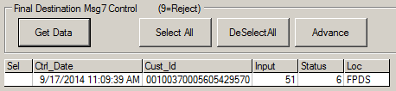

|  |  |
| --- | --- |
| Column | Description |
| Sel | Y or <blank> to determine if the record is Selected or not. |
| Ctrl_Date | The date the record was last touched in the RAID CUST_PALLET table |
| Cust_Id | The Unit Load ID with the check digit. |
| Input | The ASRS input to send to the WCS for the CUST_ID. Use 9 to send to Reject |
| Status | Internal status used by RAID to track what messaging step the CUST_ID. Normally a 6 to indicate the Msg6 has been received. |
| Loc | The current location of the Customer ID (ULID) in ASRS database table CUST_PALLET |

Destination Msg7 Flow:

* Advancing a UL sends a Msg7 to the WMS
* If the UL Loc was a input location:

RAID updates the CUST_PALLET location to the ASRS storage location

* If the UL was sent to Reject:

WMS should send a RequestLocForPallet with MESSAGE_TYPE D8

RAID deletes the CUST_ID from CUST_PALLET

RAID shows the ULID as unknown to ASRS on the RTCIS Infeed Control

### ASRS Inventory Summary

Once inventory is placed into the ASRS location within the ASRS database, the inventory summary groups inventory by Brand, Pallet Type, and QA

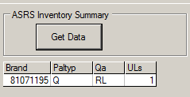

|  |  |
| --- | --- |
| Column | Description |
| Brand | The brand or item code |
| Paltyp | One character ASRS Pallet Type which in RTCIS WMS system is ULPALL.PLCPAL |
| Qa | Quality Status which in RTCIS WMS is QASTAT |
| ULs | Count of distinct ULs grouped by Brand, Pallet Type, and QA. ULs are expected to contain a single brand code only. Case Qty is not utilized nor checked on the RAID side. |

## Request Order

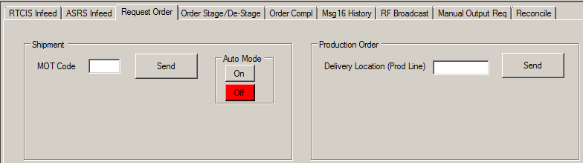

### Shipment

Press send to generate RequestNextShip message to WMS. For London related testing, normal MOT code range is A-F. Otherwise MOT Code is normally left blank.

Shipment Message Flow:

* RequestNextShip message to WMS
* If the WCS has an available shipment an AssignShip message is received
* Order Stage/Destage tab displays shipments received

### Production Order

Press send to generate RequestNextProdOrder message to WMS. Delivery Location (Prod Line) should be set to the Requested PLNumb. Auto mode has not been designed for Production Order Request as only 2 sites currently use this functionality and production orders are typically dropped as a batch.

Production Order Message Flow:

* RequestNextProdOrder message to WMS
* If the WCS has an available production order for the specified PLNumb an AssignProdOrder message is received
* Order Stage/Destage tab displays production orders received

## Order Stage/De-Stage

The Order Stage/De-Stage tab is used to display and control the start of staging, staging of individual Unit Loads, and de-staging of individual Unit Loads.

Clicking either the Sel or ShipId column for a specific row under Shipment Control displays the Line Item records for that specific shipment

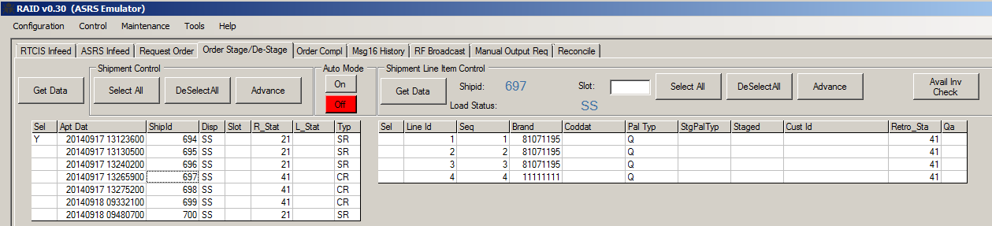

Auto Mode selection on the Order Stage/De-Stage tab applies to both the Shipment and Shipment Line Item Control Functions.

### Shipment Control

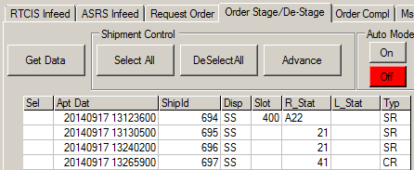

|  |  |
| --- | --- |
| Column | Description |
| Sel | Y or <blank> to determine if the record is Selected or not. |
| Apt Date | Appointment Date and Time of the Shipment sorted with oldest ton top |
| ShipId | Shipment ID |
| Disp | Disposition. Shipment Disposition (SHPHDR.ASRS_DISP)  • Spaces – Normal Disposition  • SS – Stage Short – Only Stages available Inventory  • SO– Stage Open – Stage avail and wait for missing Inventory to arrive  • SW – Stage anyWay – Stage Inventory regardless of Pallet Type |
| Slot | The assigned Slot (ACTIV_OUTPUT_LOCATION) |
| R_Stat | RTCIS_Status  An tracking mechanism to determine the step in the messaging flow the shipment is currently in |
| L_Stat | Load Status. Typically <null> If staging is stopped by WCS then ‘STPSTG’,‘STG1THENSTOP’,’CANCLD’ depending on RAID configuration settings |
| Typ | Request Type: SR=Shipment Request CR=Customization Request (Production Order) |

Shipment Staging Messaging Flow

* Advancing a Shipment with a R_Stat of 21 sends a ShipStageStart message to WMS
* The ASRS database field CUST_SHIPMENT.ACTIV_OUTPUT_LOCATION is updated with the Slot Raid selected
* Advancing a Shipment with a R_Stat of A22 attempts to Advance all Shipment Line Items for the current shipment. Using this method to advance the line items acts like an Auto Advance and no log information will appear if ULs can’t be staged

### Shipment Line Item Control

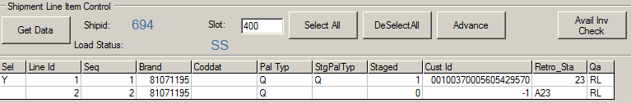

|  |  |
| --- | --- |
| Column | Description |
| Sel | Y or <blank> to determine if the record is Selected or not. |
| Line Id | Unique Sequential Identifier beginning at 1 for each Customer Id on a shipment |
| Seq | Sequence number of the Customer Id. Determined by the “RAI: Message 21 Sequence By ((U)LID /(O)RDER /(R)TCIS)” RTCIS system parameter. |
| Brand | The brand or item code |
| Coddat | The Coddat (CTLGRP) specified to pick. Normally <null> |
| Pal Typ | One character ASRS Pallet Type which in RTCIS WMS system is ULPALL.PLCPAL |
| StgPalTyp | One character ASRS Pallet Type of the staged CustID which in RTCIS WMS system is ULPALL.PLCPAL |
| Staged | 1= A CustID has been staged. 0 no staging has occurred for this line item |
| CustID | <null> = pallet has not been staged, -1= staging was attempted but unable to stage and no further attempt will be made (ex. Stage Short), else the CUST_ID that was staged |
| Retro_Sta | A tracking mechanism to determine the step in the messaging flow the shipment line item is currently in |
| Qa | Quality Status which in RTCIS WMS is QASTAT |

Shipment Line Item Control Flow:

* Advancing a UL sends a ShipULStaged to the WCS.
* Summarized staging data shown on “Order Compl” tab

## Order Compl

The Order Completion tab is used to display and control the end of staging and the removal of ULs from the ASRS. The user can send a send a ShipStageComplete prior to during or at end of staging.

Auto Mode selection on the Order Stage/De-Stage tab applies to both the Shipment Completion and UL Removal functions.

### Staging Completion

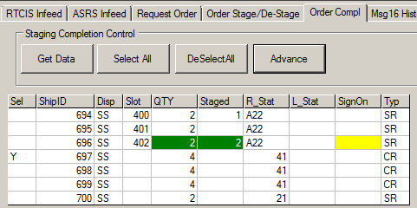

|  |  |
| --- | --- |
| Column | Description |
| Sel | Y or <blank> to determine if the record is Selected or not. |
| ShipId | Shipment ID |
| Disp | Disposition. Shipment Disposition (SHPHDR.ASRS_DISP)  • Spaces – Normal Disposition  • SS – Stage Short – Only Stages available Inventory  • SO– Stage Open – Stage avail and wait for missing Inventory to arrive  • SW – Stage anyWay – Stage Inventory regardless of Pallet Type |
| Slot | The assigned Slot (ACTIV_OUTPUT_LOCATION) |
| QTY | Quantity. Total ULs ordered for the shipment  Green highlighted if QTY=Staged |
| Staged | Total ULs staged for the shipment  Green highlighted if QTY=Staged |
| R_Stat | RTCIS Status  A tracking mechanism to determine the step in the messaging flow the shipment is currently in typically the “Message Type” but can also be “DESTAGED”. |
| L_Stat | Load Status. Typically <null> If staging is stopped by WCS then ‘STPSTG’,‘STG1THENSTOP’,’CANCLD’ depending on RAID configuration settings |
| SignOn | Indicates if a SlotSignOnOff message with SIGNON_FLG ‘Y’ has been received from WMS and is current. (No subsequent Sign Off)  Yellow highlighted if QTY=Staged and SignOn=<blank>  Green highlighted if QTY=Staged and SignOn=Y |
| Typ | Request Type: SR=Shipment Request CR=Customization Request (Production Order) |

Shipment Staging Messaging Flow

* Advancing a Shipment with a R_Stat of A22 sends a ShipStageComplete message to WMS

### UL Removal

After a slot sign on is received for a shipment post ShipStageComplete, the ability to send a ShipUlPickup message for each Customer Id is available. The Load_Flag can be set to allow the Customer Id to be truck loaded directly from the message.

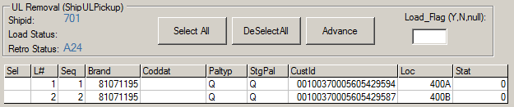

|  |  |
| --- | --- |
| Column | Description |
| Sel | Y or <blank> to determine if the record is Selected or not. |
| L# | Unique Sequential Identifier beginning at 1 for each Customer Id on a shipment |
| Seq | Sequence number of the Customer Id. Determined by the “RAI: Message 21 Sequence By ((U)LID /(O)RDER /(R)TCIS)” RTCIS system parameter. |
| Brand | The brand or item code |
| Coddat | The Coddat (CTLGRP) specified to pick. Normally <null> |
| Pal Typ | One character ASRS Pallet Type which in RTCIS WMS system is ULPALL.PLCPAL |
| StgPal | One character ASRS Pallet Type of the staged CustID which in RTCIS WMS system is ULPALL.PLCPAL |
| CustID | <null> = pallet has not been staged,  -1= staging was attempted but unable to stage and no further attempt will be made (ex. Stage Short),  Else the CUST_ID that was staged.  This is the only value required by RTCIS in the ShipUlPickup Message. All other fields are simply logged. |
| Loc | The assigned Slot (ACTIV_OUTPUT_LOCATION) with Activ Level ID. Will show “SHIPPED” once the ShipUlPickup message has been sent for the CustID |
| Stat | WITHDRAWAL_OUTPUT_STATUS |

UL Removal Control Flow:

* Advancing a UL sends a ShipUlPickup to the WMS.
* Once ShipUlPickup sent for every staged UL, then the ShipId will disappear from the RAID display. The shipment can be purged if desired or retained if desired.

De-Staging Flow:

* CancelShipment is Received from WMS
* RAID sends ShipStageComplete to WMS
* WMS sends SlotDestage to RAID

Order Complete Tab Shows:

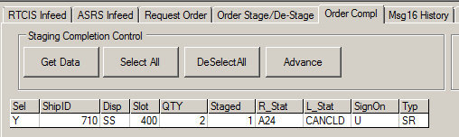

RAID send ShipStartDestage and changes internal status on D22

ULs available for Destage shown on Order Stage/De-Stage Tab

Select CustID to Destage

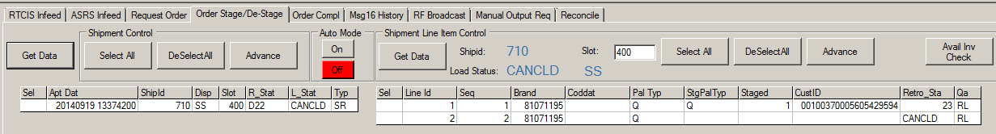

ShipULDestaged sent from RAID to WMS

Order Complete Tab

Select ShipID to Complete Destage

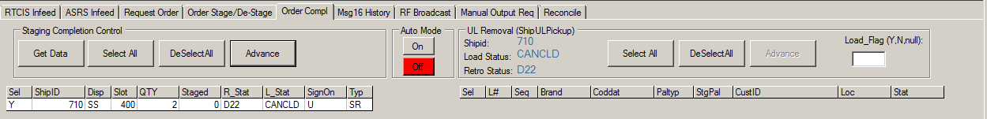

ShipDestageComplete sent to WMS

User deletes shipment if desired.

## QAChg History

The Msg16 tab is used to display a listing of QAStatusChange messages received. List can be controlled via Configuration, Main – DaysOfMsg16HistoryToDisplay. There are no user interactive features.

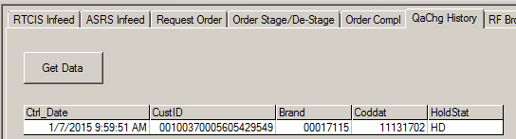

|  |  |
| --- | --- |
| Column | Description |
| Ctrl_Date | RAID System Time when the ChangeULQA message received |
| CustID | The Unit Load ID with the check digit. |
| Brand | The brand or item code |
| Coddat | The Coddat (CTLGRP) |
| HoldStat | UL_HOLD_STATUS_CODE which is the QASTAT |

## RF Broadcast

For future development. Not currently in message specification.

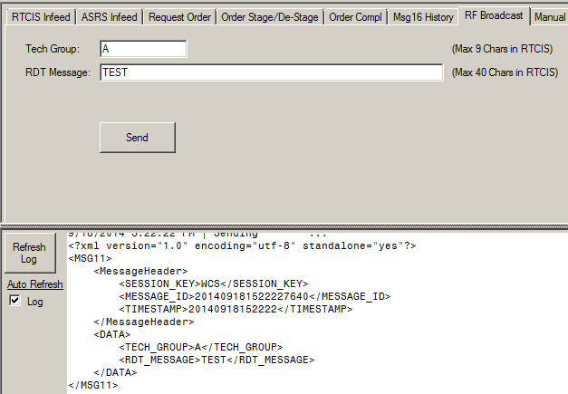

## Manual Output Req

The Manual Output Req tab is used to display and control all aspects of the Manual Withdraw process.

### Msg13 Control

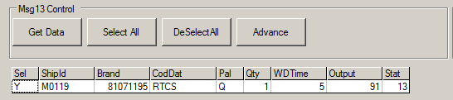

|  |  |
| --- | --- |
| Column | Description |
| Sel | Y or <blank> to determine if the record is Selected or not. |
| ShipId | Shipment ID |
| Brand | The brand or item code |
| Coddat | The Coddat (CTLGRP) specified to pick. Normally <null> |
| Pal | One character ASRS Pallet Type which in RTCIS WMS system is ULPALL.PLCPAL |
| Qty | Unit load quantity |
| WDTime | The time expected from request initiation to when the ASRS expects the CustID to be at the VTL output. |
| Output | The expected VTL output, either requested by WMS or found by RAID if not specified |
| Stat | A tracking mechanism to determine the step in the messaging flow the request is currently in. Normally 13 to indicate request received but not responded to. |

Msg13 Flow:

* WithdrawalRequest is sent to RAID and is shown in Msg13 display
* The request is advanced and the AssignWithdrawalLoc is sent to WMS
* WithdrawalRequest is removed from Msg13 display and can now be seen under Msg14 control

### Msg14 Control

Will send D14 if ULID cannot be found, otherwise will send A14 with the Ulid details

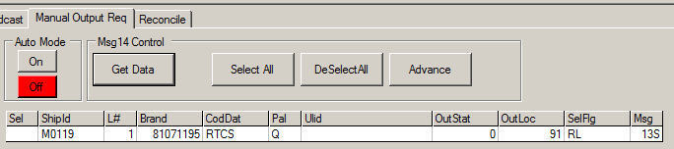

|  |  |
| --- | --- |
| Column | Description |
| Sel | Y or <blank> to determine if the record is Selected or not. |
| ShipId | Shipment ID |
| L# | Sequential Line Item ID created by RAID to make line item records unique |
| Brand | The brand or item code |
| Coddat | The Coddat (CTLGRP) specified to pick. Normally <null> |
| Pal | One character ASRS Pallet Type which in RTCIS WMS system is ULPALL.PLCPAL |
| Ulid | <null> = pallet has not been staged, -1= staging was attempted but unable to stage and no further attempt will be made (ex. Stage Short), else the CUST_ID that was staged |
| OutStat | WITHDRAWAL_OUTPUT_STATUS The status of the request from the ASRS.  • Success – 0 (RAI_OK) or an error code.  • Cancelled – -106 (RAI_UL_CANCELLED).  • Short Quantity – > 0. If the Message_type is D14, this field will contain the short quantity.  • Any other status – < 0. Unknown error. RTCIS cancels undelivered portion the request |
| OutLoc | VTL Output Location - Activ_output_location |
| SelFlg | The QA Status that RAID should base its selection of the CustID on |
| Msg | A tracking mechanism to determine the step in the messaging flow the request is currently in. |

Msg14 Flow:

* The withdraw is advanced and the WithdrawalULArrival is sent to WMS
* The withdraw advances to either a 14 status (CustID staged) or 14D
* If desired, RAID user goes to menu Maintenance, Delete Completed Withdraws once all line items are delivered

## Reconcile

Reconcile is designed to mimic the ASRS reconciliation report and to look for discrepancies between the same set of “physical” inventory that exists in both the ASRS and WMS databases. Discrepancies are highlighted in red.

Functionality is still under development…

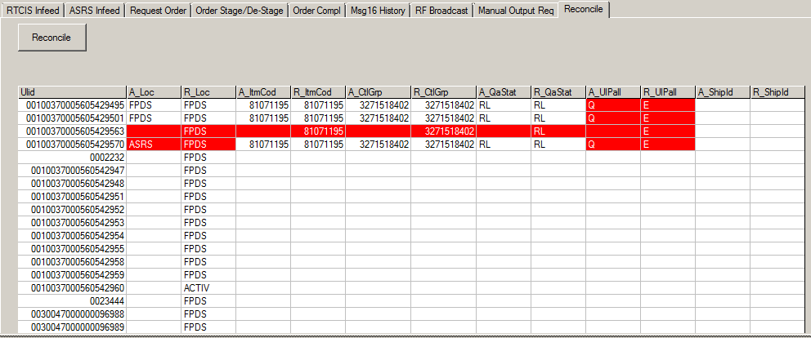

## FPDS Request

The FPDS Request tab displays the RequestFPDS messages received, sends the AssignFPDSLoc message(s), and then provides mechanism for the deletion of the database record associated with the FPDS request.

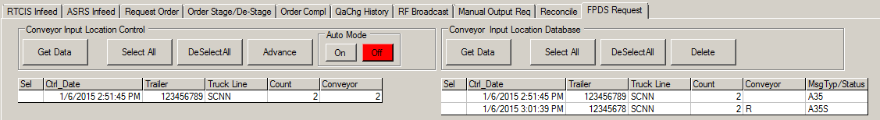

Conveyor Input Control - FPDS Requests

|  |  |
| --- | --- |
| Column | Description |
| Sel | Y or <blank> to determine if the record is Selected or not. |
| Ctrl_Date | RAID System Time when the FPDSRequest message received |
| Trailer | The trailer ID number |
| Truck Line | The truck line associated with the trailer. |
| Count | The number of unit loads associated with the trailer |
| Conveyor | A round robin value initially assigned by RAID based upon the setting Infeed, ACTIV_Input_Conveyors |

FPDS Request Flow:

* The Request_FPDS message is received from WMS and is placed into status into status A35
* The Request is advanced which sends the AssignFPDSLoc to WMS and the request is updated to A35S status.
* If desired, RAID user goes to Conveyor Input Location Database control and deletes the database record (A35 or A35S statuses are both able to be deleted)

Conveyor Input Location Database Control

|  |  |
| --- | --- |
| Column | Description |
| Sel | Y or <blank> to determine if the record is Selected or not. |
| Ctrl_Date | RAID System Time when the FPDSRequest message received |
| Trailer | The trailer ID number |
| Truck Line | The truck line associated with the trailer. |
| Count | The number of unit loads associated with the trailer |
| Conveyor | A round robin value initially assigned by RAID based upon the setting Infeed, ACTIV_Input_Conveyors |
| Msg Typ/Status | A tracking mechanism to determine the step in the messaging flow. A35 indicates Request_FPDS received. A35S indicates that AssignFPDSLoc has been sent. |

# Glossary

| **Term** | **Description** |
| --- | --- |
| BamBam | A custom windows based emulator built to crudely mimic the WMS messaging during RAID development before WMS functionality natively available. |
| FPDS | Full Pallet Delivery System. Any conveyor or series of conveyors controlled by PLCs that route pallets. P&G ASRS facilities use FPDSs to route inbound pallets from manufacturing or the warehouse floor to store them in the ASRS. |
| No Read (or No Read Pallet) | A pallet that passes by a barcode scanner without the barcode being scanned successfully. The pallet information may still be sent to from the PLC to RTCIS without the unit load Id. |
| PLC | Programmable Logic Controller. A device associated with a conveyor that may track and control pallet movement. PLCs may be directly controlled by the ASRS software or may be controlled (indirectly) by RTCIS using the RTCIS PLC Control application (also known as the RTCIS Detail Message Driver or dtlmsgdrv) and [CTI’s (Commercial Timesharing, Inc.)](https://www.ctiplcio.com/) PLCIO. |
| RAI | **R**TCIS **A**ctiv **I**nterface. The original ASRS interface developed for P&G for RTCIS and the first ASRS implementation, Retrotech’s Activ. The RAI acronym remained after the RTCIS standard interface was expanded to interface with other ASRS vendors. |
| RAI ng | The next generation interface standard for the RTCIS ASRS interface, as defined by this document. |
| RAID | **R**TCIS **A**srs **I**nterface **D**estroyer. **D** happened to be a good consonant that fit into the emulator design principle of application names consisting of 4 characters when not named after Flintstone characters. |
| Reject | An output conveyor for pallets that cannot be processed normally by the automation. There are many reasons a pallet may be routed to the reject |
| UL or Unit Load | A unit load is the P&G term for a pallet in RTCIS. |
| ULID or Unit Load Id | The barcode associated with the unit load/pallet. |
| WCS | Warehouse Control System. Generic term for automation software that communicates to RTCIS via messaging. Could include ASRS systems. |
| WMS | Warehouse Management System. RTCIS is a WMS as is PrIME. Used in this document interchangeably with RTCIS. |
| XML | Extensible Markup Language. Textual data format used for the representation of arbitrary data structures. |

## Induction Flow Using DTL Driver

Monitor the current DTL driver e.g.: tail -f dtldrv_N5_20150123.log

Set Infeed parameter SkipMsg567andSQLInsert to Y

Create a New UL on the FPDS via MULE/ 3M03

On the RTCIS infeed tab, restrict the query to item code/control group and ulpall just created.

The ULID should have ASRSKnow = N displayed for it in the grid

On the RTCIS infeed tab, Advance the ULID. ASRSKnow = Y is now displayed for it in the grid.

On the ASRS Infeed Tab, Input Location Control Sel the UL

Right Click on the CustID to copy the ULID with check digit to the clipboard

Copy the ULID into dtldrvsnd for Msg5 , with Station ID and Port ID both set to -1 and Send

Task: DTLDRVSND 8.0.0Euskirchen RTCIS TEST3 8.0.0 BDLG3256 23-Jan-2015 11:19

Unit Load Status Update

Message Type: 5

Unit Load ID: 00000470010001157233

Unit Load Weight: 0.00 Delivery Code: 0

Unit Load Status: 0

Station ID (-1 to suppress replies): -1

Port ID (-1 to suppress replies): -1

Interchange Port ID (pppMM:c):

On the ASRS Infeed Tab, Input Location Control, Select Advance

Copy the ULID into dtldrvsnd for Msg7 , with Station ID and Port ID both set to -1 and Send

On the ASRS Infeed Tab, Msg7 Control, Select Advance

Shipment Flow

MOT Syspar setup

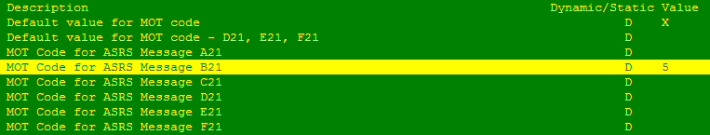

Inbound a Shipment using MULE

Set the MOLCOD to 4 (B2 Pallet) and the MOTCOD to 5

Send RequestNextShip with MOT_CODE of B (to ask for shipments with the mot value of 5 as defined by the B syspar)

# Acknowledgements

Aaron Krause of Supply Trends/JDA wrote the RTCISng Interface Spec of which this document in many cases pulled directly from. Aaron utilized RAID as part of testing RTCIS as he along with JDA coded the RTCIS changes, but for the most part avoided reading the RAID documentation.

Toni Tedesco helped revise early versions of this document. She also performed RAID/BAMBAM protype testing finding numerous bugs as well as suggesting numerous user interface and process flow improvements.

Dave Stuckman coded RAID while not keeping pace with Toni and Aarons keyboarding rate.