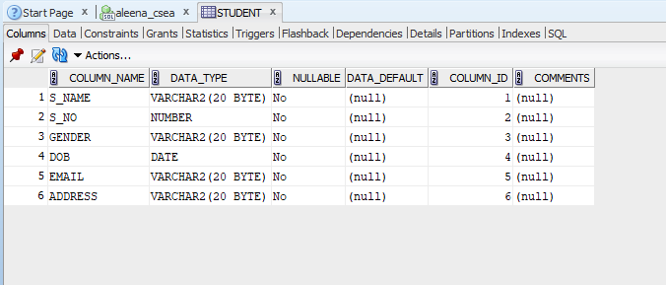
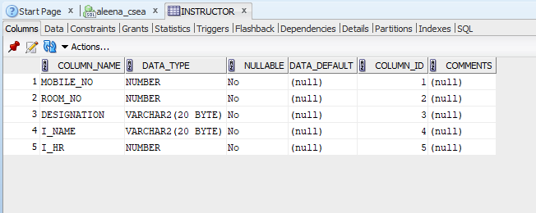
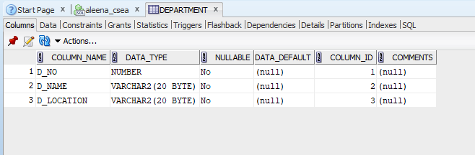
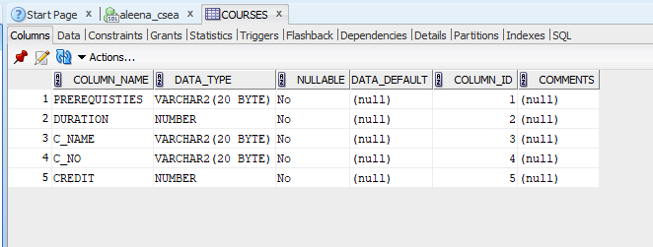
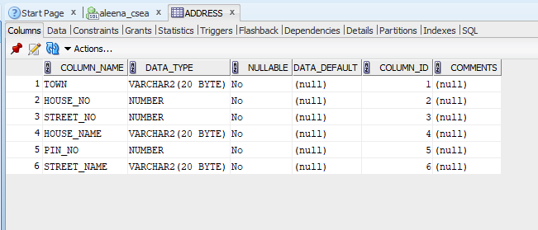

Exp 2

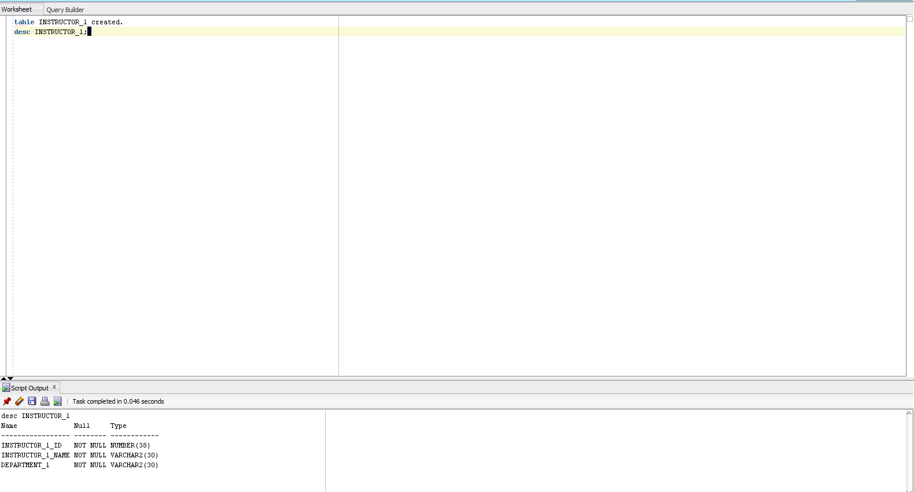
1)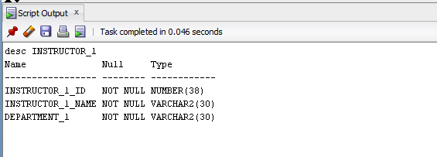
2)
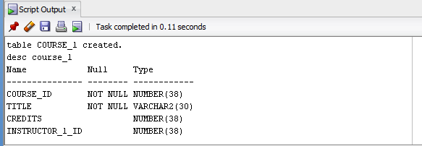
3)
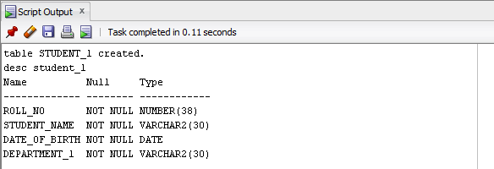
4)
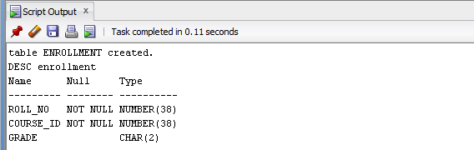
5)
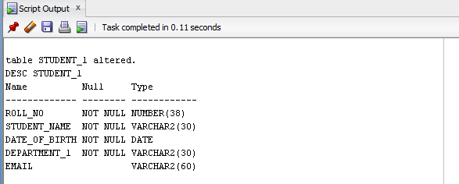
6)
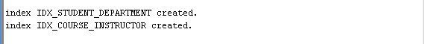

table INSTRUCTOR_1 created.
desc INSTRUCTOR_1;
CREATE TABLE COURSE_1 (
course_id INT PRIMARY KEY,
title VARCHAR(30) NOT NULL,
credits INT CHECK (credits > 0),
INSTRUCTOR_1_ID INT,
FOREIGN KEY (INSTRUCTOR_1_ID)
REFERENCES INSTRUCTOR_1(INSTRUCTOR_1_ID)
ON DELETE SET NULL
);
desc course_1;
CREATE TABLE STUDENT_1 (
ROLL_NO INT PRIMARY KEY,
STUDENT_NAME VARCHAR(30) NOT NULL,
DATE_OF_BIRTH DATE NOT NULL,
DEPARTMENT_1 VARCHAR(30) NOT NULL
);
desc student_1;
CREATE TABLE ENROLLMENT (
ROLL_NO INT,
course_id INT,
grade CHAR(2),
PRIMARY KEY (ROLL_NO, course_id),
FOREIGN KEY (ROLL_NO)
REFERENCES STUDENT_1 (ROLL_NO)
ON DELETE CASCADE,
FOREIGN KEY (course_id)
REFERENCES COURSE_1 (course_id)
ON DELETE CASCADE
);

DESC enrollment;
ALTER TABLE STUDENT_1 ADD (EMAIL VARCHAR(60));
DESC STUDENT_1;
CREATE INDEX idx_student_department
ON STUDENT_1(DEPARTMENT_1);
CREATE INDEX idx_course_instructor
ON course_1(instructor_1_id);

