**CC Lab 8**



**Session:** 2021-2025

**Submitted by:**

Aleeza Shakeel 2021-CS-15

**Submitted to :**

Sir Laeeq khan Niazi

Department of Computer Science

**University of Engineering and Technology**

**Lahore Pakistan**

**Task 1:**

**Turn this code like passing the file name from cmd (Done in lab1)**

**and take that code and pass accordingly.**

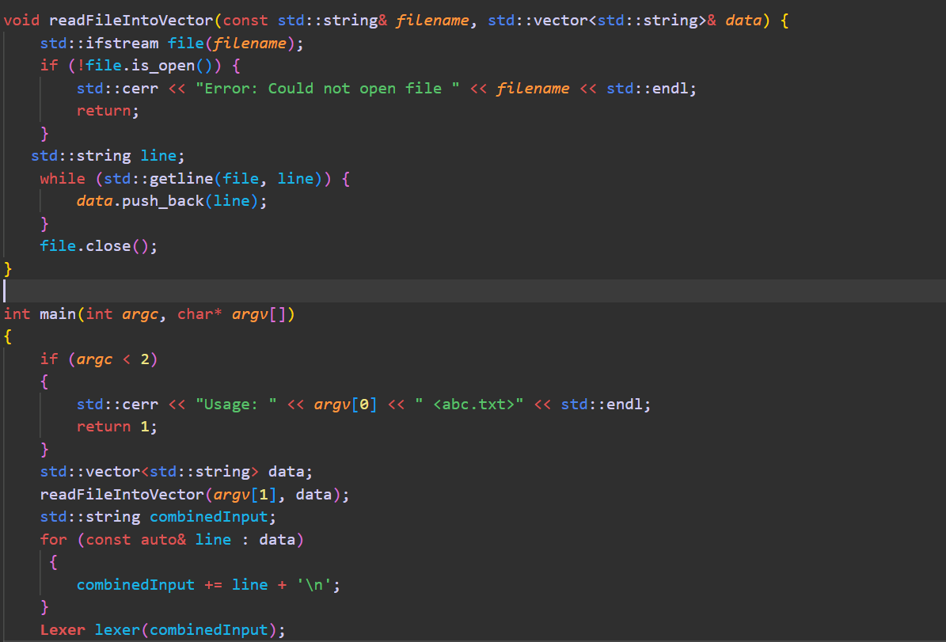

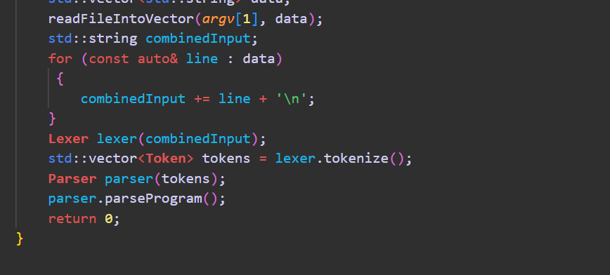

**Task 2:**

**Making your language errors more human friendly to display the line number of the error.**

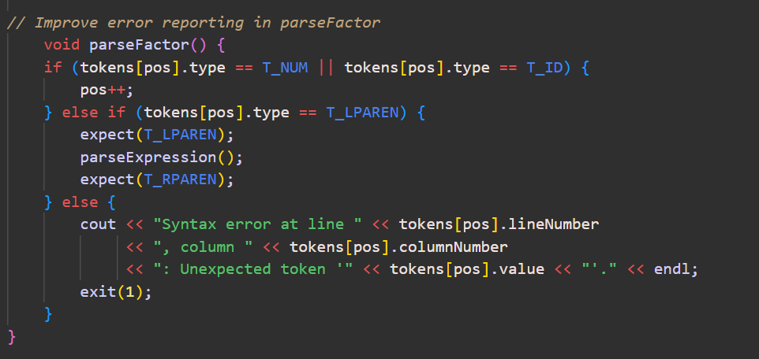

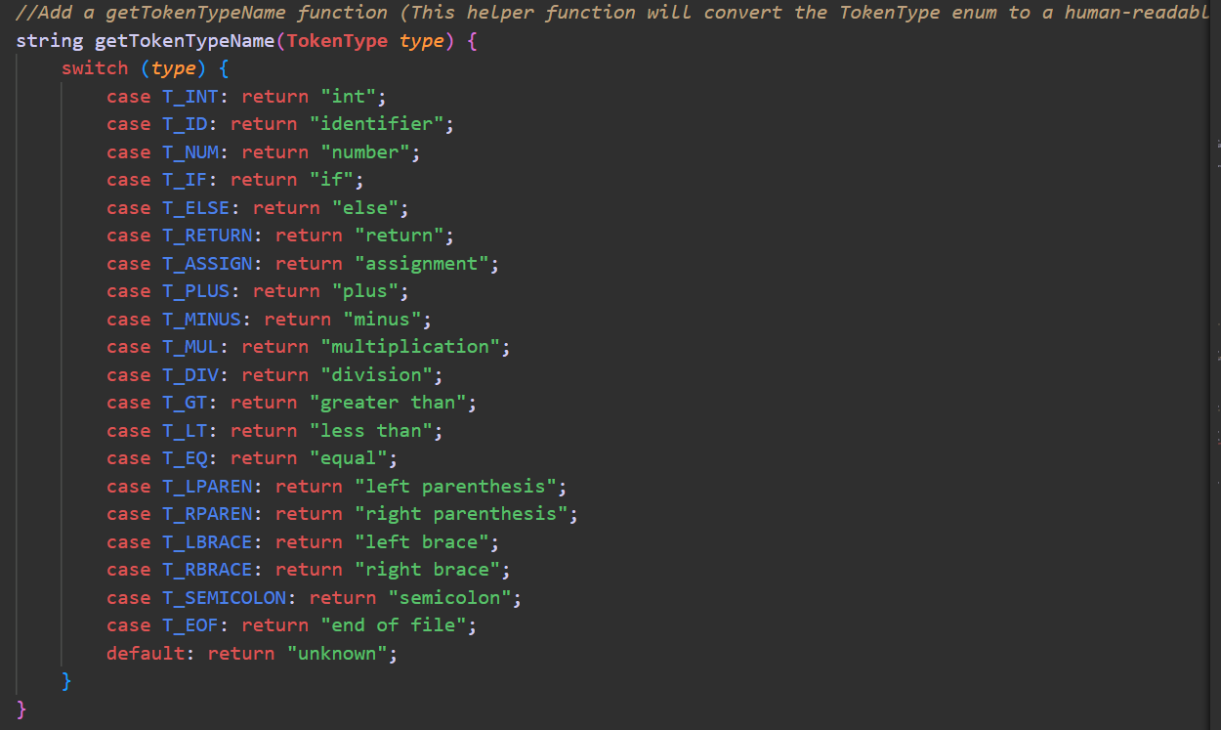

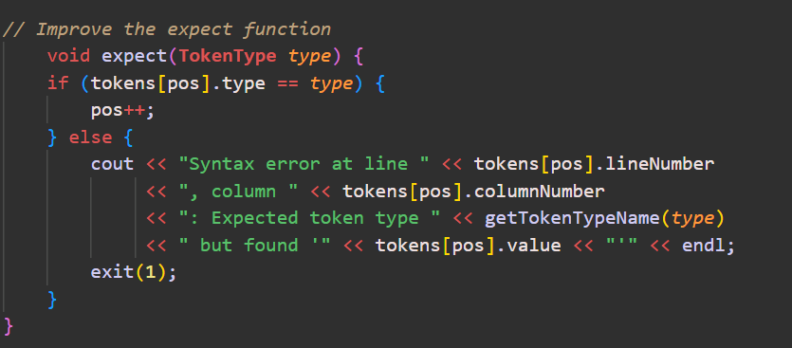

**Task 3:**

**Add more data types like float, double, string, bool, char into your**

**Language.**

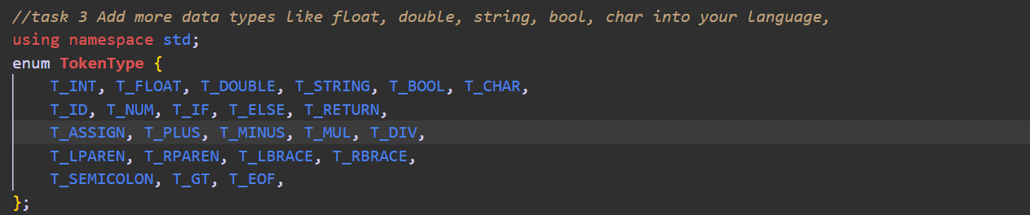

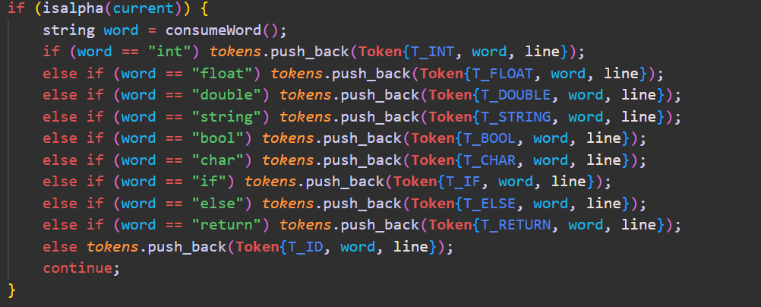

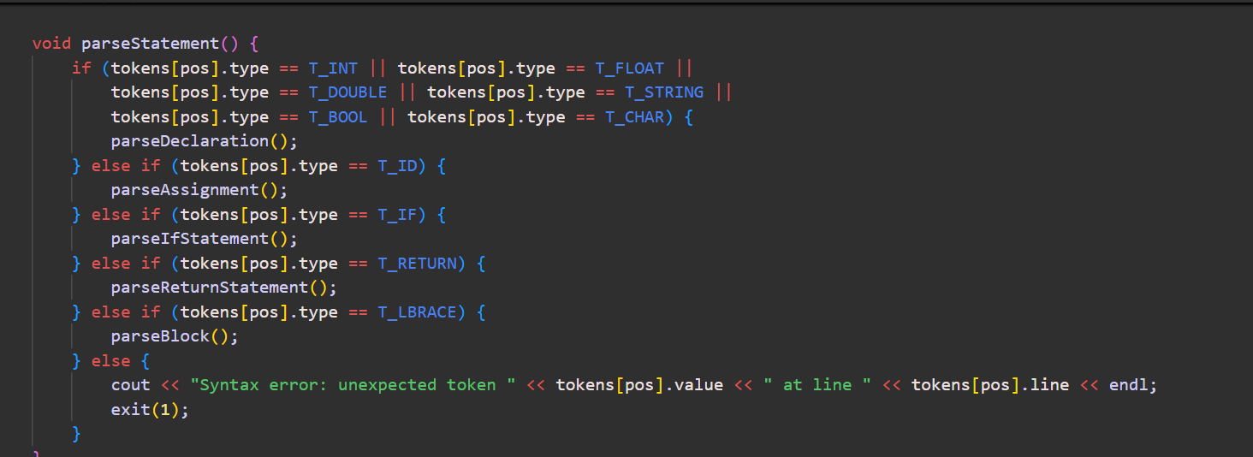

**Task 4:**

**Add more keywords into your language**

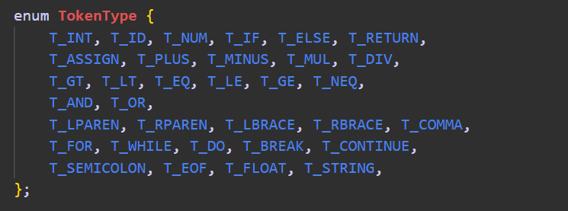

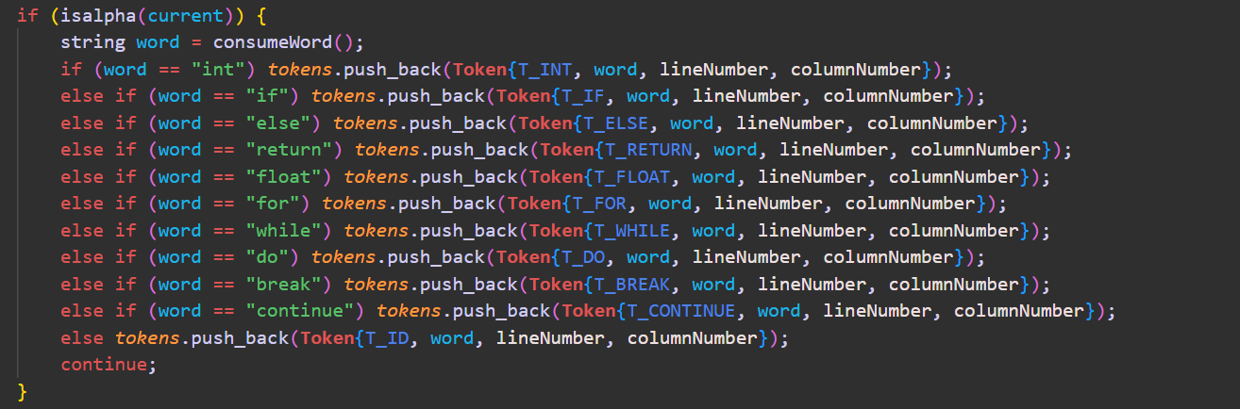

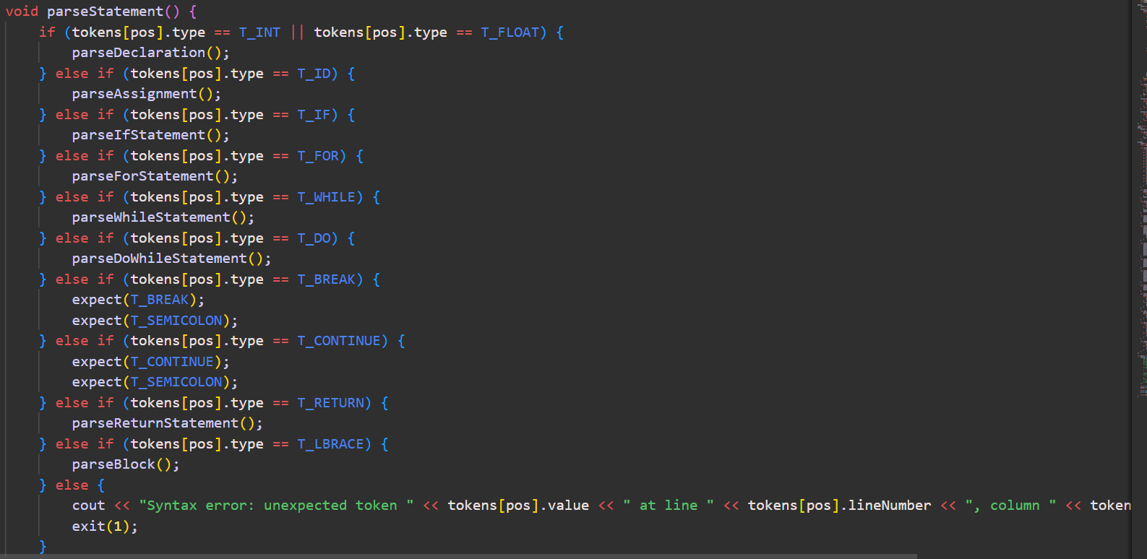

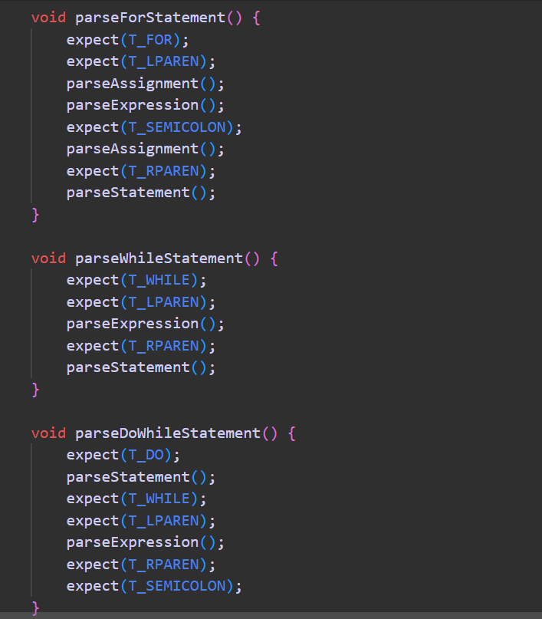

**Task 5:**

**Change the structure of conditions like you can turn if statement into Agar or any keyword of your choice.**

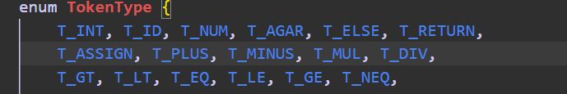

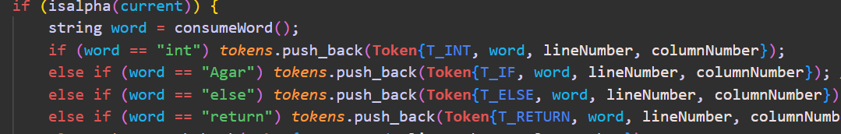

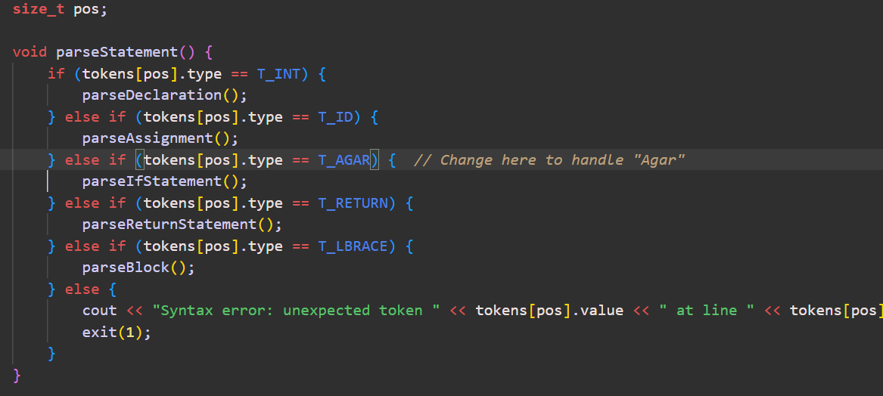

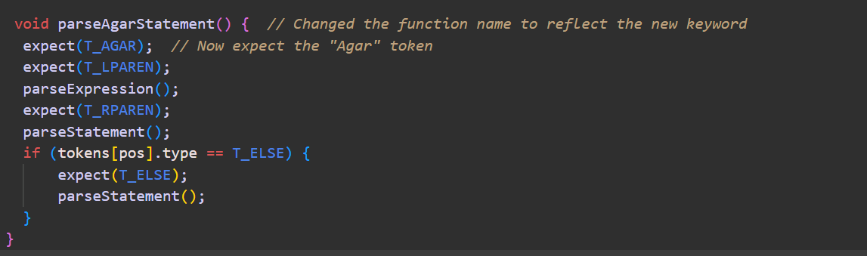

**Task 6:**

**Add the loop feature into your language (while or for)**

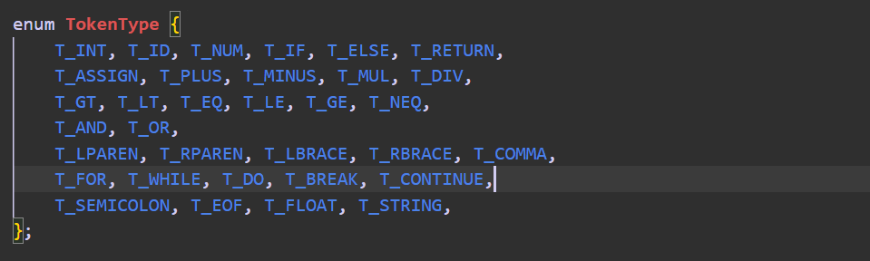

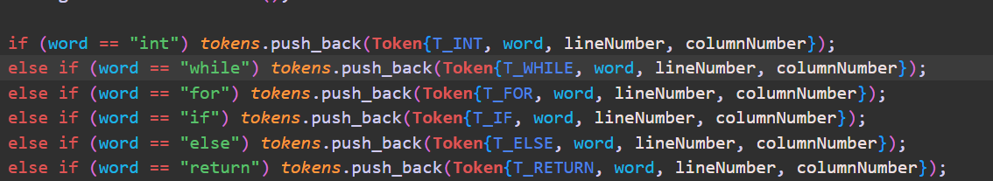

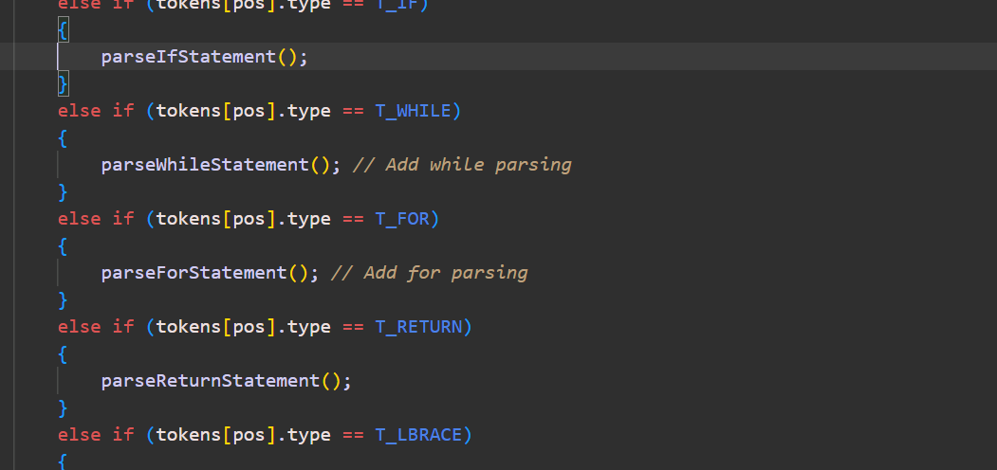

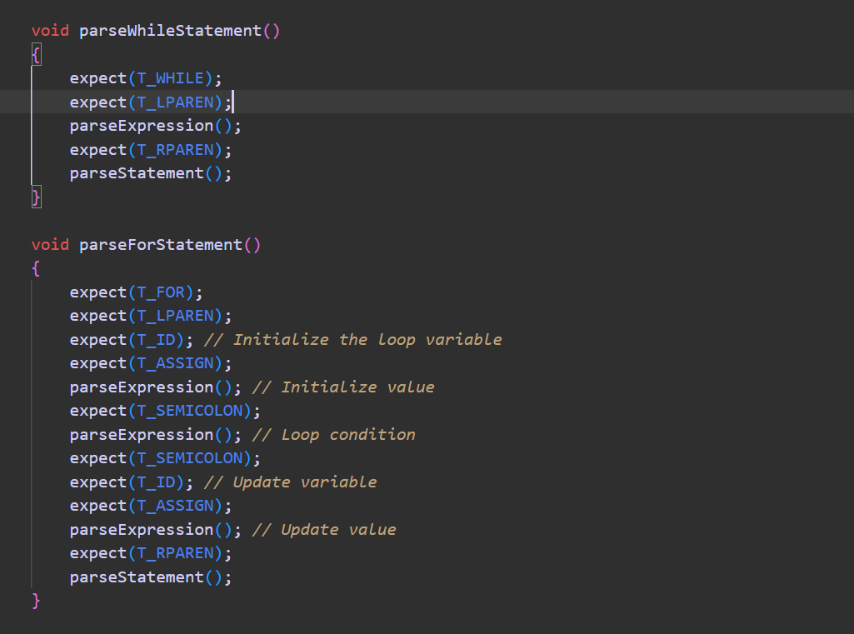

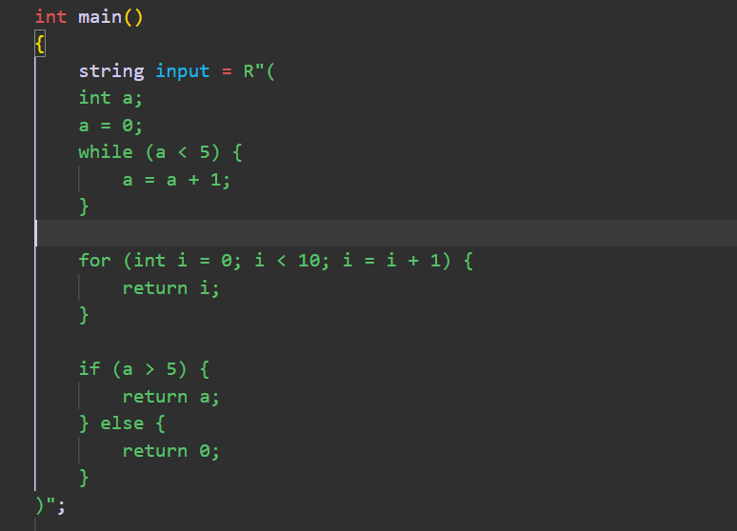

**Task 7:**

**Add logical expressions into your language inside if conditions like &amp;&amp;, ||, == and !=**

