VulNex
Database Build & Validation Specification
Fraud Alert Vulnerability analytical database
Revised Consolidation v2
Validated methodology, complete feature formulas, feature-behavior evidence, and cohort-balance visuals
Document purpose: Provide a step-by-step specification that another analyst can follow in Shape/Spark SQL to reconstruct the current VulNex analytical database, understand every major transformation, and reproduce the associated balance and data-readiness validations.

Important: the analytical target is a future qualifying fraud alert, not confirmed fraud victimization. This document therefore uses “positive” and “negative” observations even where the original request used victim/non-victim terminology.

Document status and requirement coverage
Requested item | Status in this draft | Consolidated evidence
Tables used and why | Complete | Source and derived table lineage with analytical grain and purpose.
Label variable | Complete | label_3m: first observed qualifying alert within the next 3 calendar months.
Timeframe | Complete | 48 observation months (Jan-2022 to Dec-2025); 13 technical months / 12 feature months.
Variables | Complete | Raw trade inputs, monthly aggregates, Current features, transformations and selected Z challengers.
Treatments | Complete | Point-in-time filtering, MOP normalization, aggregation, missingness/availability, log transform, winsorization.
Balance by location | Complete | Primary state at observation date; full-population match and state composition comparison.
Balance by age | Complete | Point-in-time birth date, age bands, overall and yearly SMD.
Balance by product | Complete | Product breadth comparison and descriptive outcome composition.
Balance by credit age | Complete | Observable age of oldest trade; coverage, SMD, and exact same-month support.
Gender | Not available | No validated source field; excluded rather than inferred.
Income | Not available | No validated source field; excluded rather than inferred.
Tenure / 12-month explanation | Complete | 12 months = behavioral lookback, not true customer tenure; data_date limitation documented.
Complete feature formulas | Complete | Formula dictionary added for every final Model A / Model B field, including availability, coverage, transformations, Z eligibility, winsorization and final coalescing.
Feature behavior by label | Complete | Label 0 vs Label 1 averages/medians, availability effects, grouped behavior and selected decile patterns are documented using only fields present in the final analytical database.
Balance graphics | Complete | Visual comparisons added for yearly sample balance, location, age, product breadth and Credit Age.

Contents
1. Purpose, terminology and final analytical scope
2. Source tables and table lineage
3. Outcome / label construction
4. Timeframe and 12-month historical design
5. Cohort construction and analytical population
6. Point-in-time trade extraction
7. MOP transitions and party-month aggregation
8. Feature engineering, complete formulas and feature behavior by label
9. Treatments, missingness and stability controls
10. Step-by-step rebuild sequence in Shape
11. Core QA gates and expected row counts
12. Cohort balance validations: tables, charts, location, age, product and credit age
13. Limitations and interpretation guardrails
14. Reproducibility acceptance checklist
Appendix A. Core raw trade column inventory
Appendix B. MOP mapping
Appendix C. Final Model A / Model B feature inventory
Appendix D. Key query logic for descriptive enrichments

1. Purpose, terminology and final analytical scope
The VulNex analytical database is designed to identify observable credit-behavior patterns associated with a future qualifying fraud alert. The database is constructed as a point-in-time party-level analytical sample: each party has one observation date, a forward three-month outcome, and behavioral features calculated only from information observable on or before that observation date.
Terminology guardrail: label_3m = 1 means a future qualifying alert was observed. It does not prove confirmed fraud loss or confirmed victimization. Use “positive/event” and “negative/non-event” in technical reporting.

Final object | Grain | Rows | Positive | Negative | Analytical sample rate
bu_frd.model_features_ab_final_2022_2025 | 1 row per party / observation date | 688,589 | 62,599 | 625,990 | 9.0909% positive

Observation year | Total | Positive | Negative
2022 | 145,123 | 13,193 | 131,930
2023 | 152,240 | 13,840 | 138,400
2024 | 259,127 | 23,557 | 235,570
2025 | 132,099 | 12,009 | 120,090
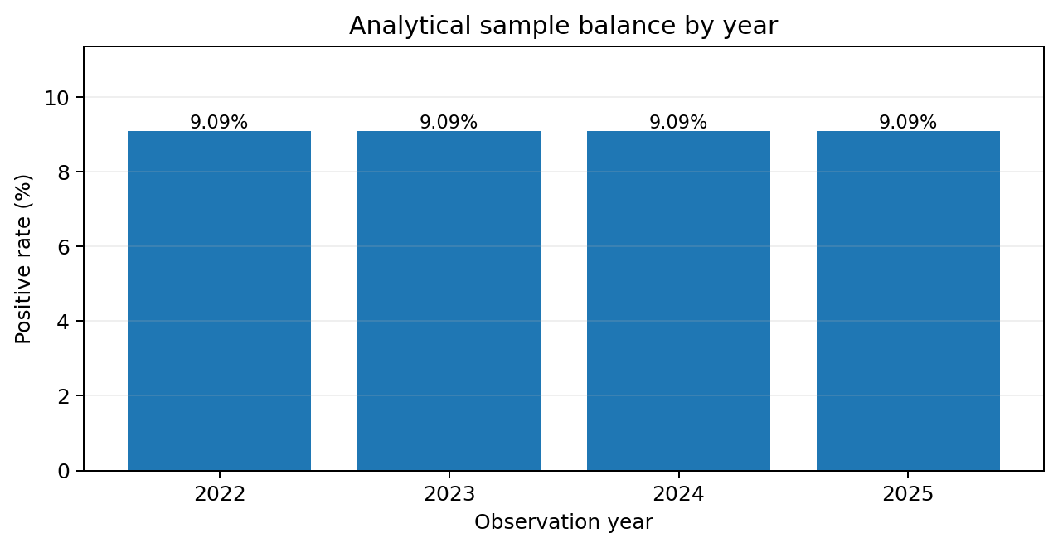
Figure 1. The analytical sample preserves an approximately 1:10 positive-to-negative design in each observation year.

2. Source tables and table lineage
Source table | Why it is used | Key fields / notes
bc3.security_alert | Authoritative fraud-alert event history used to derive the first observed qualifying alert. | party_id, alert creation date, qualifying alert type logic.
bc3.person_restricted | Source-history diagnostic only; used to assess observability / left-censoring. | party_id, data_date. data_date is not customer relationship start.
trades | Account-level credit behavior used for point-in-time behavioral history and engineered features. | party_id, acct_id, data_date, open_dte, acct_mop_cde, curr_bal_amt, cr_lmt_amt, past_due_amt, product fields.
bc3.padd | EDA / cohort-balance enrichment for location only. | party_id, data_date, addr_seq_num, state_cde, city_name. addr_seq_num=1 is primary address.
bc3.pers | EDA / cohort-balance enrichment for age only. | party_id, data_date, birth_dte.

2.1 Derived pipeline objects
Object | Stage | Purpose / grain
bu_frd.party_first_valid_alert_all | Outcome layer | One qualifying first-alert record per party.
bu_frd.model_cohort_behavioral_final_3m_2022_2025 | Cohort | One analytical observation per party with observation_date and label_3m.
bu_frd.model_cohort_month_keys_3m_2022_2025_v2 | Temporal keys | Expands each party to 13 technical months.
bu_frd.model_trades_behavioral_final_13m_2022_2025 | Point-in-time trades | Required account snapshots for cohort and relative months.
bu_frd.model_trades_transition_13m_2022_2025 | MOP transitions | Account-month transitions and deterioration/improvement flags.
bu_frd.model_party_behavior_monthly_2022_2025 | Party-month behavior | 12 feature-month rows per party.
bu_frd.model_party_utilization_monthly_2022_2025 | Party-month utilization | Average and weighted utilization on common eligible universe.
bu_frd.model_party_behavior_windows_2022_2025 | Window summaries | PRIOR 9M and RECENT 3M aggregates, SD and coverage.
bu_frd.model_behavior_features_current_2022_2025 | Current formulas | Recent-minus-prior and normalized accelerations.
bu_frd.model_behavior_features_z_2022_2025 | Z challengers | Within-party standardized deviations.
bu_frd.model_behavior_features_selected_2022_2025 | Selected Z | Frozen viable Z candidates.
bu_frd.model_behavior_features_transformed_2022_2025 | Transforms | Flags and nonlinear magnitude transformations.
bu_frd.model_features_ab_final_2022_2025 | Final analytical table | Model-ready one-row-per-party database.

3. Outcome / label construction
The outcome layer first converts raw alert history into a unique party-level first-observed qualifying event. Alert types 2 and 3 are the qualifying fraud-alert classes used by the project. Because alert recurrence/suppression can persist for years, the design models the first observed qualifying event rather than repeated occurrences.
label_3m = 1 if observation_date < first_qualifying_alert_date <= observation_date + 3 calendar months; otherwise 0
- Positive observations must have the qualifying alert strictly after the observation date and inside the three-month forward horizon.
- Negative observations must not have a qualifying alert inside the same forward horizon.
- Outcome QA found zero positives without an alert, zero positives with non-future alerts, zero positives outside the horizon, and zero negatives with an alert inside the horizon.

4. Timeframe and 12-month historical design
Observation dates cover 48 consecutive monthly observation points from January 2022 through December 2025. Each observation is linked to a fixed future three-month outcome horizon and a separate historical behavioral window.
Relative block | Months | Purpose | Enters final behavioral features?
SEED | M-12 | Provides predecessor state required to calculate the first MOP transition. | No
PRIOR | M-11 through M-3 | Nine-month behavioral baseline. | Yes
RECENT | M-2 through M0 | Three-month recent behavior. | Yes

13 technical months = 1 SEED + 9 PRIOR + 3 RECENT
12 feature months = 9 PRIOR + 3 RECENT
Tenure clarification for this deliverable: the project operationally uses a 12-month behavioral history window, not customer relationship tenure. The 12 months are intentionally split into a 9-month PRIOR baseline and a 3-month RECENT window so recent behavior can be compared with the party's own prior behavior. A separate SEED month is retained only to initialize the first MOP transition, making 13 technical months in extraction. bc3.person_restricted.data_date was evaluated but is a source-history/load date and cannot be used as true customer tenure.

5. Cohort construction and analytical population
The analytical cohort contains one observation per party. The final case-control design uses an approximately 1:10 positive-to-negative ratio. This is a sample-design rate, not a population fraud-alert prevalence rate.
Metric | Validated result
Final rows | 688,589
Distinct parties | 688,589
Duplicate parties | 0
Positive observations | 62,599
Negative observations | 625,990
Positive sample rate | 9.0909%
Negative:positive ratio | 10:1

Probability interpretation: Because the analytical sample intentionally changes outcome prevalence, raw model probabilities are not population-calibrated probabilities. Ranking, lift and discrimination remain meaningful; operational probabilities require calibration.

6. Point-in-time trade extraction
Trade history is restricted to the exact party/month keys required by the cohort. No record that becomes available after the observation date is permitted to influence an observation. The point-in-time layer is the core leakage-control boundary for the behavioral database.
- Join cohort parties to required relative month keys rather than scanning unrestricted future history.
- Require trade data_date to align to the intended feature month / observation clock.
- Require effective information dates not to exceed the source snapshot or observation date.
- Keep the SEED month for transition calculation, but exclude it from final feature aggregates.
Point-in-time QA | Result
Trade rows | 98,051,779
data_date after observation_date | 0
feature_month after observation_date | 0
effective date after data_date | 0
effective date after observation_date | 0
data month misaligned | 0
month_offset range | 0 to 12

7. MOP transitions and party-month aggregation
Account-level MOP states are normalized and compared month over month. The SEED month provides the predecessor state for the first feature month. Transition flags are then aggregated with balances, past due, utilization and account counts to party-month grain.
Transition(i,t) = normalized_MOP(i,t-1) -> normalized_MOP(i,t)
Deterioration acceleration = recent deterioration count / 3 - prior deterioration count / 9
Adverse acceleration = recent adverse-entry count / 3 - prior adverse-entry count / 9
Monthly panel QA | Validated result
Party-month rows | 8,263,068 = 688,589 x 12
Parties not having 12 feature months | 0
Duplicate / missing month offsets | 0
Future feature months | 0
Invalid PRIOR/RECENT mapping | 0
Offset range | 0 to 11

7.1 Utilization
Account utilization = curr_bal_amt / cr_lmt_amt for eligible active C/R accounts with cr_lmt_amt > 0
Average utilization = mean(account-level utilization)
Weighted utilization = sum(curr_bal_amt) / sum(cr_lmt_amt) on the same eligible universe
The project explicitly corrected weighted utilization so numerator and denominator use the same eligible account universe. Availability for average and weighted utilization was reconciled with zero mismatches.

8. Feature engineering, complete formulas and feature behavior by label
The calculation view below is intentionally structured like an audit worksheet: it shows the baseline window, recent window, calculation rule, treatment, and output fields. It can be used to explain how a single observation is converted from monthly behavior into model-ready features.
Field | PRIOR 9M | RECENT 3M | Calculation | Treatment / control | Final output
Active accounts | Prior 9M mean | Recent 3M mean | Recent mean - Prior mean | Signed change; changed flag; Z challenger | active_accounts_change_vs_baseline; active_accounts_changed_flag; active_accounts_z_model
Balance | Prior 9M mean | Recent 3M mean | Recent mean - Prior mean | Signed change + log(1+|change|); availability | balance_change_model; log1p_abs_balance_change_model
Past due | Prior 9M mean | Recent 3M mean | Recent mean - Prior mean | Availability / coverage retained | past_due_change_model
Delinquency share | Prior 9M mean | Recent 3M mean | Recent mean - Prior mean | Availability / coverage retained | delinquency_share_change_model
Average utilization | Prior 9M mean + SD | Recent 3M mean | Recent mean - Prior mean; Z | Input caps; availability; selected Z challenger | avg_utilization_change_model; avg_utilization_z_model
Weighted utilization | Prior 9M mean + SD | Recent 3M mean | Recent mean - Prior mean; Z | Same eligible universe; selected Z challenger | weighted_utilization_change_model; weighted_utilization_z_model
Deterioration | Prior count | Recent count | Recent/3 - Prior/9 | No Z: baseline SD is zero for most parties | deterioration_acceleration
Adverse entry | Prior count | Recent count | Recent/3 - Prior/9 | No Z: baseline SD is zero for most parties | adverse_acceleration
Max DPD jump | Prior context | Recent 3M | Maximum recent deterioration jump | Direct recent severity feature | max_dpd_jump_recent_3m

Current change(X) = mean(X)_Recent3 - mean(X)_Prior9
Z_X = [mean(X)_Recent3 - mean(X)_Prior9] / [SD(X)_Prior9 / sqrt(3)]
log1p_abs_balance_change = ln(1 + |balance_change|)

8.1 Z-score eligibility and frozen caps
- Z candidates were retained only where baseline variability and coverage made the statistic meaningful.
- Balance Z was dropped because of pathological extreme tails; deterioration/adverse Z was not viable because baseline SD was zero for most parties; past-due/delinquency Z had insufficient coverage.
- Frozen development caps: active_accounts_z [-13.27906, 15.01716], avg_utilization_z [-29.78358, 33.76045], weighted_utilization_z [-37.89802, 40.84790].
- Utilization inputs were capped earlier at approximately 1.821143 for average utilization and 1.76 for weighted utilization.

8.2 Complete feature formula dictionary
The formulas below cover every field used in the final Model A / Model B analytical feature set. Names are written exactly as they appear in bu_frd.model_features_ab_final_2022_2025. No analytical grouping created only for reporting is presented as a database feature.
Notation | Definition
RecentAvg(X) | AVG(X) over month_offset 0-2 (RECENT 3M); SQL AVG ignores null months.
PriorAvg(X) | AVG(X) over month_offset 3-11 (PRIOR 9M).
PriorSD(X) | STDDEV_SAMP(X) over month_offset 3-11.
RecentMonths(X) | COUNT of non-null monthly X values over month_offset 0-2.
PriorMonths(X) | COUNT of non-null monthly X values over month_offset 3-11.
Clamp(x,L,U) | MAX(L, MIN(x,U)); used for frozen winsorization.
I(condition) | 1 when the condition is true, otherwise 0.

Upstream monthly calculations used by final features
Monthly metric | Formula / aggregation
avg_balance_active | AVG(curr_bal_amt) across accounts satisfying the validated active-account rule in the party-month.
avg_past_due_active | AVG(past_due_amt) across active accounts in the party-month.
delinquent_account_share | delinquent_active_accounts / rated_active_accounts when the rated denominator is available.
Account utilization | curr_bal_amt / cr_lmt_amt for eligible active C/R accounts with cr_lmt_amt > 0.
avg_utilization | AVG(account utilization) across utilization-eligible accounts.
weighted_utilization | SUM(curr_bal_amt) / SUM(cr_lmt_amt) using the same utilization-eligible account universe.
deterioration_count | SUM(account-level deterioration flags) within party-month.
adverse_entry_count | SUM(account-level adverse-entry flags) within party-month.
max_dpd_jump | MAX(account-level DPD deterioration jump) within party-month.

Final analytical feature formulas
Final database feature | Exact formula / rule | Treatment / interpretation
deterioration_acceleration | deterioration_recent_count / 3 - deterioration_prior_count / 9 | Recent-vs-prior normalized event rate.
adverse_acceleration | adverse_recent_count / 3 - adverse_prior_count / 9 | Recent-vs-prior normalized adverse-entry rate.
max_dpd_jump_recent_3m | COALESCE(MAX(max_dpd_jump over RECENT 3M), 0) | Recent maximum deterioration severity.
active_accounts_change_vs_baseline | RecentAvg(active_accounts) - PriorAvg(active_accounts) | Signed change; no coalescing required in final panel.
active_accounts_changed_flag | I(ABS(active_accounts_change_vs_baseline) > 0) | Indicates any non-zero active-account change.
balance_change_model | COALESCE(RecentAvg(avg_balance_active) - PriorAvg(avg_balance_active), 0) | Zero is paired with balance_change_available_flag.
log1p_abs_balance_change_model | COALESCE(LN(1 + ABS(raw balance change)), 0) | Magnitude transform; available only when raw balance change is available.
balance_change_available_flag | I(RecentAvg(avg_balance_active) IS NOT NULL AND PriorAvg(avg_balance_active) IS NOT NULL) | Distinguishes observed zero from unavailable change.
balance_recent_months_available | RecentMonths(avg_balance_active) | Integer 0-3.
balance_prior_months_available | PriorMonths(avg_balance_active) | Integer 0-9.
past_due_change_model | COALESCE(RecentAvg(avg_past_due_active) - PriorAvg(avg_past_due_active), 0) | Zero paired with past_due_change_available_flag.
past_due_change_available_flag | I(RecentAvg(avg_past_due_active) IS NOT NULL AND PriorAvg(avg_past_due_active) IS NOT NULL) | Availability indicator.
past_due_recent_months_available | RecentMonths(avg_past_due_active) | Integer 0-3.
past_due_prior_months_available | PriorMonths(avg_past_due_active) | Integer 0-9.
delinquency_share_change_model | COALESCE(RecentAvg(delinquent_account_share) - PriorAvg(delinquent_account_share), 0) | Zero paired with delinquency_change_available_flag.
delinquency_change_available_flag | I(RecentAvg(delinquent_account_share) IS NOT NULL AND PriorAvg(delinquent_account_share) IS NOT NULL) | Availability indicator.
delinquency_recent_months_available | RecentMonths(delinquent_account_share) | Integer 0-3.
delinquency_prior_months_available | PriorMonths(delinquent_account_share) | Integer 0-9.
avg_utilization_change_model | COALESCE(RecentAvg(avg_utilization) - PriorAvg(avg_utilization), 0) | Current-formula value uses uncapped utilization.
weighted_utilization_change_model | COALESCE(RecentAvg(weighted_utilization) - PriorAvg(weighted_utilization), 0) | Current-formula value uses uncapped utilization.
utilization_change_available_flag | I(avg-util recent/prior averages AND weighted-util recent/prior averages are all non-null) | Common availability flag for both current utilization changes.
utilization_recent_months_available | MIN(RecentMonths(avg_utilization), RecentMonths(weighted_utilization)) | Common recent coverage, integer 0-3.
utilization_prior_months_available | MIN(PriorMonths(avg_utilization), PriorMonths(weighted_utilization)) | Common prior coverage, integer 0-9.
active_accounts_z_model | COALESCE(Clamp((RecentAvg(active_accounts)-PriorAvg(active_accounts)) / (PriorSD(active_accounts)/SQRT(3)), -13.27906, 15.01716), 0) | Z available only when PriorSD(active_accounts) > 0.
active_accounts_z_available_flag | I(PriorSD(active_accounts) > 0) | Pairs with active_accounts_z_model.
avg_utilization_z_model | COALESCE(Clamp((RecentAvg(capped avg utilization)-PriorAvg(capped avg utilization)) / (PriorSD(capped avg utilization)/SQRT(3)), -29.78358, 33.76045), 0) | Monthly avg-util Z input is capped at 1.821143; require recent coverage=3, prior coverage>=6, prior SD>0.
avg_utilization_z_available_flag | I(avg-util recent months=3 AND avg-util prior months>=6 AND PriorSD(capped avg utilization)>0) | Eligibility flag for avg_utilization_z_model.
weighted_utilization_z_model | COALESCE(Clamp((RecentAvg(capped weighted utilization)-PriorAvg(capped weighted utilization)) / (PriorSD(capped weighted utilization)/SQRT(3)), -37.89802, 40.84790), 0) | Monthly weighted-util Z input is capped at 1.76; require recent coverage=3, prior coverage>=6, prior SD>0.
weighted_utilization_z_available_flag | I(weighted-util recent months=3 AND weighted-util prior months>=6 AND PriorSD(capped weighted utilization)>0) | Eligibility flag for weighted_utilization_z_model.

Validation formulas used in this document
Validation metric | Formula / rule
Positive rate | positive_parties / total_parties
Coverage | parties_with_value / total_parties
Representation ratio | (% of positives in stratum) / (% of negatives in stratum)
Difference score (SMD) | (mean_positive - mean_negative) / SQRT((variance_positive + variance_negative)/2)
Credit Age | FLOOR(MONTHS_BETWEEN(observation_date, earliest_open_dte))
Age at observation | FLOOR(MONTHS_BETWEEN(observation_date, birth_dte) / 12)
Exact Credit Age support | Positive is supported when at least one negative exists at the same observation_date and exact credit_age_months.

8.3 Feature behavior by label
This section shows how final database features behave for label_3m = 0 versus label_3m = 1. The goal is descriptive: show actual differences, value patterns and availability effects. These results do not replace multivariate model validation and are not used here to re-select the feature set.
Difference score (SMD) is retained because it puts features measured on different scales onto one comparable scale. In the presentation tables it is treated only as a simple difference score; decile and availability patterns are used alongside it because some relationships are not linear.
Feature | Avg L0 | Avg L1 | Median L0 | Median L1 | Difference score | Simple read
log1p_abs_balance_change_model | 6.49 | 6.89 | 6.70 | 6.96 | 0.184 | Positives show larger balance-change magnitude.
delinquency_share_change_model | 0.0064 | 0.0018 | 0 | 0 | -0.053 | Small average difference; grouped pattern is more informative.
max_dpd_jump_recent_3m | 0.082 | 0.070 | 0 | 0 | -0.039 | Small standalone difference.
weighted_utilization_change_model | 0.0076 | 0.0021 | 0 | -0.0015 | -0.037 | Average difference is small; deciles show a non-linear pattern.
avg_utilization_change_model | 0.0080 | 0.0029 | 0 | -0.0016 | -0.032 | Average difference is small; middle ranges show higher positive rates.
active_accounts_change_vs_baseline | 0.0347 | 0.0666 | 0 | 0 | 0.030 | Mean difference is modest; change vs no change is much clearer.
active_accounts_z_model | 0.153 | 0.189 | 0.218 | 0.231 | 0.014 | Small average difference.
balance_change_model | 414 | 216 | -47.2 | -111 | -0.012 | Signed values are heavy-tailed; magnitude/decile view is more useful.
adverse_acceleration | 0.00082 | 0.00019 | 0 | 0 | -0.010 | Limited standalone difference.
weighted_utilization_z_model | 0.242 | 0.220 | 0.0012 | -0.091 | -0.006 | Small average difference.
avg_utilization_z_model | 0.260 | 0.243 | -0.0024 | -0.088 | -0.005 | Small average difference.
past_due_change_model | 0.123 | 4.25 | 0 | 0 | -0.004 | Heavy tails make means unstable; availability and grouped behavior matter more.
deterioration_acceleration | 0.0037 | 0.0030 | 0 | 0 | -0.002 | Limited standalone difference.

Availability effect
Final database flag | Positive rate when available | Positive rate when not available | Rate ratio
past_due_change_available_flag | 10.93% | 1.52% | 7.17x
balance_change_available_flag | 10.93% | 1.53% | 7.17x
delinquency_change_available_flag | 10.73% | 1.61% | 6.67x
utilization_change_available_flag | 11.67% | 2.74% | 4.26x
avg_utilization_z_available_flag | 12.31% | 3.69% | 3.33x
weighted_utilization_z_available_flag | 12.31% | 3.69% | 3.33x
active_accounts_z_available_flag | 11.93% | 4.57% | 2.61x
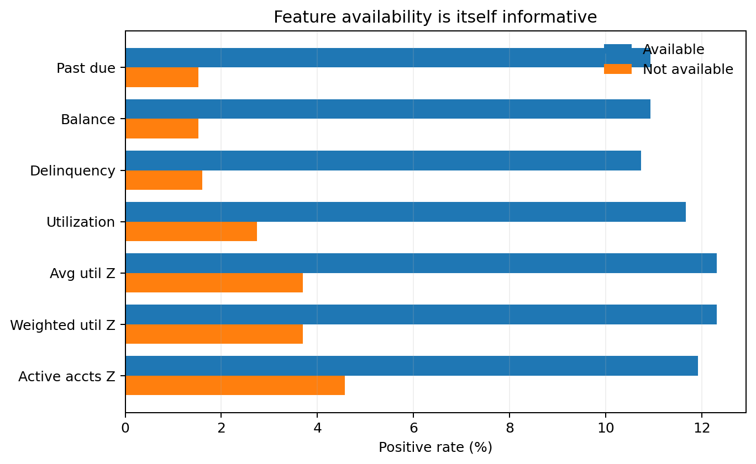
Figure 2. Positive rate is consistently higher when these behavioral measures are available; the availability flags therefore capture meaningful observability differences.

Selected grouped behavior using existing database fields
Feature | Value group | Parties | Positive rate | Lift vs 9.09% baseline
active_accounts_change_vs_baseline | < 0 | 207,898 | 11.42% | 1.26x
active_accounts_change_vs_baseline | = 0 | 247,854 | 4.57% | 0.50x
active_accounts_change_vs_baseline | > 0 | 232,837 | 11.82% | 1.30x
active_accounts_changed_flag | 0 | 247,854 | 4.57% | 0.50x
active_accounts_changed_flag | 1 | 440,735 | 11.63% | 1.28x
max_dpd_jump_recent_3m | 0 | 639,919 | 9.20% | 1.01x
max_dpd_jump_recent_3m | 1 | 43,678 | 7.61% | 0.84x
max_dpd_jump_recent_3m | 2+ | 4,992 | 8.61% | 0.95x
balance_recent_months_available | 0 | 131,633 | 1.41% | 0.16x
balance_recent_months_available | 3 | 535,733 | 11.08% | 1.22x
past_due_recent_months_available | 0 | 131,552 | 1.41% | 0.16x
past_due_recent_months_available | 3 | 535,839 | 11.08% | 1.22x
delinquency_recent_months_available | 0 | 120,736 | 1.49% | 0.16x
delinquency_recent_months_available | 3 | 547,221 | 10.87% | 1.20x
utilization_recent_months_available | 0 | 193,148 | 2.59% | 0.28x
utilization_recent_months_available | 3 | 460,478 | 11.86% | 1.30x

Selected low-to-high value patterns
Feature | Low-value rate | Middle / peak | High-value rate | Simple pattern
log1p_abs_balance_change_model | 6.94% | — | 13.00% | Generally increasing
active_accounts_change_vs_baseline | 11.88% | ~4.54% near zero | 12.24% | Change away from zero matters
balance_change_model | 13.71% | 7.00% around D7 | 12.01% | Two-sided / non-linear
avg_utilization_change_model | 9.82% | 14.07% peak around D4 | 8.77% | Middle-range peak
weighted_utilization_change_model | 10.05% | 13.82% peak around D4 | 8.88% | Middle-range peak
past_due_change_model | 9.16% | 11.62% around D5 | 8.32% | Weak / mixed
avg_utilization_z_model | 10.70% | 13.62% around D5 | 11.53% | Middle-range peak
weighted_utilization_z_model | 10.67% | 13.45% around D5 | 11.59% | Middle-range peak
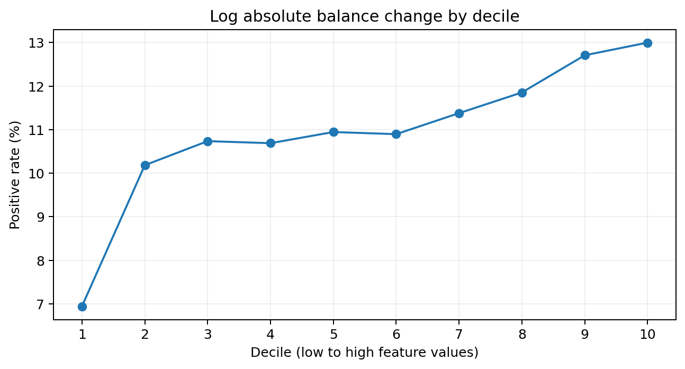
Figure 3. Example of a clear feature pattern: the positive rate rises as log absolute balance-change magnitude increases.

9. Treatments, missingness and stability controls
Treatment | Rule / rationale
Point-in-time filtering | No source record after the observation date may affect the observation.
Availability flags | Missing/structurally unavailable measures are accompanied by explicit availability indicators.
Coalesce-to-zero | Used only where paired with an availability flag so zero does not silently mean “observed zero”.
Coverage counts | Recent and prior months available are retained for balance, past due, delinquency and utilization.
Active account treatment | Retain signed change plus changed/not-changed flag; absolute change is not the primary linear representation.
Balance treatment | Retain signed change and log magnitude because the observed relationship is not purely directional.
Z-score winsorization | Use frozen development-time caps; do not re-estimate caps on later periods.
Sample prevalence | 1:10 design is analytical sampling, not population prevalence.

10. Step-by-step rebuild sequence in Shape
Execute the analytical build in the following dependency order. Each stage should pass its QA gate before the downstream object is created.
Step | Stage | Input | Output | Action
1 | Outcome | bc3.security_alert | bu_frd.party_first_valid_alert_all | Normalize qualifying alerts and retain the first observed qualifying event per party.
2 | Cohort | Outcome + cohort eligibility source logic | bu_frd.model_cohort_behavioral_final_3m_2022_2025 | Assign observation_date, label_3m and deterministic 1:10 controls.
3 | Month keys | Final cohort | bu_frd.model_cohort_month_keys_3m_2022_2025_v2 | Generate M-12 through M0 and window labels SEED / PRIOR / RECENT.
4 | PIT trades | Month keys + trades | bu_frd.model_trades_behavioral_final_13m_2022_2025 | Retrieve only required point-in-time account snapshots.
5 | MOP transitions | PIT trades | bu_frd.model_trades_transition_13m_2022_2025 | Normalize MOP and calculate account-level transitions.
6 | Party-month behavior | Transitions / PIT trades | bu_frd.model_party_behavior_monthly_2022_2025 | Aggregate balances, past due, account counts, delinquency and transition counts.
7 | Utilization | PIT trades | bu_frd.model_party_utilization_monthly_2022_2025 | Calculate average and weighted utilization on the same eligible universe.
8 | Window summaries | Party-month behavior + utilization | bu_frd.model_party_behavior_windows_2022_2025 | Create PRIOR 9M and RECENT 3M means/counts, SD and coverage.
9 | Current features | Behavior windows | bu_frd.model_behavior_features_current_2022_2025 | Create recent-minus-prior and acceleration features.
10 | Z features | Behavior windows | bu_frd.model_behavior_features_z_2022_2025 | Calculate eligible within-party standardized deviations.
11 | Selected / transformed | Current + Z | selected / transformed feature tables | Freeze viable Z features and add change flags / log magnitude transforms.
12 | Final join | Current + transformed + selected Z | bu_frd.model_features_ab_final_2022_2025 | One row per party with outcome, metadata and final feature set.
13 | EDA enrichments | Final table + bc3.padd + bc3.pers | Descriptive-only outputs | Add state and age for cohort-balance reporting; do not make them automatic model inputs.
14 | Credit-age validation | Final table + M0 PIT trades | bu_frd.eda_credit_age_2022_2025 | Derive age of oldest observable trade for balance validation only.

Reproducibility status: The methodology, object dependencies, formulas, validated counts and QA rules are consolidated here. Before an external production handoff, any upstream SQL blocks that were reconstructed rather than preserved verbatim should be reconciled against the original Shape notebook/code. Do not label reconstructed templates as production-exact until that reconciliation is complete.

11. Core QA gates and expected row counts
QA gate | Expected / validated result
Final table uniqueness | 688,589 rows = 688,589 distinct parties; no duplicate party observations.
Label integrity | 62,599 positives; 625,990 negatives; no invalid labels.
Outcome timing | No positive without future in-horizon alert; no negative with qualifying alert in horizon.
PIT trades | 98,051,779 rows; zero future/misaligned records in validated QA.
Party-month panel | 8,263,068 rows = 688,589 x 12; every party has 12 feature months.
Logical monthly checks | No negative account counts; active <= reported; rated <= active; delinquent <= rated; no invalid delinquency share.
Final model feature NULLs | No unresolved model-feature NULLs after documented transforms / coalescing and availability flags.

12. Cohort balance validations
The requested “victim/non-victim balance” is implemented as positive-versus-negative sample-composition validation. These analyses describe the analytical sample; they are not population prevalence estimates. Each available balance dimension is shown with both a numerical table and a visual comparison. Gender and income are explicitly excluded because no validated fields exist in the source set.

12.1 Location balance
Location is obtained from bc3.padd at the exact observation date. The data dictionary confirms addr_seq_num = 1 is the primary address. This resolves the multiple-address problem observed when party_id alone was used.
Join rule: f.party_id = p.party_id AND p.data_date = f.observation_date AND p.addr_seq_num = 1
Location QA | Validated result
Positive parties matched | 62,599 / 62,599
Duplicate positive party-dates after primary-address filter | 0
Positive party-dates with multiple states | 0
Full analytical rows matched | 688,589
Full analytical distinct parties | 688,589
Missing primary state | 0

State | Positive N | Negative N | Positive share | Negative share | Representation ratio
CA | 6,991 | 73,913 | 11.17% | 11.81% | 0.95
TX | 4,870 | 53,967 | 7.78% | 8.62% | 0.90
FL | 4,515 | 44,431 | 7.21% | 7.10% | 1.02
NY | 3,566 | 36,968 | 5.70% | 5.91% | 0.96
PA | 2,958 | 24,696 | 4.73% | 3.95% | 1.20
IL | 2,733 | 23,469 | 4.37% | 3.75% | 1.16
OH | 2,620 | 21,270 | 4.19% | 3.40% | 1.23
NC | 1,862 | 19,821 | 2.97% | 3.17% | 0.94
GA | 2,021 | 19,216 | 3.23% | 3.07% | 1.05
MI | 1,918 | 18,514 | 3.06% | 2.96% | 1.04
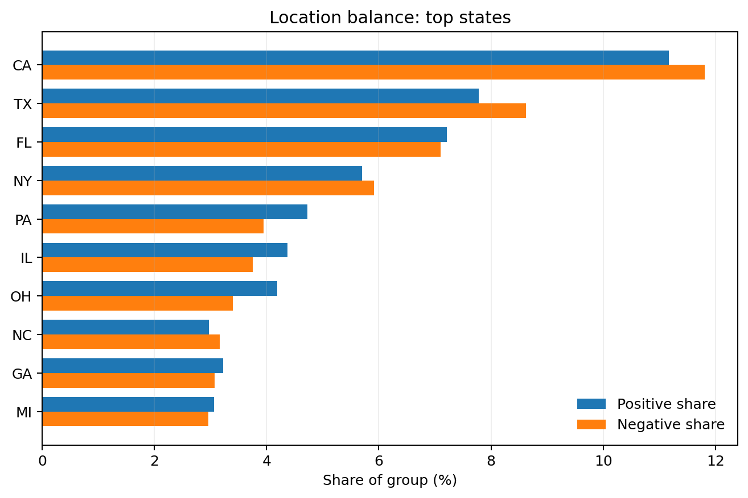
Figure 4. Positive and negative geographic shares for the ten highest-volume states.

Interpretation: High-volume states are broadly comparable in composition, with some localized differences. Representation ratio is descriptive sample composition only: ratio >1 means the state forms a larger share of positives than negatives in the analytical sample; it is not a population fraud rate.

12.2 Age balance
Age is calculated point-in-time from bc3.pers.birth_dte using the exact observation-date snapshot. All 688,589 parties match one pers record; no party has multiple birth dates at the observation date.
age_at_observation = floor(months_between(observation_date, birth_dte) / 12)
Age / pers QA | Negative | Positive
Parties | 625,990 | 62,599
Birth-date coverage | 97.591% | 99.984%
Missing birth_dte | 15,079 | 10
Multiple birth-date conflicts | 0 | 0

Age band | Positive N | Negative N | Positive share | Negative share | Representation ratio
<18 | 10 | 596 | 0.02% | 0.10% | 0.17
18-24 | 2,937 | 45,795 | 4.69% | 7.32% | 0.64
25-34 | 9,203 | 104,094 | 14.70% | 16.63% | 0.88
35-44 | 9,897 | 101,761 | 15.81% | 16.26% | 0.97
45-54 | 10,178 | 89,776 | 16.26% | 14.34% | 1.13
55-64 | 11,968 | 92,448 | 19.12% | 14.77% | 1.29
65-74 | 11,946 | 81,122 | 19.08% | 12.96% | 1.47
75+ | 6,450 | 95,319 | 10.30% | 15.23% | 0.68
Missing birth date | 10 | 15,079 | 0.02% | 2.41% | 0.01
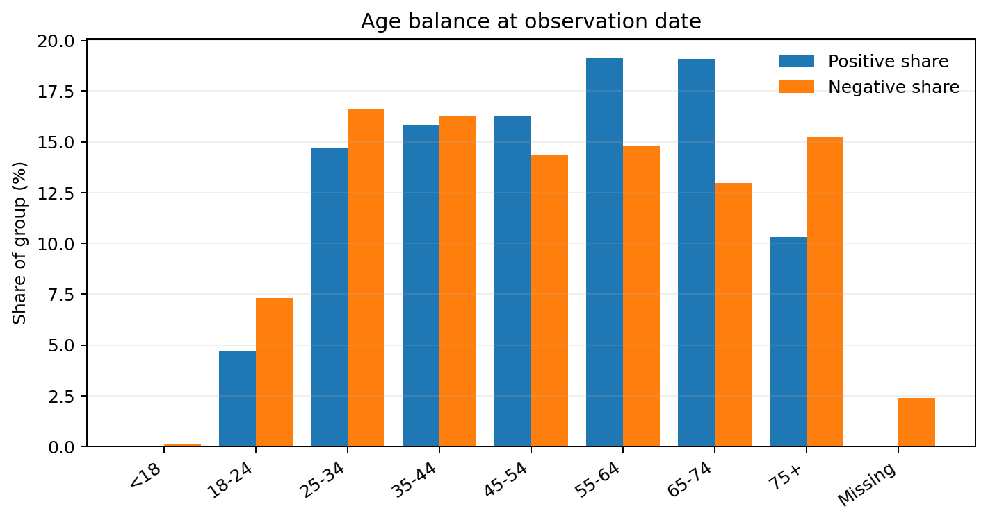
Figure 5. Positive and negative age composition at the point-in-time observation date.

Age summary | Negative | Positive
Mean age | 51.99 | 52.63
Median age | 51 | 54
P25 | 35 | 38
P75 | 67 | 67
Overall standardized mean difference | — | 0.0336

Observation year | Positive mean age | Negative mean age | Mean difference | SMD
2022 | 50.09 | 53.53 | -3.44 | -0.181
2023 | 52.24 | 52.13 | +0.10 | 0.005
2024 | 55.44 | 51.73 | +3.70 | 0.201
2025 | 50.36 | 50.70 | -0.34 | -0.018

Interpretation: Overall mean age is well balanced (SMD 0.034), but yearly composition is not uniform: 2024 shows the largest positive-negative age difference. Birth-date availability is also asymmetric (99.98% positive vs 97.59% negative), so the missingness itself should be documented.

12.3 Product balance
Product balance is summarized using product breadth (number of distinct product/account categories observed). This is a direct positive-versus-negative composition check and complements the separate account-type profile.
Product breadth | Positive N | Negative N | Positive share | Negative share | Representation ratio | Sample positive rate
0 | 1 | 69 | 0.00% | 0.01% | 0.14 | 1.43%
1 | 1,984 | 119,031 | 3.17% | 19.01% | 0.17 | 1.64%
2 | 5,030 | 86,735 | 8.04% | 13.86% | 0.58 | 5.48%
3 | 8,090 | 90,470 | 12.92% | 14.45% | 0.89 | 8.21%
4 | 10,547 | 91,472 | 16.85% | 14.61% | 1.15 | 10.34%
5+ | 36,947 | 238,213 | 59.02% | 38.05% | 1.55 | 13.43%
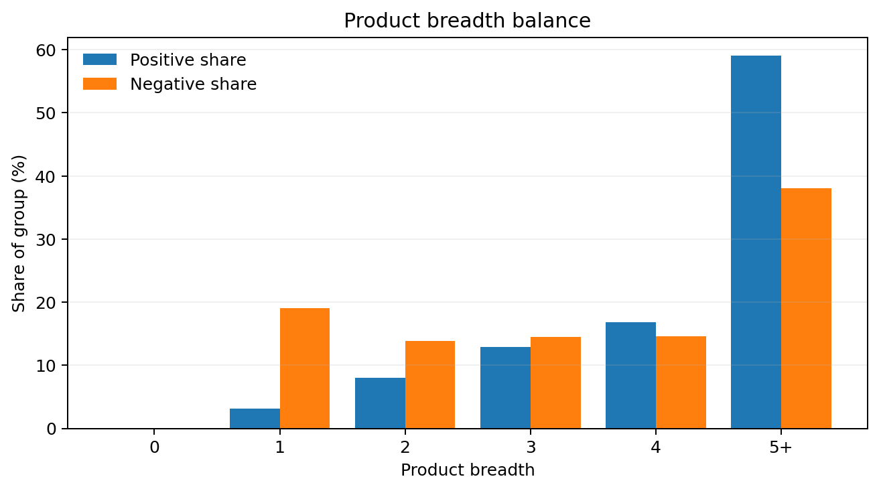
Figure 6. Product-breadth composition differs materially between positive and negative observations.

Interpretation: Positives are disproportionately concentrated among parties with broader product exposure: the 5+ product group contains about 59% of positives versus about 38% of negatives. This is descriptive of the analytical sample and should not be interpreted causally.

12.4 Credit Age validation
Credit Age is a validation-only diagnostic. It is not a current model input. It is defined from the oldest observable trade opening date available in the observation-date point-in-time trade snapshot.
credit_age_months = floor(months_between(observation_date, min(open_dte at M0)))
Credit Age validation | Negative | Positive
Parties | 625,990 | 62,599
Parties with Credit Age | 625,959 | 62,599
Missing Credit Age | 31 | 0
Coverage | 99.995% | 100.000%
Mean Credit Age (months) | 203.96 | 248.21
Median Credit Age (months) | 176 | 231
P25 / P75 | 99 / 279 | 140 / 336
P95 | 471 | 502
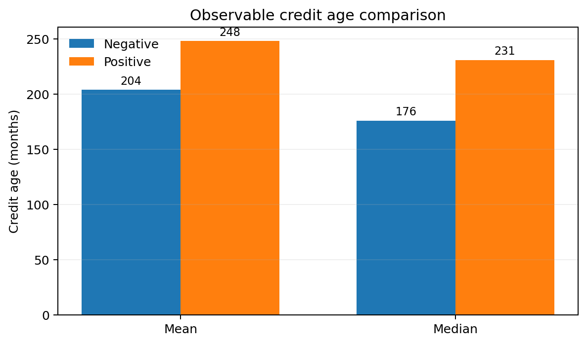
Figure 7. Positives have older observable credit files on average and at the median; Credit Age is a validation diagnostic only.

Balance statistic | Result
Mean difference | 44.24 months (positives older)
Pooled SD | 139.13 months
Standardized mean difference | 0.318
Positive observation-date x exact-credit-age strata | 21,839
Supported strata | 21,516
Unsupported strata | 323
Positives with exact negative support | 62,244 / 62,599 = 99.43%
Positives without exact negative support | 355 / 62,599 = 0.57%

Interpretation: Credit Age has very strong overlap but is not distributionally balanced. Nearly every positive has a negative comparator at the same observation date and exact Credit Age month (99.43%), yet positives have materially older observable credit files overall (SMD 0.318). No re-matching or reweighting is applied in the current database; this remains a documented cohort-balance diagnostic.

12.5 Requested dimensions that are not available
Dimension | Status | Treatment
Gender | Unavailable | No validated gender field exists in the current source set. Do not infer or proxy it.
Income | Unavailable | No validated income field exists in the current source set. Do not infer or proxy it.

12.6 Deliverable double-check
Requested deliverable | Where / status in revised document
Which tables were used and why | Included: source table inventory plus derived lineage and grain.
What variable is used as label | Included: label_3m definition and future 3-month horizon.
Timeframe | Included: Jan-2022 to Dec-2025 observation coverage, 13 technical months, 12 feature months and 3-month outcome horizon.
Variables | Included: final Model A / Model B inventory with exact database names.
Any treatment applied | Included: point-in-time filtering, MOP normalization, window aggregation, availability handling, coalescing, log transform, Z eligibility and frozen caps.
All formulas | Included: complete formula dictionary for every final Model A / Model B field plus upstream monthly and validation formulas.
Balance validations | Included with tables and charts for location, age, product breadth and Credit Age; yearly sample balance also visualized.
Gender / income | Not available in validated source set; explicitly documented as unavailable rather than inferred.
How tenure was defined | Included: operational tenure requirement is the 12-month behavioral lookback = 9-month PRIOR + 3-month RECENT; separate SEED month supports transitions. data_date is not customer tenure.
Credit Age validation | Included: oldest observable open_dte at M0, 99.995% negative / 100% positive coverage, SMD 0.318 and 99.43% exact same-month negative support.
Clear instructions to rebuild in Shape | Included: source/derived lineage, dependency-ordered rebuild sequence, QA gates and expected row counts. Remaining caveat: reconstructed upstream SQL must be reconciled with original Shape code before a production-exact handoff.

13. Limitations and interpretation guardrails
- The target is an observed qualifying alert, not confirmed fraud loss or confirmed victimization.
- The 1:10 analytical sample changes class prevalence; sample positive rates are not population prevalence estimates.
- True customer tenure is not recoverable from the validated sources. bc3.person_restricted.data_date measures source-history availability and is left-censored.
- The 12-month history is a modeling lookback design, not customer tenure.
- Age has asymmetric birth-date availability (99.98% positive vs 97.59% negative); this should remain visible in reporting.
- Credit Age shows strong common support but a material distribution difference (SMD about 0.318). It is a validation diagnostic, not a current model feature.
- Location and product representation ratios describe sample composition only and must not be described as state/product fraud prevalence.
- Availability and coverage variables are themselves informative and likely capture observability/file depth in addition to behavior.
- Where exact low-level upstream SQL predicates were not preserved verbatim, the reconstructed SQL must be reconciled with original Shape code before declaring the rebuild production-exact.

14. Reproducibility acceptance checklist
Acceptance item | Complete
Outcome table built from qualifying alert logic | [ ]
Observation cohort contains 688,589 unique parties | [ ]
Positive / negative counts equal 62,599 / 625,990 | [ ]
13 technical month keys created per observation | [ ]
12 final feature months per party after SEED exclusion | [ ]
Point-in-time future-date QA returns zero violations | [ ]
MOP transition and monthly logical QA passes | [ ]
Utilization universe reconciliation passes | [ ]
Current / transformed / selected-Z feature tables created | [ ]
Final analytical table has no unresolved model-feature NULLs | [ ]
Location match uses exact observation date + addr_seq_num=1 | [ ]
Age match uses exact observation date in bc3.pers | [ ]
Credit Age uses oldest open_dte at the M0 PIT snapshot | [ ]
Balance results reconcile to documented counts | [ ]
Reconstructed SQL blocks reconciled with original Shape code | [ ]

Appendix A. Core raw trade column inventory
Column | Classification | Role
party_id | CORE | Join key / party grain
trades_seq_num | Context / source
acct_id | CORE | Account grain
acct_num | Context / source
acct_typ_cde | CORE | Product/account type
agcy_id_cde | Context / source
bloon_payt_amt | Context / source
bloon_payt_due_dte | Context / source
crdtr_cls_cde | Context / source
defr_payt_strt_dte | Context / source
ecoa_cde | Context / source
end_dte | Context / source
erl_maxdlq_rte_dte | Context / source
erl_mxdlq_psdu_amt | Context / source
inp_seg_src_cde | Context / source
kob_posn_1_cde | CORE | Product/business context
kob_posn_2_cde | CORE | Product/business context
legis_prhib_cde | Context / source
max_delq_amt | Context / source
max_delq_dte | Context / source
max_delq_rte_cde | Context / source
mortg_id_num | Context / source
open_dte | CORE | Credit Age validation / trade age
orgn_chrg_off_amt | Context / source
orgn_cint_nme | Context / source
payt_schd_mth_cnt | Context / source
porf_sale_ind_cde | Context / source
port_sale_nme | Context / source
porf_typ_cde | Context / source
rem_frst_rpt_dte | Context / source
rsub_base_cde | Context / source
rsub_sfx_cde | Context / source
scnd_agcy_acct_num | Context / source
terms_freq_cde | Context / source
acct_mop_cde | CORE | MOP status / transitions
affil_rem_cde | Context / source
clsd_dte | CORE | Active-account logic input
cmpinc_rem_cde | Context / source
cmplrem_frsrpt_dte | Context / source
cr_lmt_amt | CORE | Utilization denominator
curr_bal_amt | CORE | Balance / utilization numerator
eff_dte | CORE | Point-in-time validation
gnre_rem_cde | Context / source
gnrcrem_frsrpt_dte | Context / source
high_cr_amt | CORE | Credit context
paid_out_dte | CORE | Account status context
past_due_amt | CORE | Past-due behavior
payt_amt | Context / source
payt_dte | Context / source
payt_due_amt | Context / source
payt_pttrn_txt | Context / source
payt_typ_cde | Context / source
rte_rem_cde | Context / source
rte_rem_frsrpt_dte | Context / source
acct_verf_cde | Context / source
acct_rte_prfl_cde | Context / source
end_dte_age | Context / source
rem_frst_rpt_dte_age | Context / source
open_dte_age | Context / source
defr_payt_strt_dte_age | Context / source
bloon_payt_strt_dte_age | Context / source
max_delq_dte_age | Context / source
erl_max_delq_rte_dte_age | Context / source
eff_dte_age | Context / source
cmpl_rem_frst_rpt_dte_age | Context / source
gnrc_rem_frst_rpt_dte_age | Context / source
rte_rem_frst_rpt_dte_age | Context / source
cls_dte_age | Context / source
paid_out_dte_age | Context / source
payt_dte_age | Context / source
frst_delq_dte | Context / source
frst_rpt_dte | Context / source
acat_upd_tsp | Context / source
frst_rpt_dte_age | Context / source
frst_delq_dte_age | Context / source
acat_upd_tsp_age | Context / source
acat_upd_tsp_age_dys | Context / source
data_date | CORE | Snapshot / PIT date

Appendix B. MOP mapping
MOP | Normalized interpretation
01 | Current
02 | 30 DPD
03 | 60 DPD
04 | 90 DPD
05 | 120+ DPD
06 | 150+ DPD
8A | Surrender
8B | Repossession
8P | Paid - was repossession
09 | Charge-off
9B | Collection
9P | Paid collection / charge-off
UR | Unrated
07 / 08 | Undefined / unknown / other; no unsupported severity order imposed

Appendix C. Final Model A / Model B feature inventory
Feature set | Feature
Model A | deterioration_acceleration
Model A | adverse_acceleration
Model A | max_dpd_jump_recent_3m
Model A | active_accounts_change_vs_baseline
Model A | active_accounts_changed_flag
Model A | balance_change_model
Model A | log1p_abs_balance_change_model
Model A | balance_change_available_flag
Model A | balance_recent_months_available
Model A | balance_prior_months_available
Model A | past_due_change_model
Model A | past_due_change_available_flag
Model A | past_due_recent_months_available
Model A | past_due_prior_months_available
Model A | delinquency_share_change_model
Model A | delinquency_change_available_flag
Model A | delinquency_recent_months_available
Model A | delinquency_prior_months_available
Model A | avg_utilization_change_model
Model A | weighted_utilization_change_model
Model A | utilization_change_available_flag
Model A | utilization_recent_months_available
Model A | utilization_prior_months_available
Model B incremental | active_accounts_z_model
Model B incremental | active_accounts_z_available_flag
Model B incremental | avg_utilization_z_model
Model B incremental | avg_utilization_z_available_flag
Model B incremental | weighted_utilization_z_model
Model B incremental | weighted_utilization_z_available_flag

Appendix D. Key query logic for descriptive enrichments
These snippets capture the validated join/calculation rules used for the new balance validations. They are intentionally short; full execution SQL should remain in the project SQL repository / Shape notebook.

Primary location at observation date
ON f.party_id = p.party_id
AND p.data_date = f.observation_date
AND p.addr_seq_num = 1

Age at observation
ON f.party_id = p.party_id
AND p.data_date = f.observation_date
age_at_observation = FLOOR(MONTHS_BETWEEN(f.observation_date, p.birth_dte) / 12)

Credit Age validation
M0 snapshot only
earliest_open_dte = MIN(open_dte) where open_dte <= observation_date
credit_age_months = FLOOR(MONTHS_BETWEEN(observation_date, earliest_open_dte))

Representation ratio
representation_ratio = (% of positives in stratum) / (% of negatives in stratum)
End state: A successful rebuild should reproduce the documented table lineage, final population counts, point-in-time QA, 12-month behavioral panel, every final feature formula, feature-behavior diagnostics, and the location/age/product/credit-age balance validations shown in this document.

