

**<<ONLINE SHOPPING>>**

**Software Requirement Specification**

– Ho Chi Minh, May 2021 –

Table of Contents

**I.Overview4**

1) Introduction4

2) System Function5

a. Screen Flow5

b. Screen Detail5

c. Authorization Table8

d. Non-screen functions12

3) Common Requirements12

**II.Functional Requirements13**

1) Common Features13

a. Authentication13

b. Authorization13

c. User Register14

d. Update user's profile15

e. Change Password15

f. Reset Password16

2) Public Features17

a. Get a list of available products17

b. Get a product’s detail17

c. Get a list of Blogs17

d. Get a Blog’s detail18

3) Customer Features18

a. Create a new order18

b. Cancel an order19

c. Get a list of User’s orders20

d. Get an order’s detail20

4) Marketing Features21

a. Add a new product21

b. Update a product21

c. Add a new Post22

d. Update a post23

e. Get a list of Sliders24

f. Add new post to slider 25

g. Remove post from slider25

h. Get a list of Customer accounts26

i. Get a Customer details26

j. Get Marketing statistic26

5) Sale Features27

a. Get a list of of all orders27

b. Get an order’s detail27

c. Change status of an assigned order28

d. View Sale statistic29

6) Admin Features29

a. Add new account29

b. Get a list of all user account29

c. Get a user account’s detail30

d. Activate/Deactivate a user account30

e. View Admin statistic31

# I.Overview

## 1) Introduction

Nowadays, the Internet is playing an important role in our society, together with the Internet-connected devices. As a matter of fact,the Online Market has grown remarkably in recent years, the number of Brands started to sell on the Internet has grown remarkably. Despite that the internet is virtual, it helps a lot of brands to mark up the market share and helps the customer to approach the product much easier instead of going to the retail office.

Our project is developed for an online shopping system - web which supports a shop or a chain of stores to manage, market and sell merchandise on the Internet. In our supposed system, there are 6 authenticated types of user:

a. Guest: Unregistered Users.

b. Customer: Registered Users, who can be actual customers or can be potential customers.

c. Marketing: Marketing Staff who are in the Marketing Department.

d. Sale: Sale members who are in the Sales Department.

e. Admin: the manager who acts as the administrator and monitoring the whole system.

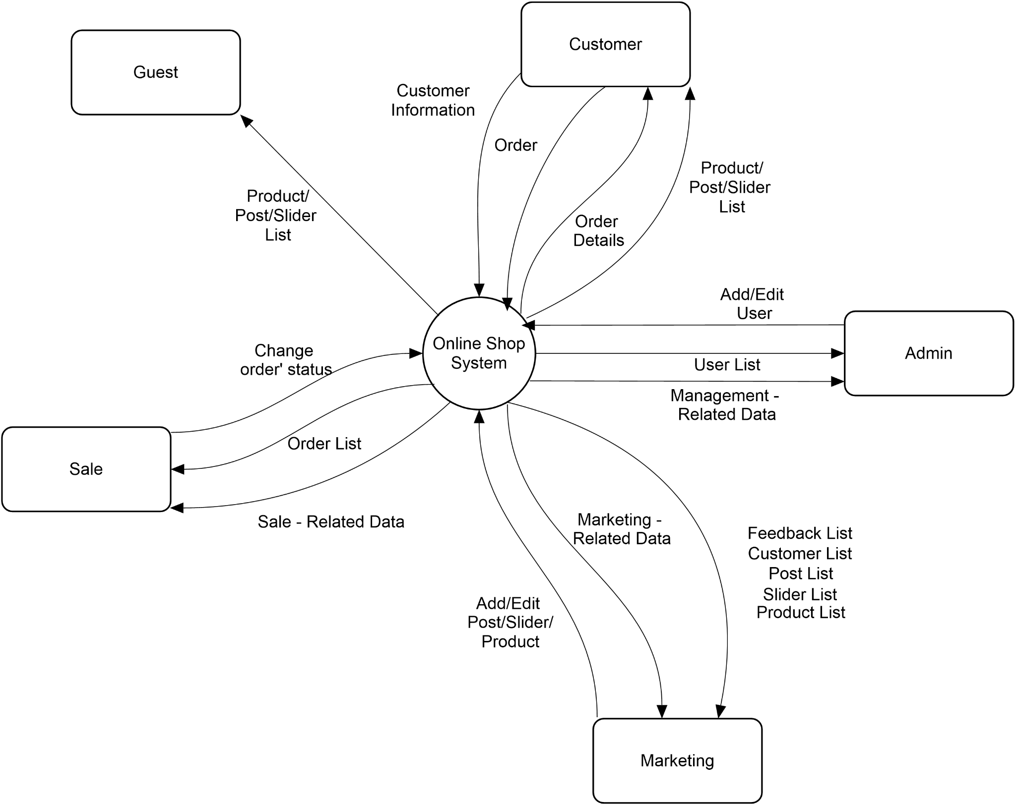

## 2) System Function

### a) Screen Flow

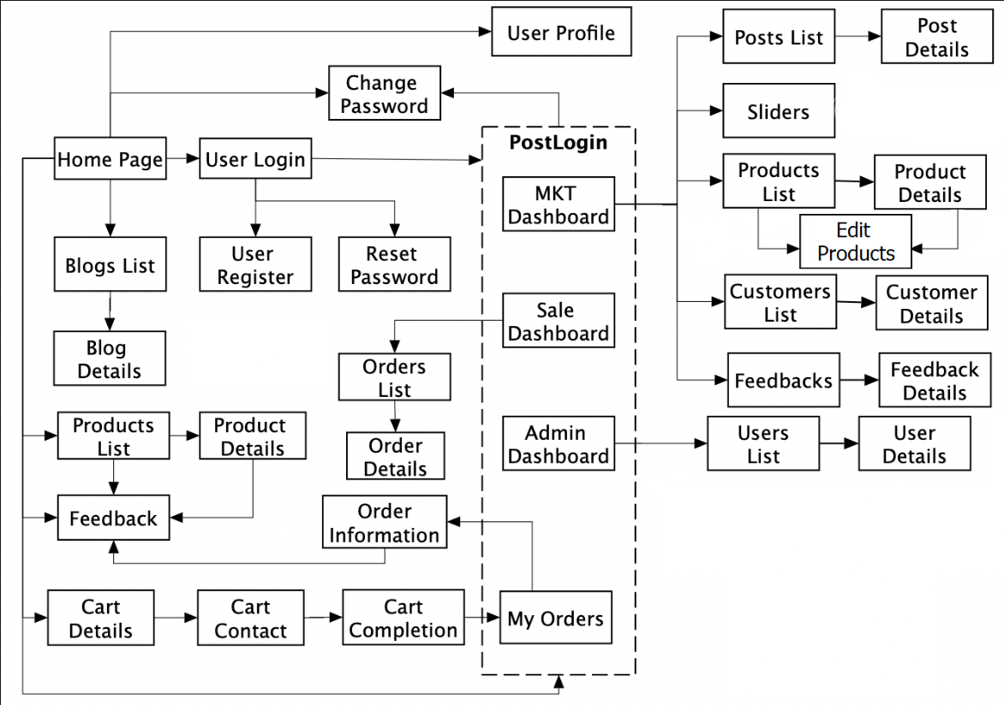

### b) Screen Detail

|  |  |  |  |
| --- | --- | --- | --- |
| No. | Feature | Screen | Description |
| 1 | Starting Page | Home Page | -Show sliders, hot posts, featured products + the sider with the latest posts, static contacts/links  -Show slider, post, product information |
| 2 | Show Shared Post List | Blog List | -Show the posts in pages + the sider with the post search box, post categories, the latest posts, and static contacts/links  -Show post information |
| 3 | Show details of the selected Shared Post | Blog Details | -Show post details + the sider with the post search box, post categories, static contacts/links |
| 4 | Show Active Products List | Product Lists | -Show the products in pages + the sider with the product search box, product categories, the latest products, and static contacts/links;  -Show product information |
| 5 | Show details of the selected Product | Product Details | -Show product details + the sider with the product search box, product categories, the latest products, and static contacts/links |
| 6 | Show details of the user carts | Cart Details | -Show the cart details with list of the user's chosen products and the total order price + the sider with the product search box, product categories, the latest products, and static contacts/links  -The user can edit Cart |
| 7 | Edit Order receiver information | Cart Contact | -Show the list of user chosen product, the total order price and the receiver information + the sider with the product search box, product categories, the latest products, and static contacts/links  - Users can edit/change the receiver information and submit orders. |
| 8 | Order Completion Confirmation | Cart Completion | -This page show the cart completion notes + the sider with the product search box, product categories, the latest products, and static contacts/links  - The customer/user would receive the order confirmation via his/her phone number. |
| 9 | Login to system | User Login | -This is a pop-up screen which allows the user to enter email & password to login |
| 10 | Register new user into the System | User Register | -This is a pop-up screen which allows the user to register to the system |
| 11 | Reset User Password incase User forget it | Reset Password | -The user to can request to reset his/her password. The system will auto generate a new password and send to the user via their phone number. |
| 12 | Change User Password | Change Password | -This is a pop-up screen which allows the user to change password |
| 13 | View & Edit User Profile | User Profile | -This is a pop-up screen which allows the user to edit profile information |
| 14 | View Summited Orders | My Orders | -Show the list of user's orders in pages + the sider with the product search box, product categories, the latest products, and static contacts/links |
| 15 | View User’ Orders Details | Order Information | -Show the order details + the sider with the product search box, product categories, the latest products, and static contacts/links |
| 16 | View Marketing Related Data | MKT Dashboard | -Show statistics of posts, products, customers & the trend of new customers |
| 17 | View & Edit existing Posts | MKT Post List | -Show the paginated list of posts  -Marketing can edit or add new posts |
| 18 | View & Edit Details of existing Posts | MKT Post Details | -Show detailed post information  -Marketing can edit detail of each post |
| 19 | View & Edit existing Sliders | MKT Sliders | -Show the paginated list of sliders  -Marketing can add new or remove Sliders |
| 20 | View & Edit existing Products | MKT Product List | -Show the paginated list of products  -Marketing can edit or add new Products |
| 21 | View & Edit Details of existing Products | MKT Products Details | -Show detailed product information  -Marketing can edit detail of each product |
| 22 | View existing Customers | MKT Customer List | -Show the paginated list of customers / contacts. |
| 23 | View Details of existing Customers | MKT Customer Details | -Show detailed customer/contact information |
| 24 | View Sale - related Data | Sale Dashboard | -Show the trend of success/total orders, and the revenues trends |
| 25 | View existing Orders | Sale Orders List | -Show the list of orders paginated |
| 26 | View & Edit the Status of existing assigned Orders | Sale Order Details | -Show the order details  -Sale can change the status of their assigned order |
| 27 | View Management - related Data | Admin Dashboard | -Show statistics of new orders, revenues, customers & the trend of order counts |
| 28 | View existing Users | User List | -Show the paginated list of registered users  -From each user, the admin can choose to view its details  -The admin can create a new user account. |
| 29 | View & Edit Details of existing Users | User Details | -Show detailed user information  -The Admin can update user’s status |

### c) Authorization Table

|  |  |  |  |  |  |
| --- | --- | --- | --- | --- | --- |
| Screen | Guest | Customer | Sale | Marketing | Admin |
| Home Page | X | X |  |  |  |
| Blog List | X | X |  |  |  |
| Blog Details | X | X |  |  |  |
| Product Lists | X | X |  |  |  |
| Product Details | X | X |  |  |  |
| Cart Details |  | X |  |  |  |
| - Edit Cart |  | X |  |  |  |
| Cart Contact |  | X |  |  |  |
| - Change receiver information |  | X |  |  |  |
| - Submit order |  | X |  |  |  |
| Cart Completion |  | X |  |  |  |
| User login | X |  |  |  |  |
| User Register | X |  |  |  |  |
| Change Password |  | X | X | X | X |
| Reset Password |  | X | X | X | X |
| User profile |  | X | X | X | X |
| - Update user’s profile |  | X | X | X | X |
| My Orders |  | X |  |  |  |
| Order Information |  | X |  |  |  |
| Marketing Dashboard |  |  |  | X |  |
| - View Marketing data |  |  |  | X |  |
| Marketing Post List |  |  |  | X |  |
| - View Post List |  |  |  | X |  |
| - Add new post |  |  |  | X |  |
| Marketing Post Details |  |  |  | X |  |
| - View post details |  |  |  | X |  |
| - Update post details |  |  |  | X |  |
| Marketing Slider |  |  |  | X |  |
| - View all existing slider |  |  |  | X |  |
| - Add / remove a post from slider |  |  |  | X |  |
| Marketing Product List |  |  |  | X |  |
| - View product list |  |  |  | X |  |
| - Add a new product |  |  |  | X |  |
| Marketing Product details |  |  |  | X |  |
| - View product details |  |  |  | X |  |
| - Update product details |  |  |  | X |  |
| Marketing Customer List |  |  |  | X |  |
| - View customer list |  |  |  | X |  |
| Marketing Customer details |  |  |  | X |  |
| - View customer’s details |  |  |  | X |  |
| - Update customer’s details |  |  |  | X |  |
| Sale Dashboard |  |  | X |  |  |
| - View the trend of success/total orders, and the revenues trends |  |  | X |  |  |
| Sale Orders List |  |  | X |  |  |
| - View assigned orders |  |  | X |  |  |
| - View all orders |  |  | X |  |  |
| Sale Orders Details |  |  | X |  |  |
| - View assigned order’s details |  |  | X |  |  |
| - View all order’s details |  |  | X |  |  |
| - Update assigned order’s status |  |  | X |  |  |
| Admin Dashboard |  |  |  |  | X |
| - View statistics of new orders, revenues, customers & the trend of order counts |  |  |  |  | X |
| User List |  |  |  |  | X |
| - View user list |  |  |  |  | X |
| User Details |  |  |  |  | X |
| - View user’s details |  |  |  |  | X |
| - Update User’s status |  |  |  |  | X |
| Error Page | X | X | X | X | X |
| - Navigate to corresponding home page / dashboard | X | X | X | X | X |

### d) Non-screen functions

|  |  |  |
| --- | --- | --- |
| No. | Feature | Description |
| 1 | User Authentication | The function is used to determine whether one user exists and be able to access the resources on the system or not. |
| 2 | User Authorization | The function is used to check the user’s role before redirecting them to an appropriate dashboard so that they can access appropriate resources on the system. |

## 

## 3) Common Requirement

* Users need to login to make an order
* Users can cancel orders that are not yet confirmed by Sale.
* The order will be automatically assigned to the salesperson with the least assigned orders at that moment.
* User’s password will be encrypted.

# II. Functional requirements

## 1. Common Features

### a. Authenticate

- Function trigger: The function is triggered when the user clicks on the “Login” button

- Function description: The function is used to determine whether one user’s record exists in the database and be able to access the system or not.

- Function detail

+Data validation:

o Email field: email inputted must exist in and match with the corresponding email in the database

o Password field: password inputted must match with the corresponding password in database

o The user has to complete the captcha

· +Data processing: After the user requests login, the system will check the captcha. If the user did it correctly, the system will then check the email and password entered with the email and password in the system’s user data. If the entered information exists and matches the data in the system then the user is a member of the system and lets them log in. Otherwise, the user is not a member of the system and it will show an incorrect login error. After login the system has yet to determine the role of the user and what they have access to so the system will call the authorization function.

### 

### b. Authorize

- Function trigger: This function is triggered after the system has authenticated the user successfully.

- Function description: The function is used to check the user’s role before redirecting them to an appropriate dashboard so that they can access appropriate resources on the system.

- Function details

· +Data validation: N/A

· +Data processing: After authenticated successfully, the system will query for the user’s role in the database. Then, the user will be redirected to the corresponding dashboard page.

### 

### c. Register a User

- Function trigger: The function is triggered when the user requests to register an account.

- Function description: The function is used to create a new customer record in the database.

- Function details:

· +Data validation:

o Email field: the input data must meet the following regular expression

“^[a-zA-Z0-9_!#$%&’*+/=?`{|}~^.-]+@[a-zA-Z0-9.-]+$”.

o Password field: the input data must have the length between 8-20 characters.

o Repeat password field: The input data must match the data in the “Password” field

o Full name: the input data must contain no digit and special character. Its length is between 6-50 characters.

o Gender must be chosen from 3 following options: Male, Female and Not Specified.

o Address field: the input data must be between 10-100 characters.

o Phone number: the input data must be 10-12 digits long.

· +Data processing: After the user requests to register an account, the system will then validate the input data. If the inputs are valid, they will be redirected to the Customer Dashboard page and a new customer record will be created in the database. Otherwise, the user will stay on the Register page, the account won’t be created and error messages will be shown.

### 

### d. Update user's profile

- Function trigger: The function is triggered when the user request to update their profile

- Function description: The function is used to view and edit a user's information, validating it before updating the existing corresponding record in the database.

- Function details

· +Data validation:

o Email field cannot be edited.

o Password field cannot be edited in this function. It can only be changed in the “Change Password” function.

o Full name field: the input data must contain no digit and special character. Its length is between 6-50 characters.

o Gender must be chosen from 3 following options: Male, Female and Not Specified.

o Address field: the input data must be between 10-100 characters.

o Phone number field: the input data must be 10-12 digits long.

· +Data processing:After the user requests updating the profile, the system will validate the input data. If the data validated successfully, the system will update the corresponding record in the database with the new data. Otherwise, the user will stay on the current screen and error messages will be shown.

### 

### e. Change Password

- Function trigger: The function is triggered when the user requests to change their password.

- Function description: The function is used to allow a user to change his/her account’s password

- Function details

· +Data validation:

o Current Password: the input data must match the current password.

o New Password field: the input data must have the length between 8-20 characters.

o Repeat new password field: the input data must match the data in the “New password” field

· +Data processing: When a user clicks on the “Update” button, the system will validate the input data. If the data validated successfully, the system will update the corresponding record in the database with the new data. Otherwise, the user will stay on the current screen and error messages will be shown.

### 

### f. Reset Password

- Function trigger: The function is triggered when the user request to reset their password

- Function description: The function is used to allow a user to reset his/her account’s password in case they forget it. The system will send the newly generated password to the user's phone number, so that they can log in and change their password to their desired one.

- Function details

· +Data validation: N/A

· +Data processing: When the user requests to reset their password. The system will then generate a new password for the user account and then send it to the user phone number. After receiving the new password the user can use the new password to login to their account and then later on change their password to their desired one through the “Change Password” function.

## 

## 2. Public Features

### a. Get a list of available products

- Function trigger: The function is triggered when the user requests to view all products

- Function description: The function is used to query the database and get all of the available products and display it on the screen. The system will show a picture, original price, sale price (if any) and name of the product.

- Function details

· +Data validation: N/A

· +Data processing: The system will query the database for all available products and display it on the screen, 15 records per page.

### b. Get a product’s detail

- Function trigger: The function is triggered when customer clicks on a specific product in the list displayed on the screen

- Function description: The function is used to query for detailed information of the specific product from the database before displaying it on the screen. The system will show a picture, original price, sale price (if any), description and name of the product.

- Function details

· +Data validation: N/A

+Data processing: The system will query the database for all detailed information of a specific product before displaying it on the screen.

### 

### c. Get a list of Blogs

- Function trigger: The function is triggered when a user requests to view all blogs.

- Function description: The function is used to query the database and get all of the available Blogs and display it on the screen. The system will display a thumbnail, title and a short description of the blog.

- Function details

· +Data validation: N/A

· +Data processing: The system will query the database for all public blogs and display it on the screen, 10 records per page.

### d. Get a Blog’s detail

- Function trigger: The function is triggered when a customer clicks on a specific Thumbnail of a Blog.

- Function description: The function is used to query for detailed information of the specific blog from the database before displaying it on the screen. The system will display the thumbnail, title and full description of the blog.

- Function details

· +Data validation: N/A

+Data processing: The system will query the database for all detailed information of a specific blog before displaying it.

## 3. Customer Features

### a. Create a new order

- Function trigger: The function is triggered when a customer clicks on the “Order” button on the Cart Contact screen. If the user is not logged in, the Login page will pop-up and require the user to login.

- Function description: The function is used to create a new order record in the database.

- Function details

· +Data validation:

o The cart must not be empty (must have at least 1 product in it with quantity > 0).

o Receiver name field: the input data must contain no digit and special character. the input data must be between 6-50 characters.. If the user is logged in, the default input data is the user’s Full name.

o Phone number field: the input data must be 10-12 digits long. If the user is logged in, the default input data is the user’s phone number.

o Address field: the input data must be between 10-100 characters. If the user is logged in, the default input data is the user’s address.

· +Data processing: After the user requests to order, the system will validate the input information. If the input is valid, the system will create a new order record in the database with “Unconfirmed” status. Otherwise, the user will stay on the current screen and error messages will be shown.

### b. Cancel an order

- Function trigger: The function is triggered when a customer requests to cancel the submitted order given it hasn’t been confirmed by the salesperson.

- Function description: The function is used to update the status of the corresponding order record from the database when the user confirms to perform the action.

- Function details

· +Data validation:

o The user clicks on the “Yes” button on the pop-up window.

o The Order’s status is “Unconfirmed”.

· +Data processing: The system will verify the user choice. If the user chooses “Yes'' and The Order’s status is “Unconfirmed” , the system will then update the status of the corresponding order record in the database to “Canceled”. Otherwise, the system would show the user the error message.

### 

### 

### c. Get a list of User’s orders

- Function trigger: The function is triggered when a customer requests to view his/her submitted orders.

- Function description: The function is used to query for a list of submitted orders created by the corresponding customer from the database and display it on the screen. The system will show the order’s Date, total Price and Status.

- Function details

· +Data validation: N/A

· +Data processing: The system will query the database for the order that belongs to the corresponding user and display it on the screen, 10 records per page.

### 

### d. Get an order’s detail

- Function trigger: The function is triggered when customer clicks on a specific order in the list displayed on the screen.

- Function description: The function is used to query for detailed information of a specific order which belongs to the corresponding user from the database. The system will display the products and their thumbnails, quantity along with the Date, total price and status of the order.

- Function details

· +Data validation: N/A

· +Data processing: The system will query the database for all detailed information of a specific order before displaying it on the screen.

## 

## 4. Marketing Features

### a. Add a new product

- Function trigger: The function is triggered when Marketing people request to add a new product.

- Function description: The function is used to create a new product record in the database.

- Function details:

· +Data validation:

o The Price field: the input data must be a number and it must be greater than 0 and smaller than 10000000 (Unit is Viet Nam Dong).

o The Name field: the input data must contain character and/or digit. No special character is allowed. Its length must be between 5-50 characters.

o The Image field: the user must upload an image of the product.

o The “Category” field: user must choose from one of the existing categories.

o The Description field: the input data must be between 10-200 characters.

o The field “Status” must be chosen from the following status: On/Off

o The “Sale” box is optional. If it is checked, the field “Sale Price” will appear, the input data must be a number greater than 0 but lower than the “Price” field’s input.

· +Data processing: If the input values are valid, the system will create a new product record in the database. Otherwise, the user will stay on the current screen and error messages will be shown.

### b. Update a product

- Function trigger: The function is triggered when the marketing person requests to update the details of the product.

- Function description: The function is used to validate the input information before updating the existing information of a specific product in the database.

- Function details:

· +Data validation:

o The Price field: the input data must be a number and it must be greater than 0 and smaller than 10000000 (Unit is Viet Nam Dong).

o The Name field: the input data must contain character and/or digit. No special character is allowed. Its length must be between 5-50 characters.

o The Image field: the user must upload an image of the product.

o The “Category” field: user must choose from one of the existing categories.

o The Description field: the input data must be between 10-200 characters.

o The field “Status” must be chosen from the following status: On/Off

o The “Sale” box is optional. If it is checked, the field “Sale Price” will appear, the input data must be a number greater than 0 but lower than the “Sale” field’s input.

· +Data processing: If the input values are valid, the system will update details of the corresponding product record in the database with the new data. Otherwise, the user will stay on the current screen and error messages will be shown.

## 

### c. Add a new post

- Function trigger: The function is triggered when Marketing people request to add a new post.

- Function description: The function is used to create a new post record in the database.

- Function details:

· +Data validation:

o The “Title” field: the input data must contain character and/or digit. No special character is allowed. Its length must be between 5-150 characters.

o The “Thumbnail” field: the user must upload a thumbnail for the post.

o The “Category” field: user must choose from one of the existing categories (System news or Promotion news).

o The “Author” field: the default input is the user’s full name and it cannot be changed.

o The Description field: the input data must be between 50-1000 characters.

o The “Status” box is unchecked at default. If it is checked, the Post will be public and everyone with the link can see it. If not, the Post will be in private and only Marketing can see it.

o The “onSlider” box is unchecked at default and cannot be edited in this function. It can only be changed in the “Add new Post to Slider” or “Remove post from slider” function.

· +Data processing: If the input values are valid, the system will create a new record of the post in the database.Otherwise, the user will stay on the current screen and error messages will be shown.

### d. Update a post

- Function trigger: The function is triggered when Marketing people request to update the details of the post.

- Function description: The function is used to validate the input information before updating the existing information of a specific post in the database.

- Function details:

· +Data validation:

o The “Title” field: the input data must contain character and/or digit. No special character is allowed. Its length must be between 5-150 characters.

o The “Thumbnail” field: the user must upload a thumbnail for the post.

o The “Category” field: user must choose from one of the existing categories (System news or Promotion news).

o The “Author” field: the default input is the user’s full name and it cannot be changed.

o The Description field: the input data must be between 50-1000 characters.

o The “Status”: if it is checked, the Post will be public and everyone with the link can see it. If not, the Post will be in private and only Marketing can see it.

o The “onSlider” box cannot be edited in this function. It can only be changed in the “Add new Post to Slider” or “Remove post from slider” function.

· +Data processing: If the input values are valid, the system will update details of the corresponding post record in the database with the new data. Otherwise, the user will stay on the current screen and error messages will be shown.

### 

### e. Get a list of Sliders

- Function trigger: The function is triggered when Marketing people request to view all sliders.

- Function description: The function is used to get a list of posts that are featured on Sliders and display it on the screen. The system will show the post’s thumbnail, title and author.

- Function details:

· +Data validation: N/A

· +Data processing: The system will query the database for all featured posts and display it on the screen, 5 records per page.

### f. Add new post to slider

- Function trigger: The function is triggered when Marketing people request to add new posts to the slider list.

- Function description: The function is used to add new Post to the slider list.

- Function details:

· +Data validation:

o User can choose one of the existing Post to add to the slider list. The Post’s “status” field must be “Public” and the “onSlider” field must be “Off”.

o The current number of Sliders is less than 10.

o The user clicks on the “Yes” button on the pop-up window.

· +Data processing: The system will verify the user choice. If the user chooses “Yes'' and the number of sliders are less than 10 , the system will then update the “onSlider” field to “On”. Otherwise, the system would show the user the error message.

### g. Remove post from slider

- Function trigger: The function is triggered when Marketing people request to remove posts from the slider list.

- Function description: The function is used to remove posts from the slider list.

- Function details:

· +Data validation:

o The user clicks on the “Yes” button on the pop-up window.

· +Data processing: The system will verify the user choice. If the user chooses “Yes'', the system will then update the “onSlider” field to “Off”. Otherwise, the system would do nothing.

### 

### 

### h. Get a list of Customer accounts

- Function trigger: The function is triggered when the Marketing requests to view the list of all active customer accounts in the system.

- Function description: The function is used to query the database for a list of active customers in the system. The system will display the account’s id and email.

- Function details:

· +Data validation: N/A

· +Data processing: The system will query the database for a list of created users in the system, 15 records per page.

### i. Get a Customer details

- Function trigger: The function is triggered when marketing clicks on a specific customer account in the list displayed on the screen

- Function description: The function is used to query for detailed information of a specific customer account. The system will display the user id, full name, gender, email, mobile, role and status.

- Function details

· +Data validation: N/A

+Data processing: The system will query the database for all detailed information of a specific customer account before displaying it on the screen.

### j. Get Marketing statistic

* Function trigger: When the marketing employee login, they can view marketing statistics and chart on the Marketing dashboard.
* Function description: When a marketing employee login, the system will automatically query related data, calculate and display on the Marketing dashboard.
* Function detail:
* Data validation: N/A
* Data processing: Whenever a marketing person login, data will be fetched automatically from the database,stored , calculated and generate statistical records on screen. If errors occur, it will show a error message “Data could not be displayed at the moment”

## 

## 5. Sale Feature

### a. Get a list of of all orders

- Function trigger: The function is triggered when a Sale requests to view all orders.

- Function description: The function is used to query for a list of orders from the database and display it on the screen. The system will show the order’s “Email”, “Date”, and “Status”.

- Function details

· +Data validation: N/A

· +Data processing: The system will query the database for all orders and display it on the screen, 10 records per page.

### b. Get an order’s detail

- Function trigger: The function is triggered when sale clicks on a specific order in the list displayed on the screen.

- Function description: The function is used to query for detailed information of a specific order from the database. The system will display the products and their thumbnails, quantity along with the Date, total price and status of the order.

- Function details

· +Data validation: N/A

· +Data processing: The system will query the database for all detailed information of a specific order before displaying it on the screen.

### 

### c. Change status of an assigned order

- Function trigger: The function is triggered when Sale requests to change an Order's status.

- Function description: The function is used to update the status of the corresponding order record from the database.

- Function details

· +Data validation:

o The order is assigned to that Sale.

o Sale clicks on the “Yes” button on the pop-up window.

· +Data processing: The system will verify the user choice. If the user chooses “Yes”, the system will then update the status of the corresponding order record in the database. Otherwise, the system would do nothing.

### d. View Sale statistic

- Function trigger: When the Sale employee login, they can view marketing statistics and chart on the Sale dashboard

- Function description: The function is used to query the database for a list of sale related data, calculate and the this display the result on the Sale dashboard

- Function details:

· +Data validation: N/A

· +Data processing: Whenever a Sale login, data will be fetched automatically from the database, stored , calculated and generate statistical records on screen. If errors occur, it will show a error message “Data could not be displayed at the moment”

## 

## 6. Admin’s Account management

### a. Add new account

- Function trigger: The function is triggered when the admin requests to add a new account to the system.

- Function description: The function is used to create a new account record in the database.

- Function details:

· +Data validation:

o Email field: the input data must meet the following regular expression

“^[a-zA-Z0-9_!#$%&’*+/=?`{|}~^.-]+@[a-zA-Z0-9.-]+$”.

o Password field: will be automatically generated by the system

o Role field: the admin must choose between sale, customer, marketing or admin role.

o Full name: the input data must contain no digit and special character. Its length must be between 6-50 characters.

o Gender must be chosen from 3 following options: Male, Female and Not Specified.

o Address field: the input data must be between 10-100 characters.

o Phone number: the input data must be 10-12 digits long.

+Data processing: If the inputs are valid, a new account record will be created in the database and the generated password will be sent to the new user phone number. Else, the admin will stay on the current page and error messages will be shown.

### b. Get a list of all user account

- Function trigger: The function is triggered when the admin requests to view the list of all users on the system.

- Function description: The function is used to query the database for a list of created users in the system. The system will display the user id, email, role and status.

- Function details:

· +Data validation: N/A

· +Data processing: The system will query the database for a list of created users in the system, 15 records per page.

### 

### c. Get a User account’s detail

- Function trigger: The function is triggered when admin clicks on a specific account in the list displayed on the screen

- Function description: The function is used to query for detailed information of a specific account. The system will display the user id, full name, gender, email, password, mobile, role and status.

- Function details:

· +Data validation: N/A

· +Data processing: The system will query the database for all detailed information of a specific account before displaying it on the screen.

### d. Activate/Deactivate a user account

- Function trigger: The function is triggered when admin requests to either activate or deactivate an account of a user

- Function description: The function is used to change the “status” of a user account from active to inactive (or from inactive to active), and then update the status in the database.

- Function details

· +Data validation: N/A

· · o The user clicks on the “Yes” button on the pop-up window.

· +Data processing: The system will verify the user choice. If the user chooses “Yes'', the system will then update the status of the corresponding account in the database”. Otherwise, the system would do nothing.

### 

### e. View Admin statistic

- Function trigger: When the Admin login, they can view the system statistics on the Admin dashboard.

- Function description: The function is used to query the database for a list of Admin related data, calculate and then display the result on the Admin dashboard. The information will be displayed are statistics of new orders (success, cancelled, submitted), revenues (total, by product categories), customers (newly registered, newly bought) & the trend of order counts (success, all) by day for the last 7 days.

- Function details:

· +Data validation: N/A

· +Data processing: Whenever the Admin login, data will be fetched automatically from the database, stored, calculated and then generate statistical records on screen. If errors occur, it will show a error message “Data could not be displayed at the moment”