Software Requirements Specification

for

RouteGuesser
Version 1.0 approved
Prepared by Group 9:
CJ Reitter, Anna Marini, Nico Ramos-Fernandez, Laith Agbaria, Mateusz Wilk, & Alex Lopez-Ruiz
10/12/24
Table of Contents
Table of Contents ii
1. Introduction 1
1.1 Purpose 1
1.2 Document Conventions 1
1.3 Intended Audience and Reading Suggestions 1
1.4 Project Scope 1
1.5 References 1
2. Overall Description 2
2.1 Product Perspective 2
2.2 Product Features 2
2.3 User Classes and Characteristics 2
2.4 Operating Environment 2
2.5 Design and Implementation Constraints 3
2.6 User Documentation 3
2.7 Assumptions and Dependencies 3
3. System Features 3
3.1 Running RouteGuesser 3
3.2 Difficulty Adjustment 4
4. External Interface Requirements 4
4.1 User Interfaces 4
4.2 Hardware Interfaces 4
4.3 Software Interfaces 5
4.4 Communications Interfaces 5
5. Other Nonfunctional Requirements 5
5.1 Performance Requirements 5
5.2 Software Quality Attributes 5

Introduction

Purpose
RouteGuesser is a web-based game where the user guesses the best possible route between two points in Leiden. The user is given an interactive map of Leiden with a starting and ending point, and they have to connect them through nodes to create the most efficient route possible. The program evaluates the result and updates a final score. The game stops after the number of rounds initially put in are completed, in which case the user may restart the game.

This is revision 1.2 of the project, released on 31/12/24. This will be the final revision of this product for the purposes of the Software Development class. It describes the entirety of the web-based game.

Document Conventions
This SRS is divided into 5 sections, with their own labeled subsections, bolded and sized accordingly. There is no particular relevance to any of the fonts or colors used, formatted using the default Google Docs settings.

Intended Audience and Reading Suggestions
This document is intended to be read mainly by Group 9 and the Software Development professors/TAs. Other casual users (players) of RouteGuesser also have access to this document, though none of it is needed to run the game, as the README.md details the instructions for running RouteGuesser on a local server.

Software Development professors/TAs should read the entire document to fully understand the scope of the project. There is no set order for which this document should be read. Players need only read section 1, 4, and 5 if they deem it necessary.

Project Scope
RouteGuesser is a web-based game intended to be given to incoming First Year students of Leiden University. It aims to give those students a fun and engaging way to better understand the city of their university by turning exploring the city into a browser game. There are no specific landmarks in mind, allowing the user to learn routes and places they would like to check out on their own.

It is made to be both helpful to onboarding students who can play the game while exploring the city, as well as prospective students who can’t physically be in the city.

References
[1] Ecma International. ECMAScript Language Specification. Ecma International, June 2023,
https://262.ecma-international.org/14.0/. Accessed 17 Nov. 2024.
[2] Python Software Foundation. The Python Standard Library. Python.org, 2024,
https://docs.python.org/3/library/index.html. Accessed 17 Nov. 2024.

Overall Description

Product Perspective
RouteGuesser is a standalone web-based game made purely for use on the local server it hosts, with no relation to any other software, programs, apps, etc. that may exist right now or in the future aside from running the local server. RouteGuesser was made to be a game played by Leiden University First Years, as we looked to find a way for the First Years to get to know their host city better through exploration of its mapping.

Product Features
RouteGuesser is a simple game with only one function: running said game. After the difficulty of the game and the number of rounds (3-10) are selected, the user iterates through rounds of the game, where they move through a map of Leiden, clicking on nodes to advance, reaching a given randomly generated final destination and receiving a score based on how accurate their path is against the fastest possible path calculated by the program subtracting points accordingly based on if and when the user backtracks on their path. After each iteration where all rounds have been completed, the user is able to restart the game, with no progress between the two iterations saved.

User Classes and Characteristics
There are two main user classes, differentiated by their access to the backend of the program. Software development teachers and TAs will be able to access RouteGuesser, the databases, and the Python and JavaScripts programs that run the game and UI respectively.

All other users, ideally students at Leiden University, specifically First Years, will only have access to the actual game, without any access to the backend that allows the game to run. As we are using a private server, this is by receiving the programs that allows the local server to initialize and run the game, along with the README files that guide them through this process.

Both user classes are able to freely play the game, with no limit on how long they can play the game for. They can change the difficulty and have no different abilities or rules while playing the game.

Operating Environment
RouteGuesser operates on a private web server which can be accessed by anyone given access to the game’s server, and therefore, ideally operates on all operating systems. However, since the local server is ideally run using Docker Desktop, realistically only Linux, Windows, and MacOS are considered acceptable operating systems.

An internet connection is required to maintain RouteGuesser’s ability to run on a local server and connect to its backend.

Design and Implementation Constraints
A device able to run a small local server and hold an internet connection is needed to run RouteGuesser. The game is point and click so the only controls needed are a mouse(pad) depending on the device the game is run on. The game is run on a private server and the ability to run that server is needed to run it.

All rules and documentation for RouteGuesser are written in English so users are limited based on their ability to read English.

User Documentation
Standard README.md with default formatting will be attached, acting as a user manual for running RouteGuesser and a rulebook for the game.

Assumptions and Dependencies
A stable internet connection is assumed to be needed to run RouteGuesser consistently as there is no save feature implemented so it’s assumed that if the internet cuts out, the program will restart. Furthermore, refreshing the browser the game runs on will restart it as well.

For a comfortable experience with the game, it is assumed that the user should be able to read a map and have basic spatial intelligence.

System Features

Running RouteGuesser
3.1.1 Description and Priority
This is the highest priority task for this project. RouteGuesser running as the most simple
form of the game as it was designed can be the basic goal of this project.
3.1.2 Stimulus/Response Sequences
User presses “start” or “play again”: System loads RouteGuesser map, all possible nodes, starting node, adjacent nodes and destination goal.
User clicks adjacent node: Perspective of map changes to that node, loads new adjacent nodes, and adds node to the path user has made
User clicks previous node: Perspective of map changes to that node, loads new adjacent nodes, removes points for the possible score, and removes node from the path user has made
User reaches destination node: Score based on the path’s closeness to the ideal path is graded, score shown to user, asked if user wants to play again

3.1.3 Functional Requirements
REQ-1: Front-end UI implemented to properly show user menus, the map, and nodes
REQ-2: Algorithm implemented to take map JSON data of Leiden and convert it into a list of nodes and visual the map
REQ-3: Algorithm implemented to track the path the user creates while playing the game and calculates the time it takes to traverse said path
REQ-4: Algorithm implemented to find the optimal path between the source and destination node
REQ-5: Scoring algorithm implemented that compares the two paths, generating a ideal score, subtracting

Difficulty Adjustment
3.1.1 Description and Priority
This is the lowest priority task for this project, only done if all above requirements are implemented. This creates three different difficulty options for the user, which adjusts how the map and nodes are displayed accordingly
3.1.2 Stimulus/Response Sequences
User choses “easy” difficulty: Map loads as its default
User choses “medium” difficulty: Map loads with “blocked roads”, nodes that the user is no longer able to use to get to the destination node. Shown at the beginning of the game
User choses “hard”: Map loads with an increased number of blocked roads. Only shown if user is adjacent to one

3.1.3 Functional Requirements
REQ-1: UI implemented to properly show user the ability to change difficulties, affecting the program accordingly
REQ-2: Algorithm implemented that creates random “blocked roads” that don’t interfere with the creation of possible paths
REQ-3: REQ-2 algorithm can adjust how many blocked roads that it generates

External Interface Requirements

User Interfaces
User Interface is run using JavaScript, CSS, and HTML. Backend is stagnate rather than dynamic so the frontend program calls it whenever there is an update in the image of the game (ie selecting a node, clicking start, etc.). It consists of a starting page, with a text box that allows you to set how many routes you want to play and the difficulty, a game page, with nodes you can click on to create a path and a reset button to undo said path, and a score page, which lists your score for the round and a “play again” button. Throughout the entire game, the map of Leiden acts as a background, which you can click and drag during the game page.

Software Interfaces
RouteGuesser’s program is mainly written in Python, with it’s UI designed and programmed using HTML and JavaScript. All standard language protocol is followed for each of these languages while writing the program [1][2].

RouteGuesser’s program has a built-in JSON database that it pulls from to create the map. The database is stagnant so there is no communication in this step. From there, the local server sends requests to the program which the program relays back to the server which projects to the browser being used, allowing the game to update and allow the user to progress with the game.

Communications Interfaces
RouteGuesser’s program is hosted on a private local server that ideally runs on any standard operating system. A simple web-based game, there is very little communication aside from between the program and the local server. The user therefore doesn’t need to follow any standard communication protocol aside from having a stable internet connection to allow the web browser to run and an understanding of the application they are using to run the server (i.e. basic Git operations understanding if running server using Docker).

Other Nonfunctional Requirements

Performance Requirements
As this is a small game based on a local server running, RouteGuesser needs the performance requirements needed to run a local server. If using Docker to run the server, this requires at least 2GB of RAM, 300MB of storage, and a stable internet connection of at least 100 MBps that is needed to run any small server comfortably.

Software Quality Attributes
RouteGuesser is a very rudimentary web-based game in early development, and therefore, has not been tested as extensively as generally necessary for a public web-based game and does not have a constantly running server. So README.md should be read before running the game.

Furthermore, RouteGuesser has zero save functionality, so all progress in the game is lost if the webpage is closed or refreshed. So reusing this program will always restart a user’s progress.
Appendix A: Analysis Models
<Optionally, include any pertinent analysis models, such as data flow diagrams, class diagrams, state-transition diagrams, or entity-relationship diagrams.>

A.1 Incremental Process Model for RouteGuesser Development
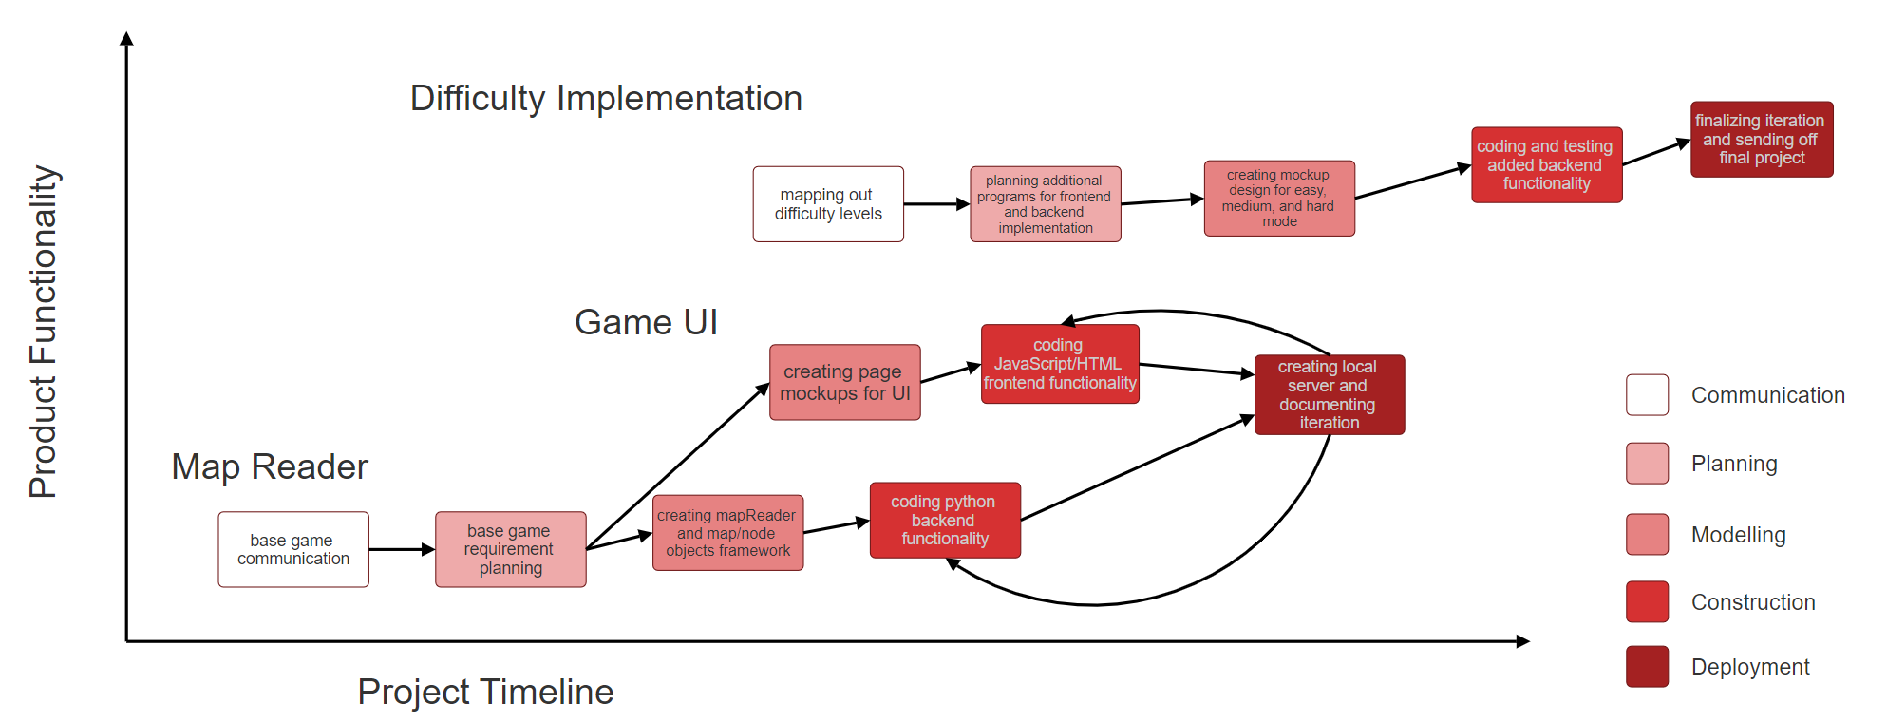

A.2 RouteGuesser Map Class ER Diagram
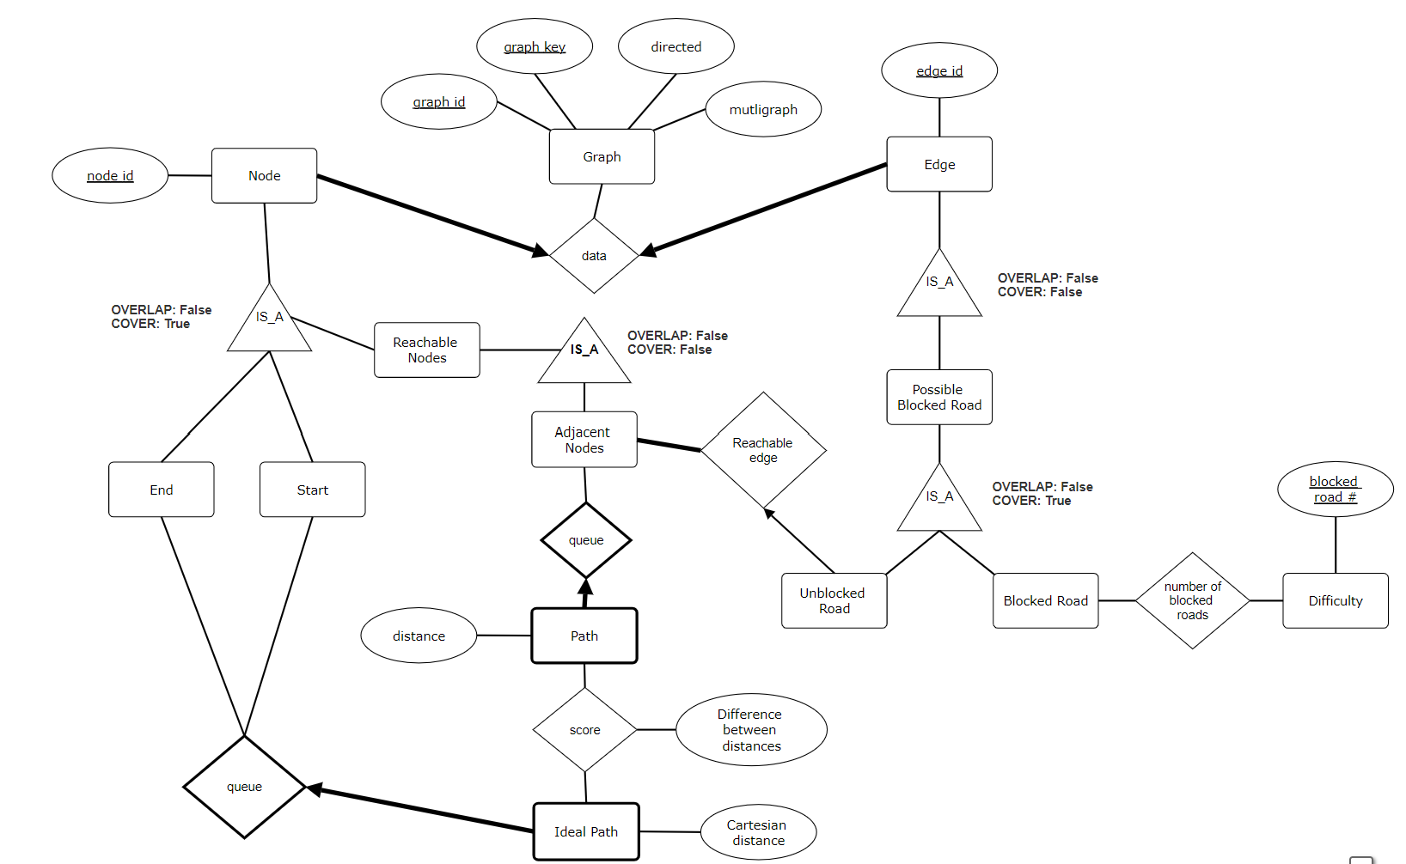

A.3 RouteGuesser Sequence Diagram
