03_prueba_p_una_muestra.R

Usuario

2023-09-05

# Alejandra Janeth Nuñez Treviño <33  
# 21/08/2023  
# Matricula: 2070873  
  
# Importar datos ----------------------------------------------------------  
# Funcion read.csv (sirve para importar datos csv a R)  
  
setwd("C:/Met_Es/Codigos")  
Plantacion <-read.csv("Tab.csv", header = TRUE)  
  
# Descriptivas ------------------------------------------------------------  
  
# Usar la libreria dpylr para seleccionar datos mediante   
# restricciones   
  
  
library(dplyr)

##   
## Attaching package: 'dplyr'

## The following objects are masked from 'package:stats':  
##   
## filter, lag

## The following objects are masked from 'package:base':  
##   
## intersect, setdiff, setequal, union

a <- Plantacion %>%   
 filter(Tratamiento == "a")  
  
b <- Plantacion %>%   
 filter(Tratamiento == "b")  
  
mean(a$IE)

## Warning in mean.default(a$IE): argument is not numeric or logical: returning NA

## [1] NA

mean(b$IE)

## Warning in mean.default(b$IE): argument is not numeric or logical: returning NA

## [1] NA

Descriptivo <- Plantacion %>%   
 group_by(Tratamiento) %>%   
 summarise(  
 n = n (),  
 media = mean(Altura),  
 mediana = median(Altura),   
 sd = sd(Altura),   
 var = var(Altura)  
 )  
Descriptivo

## # A tibble: 2 × 6  
## Tratamiento n media mediana sd var  
## <chr> <int> <dbl> <dbl> <dbl> <dbl>  
## 1 a 30 39.8 39.6 4.90 24.1  
## 2 b 30 45.9 45.2 4.17 17.4

# Grafica -----------------------------------------------------------------  
  
boxplot(Plantacion$Altura ~ Plantacion$Tratamiento,  
 xlab = "Tratamiento",  
 ylab = "Indice Esbeltes",  
 main = "vivero",  
 col = "pink")

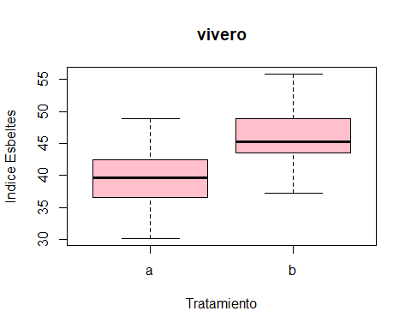

t.test(Plantacion$Altura ~ Plantacion$Tratamiento, var.equal = T)

##   
## Two Sample t-test  
##   
## data: Plantacion$Altura by Plantacion$Tratamiento  
## t = -5.2103, df = 58, p-value = 2.61e-06  
## alternative hypothesis: true difference in means between group a and group b is not equal to 0  
## 95 percent confidence interval:  
## -8.480898 -3.773102  
## sample estimates:  
## mean in group a mean in group b   
## 39.76467 45.89167

# Conclusiones ------------------------------------------------------------  
  
#Al comparar las graficas a y b en sus tratamientos note que el segundo tratamiento tenia un desarrollo mas rapido  
#Por tanto el segundo tratamiento es mas apto