ANNEX A: Design

1. Use case diagram

Fig 1
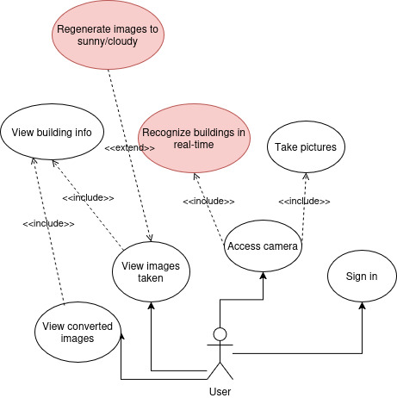

We will look into details the two core use cases (red bubbles) in the lower section in their respective sequence diagrams. View building info is also an extension of the “Recognize buldings in real-time” use case.

2. Sequence diagrams of core use case

Fig 2.1 – Image detection
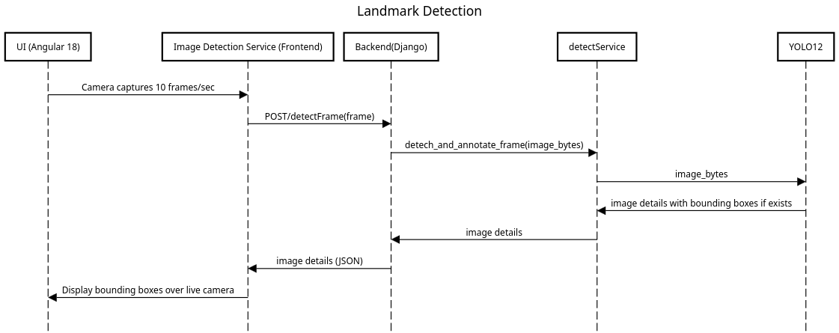
Note that image details in this flow is repersented by its bounding boxes (if detected), its label (e.g. Merlion), and its class_id. Both the label and class_id are saved to the database, henceforth this particular landmark will be queried based on these two attrubutes.

Fig 2.2 – Image weather conversion
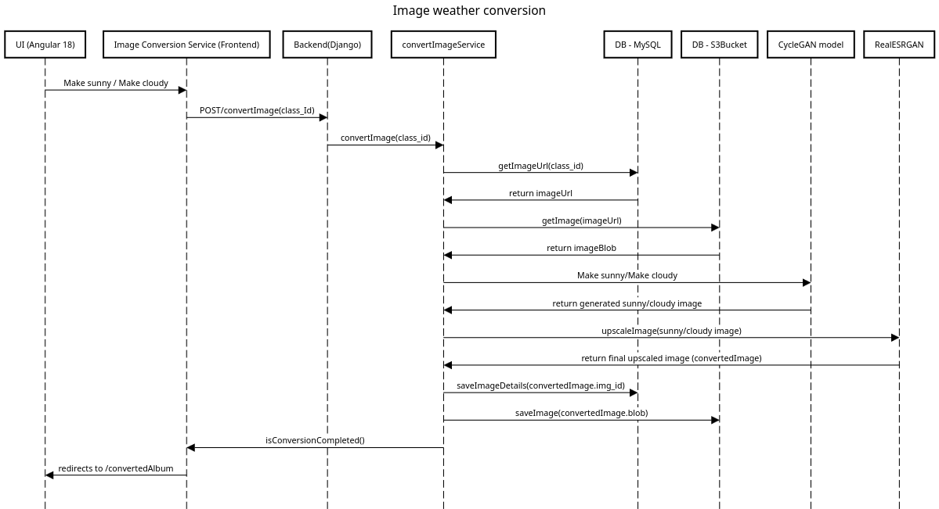
Both CycleGAN and RealESRGAN run in realtime hence this process could take up to 8 seconds to complete. Reconstruction of images do have some limitation based on the current image generation technology. This flow ends at the redirection of the frontend webpage as noted by the last arrow in the diagram. The redirection starts another sequence of getting the converted images to display them.

ANNEX B: Architecture
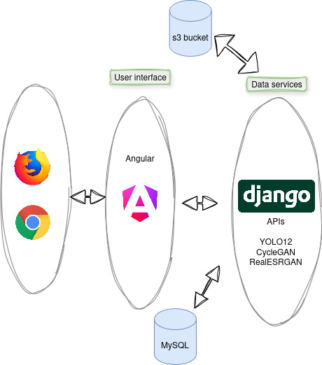

For the application, we have chosen a simple web application stack with Angular as the frontend and Django as the backend to harness the power of the different models that we are using for our core services.

Text-based information like user details, building details are all stored and accessed via MySQL while image based data like blobs are stored on the cloud in S3Bucket. Both databases are hosted on the cloud using DigitalOcean.

The Angular frontend is deployed and hosted on Vercel. For the Django backend, a secure tunnel was established via ngrok, providing a publicly accessible HTTPS endpoint for remote testing and member usage.

Application is fully accessible by: https://travel-frontend-one.vercel.app/

ANNEX C: Application screenshots

Fig 1 – Log in page



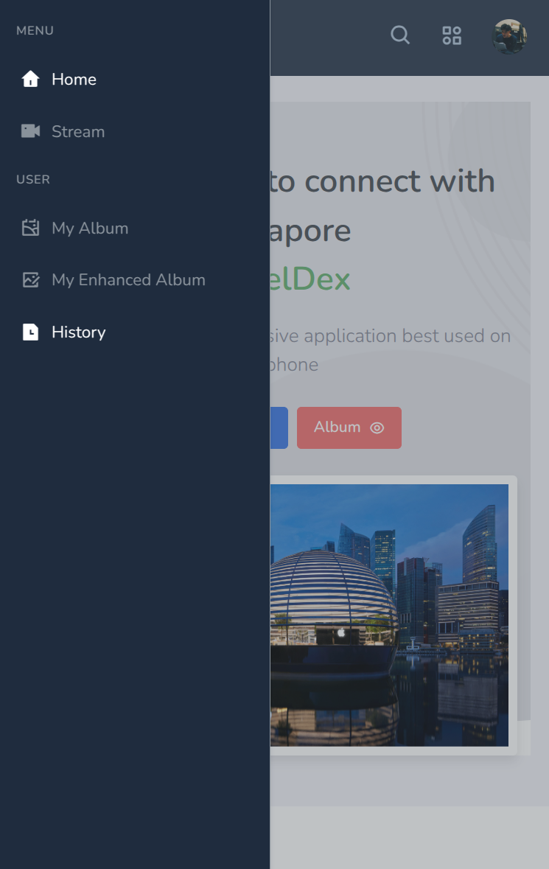
Fig 2 – Landing page and side nav menu


Fig 3 – Real time image detection (multiple): Helix bridge and Flyer
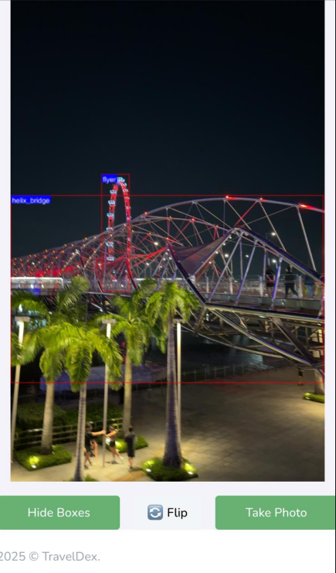

Fig 4 – Building info view
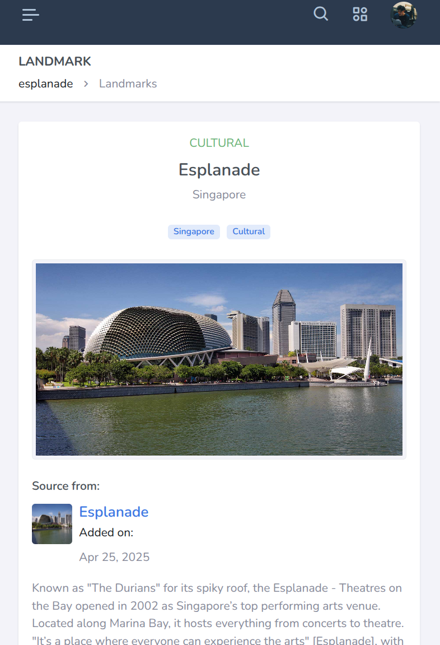

Fig 5 – Image convertion sunny and cloudy




Fig 6 – Admin view of user image (Only viewable by admin)
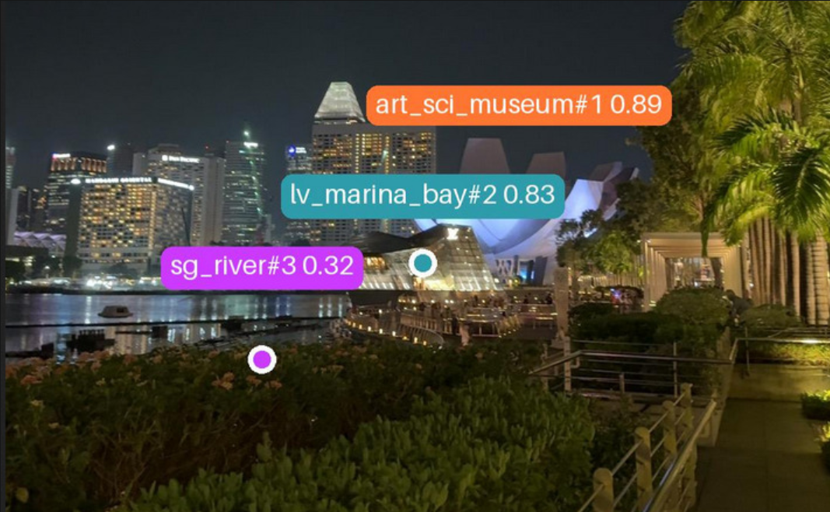

Fig 7 – Picture view (when user clicks on images that was taken)
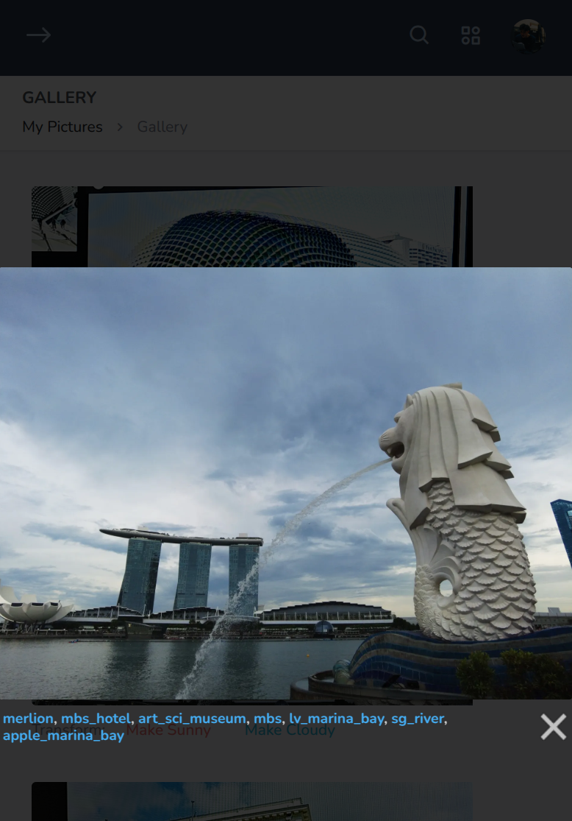

The tags can all be clicked and building view will be accessed.

ANNEX D: Database design

