**UNIVERSIDAD TECNOLOGICA DE SANTIAGO**

**(UTESA)**

**COMPUTACION GRAFICA**

**PRACTICA:** PARQUEO

**Componentes:**

* 1-Formulario
* 11-Panel
* 2-Label
* 1-PictureBox
* 1-Button
* 1-Textbox
* 2-Timer

**LABEL**

**PANEL**

**FORM**

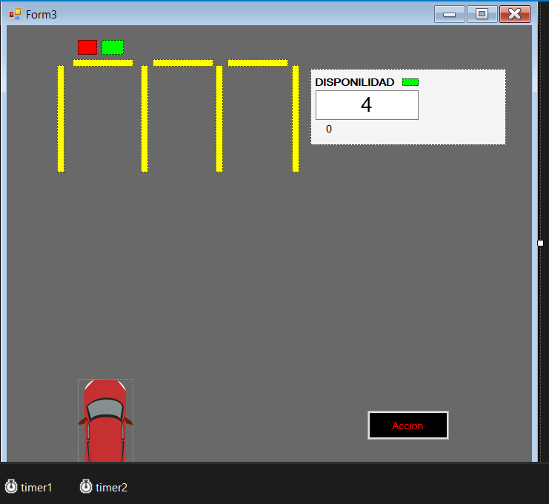

**PANEL**

**LABEL-1**

**TEXTBOX**

**PICTUREBOX**

**BUTTON-1**

**TIMER-1**

**TIMER-2**

**EVENTO: TIMER _TICK**

**TIMER-1**

**private void timer1_Tick(object sender, EventArgs e)**

**{**

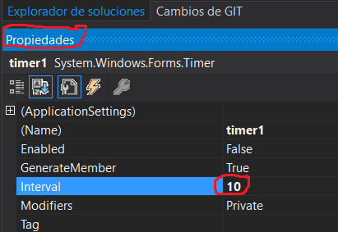 Subir = 1;

X = Vehiculo1.Location.X;

Y = Vehiculo1.Location.Y;

textBox1.Text = "4";

Vehiculo1.Location = new Point(X, Y - Subir);

Subir++;

**}**

**NOTA:** Propiedades del TIMER-1

**TIMER-2**

**EVENTO: TIMER _TICK**

**private void timer2_Tick(object sender, EventArgs e)**

**{**

timer1.Enabled = true;

int contadorLuzverde;

contadorLuzverde = Convert.ToInt32(label1.Text);

contadorLuzverde += 1;

label1.Text = contadorLuzverde.ToString();

if (contadorLuzverde == 50)

{

timer1.Enabled = false;

timer1.Stop();

timer2.Stop();

p1LVerde.Visible = false;

p1LRoja.Visible = true;

textBox1.Text ="3";

}

**}**

**FORM**

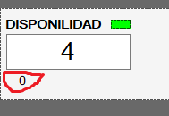

**EVENTO: LOAD**

private void Form1_Load(object sender, EventArgs e)

{

label1.Visible=false;

}

**BUTON-1**

**EVENTO: CLICK**

 private void button1_Click(object sender, EventArgs e)

{

timer2.Start();

}

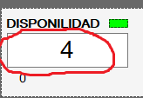

**TEXTBOX-1**

**Propiedad** Text: 4



**PANEL 1 y 2**

**Propiedad** Name: p1LRoja **Backcolor:** Rojo

**Propiedad**  Name: p2LVerde **Backcolor:** Verde

**PICTUREBOX-1**

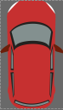

**Cargar** Imagen: Carro