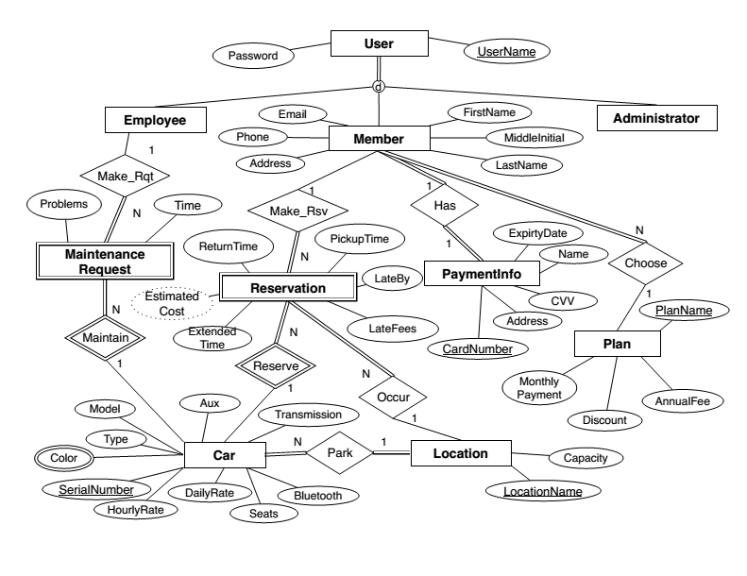

User

|  |  |
| --- | --- |
| User Name | Password |

Employee

|  |
| --- |
| User Name |

Administrator

|  |
| --- |
| UserName |

Member

|  |  |  |  |  |  |  |  |  |
| --- | --- | --- | --- | --- | --- | --- | --- | --- |
| User Name | Password | First Name | Last Name | Email | Phone | Addres | Plan Name | Card Number |

Location

|  |  |
| --- | --- |
| Capacity | Location Name |

Car

|  |  |  |  |  |  |  |  |  |  |
| --- | --- | --- | --- | --- | --- | --- | --- | --- | --- |
| Type | Model | Transmission | Bluetooth | Seats | Daily Rate | Hourly Rate | Serial Number | Color | Location Name |

Plan

|  |  |  |  |
| --- | --- | --- | --- |
| PlanName | Monthly Payment | Discount | Annual Fee |

Maintenance Request

|  |  |  |  |
| --- | --- | --- | --- |
| Serial Number | Problems | Time | User Name |

Reservation

|  |  |  |  |  |  |  |  |  |
| --- | --- | --- | --- | --- | --- | --- | --- | --- |
| User Name | Pickup Time | Return Time | Late by | Late fees | Estimated Cost | Return Status | Serial Number | Location Name |

Payment Info

|  |  |  |  |  |
| --- | --- | --- | --- | --- |
| Card Number | Name | CVV | Address | Expiration Date |