**Metadata – Australian Wet Tropics ringtail possums**

Fur dataset – clean database is compiled in file “fur_dataset_clean.xlsx”, stored in the shared folder in OneDrive.

Green Ringtail Possum (GRTP)

Number of pelts: 7

* Hair length – original file name: hair_length_grpt.xlsx

Hair description

Smooth and woolly towards the base (next to the skin), likely providing insulation. Towards the base, the hair its grey and much thinner and softer. Hairs get

tougher towards the tip, where they get the greenish colour close to the tip. Right before the tip, the hair thins again, allowing the tip to curve (in a fishhook shape).

This is likely making the fur to bend in the same direction, protecting the base.

Guard hairs are straight, black hairs. They are also much thicker than the fur hairs. They are in a much lower density. The length of guard hairs seem

to be like the fur hairs, but because they are straight, they stand out in the fur.

No guards on the ventral side.

Description

GRTP has not a double coated (as initially though as a possibility). After a thorough examination under the microscope, we noted that the fur has two types of hairs: guard hairs, and the main fur that composes the coat of the animal. Fur hairs have a complex structure, varying in thickness from the bottom to the tip. Close to the skin, the hairs are soft and thin, providing an intertwined structure for insulation. The hairs get thicker towards the tip where they get the green-ish colour. However, right before the tip the hairs thin again. This makes the tip to be bended, "closing" the coat. With all the tips bending in the same direction (hook-shaped tip), it creates a smooth coat that might be the responsible for the protection of the insulation area. There is also guard hairs, which are black, straight, and thick. They stand out from the coat, but they have roughly the same length than the other hairs. The ventral area is composed of short, soft, white hairs.

Measurement

We randomly sampled 7 dorsal and 7 ventral areas per pelt. Within each sampling area, we randomly selected 10-13 hairs of each type (fur and guard). We photographed each hair with a macro lens. We measured the length of each individual hair on ImageJ software using a 0.5 mm scale.

* Fur depth - original file name: fur_depth_grpt.xlsx

Measurement

For each pelt (n=7), we defined 7 positions to measure the fur depth (figure 1). At each position within the fur, we selected a random area from where we took 6 measures of fur depth using the back end of an opened calliper, we closed the calliper until the bottom of the calliper touched the surface of the fur. I calculated the dorsal depth using the weighted average of the dorsal positions (e.g., including hear, tail).

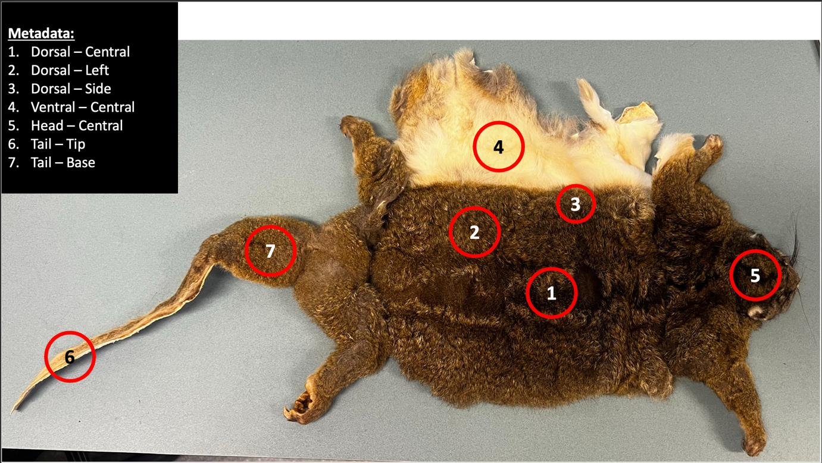

* Thermal conductance – original file name: “Mean values worksheet - GRTP fur thermal conductance - full raw data set.xls”. Summarised data file name: “thermal_conductance_summary_GRTP.xlsx”.

Calculations:

Using Krockenberger’s raw data from the wind tunnel, I summarised for each pelt, fur side (dorsal, ventral, and side), and wind treatment (0, 1, 2, 3, 4, and 6 m/s) combination: (i) heat flow (HFT), (ii) basal temperature, and (iii) fur tip temperature. Then, I apply the formula for thermal conductance:

Where is the thermal conductance, *j i*s the heat flow, *d* is the sample thickness in m, and is the difference in temperature across the sample. The sample thickness was defined for each side of the pelt (dorsal, side, ventral) based on the fur depth average calculations above. The difference in temperature was calculated using the difference between base temperature and ambient temperature.

Comparison between estimated and observed conductivity:

|  |  |  |  |
| --- | --- | --- | --- |
| Area | Effective thermal conductivity | Observed thermal conductivity | Difference (absolute) |
| mean | 0.027 | 0.037 | 0.01 |
| dorsal | 0.027 | 0.045 | 0.018 |
| ventral | 0.026 | 0.022 | 0.004 |

In previous estimations, I used the fur depth averaged across sides (dorsal, ventral, and flank) to calculate thermal conductance. The result looked unrealistic for the ventral conductivity. It was too low.

Lower than theoretically possible.

A possible solution was to account for intra-variability across pelts. This was done by using the average depth (n = 6 measurements) for each individual pelt and side (ventral, dorsal, flank). This is a more logical approach than assuming a constant depth. Especially since thermal conductance is sensitive to depth.

After account for this, the results look very similar. This is because the variability across pelts is not great, so we still get a very low value of thermal conductance (>0.025).

Next, I considered human error. Did I induce bias on some of the measurements taken on the ventral part of the fur? This part is tricky to measure.

This would be especially easy for the ventral area of the fur, because it is very short. A slight push with the caliper would mean double or triple the measure you would get. Thus, the sensitivity of manually measuring fur depth on the ventral part would be susceptible to human error.

I consider this possibility by increasing the depth of the pelts with the lowest value by an error rate.

I increased the error until the values of the ventral thermal conductance was closer, but below, the flank observed measurements (which would be the logical value they should get).

I then compared this new observed measure to the effective thermal conductance simulated with NicheMapR, with the idea that the values should be higher than KEFF estimations.

I would have to have induced an error across the measurements of 70-100% to have a value close to the expected reality (100% to be above the KEFF line).

* Hair diameter – original file name: “fur density data.xls”.
* Hair density – original file name: “fur density data.xls”.
* Fur area – original file name: “fur density data.xls”.
* Body mass – original file name: “GRTP RMR summary for Will 22nd March 2011.xls”.
* Body temperature – original file name: “GRTP RMR summary for Will 22nd March 2011.xls”.