**Technical manual.**

1. 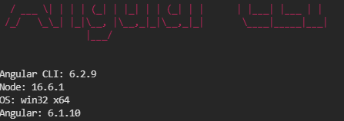

* Angular cli version 6.2.9, angular version 6.1.10 and node 16.6.1 were used to make the project software.

1. 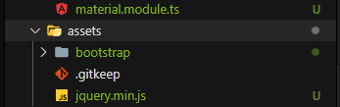

* For the styles I used bootstrap, css and the angular material libraries

1. 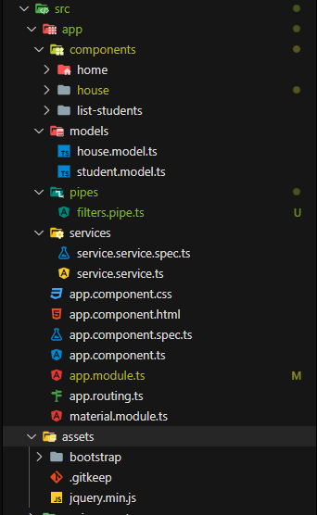

* For my logic I implemented 3 components (home, house, student): which in the logical implementations are in home which is the home interface and house where the central logic of the project is made.
* I have 2 modules (house, students): house has a variable house and a list of students and the module students has all the variables that are needed from the students that are shown in the table
* I have the services and the routes, in which I consume the Api and in the routes I address the pages.
* I have a logic of pipes to be able to filter the information in the search engine.

**User manual.**

1. 

* Start the program and the server.

1. In the search engine of the internet browser place localhost: 4200 that the path in angular displays its services.
2. 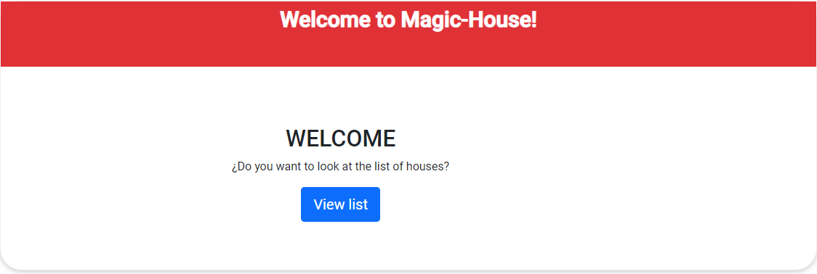

* The start menu will be displayed which we give in the viem list button.

1. 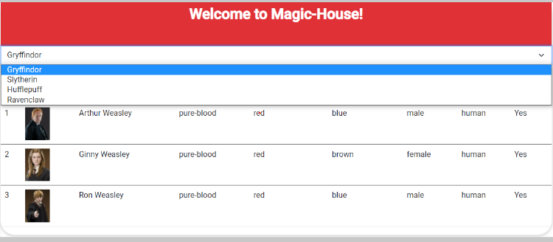

* It will route us to the house interface which contains a list of houses to

select.

1. 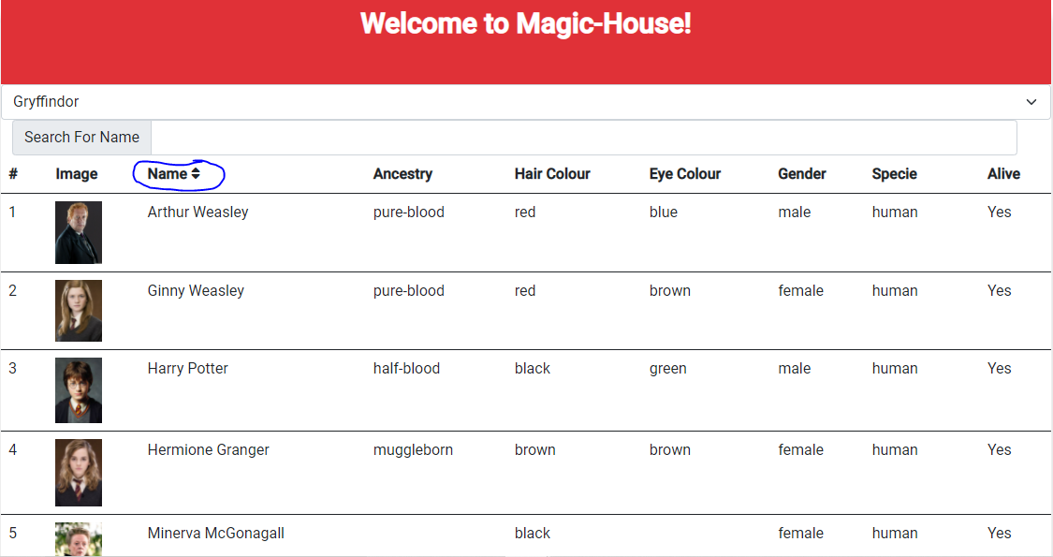

* it is ordered ascending and descending by clicking on the Name box

1. 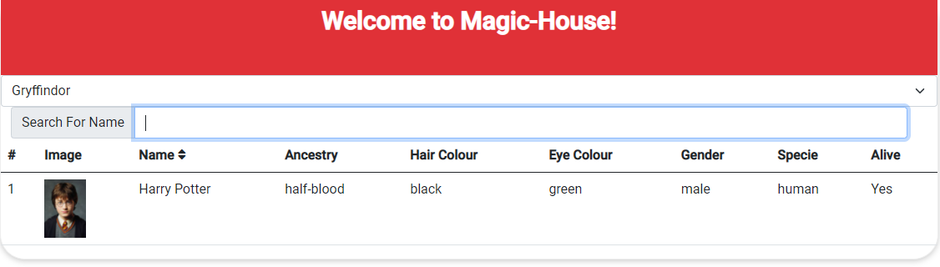

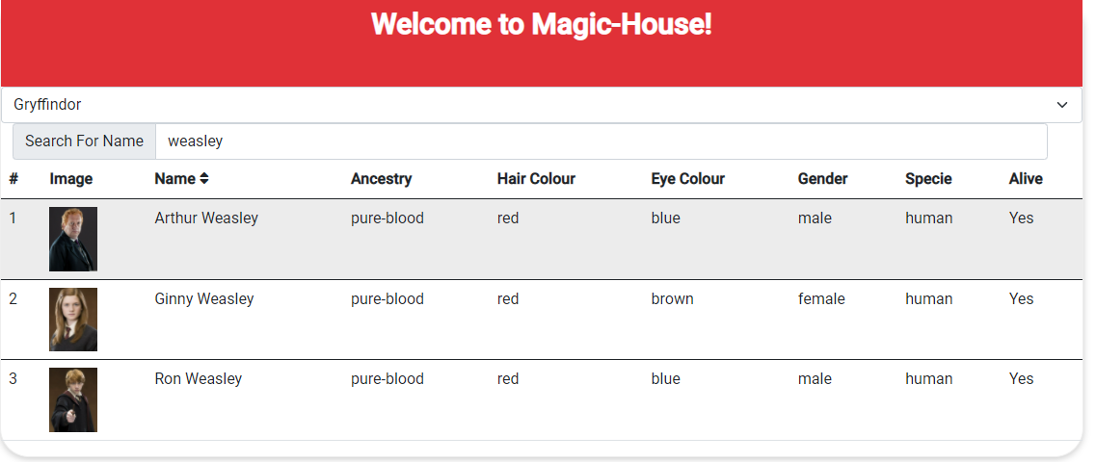

* The user is at the facility of filtering the names that he sees fit and the table will respond with the matches found.

Technologies not applied.

* SASS 🡪 I had no knowledge