Go First App

Manual

Version 2.0



|  |  |  |  |  |
| --- | --- | --- | --- | --- |
| Control data | | | | |
| ***TÍTULO*** | | | Go First App | |
| ***VERSIÓN*** | | | 2.0 | |
| ***TYPE*** | | | MANUAL | |
| ***STATE*** | | | ENDED | |
| ***LANGUAGE*** | | | ENGLISH | |
| ***AUTHOR*** | | | ALEJANDRO LAYOS | |
| ***CREATION DATE*** | | | 17/02/2020 | |
| ***UPDATED*** | | | 18/02/2020 | |
| Control changes | | | | |
| ***VERSION*** | ***AUTHOR*** | ***DATE*** | | ***CHANGE DESCRIPTION*** |
| 2.0 | Layos | 17/02/2020 | | First version |
|  |  |  | |  |
|  |  |  | |  |
|  |  |  | |  |
|  |  |  | |  |
|  |  |  | |  |
|  |  |  | |  |
|  |  |  | |  |
|  |  |  | |  |
|  |  |  | |  |
|  |  |  | |  |
|  |  |  | |  |
|  |  |  | |  |

Contenido

**1.**Introduction 4

2.Requirements 4

3. Class Diagram 5

4.Sequence Diagram 6

5. Installation 7

6.Usage 7

6.1.Some examples **¡Error! Marcador no definido.**

6.2.Unit test run 8

7.Versions 8

# **1.**Introduction

This document contains all the details about the application “Go First App”. All requirements for this development have been defined by Lab Cab. The purpose of this document is to explain the architecture and usage of the requested app

# 2.Requirements

* Create a java app to get some information from an API. The main class should communicate with an intermediate service that returns a JSON built with the API information retrieved.
* This service must use a third party library to make a GET request.
* The information retrieved should be stored so that it can be handled to perform searches depending on the user entry
* We need to run the app by command line:

bash$ java swcatalog “Han Solo”

* The argument will be the name of a Star Wars character and the app will search in the API.
* If the character exist the app returns all the information
* If the character do not exist the app will show a message : “The character do not exist”

# 3. Class Diagram

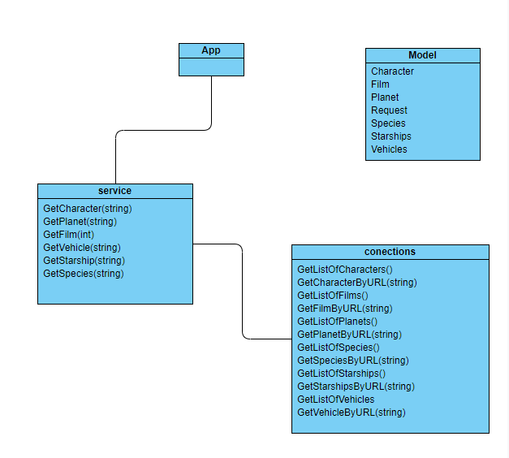

# 4.Sequence Diagram

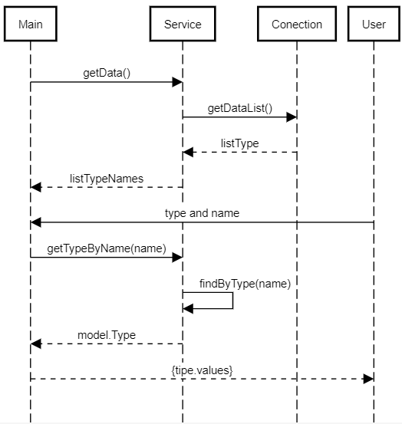

# 5. Installation

1. Install go distribution from here <https://golang.org/dl/>
2. Clone the repository <https://github.com/AlejandroLayos/startingGo.git>
3. Go to src/main
4. Open a console and type > go build swcatalog.go

# 6.Usage

* To execute the app type: .\swcatalog
* User **PowerShell** (in windows) for a better performance
* The different types of objects are:

planet, character, species, starship, vehicles, films

* Chose an object to search
* Select one of the object list
* Say “y” if you want to do another search

## 6.2.Unit test run

* Go to \src\test
* Open a console and type go test

# 7.Versions

Golang go1.13.8 windows/amd64

Visual Studio Code 1.42.1