

**MODELADO DE DATOS**

|  |  |  |  |
| --- | --- | --- | --- |
| Nombre del proyecto: | *Smart Parking* | | |
| Alias del proyecto: | *Smart_Parking_App* | | |
| Versión: | *1.0* | Fecha última modificación: | *18/02/2017* |

Contenido

DIAGRAMA ENTIDAD RELACIÓN 2

DIAGRAMA RELACIONAL 3

DIAGRAMA LÓGICO 4

SCRIPT BASE DE DATOS 5

# DIAGRAMA ENTIDAD RELACIÓN

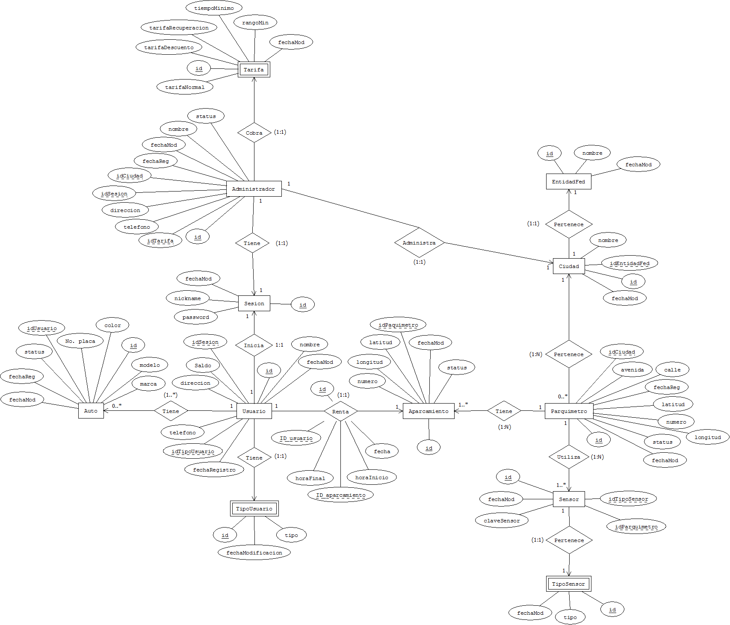

# DIAGRAMA RELACIONAL

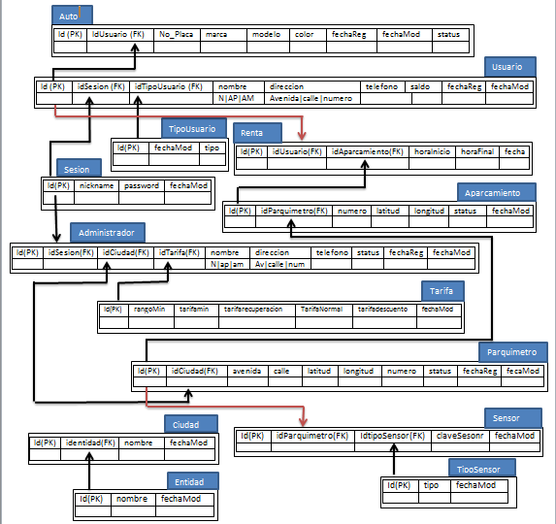

# DIAGRAMA FÍSICO

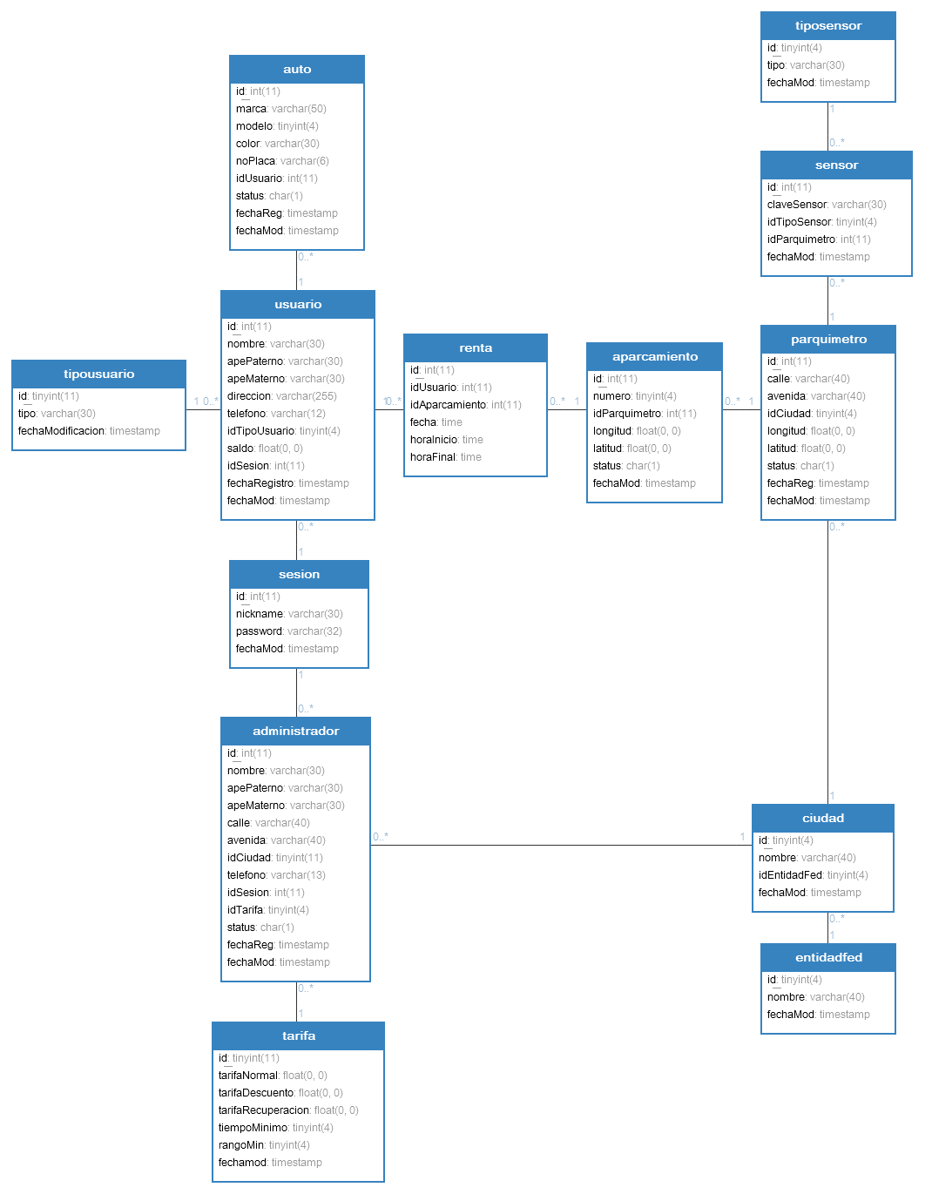

# 

# SCRIPT BASE DE DATOS

/*

Navicat MySQL Data Transfer

Source Server : MYSQLocal

Source Server Version : 50539

Source Host : localhost:3306

Source Database : smartparkingdb

Target Server Type : MYSQL

Target Server Version : 50539

File Encoding : 65001

Date: 2017-02-15 15:21:14

*/

SET FOREIGN_KEY_CHECKS=0;

-- ----------------------------

-- Table structure for administrador

-- ----------------------------

DROP TABLE IF EXISTS `administrador`;

CREATE TABLE `administrador` (

`id` int(11) NOT NULL ,

`nombre` varchar(30) CHARACTER SET utf8 COLLATE utf8_spanish_ci NOT NULL ,

`apePaterno` varchar(30) CHARACTER SET utf8 COLLATE utf8_spanish_ci NOT NULL ,

`apeMaterno` varchar(30) CHARACTER SET utf8 COLLATE utf8_spanish_ci NOT NULL ,

`calle` varchar(40) CHARACTER SET utf8 COLLATE utf8_spanish_ci NOT NULL ,

`avenida` varchar(40) CHARACTER SET utf8 COLLATE utf8_spanish_ci NOT NULL ,

`idCiudad` tinyint(11) NOT NULL ,

`telefono` varchar(13) CHARACTER SET utf8 COLLATE utf8_spanish_ci NOT NULL ,

`idSesion` int(11) NOT NULL ,

`idTarifa` tinyint(4) NOT NULL ,

`status` char(1) CHARACTER SET utf8 COLLATE utf8_spanish_ci NOT NULL ,

`fechaReg` timestamp NOT NULL DEFAULT '0000-00-00 00:00:00' ON UPDATE CURRENT_TIMESTAMP ,

`fechaMod` timestamp NOT NULL DEFAULT '0000-00-00 00:00:00' ,

PRIMARY KEY (`id`),

FOREIGN KEY (`idCiudad`) REFERENCES `ciudad` (`id`) ON DELETE RESTRICT ON UPDATE CASCADE,

FOREIGN KEY (`idSesion`) REFERENCES `sesion` (`id`) ON DELETE RESTRICT ON UPDATE CASCADE,

FOREIGN KEY (`idTarifa`) REFERENCES `tarifa` (`id`) ON DELETE RESTRICT ON UPDATE CASCADE,

INDEX `fk_sesionAdm` (`idSesion`) USING BTREE ,

INDEX `fk_tarifa` (`idTarifa`) USING BTREE ,

INDEX `fk_ciudadAdm` (`idCiudad`) USING BTREE

)

ENGINE=InnoDB

DEFAULT CHARACTER SET=utf8 COLLATE=utf8_spanish_ci

;

-- ----------------------------

-- Records of administrador

-- ----------------------------

BEGIN;

COMMIT;

-- ----------------------------

-- Table structure for aparcamiento

-- ----------------------------

DROP TABLE IF EXISTS `aparcamiento`;

CREATE TABLE `aparcamiento` (

`id` int(11) NOT NULL ,

`numero` tinyint(4) NOT NULL ,

`idParquimetro` int(11) NOT NULL ,

`longitud` float NOT NULL ,

`latitud` float NOT NULL ,

`status` char(1) CHARACTER SET utf8 COLLATE utf8_spanish_ci NOT NULL ,

`fechaMod` timestamp NOT NULL DEFAULT '0000-00-00 00:00:00' ON UPDATE CURRENT_TIMESTAMP ,

PRIMARY KEY (`id`),

FOREIGN KEY (`idParquimetro`) REFERENCES `parquimetro` (`id`) ON DELETE RESTRICT ON UPDATE CASCADE,

INDEX `fk_parquimetroAp` (`idParquimetro`) USING BTREE

)

ENGINE=InnoDB

DEFAULT CHARACTER SET=utf8 COLLATE=utf8_spanish_ci

;

-- ----------------------------

-- Records of aparcamiento

-- ----------------------------

BEGIN;

COMMIT;

-- ----------------------------

-- Table structure for auto

-- ----------------------------

DROP TABLE IF EXISTS `auto`;

CREATE TABLE `auto` (

`id` int(11) NOT NULL ,

`marca` varchar(50) CHARACTER SET utf8 COLLATE utf8_spanish_ci NOT NULL ,

`modelo` tinyint(4) NOT NULL ,

`color` varchar(30) CHARACTER SET utf8 COLLATE utf8_spanish_ci NOT NULL ,

`noPlaca` varchar(6) CHARACTER SET utf8 COLLATE utf8_spanish_ci NOT NULL ,

`idUsuario` int(11) NOT NULL ,

`status` char(1) CHARACTER SET utf8 COLLATE utf8_spanish_ci NOT NULL ,

`fechaReg` timestamp NOT NULL DEFAULT '0000-00-00 00:00:00' ON UPDATE CURRENT_TIMESTAMP ,

`fechaMod` timestamp NOT NULL DEFAULT '0000-00-00 00:00:00' ,

PRIMARY KEY (`id`),

FOREIGN KEY (`idUsuario`) REFERENCES `usuario` (`id`) ON DELETE RESTRICT ON UPDATE CASCADE,

INDEX `fk_idUsuario` (`idUsuario`) USING BTREE

)

ENGINE=InnoDB

DEFAULT CHARACTER SET=utf8 COLLATE=utf8_spanish_ci

;

-- ----------------------------

-- Records of auto

-- ----------------------------

BEGIN;

COMMIT;

-- ----------------------------

-- Table structure for ciudad

-- ----------------------------

DROP TABLE IF EXISTS `ciudad`;

CREATE TABLE `ciudad` (

`id` tinyint(4) NOT NULL ,

`nombre` varchar(40) CHARACTER SET utf8 COLLATE utf8_spanish_ci NOT NULL ,

`idEntidadFed` tinyint(4) NOT NULL ,

`fechaMod` timestamp NOT NULL DEFAULT '0000-00-00 00:00:00' ON UPDATE CURRENT_TIMESTAMP ,

PRIMARY KEY (`id`),

FOREIGN KEY (`idEntidadFed`) REFERENCES `entidadfed` (`id`) ON DELETE RESTRICT ON UPDATE CASCADE,

INDEX `fk_entidadFed` (`idEntidadFed`) USING BTREE

)

ENGINE=InnoDB

DEFAULT CHARACTER SET=utf8 COLLATE=utf8_spanish_ci

;

-- ----------------------------

-- Records of ciudad

-- ----------------------------

BEGIN;

COMMIT;

-- ----------------------------

-- Table structure for entidadfed

-- ----------------------------

DROP TABLE IF EXISTS `entidadfed`;

CREATE TABLE `entidadfed` (

`id` tinyint(4) NOT NULL ,

`nombre` varchar(40) CHARACTER SET utf8 COLLATE utf8_spanish_ci NOT NULL ,

`fechaMod` timestamp NOT NULL DEFAULT '0000-00-00 00:00:00' ON UPDATE CURRENT_TIMESTAMP ,

PRIMARY KEY (`id`)

)

ENGINE=InnoDB

DEFAULT CHARACTER SET=utf8 COLLATE=utf8_spanish_ci

;

-- ----------------------------

-- Records of entidadfed

-- ----------------------------

BEGIN;

COMMIT;

-- ----------------------------

-- Table structure for parquimetro

-- ----------------------------

DROP TABLE IF EXISTS `parquimetro`;

CREATE TABLE `parquimetro` (

`id` int(11) NOT NULL ,

`calle` varchar(40) CHARACTER SET utf8 COLLATE utf8_spanish_ci NOT NULL ,

`avenida` varchar(40) CHARACTER SET utf8 COLLATE utf8_spanish_ci NOT NULL ,

`idCiudad` tinyint(4) NOT NULL ,

`longitud` float NOT NULL ,

`latitud` float NOT NULL ,

`status` char(1) CHARACTER SET utf8 COLLATE utf8_spanish_ci NOT NULL ,

`fechaReg` timestamp NOT NULL DEFAULT '0000-00-00 00:00:00' ON UPDATE CURRENT_TIMESTAMP ,

`fechaMod` timestamp NOT NULL DEFAULT '0000-00-00 00:00:00' ,

PRIMARY KEY (`id`),

FOREIGN KEY (`idCiudad`) REFERENCES `ciudad` (`id`) ON DELETE RESTRICT ON UPDATE CASCADE,

INDEX `fk_ciudad` (`idCiudad`) USING BTREE

)

ENGINE=InnoDB

DEFAULT CHARACTER SET=utf8 COLLATE=utf8_spanish_ci

;

-- ----------------------------

-- Records of parquimetro

-- ----------------------------

BEGIN;

COMMIT;

-- ----------------------------

-- Table structure for renta

-- ----------------------------

DROP TABLE IF EXISTS `renta`;

CREATE TABLE `renta` (

`id` int(11) NOT NULL ,

`idUsuario` int(11) NOT NULL ,

`idAparcamiento` int(11) NOT NULL ,

`fecha` time NOT NULL ,

`horaInicio` time NOT NULL ,

`horaFinal` time NOT NULL ,

PRIMARY KEY (`id`),

FOREIGN KEY (`idAparcamiento`) REFERENCES `aparcamiento` (`id`) ON DELETE RESTRICT ON UPDATE CASCADE,

FOREIGN KEY (`idUsuario`) REFERENCES `usuario` (`id`) ON DELETE RESTRICT ON UPDATE CASCADE,

INDEX `fk_usuarioRenta` (`idUsuario`) USING BTREE ,

INDEX `fk_aparcamientoRenta` (`idAparcamiento`) USING BTREE

)

ENGINE=InnoDB

DEFAULT CHARACTER SET=utf8 COLLATE=utf8_spanish_ci

;

-- ----------------------------

-- Records of renta

-- ----------------------------

BEGIN;

COMMIT;

-- ----------------------------

-- Table structure for sensor

-- ----------------------------

DROP TABLE IF EXISTS `sensor`;

CREATE TABLE `sensor` (

`id` int(11) NOT NULL ,

`claveSensor` varchar(30) CHARACTER SET utf8 COLLATE utf8_spanish_ci NOT NULL ,

`idTipoSensor` tinyint(4) NOT NULL ,

`idParquimetro` int(11) NOT NULL ,

`fechaMod` timestamp NOT NULL DEFAULT '0000-00-00 00:00:00' ON UPDATE CURRENT_TIMESTAMP ,

PRIMARY KEY (`id`),

FOREIGN KEY (`idParquimetro`) REFERENCES `parquimetro` (`id`) ON DELETE RESTRICT ON UPDATE CASCADE,

FOREIGN KEY (`idTipoSensor`) REFERENCES `tiposensor` (`id`) ON DELETE RESTRICT ON UPDATE CASCADE,

INDEX `fk_tipoSensor` (`idTipoSensor`) USING BTREE ,

INDEX `fk_parquimetro` (`idParquimetro`) USING BTREE

)

ENGINE=InnoDB

DEFAULT CHARACTER SET=utf8 COLLATE=utf8_spanish_ci

;

-- ----------------------------

-- Records of sensor

-- ----------------------------

BEGIN;

COMMIT;

-- ----------------------------

-- Table structure for sesion

-- ----------------------------

DROP TABLE IF EXISTS `sesion`;

CREATE TABLE `sesion` (

`id` int(11) NOT NULL ,

`nickname` varchar(30) CHARACTER SET utf8 COLLATE utf8_spanish_ci NOT NULL ,

`password` varchar(32) CHARACTER SET utf8 COLLATE utf8_spanish_ci NOT NULL ,

`fechaMod` timestamp NOT NULL DEFAULT '0000-00-00 00:00:00' ON UPDATE CURRENT_TIMESTAMP ,

PRIMARY KEY (`id`)

)

ENGINE=InnoDB

DEFAULT CHARACTER SET=utf8 COLLATE=utf8_spanish_ci

;

-- ----------------------------

-- Records of sesion

-- ----------------------------

BEGIN;

COMMIT;

-- ----------------------------

-- Table structure for tarifa

-- ----------------------------

DROP TABLE IF EXISTS `tarifa`;

CREATE TABLE `tarifa` (

`id` tinyint(11) NOT NULL ,

`tarifaNormal` float NOT NULL ,

`tarifaDescuento` float NOT NULL ,

`tarifaRecuperacion` float NOT NULL ,

`tiempoMinimo` tinyint(4) NOT NULL ,

`rangoMin` tinyint(4) NOT NULL ,

`fechamod` timestamp NOT NULL DEFAULT '0000-00-00 00:00:00' ON UPDATE CURRENT_TIMESTAMP ,

PRIMARY KEY (`id`)

)

ENGINE=InnoDB

DEFAULT CHARACTER SET=utf8 COLLATE=utf8_spanish_ci

;

-- ----------------------------

-- Records of tarifa

-- ----------------------------

BEGIN;

COMMIT;

-- ----------------------------

-- Table structure for tiposensor

-- ----------------------------

DROP TABLE IF EXISTS `tiposensor`;

CREATE TABLE `tiposensor` (

`id` tinyint(4) NOT NULL ,

`tipo` varchar(30) CHARACTER SET utf8 COLLATE utf8_spanish_ci NOT NULL ,

`fechaMod` timestamp NOT NULL DEFAULT '0000-00-00 00:00:00' ON UPDATE CURRENT_TIMESTAMP ,

PRIMARY KEY (`id`)

)

ENGINE=InnoDB

DEFAULT CHARACTER SET=utf8 COLLATE=utf8_spanish_ci

;

-- ----------------------------

-- Records of tiposensor

-- ----------------------------

BEGIN;

COMMIT;

-- ----------------------------

-- Table structure for tipousuario

-- ----------------------------

DROP TABLE IF EXISTS `tipousuario`;

CREATE TABLE `tipousuario` (

`id` tinyint(11) NOT NULL ,

`tipo` varchar(30) CHARACTER SET utf8 COLLATE utf8_spanish_ci NOT NULL ,

`fechaModificacion` timestamp NOT NULL DEFAULT '0000-00-00 00:00:00' ON UPDATE CURRENT_TIMESTAMP ,

PRIMARY KEY (`id`)

)

ENGINE=InnoDB

DEFAULT CHARACTER SET=utf8 COLLATE=utf8_spanish_ci

;

-- ----------------------------

-- Records of tipousuario

-- ----------------------------

BEGIN;

COMMIT;

-- ----------------------------

-- Table structure for usuario

-- ----------------------------

DROP TABLE IF EXISTS `usuario`;

CREATE TABLE `usuario` (

`id` int(11) NOT NULL ,

`nombre` varchar(30) CHARACTER SET utf8 COLLATE utf8_spanish_ci NOT NULL ,

`apePaterno` varchar(30) CHARACTER SET utf8 COLLATE utf8_spanish_ci NOT NULL ,

`apeMaterno` varchar(30) CHARACTER SET utf8 COLLATE utf8_spanish_ci NOT NULL ,

`calle` varchar(40) CHARACTER SET utf8 COLLATE utf8_spanish_ci NOT NULL ,

`avenida` varchar(40) CHARACTER SET utf8 COLLATE utf8_spanish_ci NOT NULL ,

`telefono` varchar(12) CHARACTER SET utf8 COLLATE utf8_spanish_ci NOT NULL ,

`idTipoUsuario` tinyint(4) NOT NULL ,

`saldo` float NOT NULL ,

`idSesion` int(11) NOT NULL ,

`fechaRegistro` timestamp NOT NULL DEFAULT '0000-00-00 00:00:00' ON UPDATE CURRENT_TIMESTAMP ,

`fechaMod` timestamp NOT NULL DEFAULT '0000-00-00 00:00:00' ,

PRIMARY KEY (`id`),

FOREIGN KEY (`idSesion`) REFERENCES `sesion` (`id`) ON DELETE RESTRICT ON UPDATE CASCADE,

FOREIGN KEY (`idTipoUsuario`) REFERENCES `tipousuario` (`id`) ON DELETE RESTRICT ON UPDATE CASCADE,

INDEX `fk_tipoUsuario` (`idTipoUsuario`) USING BTREE ,

INDEX `fk_sesion` (`idSesion`) USING BTREE

)

ENGINE=InnoDB

DEFAULT CHARACTER SET=utf8 COLLATE=utf8_spanish_ci

;

-- ----------------------------

-- Records of usuario

-- ----------------------------

BEGIN;

COMMIT;